WEEK 4 | PREDICTIVE MODELING AND OPTIMIZATION REPORT

Predictive Modeling and Optimization
in Logistics Systems
Forecasting Last-Mile Delivery Time with Machine Learning and Optimizing Agent Assignment Using the Amazon Delivery Dataset
Submitted by
Prajwal Ashok Zolage
B.E. in AIDS (Artificial Intelligence and Data Science)

Contents
1. Problem Definition and Objective
2. Dataset and Feature Description
3. Model Selection and Rationale
4. Implementation: Data Preparation and Model Training
5. Evaluation and Validation
6. Feature Importance and Model Insights
7. Optimization Strategies
8. Recommendations
9. Limitations and Future Work
10. Conclusion
References

1. Problem Definition and Objective
The earlier stages of this project planned the analysis of last-mile delivery performance (Week 1), produced a clean, model-ready dataset from the raw Amazon Delivery file (Week 2), and explored the drivers of delivery performance through statistics and visualizations (Week 3). Week 4 moves from describing the past to predicting the future and acting on that prediction. The objective is to build a predictive model that forecasts how long an order will take to deliver, and then to use that forecast to propose and demonstrate concrete ways of improving operational performance.
The prediction problem. Given the information available when an order is dispatched (the product category, the route distance, the traffic and weather conditions, the vehicle, the delivery area, and the profile of the assigned agent), predict the delivery time in minutes. This is a supervised regression problem with Delivery_Time as the target variable.
Why this metric matters. Delivery time is the core service metric of a last-mile operation. An accurate forecast supports three decisions a logistics manager makes every day: what ETA to promise the customer, which orders are at risk of missing a service-level target and need intervention, and which agent should carry which order. The report therefore has two halves: a predictive half (Sections 3 to 6) and an optimization half (Section 7) that turns predictions into decisions.
The dataset is the cleaned Amazon Delivery Dataset carried forward from Week 2, so no synthetic data was needed for the prediction task. All model results in this report are the actual output of the notebook documented in Section 4.

2. Dataset and Feature Description
The modeling table contains 6,879 delivery records and 22 columns after Week 2 preprocessing. One record has a missing target value and one has a missing product category, so both were dropped before modeling, leaving 6,878 records. Nine predictor columns (four numeric and five categorical) were used, as summarised in Table 1.
Feature | Type | Meaning and role
Delivery_Time | Numeric (target) | Delivery time in minutes; mean 126.2, standard deviation 52.1, range 10 to 270
dist_km | Numeric | Haversine distance between store and drop location, engineered in Week 2
Agent_Age | Numeric | Age of the delivery agent in years
Agent_Rating | Numeric | Customer rating of the delivery agent (2.5 to 5.0)
pickup_wait | Numeric | Minutes between order placement and pickup, engineered in Week 2
Weather | Categorical | Weather at delivery (Sunny, Cloudy, Fog, Stormy, Windy, Sandstorms)
Traffic | Categorical | Traffic level (Low, Medium, High, Jam)
Vehicle | Categorical | Motorcycle, scooter, or van
Area | Categorical | Urban, Metropolitan, Semi-Urban, or Other
Category | Categorical | Product category (for example Grocery, Electronics, Toys, Jewelry)
Table 1. Target and predictor variables used for modeling.
The categorical columns were one-hot encoded with the first level of each dropped to avoid redundant columns, which expands the nine predictors into 32 model features. The data was then split 80/20 into a training set of 5,502 records and a test set of 1,376 records using a fixed random seed (42) so that every result can be reproduced. The test set was held out entirely until the final evaluation of each model.

3. Model Selection and Rationale
Four regression models were chosen to form a ladder of increasing flexibility. Starting with the simplest model and moving up makes it possible to see how much of the problem is linear and how much requires non-linear interactions, instead of jumping directly to a complex model without justification.
Model | Why it was chosen | Configuration used
Linear Regression | Transparent baseline. If a straight-line relationship were enough, no complex model would be needed. | Default ordinary least squares
Decision Tree | Captures non-linear effects and interactions (for example traffic combined with distance) and is easy to explain as a set of rules. | max_depth = 10
Random Forest | Averages many decorrelated trees, which reduces the high variance of a single tree and handles mixed numeric and one-hot features well. | n_estimators = 150, max_depth = 14
Gradient Boosting | Builds trees sequentially, each correcting the errors of the last, and is often the strongest model on tabular data. | n_estimators = 150, max_depth = 4
Table 2. Candidate models, rationale, and starting configuration.
Tree-based models were expected to outperform the linear baseline because Week 3 showed that no single numeric variable correlates strongly with delivery time (the strongest was about 0.32), which points to interactions between conditions, resources, and agents rather than a simple linear trend. Ensemble methods were included because they are the standard remedy for the instability of a single decision tree.

4. Implementation: Data Preparation and Model Training
This section documents the code that was run. Each snippet is followed by a short explanation of what it does and why.

4.1 Setup and data loading
import pandas as pd
import numpy as np
import matplotlib.pyplot as plt
import seaborn as sns

from sklearn.model_selection import train_test_split, GridSearchCV, cross_val_score
from sklearn.linear_model import LinearRegression
from sklearn.tree import DecisionTreeRegressor
from sklearn.ensemble import RandomForestRegressor, GradientBoostingRegressor
from sklearn.metrics import mean_absolute_error, mean_squared_error, r2_score

df = pd.read_csv('amazon_delivery_cleaned.csv')
print("Shape:", df.shape) # (6879, 22)

4.2 Final cleaning, encoding, and train/test split
# Drop the few rows still missing the target or a categorical predictor
df = df.dropna(subset=['Delivery_Time'])
df = df.dropna(subset=['Weather', 'Traffic', 'Vehicle', 'Area', 'Category'])

cats = ['Weather', 'Traffic', 'Vehicle', 'Area', 'Category']
nums = ['Agent_Age', 'Agent_Rating', 'dist_km', 'pickup_wait']

X = pd.get_dummies(df[cats + nums], columns=cats, drop_first=True)
y = df['Delivery_Time']

X_train, X_test, y_train, y_test = train_test_split(
X, y, test_size=0.2, random_state=42)
# X: (6878, 32) Train: (5502, 32) Test: (1376, 32)

pd.get_dummies converts each category into 0/1 columns that the models can use, and drop_first=True removes one level per variable so the columns are not perfectly redundant. No feature scaling was applied because the final models are tree-based and unaffected by feature scale, and the linear baseline does not need scaling to produce valid predictions.

4.3 Training and comparing the four models
models = {
'Linear Regression': LinearRegression(),
'Decision Tree': DecisionTreeRegressor(max_depth=10, random_state=42),
'Random Forest': RandomForestRegressor(n_estimators=150, max_depth=14,
random_state=42, n_jobs=-1),
'Gradient Boosting': GradientBoostingRegressor(n_estimators=150, max_depth=4,
random_state=42),
}

results = []
for name, model in models.items():
model.fit(X_train, y_train)
pred = model.predict(X_test)
mae = mean_absolute_error(y_test, pred)
rmse = np.sqrt(mean_squared_error(y_test, pred))
r2 = r2_score(y_test, pred)
results.append([name, mae, rmse, r2])
print(f"{name}: MAE={mae:.2f} RMSE={rmse:.2f} R2={r2:.3f}")

Every model is trained on the same training set and scored on the same untouched test set, which makes the comparison fair. The loop records three complementary metrics for each model, which are explained in Section 5.

5. Evaluation and Validation

5.1 Evaluation metrics
Three metrics were used, because each answers a different question about prediction quality.
- MAE (Mean Absolute Error) is the average size of the error in minutes. It is the most intuitive measure for operations: an MAE of 19 means a typical prediction is about 19 minutes off.
- RMSE (Root Mean Squared Error) also reports error in minutes but squares errors before averaging, so large misses are penalised more heavily. A gap between RMSE and MAE signals the presence of occasional large errors.
- R² (coefficient of determination) is the share of the variation in delivery time that the model explains, from 0 (no better than predicting the average) to 1 (perfect).

5.2 Hold-out test results
Model | Test MAE (min) | Test RMSE (min) | Test R²
Linear Regression | 25.50 | 32.28 | 0.626
Decision Tree | 20.32 | 27.02 | 0.738
Random Forest | 18.94 | 24.75 | 0.780
Gradient Boosting | 19.18 | 24.58 | 0.783
Table 3. Hold-out test performance of the four models (n = 1,376 test records).
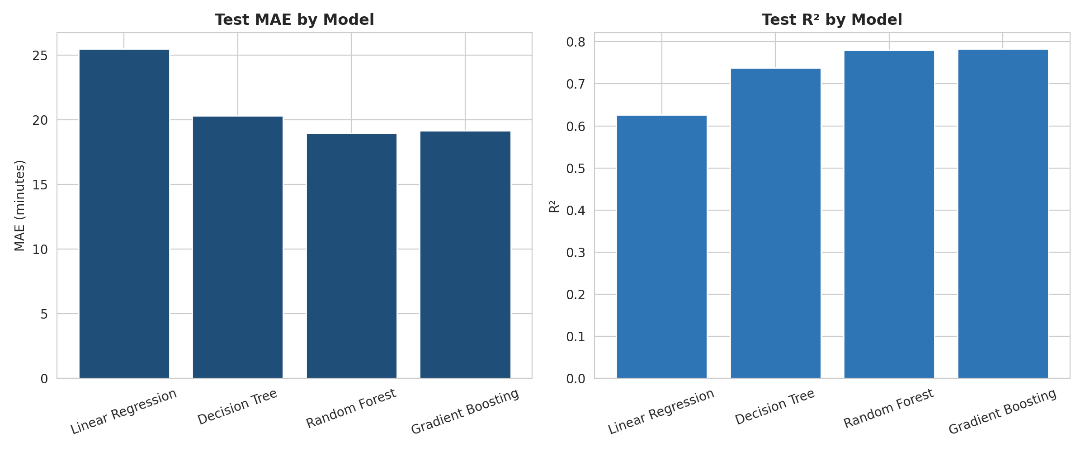
Figure 1. Test MAE (left) and test R² (right) for each model.
Moving from the linear baseline to a single decision tree cuts MAE from 25.5 to 20.3 minutes, and the two ensembles reduce it further to about 19 minutes. This confirms that the relationship between the conditions and delivery time is substantially non-linear. Random Forest and Gradient Boosting are effectively tied: Random Forest has the lower MAE (18.94 versus 19.18), while Gradient Boosting has a marginally lower RMSE (24.58 versus 24.75) and higher R² (0.783 versus 0.780). Differences this small are within the normal run-to-run variation, so the test set alone cannot separate them.

5.3 Cross-validation
A single train/test split can be lucky or unlucky, so each model was also evaluated with 5-fold cross-validation over the full dataset. The data is divided into five parts, and each part takes a turn as the validation set while the model trains on the other four.
for name, model in models.items():
cv_mae = -cross_val_score(model, X, y, cv=5,
scoring='neg_mean_absolute_error', n_jobs=-1)
cv_r2 = cross_val_score(model, X, y, cv=5, scoring='r2', n_jobs=-1)
print(f"{name}: CV MAE = {cv_mae.mean():.2f} (+/- {cv_mae.std():.2f}) "
f"CV R2 = {cv_r2.mean():.3f}")

Model | CV MAE (mean) | CV MAE (std dev) | CV R² (mean)
Linear Regression | 25.60 | 0.41 | 0.614
Decision Tree | 20.04 | 0.18 | 0.742
Random Forest | 18.63 | 0.26 | 0.784
Gradient Boosting | 19.06 | 0.23 | 0.780
Table 4. Five-fold cross-validation results.
The cross-validated scores agree closely with the hold-out scores for every model, so the test results are not a product of a favourable split. The standard deviation of MAE across folds is small (0.18 to 0.41 minutes), which shows the models are stable. Under cross-validation Random Forest edges ahead of Gradient Boosting on both MAE (18.63 versus 19.06) and R² (0.784 versus 0.780). Combined with its lowest test MAE, this makes Random Forest the selected model, and it was carried forward to hyperparameter tuning.

5.4 Hyperparameter tuning
The Random Forest was tuned with an exhaustive grid search, evaluated by 5-fold cross-validation on the training set only so that the test set stayed untouched. The search covered three parameters: the number of trees, the maximum tree depth, and the minimum number of samples required in a leaf (a regularisation control that prevents trees from fitting noise). That gives 3 × 3 × 3 = 27 combinations and 135 model fits.
param_grid = {
'n_estimators': [100, 150, 200],
'max_depth': [10, 14, 18],
'min_samples_leaf': [1, 2, 4]
}

grid = GridSearchCV(
RandomForestRegressor(random_state=42, n_jobs=-1),
param_grid, cv=5, scoring='neg_mean_absolute_error', n_jobs=-1, verbose=1)
grid.fit(X_train, y_train)

best_model = grid.best_estimator_
pred_tuned = best_model.predict(X_test)

Item | Value | Note
Best n_estimators | 200 | Edge of the searched range
Best max_depth | 14 | Middle of the range
Best min_samples_leaf | 4 | Edge of the searched range
Best cross-validated MAE | 18.52 min | Training set, 5-fold
Tuned test MAE | 18.92 min | Was 18.94 before tuning
Tuned test RMSE | 24.69 min | Was 24.75 before tuning
Tuned test R² | 0.781 | Was 0.780 before tuning
Table 5. Grid search outcome and tuned Random Forest performance.
Tuning produced only a marginal gain (test MAE improved from 18.94 to 18.92 minutes). This is a useful finding in its own right: it shows the original configuration was already close to the best this model family can do on these features, so further tuning would deliver little. The more promising path to better accuracy is better information (new features), not more tuning. Because the best values for n_estimators and min_samples_leaf sit at the edge of the grid, a wider search might find small further improvements.

5.5 Predicted versus actual
plt.figure(figsize=(7, 7))
plt.scatter(y_test, pred_tuned, alpha=0.3, color='#1F4E79')
plt.plot([y_test.min(), y_test.max()], [y_test.min(), y_test.max()],
color='#C0392B', lw=2) # perfect-prediction line
plt.xlabel('Actual Delivery Time (minutes)')
plt.ylabel('Predicted Delivery Time (minutes)')

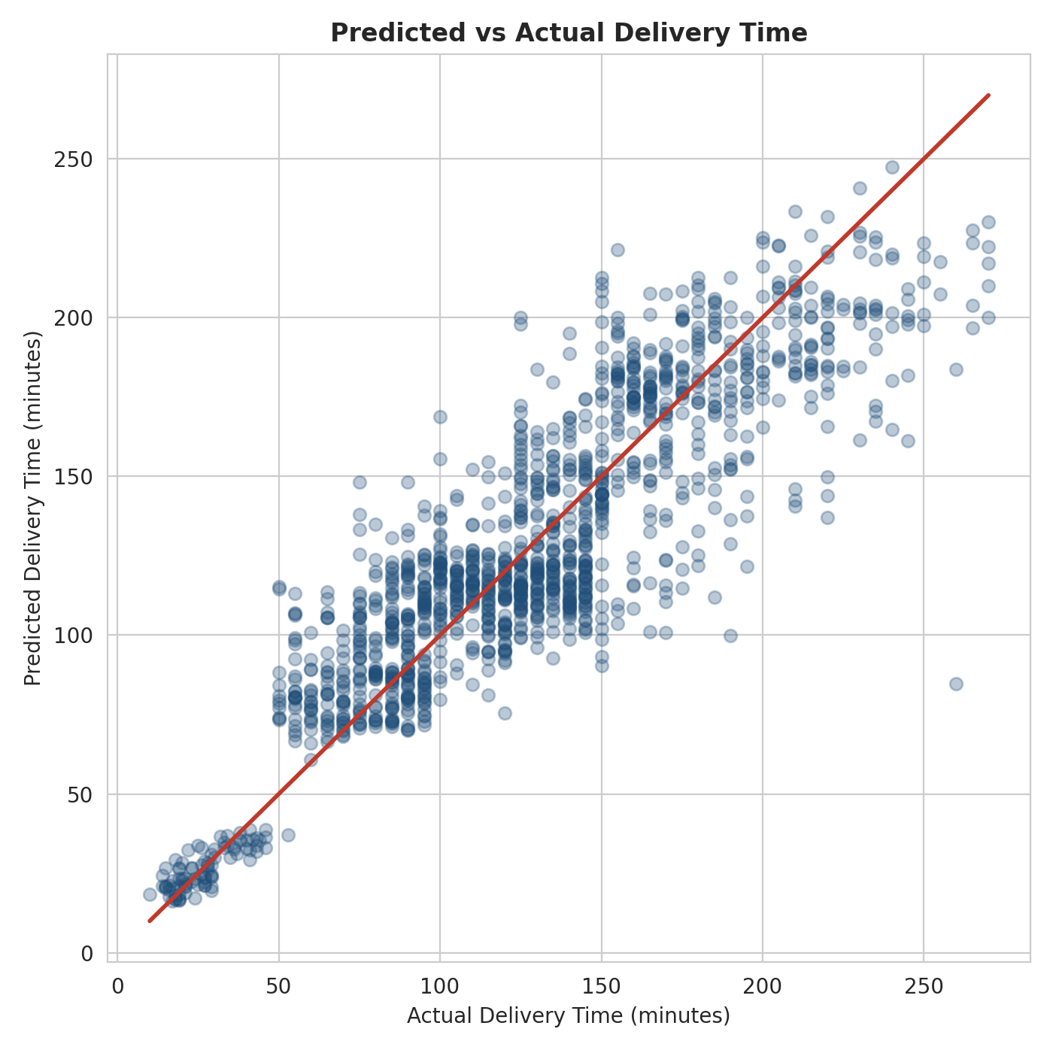
Figure 2. Predicted versus actual delivery time for the tuned Random Forest on the test set. The red line marks perfect prediction.
The points follow the diagonal closely, so the model captures the overall pattern. Three features of the plot are worth noting. First, very short deliveries (under about 50 minutes) are predicted accurately and form a tight cluster; these are the Grocery orders discussed in Section 6. Second, the cloud flattens at the extremes: orders that actually took 50 to 90 minutes tend to be over-predicted, and orders that took more than 200 minutes tend to be under-predicted. This is the usual tendency of averaging models to pull predictions toward the middle. Third, the vertical stripes appear because the recorded delivery times are in steps of 5 minutes. One extreme point (an actual time near 260 minutes predicted at about 85) is an unexplained long delay that none of the available features could anticipate.

5.6 Additional error diagnostics
To judge whether the model is useful in practice, the tuned model was also examined against a naive benchmark and by the size of its errors. These figures were computed on the same 1,376 test records.
Diagnostic | Result
Naive benchmark (always predict the training mean) | MAE of 41.95 min
Tuned Random Forest | MAE of 18.92 min, a 54.9% reduction in error
Predictions within 15 minutes of actual | 49.2% of orders
Predictions within 30 minutes of actual | 80.3% of orders
Average bias (actual minus predicted) | +0.60 min (very slight under-prediction)
Table 6. Practical error diagnostics for the tuned model.
Traffic level | Test orders | MAE (min) | Interpretation
Low | 443 | 14.48 | Most predictable
Medium | 321 | 19.67 | Moderate
High | 138 | 20.65 | Moderate
Jam | 474 | 22.07 | Least predictable
Table 7. Test error by traffic level.
The model cuts the naive error by more than half and has almost no systematic bias. However, only about half of predictions land within 15 minutes, so the model is better suited to ranking and flagging orders than to promising an exact arrival minute. Error rises steadily with traffic congestion, from 14.5 minutes under Low traffic to 22.1 minutes under Jam, which matches the Week 3 finding that jammed traffic makes delivery time far less predictable. A sensible operational response is to quote wider ETA windows when traffic is heavy.

6. Feature Importance and Model Insights
A Random Forest reports how much each feature contributed to reducing prediction error across all of its trees. This turns the model from a black box into a source of operational insight, since it shows which factors the forecast depends on most.
importances = pd.Series(best_model.feature_importances_, index=X.columns)
importances = importances.sort_values(ascending=False)
importances.head(10)[::-1].plot(kind='barh', color='#1F4E79')

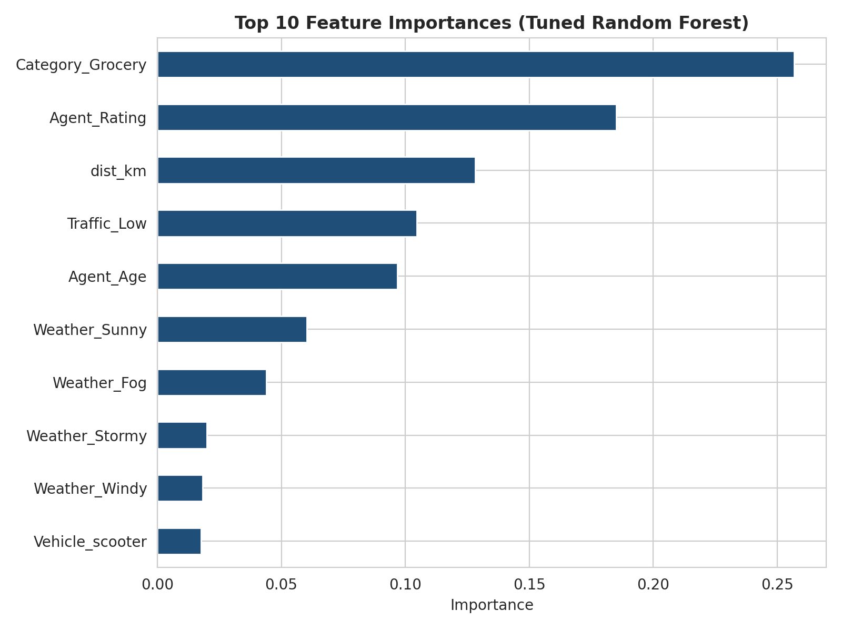
Figure 3. Top ten feature importances of the tuned Random Forest.
Feature | Importance | Reading
Category_Grocery | 0.257 | Grocery orders behave very differently from all others
Agent_Rating | 0.185 | Agent quality is the second strongest signal
dist_km | 0.128 | Route distance matters, but less than expected
Traffic_Low | 0.105 | Whether traffic is light is a strong signal
Agent_Age | 0.097 | Agent profile carries real information
Weather_Sunny | 0.060 | Clear weather separates fast from slow days
Weather_Fog | 0.044 | Fog has its own measurable penalty
Weather_Stormy / Windy | 0.020 / 0.018 | Minor individual effects
Vehicle_scooter | 0.018 | Vehicle type has a small effect
Table 8. Top feature importances with a plain-language reading.
The five most important features together account for about 77% of the total importance. Three insights stand out.
- Grocery is a distinct delivery type. In the data, the 411 Grocery orders average only 26.6 minutes, against 132.5 minutes for all other categories. This looks like a hyperlocal, quick-commerce flow served from nearby stores, and it explains the tight cluster of short deliveries in Figure 2. Because this single flag carries so much of the model, the operation is in effect running two businesses with very different time profiles, and they should be planned separately.
- Agent attributes matter as much as conditions. Agent_Rating and Agent_Age together contribute about 28% of the importance, more than distance and traffic combined for Agent_Rating alone. Unlike weather and traffic, the choice of agent is within the operator's control, which is what makes the assignment optimization in Section 7 worthwhile.
- Distance is not the main story. Distance ranks third. Delivery time here is shaped far more by order type, agent, and conditions than by how far the order travels, so route-length reduction alone would capture only part of the available improvement.
Two cautions apply when reading these numbers. Importance scores describe what the model relies on, not what causes delays, so they should guide investigation rather than be treated as proof. In addition, impurity-based importance can favour features with many possible split points, and a categorical variable that has been one-hot encoded has its effect spread across several columns (for example, the weather effect is split between Sunny, Fog, Stormy, and Windy).

7. Optimization Strategies
A forecast is only valuable if it changes a decision. This section proposes three ways the model can be used to improve operations, two of which were implemented and demonstrated in code.

7.1 Strategy 1: Predictive SLA-breach flagging
The first strategy converts the numeric forecast into an early-warning signal. A service-level target of 120 minutes was set, and any order whose predicted delivery time exceeds it is flagged as high risk at dispatch. The 120-minute figure is an illustrative target chosen to sit close to the dataset median of 125 minutes; a real operator would substitute its own commitment.
SLA = 120 # minutes
df_test = X_test.copy()
df_test['actual'] = y_test.values
df_test['predicted'] = pred_tuned
df_test['predicted_breach'] = df_test['predicted'] > SLA
df_test['actual_breach'] = df_test['actual'] > SLA

accuracy = (df_test['predicted_breach'] == df_test['actual_breach']).mean()
print(f"SLA-breach flagging accuracy: {accuracy*100:.1f}%") # 82.0%
print(df_test['predicted_breach'].sum(), 'of', len(df_test)) # 669 of 1376

 | Predicted: within SLA | Predicted: breach
Actual: within SLA | 550 (correct) | 91 (false alarm)
Actual: breach | 157 (missed breach) | 578 (correctly flagged)
Table 9. Confusion matrix for SLA-breach flagging on the test set (n = 1,376).
The flagging is correct for 82.0% of orders. Of the 669 orders flagged as high risk, 578 genuinely breached the target (precision of 86.4%), and of the 735 orders that actually breached, 578 were caught in advance (recall of 78.6%). In other words, roughly four out of five real breaches are identified before the delivery starts, and fewer than one in seven flags is a false alarm. Flagged orders can be handled proactively: assigned to a higher-rated agent, dispatched earlier, given a wider ETA message, or monitored by a dispatcher. A caveat is that more than half of all orders (53.4%) breached this particular target, so the operation faces a structural lateness problem rather than an occasional one.

7.2 Strategy 2: Optimal agent-to-order assignment (linear programming)
The second strategy uses optimization to decide who delivers what. Given a batch of waiting orders and a pool of available agents, the goal is to assign orders so that the total predicted delivery time is as small as possible, subject to each order being delivered exactly once and no agent exceeding a workload limit. This is the classic assignment problem and can be solved exactly with linear programming.
Formulation. Let x[i, j] equal 1 if agent i delivers order j, and 0 otherwise, and let c[i, j] be the predicted delivery time of order j when carried by agent i.
- Objective: minimise the sum over all agents and orders of c[i, j] × x[i, j].
- Constraint 1: every order is assigned to exactly one agent (the sum of x[i, j] over agents equals 1 for each order).
- Constraint 2: each agent carries at most 3 orders (the sum of x[i, j] over orders is at most 3 for each agent).
The demonstration used a batch of 8 orders and 4 agents.
from scipy.optimize import linprog

np.random.seed(42)
n_orders, n_agents, capacity = 8, 4, 3

# Predicted time (minutes) for every agent-order pair. In production this matrix
# is filled by running the trained model once per agent profile and order.
cost = np.random.randint(60, 200, size=(n_agents, n_orders))
n_vars = n_agents * n_orders
c = cost.flatten()

# Constraint 1: each order goes to exactly one agent
A_eq, b_eq = [], []
for j in range(n_orders):
row = np.zeros(n_vars)
for i in range(n_agents):
row[i * n_orders + j] = 1
A_eq.append(row); b_eq.append(1)

# Constraint 2: each agent carries at most `capacity` orders
A_ub, b_ub = [], []
for i in range(n_agents):
row = np.zeros(n_vars)
for j in range(n_orders):
row[i * n_orders + j] = 1
A_ub.append(row); b_ub.append(capacity)

result = linprog(c, A_eq=A_eq, b_eq=b_eq, A_ub=A_ub, b_ub=b_ub,
bounds=[(0, 1)] * n_vars, method="highs")
assignment = result.x.reshape(n_agents, n_orders).round().astype(int)

Naive baseline. To measure the benefit, the optimized plan was compared with a round-robin rule that hands order 0 to agent 1, order 1 to agent 2, and so on, ignoring cost entirely.
naive_total = 0
for j in range(n_orders):
naive_total += cost[j % n_agents, j] # round-robin assignment

optimized_total = result.fun
print(f"Improvement: {naive_total - optimized_total:.0f} min "
f"({(1 - optimized_total/naive_total)*100:.1f}% reduction)")

Agent | Assigned orders (0-indexed) | Orders | Total time (min)
Agent 1 | 2, 5 | 2 | 154
Agent 2 | 6, 7 | 2 | 173
Agent 3 | 3 | 1 | 80
Agent 4 | 0, 1, 4 | 3 | 306
Total |  | 8 | 713
Table 10. Optimal assignment found by linear programming.
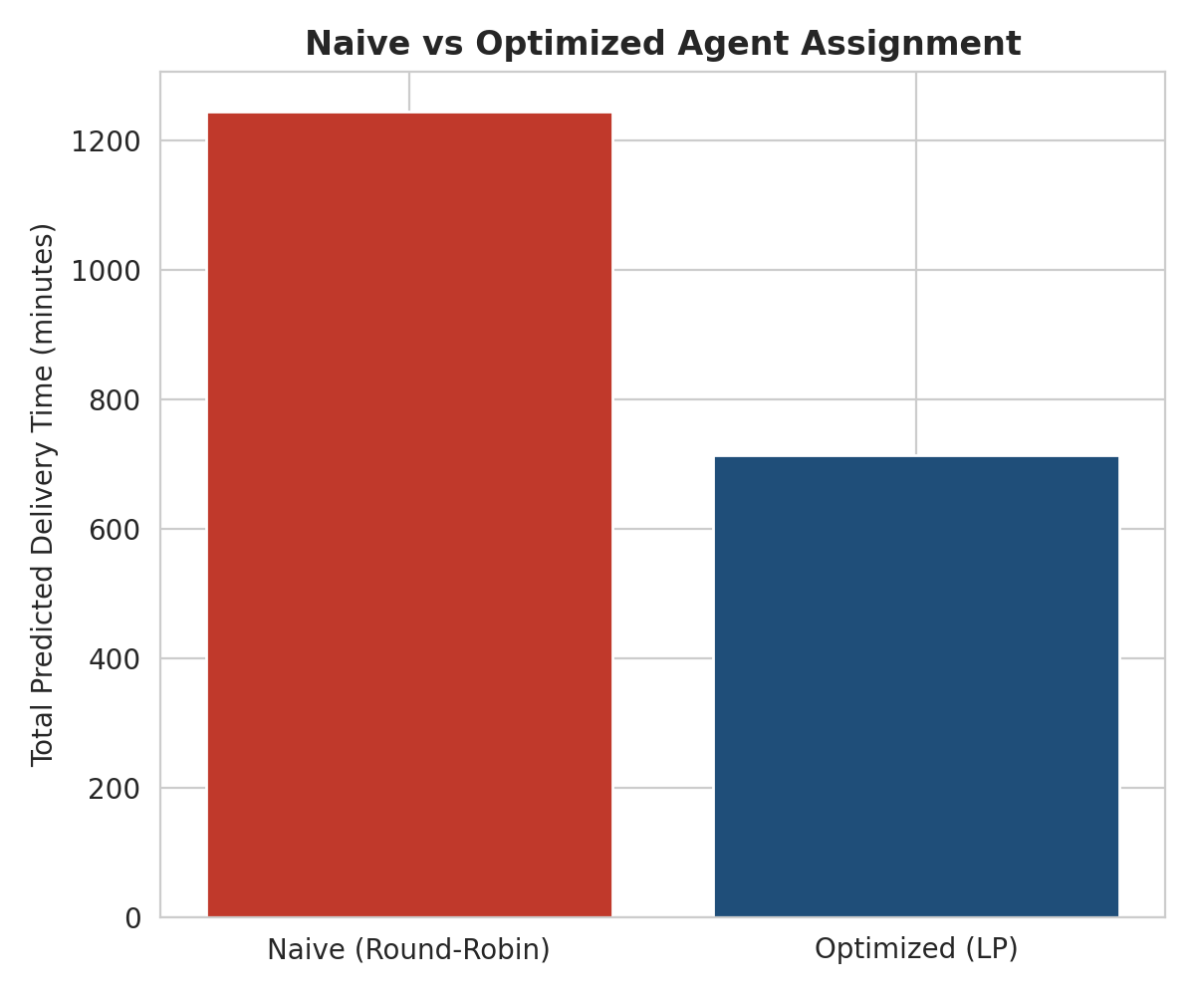
Figure 4. Total predicted delivery time under naive round-robin and optimized assignment.
The round-robin plan totals 1,244 minutes, while the optimized plan totals 713 minutes, a saving of 531 minutes or 42.7%. Each order goes to the agent best suited to it instead of the next agent in the queue.
Important interpretation note. In this demonstration the time matrix was filled with random integers between 60 and 200 minutes, not with predictions from the trained model, as the code comment states. The 42.7% figure therefore shows that the method works and how large the gap between a cost-blind and a cost-aware plan can be on a small batch; it should not be quoted as an expected saving for the real operation. Likewise, round-robin is a deliberately weak baseline. The real saving can only be measured by populating the matrix with model predictions and comparing against the operator's actual dispatch rule.
A second limitation is visible in Table 10: because the objective is the sum of times, it lets Agent 4 carry three orders (306 minutes) while Agent 3 carries one (80 minutes). If fairness or finishing time matters, a balancing constraint, such as limiting the longest single agent workload, should be added.

7.3 Strategy 3: Condition-aware planning (proposed)
The third strategy uses the feature-importance and error findings to plan around conditions rather than react to them. It was not coded in this task, but follows directly from the results.
- Traffic-aware scheduling. Traffic is the largest controllable-by-timing factor. Week 3 showed the evening peak around 21:00 and heavy congestion windows, so non-urgent orders can be batched and dispatched outside peak congestion, and ETAs for jammed periods can be widened (error is 22.1 minutes under Jam versus 14.5 under Low traffic).
- Separate Grocery and non-Grocery operations. With Grocery averaging 26.6 minutes versus 132.5 for other orders, the two flows need different agent pools, SLAs, and capacity plans. Grocery can be served from nearby stores with short-route agents, which frees longer-route capacity for everything else.
- Rating-aware allocation. Since Agent_Rating is the second strongest predictor, the strongest agents should be matched to the orders flagged as high risk by Strategy 1, and low-rated agents to low-risk, short-distance orders or to coaching.

8. Recommendations
No. | Recommendation | Evidence and expected effect
1 | Adopt the tuned Random Forest as the delivery-time forecaster | Lowest test and cross-validated MAE (about 19 min); 54.9% lower error than the naive benchmark and almost no bias
2 | Deploy SLA-breach flagging at dispatch | 82.0% accuracy; catches 78.6% of real breaches in advance with 86.4% precision, allowing proactive intervention
3 | Replace cost-blind dispatch with optimized assignment fed by model predictions | LP assignment halves total predicted time in the demonstration (42.7%); the real gain should be validated on live data
4 | Plan Grocery and non-Grocery flows separately | Grocery averages 26.6 min versus 132.5 min and is the single most important feature (0.257)
5 | Match high-rated agents to high-risk orders | Agent_Rating is the second most important feature (0.185) and is within management control
6 | Widen ETA windows under heavy traffic | Prediction error rises from 14.5 min (Low) to 22.1 min (Jam), so honest ranges protect customer trust
7 | Retrain the model regularly and monitor error by traffic level | Model accuracy will drift as demand, routes, and the agent pool change
Table 11. Actionable recommendations linked to the evidence in this report.

9. Limitations and Future Work
- Accuracy ceiling. An R² of about 0.78 means roughly 22% of the variation is unexplained, and only about half of predictions fall within 15 minutes. The model is suited to ranking and flagging, not to minute-level promises.
- Illustrative optimization inputs. The assignment demonstration used a randomly generated time matrix and a small batch (8 orders, 4 agents). It proves the method, not the real savings.
- Sum-of-time objective. The objective ignores workload balance and agent availability windows; a balanced or makespan-based objective is a natural extension.
- Association, not causation. Feature importances show what the model uses, and agent attributes may be standing in for factors that are not recorded, such as agent route familiarity.
- Single split and fixed SLA. The 120-minute target was illustrative, and the modeling used one random split supported by cross-validation rather than a time-based split that mimics future deployment.
Future work. The most promising improvements are richer features (hour of day, day of week, historical agent speed, store preparation time), a time-ordered validation scheme, a wider hyperparameter search, a comparison with tuned gradient boosting, and extending the optimization to routing (sequencing multiple drops per agent) with workload-balance constraints.

10. Conclusion
This report built and evaluated a predictive model for last-mile delivery time and used it to propose operational improvements. Four regression models were compared on a clean dataset of 6,878 deliveries. Tree-based ensembles clearly outperformed the linear baseline (test MAE of about 19 versus 25.5 minutes), and five-fold cross-validation confirmed that the results are stable. The Random Forest was selected and tuned by grid search, reaching a test MAE of 18.92 minutes, an RMSE of 24.69 minutes, and an R² of 0.781, which is 54.9% lower error than a naive average-based forecast.
The model also yielded insight. Grocery orders form a distinct, very fast delivery type, and agent rating is the second strongest signal, ahead of distance and traffic. Two optimization strategies were demonstrated: predictive SLA-breach flagging, which correctly classifies 82.0% of orders and catches nearly four of five breaches in advance, and linear-programming assignment, which showed in a simulation that cost-aware dispatch can sharply reduce total delivery time compared with round-robin. A third strategy, condition-aware planning, is proposed from the findings.
Taken together, the work shows how a forecast moves from a number on a chart to a set of dispatch decisions. The next step is to feed real model predictions into the assignment problem and measure the savings on live operations.

References
[1] Suthar, S. Amazon Delivery Dataset [Data set]. Kaggle. https://www.kaggle.com/datasets/sujalsuthar/amazon-delivery-dataset
[2] Pedregosa, F., et al. (2011). Scikit-learn: Machine Learning in Python. Journal of Machine Learning Research, 12, 2825-2830.
[3] Breiman, L. (2001). Random Forests. Machine Learning, 45(1), 5-32.
[4] Friedman, J. H. (2001). Greedy Function Approximation: A Gradient Boosting Machine. Annals of Statistics, 29(5), 1189-1232.
[5] Virtanen, P., et al. (2020). SciPy 1.0: Fundamental Algorithms for Scientific Computing in Python. Nature Methods, 17, 261-272.
[6] Huangfu, Q. and Hall, J. A. J. (2018). Parallelizing the dual revised simplex method (HiGHS). Mathematical Programming Computation, 10, 119-142.

