Reverse engineering using water immersion.

-VISHAL KUMAR JAMUAR

-RAUT PRAJWAL VISHVANATH

ABSTRACT

This paper presents a novel idea on three-dimensional prismatic shape reconstruction method fully based on the relationship between the volume of the object submerged and the displacement of the fluid caused by submerging the object into it. We dip the object repeatedly taking different depth into the fluid (water, more precisely) at different orientation. These orientation and corresponding depth are determined beforehand and provide to the object with the help of a mechanical arm. The fluid into which the object is dipped is contained within a container(beaker) that show us the water level displacement during dipping. The many advantages and uniqueness of our method are discussed in detail in this paper.

INTRODUCTION

In many areas of industry, it is desirable to create geometric models of existing objects for which no such model is available. This paper describes a unique process of reverse engineering of shapes and its advantage over other methods. Currently, a CMM (coordinate measuring machine) and a three-dimensional (3D) laser scanner are widely used in the fields for shape reverse engineering and quality inspection. Most CMMs use a trigger-type probe, but the ones with mechanical analogue scanning probe do exist. The trigger-type CMM acquires point data by touching the probe to the part, such that it is appropriate for measuring primitive features that need small number of point data. The scanning-type CMMs can capture more sampling points than the touch trigger-type and have better accuracy than vision sensors. They can be used for measuring freeform features, however, they cannot measure a part made of soft materials. Moreover, these processes yield point clouds with noises and are often incomplete. In laser scanning of complex 3D parts, it is difficult to determine the number of necessary scans, the directions of scans and scan paths since the device has several optical constraints such as depth of field (DOF), field of view (FOV), and self-occlusion. It takes much time and cost due to trial and errors when the parts are scanned manually.

Notably, these techniques fall short in cases where the shapes contain highly occluded parts that are inaccessible to

the scanner’s line-of-sight. Thus, complex shapes cannot be properly acquired nor reconstructed based on conventional (optical) scanners. Moreover, some objects, are made of glossy or transparent materials, which pose another challenge that common optics cannot deal with.

In this paper we talk about a completely different approach of shape reconstruction in which we dip the given object into a fluid at many different orientations. At a particular orientation we give the object some certain pre-determined depth and measure the corresponding water level displacement at every depth given. In this paper we also have described how we determined the number of dips that is required and which orientations are needed to successfully reconstruct the given shape and these can be used for any object irrespective of whatever the shape is. All we have to do in this method is to collect a data comprising of water level displacement at each dip and this data is transferred to our algorithm that we have described in later section in this paper.

The key advantage of the presented approach is that it employs liquid as the sensor. Unlike optical sensors, the liquid has no line-of-sight requirements, it penetrates into cavities and hidden parts of the subject, bypassing all visibility and optical limitations of conventional scanning devices. Using this approach, we can even reconstruct highly reflecting or even transparent materials that are impossible to be reconstructed using different optical scanning methods. The cost of these heavier machines like CMM and laser scanner are enormously high whereas our approach is too economically feasible to be installed in small labs.

The algorithm that we used in this method is described in detail in the methodology section and can be understood easily.

LITERATURE

The basic idea comes from the idea of dip transform for 3D shape reconstruction (Kr Aberman, Oren Katzir*, Qiang Zhou, Zegang Luo, Andrei Sharf, Chen Greif, Baoquan Chen, and Daniel Cohen-Or. 2017. Dip Transform for 3D Shape Reconstruction. ACM Trans. Graph. 36, 79, Article 79 (July 2017)) These group of researchers generated the dip transform: a novel volumetric shape representation that characterizes the object’s surface. Their technique of reconstructing 3D shapes with the dip transform is related to computed tomography. Common tomography methods use optical systems with penetrating waves to sample the absorption of the radiation along multiple parallel beams. They show that the dip transform is equivalent to the Radon transform for binary volumes. While tomography acquisition devices based on radiation systems are expensive, bulky and must be used in a safe special environment, their dip-based tomography is inexpensive and safe, while capturing hidden parts and structures. As such, it provides an appealing alternative approach, generating a complete shape at a low computational cost, using a novel data acquisition technique. These methods are beyond the scope of this paper. Instead we used our programming skill and developed an algorithm that can tell us in which orientations we need to dip the object and up to what depth it is to be dipped in each orientation.

The mechanical arm:

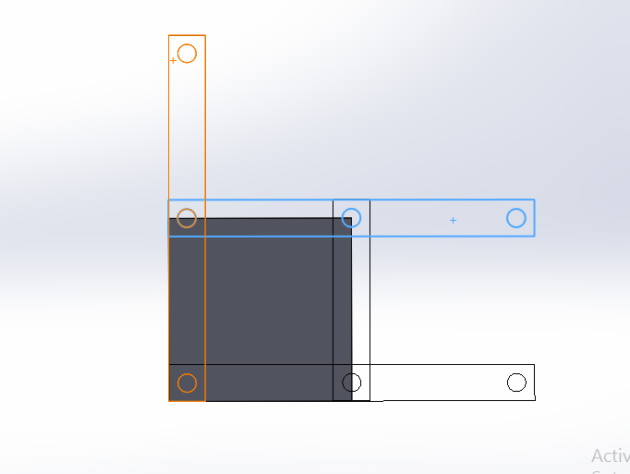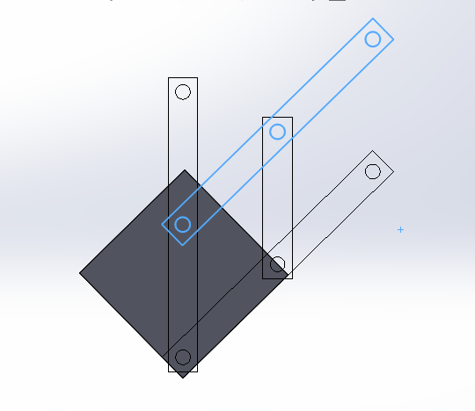

We designed a mechanical arm which is capable of holding the object in order to perform the activity and providing it with required mobility. The design is rather simple. It can provide the object a particular depth inside the fluid in linear axis and can also make the object rotate to attain the orientation in which it is required to be dipped each time.

# MEHTODOLGY AND ALGORITHM :

Basic idea behind this method is to imagine the 3 dimensional prismatic object as a binary matrix as shown in the given diagram. To get more accuracy in shape, value of n can be increased.

 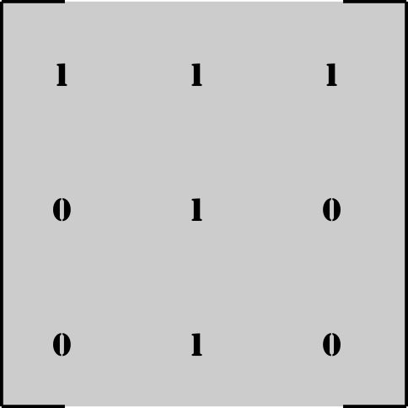

Prismatic object having T-shaped base In this case, n = 3.

So now, we have to solve for these n2 variables whose values will either be 1 or 0. For these we plan to get n2 linearly independent linear equations. Then we will use matrix inversion method to solve for n2 variables.

# MEHTOD FOR OBTAINING A LINEAR EQUATION BY IMMERSING OBJECT IN WATER :

Let’s consider an object shown and imagine it as a binary matrix. For simplicity of understanding, let’s take n = 3 (i.e. 3x3 matrix).

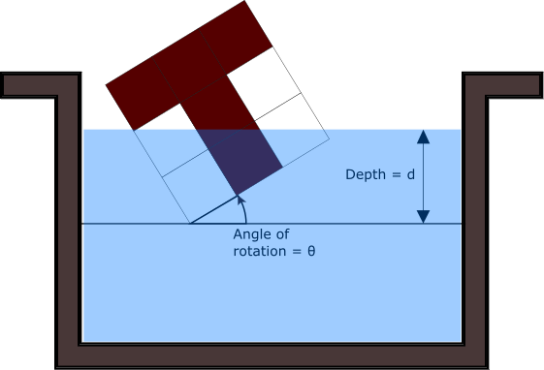 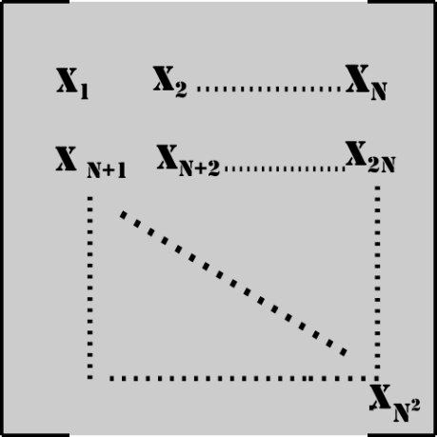

Now, rotate the matrix by an angle ‘ϴ’ clockwise and dip it in the water by a depth ‘d’. As shown in figure below, contribution by each cell in amount of water displaced will be equal to

‘(Ci ). (Xi)’.

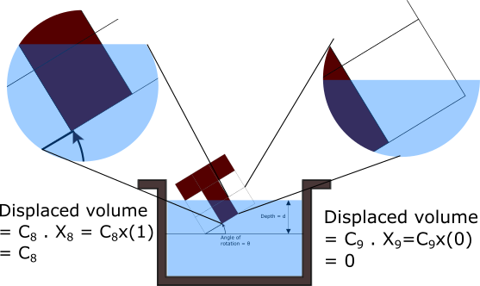

So total volume displaced will be

Vdisplaced =

Where,

Ci is the ratio volume submerged in water to total volume of ith cell

Xi = 1 if ith cell is filled,

0 if ith cell is empty.

For each value of ‘ϴ’ and ‘d’ we get an equation.

Now, problem arises that many of these equations we get for different values of ‘ϴ’ and ‘d’ are linearly dependent. We need exact n2 linearly independent equations. This will make sure that we get a unique solution.

# Method to get n2 linearly independent linear equations :

1. Take a square matrix A n2 x n2. Make all the elements of the matrix 0. Take different values of ‘ϴ’ and ‘d’. For each value of ‘ϴ’ and ‘d’, we will get a equation of form $\sum_{1}^{n^2}{(Ci ). (Xi)}$.
2. Replace a row of matrix A having all elements 0 by C1, C2, C3 … C(n^2) respectively. Check whether rank of matrix A has increased after replacing the row.
3. If the rank has not increased, then make all the elements of that row 0 again.
4. If the rank has increased, then replace that row permanently with C1, C2, C3 … C(n^2) respectively and note down the values of ‘ϴ’ and ‘d’.
5. Continue the same procedure for new values of ‘ϴ’ and ‘d’ until we get the rank of A equal to n2. Now this matrix A will be the coefficient matrix which we can use in matrix inversion method.

Basically, if the rank of A increases after replacing a row, it means that the equation we have, is linearly independent with all other equations which previously have replaced a row in matrix A.

So, this is how we can obtain coefficient matrix whose rank is n2.

# VOLUME MATRIX :

VOLUME MATRIX :

For matrix equation of form:

[Coefficient matrix] x [X] = [Volume matrix],

We have obtained coefficient matrix of size n2 X n2 whose rank is n2. Now we only need to find volume matrix. For getting volume matrix, we use the n2 values of ‘ϴ’ and ‘d’ which we had noted down while finding coefficient matrix. Using those values, we transform the object accordingly and dip it. We can then measure the volume of water displaced, and get the Volume matrix.

So, now that we have found both, coefficient matrix as well as volume matrix, using simple matrix inversion method, we can get the values of all the variables.

[X] = [Coefficient matrix]-1 x [Volume matrix]

The following algorithm takes ‘n’ as input and outputs the coefficient matrix and corresponding values of ‘ϴ’ and ‘d’.

A code was implemented which took ‘n’ as input and gave the coefficient matrix and corresponding n2 values of theta and d. This code is based on following logic.

# ALGORITHM :

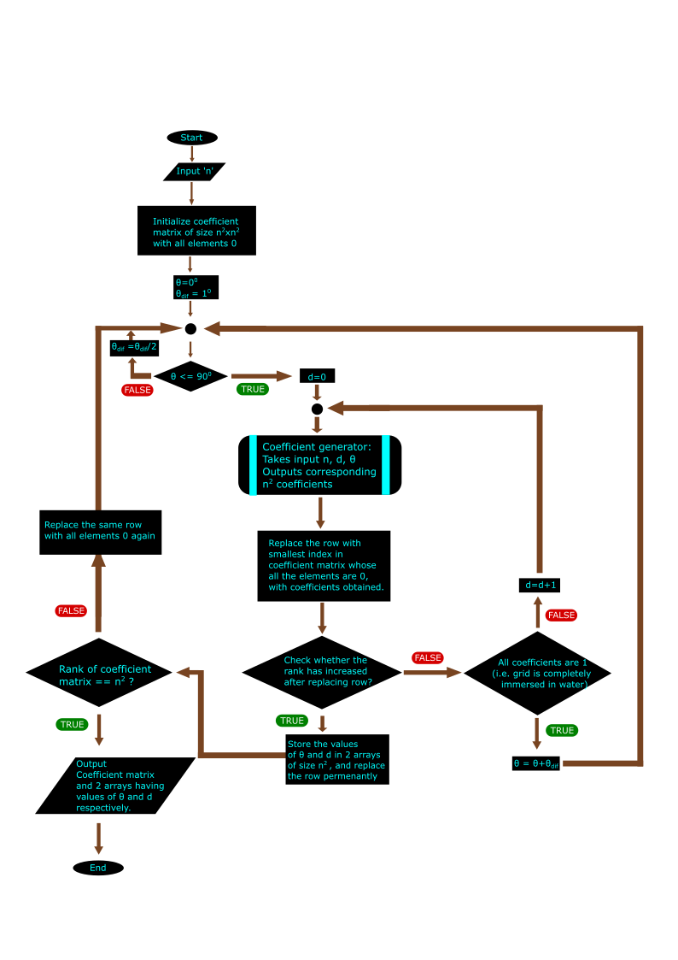

For 0 <= i,j <=n :

x_matrix and y_matrix are 2D arrays of (n+1)x(n+1) such that,

x_matrix[i][j] = x coordinate of point(i,j) after rotating it by θ in clockwise direction about origin.

y_matrix[i][j] = x coordinate of point(i,j) after rotating it by θ in clockwise direction about origin.

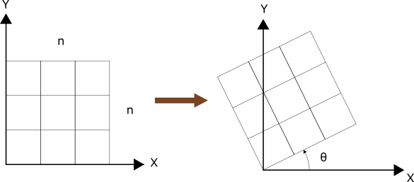

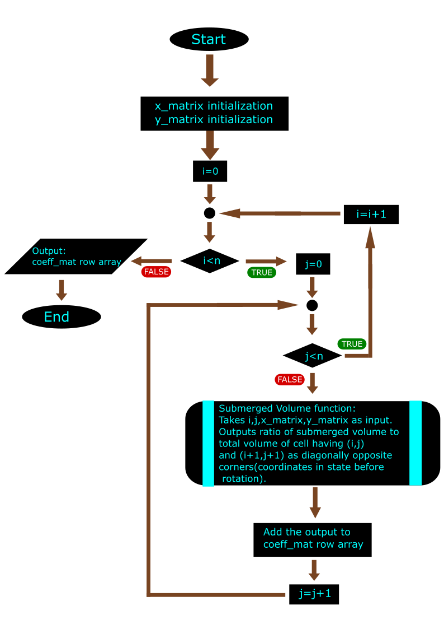

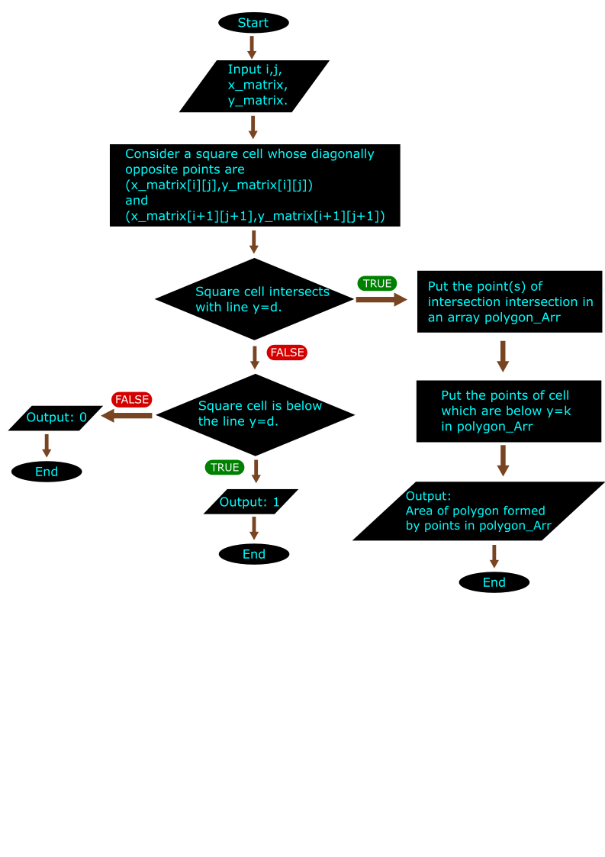

RESULT and DISCUSSION: