
Table of Contents
1. Executive summary 3
Key findings 3
Top recommendations 3
2. Business context and objectives 3
Objectives 3
Success criteria and outcome 4
3. Data overview and preparation 4
Cleaning decisions 4
4. Customer segmentation 5
Method 5
What this means for the business 6
5. Churn prediction model 7
Architecture 7
Development iterations 7
Final performance 7
Feature importance 8
6. Key factors driving churn and retention 9
Factors that increase churn 9
Factors with little or no effect 10
Retention factors 10
7. Recommended retention strategies 10
What not to prioritise 11
Suggested rollout 11
8. Limitations, challenges and proposed solutions 11
9. Conclusion and next steps 13
Recommended next steps 13
Project artefacts 13
List of Figures
Figure 1: Churn class balance and feature distributions 5
Figure 2: Elbow method for choosing the number of clusters 5
Figure 3: Customer segments by tenure and monthly charges 6
Figure 4: Churn rate by customer segment 6
Figure 5: Training and validation accuracy 7
Figure 6: Confusion matrix on the test set 8
Figure 7: ROC curve for the final model 8
Figure 8: Correlation between numeric features 9
Figure 9: Churn rate by tenure group 9
Figure 10: Churn rate by contract type 10

1. Executive summary
Churn is concentrated in newer customers paying high monthly charges. This one segment holds 31% of customers but 58% of everyone who churned, so retention spending should start there.
The team analysed 7,043 customer records, of whom 26.5% churned. We segmented customers with K-Means clustering and built an Artificial Neural Network (ANN) to predict which customers will churn.
Key findings
- Tenure is the strongest driver of churn. 47.4% of customers in their first 12 months churned, compared with 9.5% of customers with more than 4 years of tenure.
- High monthly charges raise churn. Customers paying over $70 a month churn at 33–37%, compared with 11.9% for those paying $40 or less.
- Senior citizens (41.7%) and customers without dependents (31.3%) churn more than the average (26.5%).
- Contract type, internet type, phone services and gender have almost no effect in this dataset. Every group sits within about 2 percentage points of the average.
- The ANN model identifies 72% of churners (recall 0.72) and ranks customers by risk well (ROC-AUC 0.81). Its test accuracy (72.9%) and churn F1-score (0.58) fall below the project targets, so it is best used to rank customers for outreach rather than as a precise yes/no predictor.
Top recommendations
- Run a first-year onboarding and check-in programme for new customers, prioritising those on high charges.
- Offer plan reviews to high-charge customers so they stay on the plan that suits them.
- Give senior citizens tailored plans and dedicated support.
- Use the ANN churn probability scores to rank customers so the retention team contacts the highest-risk customers first.
- Treat contract upgrade campaigns as a secondary lever, because contract type does not reduce churn in this data.

2. Business context and objectives
High customer churn is a persistent threat to growth in the telecommunications industry. This project analyses the company’s customer data to find out who churns and why, so the retention team can act before customers leave.
The project ran from 26 July to 26 October 2026 in four sprints: data preparation, clustering, predictive modelling, then reporting. All four members also shared the Project Manager role on a rotating basis.
Objectives
- Clean and prepare a reliable dataset for analysis.
- Segment customers with clustering to uncover churn patterns.
- Build and evaluate an ANN that predicts customer churn.
- Identify the main drivers of churn and retention.
- Recommend targeted, actionable retention strategies.

Success criteria and outcome
Criterion (from Project Charter) | Target | Outcome | Status
Data quality | Duplicates reviewed and resolved, categories encoded | 302 duplicates reviewed and kept on purpose (see Section 3); all categories encoded | Met, with a documented change
Clustering | Interpretable segments with a documented choice of k | 4 segments; elbow method and silhouette score (0.476) both support k = 4 | Met
Model accuracy (test set) | ≥ 80% | 72.9% | Below target
Model F1-score (churn class) | ≥ 0.70 | 0.58 | Below target
Final report and presentation | Accepted by mentor | This report and the stakeholder presentation | Submitted

3. Data overview and preparation
The dataset (Dataset_ATS_v2.csv) has 7,043 customers and 10 columns, with no missing values. 26.5% of customers churned, a mild class imbalance that the model had to correct for.
Column | Meaning | Values
gender | Customer gender | Female / Male
SeniorCitizen | Customer is a senior citizen | 0 / 1 (16% are seniors)
Dependents | Customer has dependents | No / Yes (30% have dependents)
tenure | Months with the company | 0–72 (mean about 32)
PhoneService | Has phone service | No / Yes
MultipleLines | Has more than one phone line | No / Yes
InternetService | Internet type | DSL / Fibre optic
Contract | Contract length | Month-to-month / One year / Two year
MonthlyCharges | Monthly bill ($) | 18–119 (mean about 65)
Churn | Customer left the company | No / Yes (target)
Cleaning decisions (Data Engineer)
- Duplicates: 302 exact duplicate rows were found but kept. Without a customer ID, there is no way to tell true duplicates from different customers who happen to share every attribute, and removing them could discard real customers. This changes the plan in the Project Charter, which assumed they would be removed.
- Logical errors: 260 rows had no phone service but “multiple lines = Yes”. These were recoded to “No”.
- Encoding: yes/no fields were mapped to 0/1, and Contract was one-hot encoded.
- New features: ContractMonths (0/12/24), TenureYears, TenureGroup, ServiceCount and MonthlyChargePerService (a price-sensitivity measure).
- Scaling: StandardScaler was applied to the whole dataset for clustering. For the ANN it was fitted on the training set only, to avoid data leakage.
All quality checks passed after cleaning: no missing values, no remaining logical errors, and a binary churn target.
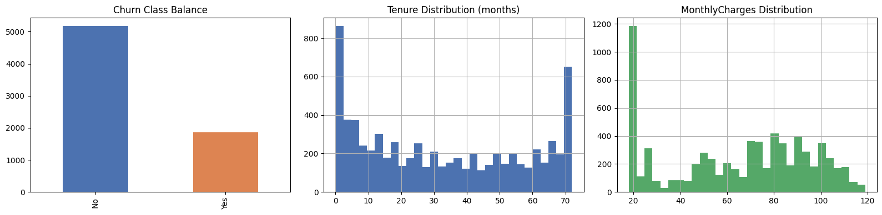
Figure 1: Churn class balance, tenure distribution and monthly charges distribution (Data Engineer)

4. Customer segmentation
K-Means clustering split customers into four segments by tenure and monthly charges. Churn ranges from 4.8% to 49.2% across them, so where a customer sits matters a great deal.
Method. The model used two scaled features, tenure and MonthlyCharges. The elbow method showed diminishing returns after k = 4, and k = 4 also had the highest silhouette score (0.476, against 0.411–0.446 for other values). Churn was not used to build the clusters, only to compare them afterwards.
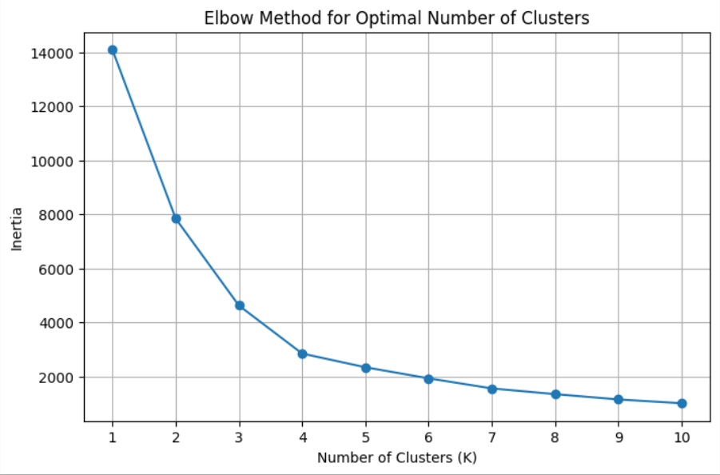
Figure 2: Elbow method: inertia flattens after k = 4 (Clustering Analyst)
Segment | Customers | Avg tenure (months) | Avg monthly charge ($) | Churn rate | Share of all churners
Newer – High Charges | 2,202 (31%) | 14.8 | 81.23 | 49.2% | 58%
Newer – Low Charges | 1,733 (25%) | 10.5 | 32.49 | 24.5% | 23%
Long-term – High Charges | 1,948 (28%) | 58.8 | 93.08 | 15.7% | 16%
Long-term – Low Charges | 1,160 (16%) | 54.1 | 34.15 | 4.8% | 3%
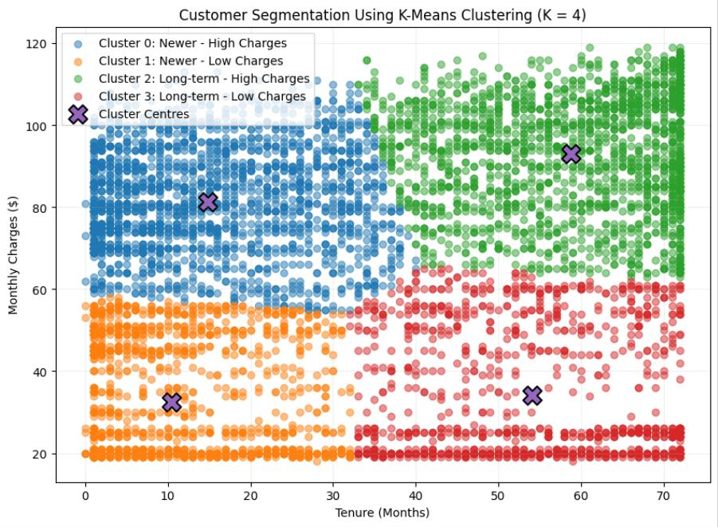
Figure 3: The four customer segments by tenure and monthly charges (Clustering Analyst)
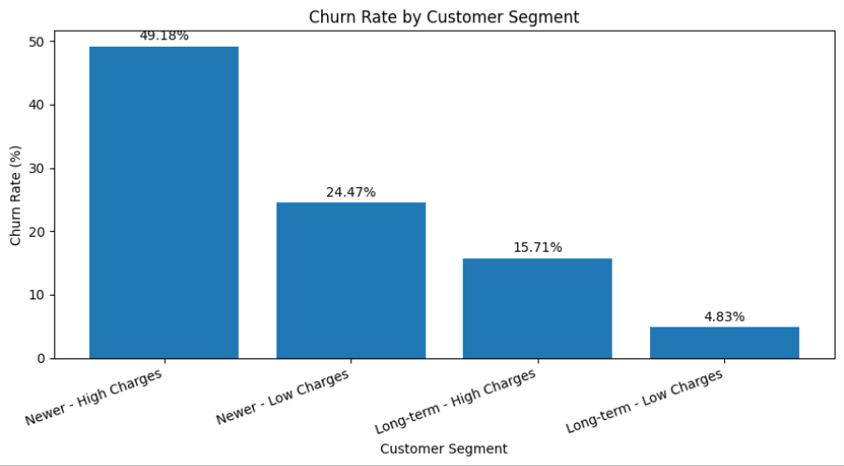
Figure 4: Churn rate by customer segment (Clustering Analyst)
What this means for the business
- Newer – High Charges is the priority segment. Half of these customers churn, and they account for nearly six in ten of all churners.
- Length of relationship protects more than price. Long-term high-charge customers pay the most ($93 on average) yet churn at only 15.7%, a third of the rate of newer high-charge customers.
- Long-term – Low Charges is the loyal core. Fewer than 1 in 20 churn. They need little retention spending, and they show what a successful long-term customer looks like.

5. Churn prediction model
The final ANN catches 72% of actual churners and correctly ranks a churner above a non-churner 81% of the time (ROC-AUC 0.807). It missed both accuracy and F1 targets on the test set, but it is useful for building a ranked list of at-risk customers.
Architecture. The model is a feed-forward network built in Keras/TensorFlow with 14 input features. It has dense layers of 32, 16 and 8 units (ReLU), dropout of 0.3 and 0.2, and a sigmoid output giving a churn probability. It was trained with the Adam optimiser and binary cross-entropy loss, using an 80/20 stratified train/test split. In total the network has 1,153 trainable parameters.
Development iterations
Iteration | Change | Result
Model 1 (baseline) | Simple dense network | High accuracy but missed most churners (recall about 0.47)
Model 2 (interim) | Added dropout, tuned layer sizes | Less overfitting; recall improved only slightly
Model 2 (final) | Added balanced class weights (0.68 / 1.88) and early stopping | Churn recall 0.72, test accuracy 72.9%, ROC-AUC 0.807
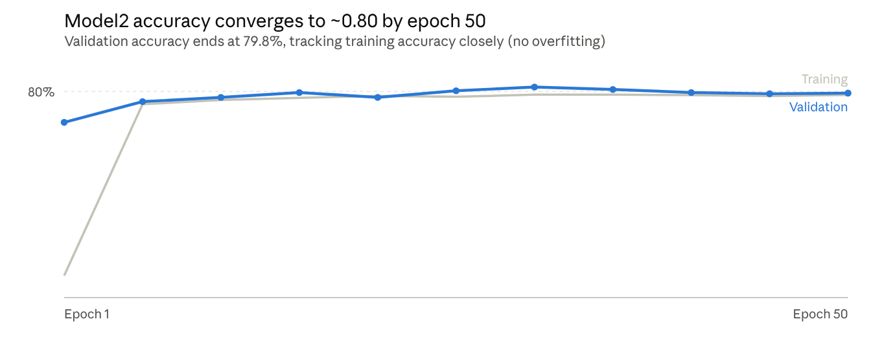
Figure 5: Training and validation accuracy across 50 epochs; validation accuracy, not test-set accuracy (Predictive Modelling)

Final performance
Measure | Result | What it means
Recall (churn) | 0.72 | Identifies 72 of every 100 customers who will churn (268 of 374 in the test set)
Precision (churn) | 0.49 | About half of the customers it flags actually churn
F1-score (churn) | 0.58 | Below the 0.70 target
Accuracy (test set) | 72.9% | Below the 80% target
ROC-AUC | 0.807 | Ranks customers by risk well, at any cut-off
The test set held 1,409 customers, 374 of whom churned. The model correctly flagged 268 churners and missed 106. It also flagged 276 customers who stayed, which is why precision is 0.49. An earlier figure of 79.8% accuracy came from the validation curve during training, not the held-out test set; the test-set figures above are the ones reported.
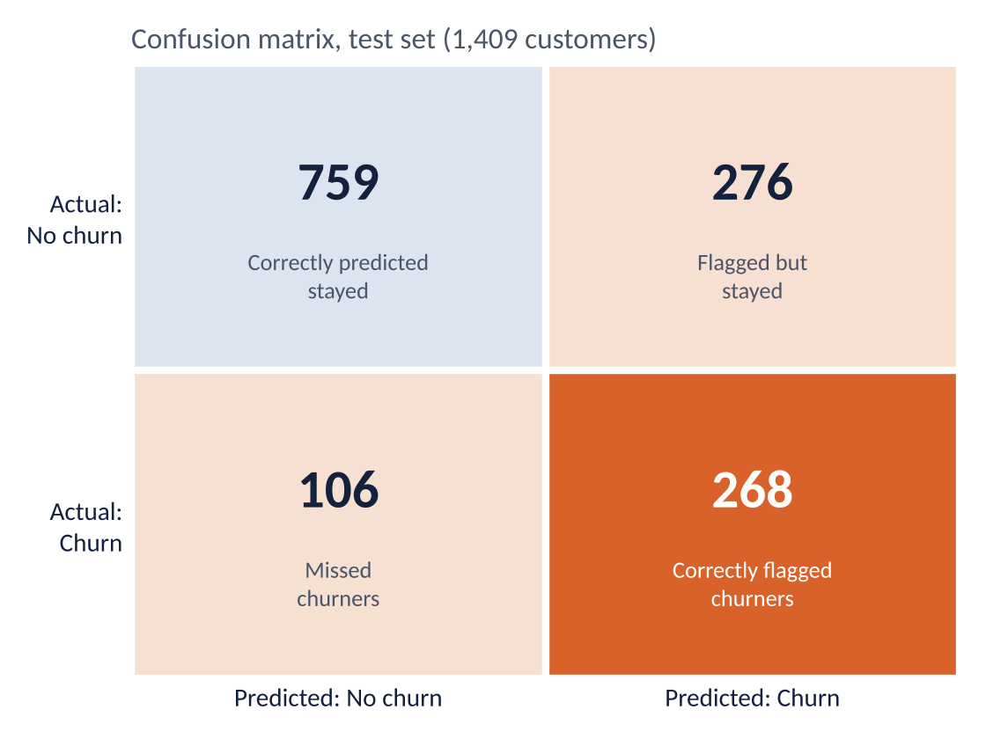
Figure 6: Confusion matrix for the final model on the test set (Predictive Modelling)
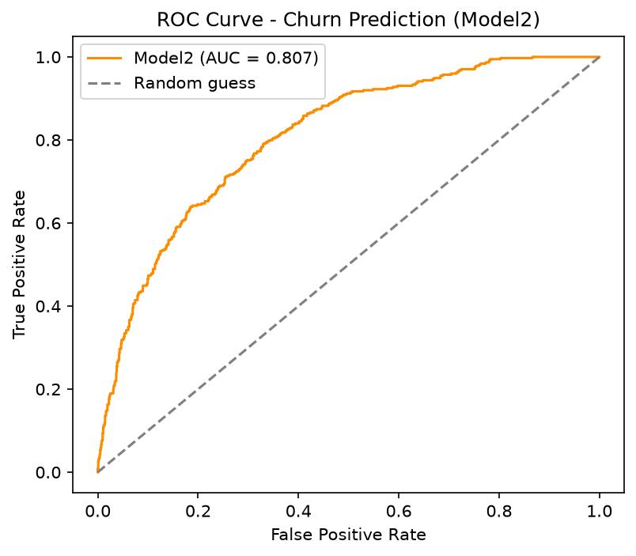
Figure 7: ROC curve for the final model, AUC = 0.807 (Predictive Modelling)
The team deliberately accepted lower accuracy and precision in exchange for higher recall (0.72, up from 0.47 at baseline). For retention, missing a customer who is about to leave usually costs more than contacting one who would have stayed. Because about half of flagged customers would have stayed anyway, the model suits low-cost interventions such as check-in calls, rather than expensive discounts for every flagged customer.
Feature importance. Permutation importance showed tenure as the dominant predictor (0.179), more than three times the next feature, monthly charges (0.054). Contract-type features scored close to zero. This is not because contract overlaps with tenure: in this dataset the two are uncorrelated (r = 0.002). It is because contract type has very little link to churn here (Section 6).
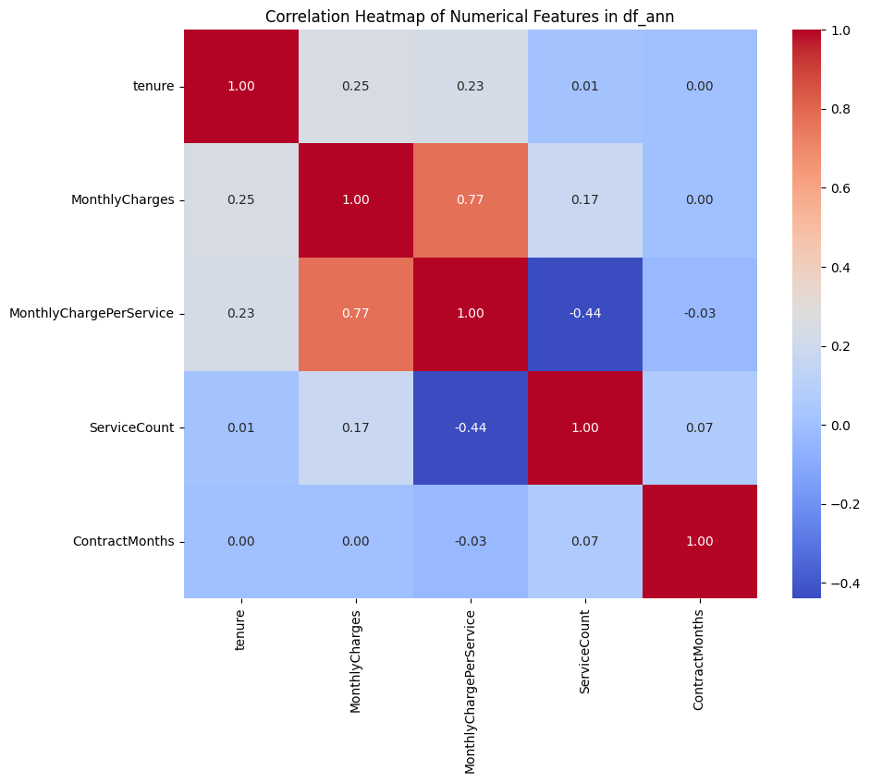
Figure 8: Correlation between numeric features: tenure and contract length are uncorrelated (0.00)

6. Key factors driving churn and retention
Four factors drive churn: short tenure, high monthly charges, being a senior citizen and having no dependents. Contract type, internet type, phone services and gender barely matter. All figures below were calculated directly from the full 7,043-customer dataset.
Factors that increase churn
Factor | Higher-risk group | Lower-risk group | Effect
Tenure | 0–12 months: 47.4% | 49–72 months: 9.5% | Very strong
Monthly charges | $71–90: 37.0%; over $90: 33.1% | $40 or less: 11.9% | Strong
Senior citizen | Senior: 41.7% | Non-senior: 23.6% | Strong
Dependents | No dependents: 31.3% | Has dependents: 15.5% | Moderate
Churn falls steadily with tenure: 47.4% (0–12 months), 28.7% (13–24), 20.4% (25–48) and 9.5% (49–72). The first year is the danger zone, and risk keeps falling the longer a customer stays.
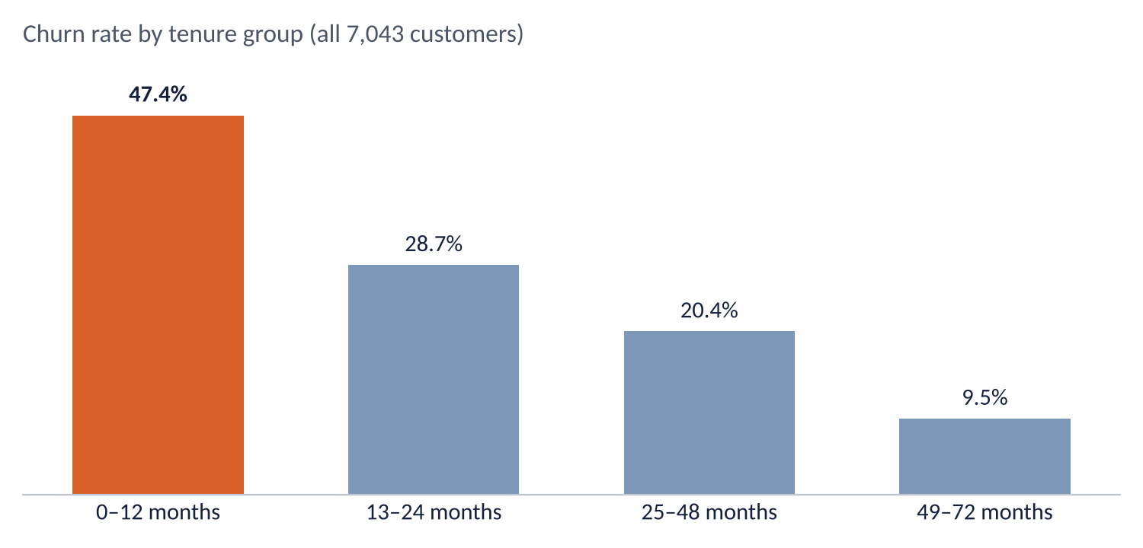
Figure 9: Churn rate falls steadily with tenure
The demographic factors add up. Senior citizens without dependents churn at 43.2% (1,051 customers), while non-seniors with dependents churn at only 15.1%.

Factors with little or no effect
Factor | Churn rates | Gap
Contract | Month-to-month 27.3%, one year 25.8%, two year 25.4% | 1.9 points
Internet type | DSL 27.4%, fibre optic 25.4% | 2.0 points
Phone service | No 24.9%, yes 26.7% | 1.8 points
Gender | Female 26.9%, male 26.2% | 0.7 points
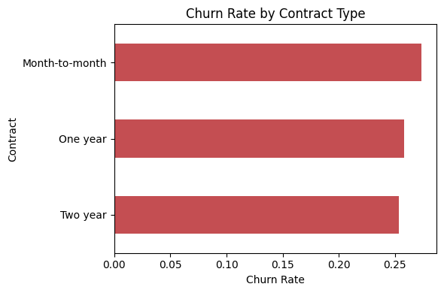
Figure 10: Churn rate by contract type: almost identical across all three (Data Engineer)
Retention factors. The reverse of the drivers shows who stays: long-tenure customers, customers with dependents, and customers on lower monthly charges.
Important note. In most real telecommunications data, month-to-month contracts and fibre internet are strong churn drivers. They are not here, and average tenure and charges are almost identical across contract types. This may mean the dataset is partly synthetic, so these specific results should be re-checked on live company data before acting on them (Section 8).

7. Recommended retention strategies
The retention budget should go first to newer customers on high charges, using the model’s risk scores to decide who to contact. Each strategy below is tied to a specific finding.
Priority | Strategy | Target group | Evidence | Measure of success
1 | First-year onboarding programme: welcome call, check-ins at months 1, 3 and 6, and a loyalty reward at 12 months | All customers in their first 12 months, starting with Newer – High Charges | 47.4% first-year churn; this segment holds 58% of churners | First-year churn rate
2 | Risk-based outreach: score customers monthly with the ANN and have the retention team contact the highest-risk customers first | Top-scored customers across all segments | Model catches 72% of churners; ROC-AUC 0.81 | Churn among contacted vs. not contacted customers
3 | Plan review and right-sizing: proactively offer a cheaper plan or a bundle discount where a customer is paying for more than they use | Customers paying over $70 a month, especially newer ones | 33–37% churn above $70, against 11.9% at $40 or less | Churn and revenue kept in the high-charge segment
4 | Senior customer care: simple plans, a dedicated support line and help with setup | Senior citizens, especially those without dependents | 41.7% churn (43.2% without dependents) | Senior churn rate
5 | Family and household bundles: multi-person plans that make it more attractive to add family members | Customers without dependents | 31.3% churn without dependents, 15.5% with | Uptake and churn of bundled customers
6 | Loyalty recognition: low-cost rewards (anniversary thank-yous, priority support) to keep the loyal core engaged | Long-term – Low Charges | Only 4.8% churn, so a light touch is enough | Retention stays below 5%
What not to prioritise. Contract-upgrade campaigns are unlikely to reduce churn on their own, because churn is almost the same on every contract type (25–27%). Discounts on fibre or phone services alone are also unlikely to help, as these show no meaningful link to churn.
Suggested rollout
- Months 1–2: pilot the first-year onboarding programme and risk-based outreach on Newer – High Charges customers, keeping a control group for comparison.
- Months 3–4: measure results, then add plan reviews and senior care.
- Month 6: retrain the model on new data and expand the programmes that worked.

8. Limitations, challenges and proposed solutions
The biggest limitation is the dataset itself: it has only nine predictors, no customer ID, and patterns that differ from typical telecommunications data. The findings are sound for this data, but they should be confirmed on live company data before large investments are made.
Limitation or challenge | Impact | Proposed solution
No customer ID | 302 duplicate rows could not be confirmed as true duplicates, so they were kept | Request a unique customer ID in future data extracts
Limited features (no billing history, payment method, support tickets or usage data) | Caps how accurate any model can be | Add payment method, complaints, support contacts and usage data in the next phase
No TotalCharges or lifetime-value field | Cannot prioritise customers by their value to the company | Add total billed amount so outreach can target high-value, high-risk customers
Possibly synthetic data: contract and internet type show almost no effect, and tenure and charges are near-identical across contracts | Some conclusions may not transfer to the real customer base | Validate the key findings on a sample of live company data before rollout
Class imbalance (26.5% churn) | The baseline model missed most churners (recall 0.47) | Solved with balanced class weights; threshold tuning could improve it further
Model below accuracy and F1 targets (test accuracy 72.9% vs. 80%; churn F1 0.58 vs. 0.70) | Many flagged customers would not have churned (precision 0.49) | Tune the decision threshold, add richer features, and use the model to rank customers rather than as a yes/no decision
ANN is hard to explain (“black box”) | Stakeholders may not trust predictions they cannot see reasoning for | Use permutation importance (done) and add SHAP explanations per customer
Clustering used only two features | Segments do not reflect demographics such as senior status | Re-run clustering with the engineered feature set (8 features) and compare
Single snapshot in time | Customer behaviour and offers change over time | Retrain the model and refresh segments every 3–6 months
Technical setup: TensorFlow needed a separate Conda environment | Delayed modelling work | Documented the environment set-up in the GitHub repository for reuse
Coordinating a 4-person team across 5 roles | Shared PM duties and handovers needed careful tracking | Rotating PM, bi-weekly meetings, Jira and GitHub for version control

9. Conclusion and next steps
The project answered its core questions: who churns, why, and how to find them in advance. Customers churn most in their first year, especially when they pay high monthly charges, and one segment accounts for 58% of all churn. The ANN model finds 72% of churners and ranks customers by risk well, although it fell short of the accuracy and F1 targets. With richer data it should improve, and even now it lets the retention team focus its effort where it counts.
Recommended next steps for the company
- Pilot the first-year onboarding programme and risk-based outreach on Newer – High Charges customers, with a control group.
- Validate the findings on live company data, especially the weak effect of contract type.
- Collect richer data (customer ID, payment method, support history, total charges) to improve the model.
- Retrain the model and refresh the segments every 3–6 months.
Project artefacts. All code, the cleaned datasets, the trained model (churn_ann_model.keras), the fitted scaler and the individual workstream reports are stored in the team’s GitHub repository (telco-customer-churn-analysis).

