Installed Android Studio

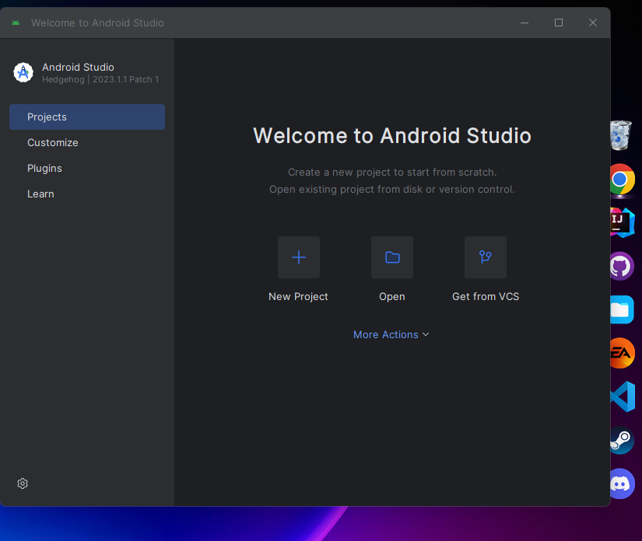

Added Flutter plugin also dart as it required dart to add flutter plugins

Created the first project



