Test-1 (Part-B)

Name: Prajwol G C Marks: /50

- Create a website with the theme “My College Education at Sault College”.
Your homepage is a way to organize your college courses and provide information to Grade-12 age group about your learning experiences at Sault College, its uniqueness, location, etc.
Focussing on Web Design; create using pen and paper:

  - a wireframe layout to use header, nav, main with a few div and footer elements.
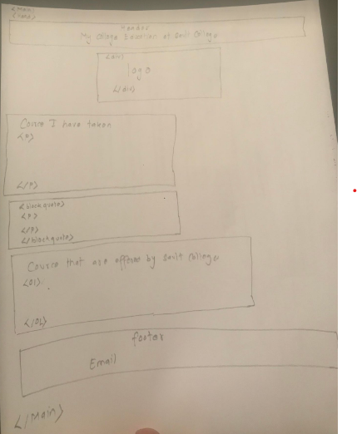
4
  - hierarchical site map linking to all different courses you are taking this semester.
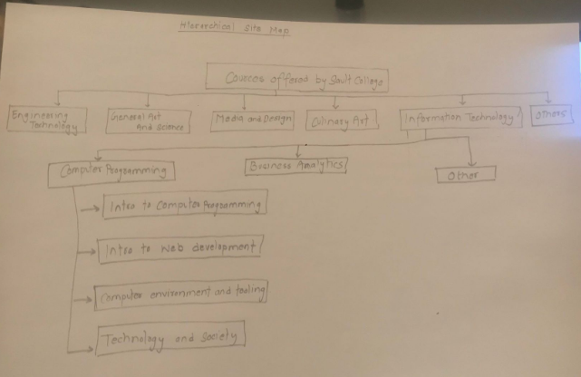 4

Add the use of the following html elements: 22

- Title
- Heading
- Alignment
- blockquote
- OL
- UL
- Links showing use of relative and an absolute addressing
- Special characters (e.g., &, ”)
- div and span
- Font colour and background colour
- Include an optimized image

- Once done save this page “Test-1.html” in a folder “LabTest-1” and upload the folder to your GitHub www repository you created during Lab-3 and 3b. 2
- Make a link “LabTest-1” on your existing home page to this page. 2
- Make a link “Home Page” on this page to go back to your home page. 2
- Write the URL of your homepage: 2

- Submit the zipped Website folder and files in the LabTest-1_DropBox. 2
Any submission dated after 11:59PM on 8th November 2022 will not be accepted. Even if I consider at least 50% marks will be deducted.

Marks for:
- Is the Website appealing? 4
- Are the links working? 4
- Is there a way to go back to the home page from the linked pages? 2

