**Kathmandu University**

**Department of Computer Science and Engineering**

**Dhulikhel, Kavre**



A

Proposal

on

**“Neural Machine Translation on Nepali Texts”**

**Code No:** COMP 473

**Submitted By**

Junth Basnet (05)

Prajwol Lamichhane (26)

Anukul Parajuli (34)

**Submitted To**

Bal Krishna Bal, PhD

Associate Professor, HoD

Department of Computer Science and Engineering

**Date of Submission:** 2020-06-18

**Abstract**

Neural Machine Translation(NMT) is the implementation of neural networks for the translation of one human language to another. The idea is to predict the likelihood of a sequence of words, often in the form of whole sentences. The structure of the NMT uses recurrent neural networks(RNN) with attention which consists of an encoder for converting the source sentences into word vectors and a decoder for predicting the words into the target language. Input to the network is Nepali and English texts. The dataset consists of 10,000 Nepali sentences and its corresponding English conversion. Both, Nepali or English sentences are given as an input on the basis of the conversion we want to obtain. The objective of this work is to obtain the translation in a shorter span of time compared to the time in which an actual human translation is done. The application of this project is to develop a platform for translation of Nepali sentences to English and vice-versa.

**Keywords- Neural Machine Translation(NMT), Recurrent Neural Networks(RNN), Attention**

**Introduction**

Neural Machine Translation takes an input text (source language) and translates into another language (target language). As it uses recurrent neural networks, encoder and decoder implementation is used. The encoder converts the sentences and words into a number matrix in the form of word embeddings and maps them on to a latent space. The decoder uses the encoder output to predict the next words sequentially into a target language. Since attention is used, the neural network does not consider the output only at the final time steps of the encoder while the output at each time step is considered.

The idea of the project is to translate sentences from Nepali to English and vice-versa. When we are converting a sentence from English to Nepali, the source language is English and the target language is Nepali. While if we are converting a sentence from Nepali to English, the source language is Nepali and the target language is English. Besides the language input, two tags, the start tags and the end tags are also given as input at the starting and ending of the sentence.

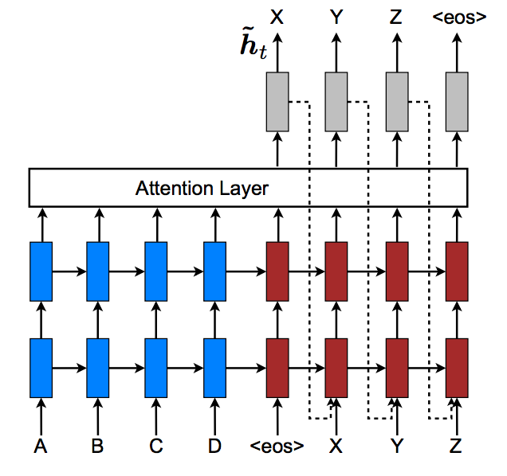

**Fig. 1.** Attention in Neural Machine Translation

In the Fig. 1, for example, when converting a sentence from Nepali to English, in the above figure, ABCD are the Nepali word inputs at each time step and XYZ are the english word outputs at each time step. <eos> is the end of sentence tag. On the decoder side, if the output of one time step is used as the input to the next time step, the process is called teacher forcing. So, an optimization with both using and non using of teacher forcing will result in the state of the art project.

**References**

[1]. Neural Machine Translation by Jointly Learning to Align and Translate by D. Bahdanau, K. Cho, Y. Bengio. (Source: <https://arxiv.org/pdf/1409.0473>, visited on: 2nd June, 2020)

[2]. Neural Machine Translation Application with Tensorflow. (Source: <https://www.tensorflow.org/tutorials/text/nmt_with_attention>, visited on: 8th June, 2020)