**Kathmandu University**

**Department of Computer Science and Engineering**

**Dhulikhel, Kavre**



A Mini Project Report

On

**“Projectile Path Simulation”**

[Code No.: COMP 342]

**Submitted by:**

Prajwol Lamichhane (26)

**Submitted to:**

Mr. Dhiraj Shrestha

Asst. Professor

Department of Computer Science and Engineering

**Submission Date:** July 28, 2019

**1. Introduction:**

Projectile motion is a form of motion experienced by an object or particle i.e a projectile that is thrown near the Earth’s Surface and moves along a curved path under the influence of gravity. The curved path was shown by Galileo to be a parabola. The study of such motion is called ballistics and such a trajectory is called ballistic trajectory. The gravity is the major force that influence the object downward thus making the object to accelerate downward. Due to the object’s inertia there is no need of horizontal force to maintain the horizontal velocity. But, many other external forces like air resistance, friction, aerodynamic drag etc does affect and while also taking in account such forces further complicated analysis has to be done. Newton’s law states that force is required to keep object in motion. But, in fact force is not required to object in motion. Force is only required to keep the object in acceleration. In the case of the projectile which is moving upward, there is a downward force and a downward acceleration. This means the object is moving upward due to initial velocity and is slowing down at the same time. This is how a projectile motion occurs.

**1.1 Objectives:**

The main objectives for doing the project are:

* To demonstrate how a horizontal projectile motion occurs on different initial velocities and different horizontal angle from the ground
* To help visualize the ballistic trajectory traced out by the projectile.

**2. Implementation:**

Various tools along with different libraries on python have been used for the completion of the project. The tools and the libraries used for this project are:

**2.1 Tools Used:**

**a. Atom IDE:** Atom is a text editor used to write codes for any programming languages. This was used for python coding. KITE framework was used along with it for automated code recommendation.

**b. Terminal:** The terminal was used for code compilation and data input. When the code was run, the input was given through terminal.

**2.2 Libraries Used:**

**a. Turtle:** Turtle is a graphics library in python. It has a pointer and several functions. The function of those in built functions is to move the pointer while it traces the path when it is moving.

**b. Pygame:** Pygame is one of the very common python libraries used for visual and audio purpose. I have used pygame here as a measure to play the sound while the projectile is moving on air and while it hits the ground.

**c. Tkinter:** Tkinter is also a graphical library. Tkinter is basically used when it comes to drawing the dialog boxes. This library is used at last for displaying the final result on a dialog box.

**3. Discussion**

The mathematical concepts that has shaped the project are as follows:

**3.1 Mathematical Concepts:**

The variables and mathematical formulas of projectile motion are:

a. Velocity: vin = initial Velocity fired from ground

b. Acceleration:ax = 0, ay = -g where, ax, ay is the velocity across x-axis and y-axis

c. Acceleration due to gravity on Earth: g

d. Horizontal angle made with X-axis: θ

e. Maximum height: ((vin)^2 * sin^2(θ))/2*g

f. Range: Horizontal distance traveled by projectile = (u^2*sin(2θ))/g

g. Time of Flight: (2*u*sin(θ))/g

**3.2 Implementation of Projectile Simulation:**

**(Code Snippet)**

while Xo<1250:

# Calculation of Time of Flight

Tucus = (2 * Vy) / g

t = 0

start = time()

while t<=Tucus:

# Calculation of "x" to move turtle. ( circle )

x = Xo + Vx*t

# Calculation of "y" to move turtle. ( circle )

y = (Vy*t) - ((g*t**2)/2)

# Gives shape of circle to turtle

color('red')

turtle.shape("circle")

turtle.shapesize(1)

turtle.pendown()

turtle.goto(x,y)

color('green')

# Determines the Speed of movement of the turtle

t=t+0.5

if int(y) == int(maxheight) and count == 0:

xMaxheight = x

# Drawing Line from Maximun Height

turtle.setpos(xMaxheight,maxheight)

turtle.left(180)

turtle.pendown()

turtle.goto(xMaxheight,0)

turtle.penup()

turtle.goto(xMaxheight,maxheight)

turtle.penup()

count += 1

# Dropping Sound Effect

if y == 0 and x != 0:

if timeDiff > 0.20:

pygame.mixer.init()

pygame.mixer.music.load("drop.wav")

pygame.mixer.music.play()

pygame.time.wait(100)

end = time()

timeDiff = end - start

# Setting new X

Xo = Xo + Tucus*Vx

# Setting new Y

Vy = Vy*0.8

if timeDiff < 0.1:

break

**Conclusion**

With the completion of the project, the project has helped me develop the concepts of a projectile motion and ballistic path traced out by the projectile. The mathematical formulas were very accurate which helped to simulate the projectile motion.

**APPENDIX**1. Entering the Initial Velocity and Angle From Ground

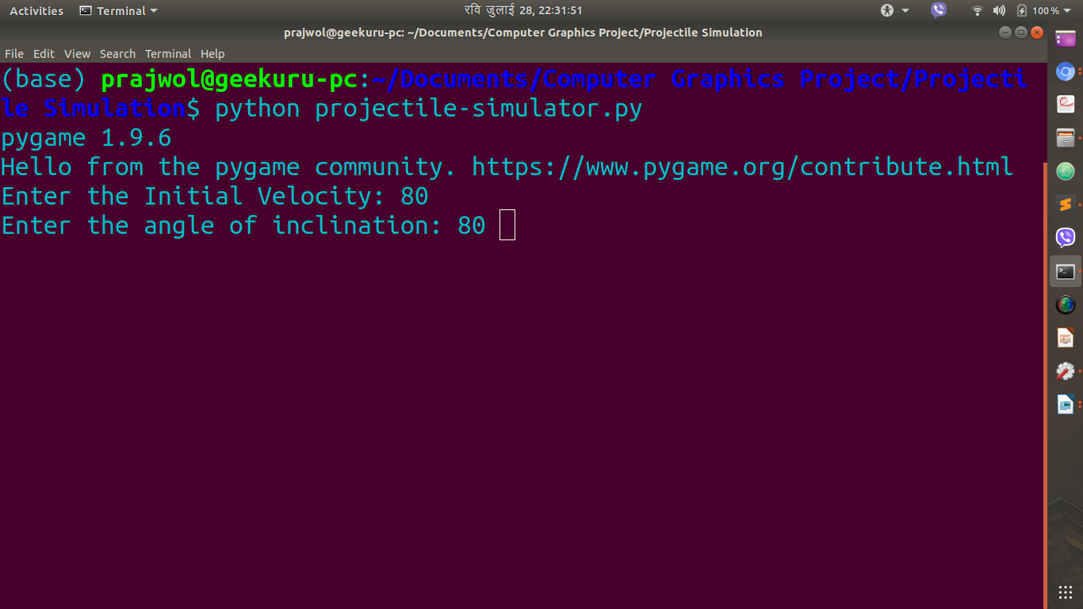2. Projectile set to move from origin.

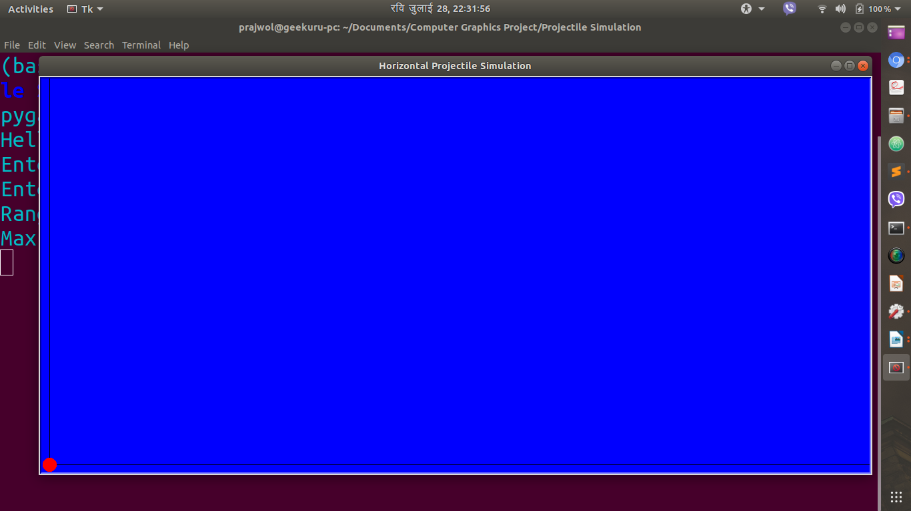

3. After drawing the maximum height of the first projectile

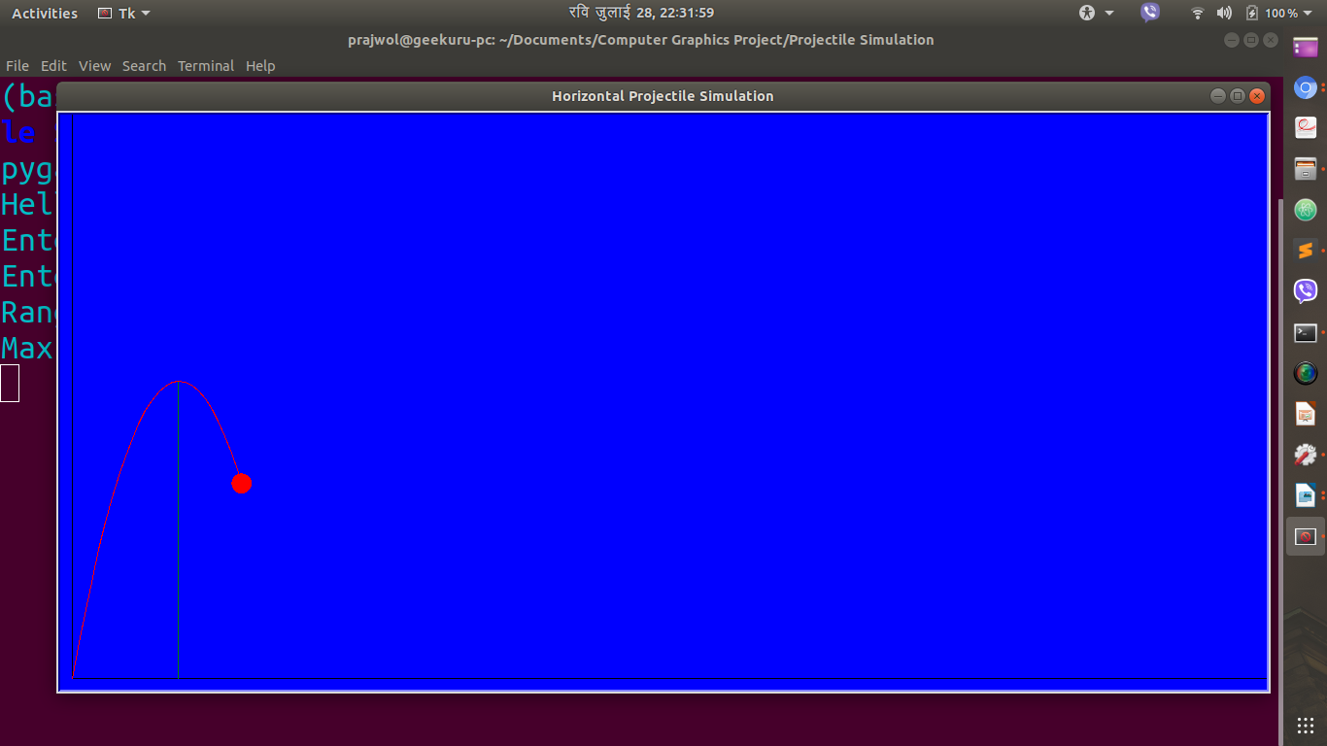

4. Displaying the Horizontal Range and Maximum Height of the First Projectile

