  
 **TRIBHUVAN UNIVERSITY**

**INSTITUTE OF ENGINEERING**

**THAPATHALI CAMPUS**

**Proposal**

**on**

**Snake –ladder game**

**Submitted by :**

[Sheikh Muhammad Samir Hoda] [THA081BCT036]

[Shishir Shrestha] [THA081BCT038]

[Prasiddha Adhikari] [THA081BCT021]

[Shivam kumar sah] [THA081BCT039]

Submitted to:

Department of Electronics and Computer Engineering

Thapathali Campus

Kathmandu, Nepal

February 2024

**ABSTRACT**

Snake and Ladder is a classic board game that originated in ancient India and is now enjoyed worldwide. The game is played on a numbered grid, usually from 1 to 100, with snakes and ladders placed at different positions. Players take turns rolling a die and move their token forward based on the number rolled. Landing on a ladder allows the player to climb up to a higher position, while landing on a snake sends them down to a lower number. The game is purely based on luck, as there are no strategic moves involved. It is often played by children for entertainment but also helps in learning number recognition and counting. Traditionally, the game was designed to teach moral lessons, where ladders represented virtues and snakes symbolized vices. The first player to reach the last square (usually 100) wins the game. Snake and Ladder is a simple yet engaging game that continues to be popular across different age groups.

The aim of this project is to create a similar game using c program that can run on a terminal . This game will use different variable to represent snake -ladder and player position. The game will also have a score system. The game will be designed for beginners who want to learn C programming and have fun at the same time.

TABLE OF CONTENTS

ABSTRACT............................................................................................................................... 2

INTRODUCTION.......................................................................................................................6

* 1. Background Introduction .........................................................................................6
  2. Motivation …………………………………………………………………………………………………………….. 7
  3. 1.3 Problem Definition ................................................................................................7

1.4 Objectives..................................................................................................................7

1.5 Scope and Applications .....................................................................................................7

2. LITERATURE REVIEW .....................................................................................................8

2.1 The history of Snake ladder game...................................................................................8

2.2 The History and Development of the C Programming Language .................................10

3. PROPOSED SYSTEM ARCHITECTURE..............................................................................11

3.1 Block Diagram or System Architecture.......................................................................11

3.2 Data Flow Diagram .......................................................................................................11

4. Methodology ....................................................................................................................12

4.1 Setting Up the Environment............................................................................................12

4.2 Game Development Steps...........................................................................................12

4.2.1 Game Board and Data:...........................................................................................12

4.2.2 Input and Movement:............................................................................................12

4.2.3 Logic and Game Loop: ...............................................................................................12

5. Time Estimation ..............................................................................................................13

6. Feasibility Analysis.....................................................................................................13

Reference:........................................................................................................................14

**LIST OF ABBERATION:**

1. Time Estimation – TE

2. Technical Feasibility – TF

3. Economic Feasibility – EF

4. Operational Feasibility – OF

5. ASCII - American Standard Code for Information Interchange

6. Graphical User Interface - GUI

**Table of figures**

Figure 1 : Snake-Ladder........................................................................................................................9

Figure 2 : C time line........................................................................................................10

Figure 3:Dennis Ritchie ………………………………………………………………………………………………..11

Figure 3 : Gantt chart...................................................................................................................13

INTRODUCTION

1. Background Introduction

When we want to communicate to each other we use our language like Nepali, Maithali, Urdu, English and so on . Likewise, if we want make computers work some task for us , we need to give introductions that the computer machine understands . Such type of language is called a programming language . Therefore , programming language is standardized communication technique for describing instructions for a computer. Each programming language has a set of syntactic and semantic rules used to define computer programs language. A language enables a programmer to precisely specify what data a computer is to act upon , how these data are to be stores/transmitted and what data a computer is to actions to be taken under various circumstances. Programming language are other kinds of software which enables us to develop different kinds of softwares. Programming language are classified mainly in two categories on the basic of creating instructions : **Low level language** and **High level langauge.**

* **Low Level Language**

These are much closer to hardware . Before creating a program for hardware , it is required to have through knowledge of that hardware . A program cannot be run on different hardware. Low level language are specific to hardware. Low level language is also divided in two types **Machine language** and **Assembly language**.

* **High Level Language**

The language are called high level language if their syntaxes are closer to human language . High level language were developed to make programming easier. Most of the high level language are English like language. They use familiar English words, special symbols (!,& etc) and mathematical symbols(+,-,*,/ etc) in their syntax. Therefore , high-level language are easier to read ,write ,understand and programming . High level languages are sometimes used to refer all language above assembly level which are **procedural oriented** languages , **problem oriented** **language** and **natural language**.

Today there is wide uses different type of programming language in different purpose including java for app development and for web development html, css etc. There are many other programming languages in use today, each with its strengths and weaknesses. Choosing the right programming language for a particular task depends on a variety of factors, including the requirements of the project, the developer's experience and expertise, and the availability of tools and libraries**.**

In 1960s programs such as COBOL, BASIC was developed to write applications for business and research. Similarly in 1970s C and Pascal was developed to write about operating system and applications. In 1990s development of scripting language such as python, perl which are used for web development.

* 1. Motivation

As new ideas grew up, we decided to enter in simple game development. We looked out for tutorial videos on YouTube and started to learn more about it. This leads us to this project untimely. It was a quite good opportunity for us to test ourselves in early phase of our learning. In the decision phase of the project, we decided to develop Snake ladder game which was most popular and best for us to learn something new. We believe the project will be big success for us and will further build our confidence level for upcoming new projects in later years.

* 1. Problem Definition

This project focuses on developing a Snake and Ladder game through the use of the C programming language. Users can add multiple players and select how many players will participate in this game. The game uses distinct colors to represent the snake positions, ladder positions and the current player position. A scoreboard displays both your position alongside those of the snakes and ladders. Roll the dice with any key press and your position will update based on the rolled number.

* 1. Objectives

Our aim to make snake ladder game using c programming . Where different snake and ladder helps to entertainments the user and also the different condition for opening the game make user excited to play the game . There are different player so they feel competition with each other. There are also a scoreboard which helps user to see their current position as well as snake and ladder position.

Throughout this project, we intend to accomplish the following goals:

* Effectively design and implement a snake- ladder game using the C programming

language, operational within a terminal setting

* Accept user keyword as a input and run according to the user input .
* Generate game visuals and accept user commands through built-in output and input function.
* Record the snake , ladder position and also the players position.
* Roll the dice after pressing a key by the user then update the position according the user input.
* After bit by snake updating the user position and also score position.

By undertaking this endeavor, participants can anticipate gaining valuable insights related tofoundational C programming principles alongside honing strategic reasoning and resolutiontactics through an entertaining medium. Concurrently, the accessibility factor ensure compatibility across diverse computing devices containing a terminal and C compiler.

* 1. Scope and Application

This project focuses on teaching novice programmers the fundamentals of the C programminglanguage and enhancing their problem-solving skills by building a simple but engaging game.While the game lacks advanced features such as complex animations and interactive menus, itprovides an excellent platform for learning C syntax, data structures, file handling, and event-driven programming. Moreover, its simplicity makes it easily portable across different operatingsystems and hardware platforms.

1. LITERATURE REVIEW

The literature review of this project will cover the following topics:

• The history of the snake ladder game.

• The history and development of the C programming language.

• The methods and techniques of creating a game using C program that can run on a terminal.

2.1 The history of the snake ladder game

The origins of the Snake and Ladder game trace back to ancient India where people called it Moksha Patam or Paramapada Sopanam which translates to "the ladder to salvation." * The game was designed to serve as a teaching tool which represented the principles of karma (actions) and dharma (righteousness).

**ORIGIN IN INDIA**

* Saints and scholars created the game to serve as an educational tool for imparting Hindu philosophy and moral lessons.
* Players could achieve Moksha (salvation) through the virtues represented by the ladders including honesty and humility along with kindness.
* The snakes in the game stood for vices like anger and greed which diverted players from achieving salvation.
* The highest achievement of the game meant arriving at the top to represent spiritual enlightenment.

**Spread to other countries**

* The British colonial powers introduced the game to England during the 19th century before transforming it into a children's activity.
* The British changed the name of the game to "Snakes and Ladders" while erasing its ethical and religious significance.
* The game made its way to England before it expanded globally to establish itself as a favorite board game for families.

**Modern Adaptation**

* In the **United States**, the game was introduced by **Milton Bradley** in 1943 as **"Chutes and Ladders"**, replacing snakes with slides.
* Today, it is played worldwide in different versions, often as a simple game of luck rather than a philosophical teaching tool.

Despite its evolution, the **core mechanics** of rolling dice, climbing ladders, and avoiding snakes remain unchanged, making it one of the most **enduring and beloved board games** in history.

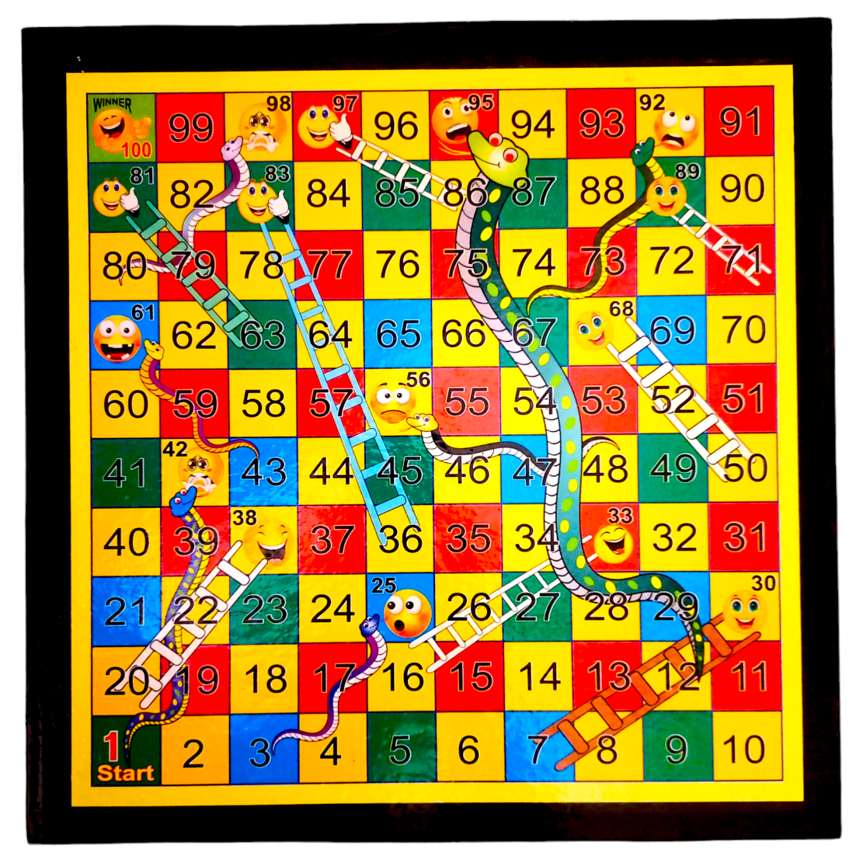

* 1. The history and development of c programming language

The C language is general purpose and procedural oriented program type of language. It is structured and machine independent language. It was developed by Dennis Ritchie in 1972 at the AT&T Bell Laboratories. It was developed along with the UNIX operating system, and is strongly linked with UNIX operating system. History of C language revolves around development as a system implementation language to write an operating system. In terms of the history of C language, its main features include low-level memory access as well as high-level memory access (so it is a middle-level programming language), a handy set of keywords, and a neat and clean style, these features make C programming language suitable for system programming. C supports a wide variety of built-in functions, standard libraries and header files. It follows a top-down approach. Many languages have derived syntax directly or indirectly from the C programming language. For example, C++ is closely a superset of the C language. Also, C programming language is very popular for system-level apps.C got its name ‘C’ as it incorporates features from its predecessor “B” also originating at Bells labs. C significantly influences the development of many other programming language especially C++ , designed as an extension of C. The programming C is maintained by the standard committees such as the ISO C . C has various standards that meticulously define its syntax, features and behavior including ANSI C(C89 or C90), C99, C11, C17 and C18.

History timeline of C programming

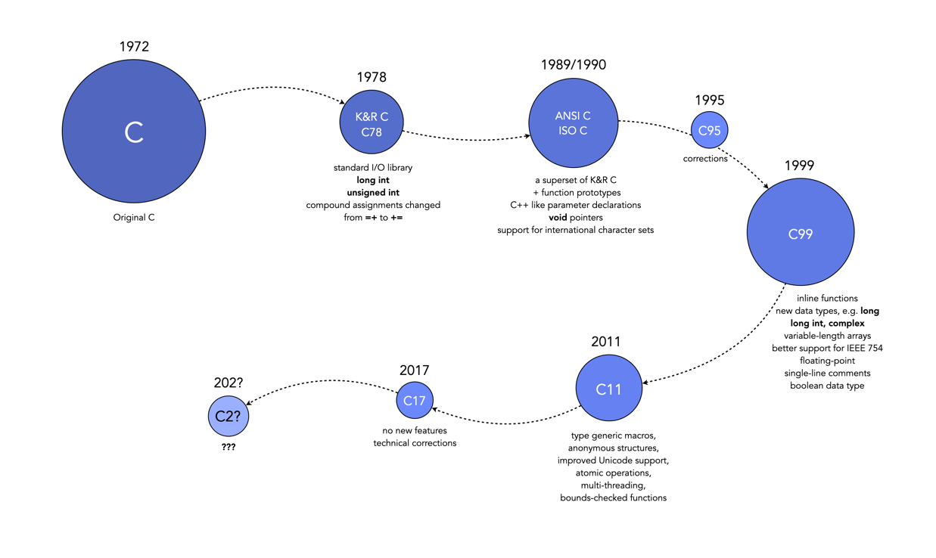



1. PROPOSED SYSTEM ARCHITECTUR

3.1 Block Diagram or System Architecture

The game contains several components : Scoreboard, Player ,snake and ladder . The scoreboard represented as 2D arrays and player represent by their name(like p1,p2 etc) and snake are represented by the colours and ladder is also represented by different colours.

* 1. Data Flow Diagram

The data flow is simple on the basis of user rolled the position of the player is updated and also current sore written after the rolling the dice.

4. Methodology

4.1 Setting Up the Environment

To develop a game using the C programming language, there are several steps that need to be followed. Firstly, you will need to set up your development environment, which includes installing a C compiler such as GCC and a text editor like Visual Studio Code. Having a suitable development environment is crucial as it provides the necessary tools needed to write and test your code.

4.2 Game Development Steps

4.2.1 Game Board and Data:

Once you have set up your environment, you can proceed to the game development process. The first step in developing a game is designing the game board and data structures. For the snake ladder game development you have to firstly create a scoreboard in which you have to add the snake ,ladder and player position. Use different colour for different species. Like you can you red colour for snake etc. For that you can use array .

4.2.2 Input and Movement:

Now you have to use any condition to enter the game like you can enter the game only after you rolled 6 . The keyboard printf() can be use to take user input and we have to update their position for that we can use any loop.

4.2.3 Logic and Game Loop:

On the basis of user dice rolled we can update player position by using loop. Also in the board we have to update the position of the player .for that you can use while() loop and when player score 100 you have to print you are winner.

By following these steps, you should be able to successfully develop a simple snake ladder game using the C programming language. However, becoming proficient requires continuous learning and practice. Some helpful resources include setting up a development environment and understanding the basics of C programming. With dedication and hard work, anyone can master C programming and build their career in software engineering.

5. Time Estimation

Start Date :8 February 2025

End date :13 February 2025

6. Feasibility Analysis

**Technical Feasibility**: Developing a basic version of the classic arcade game Snake-Ladder using the programming language C is a highly achievable goal from both technical and economic standpoints. From a technical perspective, C is widely recognized as one of the most suitable languages for game development due to its flexibility, efficiency, and wide range of libraries and frameworks available for gaming applications. Moreover, this specific project focuses on implementing fundamental concepts of the C language, making it relatively easy for beginners to comprehend and execute.

**Economic Feasibility**: In addition to being technically feasible, creating a Snake ladder game using C is also financially within reach. To get started, all that is required is a C compiler, which can be acquired at no cost whatsoever. One can either download a C compiler from various sources on the internet or utilize an online compiler without having to install anything on their local machine. Therefore, there are virtually no expenses involved in developing this project, making it an excellent choice for those who may have limited financial resources.

**Operational Feasibility:** Lastly, operational feasibility is another aspect to consider while building a Pacman game using C. After writing and compiling the code successfully, running the game on a computer equipped with a C compiler should pose no difficulties. To ensure ease of maintenance, the project's code will be thoroughly documented and structured appropriately, enabling smooth execution, modification, and updating in the future if necessary. With these factors in mind, developing a basic version of the iconic game Pacman using C seems like a promising endeavor worth pursuing.

Reference

<https://chatgpt.com/c/67af31c4-65f4-8005-a32c-9b7d96f7ca23>

[WWW.goggle.com](http://WWW.goggle.com)

<https://github.com/>

[www.youtube.com](http://www.youtube.com)

Krishna Kandel ,Learning C by Examples