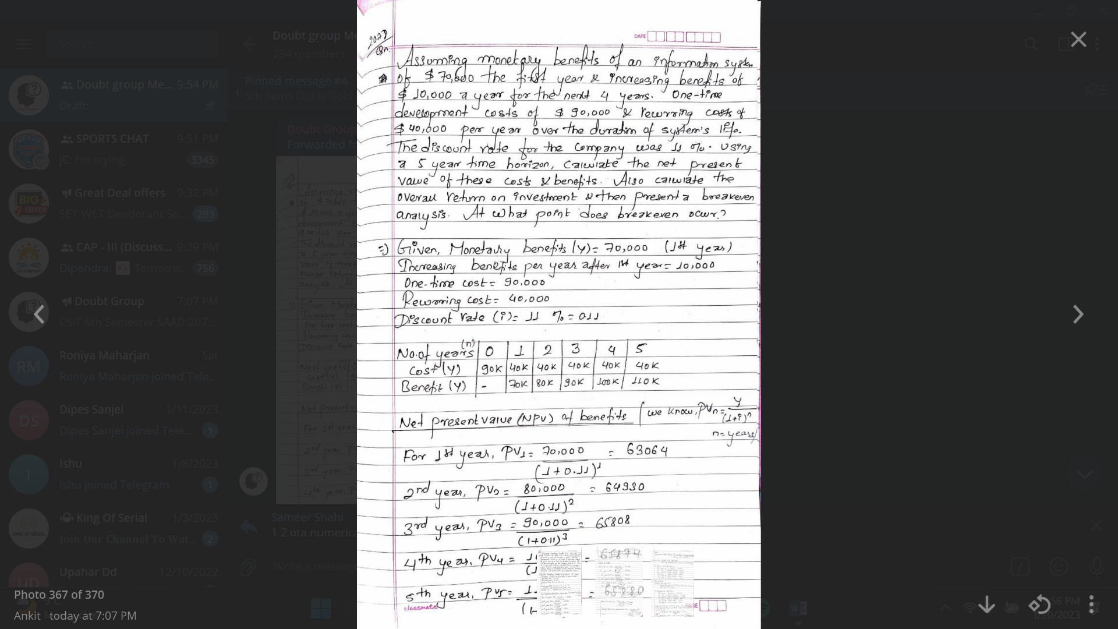

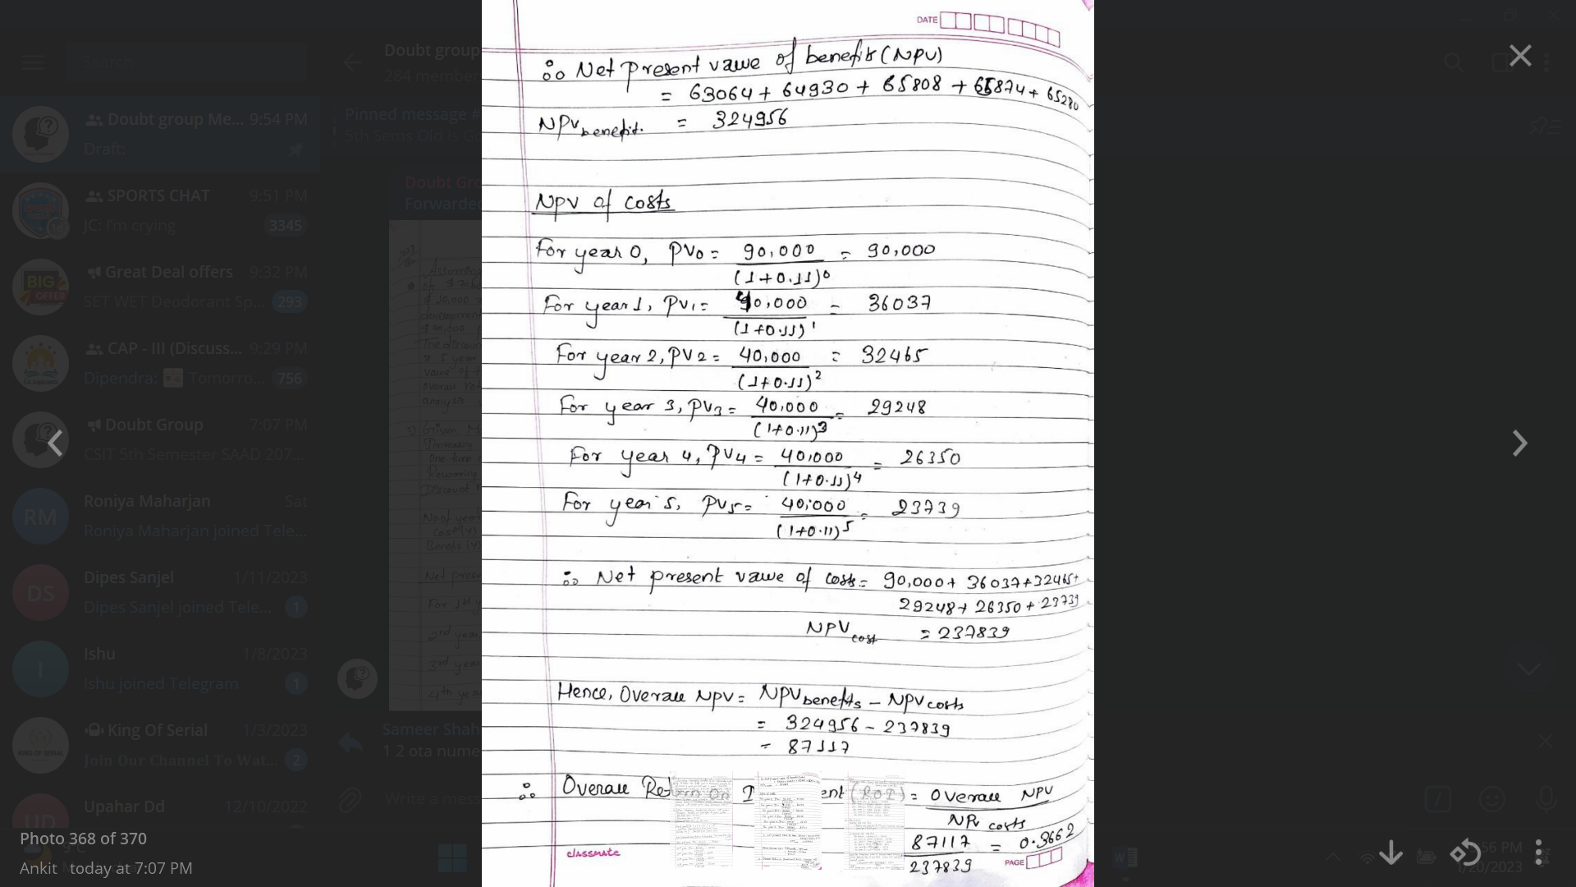

Aba break even point vneko benefit=cost huan pryo so ekdam benefit rw cost dubai involce hune vaneko cash flow ho ani teivyerw purae paila (yearly cashflow-overall cashflow )/yearly cashflow garxxa

Ani overall cash flow ma yo year ko cashflow rw agadi ko year samma ko overall cash flow jode aaihlxa

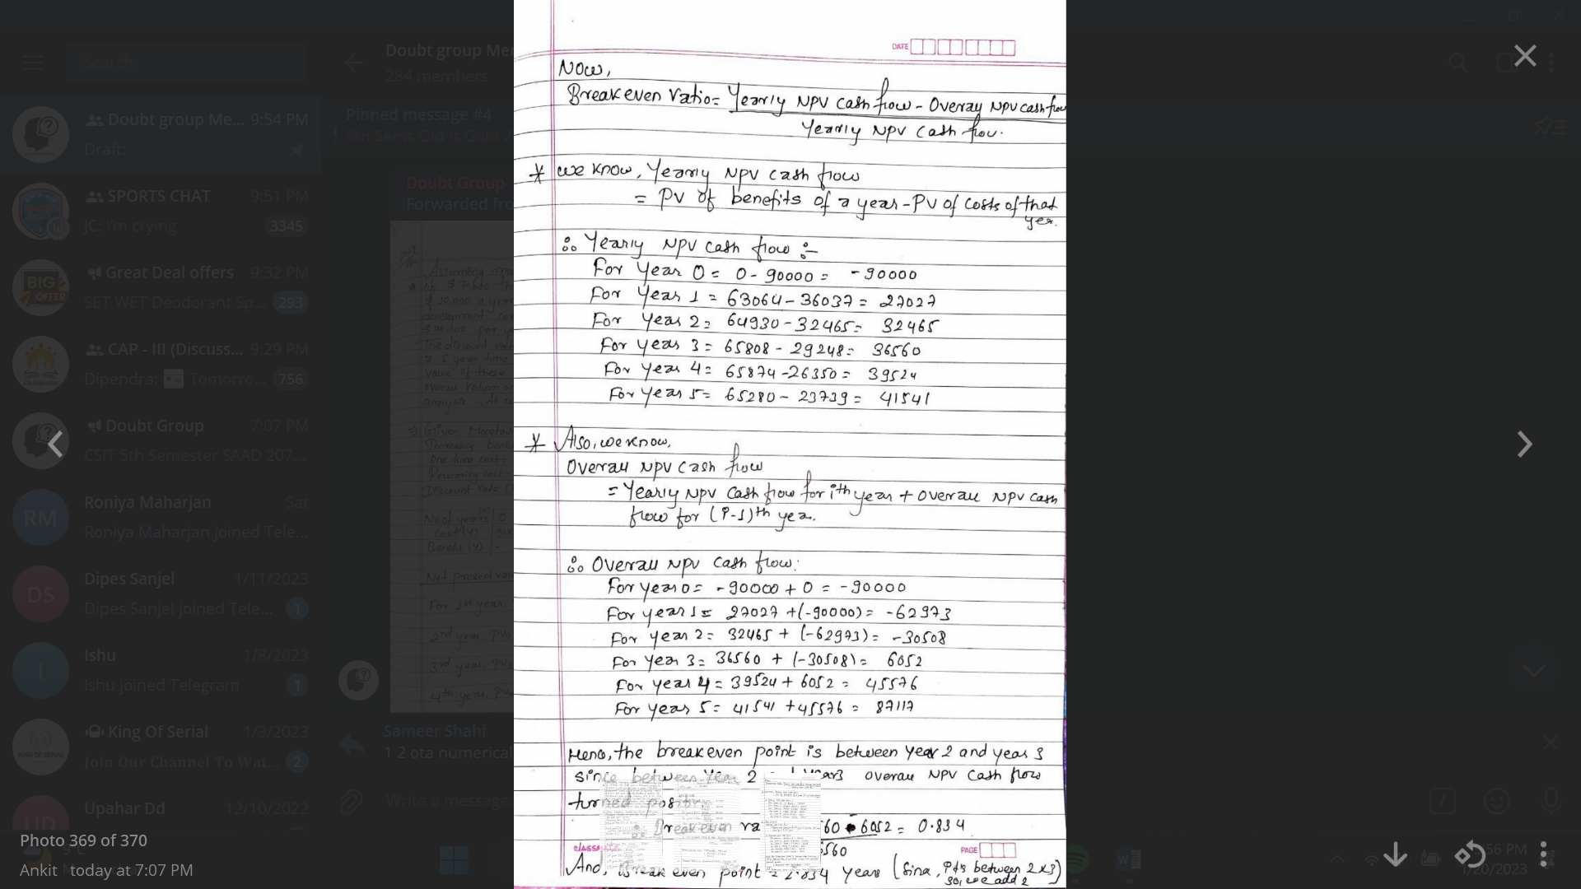

Break even point ma 36560 rw 6052 use gariraxa