**Tribhuwan University Faculty of Humanities and Social Science**

**Greenfield National College**

**Bafal, Kathmandu**

**Project Report**

**ON**

“**E-Commerce**”

For the Partial Fulfillment of Requirement for the Bachelor’s Degree of Bachelor in Computer Application

**UNDER THE SUPERVISION OF**

Mr. Keshav Karn

**Submitted By:**

Priya Tamang

Aman Tamang Lama

**SUBMITTED TO:**

Greenfield National College Faculty of Humanities and Social Science

Bafal,Kathmandu September 2021

**Tribhuvan University**

**Faculty of Humanities and Social Science**

**Greenfield National College**

**Supervisor**’s **Recommendation**

I hereby recommend that this project prepared under my supervision by Priya Tamang And Aman Tamang Lama entitled “**E-Commerce**” in partial fulfillment of the requirements for the degree of Bachelor of Computer Application is recommended for the final evaluation.

Mr.Keshav Karn

**SUPERVISOR**

Lecturer

Faculty of Humanities and Social Science Bafal, Sitapaila, Kathmandu

**Tribhuvan University**

Mr. Basant Kumar Bhattarai

**Principal**

Faculty of Humanities and Social Science

Bafal, Sitapaila, Kathmandu

Mr. Jagdish Bhatta

**External Examiner**

**Faculty of Humanities and Social Science**

**Greenfield National College**

**LETTER OF APPROVAL**

This is to certify that this project prepared by Priya Tamang and Aman Aamang Lama entitled “**E-Commerce**” in partial fulfillment of the requirements for the degree of Bachelor in Compuer Application has been evaluated. In our opinion it is satisfactory in the scope and quality as a project for the required degree.

Mr. Keshav Karn

**Lecturer** (Supervisor)

Faculty of Humanities and Social Science

Bafal, Sitapaila, Kathmandu

Mr. Keshav Karn

**Internal Examiner**

**ACKNOWLEDGEMENT**

It gives us immense pleasure to express our sincere gratitude with happiest appreciation to all those respectable personalities who helped us to make our project work successive as well as productive.

This project would not have been possible without the support of every mentors, individuals, teachers, and guidance. All that we have done is only due to such supervision and assistance and we would like to thank each of them. Firstly, we would like to express our gratitude to **GREENFIELD NATIONAL COLLEGE** for the help and support continuously throughout the project development. We acknowledge with pleasure **Mr. Keshav Karn** for supervising this project and giving assistance when we had faced problems. Without his guidance and persistent help this project would not have been possible. Consistent error correction, suggestion and further path guidelines has been extremely helpful throughout this project development. Also, we would like to thank all the teachers for giving us this opportunity to undertake this project since day one. We are also thankful to the coordinator of **Greenfield National College** of our BCA department **Mr. Ganesh Kumar Upadhyaya Athale** for providing necessary information, infrastructures and resources relevant to the project. At last, but not the least, our sincere thanks go to our parents and member of our family, who has always supported us and we would like to express our sincere thanks to all of our friends who helped us directly and indirectly during the completion of the project report.

**ABSTRACT**

The project aimed to develop an online shop using open source technologies (PHP, HTML5, CSS3, JavaScript, MySQL and Apache Web Server) for electronics products in Ghana where customers will be able to buy products online.

The designed application will have an admin view and the public or guest view. The admin view is meant for the administrator to update the products, change prices, remove and add products and also manage customers. The customer view will be accessible to the customers, and they will be able to handle their information such as their name, ad- dress, and contact. Also, the customer will be able to order products from the shop.

Keywords Customer, User, PHP, MySQL, HTML5, CSS3,Bootstrap

**Table of Contents**

i

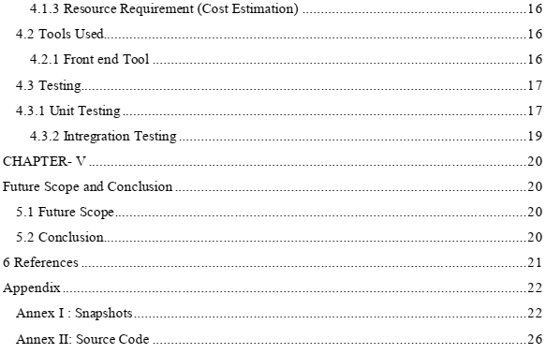

ii

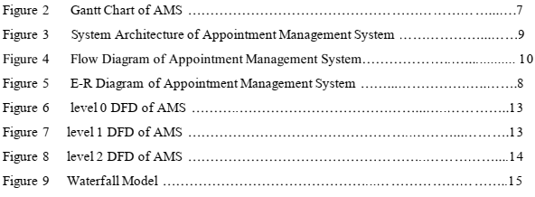**List of Figures**

iii

Figure 1 Use Case Diagram of Appointment Management System ……….…………….....5

**CHAPTER- I Introduction**

**1.1 Introduction**

Every time, while scrolling your Facebook, Instagram, or even TikTok timeline, you might have seen advertisements of several goods and services that allow you to make your order and pay for the purchase.

Along with the development of information technology, commercial transactions have also been made possible electrically. Consequently, in Nepal also, there are various companies like Daraz, Sastodeal, and Urbangirl which have thrived on the possibility of e-commerce.

This digital version of doing commercial transactions over the internet, also known as e-commerce, has been in the centre of attention among the urban youth in Nepal these days. Now, the Covid-19 pandemic has also highlighted the importance of e-commerce among the costumers as well as the vendors.

E-commerce was introduced in Nepal with an aim of letting Nepalis residing abroad send gifts to their families, friends, and relatives living here. The shift from physical stores to virtual ones began in the late 1990s.

Bal Krishna Joshi, a co-founder of thamel.com, claims his company is the first-ever e-commerce company in Nepal.

**1.2 Problem Statements**

If we see from the perspective of buyers, the first thing that comes is trust issues. Trust for what? Trust for the products they buy online. Some people have discontinued buying online because of the bad experiences of getting worst customer service, delivery of not exact products, and no return policy. On top of that there is lack of online payment gateway. Simply, buyers buy from social media such as Facebook, Instagram but they can’t pay online and are said to make cash payments when the goods will be delivered, i.e. cash on delivery. Elder generation still prefer the traditional shopping habit, going from shops to shops and barging to the fullest and getting things done.

**1.3 Objectives**

The main objectives of this project are pined below:

• To manage online selling costs in a strategic way.

• To provide convenient way of service for 24*7

• To improve customer loyalty.

• To sell more product.

**1.4 Limitations**

The Limitations of AMS web application are listed below:

• This application does not work offline.

• This may lead to numerous fraudulent activities.

• Cost of warehousing has to be borne by the business itself.

**1.7 Report Organization**

The report is organization into 5 chapters:

**Chapter 1: Introduction:** In this section, the brief introduction of our project, statement of problem and its objectives are discussed.

**Chapter 2: Background Study and Literature Review:** The work related to our projects works were studied and different feasibility analysis are summarized in this section.

**Chapter 3: System Analysis and Design:** In this section, we have design use case diagram, ER-Diagram, system flow diagram, dataflow diagram etc.

**Chapter 4: Implementation and Testing:** In this section, various implementation method and tools are discussed and also contains description of testing.

**Chapter 5: Conclusion and Future Enhancement:** In this section, conclusion to our project and description about what features can be added in the future has been described.

**CHAPTER- II**

**Background Study and Literature Review**

**2.1 Background Study**

Initially the E-Commerce was introduced in our country just with the purpose that the Nepali people residing abroad can send gifts to the one in Nepal. People outside the country were given an opportunity to send presents to their loved ones in Nepal. This is how the concept of E-Commerce in Nepal got started.

Later on, some online stores wore seen but those were just virtual stores having no product as well as lacking management of customer service. No proper process  of buying and selling online was to be seen. The purpose of virtual stores in Nepal was just to bring the awareness of E-Commerce among the mass of people. This way the E-Commerce came into existence.

**2.2 Literature Review**

E-Commerce implementation is a crucial process for an organization to make it successful and beneficial. As a consequence, intensive research works in the area of e-Commerce implementation from a diverse range of views and findings have been studied by many researchers. However, the aspect of Business-to-Customer (B2C) e-Commerce implementation has yet to be undertaken in an understandable manner in the context of a full life cycle of information systems development. This paper provides a systematic literature review of existing research studies on e-Commerce implementation to discover the extent of focus of work based on themes in the implementation phases: pre-implementation, during implementation and post implementation.

**Chapter- III**

**System Analysis and Design**

**3.1 System Analysis**

**3.1.1 Requirement Analysis**

**I) Functional Analysis**

Functional requirements define function of the system where functions are the collective sets of input, their behaviors and their output.

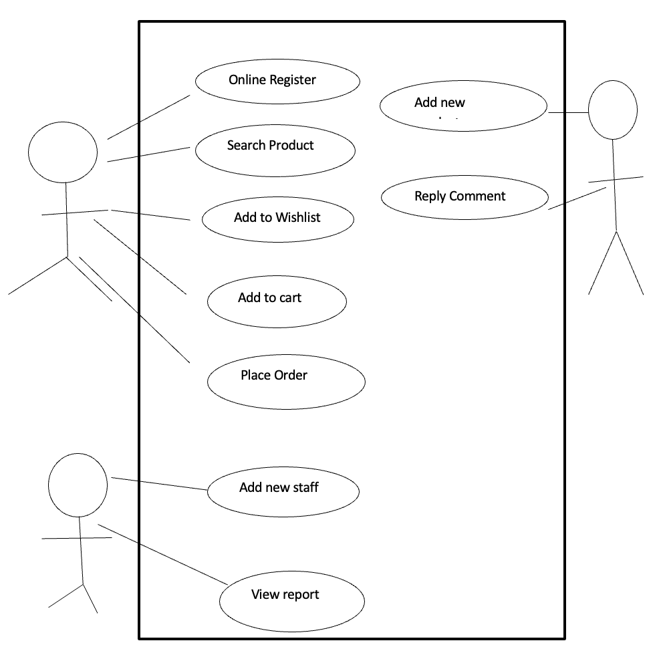

***Figure 1 Use Case Diagram of Online System*II)**

**Non-Functional Requirements**

**Usability**

The system allows the user to access the system from the internet. The system is user friendly and online help makes using the system easy and efficient.

**Performance**

The information is refreshed at regular interval depending upon whether some updates have occurred or not.

**Reliability**

The system run 7 days a week, 24 hours a day. And except the technical problem it runs every single hour.

**Maintainability**

Changes like new user addition, password changes, database changes must be verified once per day at least. The product is coded and maintained in the PHP and JS programming languages.

**3.1.2 Feasibility Analysis**

**I) Economic Feasibility**

Economic feasibility is the cost and logistical outlook for a business project or endeavor. Prior to embarking on a new venture, most businesses conduct an economic feasibility study, which is a study that analyzes data to determine whether the cost of the prospective new venture will ultimately be profitable to the company. Economic feasibility is sometimes determined within an organization, while other times companies hire an external company that specializes in conducting economic feasibility studies for them

**II) Operational Feasibility**

Operational feasibility is the ability to utilize, support and perform the necessary tasks of a system or program. It includes everyone who creates, operates or uses the system. To be operationally feasible, the system must fulfill a need required by the business.

Appointment is a user-friendly web-based application which can be operatable simply by any age citizen. It has a simple user interface where user have to click to rate any place they liked.

**III) Technical Feasibility**

The device that can run different browsers is needed so for using the product the user should visit the website and to use this online shopping.

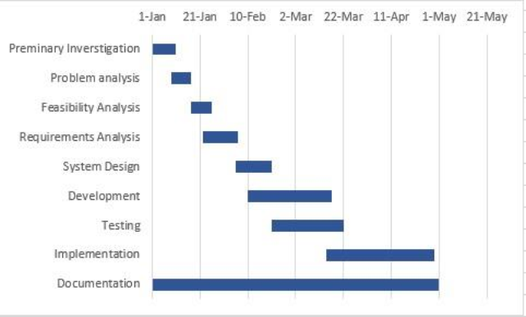**IV) Schedule Feasibility**

Time Schedule / Gantt chart according to the methodology used for development, the project is estimated to be fully developed in 4th months. The total project development task is subdivided into various phases and allocated time schedule as per requirements.

The rough schedule of the project is shown below (using Gantt chart):

**Figure 2 Gantt Chart of AMS**

**3.1.3 Data Modeling (ER-Diagram)**

***E-R Diagram ofA ppointment Management System***

8

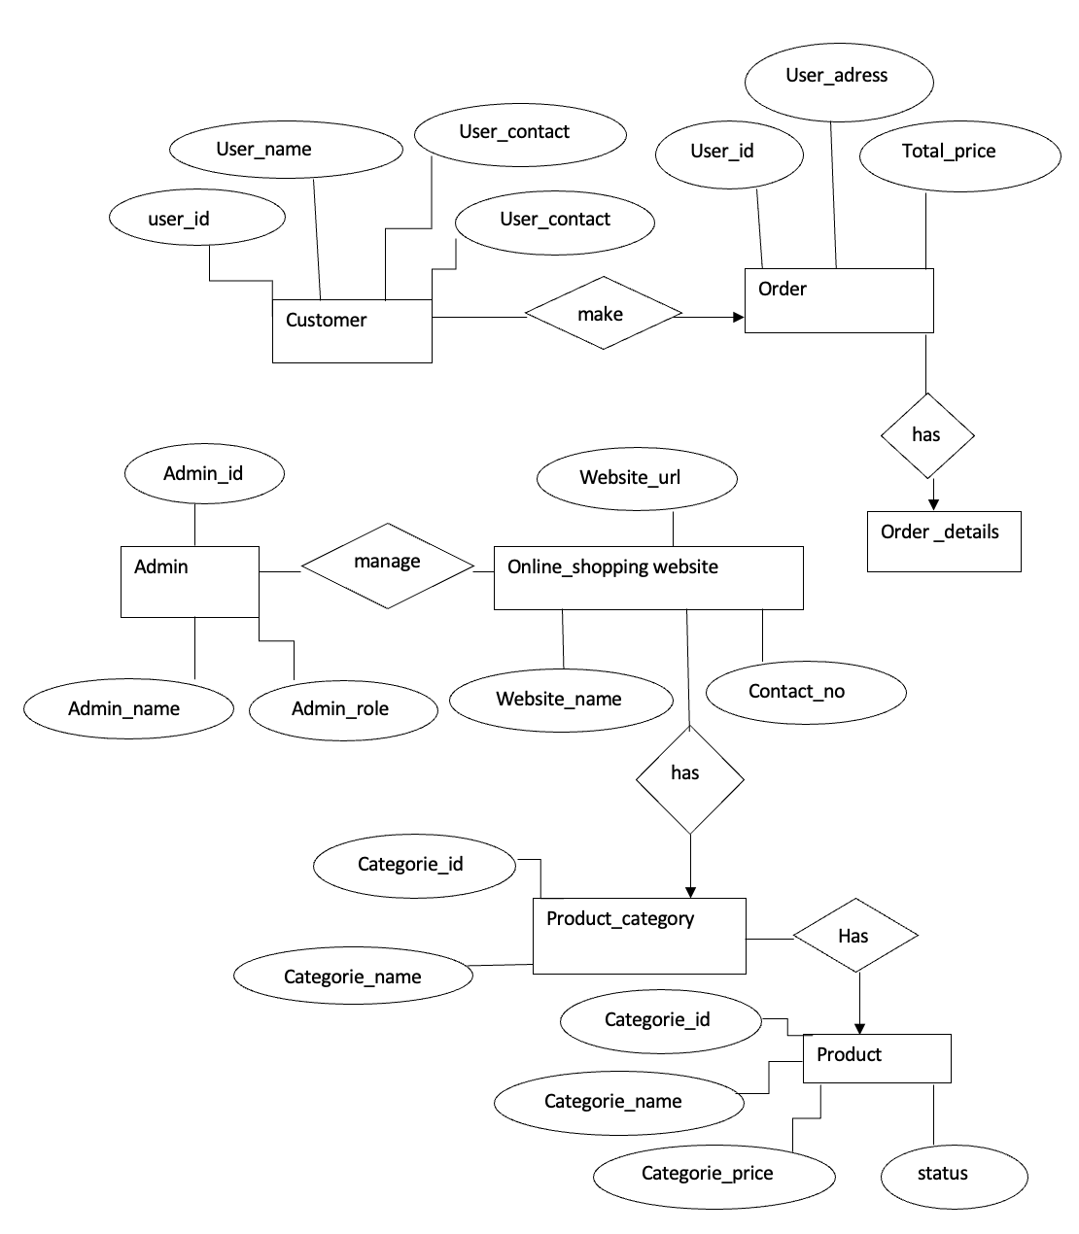

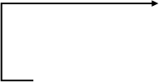**3.2 System Design**

***System Architecture of Appointment Management System***

ADMIN

**3.2.1 System Architecture**

The system architecture for the proposed project is as follows:

APPOINTMENT DATA

APPOINTMENT zzIFICATION

WEBPAGE USER INTERFACE

Database

ASSIGN/EDIT

DOCTORS DETAILS

DOCTOR

***Figure 3***

**3.2.2 System Flow Diagram**

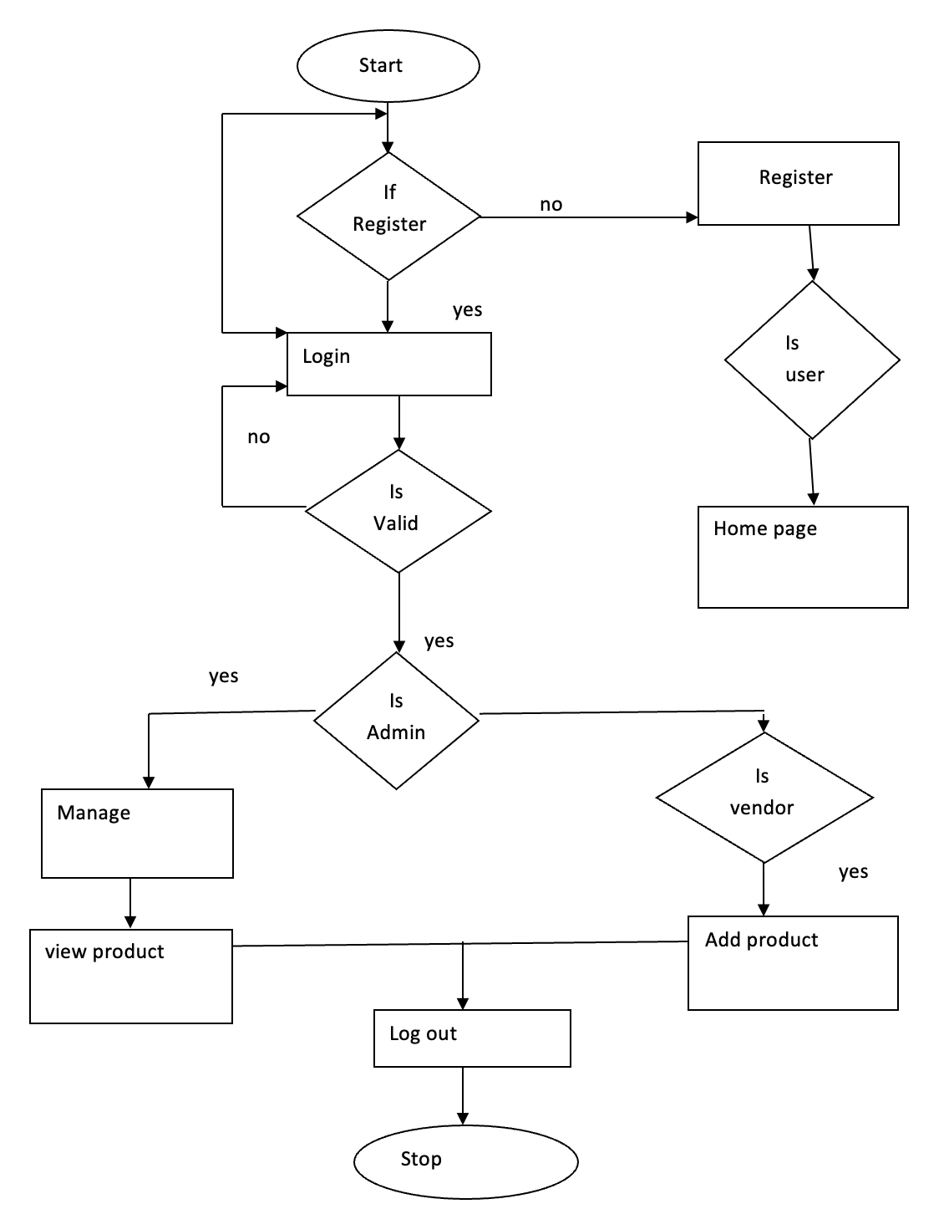***Figure 4***

***Flow Diagram ofA ppointment Management System***

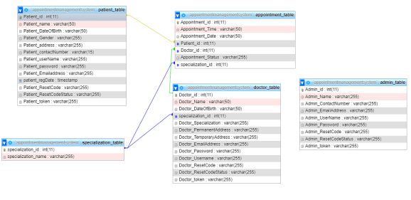**3.2.4 Database Schema Design**

***Figure 5 Database Schema Design***

**3.2.5 Interface Design**

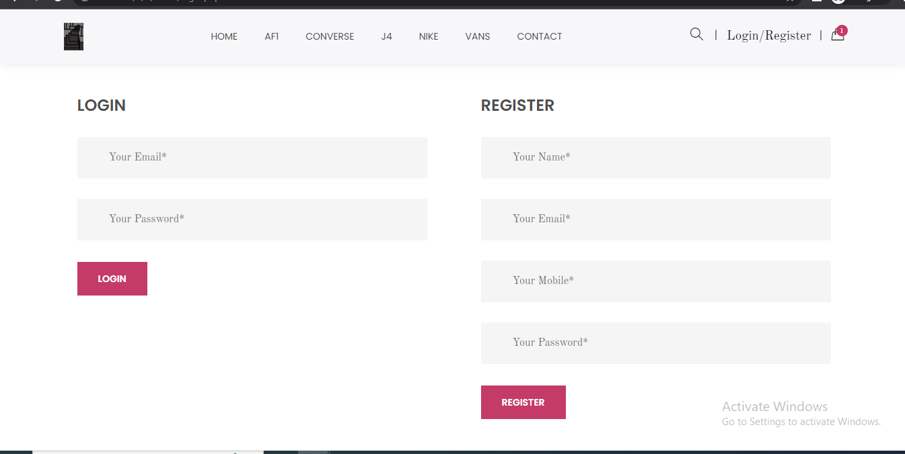

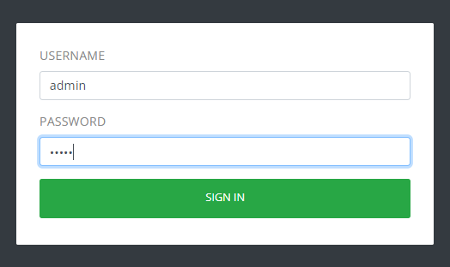

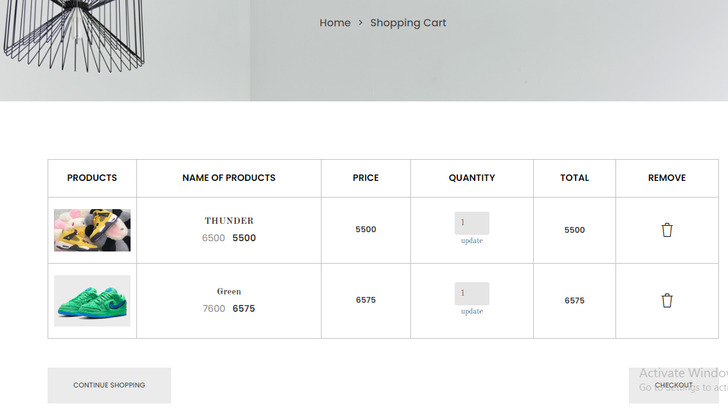

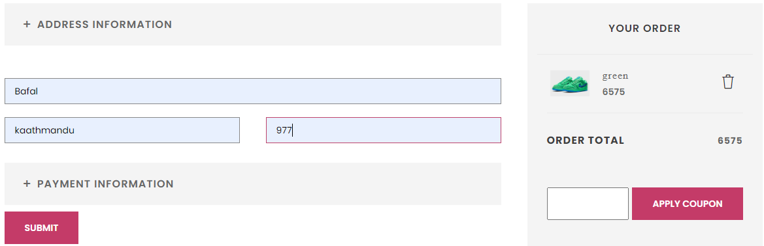

**3.2.6 Data Flow Diagram (DFD)**

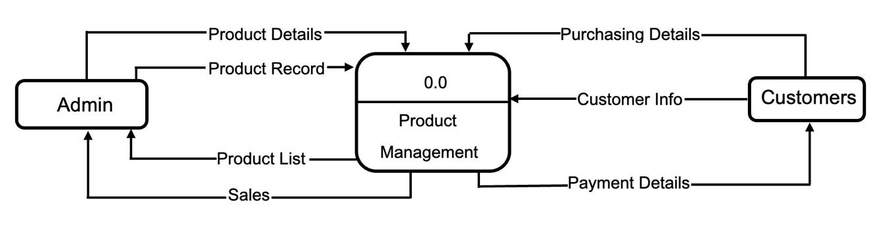

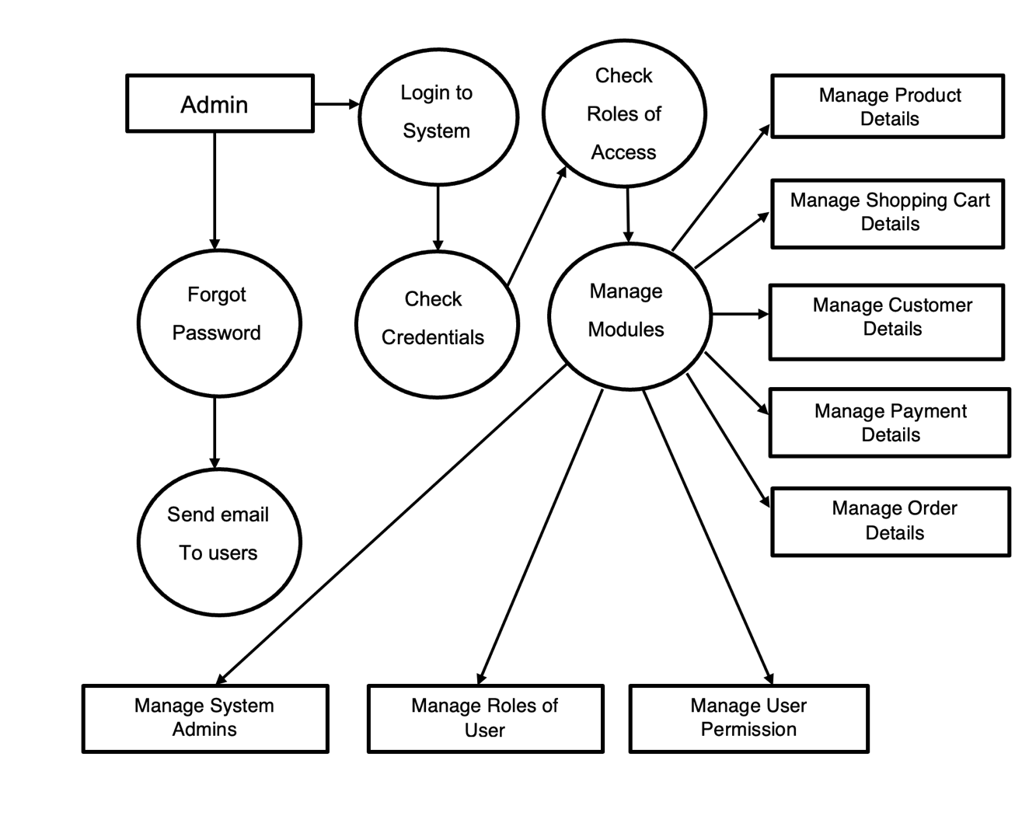

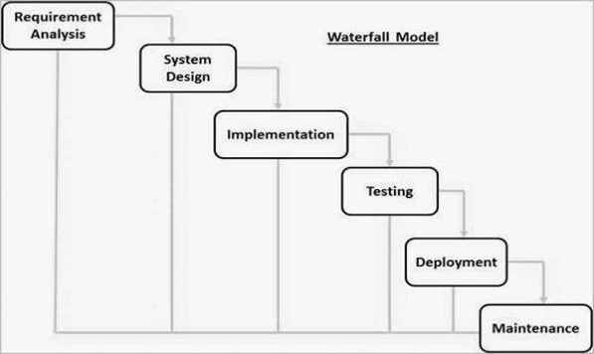**CHAPTER - IV**

***Waterfall Model***

**Implementation and Testing**

**4.1 Implementation**

**4.1.1 System Planning**

System Planning is one of the most essential tasks to be done before initializing and working on project development as it provides path and guidance to accomplish the process. After performing research and gathering complete information about the proposed project, we performed the system planning. System planning provides important outcome which embody the contribution and task to be done for proposal and design concept.

**4.1.2 System Development Model**

Waterfall model is very simple to understand and use. In a waterfall model, each step must be completed before the next stage begins. This model is easy to manage. This model steps are well defined and explained even easier to arrange tasks. The waterfall model will be used, as the requirements in this system are fixed.

***Figure 9***

The advantages of waterfall development are that it allows for departmentalization and control. A schedule can be set with deadlines for each stage of development and a product can proceed through the development process model phases one by one. Development moves from concept, through design, implementation, testing, installation, troubleshooting, and ends up at operation and maintenance. Each phase of development proceeds in strict order.

**4.1.3 Resource Requirement (Cost Estimation)**

For the cost estimation of this project Basic Constructive Cost Model was used. It is an algorithmic software constitutional model for evaluating the cost of a software package. Computer software development effort and cost as a function of program size. It is a method used to assess the human effort required for software development.

**4.2 Tools Used**

**4.2.1 Front end Tool**

It is one of the important tools used for creating user interface. It is the visible part of the application product. Through front end, user can perform some operation to the application. Some coding and designing are used to create user interface for our application. Some of the front-end tools used for our online shopping is listed below:

**a) HTML**

Html is used to provide structure and CSS is used for designing this system. Login Pages, Dashboards and Mailing skeleton was made using HTML.

**b) JavaScript**

JavaScript is used to provide a user friendlier experience JS is used. Disabling the select option and button are done using JS and also the client-slide validation was done.

**c) Visual studio**

Visual studio is used for editing and debugging the source code of the appointment management system. VS has many extensions available which makes programming easy and helps to reduce the development time.

**4.2.2 Back-end Tools**

Some of the Back-end tools used for our online shopping is listed below:

**a) PHP**

Php is used for this project to develop backend and communicate with database. It is used as programming language.

**b) Database (MySQL)**

MySQL is used in the database design and creating the relationships between entities in online shopping. MYSQL is the database programming language which follow the principle of relational database model.

**4.3 Testing**

Testing is done in every project during or after the completion of building the product. As the project is using water fall model as the software development model, the modules have been kept on testing after finishing the code.

**4.3.1 Unit Testing**

Case I: Unit Testing for Login Module

|  |  |  |  |  |  |
| --- | --- | --- | --- | --- | --- |
| Test Cases | Preconditions | Stepstobe executed | Expected  Results | Actual  Results | Pass / Fail |
| Login  for  Admin | The user  account be  registered | 1. Enter correct email and password. 2. Click login. | User must  Successfully login to the admin dashboard. | The admin is successfully logged in. | Pass |
| Login for users | The user account should be registered | 1. Enter incorrect email and password. | User cannot access user profile. | Login unsuccessful | Fail |

|  |  |  |  |  |  |
| --- | --- | --- | --- | --- | --- |
|  |  | 2. login  Click |  |  |  |

Case II: Unit Testing For Adding Users

|  |  |  |  |  |  |
| --- | --- | --- | --- | --- | --- |
| Test Cases | Preconditions | Steps to executed | Expected  Results | Actual  Results | Pass Fail |
| Adding users | The users to be registered | 1. Enter the users details .  2. Click  Submit | Users  should be  add successfully  and ID  password should be sent to the email provided | The users is successfully  added and mail sent  successfully | Pass |

Case III: Unit Testing For Appointing Doctor

|  |  |  |  |  |  |
| --- | --- | --- | --- | --- | --- |
| Test Cases | Preconditions | Steps to be executed | Expected  Results | Actual  Results | Pass / Fail |
| Appointing doctor | The doctor be appointed | 3. Enter the appointment date and select doctors  4. Click appoint | Doctor  should be  added and  that time slot  should be  prevented to  be booking  in further | Doctor is  successfully  added and  the the slot  in shown  booked | Pass |

**4.3.2 Intregration Testing**

This application was tested by integrating the different characters, environment which was tested in unit testing and it was almost accurate.

**4.3.3 System Testing**

System testing by integrating all the units as one single unit will be done once all the modules are complete.

**CHAPTER- V Future Scope and Conclusion**

**5.1 Future Scope**

Invoices and online payment need to be implemented in the shop, emails and notifications need to be sent to customers for new arrivals or discounts. The shop has to have a search engine where users and customers can search for the various products from the shop. Debit and credit cards need to be implemented in the shop as well. There have to be language varieties so that none-English users and customers can shop easily without any difficulty.

**5.2 Conclusion**

E-Commerce is not an IT issue but a whole business undertaking. Companies that use it as a reason for completely re-designing their business processes are likely to reap the greatest benefits. Moreover, E-Commerce is a helpful technology that gives the consumer access to business and companies all over the world.

**6 References**

[1] [Online]. Available: https://heoc.mohp.gov.np/service/number-of-health-facilities-in-

nepal/. [Accessed 25 Jan 2021].

[2] Research Gate, [Online]. Available: 

sforAppointment_Scheduling [Accessed 25 Feb 2021]

[3] Simply Book, [Online]. Available: https://simplybook.me/en/booking-system-features-

andintegrations. [Accessed 1 Feb 2021].

[4] [Online]. Available:https://dor.gov.in/appointments. [Accessed 5 Feb 2021].

[5] [Online]. Available:http://alkahospital.com/appointments. [Accessed 20 Feb 2021].

**Appendix**

**Annex I : Snapshots**



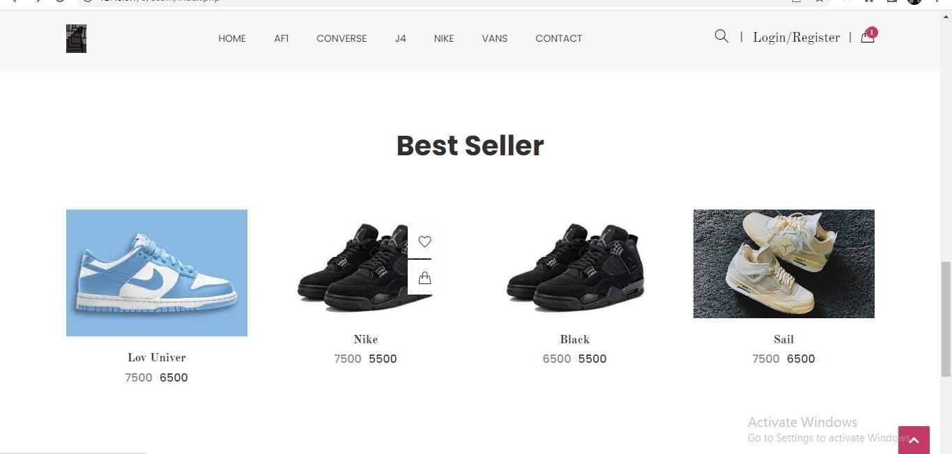





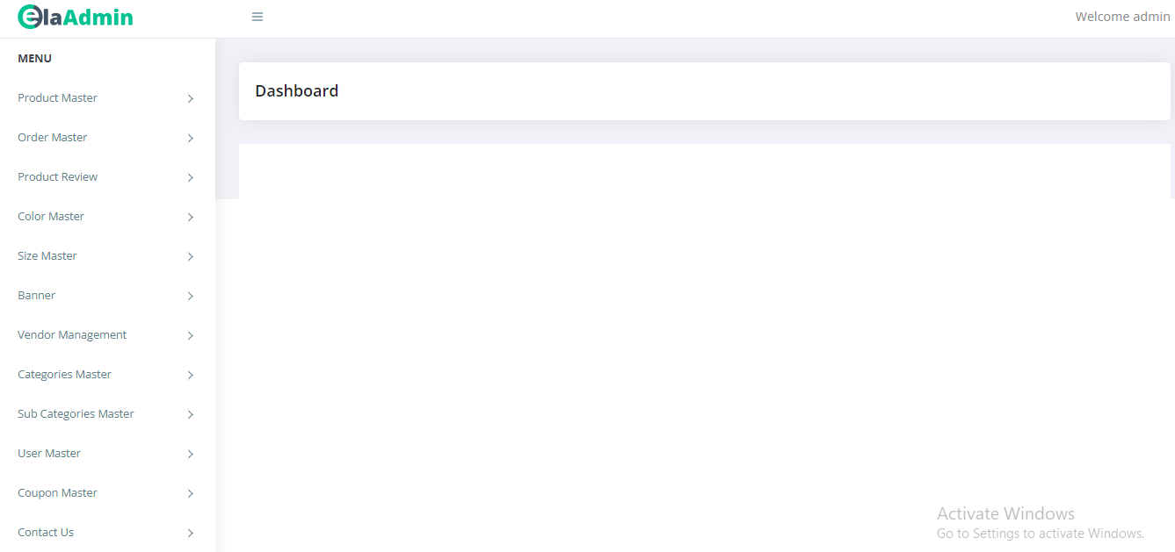

#### **Login Activity**

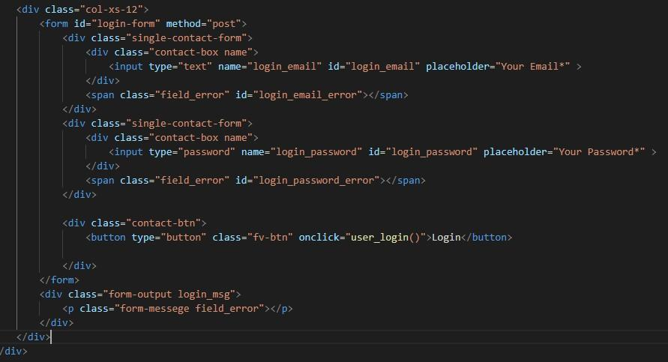

**User Registration**

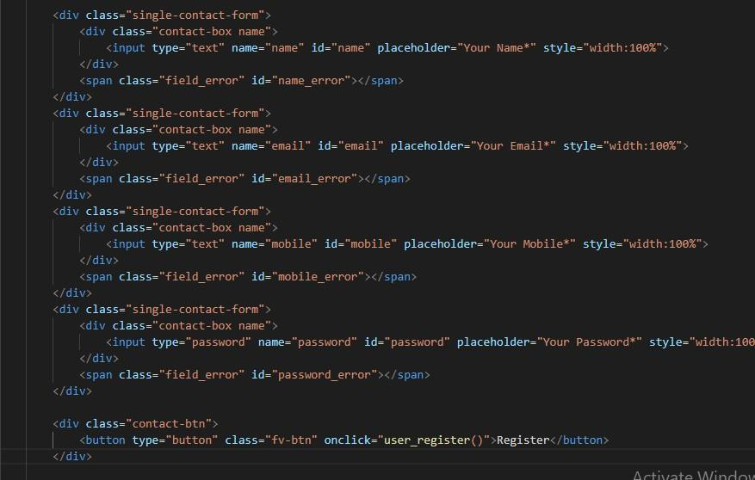

#### **Adding to wishlist**

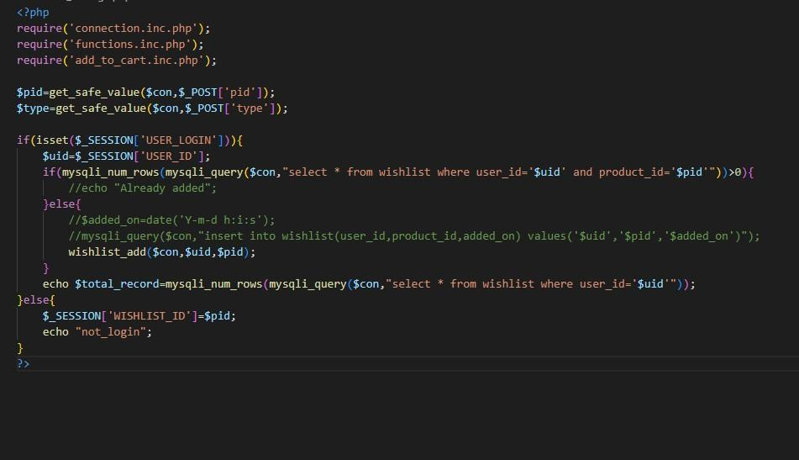

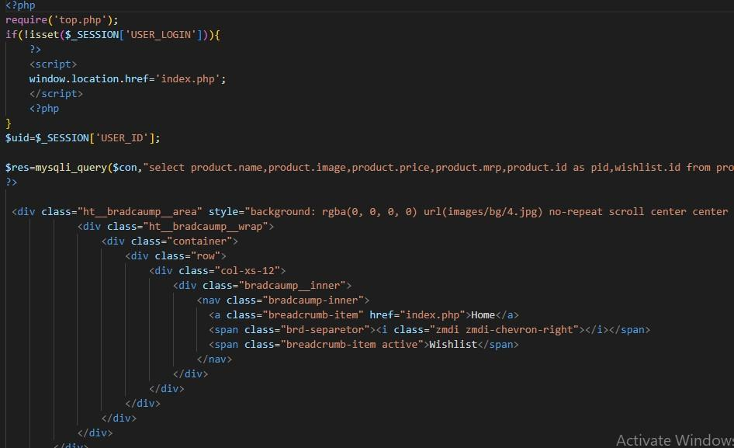

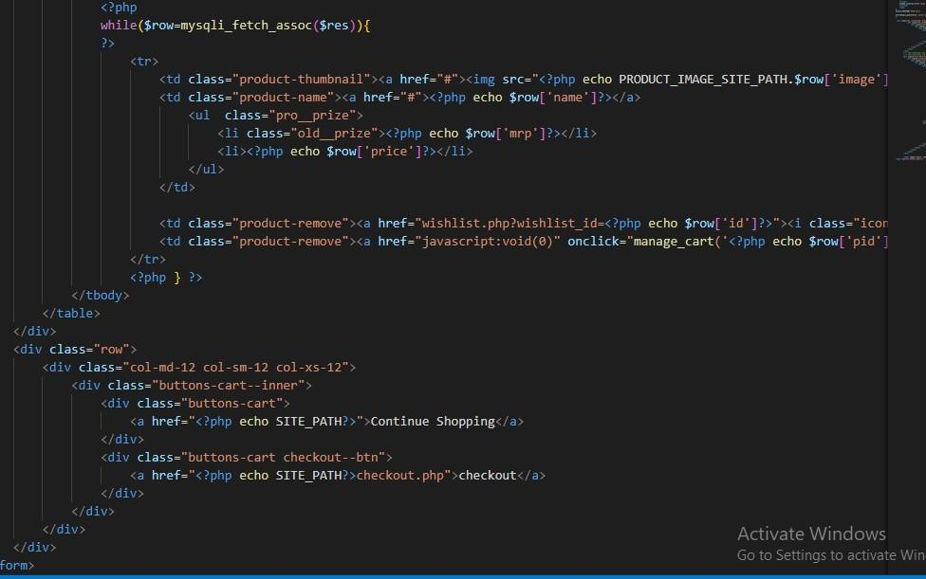

**Add to cart**

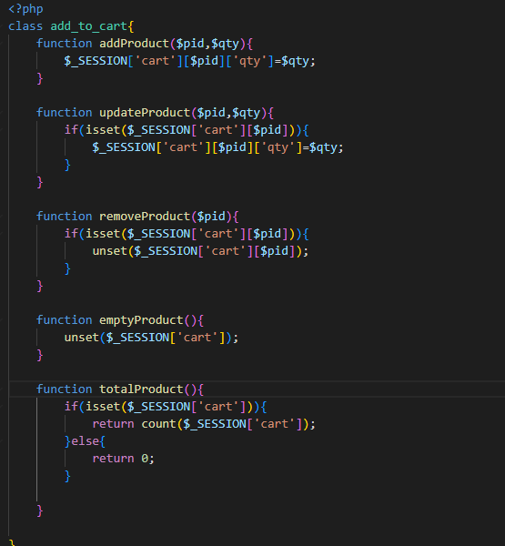

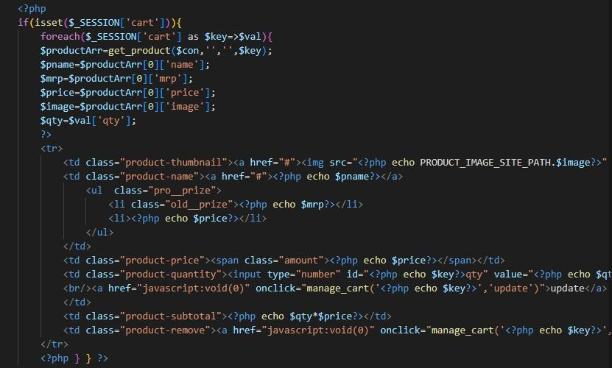

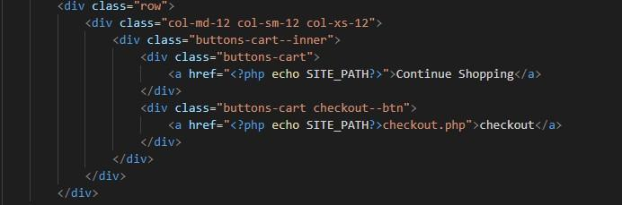

#### **Product**

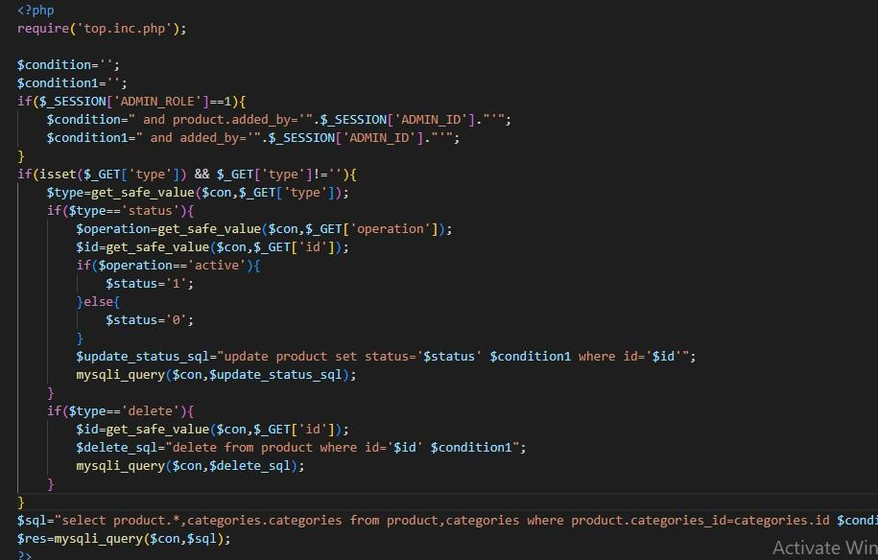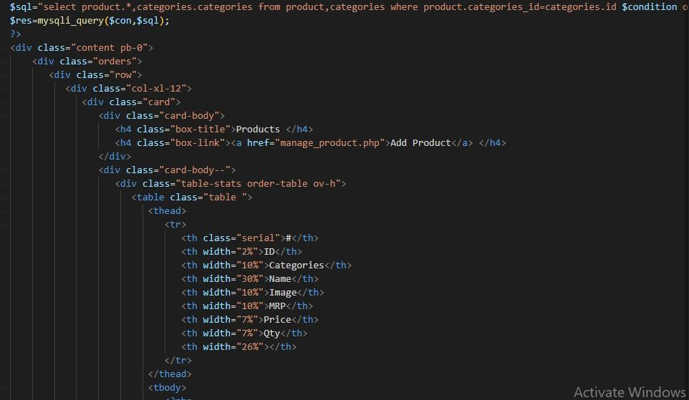

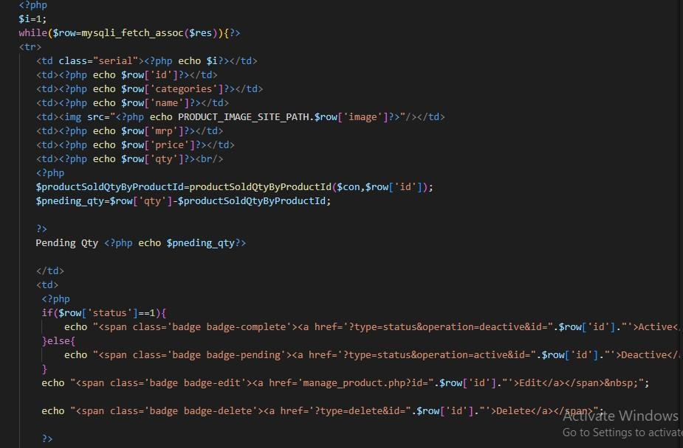

**Vendor**

