

**Tribhuvan University**

**Institute of Science and Technology**

**A PROJECT REPORT**

**On**

**ONLINE SHOPPING WEBSITE**

***GIANT-E-STORE***

**Submitted to**

**National College of Computer Studies**

**Submitted by**

**Roshani Thapa**

**Under the Supervision of**

**Pratik Chand**

# Abstract

The online shopping website abstract would describe a virtual marketplace that enables customers to purchase products and services over the internet. The website would feature a user-friendly interface with detailed product descriptions, reviews, and ratings, along with a secure payment gateway to ensure safe transactions. The website would provide various delivery options, including home delivery and store pickup, to enhance customer convenience. The platform would also offer personalized recommendations based on customer preferences, order history, and browsing behavior. The online shopping website would provide a comprehensive shopping experience, offering a vast selection of products from different brands and categories at competitive prices, with easy navigation and a responsive customer support team to address any issues or concerns.

# Acknowledgement

We would like to express our heartfelt gratitude to everyone who has contributed to the development and success of our online shopping website. Firstly, we would like to acknowledge our customers who have entrusted us with their shopping needs and provided valuable feedback to help us improve our services. We extend our appreciation to our development team, who worked tirelessly to ensure that our website functions seamlessly, providing customers with a user-friendly and secure shopping experience. We also extend our gratitude to our vendors, suppliers, and partners, who have supported us in providing a diverse range of quality products at competitive prices.

Lastly, we thank our customer support team, who have gone above and beyond to provide prompt assistance and resolve any issues that customers may have faced. We recognize the collective efforts of everyone involved in making our online shopping website a success, and we look forward to continuing to serve our customers with the best possible shopping experience.

Contents

**1. Introduction** 1

1.1 Purpose 1

1.2 Problem Statement 1

1.3 Objectives 2

1.4 Scope and Limitation 2

**2. Background Study and Literature Review** 4

2.1 Background Study 4

2.2 Literature Review 5

**3. System Analysis and Design** 6

3.1 System Analysis 6

3.1.1 Requirement Analysis 6

3.1.2 Feasibility Study 9

3.1.3 Data Modeling 10

3.1.4 Process Modeling 11

3.2 System Design 16

3.2.1 Architecture Design 16

3.2.2. Database Schema Design 17

3.2.3. Interface design 17

**4. Implementation and Testing** 20

4.1. Implementation 20

4.1.1 Implementation tools: 20

4.1.2 Implementation details of each module: 22

4.2 Testing 23

4.2.1 Testing tools 23

4.2.2 Test cases for Unit testing 24

4.2.2. Test Cases for System Testing 25

**5. Conclusion and Future Recommendations** 26

5.1. Lesson Learnt / Outcome 26

5.2. Conclusion 27

5.3. Future Recommendations 27

**Appendices** 29

**Citation and Referencing** 31

# 1. Introduction

## 1.1 Purpose

The purpose of this software requirement specification is to provide a clear, documented model of the requirements for the online shopping system. This document serves to provide top level use cases for a web customer making purchases online. The system includes the client subsystem as well the seller subsystem. The online shopping system provides a platform for conducting sales of a wide variety of goods across the globe. It is implemented as an internet based enterprise and has a vast inventory of products from books, houseware, electronics, groceries and much more. Sellers use this system to easily expand their service to a more global platform. This guarantees better flexibility, larger audience and an improved market. The appeal of online shopping systems experienced a large boost in the last decade because the customers can browse easily through various options, brands and price ranges with very little hassle. The ability to reap its benefits from the comfort of one’s own home has only bolstered its claim as one of the biggest enterprises that dominates the internet.

## 1.2 Problem Statement

Customer can browse through the product catalog and add items to the shopping cart. He can proceed to checkout as long as his shopping cart is not empty . Customer will require to login to the system when he proceed to checkout, or he can create an account if he does not yet have one. The order will charge to the credit card registered in customer’s account. Customer need to provide full name, email address, phone number, credit card and billing address details when creating an account. Customer can login to the system to maintain his account information, such as changing phone number, address, and credit card details, and check the status of his orders. Upon order received, the sales staff will process the order by change to customer’s credit card. Once the order has been charged, he will mark the order as paid and pass to courier company and deliver them to customers. If the items customer ordered is out of stock, then the order will be marked as hold.

Once the items arrived, the order will pass to courier company for delivery. Courier Company will pack the item with standard packaging, but if the order is marked as a gift, then the items will pack as gift. If the items arrived with damage, customer can return it by register in the online shop. Courier company will collect the item from the customer and sales staff will refund the money for that item. Marketing staff responsible to maintain the product catalog. He can also setup the promotion item list and send promotional emails to customers.

## 1.3 Objectives

The objective of our ecommerce business is to be able to sell goods directly to a user. It helps to select order the items online and deliver it to the customer. This provide easiest and convinenet way to shop from home. However, this user is need not only be the consumer but rather it is another company. B2B type occurs when a transaction of products or services takes place between two businesses.

## 1.4 Scope and Limitation

Scope of online shopping website:

* Global Reach: An online shopping website can reach a global audience, allowing businesses to expand their customer base beyond their physical location.
* Convenient Shopping Experience: Online shopping websites offer customers the convenience of shopping from anywhere, at any time, making it easier for them to browse products and make purchases.
* Wide Range of Products: Online shopping websites can offer a wide range of products, giving customers access to a broader selection of products than a physical store may have.
* Personalization: Online shopping websites can personalize the shopping experience for customers, offering personalized recommendations, targeted advertising, and customized promotions.
* Data Collection: Online shopping websites can collect data on customer behavior and preferences, allowing businesses to better understand their customers' needs and tailor their marketing and product offerings accordingly.
* Cost-Effective: An online shopping website can be a cost-effective way for businesses to reach customers and sell products, eliminating the need for physical stores and reducing overhead costs.
* Customer Loyalty: Online shopping websites can help build customer loyalty through personalized experiences, targeted marketing, and efficient customer service.
* Overall, an online shopping website has the potential to reach a global audience, offer a wide range of products, and provide a convenient and personalized shopping experience that can lead to customer loyalty and increased sales.

**Some limitations:**

* Lack of Physical Interaction: Online shopping websites lack the opportunity for customers to physically interact with products before making a purchase, which may lead to dissatisfaction or disappointment with the product.
* Limited Personalization: Online shopping websites may not offer the same level of personalization as physical stores. Customers cannot see and touch the products, and therefore cannot fully personalize their shopping experience.
* Delivery Times and Costs: While online shopping offers the convenience of shopping from home, it may take longer for products to arrive, and delivery fees may be added to the total cost of the purchase.
* Security Concerns: Online shopping websites face security concerns related to payment processing and customer data protection. Customers may be hesitant to share their personal information and payment details online.
* Technical Issues: Technical issues such as website downtime or slow loading times can impact the user experience and cause frustration for customers.

# 2. Background Study and Literature Review

## 2.1 Background Study

(Singh & Kashyap, 2007) Online shopping has become a popular way of shopping for consumers. This new innovatition for shopping not only brings a great number and variety of merchandise to potential consumers, but also offers a numerous business activities and huge market. Social media is no longer known only as a media that facilitates its users to present themselves on the internet but also as media to sell some products to consumers known as an online shop. Because of the numerous advantages and benefits, more people say that they prefer online shopping over conventional shopping these days.

(Cuneyt Koyuncu; Gautam Bhattacharya, 2017).Online shopping or marketing via internet is the use of technology (computer) for better marketing production. Online shop on Instagram now develops its function along the updated and the increase of people’s needs. Companies that sell stuffs such as clothes, makeup, shoes, have learned to use the recent technologies like Instagram in order to be able to reach the potential buyer since almost everyone uses social media these days. Over these past years E-commerce has developed very fast because of many advantages related to buying on internet because of easier transaction and lower cost as compared to other types of shopping. Through online shopping everyone can buy faster, have more alternatives and can order various product or services with lower price.

The Indonesia e-Commerce Report published its Statistical Report on E Commerce Development in Indonesia in April 2017 that the number of Internet users in Indonesia was 132 million in 2017 and the popularity rate was 10.5%. The data 2 shows that almost half of the netizens in Indonesia access the web via smartphones. Most of the shoppers are female, the most popular items to buy is usually clothing (67.1%) followed by shoes (20.2%) and bags (20.0%)(Intelligence, 2018). The increasing number and organizations are paving the way for business opportunities on the Internet, according to Liao & Cheung (2001), the statistics above indicates the growth in the field of internet shopping. With this developing field of shopping, many researchers are interested in studying what actually motivates consumers to shop online.

## 2.2 Literature Review

Online shopping has become increasingly popular over the years, with more consumers preferring to shop online rather than in physical stores. Research on online shopping websites has focused on various aspects, including user behavior, satisfaction, trust, and website design.

A study by Choi and Kim (2020) found that website design elements such as layout, colors, and images significantly affect users' trust and satisfaction with online shopping websites. The study also found that users preferred websites that were easy to navigate and provided relevant product information.

Another study by Wang, Chen, and Liang (2018) explored the effects of social influence on online shopping behavior. The study found that social influence significantly affects consumers' attitudes toward online shopping and their intention to make purchases.

In terms of user behavior, a study by Yan and Zhang (2020) found that consumers' past online shopping experiences and their perceived risk significantly influence their intention to shop online. The study also found that trust in the online shopping website plays a critical role in consumers' online shopping behavior.

Additionally, research has focused on the impact of website quality on consumers' perceptions and behavior. A study by Wu and Chen (2019) found that website quality, including website design, information quality, and system quality, significantly influences consumers' trust, satisfaction, and loyalty to online shopping websites.

Overall, the literature suggests that online shopping websites' design and quality play a critical role in users' trust, satisfaction, and behavior. To ensure the success of online shopping websites, businesses must focus on designing user-friendly and trustworthy websites that provide relevant product information and a seamless shopping experience.

# 3. System Analysis and Design

## 3.1 System Analysis

### 3.1.1 Requirement Analysis

Requirement analysis is an important stage in the development of any ecommerce website. It involves gathering and analyzing the requirements of the website in order to identify the goals, features, and functions that the website should have.

**SOFTWARE REQUIREMENT:**

Operating system: - Windows XP SP-3 / 7/8

Database: - MYSQL

Web Browser: - Internet Explorer 6.0/7.0,Google Chrome, Mozilla Firefox

Web Page Style sheet: - Html, Java Script, and Ajax, WebServer6.0

Program Code:-C#

**HARDWARE REQUIREMENT:**

Minimum 512MB Main Memory.

CPU speed: 2.6GHz.

Monitor: EGA / SVGA (display), 800X600 24 bits True Color.

Standard Keyboard: 106 Keys with Separate Function Keys & Numeric Pad.

Mouse: PS /2 Optical mouse.

CD-RO: Required

**I. Functional Requirements**

* User registration and login: able to create accounts, log in, and manage their personal information, order history, and payment methods.
* Product catalog: The website display a comprehensive catalog of products, organized into categories and subcategories for easy navigation.
* Product search: Users are able to search for products by name, category, brand, price, and other attributes.
* Product detail pages: Each product have a detailed page that includes photos, descriptions, specifications, pricing, and reviews.
* Shopping cart: Users are able to add products to a shopping cart, view the total cost, apply discounts or promo codes, and proceed to checkout.
* Checkout process: The checkout process is straightforward, with clear instructions and options for payment, shipping, and order confirmation.
* Order tracking: Users is able to track their orders, view their status, and receive updates on delivery times.
* Customer support: The website provide customer support via email, phone, chat, or other channels to assist users with any issues or questions they may have.
* Account management: Users are able to manage their accounts, update their personal information, change passwords, and view their order history.
* Payment processing: The website supports secure payment processing using various payment methods, such as credit cards, PayPal, or other online payment services.
* Shipping and delivery: The website offers different shipping options, such as standard, express, or overnight delivery, and provide accurate delivery times and tracking information.
* Returns and refunds: The website have clear policies for returns and refunds, including instructions for initiating a return, shipping the product back, and receiving a refund or exchange.

These are some of the key functional requirements for an online shopping website.

**II. Non Functional Requirements**

Nonfunctional Requirement of this website typically holds:

* Usability: The website is easy to use, with a clear and intuitive interface, fast loading times, and consistent navigation across all pages.
* Performance: The website is responsive and fast, with minimal latency and downtime, even under heavy traffic or high load.
* Security: The website is secure, with robust encryption, authentication, and authorization mechanisms to protect user data, payment information, and other sensitive information.
* Compatibility: The website is compatible with different browsers, devices, and operating systems, ensuring that users can access and use it regardless of their platform or device.
* Scalability: The website is scalable, with the ability to handle increasing traffic, transactions, and data volumes without affecting performance or user experience.
* Reliability: The website is reliable, with a high level of availability and uptime, ensuring that users can access it at any time without disruptions or errors.
* Accessibility: The website is accessible to users with disabilities, complying with web accessibility standards and guidelines, and offering assistive technologies such as screen readers or keyboard navigation.
* Internationalization: The website is internationalized, supporting different languages, currencies, and cultures, and adapting to local regulations and laws.
* Maintenance: The website is easy to maintain, with clear documentation, code quality standards, and automated testing and deployment processes.

### 3.1.2 Feasibility Study

Technical Feasibility:

* Availability of technical expertise to design, develop and maintain the website.
* Compatibility of the website with various web browsers and devices.
* Security measures for safeguarding users' personal and financial information.
* Integration of various payment gateways and third-party APIs.

Economical Feasibility:

* Cost-benefit analysis to evaluate the viability of the project.
* Investment required for developing and maintaining the website.
* Revenue generation through online sales, advertising, or other revenue streams.
* Market analysis to determine the potential customer base and demand for the website.

Social Feasibility:

* User adoption and acceptance of online shopping.
* Social media presence and online marketing strategies to reach a wider audience.
* User interface and user experience to ensure ease of use and accessibility for all users.
* Sustainable and ethical business practices to gain the trust and loyalty of customers.

Schedule Feasibility:

* Timeframe for website development, testing, and deployment.
* Project management methodologies to ensure timely completion of the project.
* Resource allocation and management to ensure efficient use of time and resources.

Operational Feasibility:

* Availability of resources such as servers, bandwidth, and storage to handle website traffic and data.
* Logistics and supply chain management to ensure timely delivery of products.
* Customer support and service to handle user inquiries, complaints, and feedback.
* Inventory management to ensure adequate stock levels and prevent stock outs.

Legal Feasibility:

* Compliance with local, national, and international laws and regulations related to online shopping, data privacy, and consumer protection.
* Intellectual property rights for website design, content, and trademarks.
* Liability and insurance for product liability, data breaches, and other legal issues.
* Terms and conditions for website usage, privacy policy, and refund policy.

Based on this feasibility study, the online shopping website project appears to be technically feasible with availability of technical expertise and compatible technologies

### 3.1.3 Data Modeling

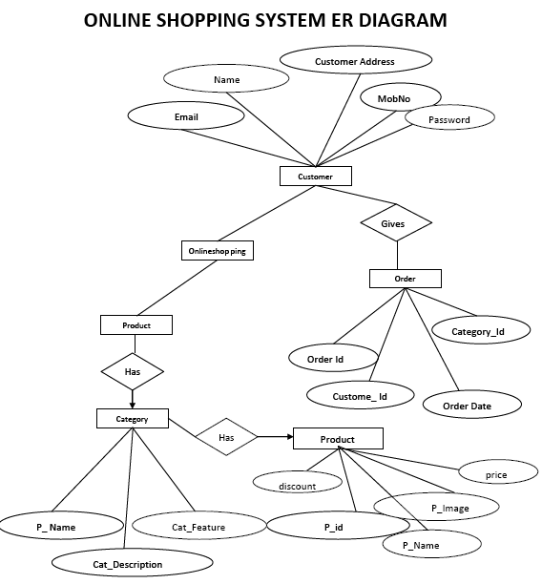

### 3.1.4 Process Modeling

Context level DFD – 0 level

The context level data flow diagram (dfd) is describe the whole system. The (o) level dfd describe the all user module who operate the system. Below data flow diagram of online shopping site shows the two user can operate the system Admin and Member user.

[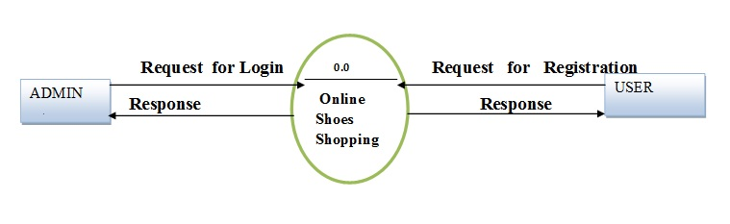](https://meeraacademy.com/wp-content/uploads/2016/09/olevel.jpg)0 – Level DFD for Online shopping website project

1st Level Admin Side DFD

The Admin side DFD describe the functionality of Admin, Admin is an owner of the website. Admin can first add category of item and then add items by category wise. And admin can manage order and payment detail.

[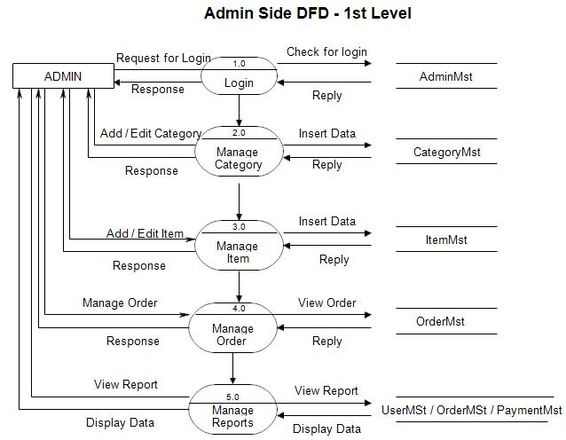](https://meeraacademy.com/wp-content/uploads/2016/09/adminside-first.jpg)

1st Level – Admin Side Data Flow Diagram

2nd Level – Admin side DFD (3.0)

[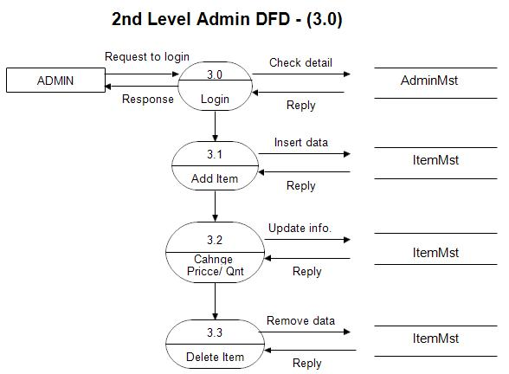](https://meeraacademy.com/wp-content/uploads/2016/09/admin3.0.jpg)

DFD for online shopping website project

2nd Level – Admin side DFD (4.0)

[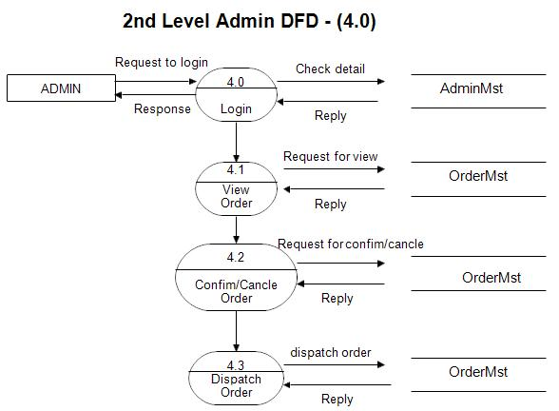](https://meeraacademy.com/wp-content/uploads/2016/09/admin4.0.jpg)

Admin side DFD for online shopping website project

2nd Level – Admin side DFD (5.0)

[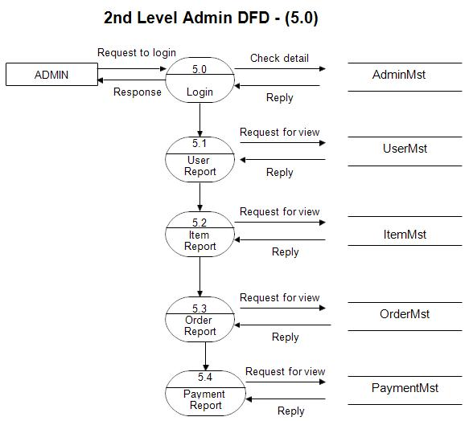](https://meeraacademy.com/wp-content/uploads/2016/09/admin5.0.jpg)

Admin side DFD for online shopping website project

1st level – User side Data flow Diagram

The user is all people who operate or visit our website. User is a customer of a website. User can first select product for buy, user must have to register in our system for purchase any item from our website. After register he can login to site and buy item by making online payment through any bank debit card or credit card.

[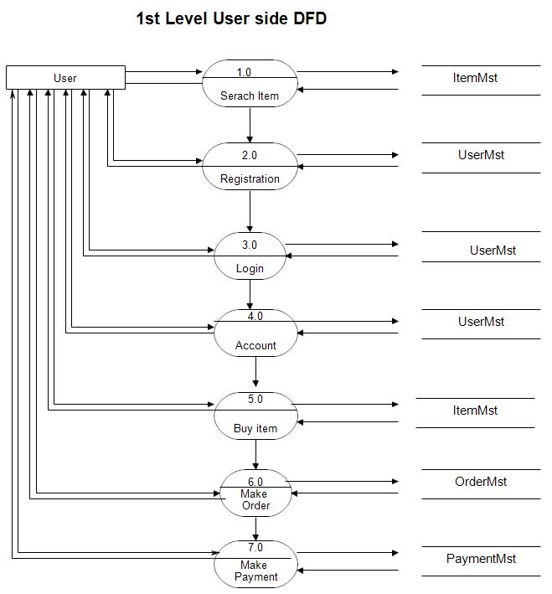](https://meeraacademy.com/wp-content/uploads/2016/09/user1st.jpg)

User side DFD for online shopping website project

2nd level – User side DFD (4.0)

[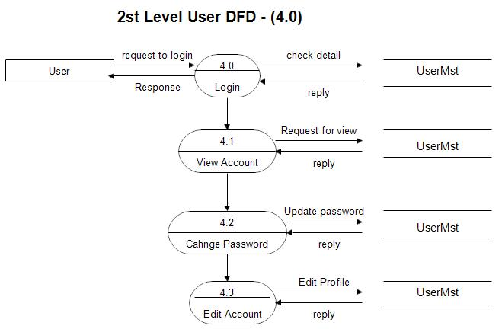](https://meeraacademy.com/wp-content/uploads/2016/09/usr4.0.jpg)

User side DFD for online shopping website project

2nd level – User side DFD (5.0)

[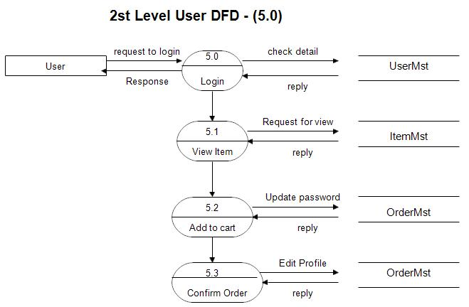](https://meeraacademy.com/wp-content/uploads/2016/09/usr5.0.jpg)

## 3.2 System Design

### 3.2.1 Architecture Design

In architecture of online shopping website we include:

Client-side components:

User interface: This is the visual design of the website that users interact with, including navigation menus, product listings, shopping cart, checkout process, etc.

Client-side scripting: This includes JavaScript, HTML, and CSS used to make the website interactive and responsive to user input.

Server-side components:

Web server: This is the software that receives and processes user requests for web pages.

Application server: This is the software that performs the business logic of the website, such as managing user accounts, handling product searches, processing orders, and managing inventory.

Database server: This is the software that stores and manages the website's data, including product information, user profiles, and order history.

Payment gateway: This is the software that securely processes payment information for customer transactions.

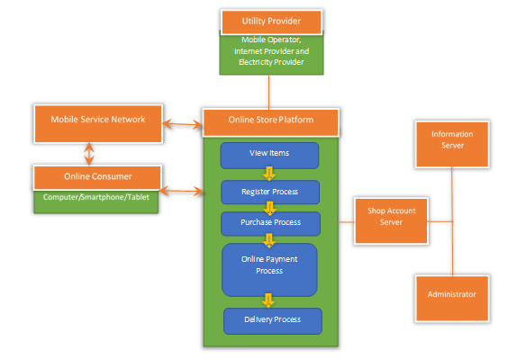

### 3.2.2. Database Schema Design

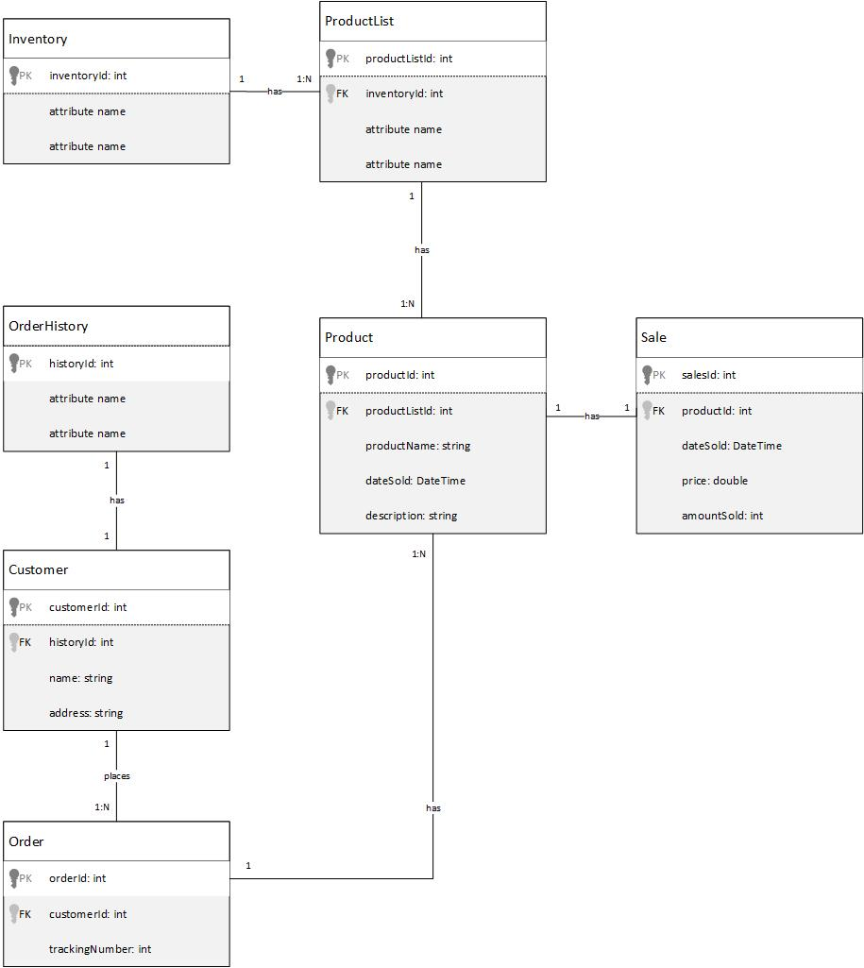

### 3.2.3. Interface design

Designing an interface for an online shopping website involves creating a user-friendly and visually appealing design that enables users to easily navigate the site, browse products, and make purchases. Here are some key components to consider when designing an interface for an online shopping website:

Homepage:

* A clear and attractive logo that represents the brand
* A search bar to enable users to search for products
* Navigation menus to guide users to different product categories and pages
* Featured products or promotions
* Testimonials or reviews from satisfied customers

Product pages:

* High-quality images of the product from multiple angles
* Clear and detailed product descriptions that include features and specifications
* Price and quantity options
* Add to cart and buy buttons
* Related products or accessories that can be purchased alongside the product

Cart and checkout pages:

* A summary of the user's cart and the ability to add or remove products
* Shipping and billing information forms
* Payment options, including credit cards, PayPal, or other methods
* A confirmation page that shows the user's order details and provides an estimated delivery date

User account pages:

* A login or registration page that allows users to create an account or log in
* User profile pages that display personal information, order history, and shipping addresses
* Options to update personal information or payment details
* A log out button

Some considerations when designing the interface of an online shopping website are:

Consistency: The design should be consistent throughout the site to create a cohesive experience for the user.

Accessibility: The design should be accessible for all users, including those with disabilities or limited mobility.

Mobile responsiveness: The design should be responsive to different screen sizes and devices, including mobile phones and tablets.

Branding: The design should be consistent with the brand's visual identity and message.

Overall, the interface design of an online shopping website will depend on the specific requirements and goals of the website, as well as the target audience and market niche. The design should prioritize usability, user experience, and visual appeal to encourage users to make purchases and return to the site.

# 4. Implementation and Testing

Implementation and testing are crucial stages in the development of an online shopping website to ensure that the website functions as intended and meets the requirements and expectations of users. Here is a brief overview of the implementation and testing stages:

## 4.1. Implementation

This stage is responsible to develop the website based on the design and architecture, including client-side and server-side components, database schema, and user interface. It integrates third-party services and APIs, such as payment gateways, shipping providers, and social media platforms. Also test the website during development to identify and fix bugs and errors.

### 4.1.1 Implementation tools:

**Case tools:**

Some case tools that are widely used for online shopping website is:

1. Rational Rose
2. Visual Paradigm
3. Sparx Systems Enterprise Architect
4. Lucidchart
5. GitHub
6. Bitbucket
7. JIRA
8. Selenium
9. TestComplete
10. Eclipse IDE
11. NetBeans IDE
12. Visual Studio
13. Subversion (SVN)

For implementation purpose of this online shopping website we use visual studio code.

**Programming languages:**

HTML (Hypertext Markup Language): HTML is a markup language used for creating and structuring web pages. It provides a set of tags that describe the content and layout of a page. HTML tags are used to define headings, paragraphs, lists, links, images, forms, and other elements of a web page. HTML is the backbone of web development and is used in conjunction with CSS and JavaScript to create modern web applications.

CSS (Cascading Style Sheets): CSS is a styling language used for controlling the presentation and layout of web pages. It provides a set of rules that define the visual properties of HTML elements, such as color, font, size, spacing, and position. CSS enables web developers to create visually appealing and responsive designs that adapt to different screen sizes and devices.

JavaScript: JavaScript is a scripting language used for creating dynamic and interactive web pages. It provides a set of programming constructs that enable developers to manipulate the HTML and CSS content of a web page in real-time. JavaScript can be used to add functionality to web pages, such as form validation, event handling, animation, and data visualization. It is also used on the server-side with Node.js to create full-stack web applications.

PHP (Hypertext Preprocessor): PHP is a server-side scripting language used for creating dynamic web pages and web applications. It is particularly useful for building database-driven applications that interact with MySQL or other databases. PHP provides a set of functions and constructs that enable developers to perform tasks such as database querying, form processing, file handling, and session management. PHP is widely used in content management systems (CMS) such as WordPress and Drupal.

**Database platform**

MySQL: MySQL is a relational database management system (RDBMS) used for storing and managing structured data. It provides a set of tools and functionalities for creating, modifying, and querying databases. MySQL is particularly useful for web development as it integrates well with PHP and provides fast and scalable data storage for web applications. It is also commonly used in e-commerce and financial applications that require reliable and secure data management.

### 4.1.2 Implementation details of each module:

1. Product catalog module: The product catalog module is one of the core components of an online shopping website. To implement this module, you need to start by designing the database schema to store the product information, such as product name, description, price, image, and category. You also need to define the relationships between product entities and other entities, such as orders and users. Next, you can develop a search feature that enables users to find products by name, category, or keyword. You can use a search algorithm, such as Elasticsearch or Solr, to index and retrieve product data efficiently. You also need to develop a product detail page that displays the product information, images, reviews, and related products. This page should have a clear call-to-action button, such as "Add to Cart" or "Buy Now", that enables users to initiate the purchase process.

2. Cart and checkout module: The cart and checkout module is responsible for managing the user's shopping cart and facilitating the payment process. To implement this module, you need to design the database schema to store the cart information, including the user's cart items, quantity, and total price. You also need to define the relationship between the cart and user entities. Next, you can develop a cart page that displays the user's cart items and enables them to update the quantity or remove items. You can use a modern front-end framework, such as React or Angular, to create a responsive and interactive cart page. You also need to develop a checkout page that collects the user's billing and shipping information, and enables them to select a payment method. You can use a payment gateway integration, such as PayPal or Stripe, to handle the payment process securely.

3. User account module: The user account module is responsible for managing the user's personal information, order history, and preferences. To implement this module, you need to design the database schema to store the user information, such as name, email, password, and shipping addresses. You also need to define the relationships between the user and other entities, such as orders and carts. Next, you can develop a user registration and login page that enables users to create an account or log in. You can use a secure authentication mechanism, such as OAuth or JWT, to handle user authentication and authorization. You also need to develop a user profile page that displays the user's personal information, order history, and shipping addresses. You can use a modern UI library, such as Material UI or Bootstrap, to create a visually appealing and user-friendly profile page. Finally, you need to implement an account settings page that enables users to update their personal information and password.

4. Order management module: The order management module is responsible for managing the order lifecycle, from order creation to delivery. To implement this module, you need to design the database schema to store the order information, including order ID, order date, products ordered, and total price. You also need to define the relationships between the order and other entities, such as users and carts. Next, you can develop an order confirmation page that displays the user's order details and estimated delivery date. You can use a real-time tracking API, such as Google Maps or Mapbox, to provide accurate and up-to-date delivery information. You also need to develop an order history page that displays the user's past orders and their status, such as shipped or delivered. You can use a notification system, such as email or SMS, to send order confirmation and shipping updates to the user. Finally, you need to implement a customer support system that enables users to contact customer service agents and resolve any issues or concerns related to their orders.

## 4.2 Testing

Testing is the process of finding the bugs in the website after implementation purpose . This is the crucial step for the success of the website so that users doesn’t have to face any bugs or problems in future.

### 4.2.1 Testing tools

1. Some of the widely used testing tools for online shopping website are :
2. Selenium
3. TestComplete
4. Apache JMeter
5. Appium
6. LoadRunner
7. BrowserStack
8. Sauce Labs
9. Ghost Inspector

### 4.2.2 Test cases for Unit testing

|  |  |  |
| --- | --- | --- |
| ID | Test case Description | Result Obtained |
| TC01 | Verify that the "Add to Cart" button adds the selected item to the cart | Items are added to the cart and cart count is also increment. |
| TC01 | Verify that the "Remove" button removes the selected item from the cart | Items are removed when clicked on remove button and cart count is also decrement |
| TC03 | Verify that the "Proceed to Checkout" button redirects to the checkout page | User is redirected to checkout page once click on proceed to checkout |
| TC04 | Verify that the user can search for products using keywords | Relevant products are displayed in search results |
| TC05 | Verify that the user can filter products by category | Only products that belongs to selected category are displayed |
| TC06 | Verify that the user can add a product to wishlist | Products can be added to wishlist |
| TC07 | Verify that the user can view the details of selected product | Products details such as description,color,available sizes are visible to user |

### 

### 4.2.2. Test Cases for System Testing

System testing is a software testing technique in which the entire system or application is tested as a whole to validate that it meets the specified requirements and functions as intended. In the context of an online shopping website, system testing would involve testing the entire website, including all the individual functions and modules, to ensure that they work together seamlessly and meet the requirements of the website.

|  |  |  |
| --- | --- | --- |
| ID | Test Case Description | Result Obtained |
| TC01 | Verify that the website is accessible and loads correctly on different web browsers and devices | The website load correctly without any errors in different browsers and devices |
| TC02 | Verify that the website is responsive and adapts to different screen sizes | The website also resizes in mobile and display correctly |
| TC03 | Verify that the website is secure and protected against common web vulnerabilities such as SQL injection and cross-site scripting | The website is not vulnerable to security threats and attacks and is secure |
| TC04 | Verify that the user registration and login process works correctly and securely | Users are able to register and login secure also no users can enter in our system without registration and login so it is secure |
| TC05 | Verify that the payment process works correctly and securely with different payment methods | Payment process works correctly also the users can pay via online using different apps or cash on delivery |
| TC06 | Verify that the website performance and scalability is tested under high traffic and load conditions | The website is able to handle high traffic and load conditions without any slowdowns or errors |

# 5. Conclusion and Future Recommendations

## 5.1. Lesson Learnt / Outcome

Here are some of the key lessons that we have learnt:

Importance of User Experience: A successful online shopping website needs to be intuitive and easy to use for the end-users. We need to pay attention to the user experience and design a website that is visually appealing, easy to navigate, and provides a seamless shopping experience.

Attention to Security: With the increasing risk of cyber-attacks and data breaches, online shopping websites need to be secure and protect user data. We need to ensure that the website is secure, with features such as secure payment processing, data encryption, and user authentication.

Need for Performance Optimization: An online shopping website needs to be fast and perform optimally under normal and peak loads. We need to optimize the website for speed, scalability, and efficiency to ensure a smooth user experience.

Importance of Testing: Testing is crucial for ensuring the quality of the online shopping website. We need to perform various types of testing, such as unit testing, integration testing, and system testing, to ensure that the website functions as intended and meets the requirements.

Continuous Improvement: An online shopping website is never really finished, and we need to continually improve and update the website to keep up with changing user needs and technology advancements.

In summary, developing an online shopping website be a great learning opportunity, as it provides valuable insights into the importance of user experience, security, performance optimization, testing, and continuous improvement.

## 5.2. Conclusion

In conclusion, an online shopping website can be a powerful tool for businesses to reach customers globally, increase sales, and offer a convenient shopping experience to their customers. Developing an online shopping website involves a range of tasks, including designing the user interface, developing the backend database, implementing security features, and testing the website for performance, security, and usability.

While developing an online shopping website can be a complex task, the lessons learned along the way, such as the importance of user experience, security, performance optimization, testing, and continuous improvement, can be invaluable for developers. Ultimately, an online shopping website that is well-designed, secure, user-friendly, and efficient can help businesses to build customer loyalty, increase revenue, and stay competitive in the fast-paced world of e-commerce.

## 5.3. Future Recommendations

As technology continues to evolve and the e-commerce landscape becomes increasingly competitive, it is important for online shopping websites to stay up-to-date with the latest trends and innovations. Here are some future recommendations for an online shopping website:

* Mobile Optimization: With more and more people using their mobile devices to shop online, it is important for online shopping websites to be optimized for mobile devices. This means having a responsive design that works well on different screen sizes and ensuring that the website loads quickly on mobile devices.
* Personalization: Personalization can be a powerful tool for increasing customer engagement and loyalty. By using data analytics and artificial intelligence, online shopping websites can personalize the shopping experience for each user, offering product recommendations based on their browsing and purchase history.
* Augmented Reality: Augmented reality (AR) can be used to enhance the shopping experience by allowing customers to visualize products in a virtual setting. For example, a customer could use AR to see how a piece of furniture would look in their home before making a purchase.
* Voice Search: With the rise of smart home devices such as Amazon Echo and Google Home, voice search is becoming increasingly popular. Online shopping websites can optimize their content for voice search by using natural language and conversational keywords.
* Social Commerce: Social media platforms such as Instagram and Facebook are increasingly being used for shopping. Online shopping websites can leverage social media by integrating social commerce features such as shippable posts and live shopping events.

By implementing these future recommendations, online shopping websites can stay ahead of the curve and offer a cutting-edge shopping experience to their customers.

# Appendices

For user:

Home page:

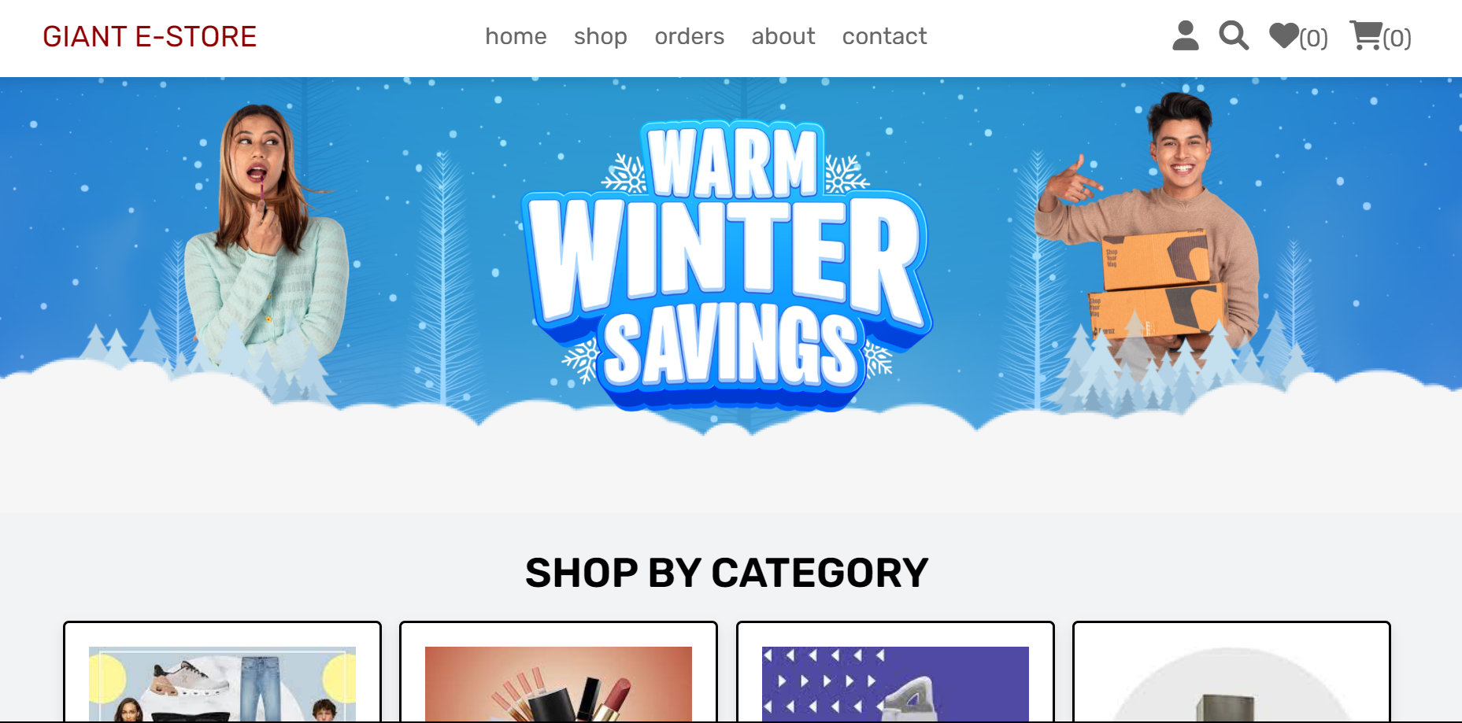

Shop page:

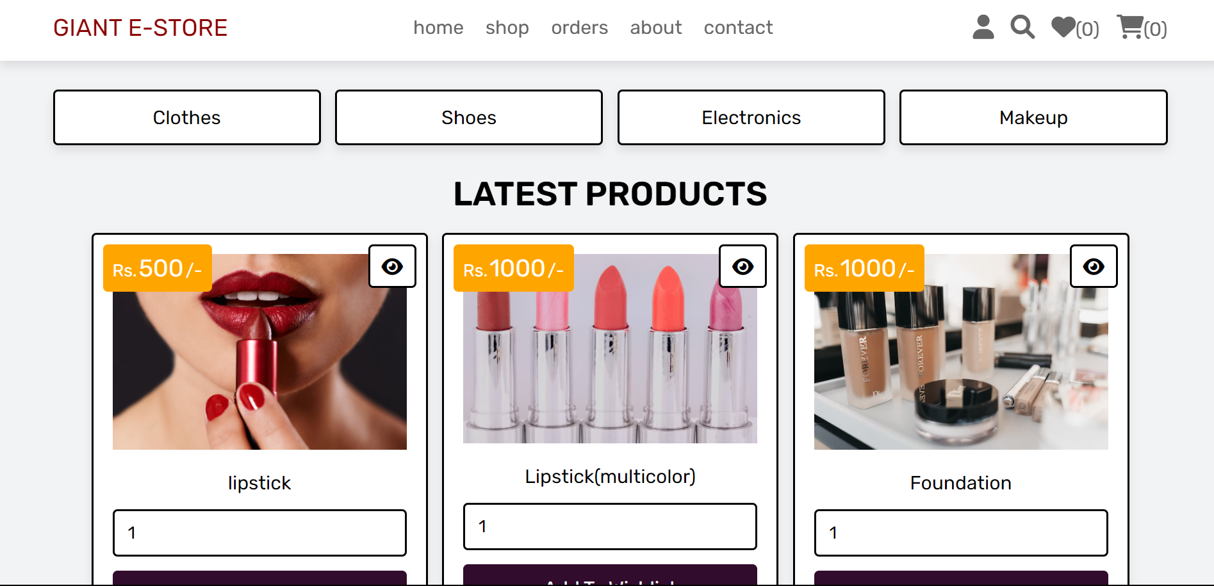

Admin page:

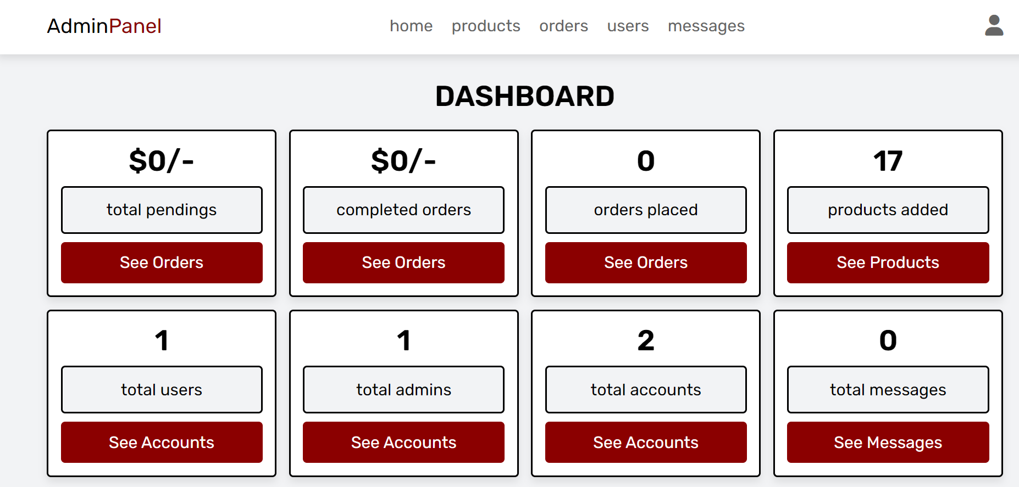

Product page:

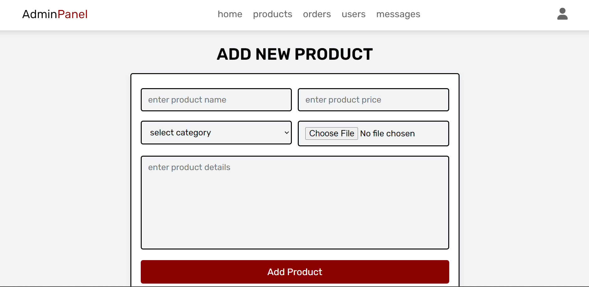

# Citation and Referencing

[1]Software Requirements Specification (SRS) Book E-Commerce System (BECS):

Authors: Andrew Blossom, Derek Gebhard, Steven Emelander, Robert Meyer

[2] Case Study: Flipkart online

Author: Aman Goel

Date: Nov, 2017

[3] 10 Problems That Every Ecommerce Business Faces and Their Solutions [Updated 2020]:

Author: Laduram Vishnoi

Date: December 14, 2020

[4] A Study on Performance Measurement of Online Retail Stores:

Authors: Binod Kumar Singh, Neeraj Anand

Date: March 2014

[5] Amazon.com Inc.’s Mission Statement & Vision Statement (An Analysis)

Author: Lawrence Gregory

Date: February 13, 2019