**Table of content**

1. Introduction……………………………………………………………………………..1

1.1 Project title…………………………………………………………………….1

1.2 Poject Overview Statement…………………………………………………....1

1.3 Project Goals and Objectives………………………………………………….2

1.4 Hardware and Software Specification…………………………………………3

1.5 Language………………………………………………………………………4

2. Analysis………………………………………………………………………………....5

2.1 Scope…………………………………………………………………………..5

2.2 Use case Diagram……………………………………………………………...6

3. System Design Specification……………………………………………………………6

3.1 Sequence Diagram……………………………………………………………..7

3.2 ER diagram…………………………………………………………………….

3.3 Data Flow Diagram…………………………………………………………….8

4. Conclusion………………………………………………………………………………9

5. Bibliography………………………………………………………………………….....9

**1. Introduction**

The project Hospital Management system includes registration of patients, storing their details into the system. Users can search the availability of a doctor and the details of a patient using the id. The Hospital Management System can be entered using a username and password. It is accessible either by an administrator or receptionist. Only they can add data into the database. The data can be retrieved easily. The interface is very user-friendly. The data are well protected for personal use and make the data processing very fast. Hospital Management System is powerful, flexible, and easy to use and is designed and developed to deliver real conceivable benefits to hospitals

**1.1 Project Title**

Hospital Management System

**1.2 Project Overview**

To overview the project, there are modules:

Following are the modules involves in HMS

1. Login Page
2. Doctors Module

* Add Doctors (Doctor ID, Doctor Name, Doctor Specialization)
* Edit Doctors Details (Name and Specialization)
* Fire Doctor (By accessing them with ID)
* View Doctors Detail

1. Patient’s Module

* Admit Patient (Patient ID, Name, Disease, Admit Date and Admit Time)
* Edit Patient Details (Name, Disease, Admit Date and Time)
* Discharge Patient (By accessing ID)
* View Doctors Detail
* Login page

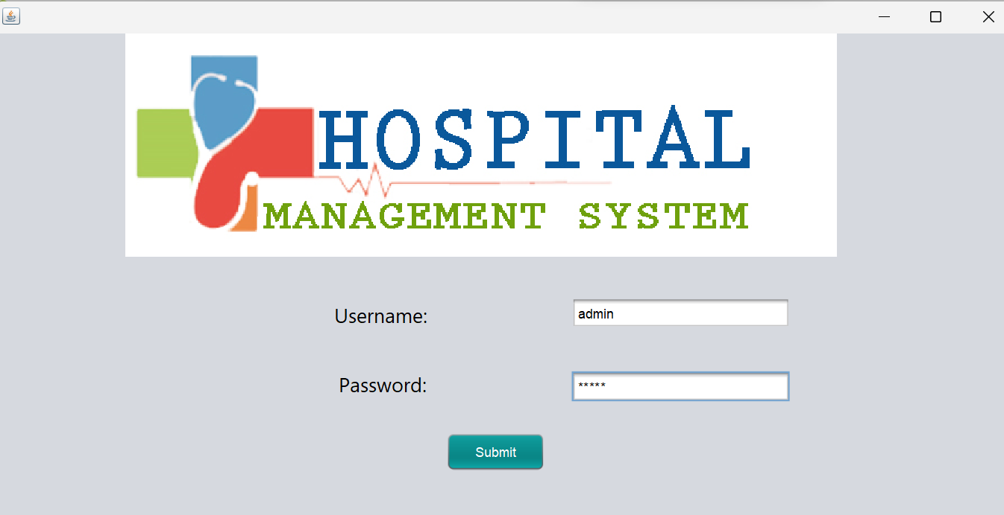

Then, Doctors Module:

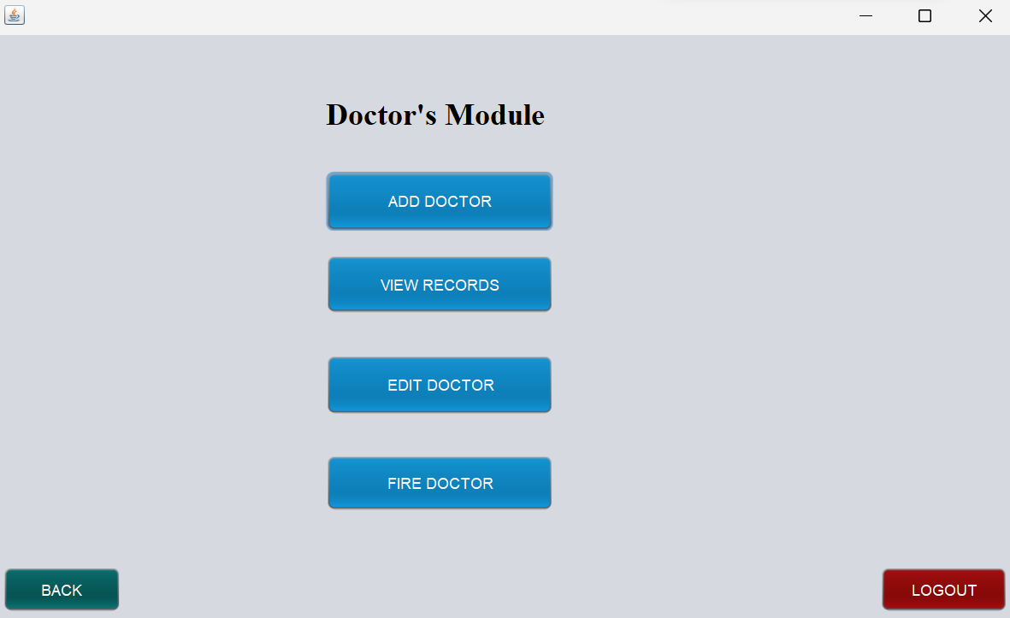

Patients Module:

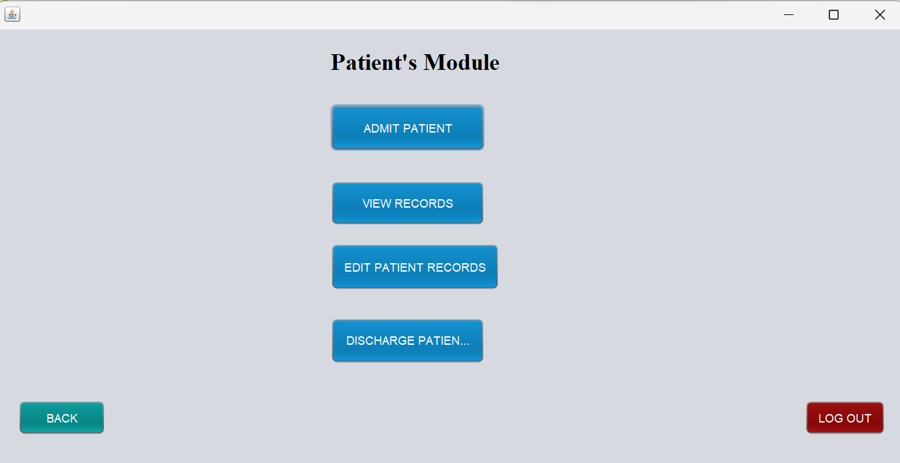

**1.3 Project goals and objectives**

GOALS

User friendly

1. Simple fast
2. Low cost and effective
3. It deals with the collection of patient’s information
4. Diagnosis

OBJECTIVES

1) Define hospital

2) Recording information about the Patients that come.

3) Recording information about the doctors and their availability

4) Recording information related to the diagnosis given to Patients.

5) Keeping a record of the Immunization provided to children/patients.

6) Keeping information about various diseases and medicines available to cure them.

**1.4 Hardware and Software Specification**

Hardware Specification:

-Laptop or Desktop with 4GB RAM specification

Software Specification

-API level 25 for device to use Application

-App will run on less than API level 25 but performance issue may come. And also this app is not friendly with smart android device.

**1.5 Language**

High level Language – JAVA

Graphical User Interface (GUI) – JAVA SWINGS

Backend Database – MySQL

Java:

Java is a programming language and a platform. Java is a high level, robust, object-oriented and secure programming language.

Java was developed by *Sun Microsystems* (which is now the subsidiary of Oracle) in the year 1995. *James Gosling* is known as the father of Java.

A list of the most important features of the Java language is given below.

Features of Java:

A list of the most important features of the Java language is given below.

1. [Simple](https://www.javatpoint.com/features-of-java#Simple)
2. [Object-Oriented](https://www.javatpoint.com/features-of-java#Object-Oriented)
3. [Portable](https://www.javatpoint.com/features-of-java#Portable)
4. [Platform independent](https://www.javatpoint.com/features-of-java#Platform-independent)
5. [Secured](https://www.javatpoint.com/features-of-java#Secured)
6. [Robust](https://www.javatpoint.com/features-of-java#Robust)
7. [Architecture neutral](https://www.javatpoint.com/features-of-java#Architecture-neutral)
8. [Interpreted](https://www.javatpoint.com/features-of-java#Interpreted)
9. [High Performance](https://www.javatpoint.com/features-of-java#High-Performance)
10. [Multithreaded](https://www.javatpoint.com/features-of-java#Multithreaded)
11. [Distributed](https://www.javatpoint.com/features-of-java#Distributed)
12. [Dynamic](https://www.javatpoint.com/features-of-java#Dynamic)

Java Swings:

Java Swing is a lightweight Java graphical user interface (GUI) widget toolkit that includes a rich set of widgets. It is part of the Java Foundation Classes (JFC) and includes several packages for developing rich desktop applications in Java.

My SQL:

MySQL is an Oracle-backed open source [relational database](https://www.techtarget.com/searchdatamanagement/definition/relational-database) management system ([RDBMS](https://www.techtarget.com/searchdatamanagement/definition/RDBMS-relational-database-management-system)) based on Structured Query Language ([SQL](https://searchsqlserver.techtarget.com/definition/SQL)). MySQL runs on virtually all platforms, including [Linux](https://www.techtarget.com/searchdatacenter/definition/Linux-operating-system), [UNIX](https://www.techtarget.com/searchdatacenter/definition/Unix) and [Windows](https://www.techtarget.com/searchwindowsserver/definition/Windows).

-Features of My SQL:

* Ease of Management
* High Performance
* Client-Server Architecture
* Compatible and Portable
* Reliable and Fast
* Connectivity and Security
* Stored Procedure
* Triggers
* Concurrency Control
* Dual Passwords
* Storage Engines

**2. Product Analysis:**

To analyze the project we can see the scope and feasibility of the project .

**2.1 Scope**:

1. Information about Doctors is done just done by writing the doctors name and their specialization also their availability. Whenever the new Doctor comes up his/her information is stored and when they leave or get fired his/her info will be deleted from the database to decrease paper load.

2. Information about Patients is done by just writing the Patients name, age, and gender. Whenever the Patient comes up his information is stored freshly.

3. All the registration process of patients can be done via this application.

4. Database is stored safely and also it reduces possible redundancy, helps to establish integrity and assure the safety of the data of the patients since only the admin can log into the system.

Hence, as all this work is done only by the administrator this app is highly secured and easy to use as well.

**2.2 Use case Diagram**

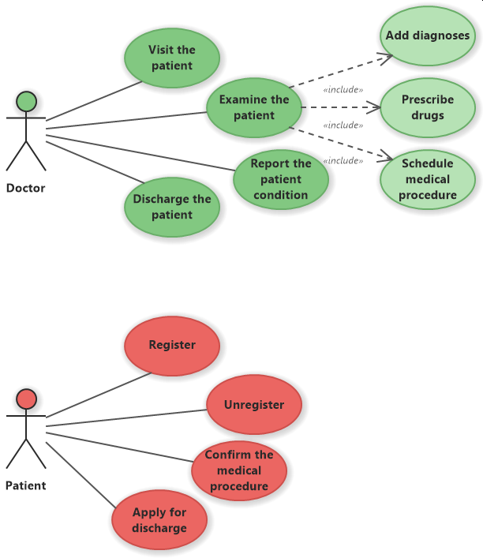

The feasibility study for a proposed Management system will be widespread.

There are several components that should be included in the study, and each will

be discussed

The feasibility study for a proposed Management system will be widespread.

There are several components that should be included in the study, and each will

be discussed.

The feasibility study for a proposed Management system will be widespread.

There are several components that should be included in the study, and each will

be discussed.

The feasibility study for a proposed Management system will be widespread.

There are several components that should be included in the study, and each will

be discussed.

The feasibility study for a proposed Management system will be widespread.

There are several components that should be included in the study, and each will

be discussed

The feasibility study for a proposed Management system will be widespread.

There are several components that should be included in the study, and each will

be discussed

**3. System Design Specification**

**3.1 Sequence Diagram**

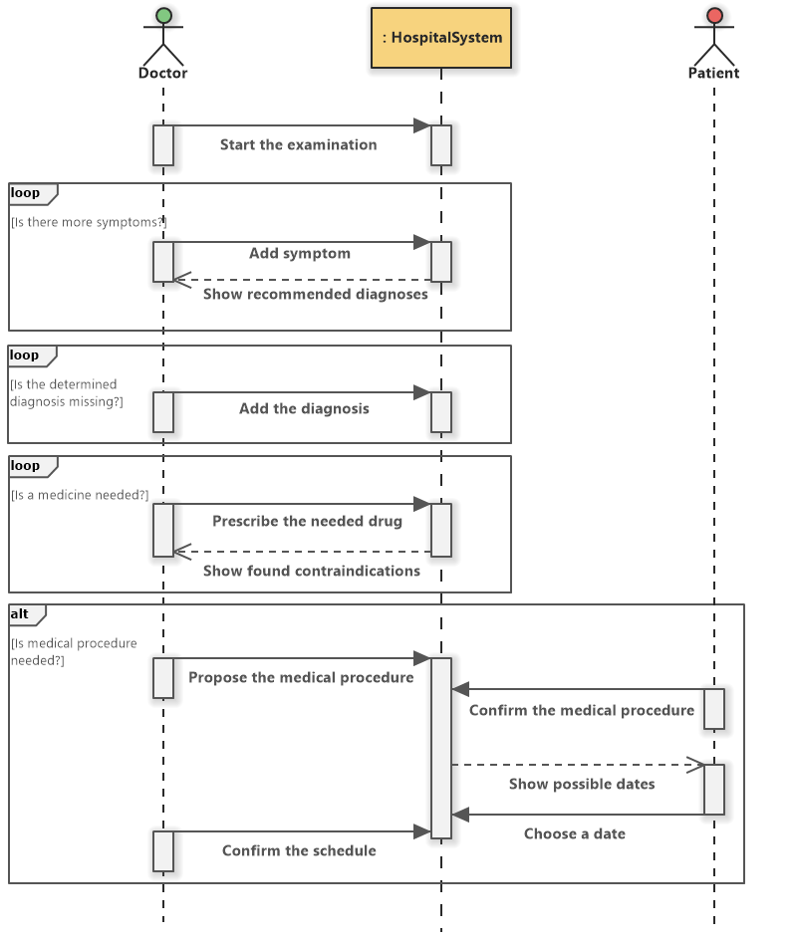

**3.2 Data Flow Diagram**

A data flow diagram (DFD) maps out the flow of information for any process or system. It uses defined symbols like rectangles, circles and arrows, plus short text labels, to show data inputs, outputs, storage points and the routes between each destination

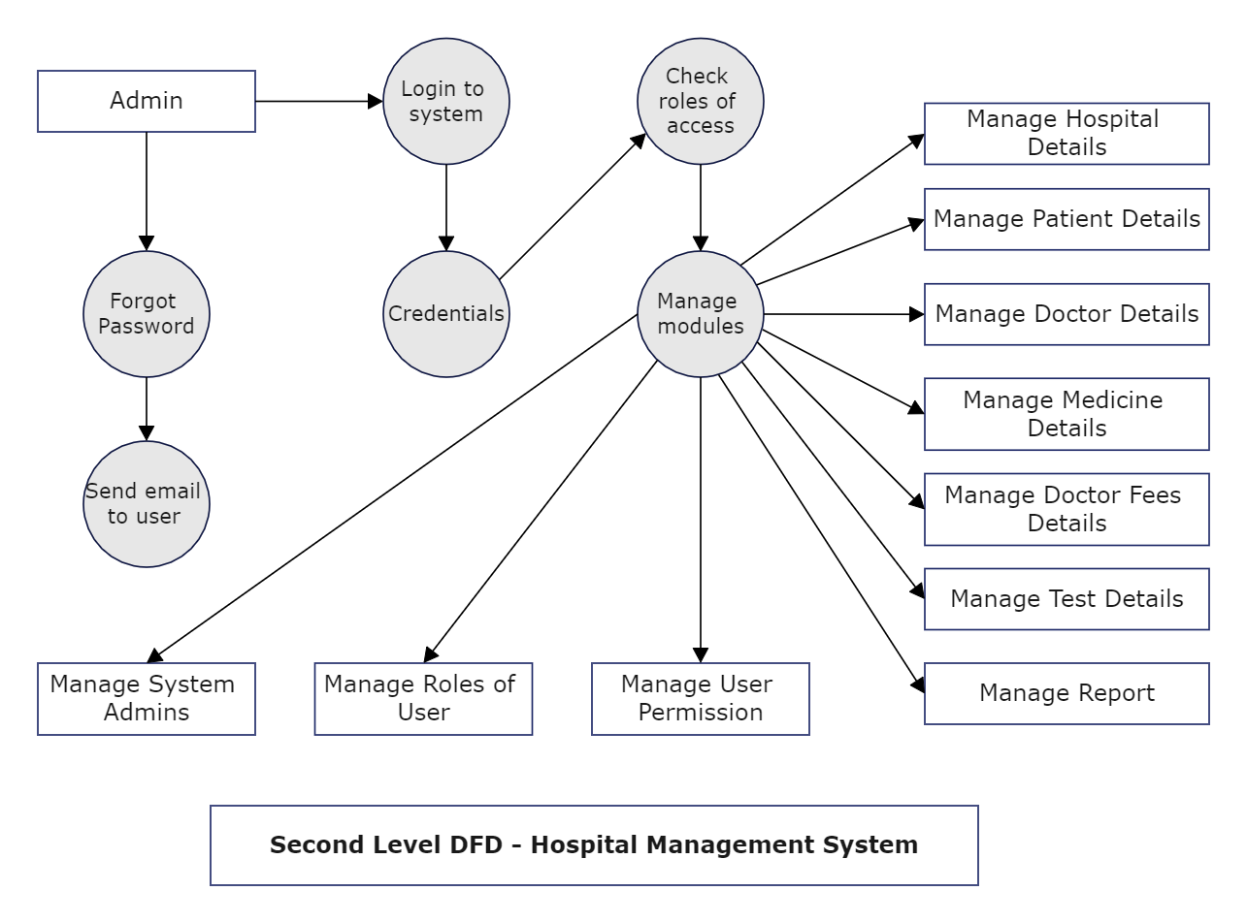

**4. Conclusion**

The Hospital Management system aids in the centralization and automation of hospital task management. The software handles and secures patients’ information, prescriptions, diagnosis, and other hospital and patient-related data and digitally records them in its database.

Here are the following results that have been achieved after completing the system and relate to system’s objective:

* Should allow the user to browse through project and its implementation
* Should allow the admin to insert patient details and modify it
* Should allow the admin to insert doctor details and modify it
* Should allow to check the number of patients in the hospital
* Should allow to check the doctor availability and their schedules
* Should allow to logout after all the operations performed

**6. Bibliography**

<https://www.softwareideas.net/> Retrieved on December 12, 2022