TeleSupport Hub
Cloud-Based Telecom Support With Flask On AWS

Project Type | MOOC / Guided Project
Technology Stack | Python, Flask, HTML, CSS, SQLite / MySQL RDS
Cloud Services | AWS EC2 and Amazon RDS
Prepared For | SmartInternz Project Submission
Prepared By | Prajyot

Submission Note: This report includes dedicated screenshot placeholders. After running the application, insert screenshots in the labelled spaces before final upload.

Table of Contents
- Introduction and project overview
- Objectives and project scope
- System architecture and workflow
- Installation and execution steps
- Database design
- Module implementation with screenshot placeholders
- Testing, deployment, monitoring, and conclusion

1. Introduction
TeleSupport Hub is a cloud-based telecom customer service portal designed to manage customer support operations efficiently. The project uses Flask for backend development and supports database integration through SQLite for local testing or Amazon RDS MySQL for cloud deployment. The system allows telecom customers to register, log in, purchase services, raise support tickets, and track ticket status. Support agents can log in separately and manage customer tickets.
Project Summary: The application demonstrates backend development, database integration, customer support workflow, and AWS deployment readiness using EC2 and RDS.

2. Objectives
- Develop a telecom support web application using Flask.
- Provide customer registration, login, dashboard, service purchase, and ticket raising features.
- Create an agent dashboard to view and update customer support tickets.
- Store customer, purchase, ticket, and agent data in a relational database.
- Prepare the project for deployment on AWS EC2 with Amazon RDS MySQL.

3. Technology Stack
Layer | Technology Used | Purpose
Frontend | HTML, CSS | User interface and page styling
Backend | Python Flask | Routes, sessions, business logic
Database | SQLite / MySQL RDS | Data storage for users, purchases, tickets
Cloud Hosting | AWS EC2 | Application deployment
Cloud Database | Amazon RDS | Managed MySQL database service

4. System Architecture
The user accesses the TeleSupport Hub web application through a browser. Flask handles HTTP requests and renders pages using templates. Customer and agent actions are processed by Flask routes and saved into the database. In the AWS version, the Flask application runs on EC2 and connects to a MySQL database hosted on Amazon RDS.
Component | Description
Customer Browser | Accesses registration, login, dashboard, service purchase, and ticket pages.
Flask Application | Processes routes, form submissions, sessions, and database queries.
Database | Stores customers, purchases, tickets, and agents.
AWS EC2 | Hosts the Flask project for public access.
AWS RDS | Provides managed MySQL database support.

Screenshot Space 1: Project Home Page
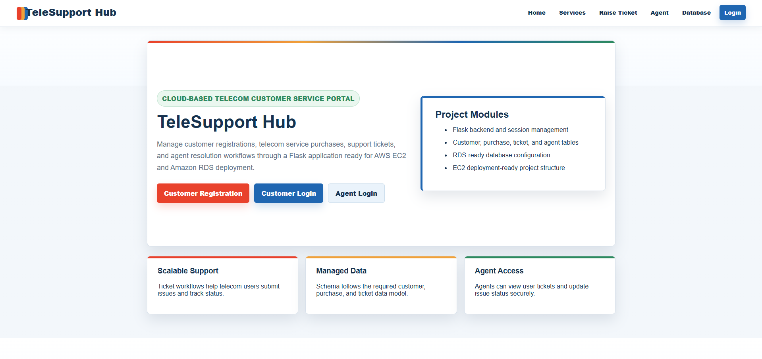

5. Installation and Project Opening Steps
To open and run the project locally, use the following steps in PowerShell:
- Open the project folder: D:\Downloads\make new folder here\telesupport-hub
- Right-click inside the folder and select Open in Terminal or Open PowerShell window here.
- Create virtual environment using: python -m venv .venv
- Activate it using: .venv\Scripts\activate
- Install dependencies using: pip install -r requirements.txt
- Run the project using: python app.py
- Open browser and visit: http://127.0.0.1:5000
Demo Login: Customer: prajyot2017@gmail.com / 123456 Agent: agent@telesupport.com / agent123

6. Database Design
The application uses four main tables. These tables match the telecom support workflow shown in the project instructions.
Table Name | Main Fields | Purpose
customers | id, name, mobile, email, password, address | Stores customer registration details.
purchases | id, customer_id, service_name, purchase_date | Stores services purchased by customers.
tickets | id, customer_id, description, plan_type, priority, status, date_raised | Stores support ticket details.
agents | id, name, email, password | Stores support agent login details.

Screenshot Space 2: Database Preview / MySQL Tables
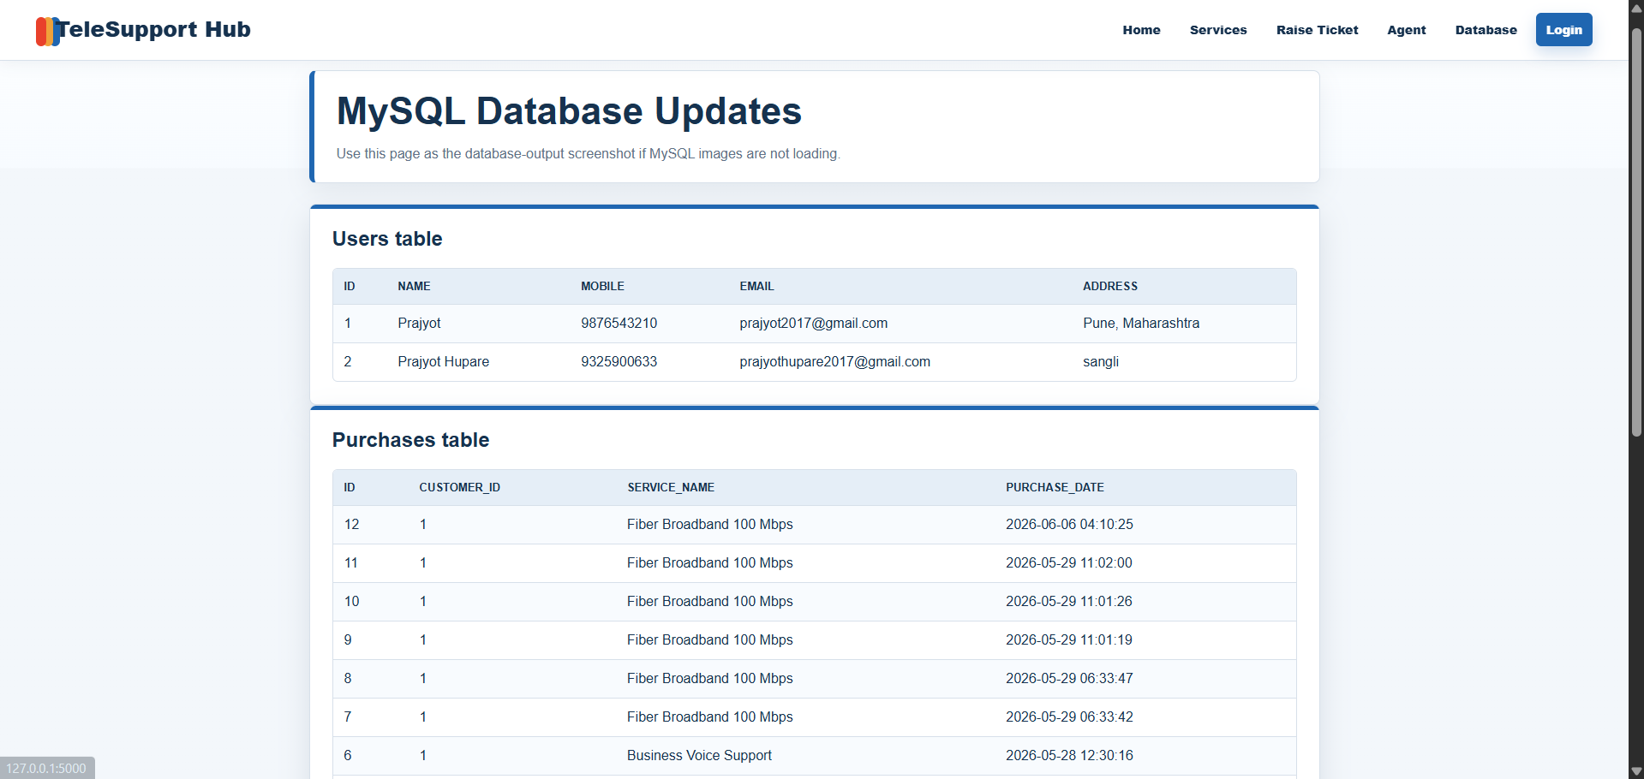

7. Application Modules

7.1 Customer Registration
The customer registration module collects name, mobile number, email, password, and address. After successful registration, the data is inserted into the customers table.
Screenshot Space 3: Customer Registration Page
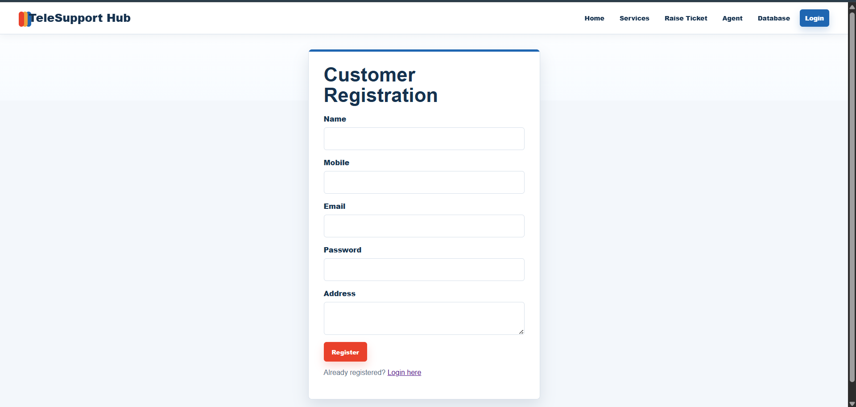

7.2 User Login
The user login module authenticates customers using email and password. After login, Flask session is created and the customer is redirected to the dashboard.
Screenshot Space 4: User Login Page
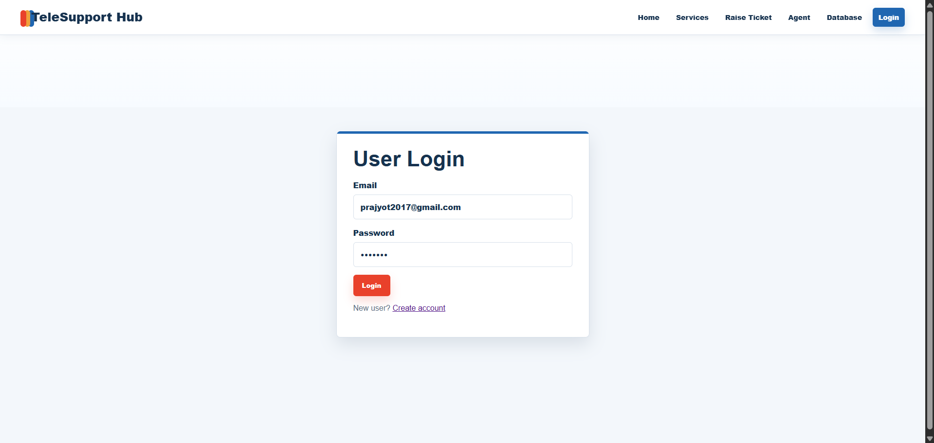

7.3 Customer Dashboard
The customer dashboard displays the logged-in customer name, purchased services, and raised support tickets. It also provides buttons to buy services and raise tickets.
Screenshot Space 5: Customer Dashboard
Insert screenshot here

7.4 Buy a Service
Customers can choose telecom plans such as Fiber Broadband, 5G Mobile Data, Business Voice Support, and OTT Combo Plan. Purchased services are saved in the purchases table.
Screenshot Space 6: Buy Service Page
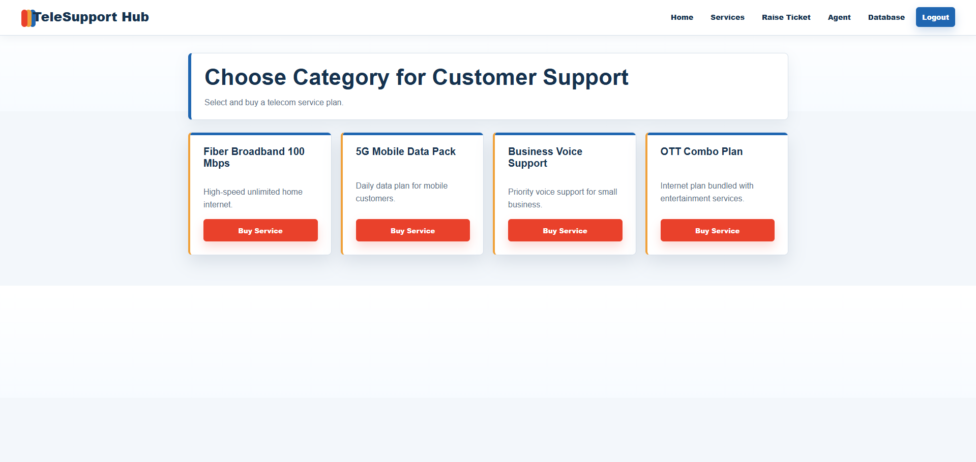

7.5 Raise Ticket
The raise ticket module allows customers to submit a support request by selecting plan type, priority, and entering the issue description. The ticket is saved with Open status by default.
Screenshot Space 7: Raise Ticket Page
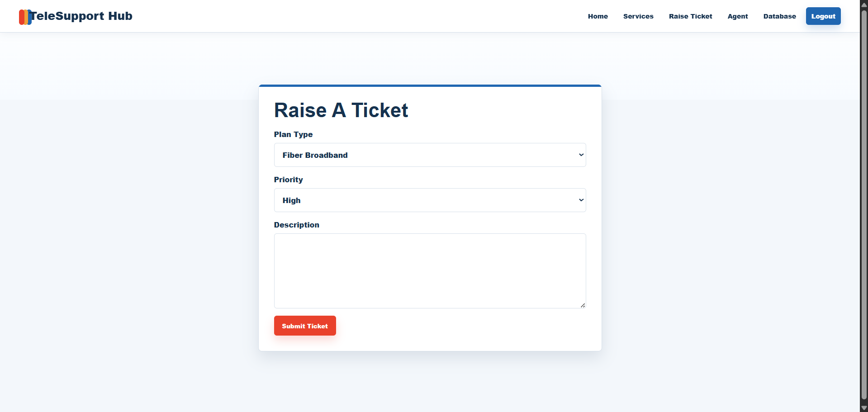

7.6 Agent Login and Agent Dashboard
Agents log in using separate credentials. The agent dashboard displays all customer tickets along with contact information, issue description, priority, and current status. The agent can update ticket status to Open, In Progress, or Resolved.
Screenshot Space 8: Agent Login Page
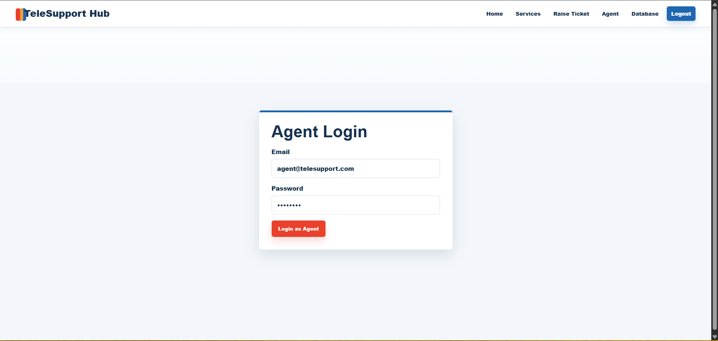

Screenshot Space 9: Agent Dashboard
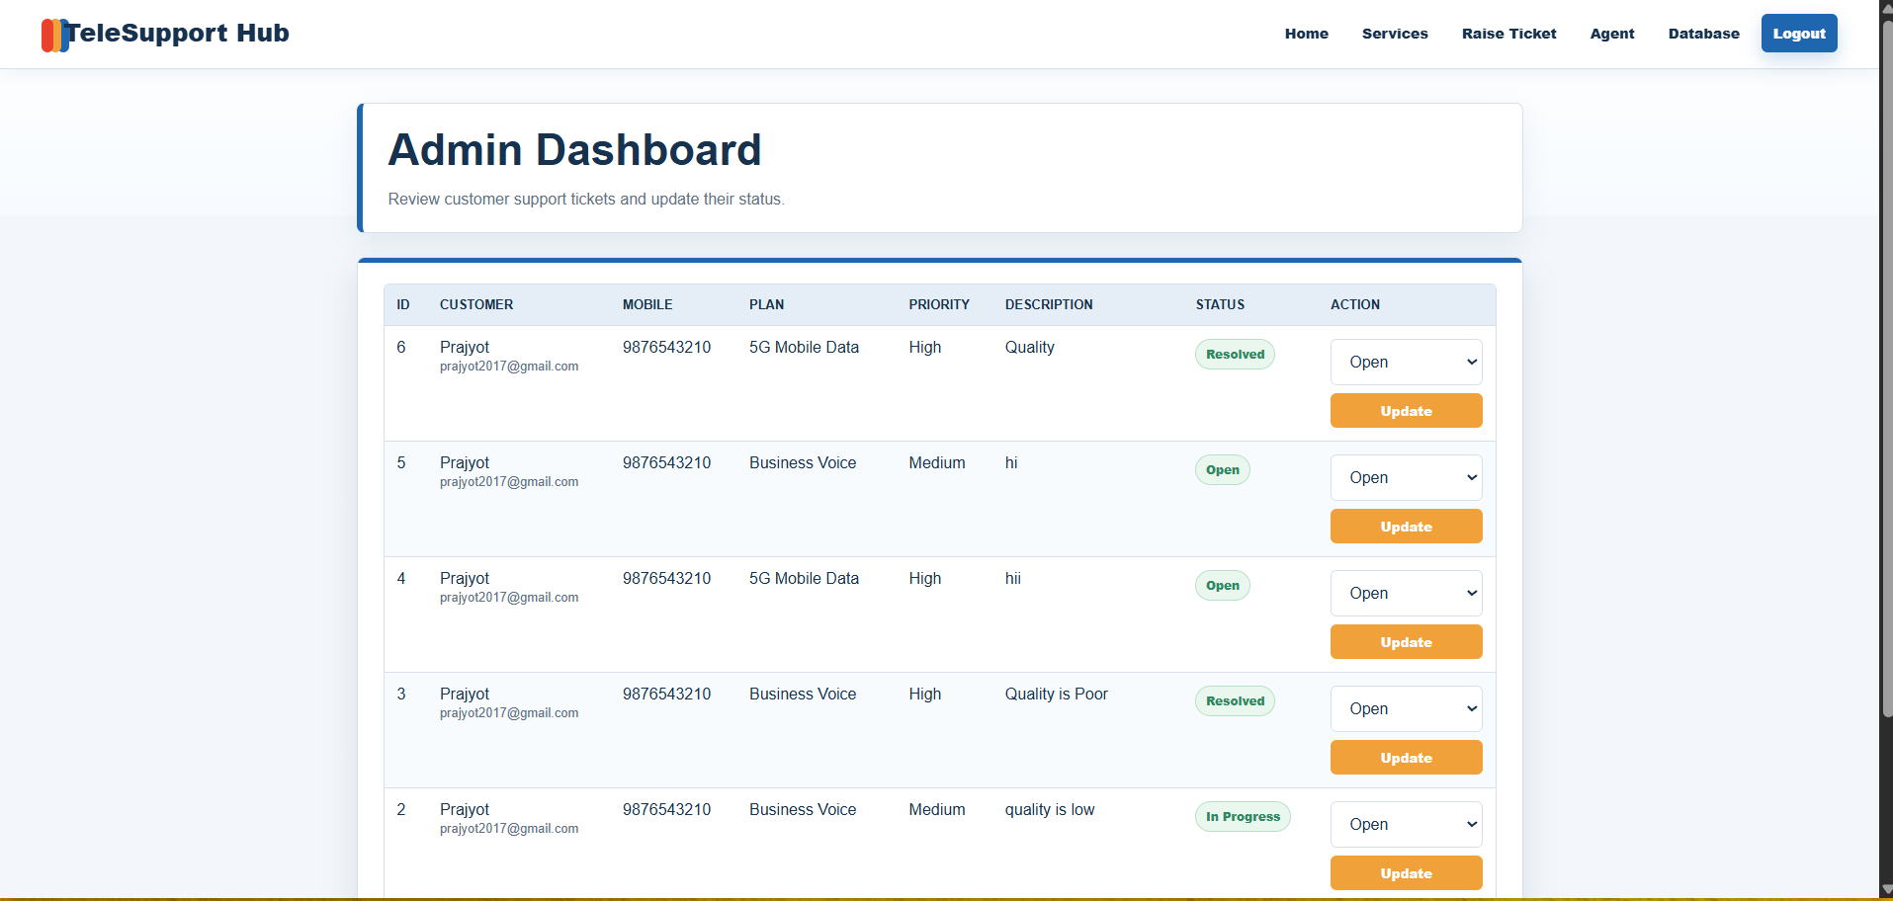

8. Testing
Test Case | Expected Result | Status
Customer registration | New customer record is created. | Pass
Customer login | Customer is redirected to dashboard. | Pass
Buy service | Service record appears in purchases table. | Pass
Raise ticket | Ticket record appears in tickets table. | Pass
Agent login | Agent dashboard opens successfully. | Pass
Update ticket status | Ticket status is updated in database. | Pass

9. AWS Deployment Plan
- Create an AWS account and log in to AWS Management Console.
- Create a MySQL database instance using Amazon RDS.
- Configure database access, username, password, endpoint, and security group rules.
- Launch a Linux EC2 instance to host the Flask application.
- Configure inbound rules for SSH, HTTP, HTTPS, and Flask demo port if required.
- Transfer project files to EC2 and install Python dependencies.
- Set RDS environment variables and run the Flask application.

10. Monitoring and Optimization
AWS CloudWatch can be used to monitor EC2 and RDS performance metrics such as CPU usage, network traffic, database connections, and uptime. Application performance can be improved using database indexing, optimized queries, and suitable EC2 instance selection based on traffic.

11. Conclusion
The TeleSupport Hub project demonstrates the development of a scalable telecom support platform using Flask and database integration. The application supports customer service workflows such as registration, login, service purchase, ticket creation, and agent-side ticket resolution. With AWS EC2 and Amazon RDS, the project can be deployed as a cloud-based support solution for telecom service providers.

