**MA653-COMPUTATIONAL FINANCIAL MODELLING**

**LAB ASSIGNMENT-2 REPORT**

**Prajyot Morey - T21009 (M.Tech CSP)**

**Q_1.**

Stock Chosen:-

1.ONGC (Oil and Natural Gas Sector)

2.TATA Motors (Automotive Sector)

3.Infosys (IT Sector)

All these 3 Stock are from the different sectors for analyzing how each sector is performing over the year period of 5 years i.e., (25-May-2017 To 25-May-2012). Below are data representations of all three stocks.

1.TATA Motors.

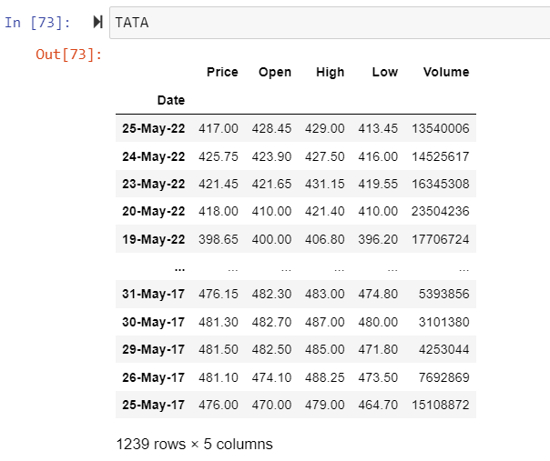

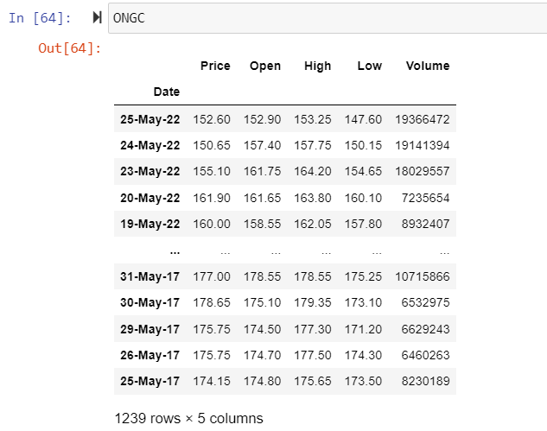2.ONGC

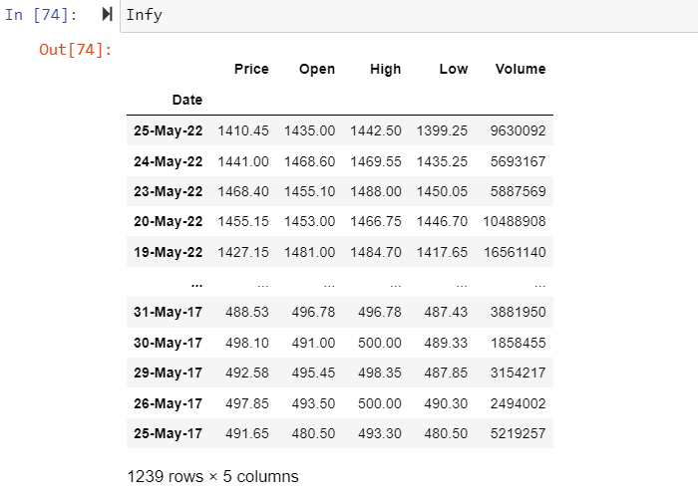3.Infosys

* 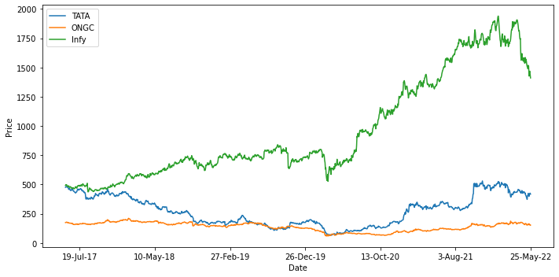**Price vs. Year Graph of All three Stocks**.
* **Plotting Daily Return stock of each Stock**

Given dataset doesn’t have the Daily Return so we have to Calculate the Daily Return of each Stock by using the following Formula.

$r_{i}$ = $\frac{p_{t}-p_{t-1}}{p_{t-1}}$

$p_{t}$ = Today`s Price of Stock.

$p_{t-1}$ = Yesterday`s Price of Stock.

$r_{i}$ = Return on day.

1. Daily Return Calculated Data Set Representation.
2. TATA Motors

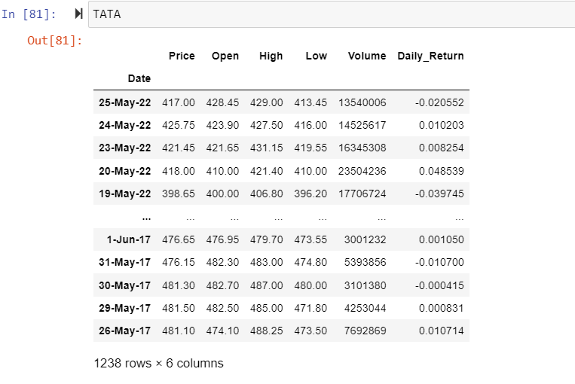

1. Infosys

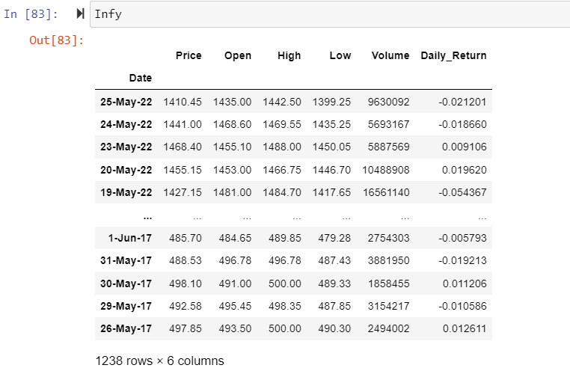

1. ONGC

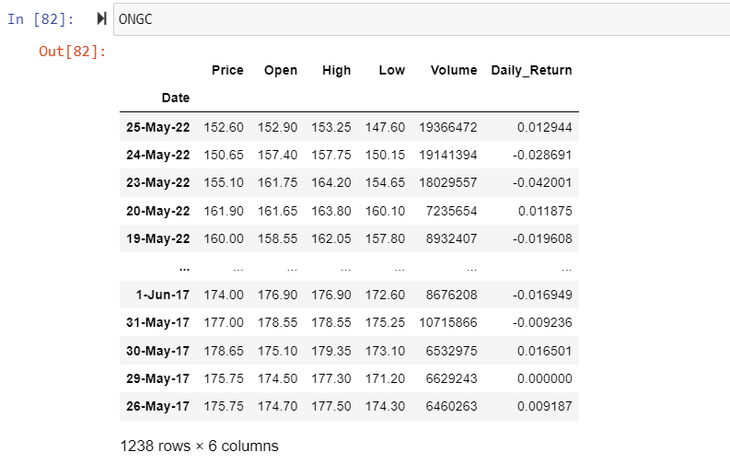

* **Daily Return plot**

1.TATA Motors

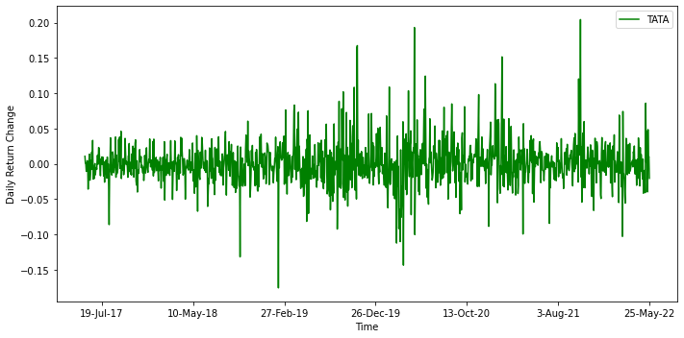

1. ONGC
2. 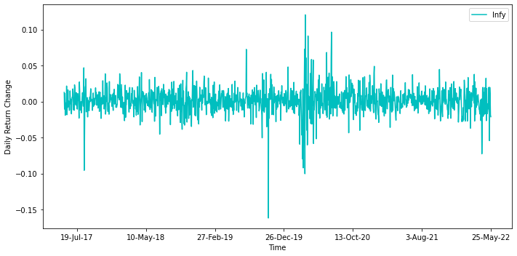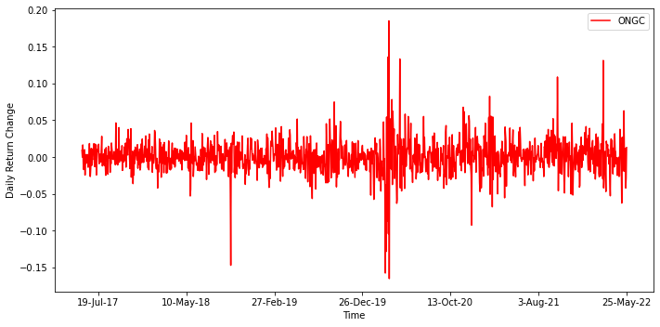Infosys

**Q_1_a:-**

Code Snippet for Random weight generation for 3 Stocks:-

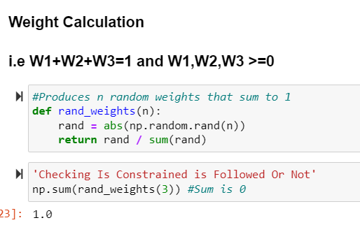

Code Snippet for Calculating Risk and Return:-

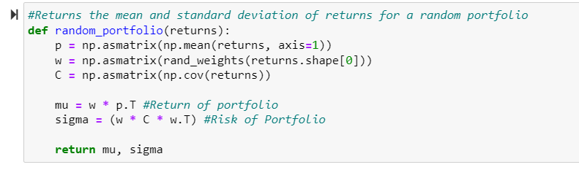

* **Risk vs. Return Plot 3 Stocks.**

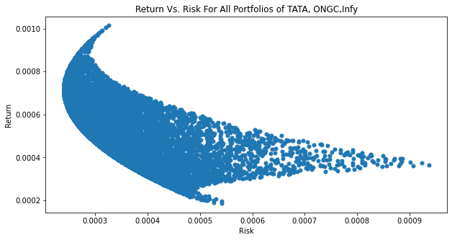

**1_C:-**

Finding Minimum Risk

