**MA653-Computational Financial Modelling**

**LAB_3-Report**

**Prajyot Morey - T21009**

Portfolio Screenshot:-

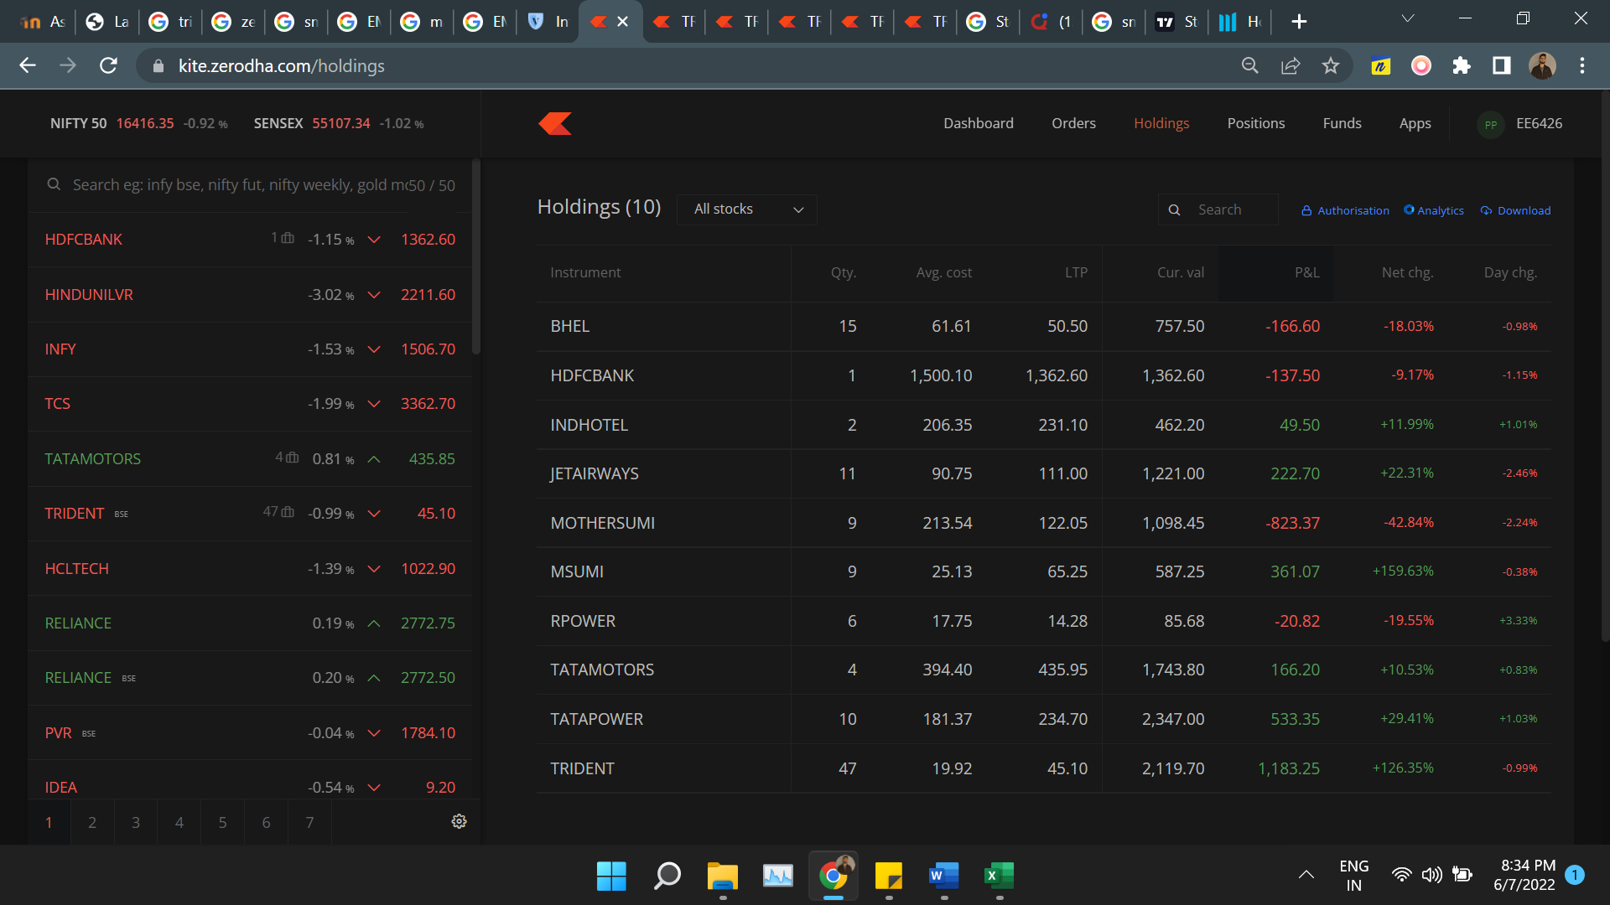

Stock Chosen:-

1. Trident
2. TATA-Power
3. Trident
4. Time Line Buy and Sell:-

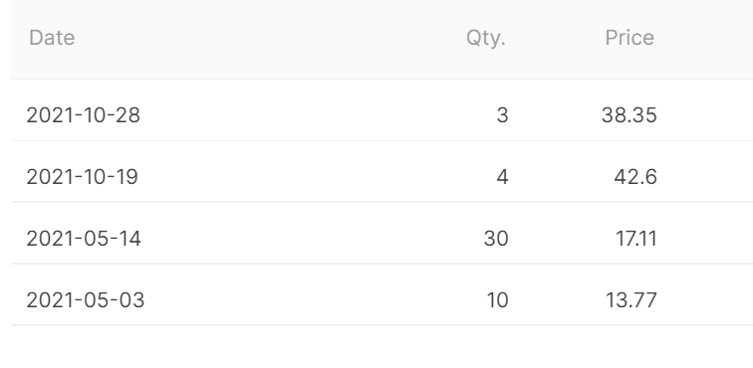

1. Indicators Snapshot:-
2. 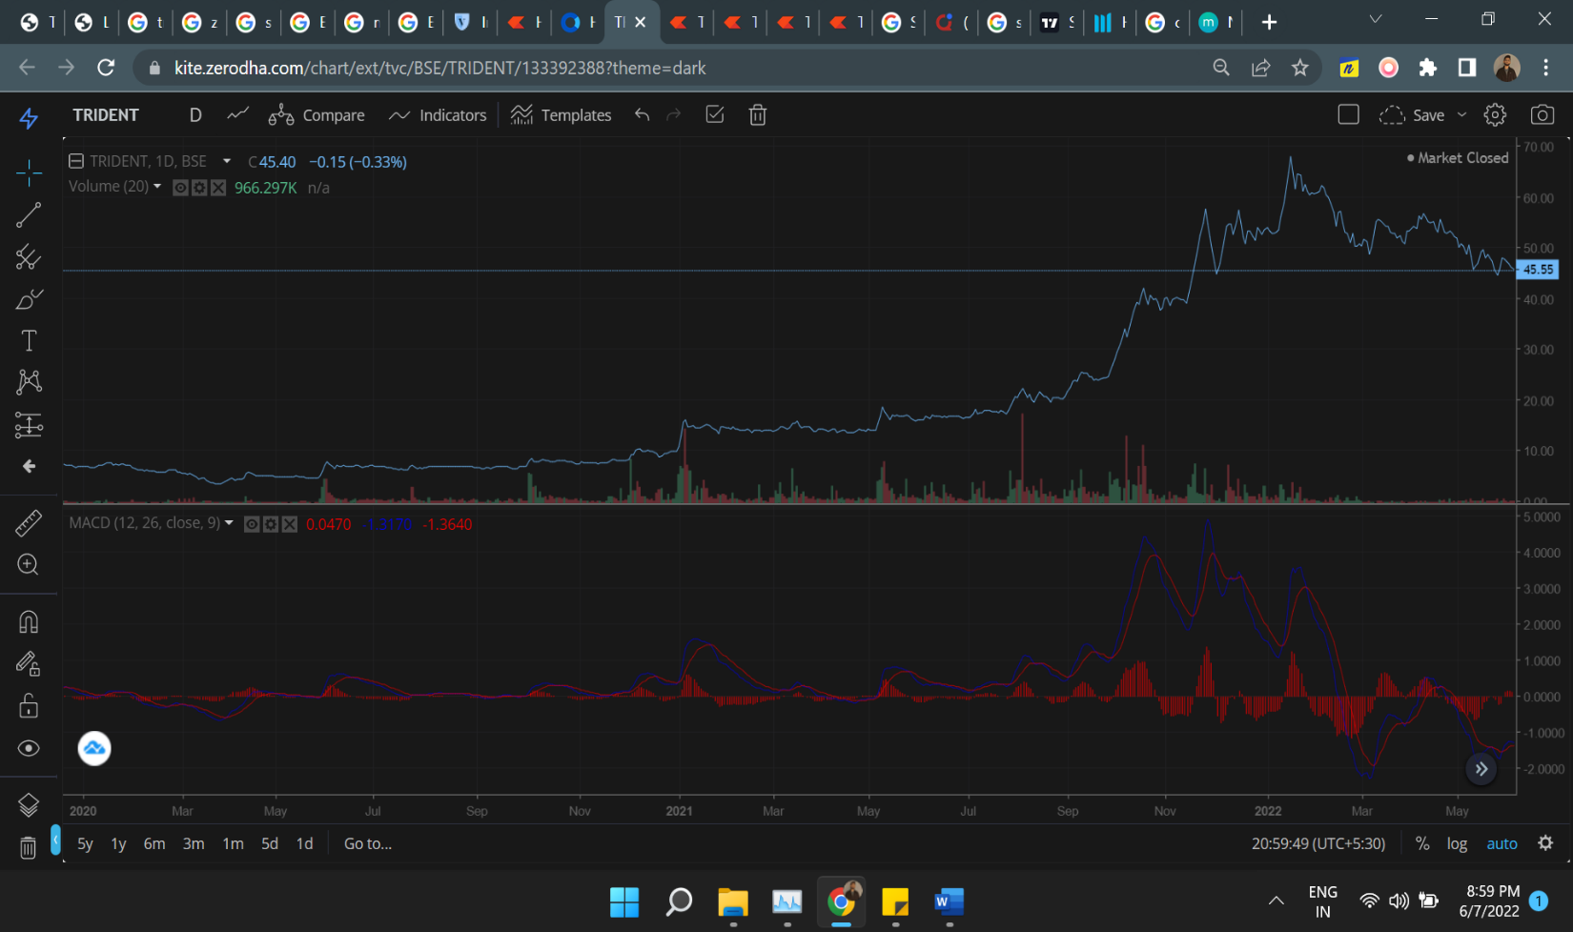MACD

MACD is Moving average convergence Divergence, It is used to spot changes in strength, direction, momentum, and duration of a trend in a stock market price. It is a computation of the difference between two exponential moving averages of the closing price.

Here I Have Taken time period of 2 year from 2020 to 2022

MACD line(blue Line): Difference between the 12 and 26 days EMAs.

Signal(Red Line): 9-day EMA of the blue line.

Histogram (bar graph): Difference between the blue and red lines.

Interpretation From Graphs:-

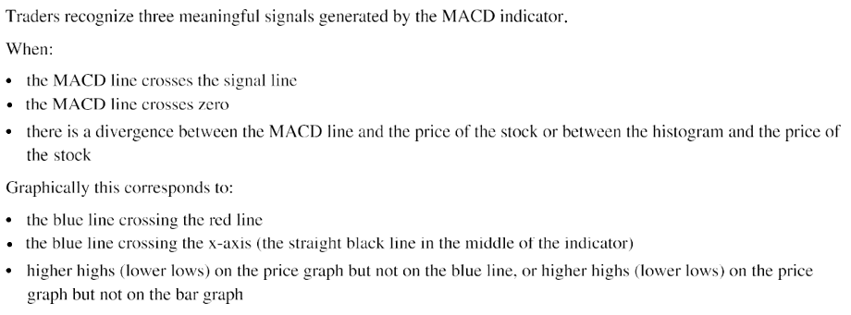

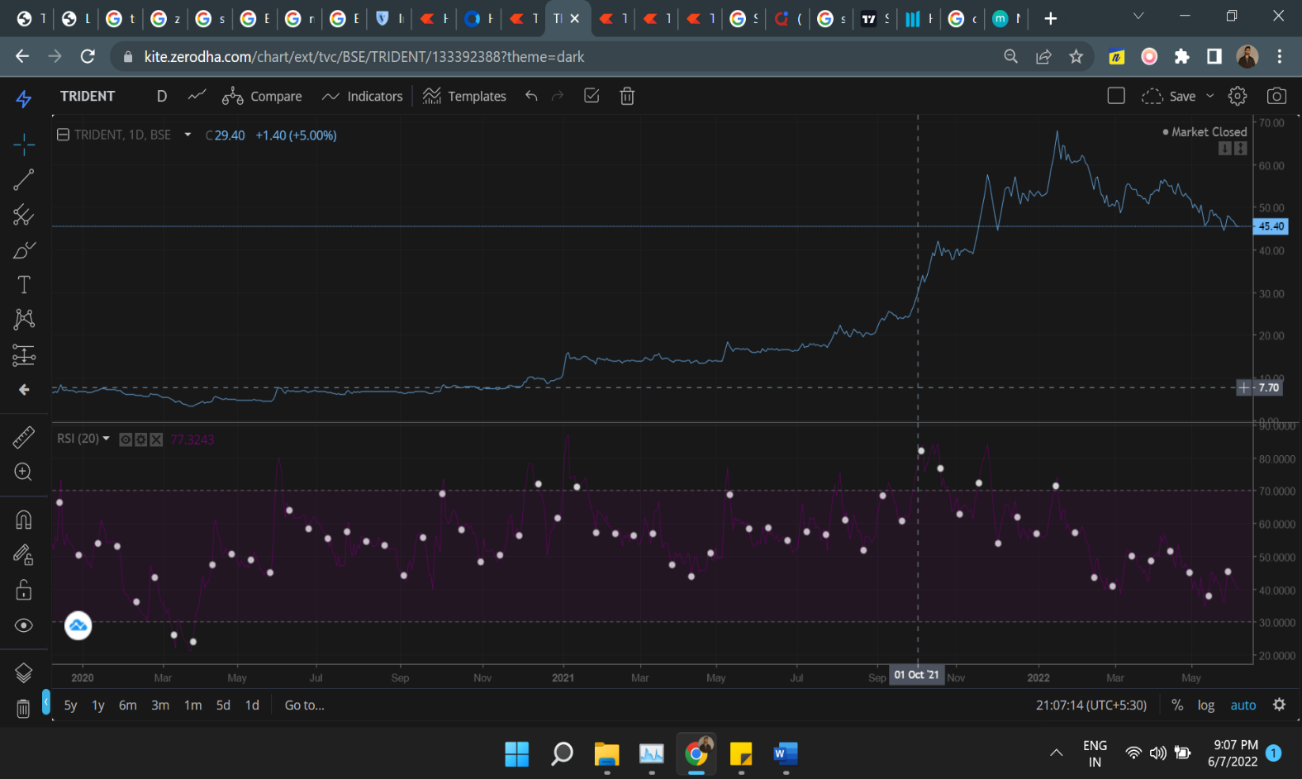2.RSI

The relative strength index (RSI) is a [momentum indicator](https://www.investopedia.com/investing/momentum-and-relative-strength-index/) used in technical analysis that measures the magnitude of recent price changes to evaluate overbought or oversold conditions in the price of a stock or other asset. The RSI is displayed as an oscillator (a line graph that moves between two extremes) and can have a reading from 0 to 100.

* The RSI provides technical traders with signals about bullish and bearish price momentum, and it is often plotted beneath the graph of an asset’s price.
* An asset is usually considered overbought when the RSI is above 70% and oversold when it is below 30%.

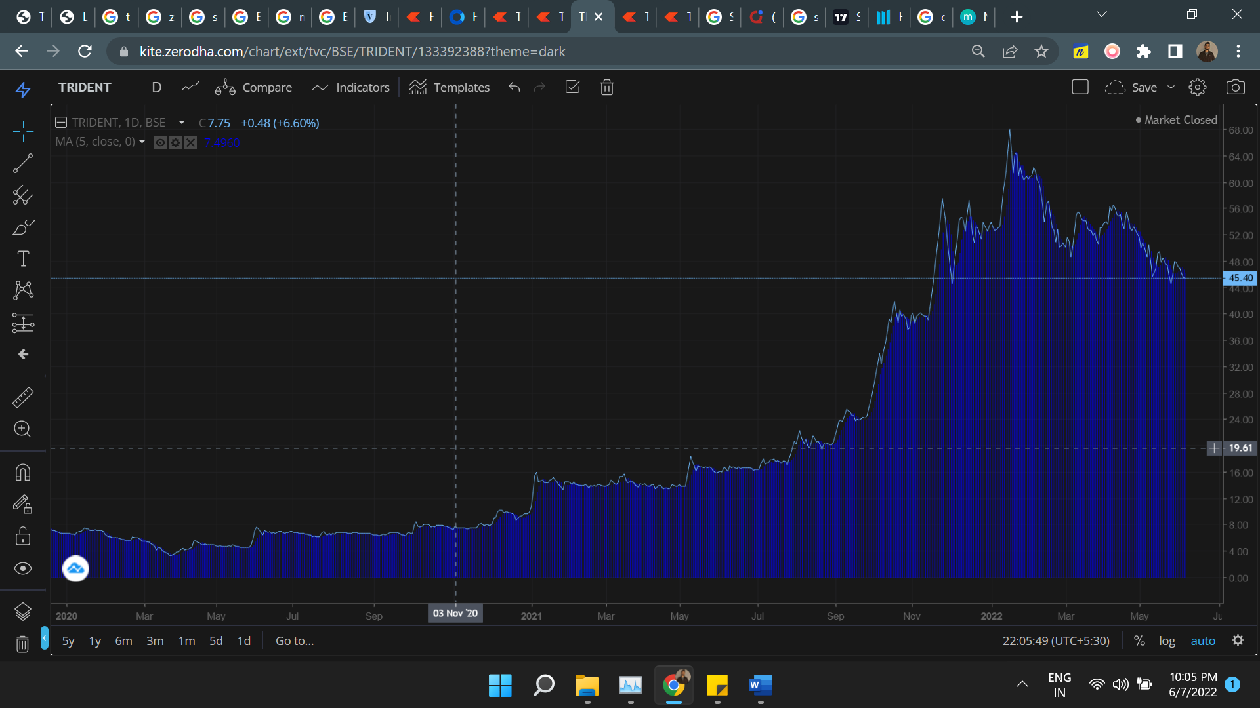3.SMA

It is simply the average price over the specified period. The average is called "moving" because it is plotted on the chart bar by bar, forming a line that moves along the chart as the average value changes.

How Indicator Works:-

* SMAs are often used to determine trend direction. If the SMA is moving up, the trend is up. If the SMA is moving down, the trend is down. A 200-bar SMA is a common proxy for the long-term trend. 50-bar SMAs are typically used to gauge the intermediate trend. Shorter period SMAs can be used to determine shorter-term trends.
* SMAs are commonly used to smooth price data and technical indicators. The longer the period of the SMA, the smoother the result, but the more lag that is introduced between the SMA and the source.
* Price crossing SMA is often used to trigger trading signals. When prices cross above the SMA, you might want to go long or cover short; when they cross below the SMA, you might want to go short or exit long.

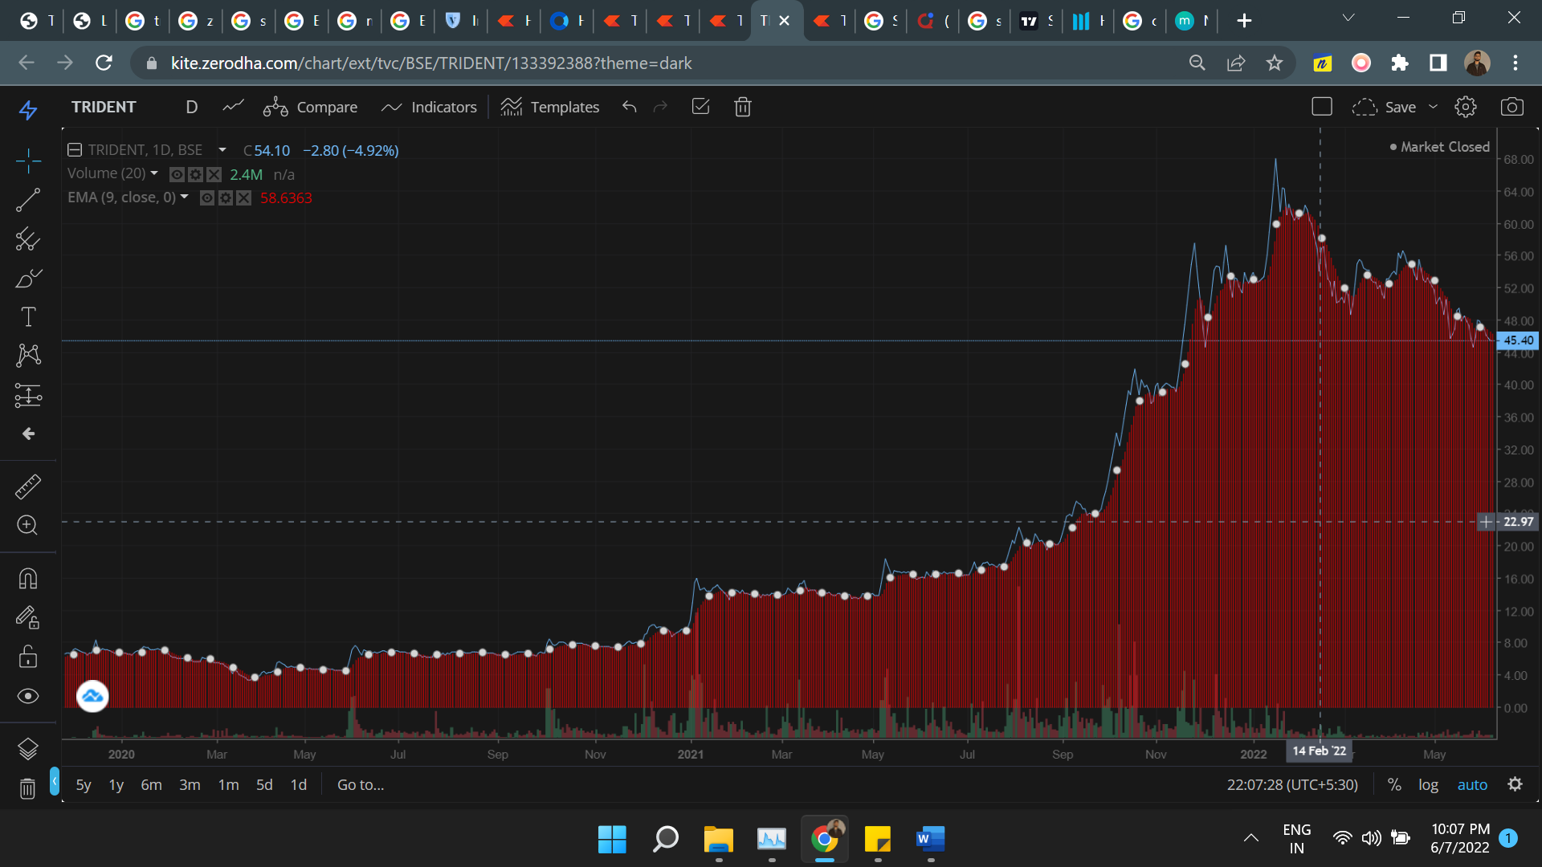4.EMA

The [exponential moving average (EMA)](https://www.investopedia.com/terms/e/ema.asp) is a technical chart indicator that tracks the price of an investment (like a stock or commodity) over time. The EMA is a type of [weighted moving average (WMA)](https://www.investopedia.com/terms/l/linearlyweightedmovingaverage.asp) that gives more weighting or importance to recent price data. Like the simple moving average (SMA), the EMA is used to see price trends over time, and watching several EMAs at the same time is easy to do with moving average ribbons.

Insight For EMA:-

* Exponential moving averages (EMAs) are designed to see price trends over specific time frames, such as 50 or 200 days.
* Compared to simple moving averages, EMAs give greater weight to recent (more relevant) data.
* Computing the EMA involves applying a multiplier to the simple moving average (SMA).
* Moving average ribbons allow traders to see multiple EMAs at the same time.

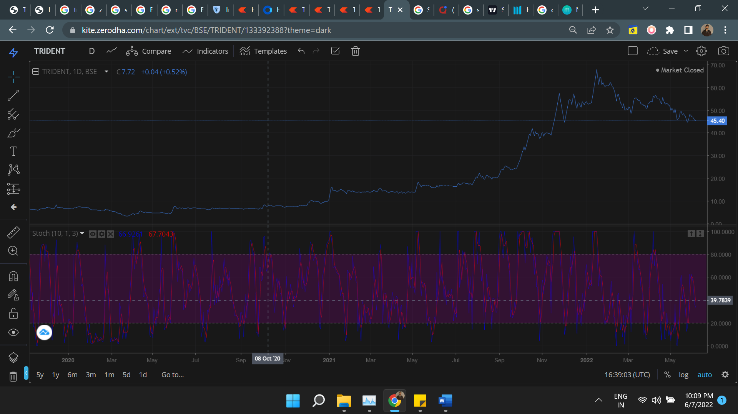5. Stochastic (%K and %D)

A stochastic oscillator is a momentum indicator comparing a particular [closing price](https://www.investopedia.com/terms/c/closingprice.asp) of a security to a range of its prices over a certain period of time. The sensitivity of the oscillator to market movements is reducible by adjusting that time period or by taking a [moving average](https://www.investopedia.com/terms/m/movingaverage.asp) of the result. The "slow" stochastic indicator is taken as %D = 3-period moving average of %K. The general theory serving as the foundation for this indicator is that in a market trending upward, prices will close near the high, and in a market trending downward, prices close near the low. Transaction signals are created when the %K crosses through a three-period moving average, which is called the %D.

2. TATA Power

A. Time Line Buy and Sell:-

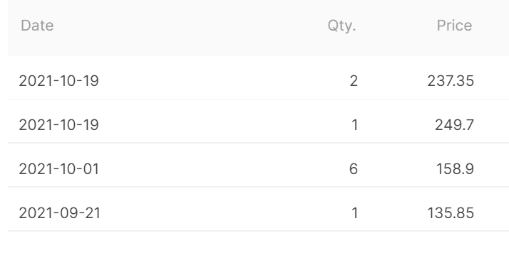

1. 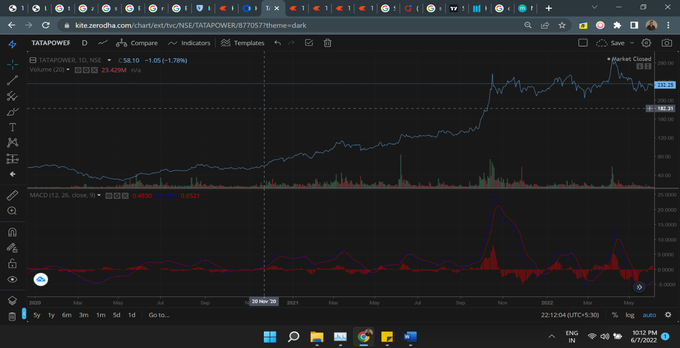MACD

MACD is Moving average convergence Divergence, It is used to spot changes in strength, direction, momentum, and duration of a trend in a stock market price. It is a computation of the difference between two exponential moving averages of the closing price.

Here I Have Taken time period of 2 year from 2020 to 2022

MACD line(blue Line): Difference between the 12 and 26 days EMAs.

Signal(Red Line): 9-day EMA of the blue line.

Histogram (bar graph): Difference between the blue and red lines.

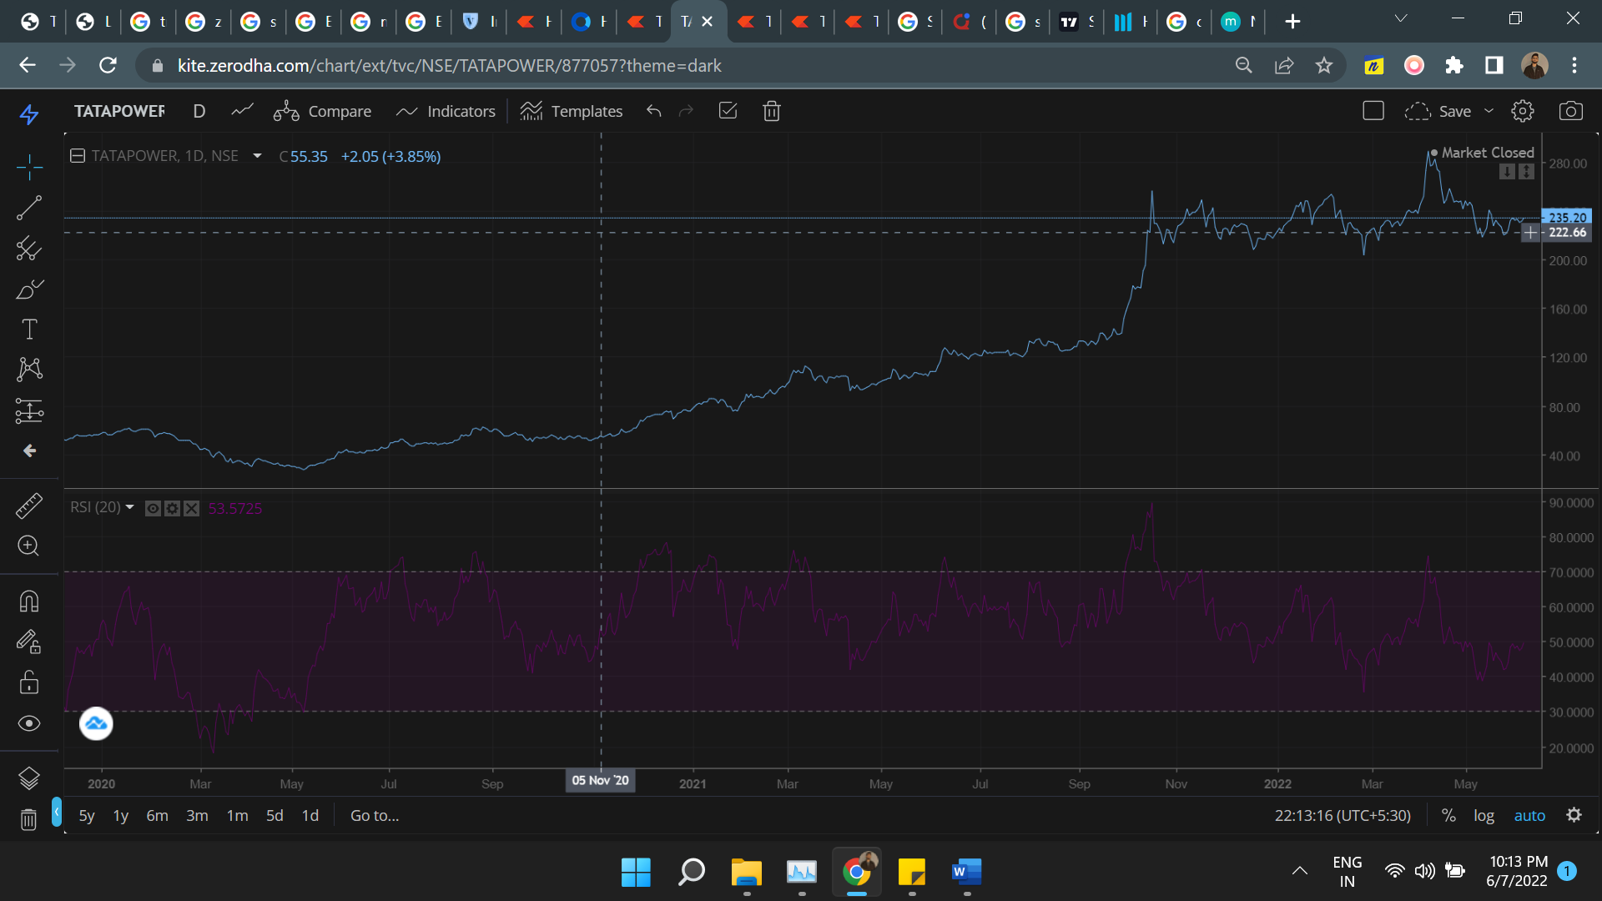2.RSI

The relative strength index (RSI) is a [momentum indicator](https://www.investopedia.com/investing/momentum-and-relative-strength-index/) used in technical analysis that measures the magnitude of recent price changes to evaluate overbought or oversold conditions in the price of a stock or other asset. The RSI is displayed as an oscillator (a line graph that moves between two extremes) and can have a reading from 0 to 100.

* The RSI provides technical traders with signals about bullish and bearish price momentum, and it is often plotted beneath the graph of an asset’s price.
* An asset is usually considered overbought when the RSI is above 70% and oversold when it is below 30%.

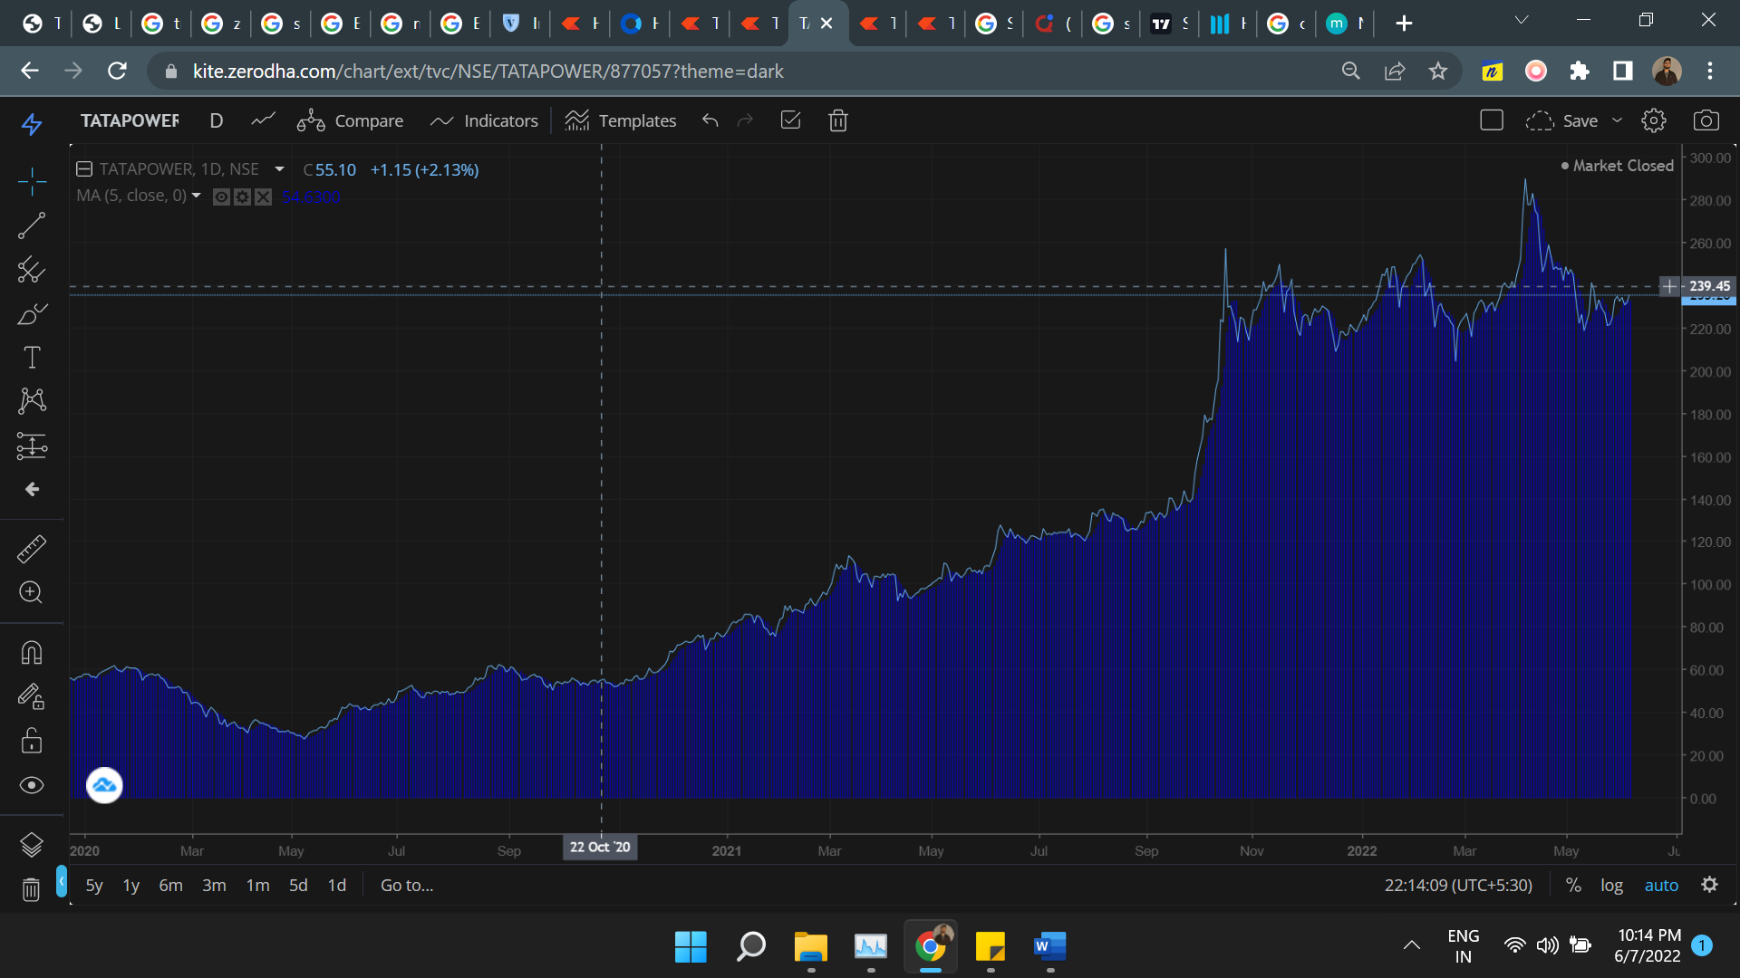3. SMA

It is simply the average price over the specified period. The average is called "moving" because it is plotted on the chart bar by bar, forming a line that moves along the chart as the average value changes.

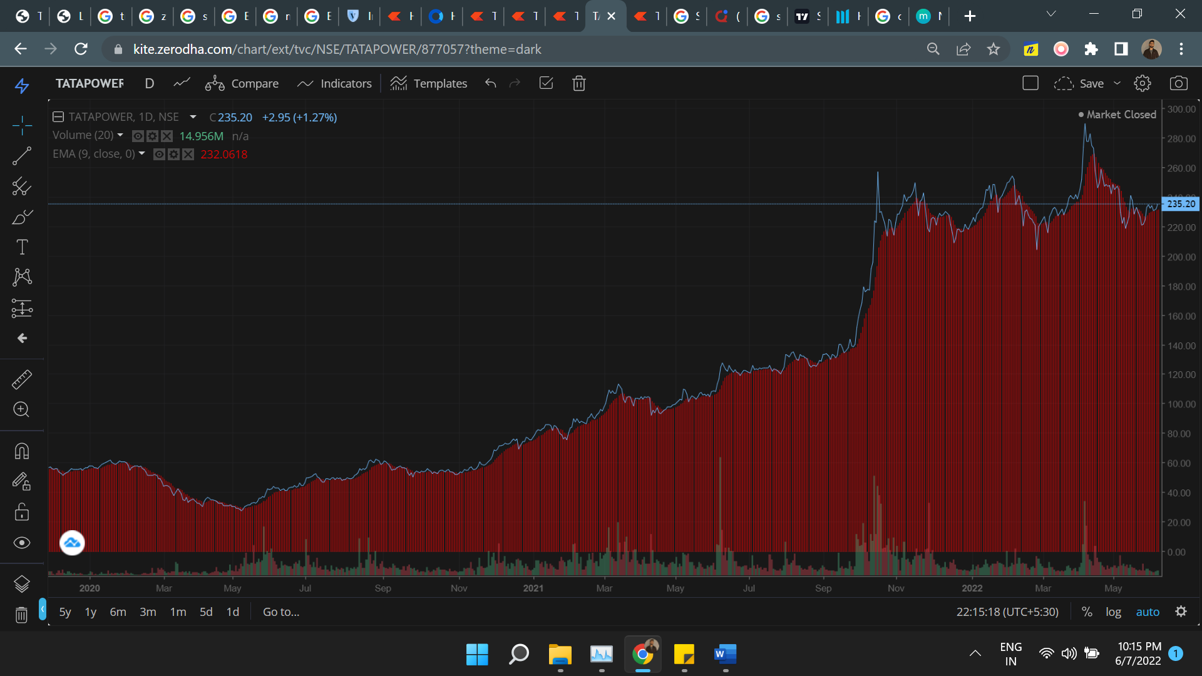4.EMA

The [exponential moving average (EMA)](https://www.investopedia.com/terms/e/ema.asp) is a technical chart indicator that tracks the price of an investment (like a stock or commodity) over time. The EMA is a type of [weighted moving average (WMA)](https://www.investopedia.com/terms/l/linearlyweightedmovingaverage.asp) that gives more weighting or importance to recent price data.

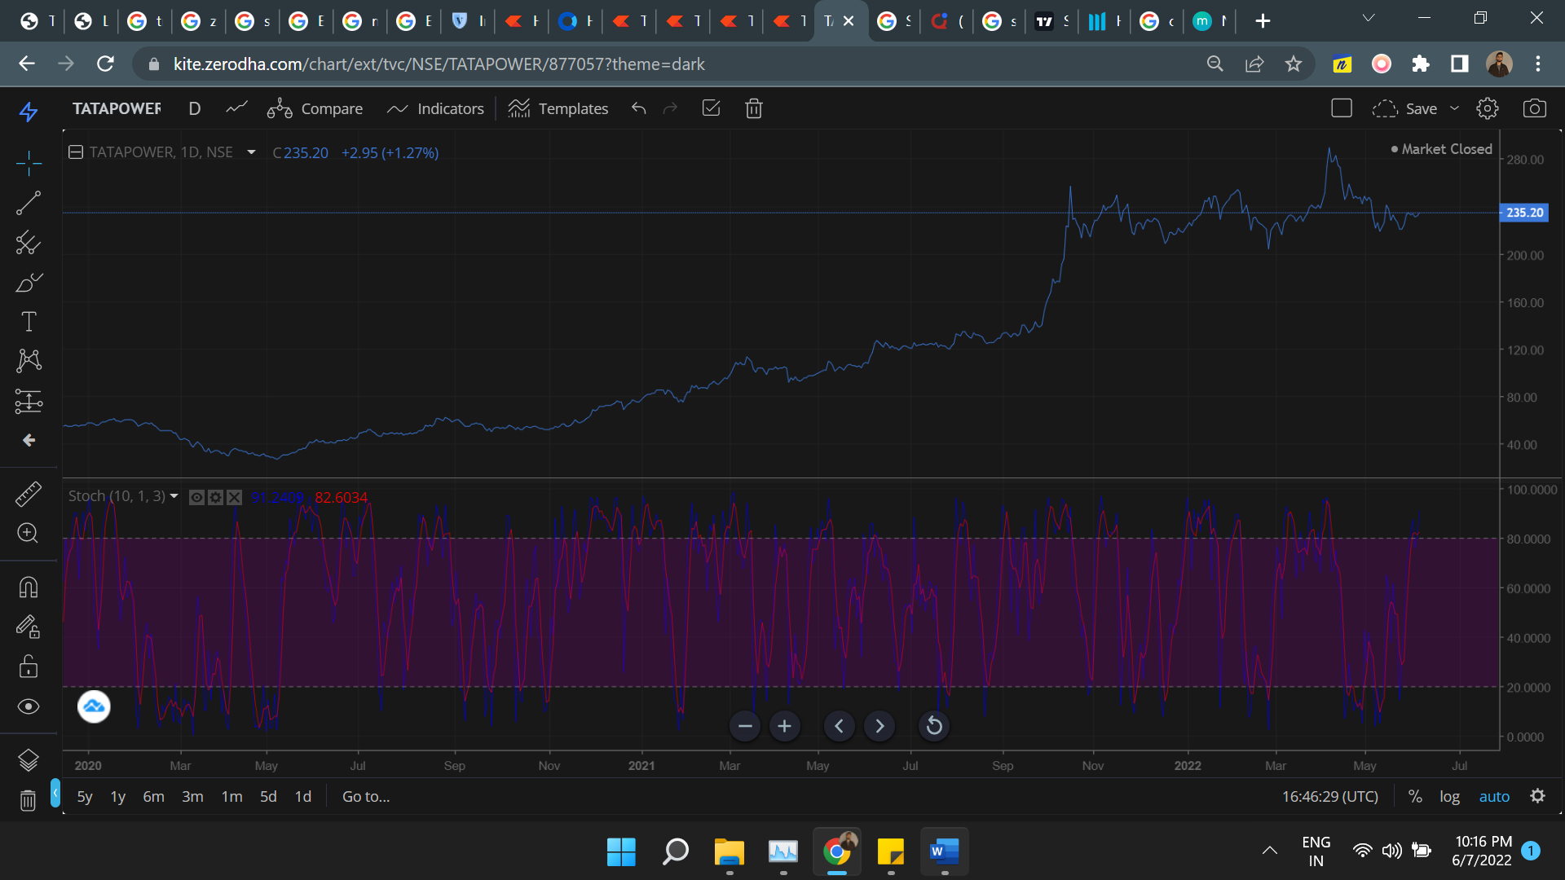5. Stochastic (%K and %D)

A stochastic oscillator is a momentum indicator comparing a particular [closing price](https://www.investopedia.com/terms/c/closingprice.asp) of a security to a range of its prices over a certain period of time. The sensitivity of the oscillator to market movements is reducible by adjusting that time period or by taking a [moving average](https://www.investopedia.com/terms/m/movingaverage.asp) of the result. The "slow" stochastic indicator is taken as %D = 3-period moving average of %K. The general theory serving as the foundation for this indicator is that in a market trending upward, prices will close near the high, and in a market trending downward, prices close near the low. Transaction signals are created when the %K crosses through a three-period moving average, which is called the %D.

Q_2:-

Support and Resistance:- Is a concept in technicle analysis that the movement of the price of the price of a security will tend to stop and reverse at certain predetermined price levels.

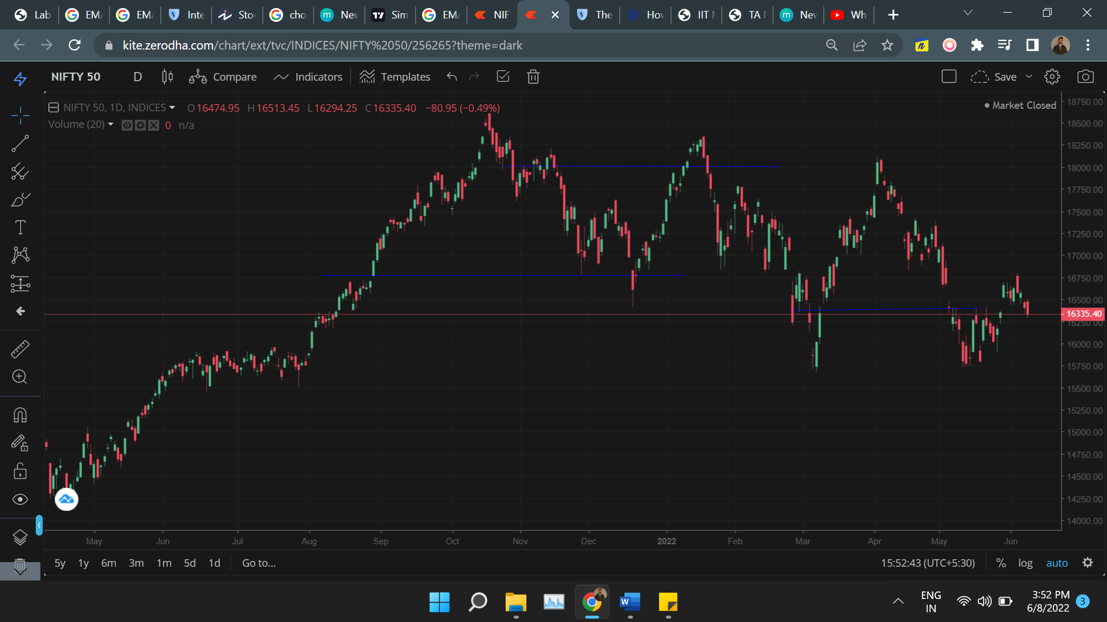

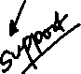

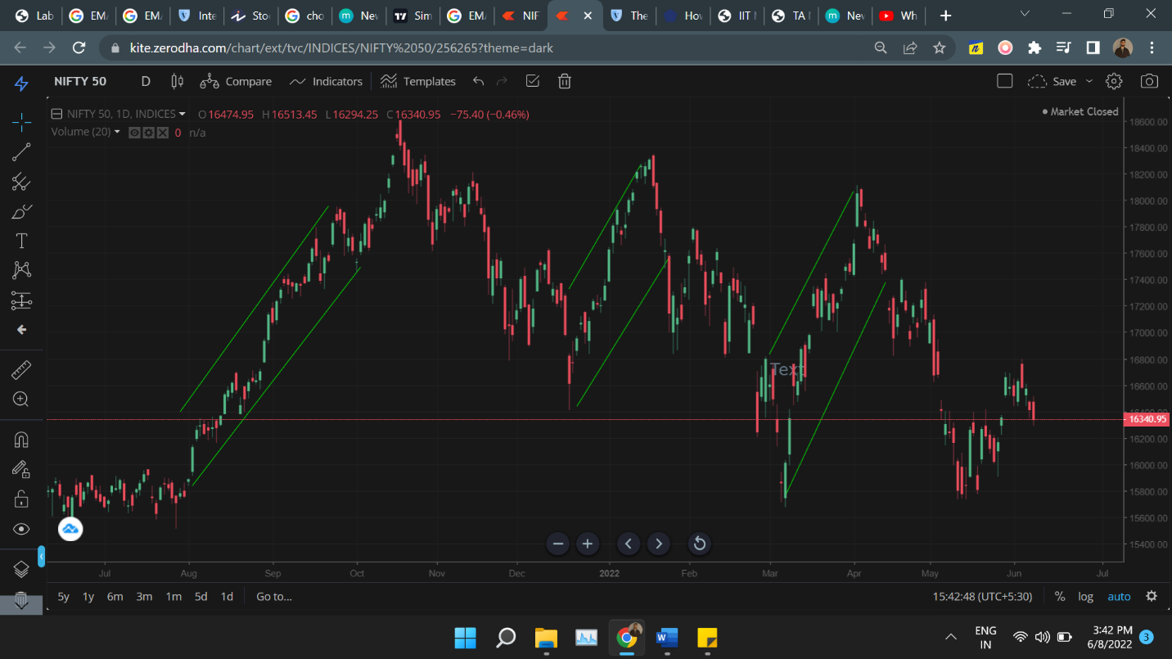

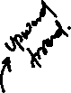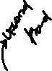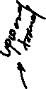

Here we can see the uptrend and downtrend from the data point for nifty-50 index. This trend line gives the trend followed by the market over the period of time, By Observing trend line we can decide support and resistance.

Resources:- Investopedia, Zeroda,