The code displays several considerations for a production-quality solution:

**Input Validation**: The code performs input validation on the "sentence" parameter. It checks if the sentence has multiple words by splitting it and checking the length. This ensures that the sentence provided is meaningful and contains more than one word.

**Consistent Error Handling:** The code handles different types of errors with appropriate error messages and **HTTP status codes**. It provides consistent error responses when invalid input or missing sentences are encountered. This improves the user experience and facilitates error troubleshooting.

**Logging Improvements:** The code includes more informative **log messages**. It logs an error when an invalid sentence type is provided or when the sentence lacks multiple words. It also logs a message when the random array is generated successfully. These logs help in monitoring and debugging the application.

**Code Readability**: The code maintains a clean and readable structure with proper indentation, clear variable names, and comments. It follows the PEP 8 style guide, which enhances code comprehension and maintainability.

**Used Black for code formatting and flake8 for styling ,errors and bad typing.**

**Security Considerations**: The code uses the request.form.get() method to retrieve the value of the "sentence" parameter from the form data. This helps protect against potential security vulnerabilities such as injection attacks.

**Swagger Configuration:** The code uses Flask-Swagger-UI to configure and serve the Swagger UI interface. It specifies the Swagger URL and API URL, along with an app name. This makes the API documentation easily accessible and user-friendly.

<http://127.0.0.1:5000/swagger/>

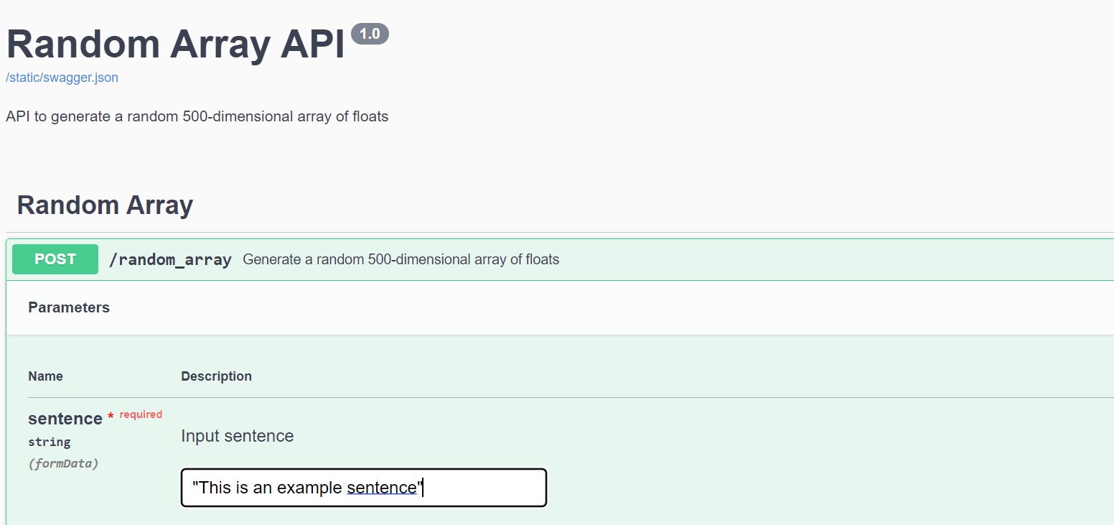

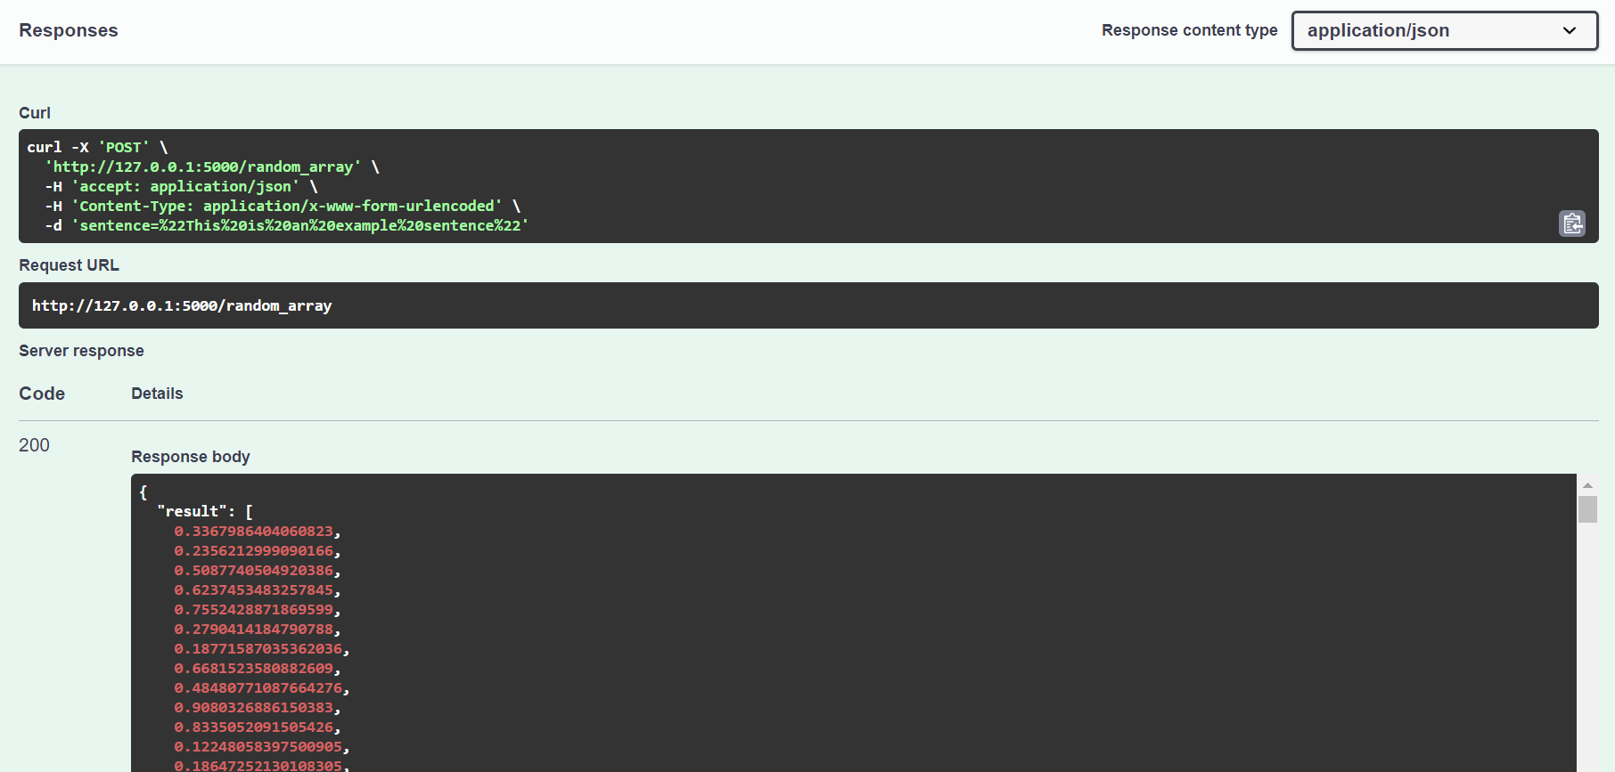

**Unit Testing**: While not present in the provided code snippet, it is essential to have comprehensive unit tests to verify the functionality of the application. Unit tests ensure that the code behaves as expected, catches potential regressions, and facilitates future modifications.

The unittest cases cover various aspects of the /random_array endpoint and the expected behavior of the API. Let's review each test case:

**test_random_array_endpoint**: This test verifies that the /random_array endpoint returns a successful response (status code 200) when a valid sentence is provided.

**test_random_array_endpoint_result**: This test checks that the response from the /random_array endpoint contains a "result" field in the JSON response.

**test_random_array_length**: This test ensures that the returned random array has a length of 500, as specified in the code.

**test_random_array_element_type**: This test confirms that each element in the returned random array is of type float.

**test_sentence_type_integer**: This test validates that when an integer value is provided as the "sentence" parameter, the endpoint returns a Bad Request response (status code 400).

**test_sentence_is_word**: This test case sends a POST request to the /random_array endpoint with a single-word sentence. It checks that the response from the endpoint returns a Bad Request status code (400), indicating that a sentence with multiple words is expected

By considering these factors, the code demonstrates an improved production-quality solution. It provides robust input validation, error handling, logging, security, documentation, and code organization, leading to a more reliable and maintainable application.

**Api Response from Postman**

