1.LEXICAL ANALYSER
1.RECURSIVE DESCENT PARSER
2.SHIFT EDUCE PARSER
3.INTERMEDIATE CODE GENERATOR
4.CONSTANT PROPAGATION
5. E CLOSURE
6.IMPLEMENTATION OF LEXICAL ANALYZER USING LEX TOOL
7.DISPLAY THE NUMBER OF LINES,WORDS AND CHARACTERS IN AN INPUT TEXT
8.CONVERT SUBSTRING abc TO ABC FROM THE GIVEN INPUT STRING USING LEX
9.FIND OUT TOTAL NUMBER OF VOWELS AND CONSONANTS FROM THE GIVEN INPUT STRING
10.RECOGNIZE A VALID ARITHMETIC EXPRESSION USING YACC
11.RECOGNIZE A VALID IDENTIFIER USING YACC
12.IMPLEMENTATION OF CALCULATOR USING LEX AND YACC

// LEXICAL ANALYZER

#include <stdio.h>
#include <stdlib.h>
#include <string.h>
#include <ctype.h>

char keywords[32][10] = {
"auto", "break", "case", "char", "const", "continue", "default", "do",
"double", "else", "enum", "extern", "float", "for", "goto", "if",
"int", "long", "register", "return", "short", "signed", "sizeof",
"static", "struct", "switch", "typedef", "union", "unsigned",
"void", "volatile", "while"
};

int isKeyword(char buffer[])
{
int i, flag = 0;

for (i = 0; i < 32; i++)
{
if (strcmp(keywords[i], buffer) == 0)
{
flag = 1;
break;
}
}

return flag;
}

int main()
{
char ch, buffer[15], operators[] = "+-*/%=";
FILE *fp;
int i, j = 0;

fp = fopen("program.txt", "r");

if (fp == NULL)
{
printf("File cannot be opened");
exit(0);
}

while ((ch = fgetc(fp)) != EOF)
{
for (i = 0; i < 6; i++)
{
if (ch == operators[i])
{
printf("%c is operator\n", ch);
break;
}
}

if (isalnum(ch))
{
buffer[j++] = ch;
}
else if ((ch == ' ' || ch == '\n' || ch == ';') && (j != 0))
{
buffer[j] = '\0';
j = 0;

if (isKeyword(buffer) == 1)
printf("%s is keyword\n", buffer);
else
printf("%s is identifier\n", buffer);
}
}

fclose(fp);
return 0;
}
Program.txt
void main()
{
int a, b, c;
c = a + b;
}

Exp no 1
RECURSIVE DESCENT PARSER

#include <stdio.h>
#include <string.h>
#include <ctype.h>

char input[100];
int i = 0;
int E(), EP(), T(), TP(), F();

void main()
{
printf("\nRECURSIVE DESCENT PARSING FOR THE FOLLOWING GRAMMAR\n");
printf("\nE -> T E'\nE' -> + T E' / @\nT -> F T'\nT' -> * F T' / @\nF -> (E) / ID\n");

printf("Enter the string to be checked: ");
scanf("%s", input);

if (E())
{
if (input[i] == '\0')
printf("\nString is accepted\n");
else
printf("\nString is not accepted\n");
}
else
printf("\nString is not accepted\n");
}

int E()
{
if (T())
{
if (EP())
return 1;
else
return 0;
}
else
return 0;
}

int EP()
{
if (input[i] == '+')
{
i++;

if (T())
{
if (EP())
return 1;
else
return 0;
}
else
return 0;
}
else
return 1;
}

int T()
{
if (F())
{
if (TP())
return 1;
else
return 0;
}
else
return 0;
}

int TP()
{
if (input[i] == '*')
{
i++;

if (F())
{
if (TP())
return 1;
else
return 0;
}
else
return 0;
}
else
return 1;
}

int F()
{
if (input[i] == '(')
{
i++;

if (E())
{
if (input[i] == ')')
{
i++;
return 1;
}
else
return 0;
}
else
return 0;
}
else if ((input[i] >= 'a' && input[i] <= 'z') ||
(input[i] >= 'A' && input[i] <= 'Z'))
{
i++;
return 1;
}
else
return 0;
}
OUTPUT

E -> T E'
E' -> + T E' | ε
T -> F T'
T' -> * F T' | ε
F -> (E) | ID

ENTER STRING TO BE CHECKED a+a
STRING ACCEPTED

EXP NO 2
SHIFT REDUCE PARSER

PROGRAM

#include <stdio.h>
#include <string.h>

int k = 0, z = 0, i = 0, j = 0, c = 0;

char a[50], ac[20], stk[50], act[20];

void check();

void main()
{
puts("GRAMMAR IS E->E+E \n E->E*E \n E->(E) \n E->id");

puts("Enter input string:");

scanf("%s", a);

c = strlen(a);

strcpy(act, "SHIFT->");

puts("stack \t input \t action");

for (k = 0, i = 0, j = 0; j < c; k++, i++, j++)
{
if (a[j] == 'i' && a[j + 1] == 'd')
{
stk[i] = 'i';
stk[i + 1] = 'd';
stk[i + 2] = '\0';

a[j] = ' ';
a[j + 1] = ' ';

printf("\n$%s\t$%s$\t%s id", stk, a, act);

i++; // important fix
j++; // skip 'd'

check();
}
else
{
stk[i] = a[j];
stk[i + 1] = '\0';

a[j] = ' ';

printf("\n$%s\t$%s$\t%s symbol", stk, a, act);

check();
}
}

check(); // final check
}

// CHECK FUNCTION

void check()
{
strcpy(ac, "REDUCE TO E");

int flag = 1;

while (flag)
{
flag = 0;

// id -> E
for (z = 0; z < strlen(stk); z++)
{
if (stk[z] == 'i' && stk[z + 1] == 'd')
{
stk[z] = 'E';

for (int x = z + 1; x < strlen(stk); x++)
stk[x] = stk[x + 1];

printf("\n$%s\t$%s$\t%s id", stk, a, ac);

flag = 1;
break;
}
}

// E+E -> E
for (z = 0; z < strlen(stk); z++)
{
if (stk[z] == 'E' && stk[z + 1] == '+' && stk[z + 2] == 'E')
{
stk[z] = 'E';

for (int x = z + 1; x < strlen(stk); x++)
stk[x] = stk[x + 2];

printf("\n$%s\t$%s$\t%s E+E", stk, a, ac);

flag = 1;
break;
}
}

// E*E -> E
for (z = 0; z < strlen(stk); z++)
{
if (stk[z] == 'E' && stk[z + 1] == '*' && stk[z + 2] == 'E')
{
stk[z] = 'E';

for (int x = z + 1; x < strlen(stk); x++)
stk[x] = stk[x + 2];

printf("\n$%s\t$%s$\t%s E*E", stk, a, ac);

flag = 1;
break;
}
}

// (E) -> E
for (z = 0; z < strlen(stk); z++)
{
if (stk[z] == '(' && stk[z + 1] == 'E' && stk[z + 2] == ')')
{
stk[z] = 'E';

for (int x = z + 1; x < strlen(stk); x++)
stk[x] = stk[x + 2];

printf("\n$%s\t$%s$\t%s (E)", stk, a, ac);

flag = 1;
break;
}
}
}

// ACCEPTANCE CHECK
if (stk[0] == 'E' && stk[1] == '\0')
printf("\n$%s\t$%s$\tString is accepted\n", stk, a);
else
printf("\n$%s\t$%s$\tString is not accepted\n", stk, a);
}

OUTPUT
E → E + E
E → E * E
E → (E)
E → id

Enter input string; id+id*id

EXP NO 3
INTERMEDIATE CODE GENERATOR

#include <stdio.h>
#include <string.h>

char op[2], arg1[5], arg2[5], result[5];

void main()
{
FILE *fp1, *fp2;

fp1 = fopen("input.txt", "r");
fp2 = fopen("output.txt", "w");

while (fscanf(fp1, "%s %s %s %s", op, arg1, arg2, result) != EOF)
{
if (strcmp(op, "+") == 0)
{
fprintf(fp2, "\nMOV R0, %s", arg1);
fprintf(fp2, "\nADD R0, %s", arg2);
fprintf(fp2, "\nMOV %s, R0", result);
}

if (strcmp(op, "*") == 0)
{
fprintf(fp2, "\nMOV R0, %s", arg1);
fprintf(fp2, "\nMUL R0, %s", arg2);
fprintf(fp2, "\nMOV %s, R0", result);
}

if (strcmp(op, "-") == 0)
{
fprintf(fp2, "\nMOV R0, %s", arg1);
fprintf(fp2, "\nSUB R0, %s", arg2);
fprintf(fp2, "\nMOV %s, R0", result);
}

if (strcmp(op, "/") == 0)
{
fprintf(fp2, "\nMOV R0, %s", arg1);
fprintf(fp2, "\nDIV R0, %s", arg2);
fprintf(fp2, "\nMOV %s, R0", result);
}

if (strcmp(op, "=") == 0)
{
fprintf(fp2, "\nMOV R0, %s", arg1);
fprintf(fp2, "\nMOV %s, R0", result);
}
}

fclose(fp1);
fclose(fp2);
}

input.txt
+ a b t1
* c d t2
- t1 t2 t
= t ? x

OUTPUT
MOV R0, a
ADD R0, b
MOV t1, R0

MOV R0, c
MUL R0, d
MOV t2, R0

MOV R0, t1
SUB R0, t2
MOV t, R0
MOV R0, t
MOV x, R0

EXP NO 4
CONSTANT PROPAGATION

// ALGORITHM:

// PROGRAM :

#include <stdio.h>
#include <string.h>
#include <ctype.h>
void input();
void output();
void change(int p, char *res);
void constant();
struct expr
{
char op[2], op1[5], op2[5], res[5];
int flag;
} arr[10];
int n;
void main()
{
input();
constant();
output();
}
void input()
{
int i;
printf("\n\nEnter the maximum number of expressions : ");
scanf("%d", &n);
printf("\nEnter the input : \n");
for (i = 0; i < n; i++)
{
scanf("%s", arr[i].op);
scanf("%s", arr[i].op1);
scanf("%s", arr[i].op2);
scanf("%s", arr[i].res);
arr[i].flag = 0;
}
}
void constant()
{
int i;
int op1, op2, res;
char op, res1[5];
for (i = 0; i < n; i++)
{
if (isdigit(arr[i].op1[0]) && isdigit(arr[i].op2[0]) || strcmp(arr[i].op, "=") == 0) /*if both digits, store them in variables*/
{
op1 = atoi(arr[i].op1);
op2 = atoi(arr[i].op2);
op = arr[i].op[0];
switch (op)
{
case '+':
res = op1 + op2;
break;
case '-':
res = op1 - op2;
break;
case '*':
res = op1 * op2;
break;
case '/':
res = op1 / op2;
break;
case '=':
res = op1;
break;
}
sprintf(res1, "%d", res);
arr[i].flag = 1; /*eliminate expr and replace any operand below that uses result of this expr */
change(i, res1);
}
}
}
void output()
{
int i = 0;
printf("\nOptimized code is : ");
for (i = 0; i < n; i++)
{
if (!arr[i].flag)
{
printf("\n%s %s %s %s", arr[i].op, arr[i].op1, arr[i].op2, arr[i].res);
}
}
}
void change(int p, char *res)
{
int i;
for (i = p + 1; i < n; i++)
{
if (strcmp(arr[p].res, arr[i].op1) == 0)
strcpy(arr[i].op1, res);
else if (strcmp(arr[p].res, arr[i].op2) == 0)
strcpy(arr[i].op2, res);
}
}

// INPUT :

// Enter the maximum number of expressions : 4

// Enter the input :
// = 3 - a
// + a b t1
// + a c t2
// + t1 t2 t3

// OUTPUT :

// Optimized code is :
// + 3 b t1
// + 3 c t2
// + t1 t2 t3

EXP NO 5
EPSILON CLOSURE

: Ɛ - closure
Algorithm:
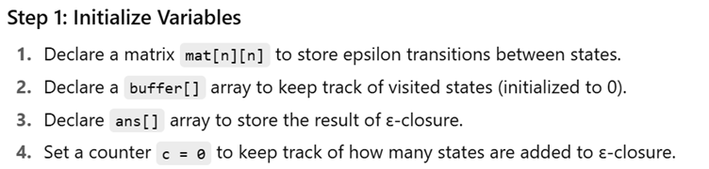
5. Open file in.txt in read mode.
6. Read the total number of states n.
7. Repeat until end of file:
- Read a transition of the form: from, symbol, to.
- If the transition symbol is 'e' (epsilon), set mat[from][to] = 1.
8. Ask the user to enter a state i for which the ε-closure should be computed

Function calc(x):
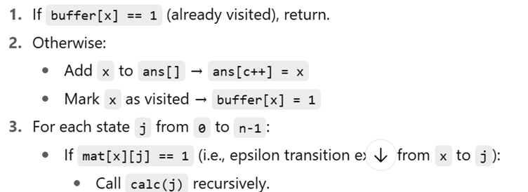
After the recursive function completes , display Ɛ closure by printing the values in ans[].

#include <stdio.h>

int mat[20][20] = {0};
int ans[20] = {0};
int n;

/* Recursive function to find ε-closure */
void calc(int x)
{
int j;

if(ans[x] == 1)
return;

ans[x] = 1;

for(j = 0; j < n; j++)
{
if(mat[x][j] == 1)
calc(j);
}
}

int main()
{
FILE *fp;
int from, to;
char symbol;
int state;

fp = fopen("in.txt", "r");

if(fp == NULL)
{
printf("File cannot be opened\n");
return 1;
}

/* Read number of states */
fscanf(fp, "%d", &n);

/* Read transitions until end of file */
while(fscanf(fp, "%d %c %d", &from, &symbol, &to) == 3)
{
if(symbol == 'e') /* epsilon transition */
mat[from][to] = 1;
}

fclose(fp);

printf("Enter the state: ");
scanf("%d", &state);

/* Compute ε-closure */
calc(state);

printf("E-closure(%d) = { ", state);

for(int i = 0; i < n; i++)
{
if(ans[i] == 1)
printf("%d ", i);
}

printf("}\n");

return 0;
}

in.txt
4
0 e 1
1 e 2
2 a 3
2 e 3

OUTPUT

Enter the state: 0
E-closure(0) = { 0 1 2 3 }

EXPERIMENT 8
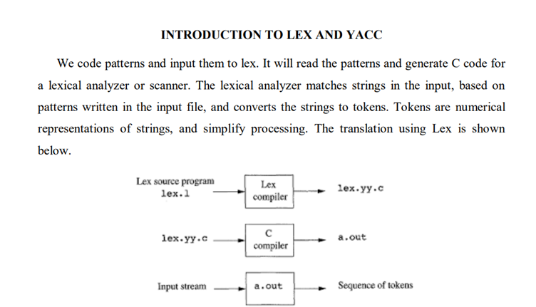
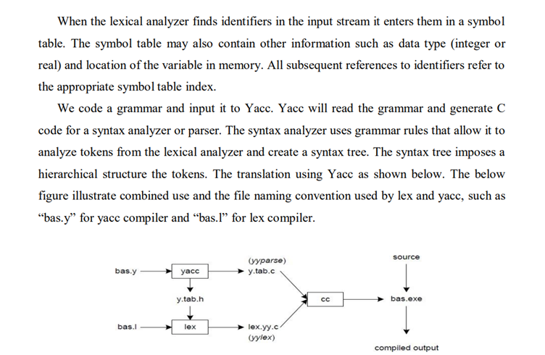
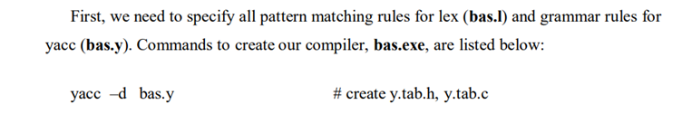
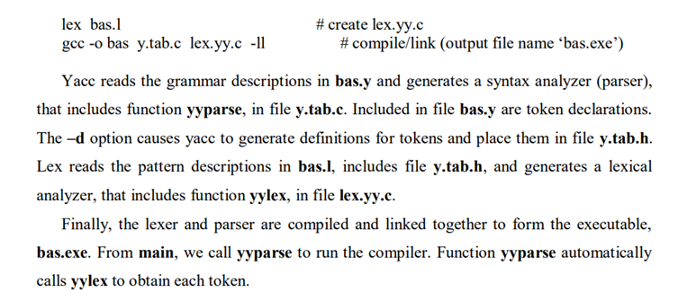
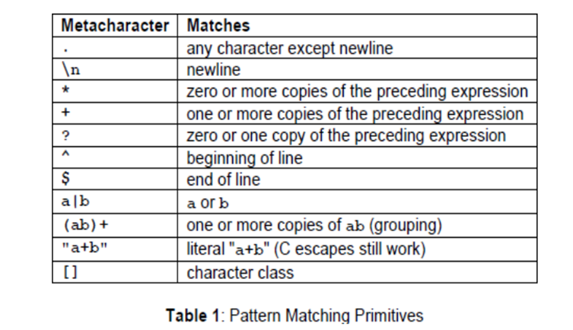
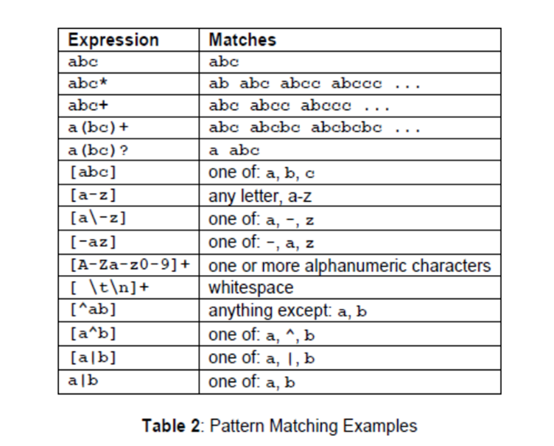
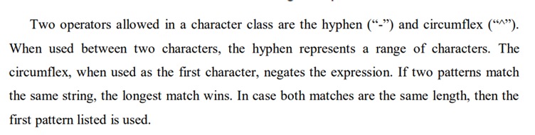

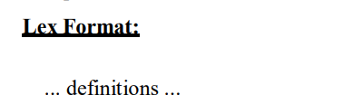
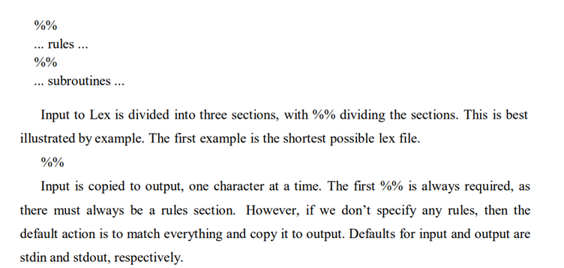
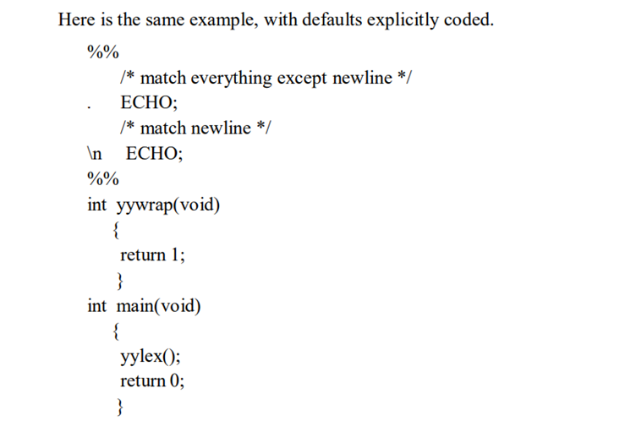
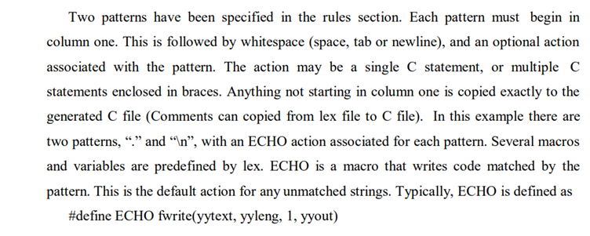
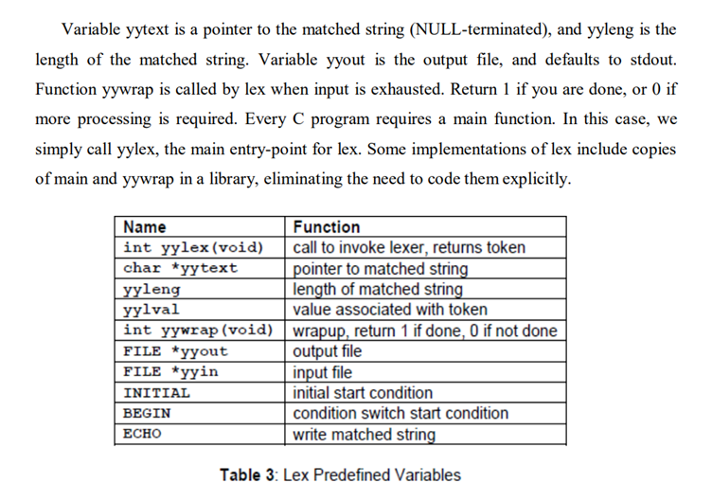
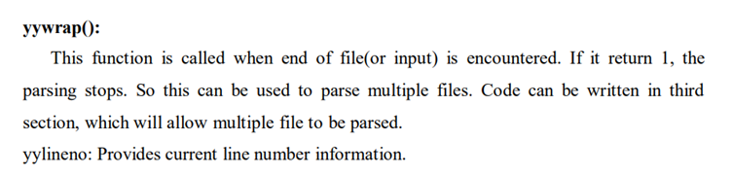
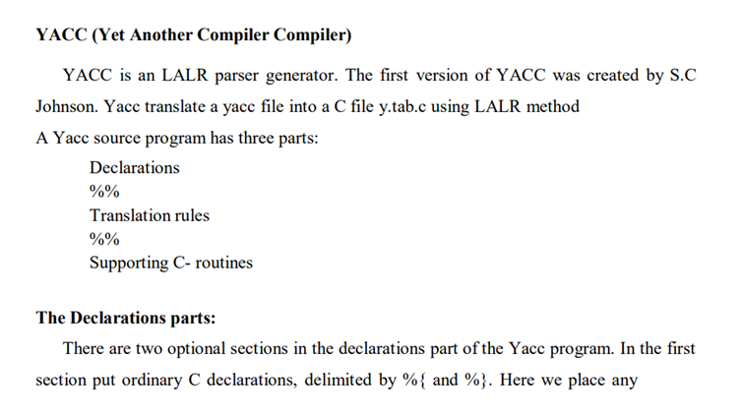
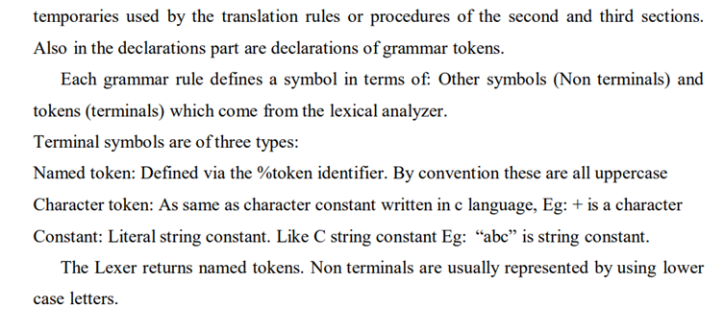
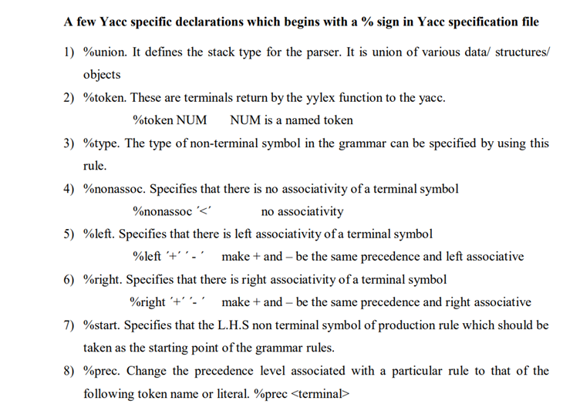
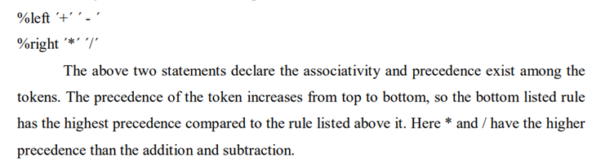
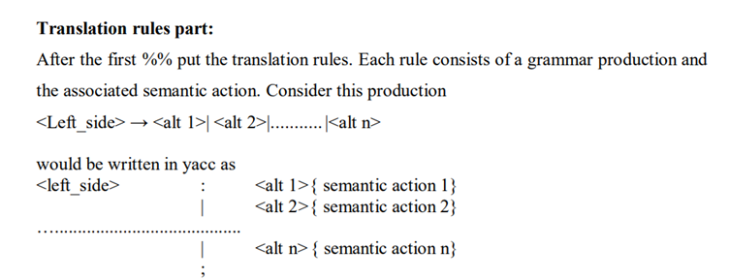
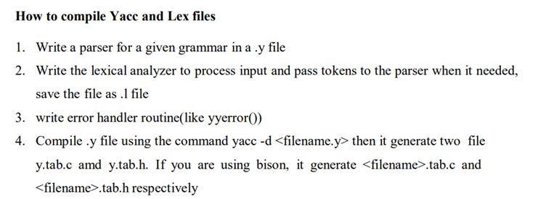
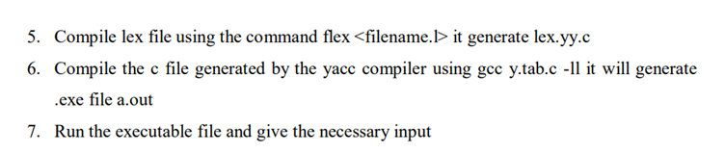

Experiment 9
IMPLEMENTATION OF LEXICAL ANALYZER USING LEX TOOL
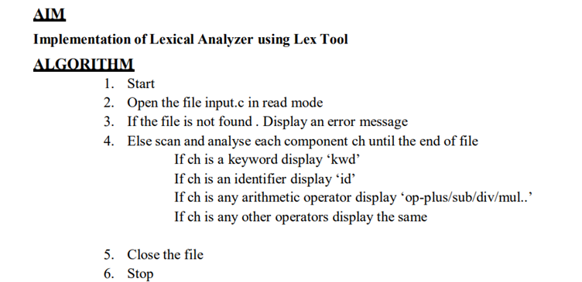
PROGRAM
Lex.l
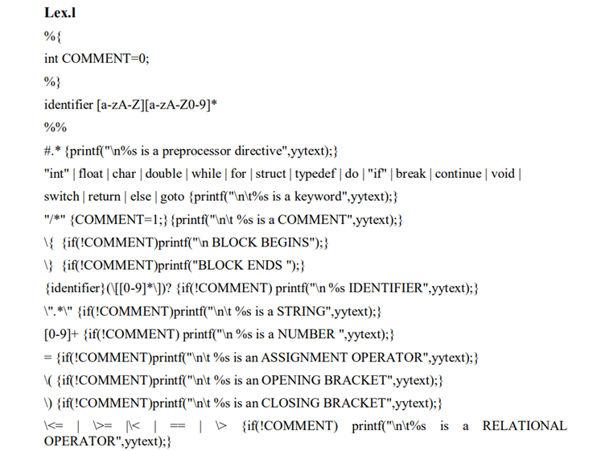
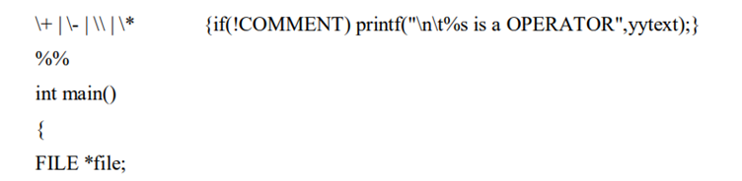
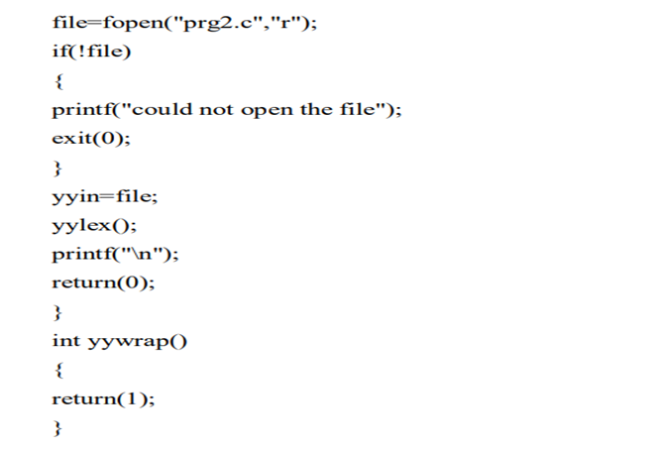
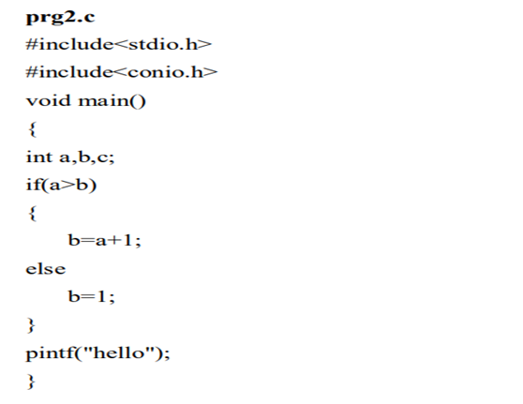

Experiment 10
DISPLAY THE NUMBER OF LINES,WORDS AND CHARACTERS IN AN INPUT TEXT
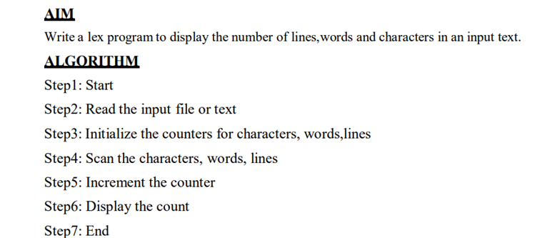
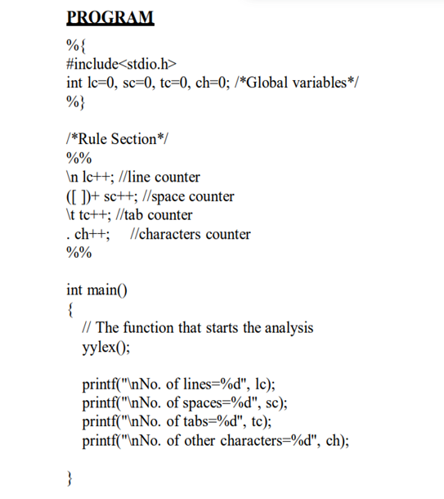
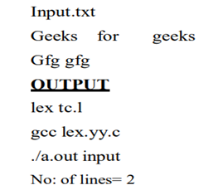
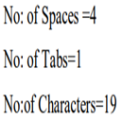

EXPERIMENT 11
CONVERT SUBSTRING abc TO ABC FROM THE GIVEN INPUT STRING USING LEX
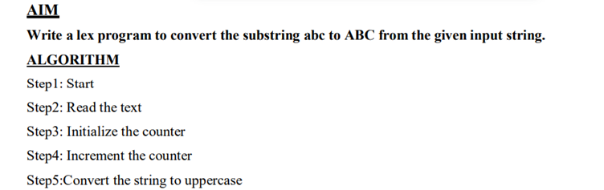

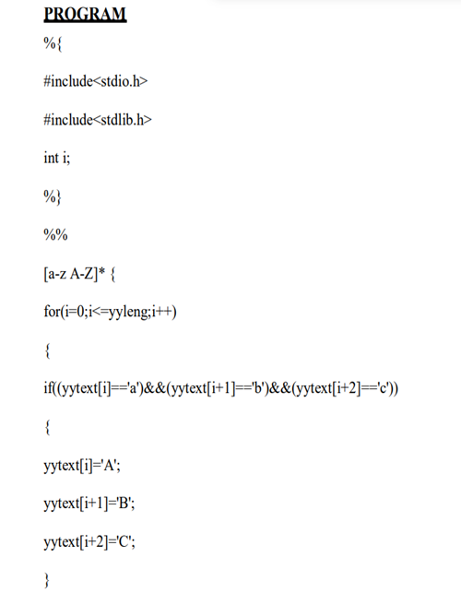
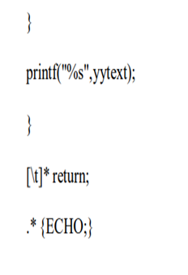
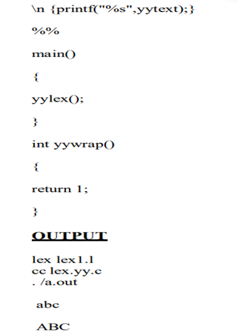

EXPERIMENT 12
FIND OUT TOTAL NUMBER OF VOWELS AND CONSONANTS FROM THE GIVEN INPUT STRING
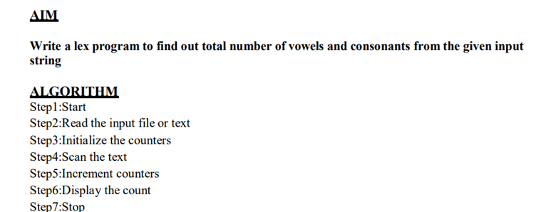
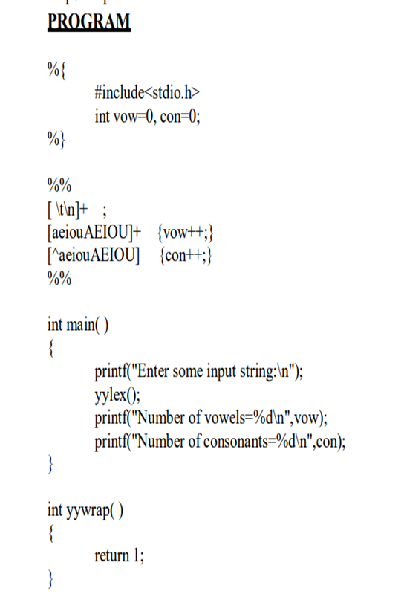
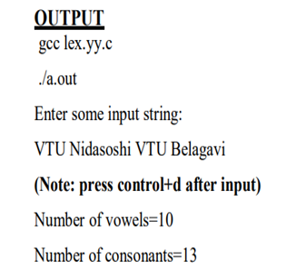

Experiment 13
RECOGNIZE A VALID ARITHMETIC EXPRESSION USING YACC
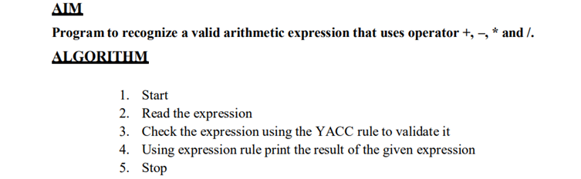
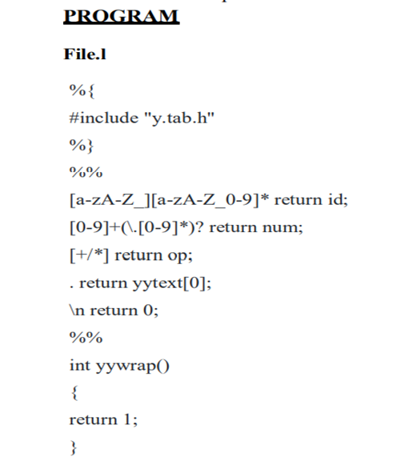
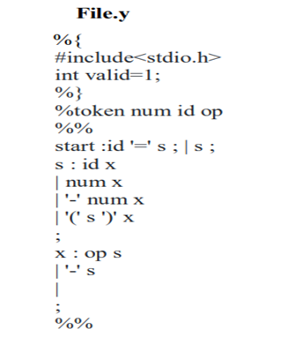
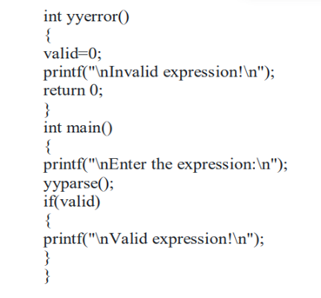
Execution:
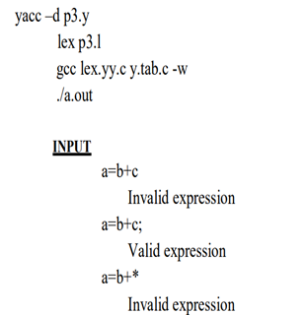

EXPERIMENT 14
RECOGNIZE A VALID IDENTIFIER USING YACC
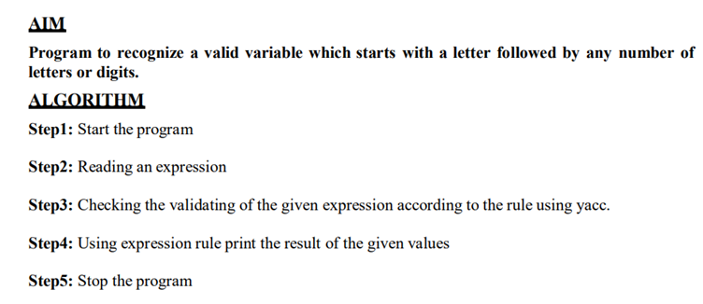
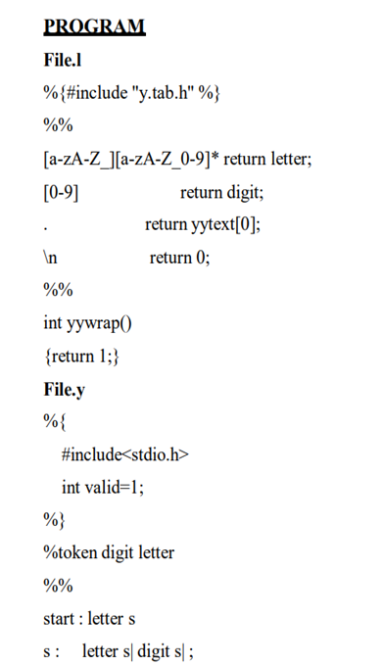
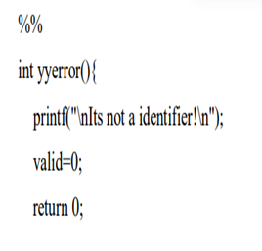
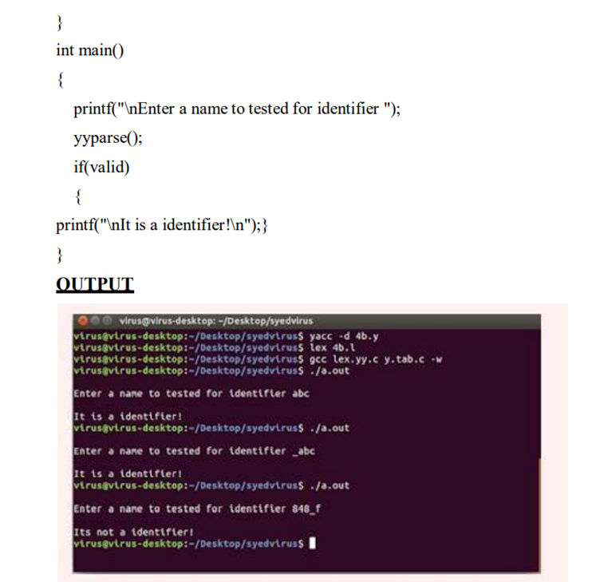

EXPERIMENT 15
IMPLEMENTATION OF CALCULATOR USING LEX AND YACC


