**Install Docker in all the nodes**

Copy the below script to the servers and execute it. The script can be found inside the docker folder.

#!/bin/bash

sudo apt update

sudo apt install -y apt-transport-https ca-certificates curl software-properties-common

curl -fsSL https://download.docker.com/linux/ubuntu/gpg | sudo apt-key add -

sudo add-apt-repository "deb [arch=amd64] https://download.docker.com/linux/ubuntu bionic stable"

sudo apt update

sudo apt install -y docker-ce

sudo usermod -aG docker $USER

**Start Rancher**

Copy the below script to the Rancher server and execute it. Install Docker in the server, before this step. (start-rancher.sh script)

#!/bin/bash

mkdir -p /opt/rancher

docker run -d --restart=unless-stopped -p 80:80 -p 443:443 -v /opt/rancher:/var/lib/rancher rancher/rancher:latest

**Access Rancher from the Browser**

<https://IPAddress> 🡪 Ex. <https://116.203.246.102>

Disable - Allow collection of anonymous statistics

Set Password and Click Continue

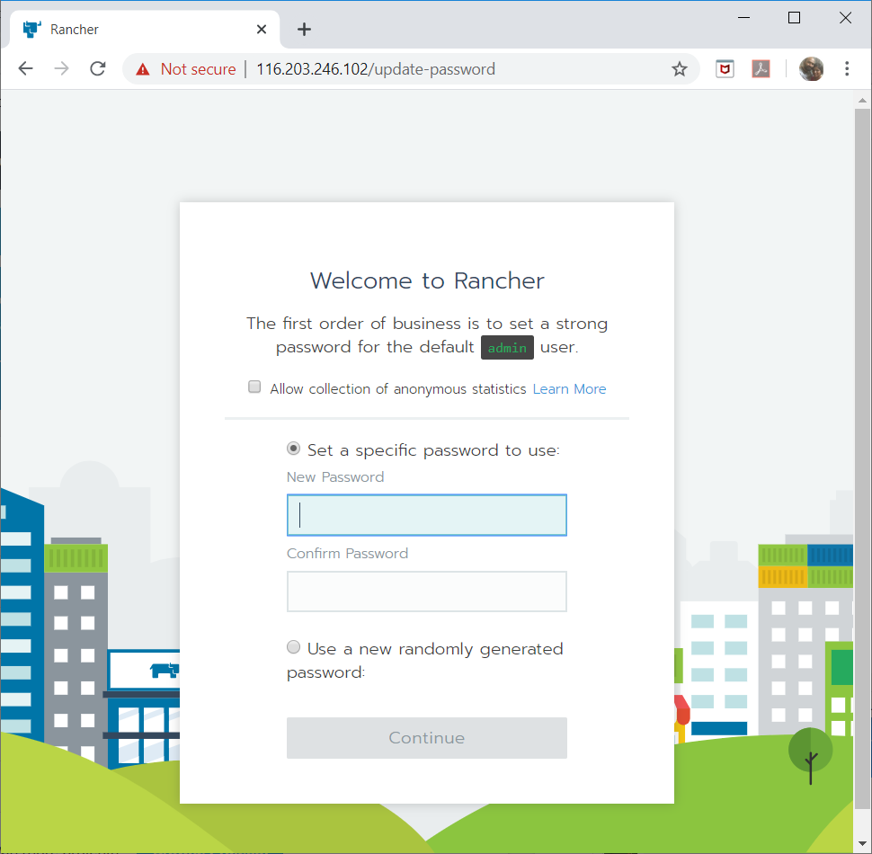

**Click Save URL**

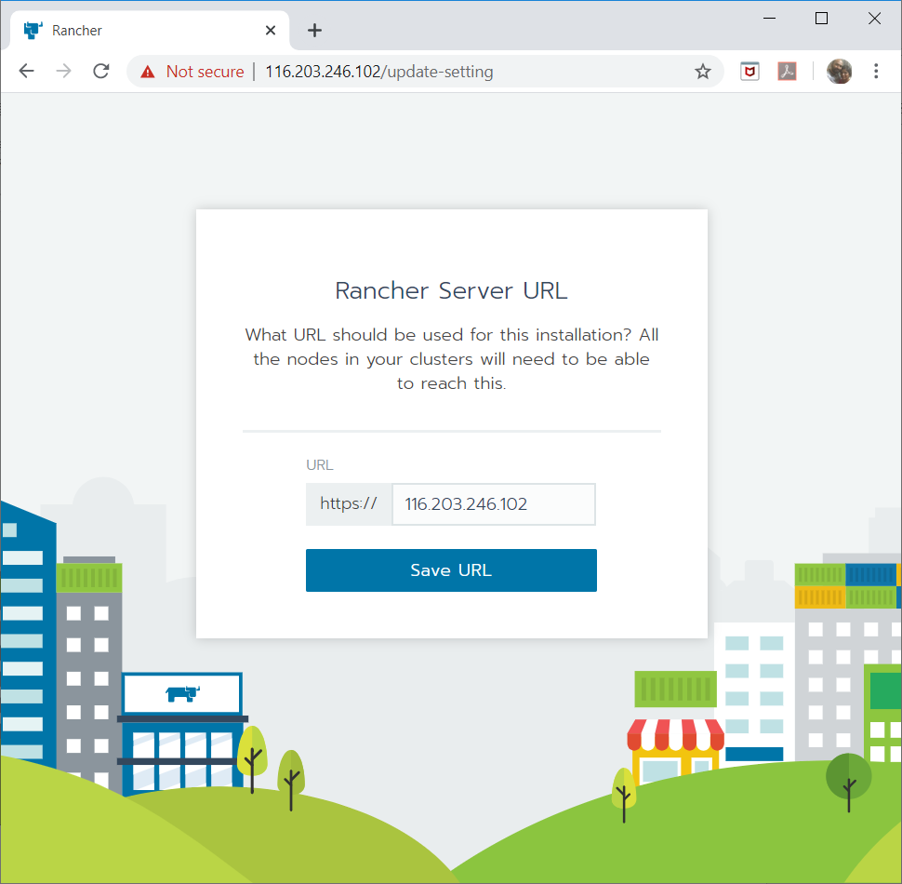

Download Rancher client (link can be found at the bottom once login) and copy it to the standard bin folder (PATH).

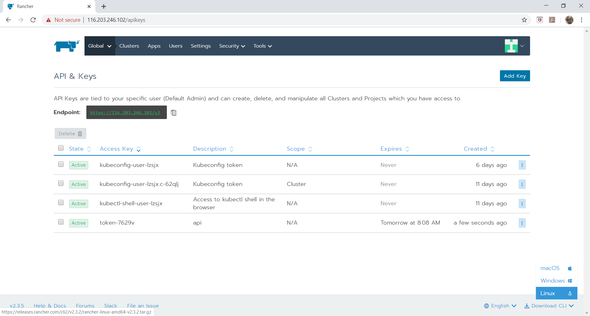

Kubectl Download and copy to bin folder (PATH) - <https://kubernetes.io/docs/tasks/tools/install-kubectl/>

**Get the API Key**

Profile (Top Right) 🡪 API & Keys

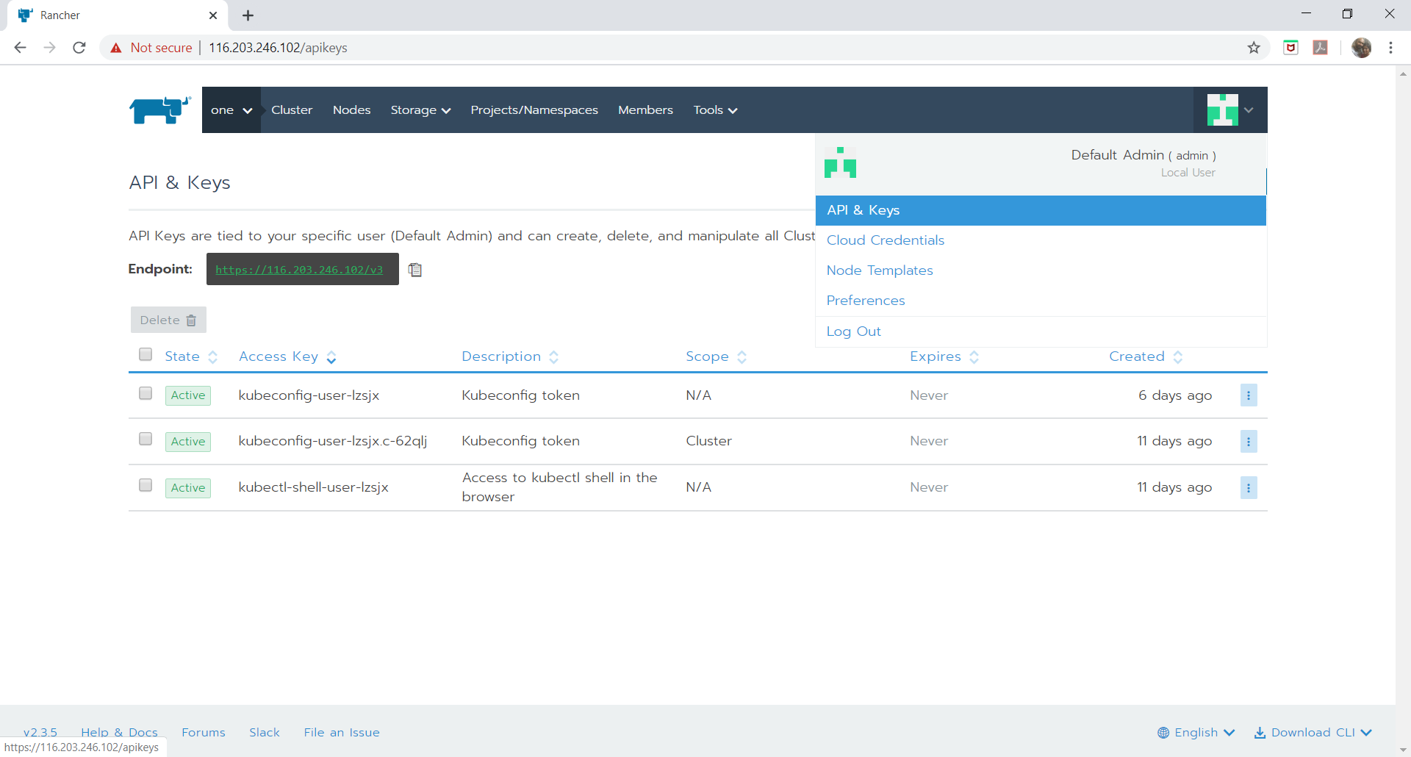

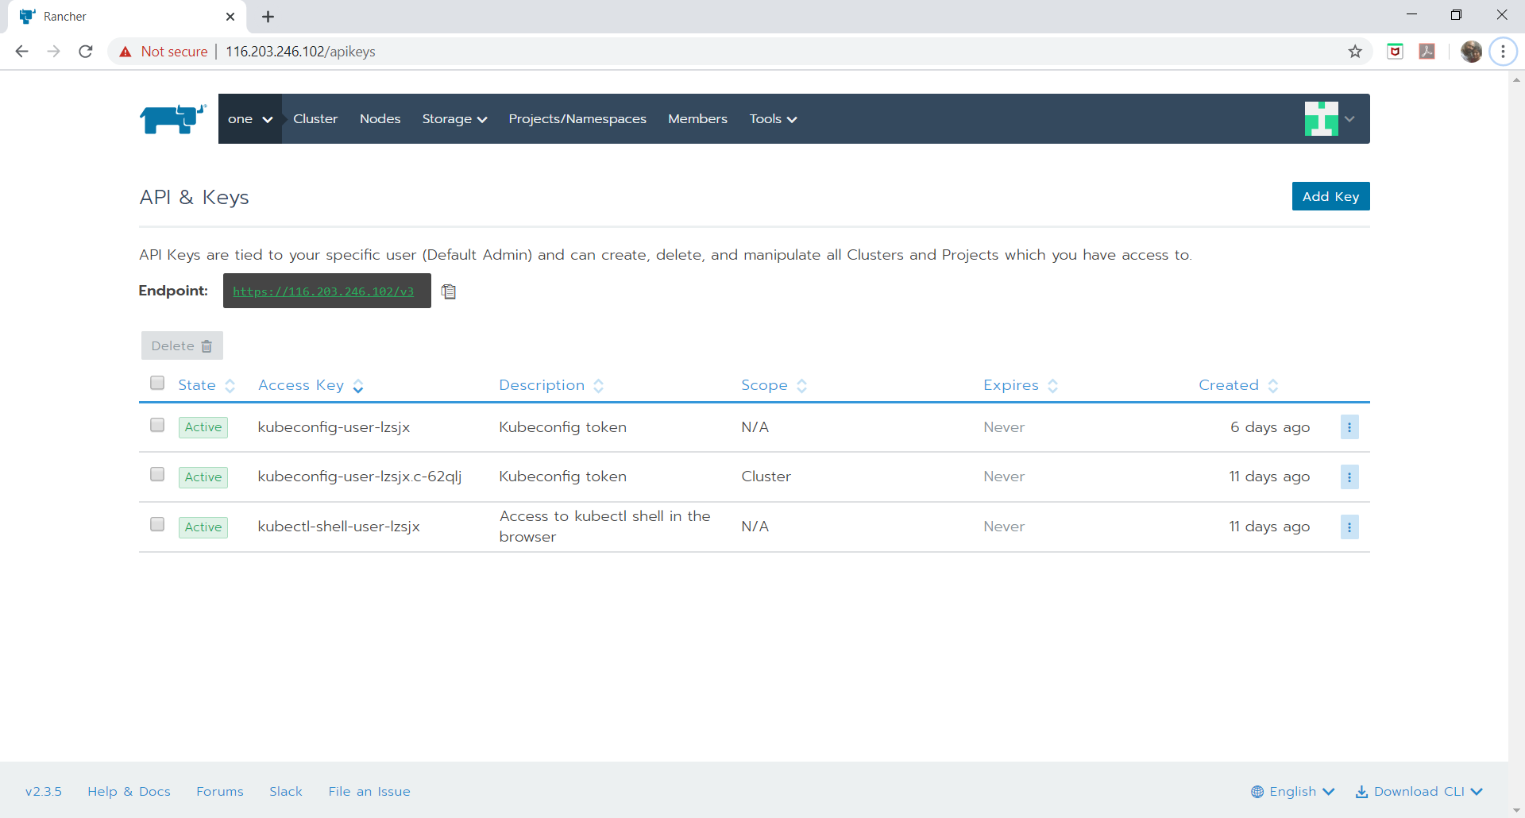

Add Key

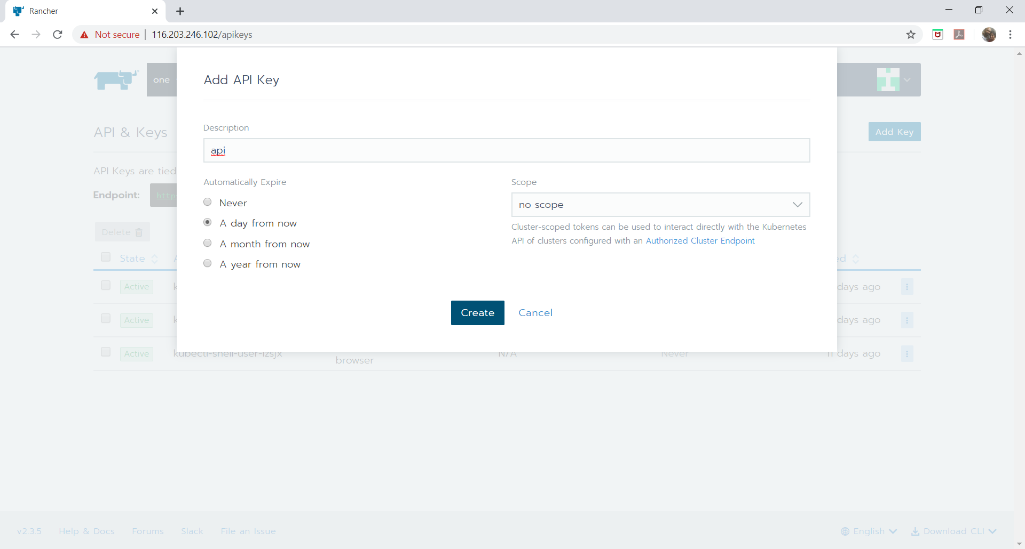

A popup with the keys will appear. Create a file (api.conf) with the details, as shown below.

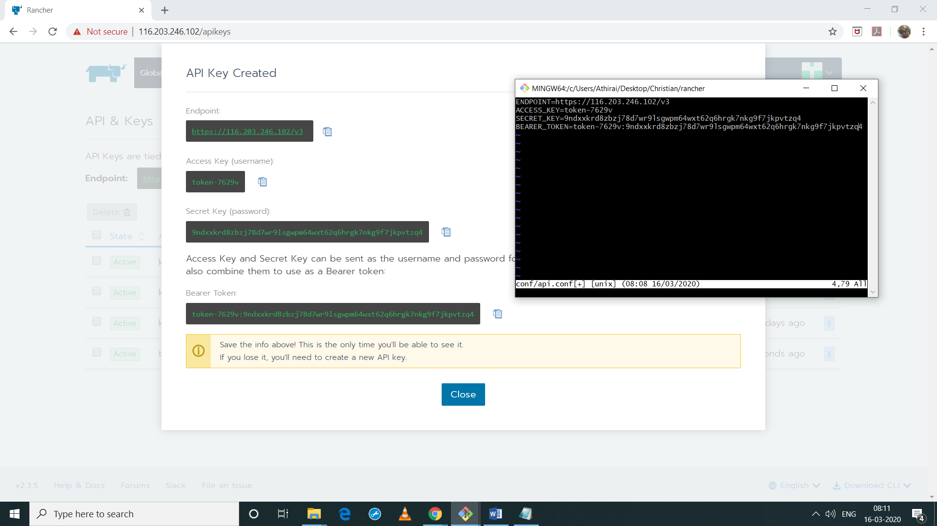

**Login**

Run login.sh <path to config file) to login to the rancher server.

Ex: ./login.sh conf/api.conf

**Cluster Create**

Run create-cluster.sh <cluster name> to create the cluster. It will output few commands in the stdout. Copy the commands and Run on the nodes (as required).

Ex: ./create-cluster.sh testcluster

The script will wait for the cluster to be up.

**Cluster Delete**

Run delete-cluster.sh <cluster name> to delete the cluster. Then run the cleanup.sh script on all the nodes to cleanup the node.

Ex: ./delete-cluster.sh testcluster

cleanup.sh is found inside docker folder.

**PostDock - Cluster**

The scripts for postgres cluster can be found inside PostDock folder.

create.sh <cluster name> - to create the cluster

Ex: ./create.sh postcluster

delete.sh <cluster name> - to delete the cluster

Ex: ./delete.sh postcluster