PROGRAM 1:

Code:

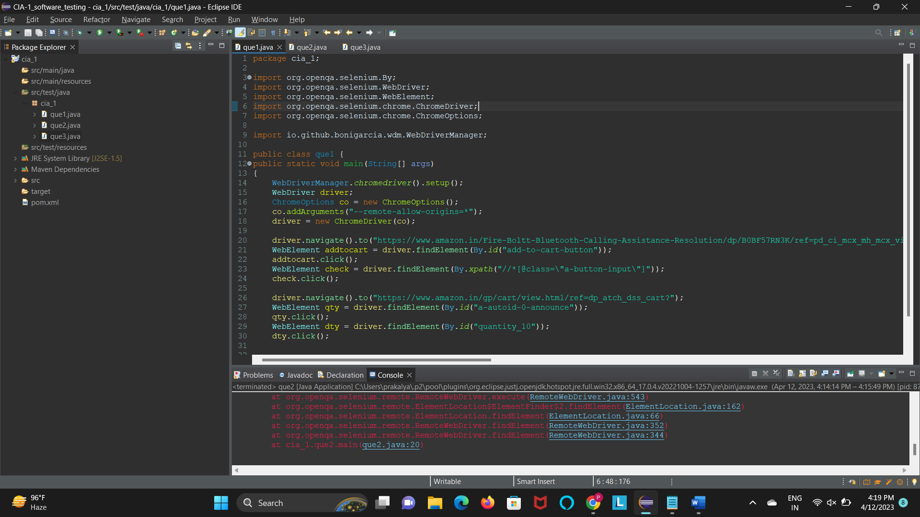

package com.selenium.test.NewTest2.SelTest;

import org.openqa.selenium.By;

import org.openqa.selenium.JavascriptExecutor;

import org.openqa.selenium.WebDriver;

import org.openqa.selenium.chrome.ChromeDriver;

import org.openqa.selenium.chrome.ChromeOptions;

import org.openqa.selenium.support.ui.Select;

import io.github.bonigarcia.wdm.WebDriverManager;

public class App

{

public static void main( String[] args ) throws InterruptedException

{

WebDriverManager.chromedriver().setup();

ChromeOptions co = new ChromeOptions();

co.addArguments(&quot;--remote-allow-origins=*&quot;);

WebDriver driver=new ChromeDriver(co);

driver.get(&quot;https://www.amazon.in/ASUS-15-6-inch-Integrated-Transparent-X515MA-

BR011W/dp/B09SGGB687?ref_=Oct_DLandingS_D_2c2d3a50_61&amp;th=1&quot;);

driver.manage().window().maximize();

String title=driver.getTitle();

System.out.println(title);

if(title.equals(&quot;Amazon.in: Buy ASUS VivoBook 15 (2021), 15.6-inch (39.62 cm) HD, Dual

Core Intel Celeron N4020, Thin and Light Laptop (4GB RAM/256GB SSD/Integrated Graphics/Windows

11 Home/Transparent Silver/1.8 Kg), X515MA-BR011W Online at Low Prices in India | ASUS Reviews &amp;

Ratings&quot;)) {

System.out.println(&quot;Verified title of the page&quot;);

}else {

System.out.println(&quot;Title not matched&quot;);

}

JavascriptExecutor js=(JavascriptExecutor) driver;

js.executeScript(&quot;window.scrollBy(0,1000)&quot;,&quot;&quot;);

driver.findElement(By.id(&quot;add-to-cart-button&quot;)).click();

System.out.println(&quot;Verified Add to Cart button&quot;);

String lnk=driver.findElement(By.id(&quot;//*[@id=\&quot;authportal-main-

section\&quot;]/div[2]/div/div[1]/form/div/div/div/h1&quot;)).getText();

if(lnk.equals(&quot;Sign in&quot;)) {

System.out.println(&quot;Sign in page landed&quot;);

}else {

System.out.println(&quot;Wrong page landed&quot;);

}

driver.quit();

}

}

Output:

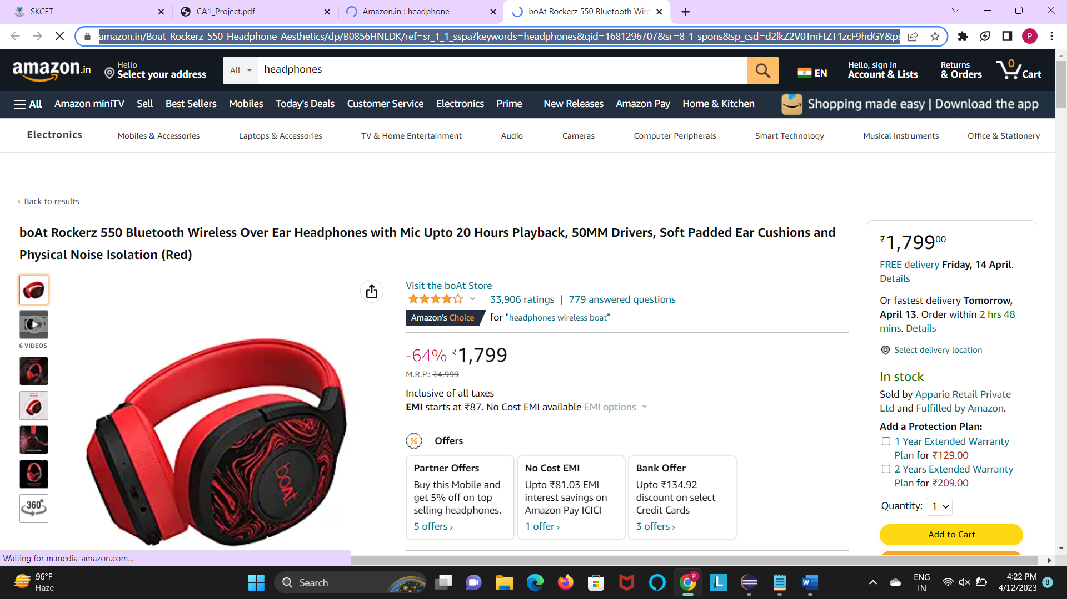

PROGRAM 2:

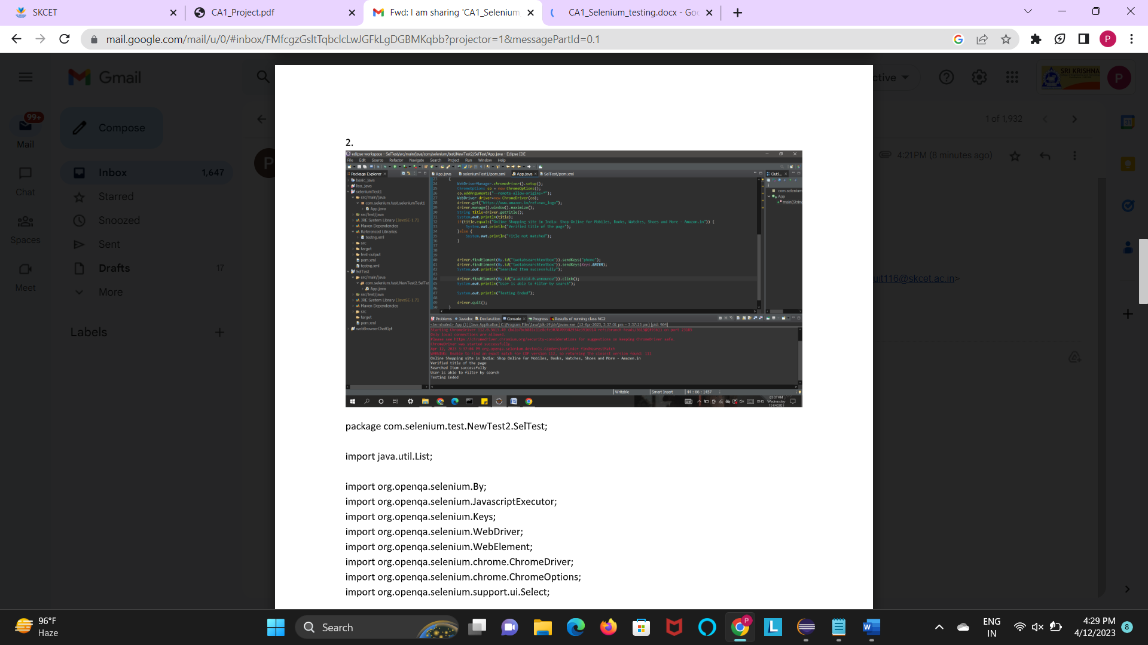

package com.selenium.test.NewTest2.SelTest;

import org.openqa.selenium.By;

import org.openqa.selenium.JavascriptExecutor;

import org.openqa.selenium.WebDriver;

import org.openqa.selenium.chrome.ChromeDriver;

import org.openqa.selenium.chrome.ChromeOptions;

import org.openqa.selenium.support.ui.Select;

import io.github.bonigarcia.wdm.WebDriverManager;

public class App

{

public static void main( String[] args ) throws InterruptedException

{

WebDriverManager.chromedriver().setup();

ChromeOptions co = new ChromeOptions();

co.addArguments(&quot;--remote-allow-origins=*&quot;);

WebDriver driver=new ChromeDriver(co);

driver.get(&quot;https://www.amazon.in/ASUS-15-6-inch-Integrated-Transparent-X515MA-

BR011W/dp/B09SGGB687?ref_=Oct_DLandingS_D_2c2d3a50_61&amp;th=1&quot;);

driver.manage().window().maximize();

String title=driver.getTitle();

System.out.println(title);

if(title.equals(&quot;Amazon.in: Buy ASUS VivoBook 15 (2021), 15.6-inch (39.62 cm) HD, Dual

Core Intel Celeron N4020, Thin and Light Laptop (4GB RAM/256GB SSD/Integrated Graphics/Windows

11 Home/Transparent Silver/1.8 Kg), X515MA-BR011W Online at Low Prices in India | ASUS Reviews &amp;

Ratings&quot;)) {

System.out.println(&quot;Verified title of the page&quot;);

}else {

System.out.println(&quot;Title not matched&quot;);

}

JavascriptExecutor js=(JavascriptExecutor) driver;

js.executeScript(&quot;window.scrollBy(0,1000)&quot;,&quot;&quot;);

driver.findElement(By.id(&quot;add-to-cart-button&quot;)).click();

System.out.println(&quot;Verified Add to Cart button&quot;);

String lnk=driver.findElement(By.id(&quot;//*[@id=\&quot;authportal-main-

section\&quot;]/div[2]/div/div[1]/form/div/div/div/h1&quot;)).getText();

if(lnk.equals(&quot;Sign in&quot;)) {

System.out.println(&quot;Sign in page landed&quot;);

}else {

System.out.println(&quot;Wrong page landed&quot;);

}

driver.quit();

}

}

PRAGRAM 3:

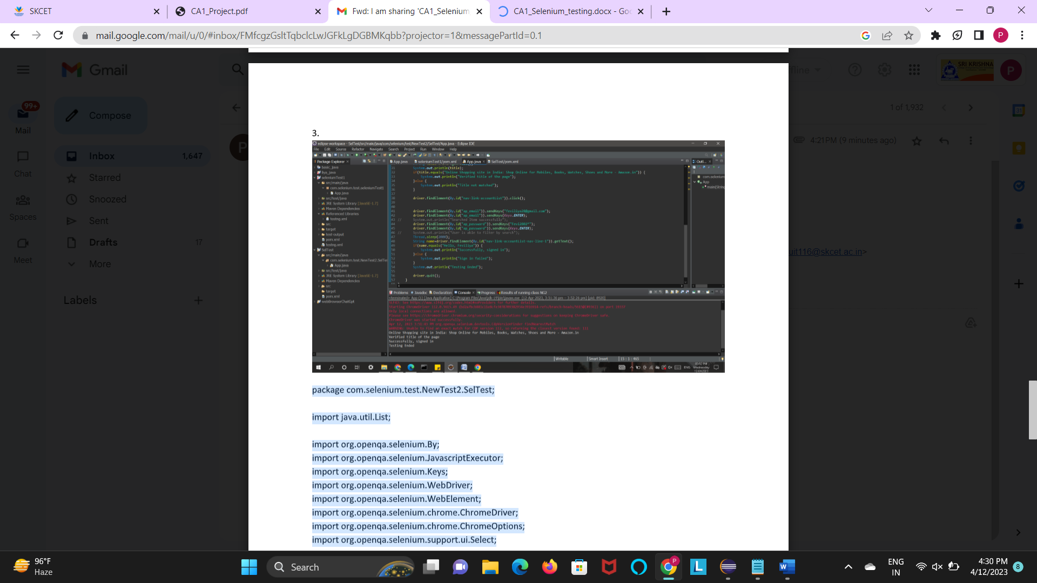

package com.selenium.test.NewTest2.SelTest;

import java.util.List;

import org.openqa.selenium.By;

import org.openqa.selenium.JavascriptExecutor;

import org.openqa.selenium.Keys;

import org.openqa.selenium.WebDriver;

import org.openqa.selenium.WebElement;

import org.openqa.selenium.chrome.ChromeDriver;

import org.openqa.selenium.chrome.ChromeOptions;

import org.openqa.selenium.support.ui.Select;

import io.github.bonigarcia.wdm.WebDriverManager;

/**

* Hello world!

*

*/

public class App

{

public static void main( String[] args ) throws InterruptedException

{

WebDriverManager.chromedriver().setup();

ChromeOptions co = new ChromeOptions();

co.addArguments(&quot;--remote-allow-origins=*&quot;);

WebDriver driver=new ChromeDriver(co);

driver.get(&quot;https://www.amazon.in/ref=nav_logo&quot;);

driver.manage().window().maximize();

String title=driver.getTitle();

System.out.println(title);

if(title.equals(&quot;Online Shopping site in India: Shop Online for Mobiles, Books, Watches,

Shoes and More - Amazon.in&quot;)) {

System.out.println(&quot;Verified title of the page&quot;);

}else {

System.out.println(&quot;Title not matched&quot;);

}

driver.findElement(By.id(&quot;nav-link-accountList&quot;)).click();

driver.findElement(By.id(&quot;ap_email&quot;)).sendKeys(&quot;feviliya28@gmail.com&quot;);

driver.findElement(By.id(&quot;ap_email&quot;)).sendKeys(Keys.ENTER);

driver.findElement(By.id(&quot;ap_password&quot;)).sendKeys(&quot;Fevi2802*&quot;);

driver.findElement(By.id(&quot;ap_password&quot;)).sendKeys(Keys.ENTER);

Thread.sleep(2000);

String name=driver.findElement(By.id(&quot;nav-link-accountList-nav-line-1&quot;)).getText();

if(name.equals(&quot;Hello, Feviliya&quot;)) {

System.out.println(&quot;Successfully, signed in&quot;);

}else {

System.out.println(&quot;Sign in failed&quot;);

}

System.out.println(&quot;Testing Ended&quot;);

driver.quit();

}

}