Assignment 1 (COL334 Computer Networks)
Prakhar Aggarwal 2019CS50441

- Networking Tools

- IP addresses are provided by an Internet Service Provider (ISP). Most likely, the ISP will provide us with a dynamic IP address (In essence, that IP address is borrowed or “leased” whenever we go online).
- When connected to the Netplus Network, IP address is: 192.168.1.10
- When connected to ZTE Network, the IP address is: 192.168.1.4
- When connected to Airtel Network, the IP address is: 192.168.43.75
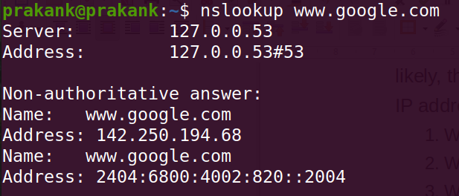
- IP address associated with
  - www.google.com:
IPv4: 142.250.194.68

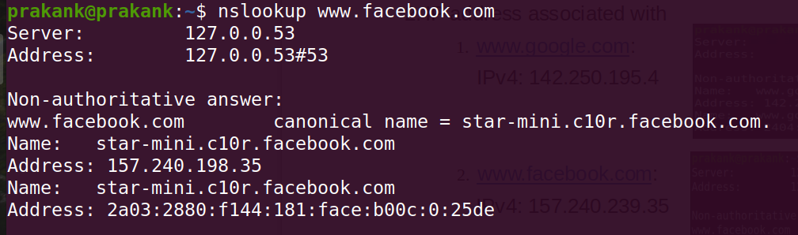
- www.facebook.com:
IPv4: 157.240.198.35

Using the Google Public DNS, IP address change as follows:
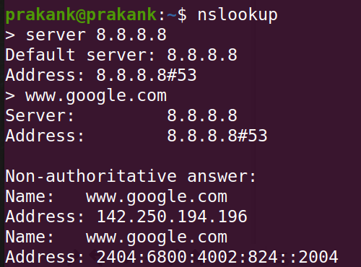
www.google.com:

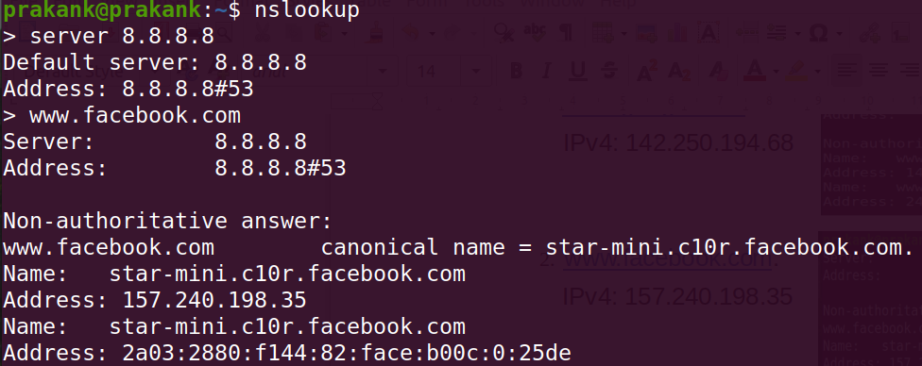
www.facebook.com:

(Reason for why IP address of google changes but for facebook, it remains the same)

(c) ping www.iitd.ac.in with packet size of 1008 bytes (1000 data bytes combined with the 8 bytes of ICMP header data)

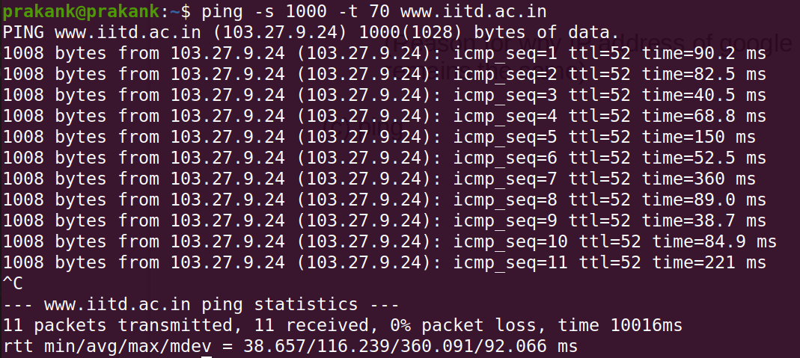

Maximum size of ping packets for www.iitd.ac.in is: (65507)
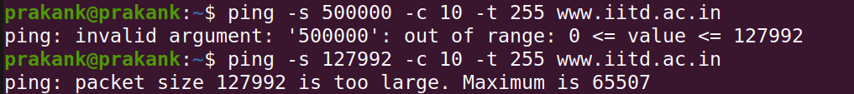

For www.google.com, it is: (127992)
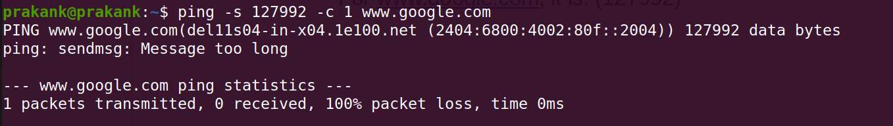

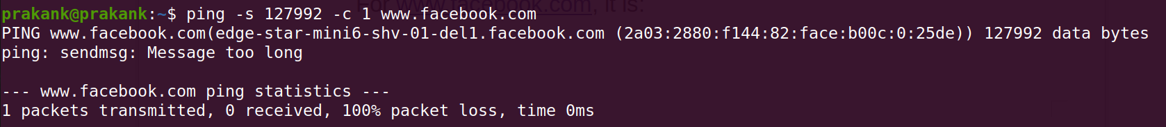
For www.facebook.com, it is: (127992)

(d) traceroute to www.facebook.com (connected to Airtel) (192.168.43.75)

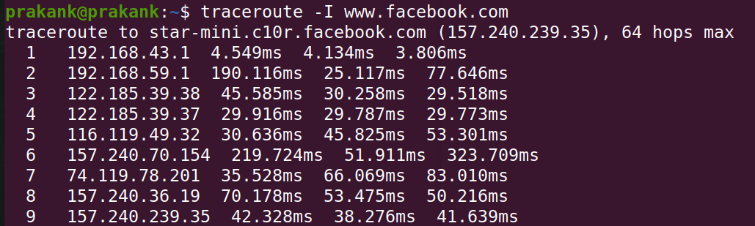

traceroute to www.facebook.com (connected to Netplus) (192.168.1.10)
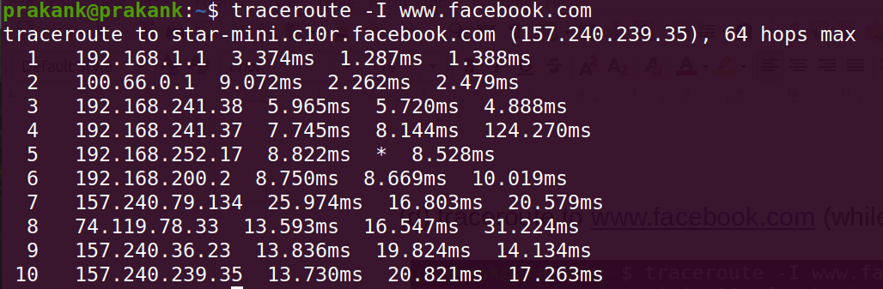

2.) Packet Analysis

To capture http://apache.org/ packets, I closed all other pages and stopped capturing the packets in wireshark once the page was loaded completely.

- For capturing dns packets, I cleared the DNS cache from the system as well as from the browser.
First packet (DNS)

Last packet (DNS)

It took a total of 4.3064 – 0.9327 = 3.3737 sec for the DNS request-response to complete.

(b) A total of 14 HTTP requests were generated for loading the http://apache.org/ page completely.

First the css (Style) rendering occurs, then the javascript part and then the images are loaded.
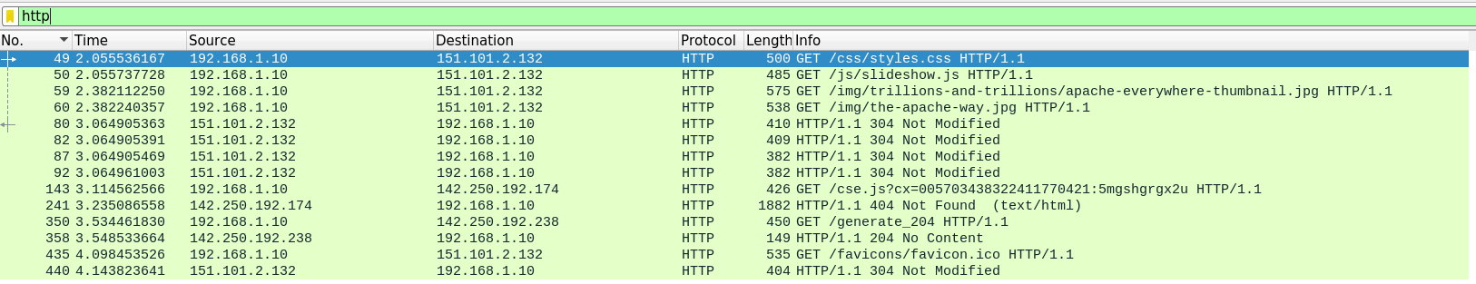
(c) Total time: time when the last content object was received – time of the first DNS request
: 4.5786 – 0.9327 = 3.6459sec

(d) There is no HTTP packet.

HTTPS means that the content is encrypted. As Wireshark can not decrypt the content the used protocol inside the TLS connection is unknown to Wireshark - it can be HTTP or any other protocol. Therefore they are displayed as TLSv1.2/TCP. Only the ports indicate that most likely it is HTTPS traffic.

