COL334 – Computer Networks
Prakhar Aggarwal
2019CS50441

Assignment-3
October 26, 2021

Part 1 (Analyzing different congestion control protocols)

In this part, we had 2 nodes N1, N2 and connected them using a point-to-point link. Analysis is done for 4 different protocols:

- HighSpeed: In this protocol, window size increases depending on the count of acknowledgement received. When this count crosses a certain threshold value, current window size is increased by Maximum Segment Size. We can observe from the below graphs, maximum peak window size is of TcpHighSpeed protocl. Reason being, the window size increases more frequently with acknowledgements. Dropped packets: 35

- NewReno: This is the default protocol used by ns3. In this, we have 2 different phase: Slow Start and Congestion avoidance. In the slow start phase, window size is increased by new acknowledgements received. Whereas, in the congestion avoidance phase, window size is increased by Maximum Segment size. Dropped packets: 35

- Vegas: In this protocol, round-trip delays are measured for every packet in the transmit buffer. TcpVegas emphasizes packet delay, rather than packet loss. This protocol uses additive increase to increase the congestion window. This protocol ddetects congestion at an early stage based on the Round trip time of a packet, wherease, other protocols detect congestion only after it has actually happened via packet loss. We can also oberve from the graph that window starts from size 1 for TcpVegas. Dropped packets: 37

- Veno: In this protocol, the window size increases by 1 for every other acknowledgement received. This is slightly different than NewReno, where, window size increases by 1 for every acknowledgement received. In case of packet loss, window size decreases by (current window)/5 and not by (current window)/2. We can see that TcpVeno and TcpNewReno behaves almost identically. Dropped packets: 35.

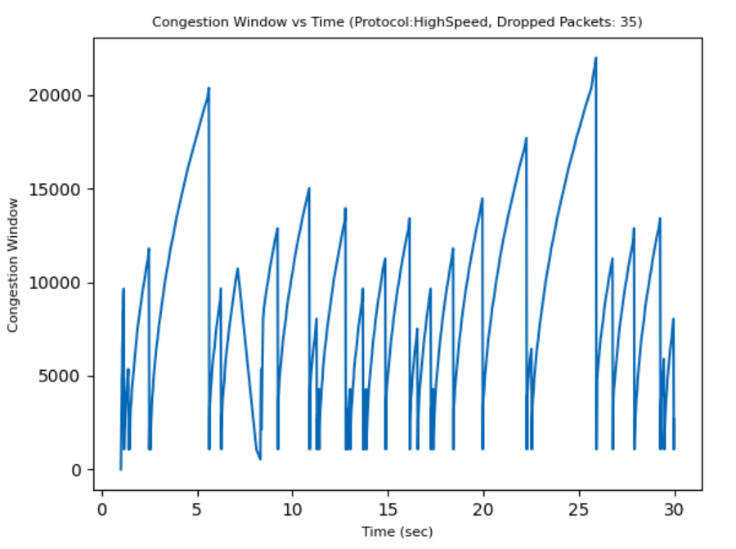Figure 1: HighSpeed
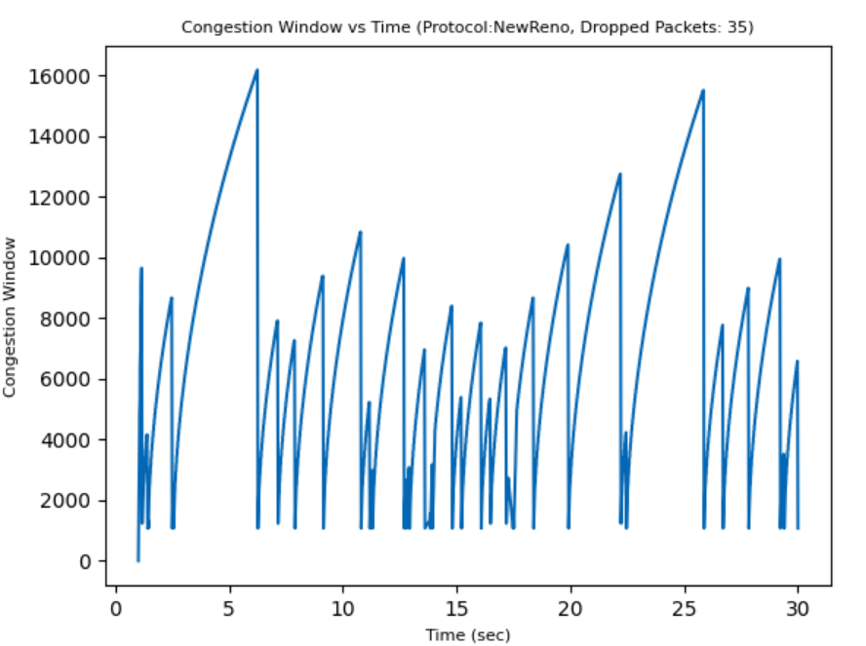Figure 2: NewReno

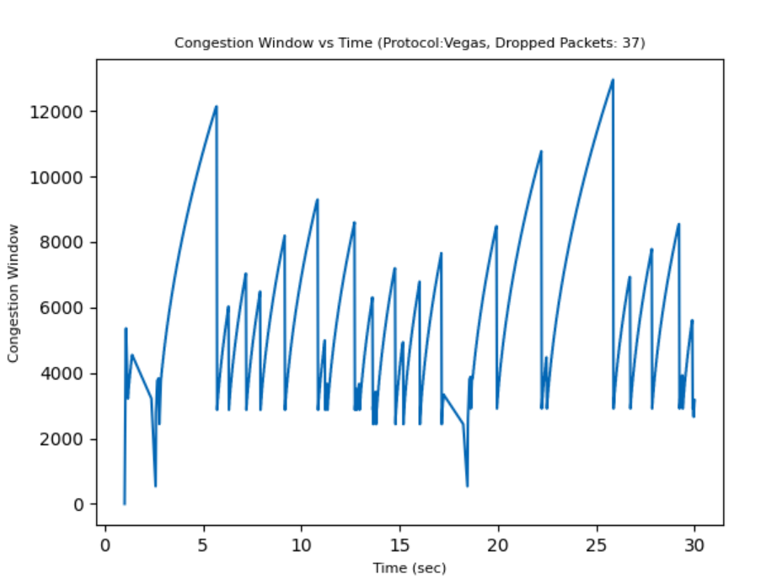Figure 3: Vegas
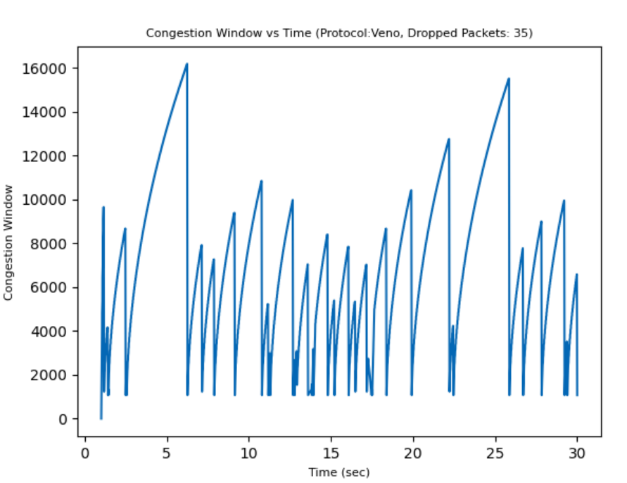Figure 4: Veno

Part 2 (Effect of Application data rate on the Congestion window)

Part a (Varying Channel Data Rate)

TcpNewReno is taken to be the default congestion protocol.

Channel Data Rates is varied among (2Mbps, 4Mbps, 10Mbps, 20Mbps, 50Mbps) with Application Data Rate = 2Mbps

- Number of dropped packets increases with increase in channel data rate. Reason for this is that, as the channel data rate increases, the rate of sending packets increases too, hence, packet loss increases as the error rate is fixed.

- Also, with more packets, the acknowledgements received increases, hence, the window size increases faster with increase in channel data rate. This can be observed from the below graphs, graph lines tend to come closer for higher channel data rate.

- Packets Dropped (ADR = 2Mbps):
  - CDR = 2Mbps: 56
  - CDR = 4Mbps: 66
  - CDR = 10Mbps: 68
  - CDR = 20Mbps: 68
  - CDR = 50Mbps: 70
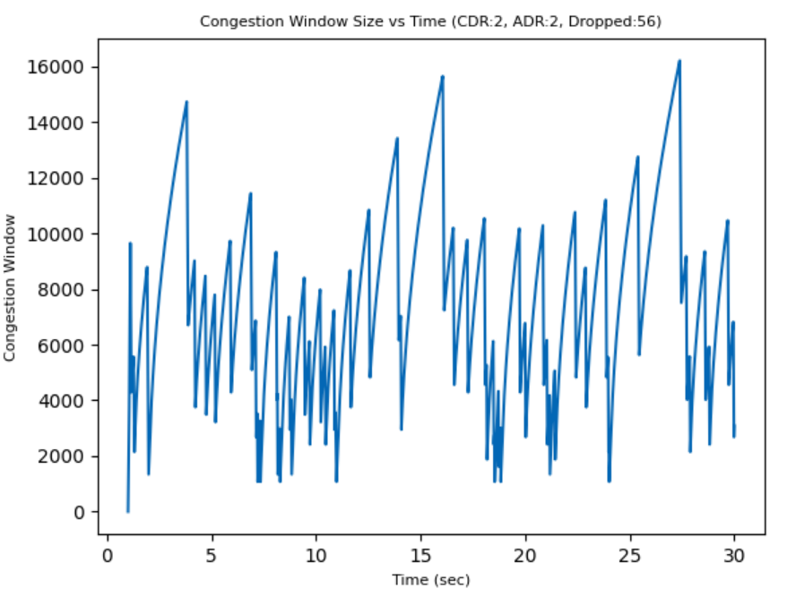
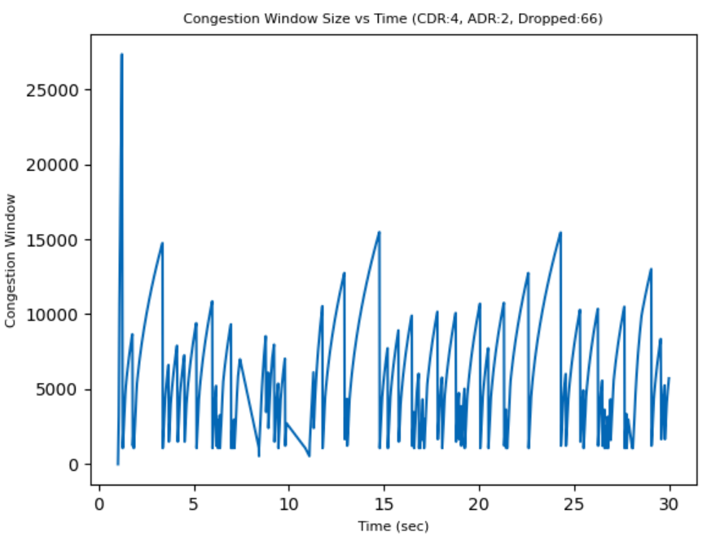

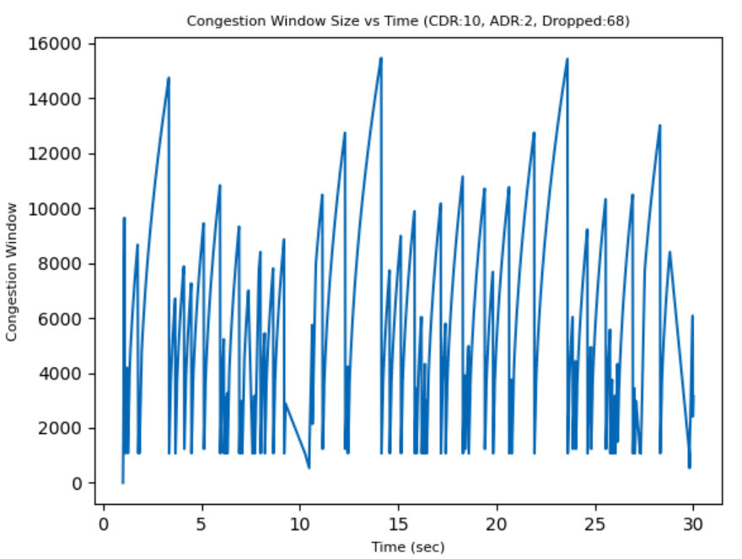
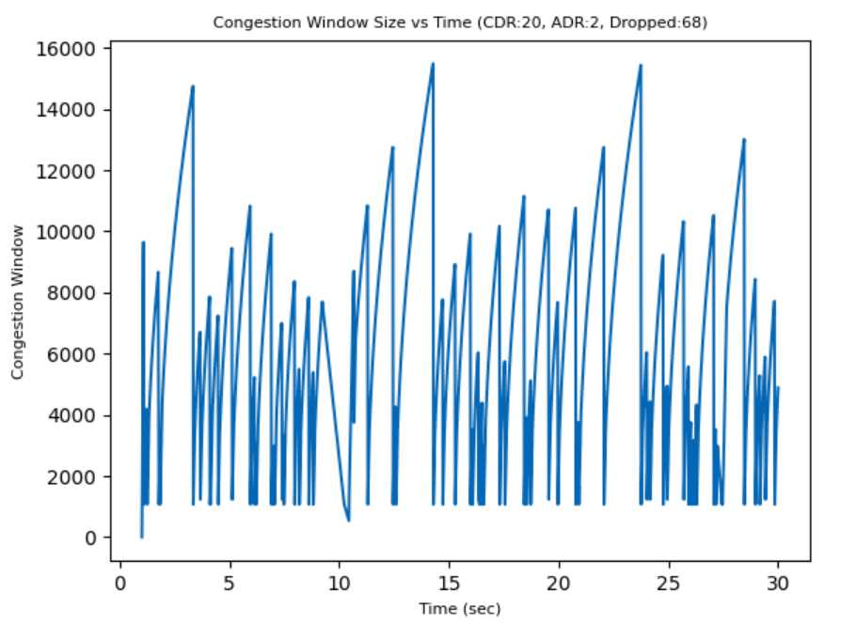

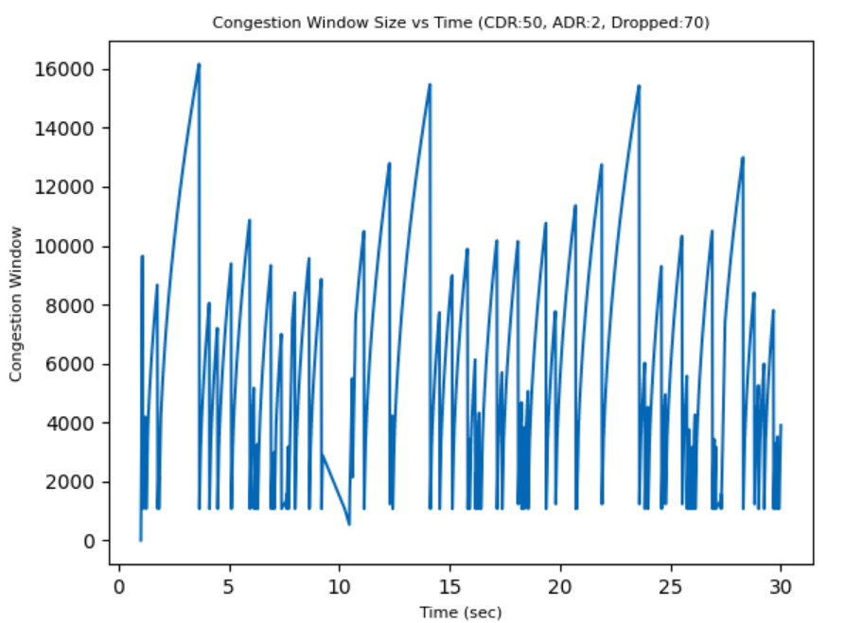

Part b (Varying Application Data Rate)

TcpNewReno is taken to be the default congestion protocol.

Application Data Rates is varied among (0.5Mbps, 1Mbps, 2Mbps, 4Mbps, 10Mbps) with Channel Data Rate = 6Mbps

- In this part too, number of dropped packets increase with increase in Application data rate. As the Application data rate increases, the rate of sending packets increases too, hence, packet loss increases as the error rate is fixed.

- In this case too, congestion window increases much more rapidly as number of acknowledgement received increases with increase in application data rate.

- As can be observed from the graphs, the lines tend to come closer with increasing application data rate.

- Packets Dropped (CDR = 6Mbps):
  - ADR = 0.5Mbps: 19
  - ADR = 1Mbps: 35
  - ADR = 2Mbps: 66
  - ADR = 4Mbps: 141
  - ADR = 10Mbps: 140

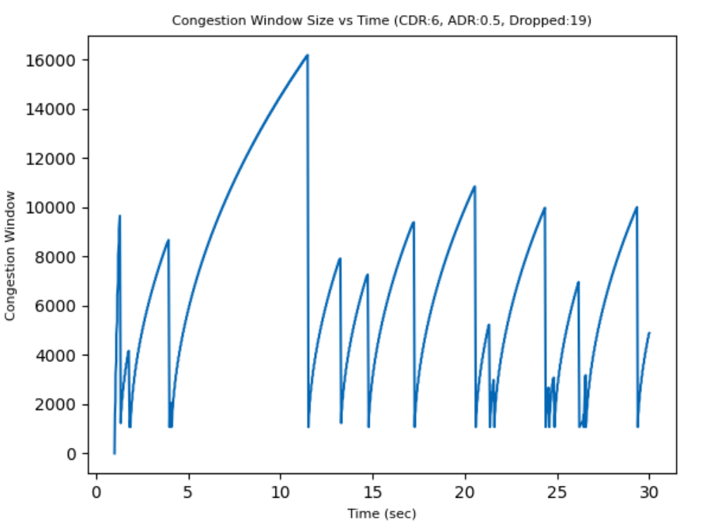
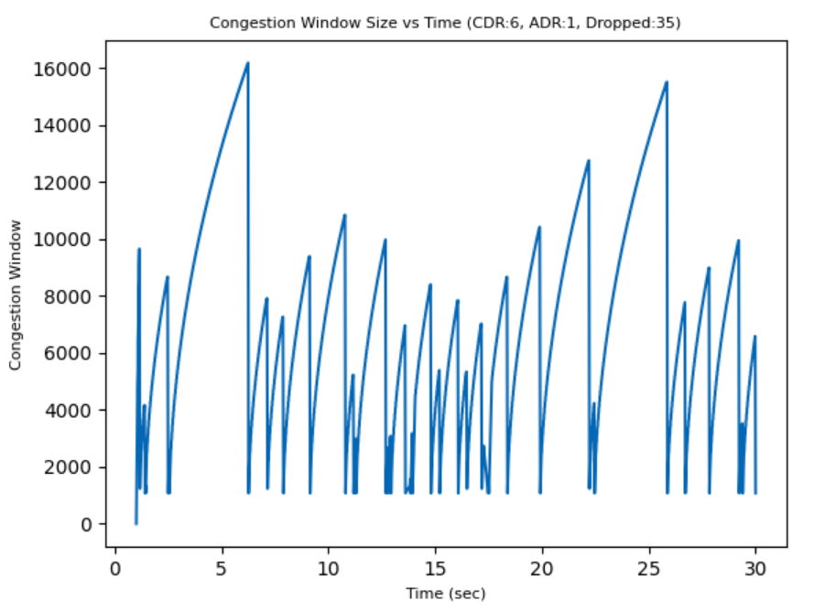

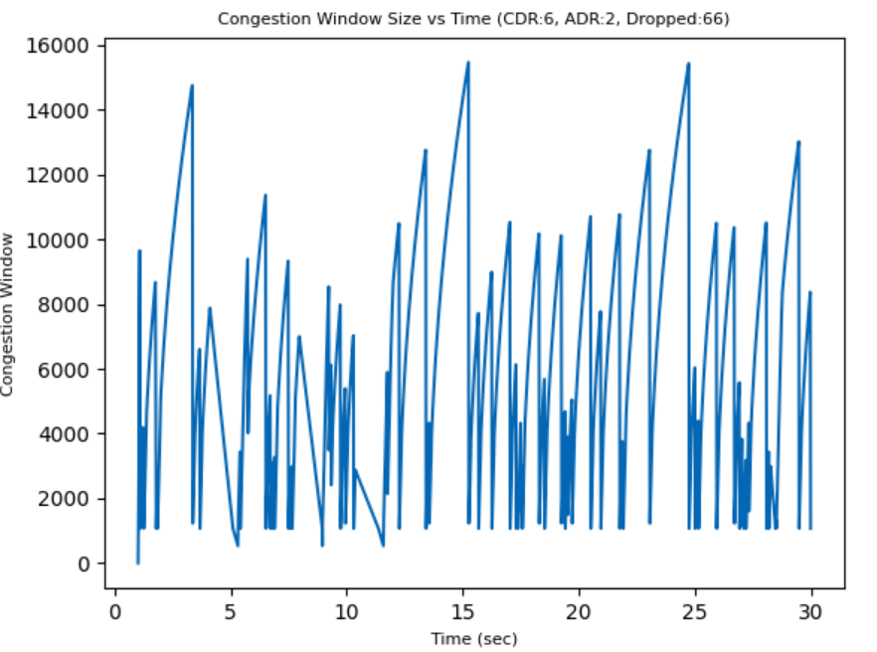
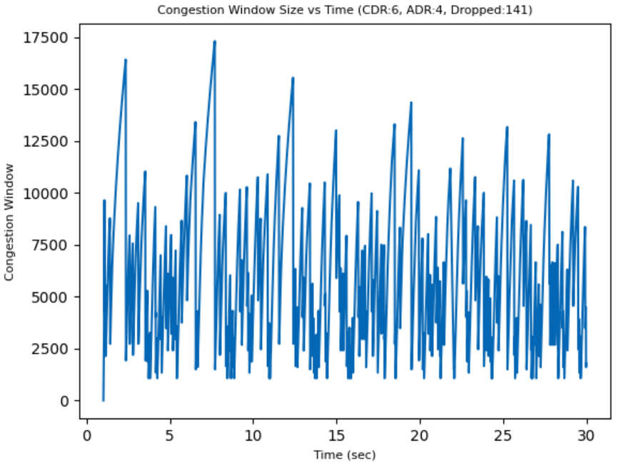

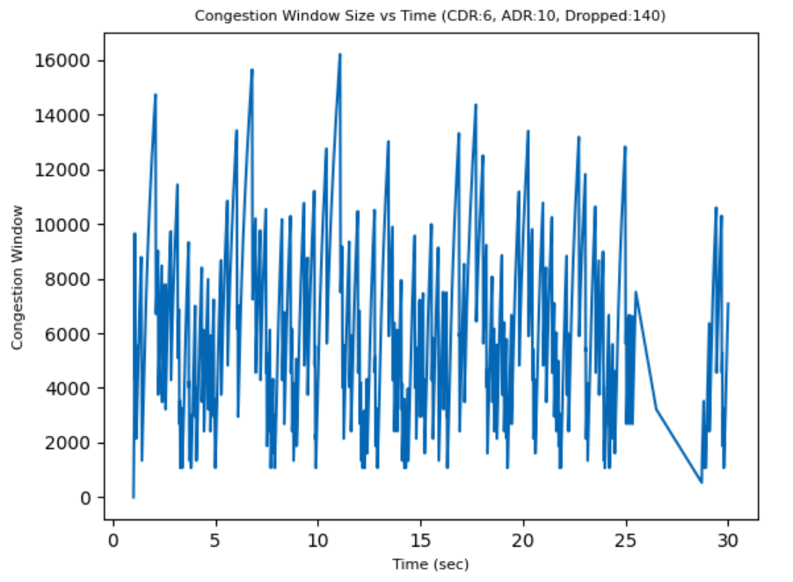

Part 3 (Effect of Application data rate on the Congestion window)

In this part, we had a network with 3 nodes. We had to model our own TCP congestion protocol (Tcp NewRenoCSE) and analyze the behaviour of congestion window for Tcp NewRenoCSE and Tcp NewReno for all 3 connections.
- We can see from the graph that the congestion window size increases much more rapidly in case of TcpNewRenoCSE because of exponential increment.
- As the congestion window size increases rapidly in TcpNewRenoCSE, the total number of packets sent also increases.
- In the congestion avoidance phase, for TcnNewReno, window size increases with inversely proportional to current window size. Whereas, for TcpNewReno, the increase in window size is linear.
- This can be observed from the graph, in the congestion avoidance phase, the shape of window size is concave for TcpNewReno whereas, it is a linear increase for TcpNewRenoCSE.
- Packet loss is roughly decreased in TcpNewRenoCSE even if packets at higher rate are sent because, the threshold for TcpNewRenoCSE is also higher.
- Due to this, higher number of packets are sent without drop

- Packet loss:
  - Connection 1
    - Configuration 1: 37
    - Configuration 2: 34
    - Configuration 3: 35
  - Connection 2
    - Configuration 1: 37
    - Configuration 2: 39
    - Configuration 3: 39
  - Connection 3
    - Configuration 1: 26
    - Configuration 2: 29
    - Configuration 3: 26

