Part-1

ip address of my machine when connected to Netplus wifi -> 192.168.1.10

ip address changes on connecting to different service providers

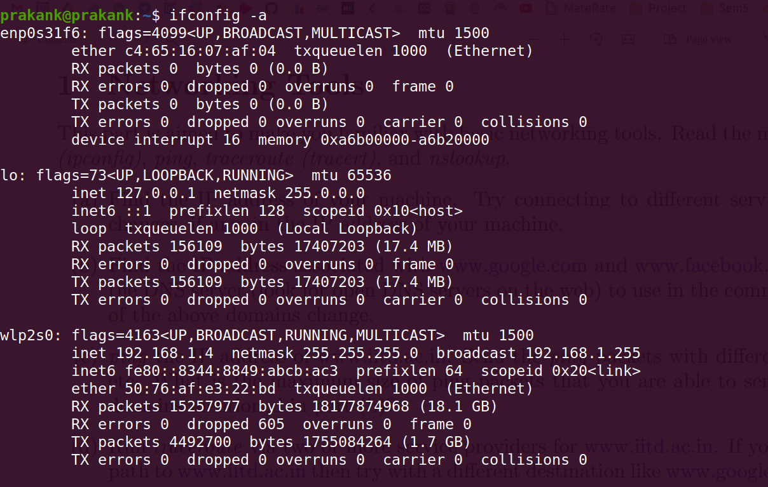
Connected to ZTE_5G

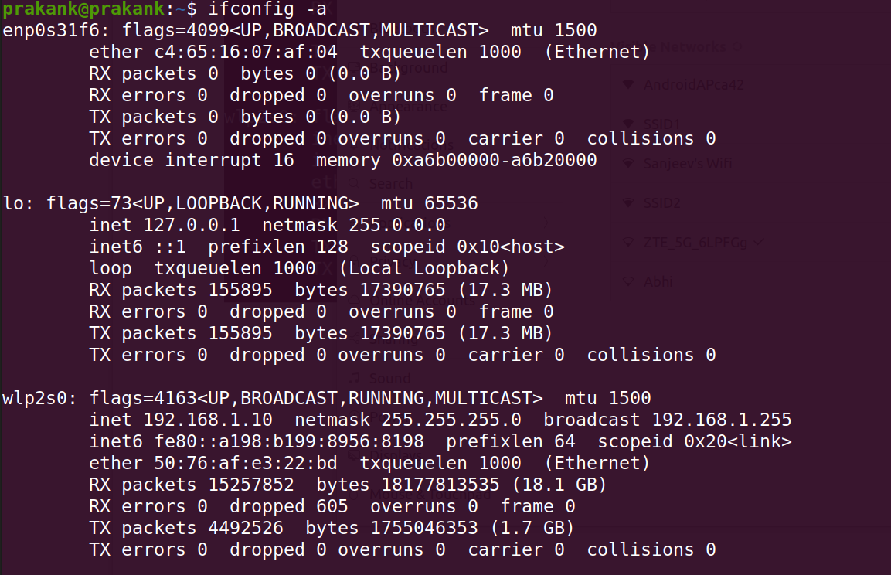
Connected to Sanjeev Wifi

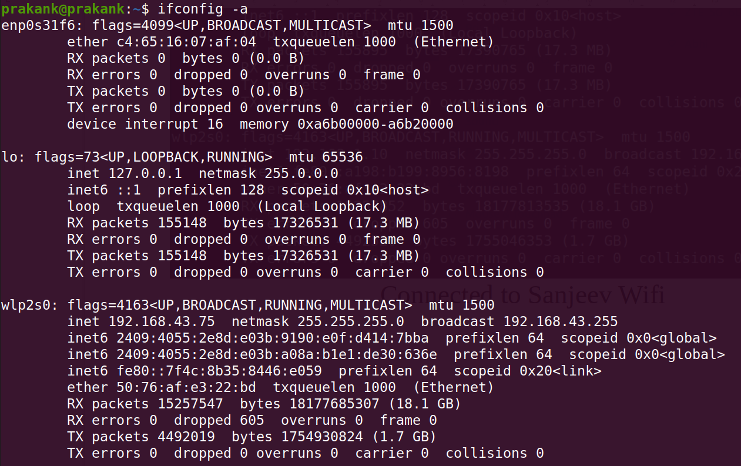
Connected to Mobile Hotspot

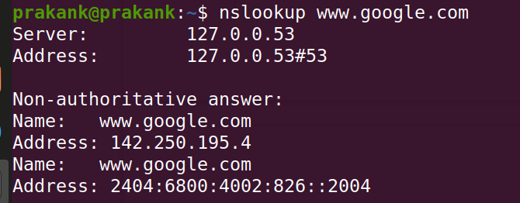
ip address of www.google.com ->

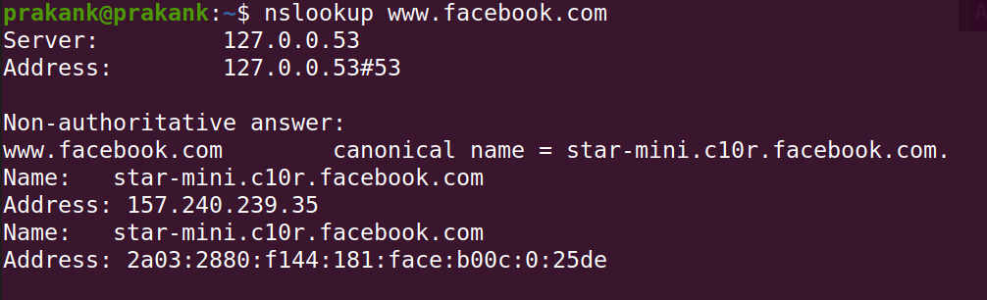
ip address of www.facebook.com ->

ip address change on changing the DNS server. (find reasonging of this behaviour)

