How to Run the Applications
TRACE-AI-FR Interactive Local Setup Guide for Windows

Item | Description
Project | TRACE-AI-FR — Transparent Reporting of AI-related Claims in Evidence: A Forensic Reasoning Framework
Repository | https://github.com/prakasamv6/TRACE-AI-FR
Audience | Professor, reviewer, examiner
Runtime | Windows 10/11, 64-bit
Recommended Method | Use dist\TRACE-AI-FR.exe. No Python setup is required.

1. Purpose
This guide is written for reviewers who want to run TRACE-AI-FR without a programming setup. It explains how to open the application, what each input field means, how to test with the sample evidence image, and how to confirm that reports were created successfully.
TRACE-AI-FR examines forensic artifacts and produces structured reports about possible AI-platform usage indicators. The tool supports forensic reasoning; it does not automatically prove user intent or reconstruct the full session unless the evidence supports that conclusion.

2. Start Here: Reviewer Checklist
- ☐ I am using Windows 10 or Windows 11.
- ☐ I downloaded or cloned the TRACE-AI-FR project folder.
- ☐ I extracted the project ZIP if I downloaded it from GitHub.
- ☐ I can see the dist folder.
- ☐ I can see TRACE-AI-FR.exe inside dist.
- ☐ I have an evidence source ready.
- ☐ For the sample test, I extracted 2020JimmyWilson_E01_Image.zip first.

3. Important File Notes
File or Folder | Meaning | Recommended Use
dist\TRACE-AI-FR.exe or Dowloaded form Google Drive “TRACE-AI-FR.exe “ | Packaged Windows application | Best option for professor/reviewer testing
2020JimmyWilson.E01 | Sample image file package | Use the E01 file as evidence
demo_evidence | Small demo folder, if included | Optional quick folder test
QUICK_START.md | Short technical guide | Optional reference
ARCHITECTURE.md | Architecture details | Technical reference
BUILD_SUCCESS.md | Build notes | Technical reference

Sample image reminder: 2020JimmyWilson_E01 image file to test the application. Then select the extracted .E01 file and choose Mode = e01.

4. Choose Your Run Option
Goal | Best Option | Difficulty
Open the application normally | Double-click dist\TRACE-AI-FR.exe or Dowloaded form Google Drive “TRACE-AI-FR.exe “ | Easy
Test the sample forensic image | 2020JimmyWilson_E01 image file path , set Mode = e01 | Easy
Test a folder export | Paste the folder path into Evidence, set Mode = mounted | Easy/Moderate
Use the command line | Run the PowerShell commands in this guide | Optional
Run from the source code | Install Python dependencies | Technical only

5. Fastest Method: Open the App by Double-Clicking
- Open File Explorer.
- Open the TRACE-AI-FR project folder.
- Open the dist folder.
- Double-click TRACE-AI-FR.exe.
- Confirm that the application window opens.
If Windows blocks the file, right-click TRACE-AI-FR.exe, choose Properties, select Unblock if shown, click OK, and open the file again.

6. Recommended Sample Test

Step 1 — Extract the sample image
- ☐ Locate 2020JimmyWilson_E01_Image.zip.
- ☐ Right-click the ZIP file.
- ☐ Choose Extract All.
- ☐ Extract it into a simple folder, for example:
C:\Evidence\2020JimmyWilson

Step 2 — Select the extracted E01 file
After extraction, use the extracted .E01 file as the Evidence path. Example:
C:\Evidence\2020JimmyWilson\2020JimmyWilson.E01

Step 3 — Use these app values
Field | What to Enter
Evidence | Path to the extracted 2020JimmyWilson.E01 file
Output | C:\TRACE-Output
Questions | Leave blank for the first test
Case Name | LOCAL-TEST-001
Examiner | Your name
Organization | Your school, agency, or organization
Enable carving | Unchecked for the first test
Mode | e01

Step 4 — Run and verify
- ☐ Confirm the Evidence path points to the extracted .E01 file.
- ☐ Confirm Mode is e01.
- ☐ Click Run Analysis.
- ☐ Wait for completion.
- ☐ Open the output folder.
- ☐ Open the generated report.

7. Application Input Field Guide
Field | Required? | Plain-English Meaning | First-Test Recommendation
Evidence | Yes | File, ZIP, or folder the app will analyze | Use the extracted sample .E01 file
Output | No | Folder where reports will be saved | Use C:\TRACE-Output
Questions | No | Optional .docx file with case questions | Leave blank
Case Name | No | Name for the case/test run | Use LOCAL-TEST-001
Examiner | No | Name of the person running the test | Enter your name
Organization | No | School, company, or agency name | Enter your organization
Enable carving | No | Turns artifact carving on/off | Leave unchecked first
Mode | No | Tells the app how to treat the input | Use e01 for the sample image

Refer to the following Fig. 1 for reference.
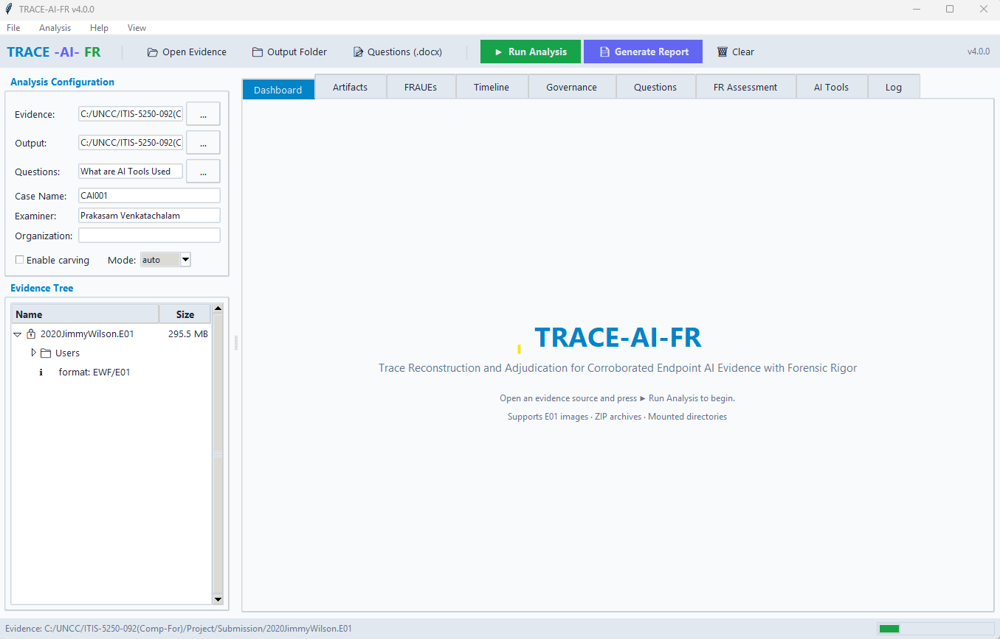
Fig - 1

Mode selection helper
Mode | Choose This When
auto | You are unsure
e01 | You are analyzing an E01 forensic image
mounted | You are analyzing a normal extracted folder
zip | You are analyzing a ZIP archive

8. Optional PowerShell Commands
Use these only if you prefer command-line execution.

Open the app
cd dist
.\TRACE-AI-FR.exe

Analyze the sample E01 image
cd dist
.\TRACE-AI-FR.exe analyze `
--evidence "C:\Evidence\2020JimmyWilson\2020JimmyWilson.E01" `
--output "C:\TRACE-Output" `
--case-id "LOCAL-TEST-001"

Test demo folder, if present
.\dist\TRACE-AI-FR.exe analyze `
--evidence demo_evidence `
--output demo_output_local `
--case-id LOCAL-TEST-001

Show tool information
cd dist
.\TRACE-AI-FR.exe info

9. Output Verification
Look in the output folder for files similar to these:
Output | Purpose
*_report.docx | Word report for review/submission
*_report.html | Browser-readable report
*_report.md | Markdown report
*_findings.json | Structured findings
*_governance_record.json | Governance/traceability record
exhibits folder | Supporting artifacts, if generated

Verification checklist
- ☐ I found the output folder.
- ☐ I found at least one report file.
- ☐ I opened the report successfully.
- ☐ The case name appears correctly.
- ☐ Examiner/organization details appear if entered.

10. Generate Report Dialog
After analysis, click Generate Report if available. The dialog may ask for:
Dialog Field | Example
Forensic Examination Name | TRACE-AI-FR Local Validation Test
Forensic Examination in the Matter of | Sample E01 Evidence Review
Examiner Name | Your name

At least one of the first two fields should be filled. If both are blank, the app may show a warning.

11. Troubleshooting
Problem | What It Usually Means | Fix
App does not open | Windows blocked the executable | Right-click .exe → Properties → Unblock
App still does not open | Permission issue | Right-click → Run as administrator
Evidence missing warning | Evidence path is blank or wrong | Paste the full path again
Sample E01 not found | ZIP was not extracted | Extract 2020JimmyWilson_E01_Image.zip first
Folder test fails | Wrong mode | Set Mode to mounted
ZIP test fails | Wrong mode | Set Mode to zip
Not sure which mode to use | Input type unclear | Use auto
No reports found | Output folder is wrong | Check the Output field
No Questions file | Questions file is optional | Leave Questions blank

12. Simple First-Test Values
Field | Value
Evidence | Extracted 2020JimmyWilson.E01 file path
Output | C:\TRACE-Output
Questions | What are the AI tools used or Leave blank
Case Name | LOCAL-TEST-001
Examiner | Your name
Organization | Your organization
Enable carving | Unchecked
Mode | e01

Refer to the Above Fig. 1 for reference.
Output:
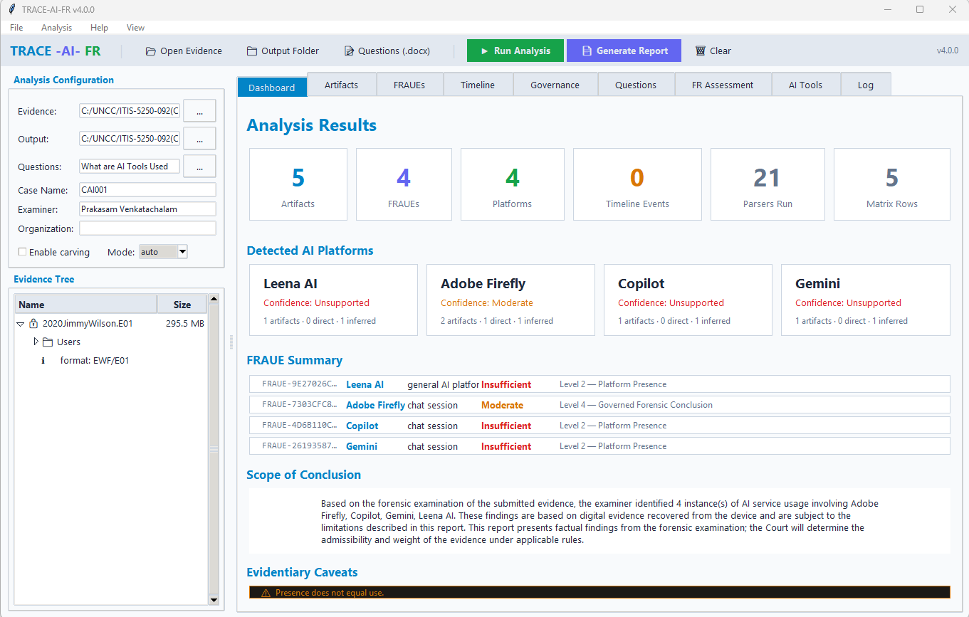

13. Academic Review Notes
TRACE-AI-FR should be reviewed as a forensic reasoning-and-reporting framework. It supports artifact-based interpretation and transparent reporting.
Important limits:
- AI-platform indicators are not automatic proof of user intent.
- Browser traces, cookies, files, and metadata must be interpreted based on source reliability.
- Carved artifacts may require lower-confidence reporting.
- Reports should be reviewed by the examiner before final use.
- The tool supports forensic reasoning; it does not replace examiner judgment.

14. Final Reviewer Checklist
- ☐ I opened the packaged Windows app.
- ☐ I selected an evidence source.
- ☐ I selected the correct mode.
- ☐ I ran the analysis.
- ☐ I opened the output folder.
- ☐ I reviewed at least one generated report.
- ☐ I reviewed the caveats and interpretation limits.

