DA-ZVAD — Phase 2 Presentation Script
Domain-Adaptive Zero-Shot Video Anomaly Detection with Vision-Language Models. Slide by slide, in order, with the transition into each next slide written out. Runs about 26 minutes; the cut list at the end takes it to 19.

How to use this
Learn the beat of each slide — the one thing it exists to say. Sentences worth saying exactly as written are marked SAY; everything else, put in your own words. A recited talk sounds recited.
Each slide ends with a → Next line. That sentence is the bridge into the following slide, and it is what turns twenty-nine slides into one argument. If you learn nothing else from this document, learn the bridges — a talk that flows is mostly a talk where no slide arrives without warning.
Two physical habits matter more than any sentence here. Point at the screen with your hand when a slide has a figure or a table; the panel follows your finger, not your words. And when you reach something that did not work, slow down instead of speeding up — the failures are the most credible material you have.

Part 1 — Framing (slides 1–4)

Slide 1 — Title · 20s · running 0:20
On screen: title, your name, supervisors, the one-line summary.
The beat: set expectations, including that there is a negative result coming.
Do not read the slide. They can read.
SAY — "This is Phase 2 of my thesis work: domain-adaptive zero-shot video anomaly detection. The one-line version is that I adapt a detector to a new environment by writing a sentence, with no training and every model frozen. I'll show you what worked, and also the part that didn't."
That last clause is worth more than anything else on this slide. It tells the panel you are not selling, which changes how they listen for the next twenty-five minutes.
→ Next: "Let me start with why moving a detector is hard at all."

Slide 2 — The problem · 60s · running 1:20
On screen: mall vs factory, the same forklift, opposite answers.
The beat: normality is a property of the place, not the object.
Lead with the example, never the definition.
A detector learns what "normal" looks like from weeks of footage at one camera. Move it somewhere else and it fails. Today that means every new site needs new footage and a full retraining cycle — and that cost is what this project removes.
Then the picture: a forklift moving through a shopping mall is an immediate alarm. The identical forklift on a factory floor is completely routine.
SAY — "Same footage. Opposite answers. The picture did not change — the rule did."
→ Next: "That distinction has a name in the literature, and where the literature puts its attention is the gap I'm working in."

Slide 3 — Research gap, 1 of 2 · 75s · running 2:35
On screen: the covariate/concept shift table, and the Liu quotation.
The beat: the field excludes concept shift by explicit decision.
This is the slide that proves you read the six surveys your supervisor assigned. Slow down.
Domain adaptation splits the differences between two places into kinds:
- Covariate shift — the appearance moves. A stop sign in fog versus sunshine. Still a
stop sign.
- Concept shift — the rule moves. A bicycle on a road versus on a footpath. Identical
image, opposite label.
Read the Liu quotation aloud off the slide. Then:
SAY — "The field scopes concept shift out by explicit decision. And for object recognition that is the right call — a cat is a cat everywhere. But anomaly detection is built on concept shift."
Make clear you are not criticising them. The scoping is correct for their problem.
→ Next: "So let me show you why that scoping is a problem specifically for anomaly detection."

Slide 4 — Research gap, 2 of 2 · 60s · running 3:35
On screen: the three-row table — running, lying down, a vehicle — normal in one domain, anomalous in the other.
The beat: in this task, normality is the deployment context.
Walk one row only. A person running is normal in a park and anomalous in a bank vault.
SAY — "In anomaly detection, normal is defined by the deployment context, not by the object. That is the definition of the task."
The consequence: methods that align appearance cannot help here, because the appearance is already identical. Two domains can share the input distribution exactly while the labelling function differs.
Volunteer the concurrent work. A 2026 position paper reaches the same premise independently. Saying that yourself answers "did you invent this problem?" before it is asked. What is still missing in the literature is a test of whether supplied context actually does any work.
→ Next: "That test is what I built. Here is the system."

Part 2 — The architecture (slide 5)
This is the slide you will spend the most time on and take the most questions on. Budget three and a half minutes and expect to be interrupted.

Slide 5 — DA-ZVAD: adapt by writing a sentence · 3m30s · running 7:05

What the diagram exists to prove
Before any of the boxes, be clear in your own mind about the claim the picture makes. It is not "here is a pipeline." It is:
Exactly one thing in this system can vary, and it is a sentence. Everything else is frozen. So if performance moves, the sentence moved it — there is no other candidate.
Every design choice in the figure serves that claim. If you keep that sentence in mind, the walkthrough tells itself.

The thirty-second version, if you get cut short
SAY — "Video comes in on the left and goes through a frozen CLIP image encoder. An operator writes one sentence describing the scene, and that goes through a frozen CLIP text encoder. The two meet in the middle, where each frame gets a score for how much more it looks 'abnormal' than 'normal'. That score is smoothed over time, thresholded, and a frozen LLaVA writes an explanation. Nothing trains. Deploying to a new site means editing the sentence."
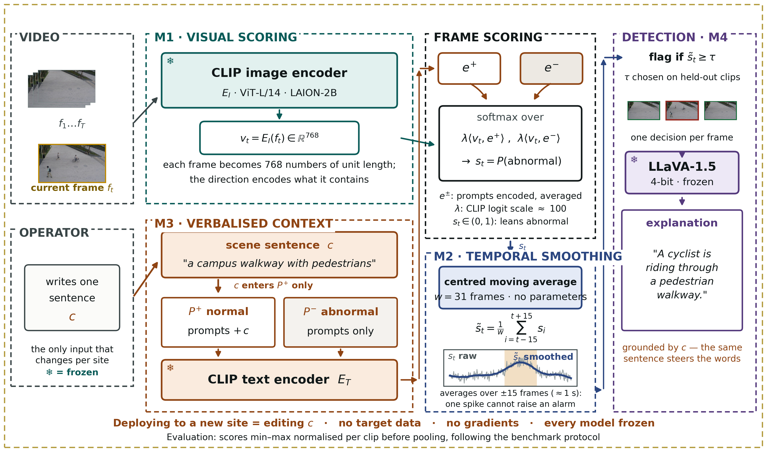
Figure 1. The DA-ZVAD framework. Every model is frozen; the verbalised scene context (M3) is the only adaptation mechanism.

Stop 1 — Two inputs, and why they are drawn separately
Start at the far left. There are two input panels, not one, and the separation is deliberate.
VIDEO is the camera: frames, with the current frame highlighted in amber. OPERATOR is a person, and all they supply is one sentence.
SAY — "I've drawn these separately on purpose. A single input feeding both branches would suggest the system learns the domain from the video. It doesn't. The video supplies frames; a human supplies the domain, in words. That separation is the method."
Point at the italic line under the operator box: the only input that changes per site. That is the deployment story in six words.

Stop 2 — M1, the visual branch
Frozen CLIP image encoder, ViT-L/14, pretrained on LAION-2B. It turns each frame into 768 numbers scaled to unit length.
SAY — "CLIP was trained on hundreds of millions of image–caption pairs, so it puts a picture and a sentence describing that picture in the same space. Here it turns each frame into 768 numbers. The length is normalised away, so only the direction carries meaning — and the direction encodes what is in the frame."
The snowflake is doing real work. Say it: nothing here is trained, and nothing here is trained on my data. This is an off-the-shelf model used as-is.

Stop 3 — M3, the language branch — the heart of the method
Slow down. This is the module the thesis is about.
The scene sentence. "a campus walkway with pedestrians." One sentence, written by a person, describing where the camera is.
Two prompt sets. P+ holds the "normal" phrases, P- the "abnormal" ones — short ensembles rather than single sentences.
The critical detail. Point at the small orange label. The scene sentence is appended to P+ only.
SAY — "This is the single most important arrow in the diagram, and getting it wrong cost me a month. The scene description tells the model what normal looks like here. An anomaly is then whatever departs from that. If I add the description to both sets, the same words land on both sides of the comparison and the two sides collapse toward each other — which is exactly what happened in my first run. I'll show you that result shortly."
That forward reference matters. It ties the architecture to the results and shows the design was earned rather than assumed.
The frozen text encoder. Each prompt is encoded and normalised, the set is averaged into one vector, and that average is normalised again — giving two prototypes: one summary vector for "normal here," one for "abnormal."

Stop 4 — Frame scoring, where the branches meet
The two prototypes sit at the top of the panel; the frame vector arrives from the left. The operation is a softmax over two similarities — how well the frame matches the normal prototype, and how well it matches the abnormal one, each scaled by a factor. The output is the probability the frame is abnormal.
Two details worth volunteering, because they show you know your own code:
On the scaling factor — SAY "That's not a hyperparameter I chose. It's CLIP's own logit scale, around 100, learned during CLIP's pretraining and shipped with the weights. I use it as-is."
On what the score means — SAY "It's between 0 and 1, and it's a relative quantity: how much more the frame reads abnormal than normal. It is not a calibrated probability that something bad is happening."
That second point pre-empts a calibration question and shows you know the limits of your own number.

Stop 5 — M2, temporal smoothing
A centred moving average over a 31-frame window. No parameters at all.
SAY — "Per-frame scores are noisy. This averages each frame with the fifteen before and the fifteen after — about a second either side — so a single odd frame can't raise an alarm, but a sustained event still stands out."
Point at the small plot inside the panel: thin grey is the raw score, thick blue is smoothed, the shaded band is the actual event. That picture answers "what does smoothing do" faster than any sentence.
If asked why 31: it came from a sweep, and it has a real optimum — performance rises to 31 and falls after. Concede immediately that no validation split exists for these benchmarks, so it was selected on held-out clips rather than a clean validation set.

Stop 6 — M4, detection and explanation
The smoothed score is thresholded. Then a frozen LLaVA-1.5, running 4-bit, writes a sentence explaining what it sees.
Be honest in the same breath. SAY — "M4 is built and it runs, but it has produced no video results yet. That's the first item that isn't finished, and it's on the Phase 3 list."
Volunteering that is far stronger than being caught by it. Note also the orange line under the explanation box: the explanation is grounded by the same sentence. One sentence steers both the detection and the words used to describe it.

The line along the bottom
Read it out — it is the summary of the whole figure:
Deploying to a new site = editing the sentence · no target data · no gradients · every model frozen
The smaller line beneath it — scores min–max normalised per clip before pooling, following the benchmark's protocol — is there because it is the bug that cost the first run. It belongs on the figure precisely because it is easy to get wrong.

Three things to point at with your hand
If the room is only half-listening, these three gestures carry the argument.
- The snowflakes. Sweep across all four. "Nothing in this system trains."
- The orange arrow into `P+`. "The sentence enters one side of the comparison, not both."
- The operator box. "This is the entire deployment cost. A person writes one sentence."

Questions they will stop you with here
"Which domain adaptation technique is this?" — None of the classical four. Fine-tuning, discrepancy alignment, adversarial adaptation and self-training all change weights using target-domain data, and I have neither target data nor gradients. They also all align the input distribution — they make source and target look alike — which only helps if the labelling function is stable. My problem is the reverse: a bicycle on a walkway and one on a road are the same pixels with opposite labels, so there is nothing to align. What I use is the foundation-model technique: adaptation through the input context with the model frozen. In the field's vocabulary — source-free, test-time, training-free, language-mediated, concept-shift-oriented.
"Why isn't that on the standard list?" — Because the vision DA surveys run 2015 to 2023 and predate foundation-model adaptation. There was no frozen model you could steer with a sentence when those taxonomies were written. That absence is the gap this thesis is about.
"Isn't CLIP already trained, so it isn't really training-free?" — CLIP is pretrained, yes, and I say so. What is training-free is the adaptation: no gradient step is taken on either benchmark and no target data is used at any point.
"Why not patch-level features?" — Whole-frame embeddings at 224×224 cannot resolve small objects, and that's a stated limitation. Patch-level scoring is item three on the Phase 3 list and the most likely route to a materially higher number.
→ Next: "The freezing isn't modesty about compute. It's the thing that makes the claim testable, and that's worth one slide on its own."

Part 3 — Method rationale and protocol (slides 6–9)

Slide 6 — Why freezing everything is the point · 60s · running 8:05
On screen: the risk, the design, the consequence, and the identifiability callout.
The beat: freezing is what makes the claim attributable rather than asserted.
The strongest methodological point in the deck. Say it slowly.
- The risk. If the system learned even a little from the new site and performance
improved, I could not say what caused it — the sentence, or the learning.
- The design. No parameter anywhere is allowed to change. Exactly one thing can vary:
the text.
- The consequence. SAY — "So any measured difference is attributable to the
sentence. There is no other candidate."
Then the point that lands hardest: you cannot run this experiment on the competing systems. Their text is learned on source data, or entangled in an LLM prior, or paired with a trained adapter. Freezing is what makes the claim falsifiable rather than rhetorical.
→ Next: "And falsifiable means there has to be a way for me to be wrong. Here's the protocol."

Slide 7 — A protocol that can prove us wrong · 60s · running 9:05
On screen: the four conditions — none, generic, matched, mismatched — and the predicted signature.
The beat: the interpretation was fixed before any measurement.
Run the identical pipeline four times, changing only the sentence. Generic controls for merely having context at all. Mismatched is the falsifying control.
SAY — "I fixed the interpretation before measuring anything: matched at least generic, generic at least none, and mismatched measurably worse. If a deliberately wrong description costs nothing, the method is ignoring its context and my claim is refuted."
A panel respects a test you could have failed. Then add: "and later in this deck, one I partly did."
→ Next: "So — what that ran on."

Slide 8 — What we ran · 30s · running 9:35
On screen: benchmarks, scale, hardware, backbone, run count, and the manifest note.
The beat: provenance. Keep it brief and let the content do the work.
Two benchmarks, 128 test clips, 28,118 frames with frame-level ground truth. College A40. Frozen CLIP ViT-L/14. Five full runs.
SAY — "Every run writes a manifest — the code commit, whether the working tree was clean, the host, GPU, driver and library versions, the full configuration, and the frame and label counts. It's committed alongside the results, so every figure in this deck traces back to the state that produced it."
Then offer it out loud: if anyone would like to see a manifest, you can open one. If the panel has any doubt about provenance, that offer is the answer.
→ Next: "And it's worth thirty seconds on what this data actually looks like, because the pictures make the argument better than I can."

Slide 9 — What the two benchmarks actually look like · 30s · running 10:05
On screen: the grid of normal and anomalous frames, one camera per column.
The beat: the concept-shift argument, as a photograph.
Thirty seconds, no more. Point down one column.
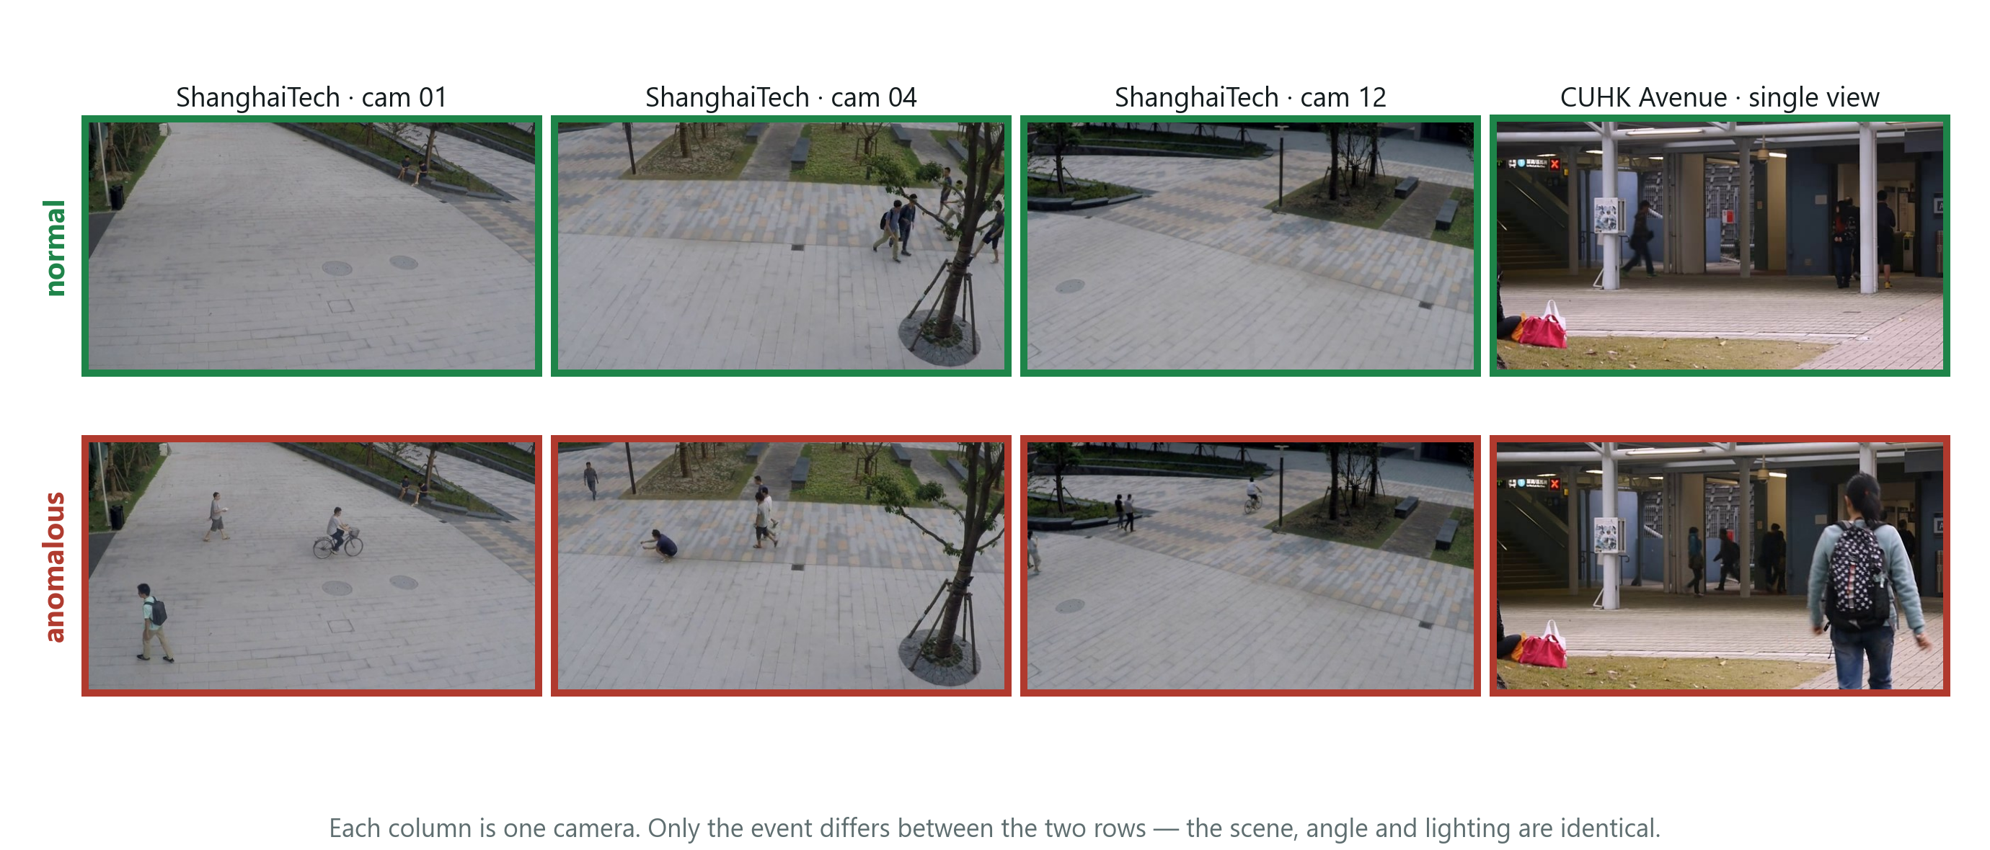
Figure 2. Normal and anomalous frames from both benchmarks. Each column is one fixed camera, so going down a column only the event changes.
SAY — "Each column is one fixed camera — the scene, the angle and the lighting are constant. Only the event changes. An empty walkway and the same walkway with a cyclist look nearly identical to a computer, and they're labelled opposite. So the label cannot be a property of how the scene looks."
If someone later challenges whether concept shift is real or contrived, come back to this slide. It is the argument in a photograph.
→ Next: "So that's the setup. Now what actually happened — and the first thing that happened is that it failed."

Part 4 — Failure and diagnosis (slides 10–13)

Slide 10 — The first result was a failure · 45s · running 10:50
On screen: 0.49, and the inverted condition table.
The beat: land the failure honestly. Do not rush and do not apologise.
0.49 AUROC. Fifty minutes of GPU time to produce a detector performing exactly as well as a coin flip.
And the central experiment came out backwards: the matched description — the correct one — was worst at 0.666, and the mismatched description, deliberately wrong, was among the best at 0.695.
SAY — "This is the point at which the idea looks broken."
Then pause. Let it sit for two seconds. The next three slides are why this talk is worth listening to.
→ Next: "There turned out to be two separate problems. The first one wasn't in the method at all — it was in how I was measuring."

Slide 11 — Diagnosis 1: we were measuring it wrong · 75s · running 12:05
On screen: the twelve views, the error, the analogy, and 0.49 → 0.71.
The beat: a measurement bug, fixed with no labels, using the benchmark's own protocol.
ShanghaiTech has 12 camera views, and CLIP sits at a different baseline score under each — different lighting, different angle. My error was pooling every frame from all twelve into one ranking.
Use the analogy. It works on everyone.
SAY — "It's like ranking students from different schools by raw marks when the schools grade differently. The comparison destroys the ordering."
Normalising each clip before pooling took the identical scores from 0.49 to 0.71.
Stress two things, twice if needed: the fix uses no labels, and it is the benchmark's own published protocol — I simply wasn't following it. And say that both figures appear in the paper.
→ Next: "That's a strong claim to make about your own bug, so let me show you the evidence for it."

Slide 12 — The evidence for that diagnosis · 45s · running 12:50
On screen: two panels — the embedding projection coloured by camera, and per-view similarity.
The beat: the diagnosis was not invented after the fact.
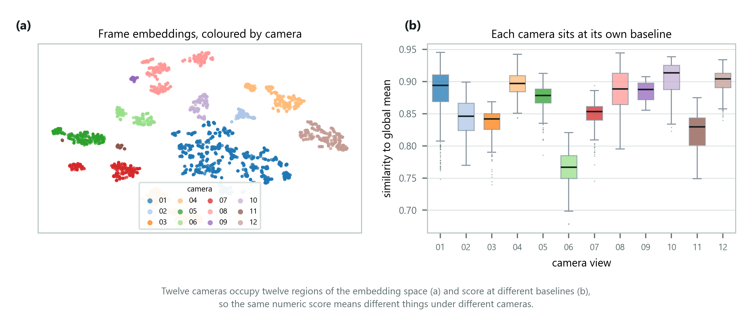
Figure 3. Left: every frame projected to two dimensions and coloured by camera. Right: similarity of each view to the average frame.
Left: every frame projected to two dimensions and coloured by camera — the views sit in separate regions. Right: how similar each view is to the average frame, differing by more than 0.13 between views.
SAY — "Neither panel uses labels, so this isn't hindsight. The cameras occupy separate regions of the space at different similarity levels, which is exactly why pooling raw scores destroyed the ordering."
→ Next: "That fixed the number. It did not fix the inversion — the correct description was still the worst one. That was a second, separate problem, and it's the more interesting of the two."

Slide 13 — Diagnosis 2: the description cancelled itself out · 90s · running 14:20
On screen: the two prompt sets with their shared words highlighted, and the fix.
The beat: the mechanism of the inversion — and why a better sentence did more damage.
The most interesting slide in the deck. Give it the time.
I had been appending the scene sentence to both prompt sets. Point at the two prompts and let the panel see the shared words.
Each set is averaged into one summary vector. Shared text enters both, so the two summaries move toward each other — and the whole method depends on them being different. I was erasing the very contrast the decision rests on.
The punchline, and it is a good one:
SAY — "An accurate description matches every frame strongly, so it absorbs the most contrast. A wrong one matches nothing, so it does no damage. That is exactly why the result inverted — the better the sentence, the worse it performed."
The fix: attach the description to the normal prompts only. The scene defines what normal looks like here; an anomaly is a departure from it.
→ Next: "So I re-ran the whole four-condition sweep with that one change. This is the result the project exists to produce."

Part 5 — The central result (slides 14–17)

Slide 14 — After the fix: the predicted signature · 75s · running 15:35
On screen: the two-row injection-point table.
The beat: the headline number, and the control that makes it mean something.
ShanghaiTech, all 107 clips, per-clip normalised. Every model frozen; only the sentence and its injection point vary.
Injection point | none | generic | matched | mismatched | gap
Both prompt sets | 0.707 | 0.670 | 0.666 | 0.695 | −0.029
Normal set only | 0.707 | 0.691 | 0.734 | 0.628 | +0.105

Point at the `none` column first. It is 0.707 in both rows.
SAY — "That column is the control. It's identical in both rows, which confirms nothing changed between them except where the sentence was injected."
Then point at 0.628.
SAY — "A wrong sentence costs ten points. Nothing else in the system was permitted to change, so the text caused it."
→ Next: "Same numbers, drawn — because the thing that matters is a distance, and a distance is easier to see than to read."

Slide 15 — The same experiment, drawn · 30s · running 16:05
On screen: grouped bars, grey for both-sets, orange for normal-only.
The beat: the quantity of interest is the gap, and it changes sign.
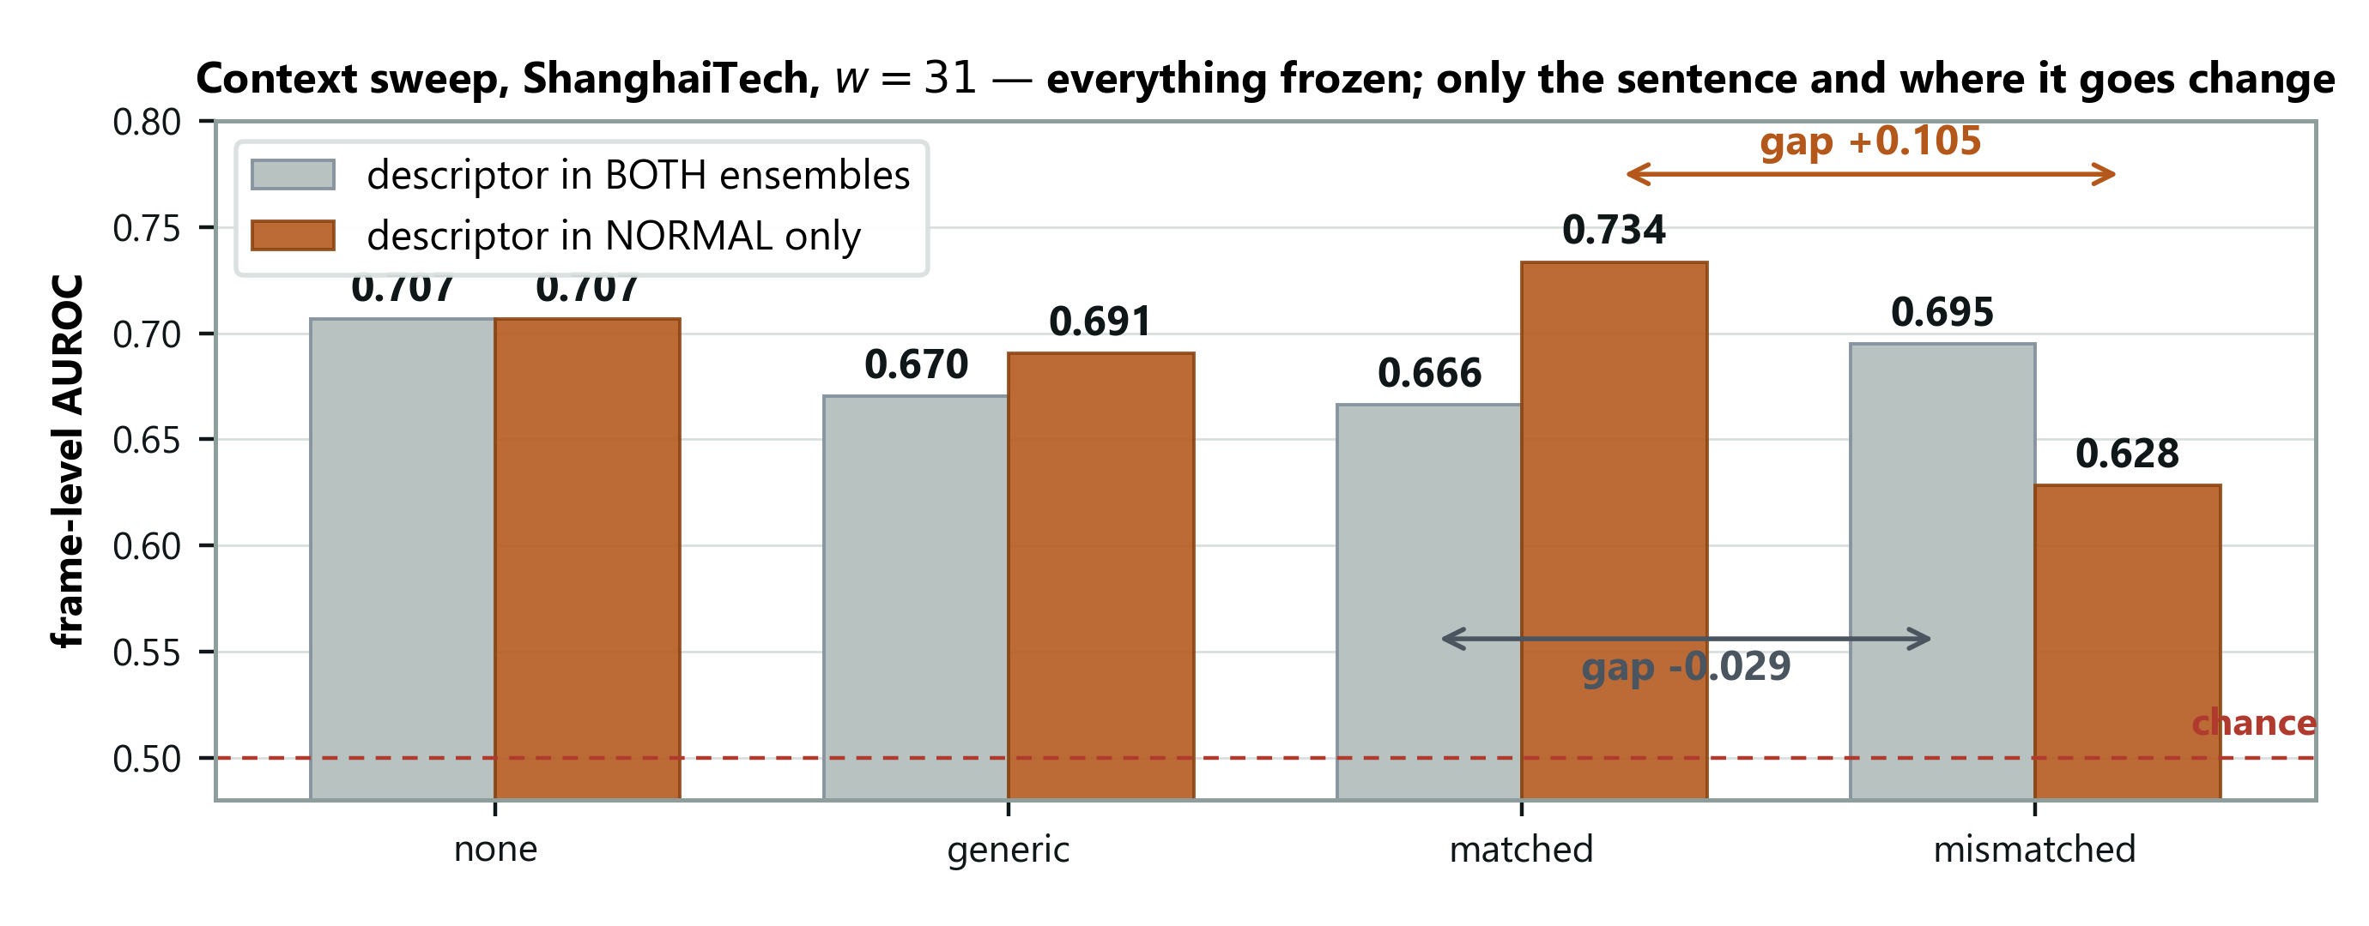
Figure 4. Grey bars put the sentence in both prompt sets; orange bars put it in the normal set only.
Trace the two arrows with your finger. The number the experiment exists to produce is the distance between the matched and mismatched bars. With grey, that distance is negative. With orange, it is +0.105.
SAY — "The only thing separating those two arrows is where the sentence was attached."
→ Next: "That's aggregated over a hundred clips. Here's what it looks like on a single one, where there's nothing aggregated to argue with."

Slide 16 — One clip, two sentences · 40s · running 16:45
On screen: two score curves over one clip, with the event marked.
The beat: the cleanest evidence in the deck — no aggregation involved.
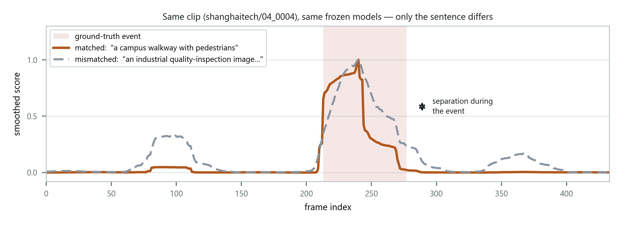
Figure 5. Same frozen models, same frames, same smoothing. Only the scene description differs.
Same frozen models, same frames, same smoothing. The only difference is whether the sentence describes a campus walkway or an industrial site.
SAY — "The curves coincide outside the event — that's on purpose, that's the control — and they separate inside it. Two runs over identical frames with identical frozen weights. There's no aggregation here to argue with."
→ Next: "Now let me be precise about what I am and am not claiming from this, because the two halves of the result are not equally strong."

Slide 17 — Stating the claim precisely · 60s · running 17:45
On screen: the weaker half, the claim made, and the mechanism.
The beat: understate deliberately. This is where credibility is won.
The weaker half. A correct description beats no description by +0.027. Positive at every smoothing window, but inside the ±0.036 split-to-split spread.
SAY — "So I report the direction, not the magnitude. I'm not claiming that number."
The claim I do make. A wrong description costs −0.105. Unambiguous, and nothing else could have caused it.
The mechanism — SAY "The description constrains a decision boundary rather than adding information. It doesn't reliably lift performance when it's correct; it degrades performance sharply when it's misdirected."
The secondary finding, not present in the literature: where the description is injected dominates what it says — to the point of reversing the sign of the effect.
→ Next: "That's the language pathway on its own. The obvious next question is whether the other components I built are earning their place."

Part 6 — Ablations and boundaries (slides 18–23)

Slide 18 — Which components earn their place · 60s · running 18:45
On screen: the five-row scoring-signal table.
The beat: language alone wins, and a prediction of mine failed.
Scoring signal | Held-out AUROC | Full test set
Scene-centre normality only | 0.585 ± 0.025 | 0.585
Semantic + scene-centre | 0.645 ± 0.034 | 0.640
Kinematic — motion only | 0.685 ± 0.015 | 0.686
Semantic + kinematic | 0.711 ± 0.034 | 0.706
Semantic — language only | 0.718 ± 0.036 | 0.707

Language alone is best. Adding motion costs 0.001; adding scene-centre normality costs 0.067.
Volunteer the surprise — SAY "I expected motion to help and it doesn't. ShanghaiTech's anomalies look kinematic — a bicycle at cycling speed — so appearance and motion ought to be complementary. Measured here, they aren't. The pooled embedding already registers enough of the motion."
Reporting a prediction that failed is stronger than reporting only the ones that held.
→ Next: "Both the smoothing window and those components are easier to judge as curves, so — briefly."

Slide 19 — Window length, and what each component adds · 35s · running 19:20
On screen: two panels — the window sweep, and the component comparison with error bars.
The beat: the window has a real optimum; the component differences do not survive their error bars.
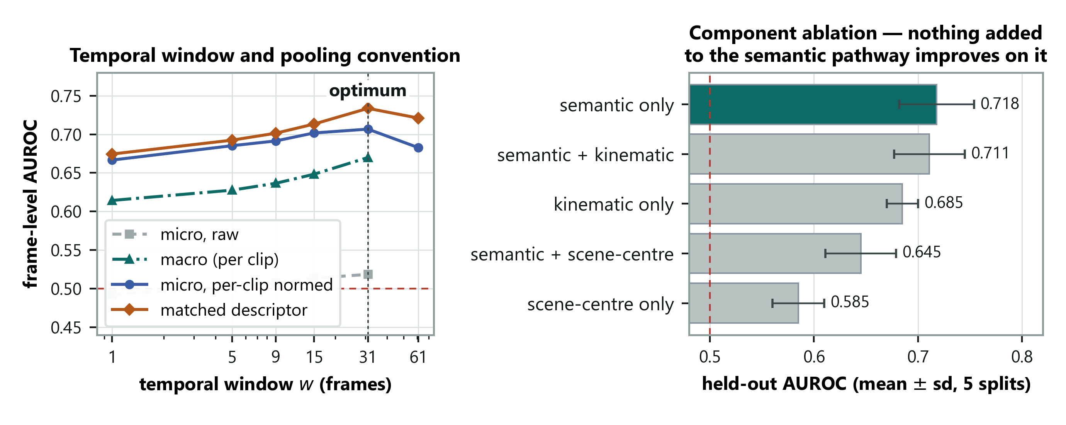
Figure 6. Left: the smoothing window sweep. Right: components with error bars.
Left: smoothing helps up to a window of 31 and then hurts — so the window has a genuine optimum rather than the metric simply rewarding more blur. The grey curve is the wrong pooling, and it never leaves chance.
Right: volunteer the weakness before anyone asks.
SAY — "The error bars overlap, so the top three are statistically tied. The honest claim is that nothing I added beat plain language. That's a negative result about my own elaborations, not a win over the alternatives."
→ Next: "Everything so far is one benchmark. The real test is whether any of it survives a second one."

Slide 20 — A second domain: the replication test · 75s · running 20:35
On screen: the two-dataset comparison table.
The beat: detection transfers, adaptation does not — and say so plainly.
Identical frozen configuration applied to CUHK Avenue. Nothing retuned. Only the sentence changed.
Dataset | none | generic | matched | mismatched | gap
ShanghaiTech (12 views) | 0.707 | 0.691 | 0.734 | 0.628 | +0.105
CUHK Avenue (1 view) | 0.706 | 0.729 | 0.677 | 0.657 | +0.020

Detection transfers. 0.706 against 0.707 with no descriptor — the detector works equally well on a dataset it was never tuned for.
Adaptation does not. The gap is five times smaller, and the correct description scores below having none at all.
Give the honest reading yourself — SAY "On Avenue a placeholder beats an accurate description. Whatever benefit the description is giving here, it cannot be domain adaptation."
Then the conjecture, stated as a conjecture, with the experiment that tests it: ShanghaiTech has twelve camera views and Avenue has one. A scene description has work to do only when there are several environments to tell apart.
→ Next: "That's a comfortable story to tell about your own negative result, so I designed a test that could have destroyed it."

Slide 21 — We tested that explanation, and it held · 75s · running 21:50
On screen: the three-row pooled / within-view / Avenue table.
The beat: a complete research cycle — observation, explanation, falsifiable test, result.
ShanghaiTech is effectively twelve single-view datasets stacked together. If the descriptor works by telling the model which scene it is in, then confining the sweep to a single camera view should reproduce Avenue's flat result.
Evaluation | Views | Clips | Gap
Pooled across views | 12 | 107 | +0.105
Within a single view (mean) | 9 | 5–34 each | +0.033
CUHK Avenue (single view) | 1 | 21 | +0.020

SAY — "A within-view gap near +0.105 would have refuted this outright. It came back at a third of that, sitting right next to Avenue's figure."
Then give the caveat before they find it: three of the nine views show a negative gap, so inside a single scene the effect is not reliable.
SAY — "What the sentence mainly supplies is which scene you're in, not what counts as normal within it. That's a narrower claim than I started with, and it's the one the data supports."
Name what this slide is: a full cycle. Something odd was observed, an explanation was formed, a test that could have killed it was designed and run, and it held.
→ Next: "And since I've just quoted an average of nine views, here they all are individually."

Slide 22 — Every camera view, one at a time · 35s · running 22:25
On screen: per-view bars against the pooled line.
The beat: show the spread yourself rather than letting them find it.
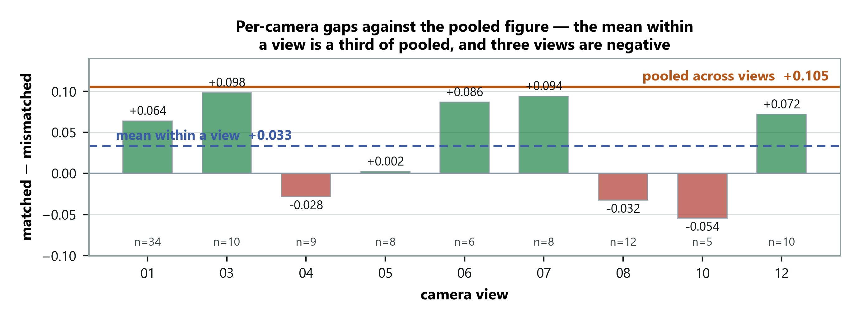
Figure 7. The orange line is the pooled result; each bar is one view on its own.
The orange line is the pooled result; each bar is one view alone. Most fall well short, three are negative — but views 03 and 07 nearly reach it. The bars rest on between five and thirty-four clips each.
SAY — "So this is a shift in the average, not a clean collapse everywhere."
Saying that before the panel spots it is the difference between a caveat and a hole.
→ Next: "The same logic applies to the design itself. The claim is that the minimal configuration is the right one, so here is everything I tried that didn't work."

Slide 23 — Six things that did not work · 45s · running 23:10
On screen: the six-row negative-results table.
The beat: negative results as evidence of real work.
Modification | Outcome
Quadrant scoring, to catch small objects | No improvement in any configuration
Prompts naming bicycles and vehicles | Much worse alone — 0.486
Clip's own average as the normality reference | 0.585, and it degrades the language signal
Adding a motion signal | Costs 0.001 — not complementary
Local temporal deviation before projection | Better scorer, but narrows the context gap
Per-prompt max pooling | 0.678 against 0.707

Do not read all six. Pick two — quadrant scoring, and the bicycle prompts — then say why the table is in the deck at all:
SAY — "The claim is that the minimal configuration is the right one. That's only credible next to the alternatives that were tried. A clean table of successes is the artefact that's easy to fabricate. Six diagnosed failures are not."
Deliver that one looking at the panel, not at the screen.
Know the second row cold, because it looks like an obvious hole until it is explained. The abnormal prompts talk about fights and accidents while ShanghaiTech's anomalies are cyclists and skateboarders. I noticed that and rewrote them to name bicycles and vehicles — and it got much worse, 0.685 down to 0.486, because the rewritten prompts repeated "walkway" and "pedestrians" on both sides and reintroduced the very dilution problem M3 had just solved.
→ Next: "So where does all of that leave the work against everyone else's?"

Part 7 — Assessment and close (slides 24–29)

Slide 24 — Where this sits against the literature · 60s · running 24:10
On screen: the three-row comparison table.
The beat: pick the right comparison, and concede the wrong one openly.
Method | AUROC | Cost per frame
Liu et al. 2018 — trained on the target scene | ≈ 0.728 | 1 trained model
LAVAD (CVPR 2024), training-free | ≈ 0.85 | Captioner + LLM + refiner
DA-ZVAD (ours), training-free | 0.734 | One frozen encoder + a sentence

Anchor on the trained baseline, not on LAVAD.
SAY — "I match the benchmark's own 2018 baseline, 0.734 against 0.728, using none of its training data."
Then concede LAVAD openly, in the same breath. It reaches about 0.85, and it runs a captioner, a large language model and a refiner on every frame. This runs one frozen encoder and a sentence, in about 7 GB.
SAY — "I don't expect to exceed trained state-of-the-art detectors on absolute AUROC, and the paper makes no such claim."
Deliver this confidently rather than apologetically. Choosing the fair comparison yourself is a strength.
→ Next: "In the same spirit, here are the limitations — stated by me rather than found by you."

Slide 25 — Limitations we are stating ourselves · 50s · running 25:00
On screen: six limitations.
The beat: deliver these as findings, not confessions.
- The mechanism is bounded. It works on ShanghaiTech and nearly vanishes on Avenue, and
the scene-diversity explanation rests on two datasets.
- Resolution ceiling. Whole-frame embeddings at 224×224 can't resolve small objects;
quadrant scoring didn't close it and patch-level scoring is untested.
- The metric is scale-sensitive. Per-clip normalisation is affine, so a monotone
rescaling of the score changes the pooled figure even though the ranking is identical. Dwell on this one — SAY "That's a real methodological point about a protocol the whole field uses, and I found it by chasing my own bug."
- Configuration selection. No validation split exists for these benchmarks, so I split
clips and report the half never used to select.
- Both video domains are outdoor pedestrian surveillance. The industrial contrast is
evaluated for detection but not for the sweep.
- M4 has produced no video results yet.
→ Next: "Each of those maps to something on the Phase 3 list."

Slide 26 — Phase 3 plan · 40s · running 25:40
On screen: four prioritised items, and the infrastructure note.
The beat: the boundary is scoped, and the experiment that settles it is named.
Priority one is the within-view sweep — SAY "That's the one that turns my explanation from a conjecture into a result."
Then the MVTec context sweep, which gives the industrial-versus-surveillance contrast for adaptation rather than only for detection; patch-level scoring; and running M4.
SAY — "The infrastructure cost is now paid. Encoding a benchmark takes 21 minutes, after which a new scoring hypothesis is evaluated in seconds instead of fifty minutes."
→ Next: "To summarise."

Slide 27 — Summary · 45s · running 26:25
On screen: the five numbered beats.
The beat: close on the boundary, not the number.
One line each, no elaboration:
- The field targets covariate shift by explicit scoping; anomaly detection is dominated by
concept shift.
- Every model frozen — which is what makes the claim identifiable.
- 0.734 with no training, and a wrong description costs 0.105.
- Where the description is injected dominates what it says. Not in the literature.
- It does not replicate on a single-scene benchmark, and the within-view control shows why.
SAY — "The claim is scoped rather than abandoned, and I've named the experiment that settles it. All results are reproducible from committed code and run manifests."
Then stop. Do not trail off, and do not add a thank-you paragraph.
→ Next: hand over for questions. Advance to the references only if asked.

Slides 28–29 — References
Do not read these out. They are an evidence base, not a slide.
The numbering is the paper's own, so a citation on screen is the same number in the report. Be ready for one question: which survey contains the quotation? — Liu et al., 2022, reference [14].

Appendix

If you need about 19 minutes
Cut in this order and stop when it fits. Advance through cut slides without stopping rather than deleting them.
Cut | Slide | Saves
1 | 15 — the drawn version of 14 | 30s
2 | 19 — the ablation charts; fold the error-bar line into 18 | 35s
3 | 22 — per-view bars; fold "three of nine negative" into 21 | 35s
4 | 12 — the diagnostic evidence; keep only if 11 is challenged | 45s
5 | 9 — the dataset grid | 30s
6 | Trim 23 to one example instead of two | 20s
7 | Compress the slide 5 walkthrough to Stops 1, 3 and 5 | 90s

Never cut: 6, 7, 10, 11, 13, 14, 20, 21. Those eight are the talk.

The five sentences to know cold
- Anomaly detectors are stuck in the place they learned; we move them by writing a sentence.
- The domain-adaptation field handles "things look different"; anomaly detection is "the same
thing means something different."
- 0.734 with no training at all — matching the benchmark's own trained baseline — and a
wrong sentence costs ten points.
- Where you put the sentence matters more than what it says; putting it wrongly reverses the
result.
- It works where there are several scenes to tell apart, and we measured that rather than
assuming it.

If a question goes somewhere you did not prepare
The domain-adaptation literature excludes concept shift by explicit choice, and anomaly detection is built on concept shift. The papers that use language show it works but never test whether it is causally responsible. We characterise the first and supply a protocol for the second — including a control that our own framework initially failed.
And if you genuinely do not know: "I haven't tested that yet — here's the experiment that would answer it." That answer is always available, and it never sounds weak.

