DA-ZVAD — Phase 3 Presentation Script
Domain-Adaptive Zero-Shot Video Anomaly Detection with Vision-Language Models. Slide by slide, in order, with the transition into each next slide written out. Runs about 29 minutes; the cut list at the end takes it to about 21. Built on the Phase 2 script: slides 1–22 are the Phase 2 talk with the architecture updated; slides 23–25 are new; 26–30 are revised.

How to use this
Learn the beat of each slide — the one thing it exists to say. Sentences worth saying exactly as written are marked SAY; everything else, put in your own words. A recited talk sounds recited.
Every slide also carries an In plain words block in a tinted box. That is the slide explained to somebody who does not work in this field — no notation, no term left undefined, and for the slides that cover something we built, an account of how it was built rather than of what it scores. It is written to be said aloud roughly as it stands. Use it as your default register and drop into the technical wording only when a panelist asks for it. A panel that follows you is a panel that asks good questions; a panel that has lost the thread asks whether you wrote this yourself.
Each slide ends with a → Next line. That sentence is the bridge into the following slide, and it is what turns thirty slides into one argument. If you learn nothing else from this document, learn the bridges — a talk that flows is mostly a talk where no slide arrives without warning.
Two physical habits matter more than any sentence here. Point at the screen with your hand when a slide has a figure or a table; the panel follows your finger, not your words. And when you reach something that did not work, slow down instead of speeding up — the failures are the most credible material you have.

Part 1 — Framing (slides 1–4)

Slide 1 — Title · 20s · running 0:20
On screen: title, your name, supervisors, the one-line summary.
The beat: set expectations, including that there is a negative result coming.
In plain words. A security camera system that spots unusual events has to be taught what "usual" looks like at that particular camera, using weeks of its own footage. Move it to a new place and you start over. What I built lets you move it by typing one sentence describing the new place. Nothing is retrained — and part of the talk is about the version of this that failed before it worked.
Do not read the slide. They can read.
SAY — "This is my Phase 3 progress on domain-adaptive zero-shot video anomaly detection. The one-line version is that I adapt a detector to a new camera with one sentence — and the system now writes that sentence itself. No training, every model frozen. I'll show you what worked, and also a prediction of mine that failed."
That last clause is worth more than anything else on this slide. It tells the panel you are not selling, which changes how they listen for the next twenty-five minutes.
→ Next: "Let me start with why moving a detector is hard at all."

Slide 2 — The problem · 60s · running 1:20
On screen: mall vs factory, the same forklift, opposite answers.
The beat: normality is a property of the place, not the object.
In plain words. The reason you cannot just copy a detector from one site to another is not that the new camera looks different. It is that the rule is different. A forklift is an emergency in a shopping mall and completely ordinary in a warehouse — and no amount of adjusting for lighting or camera angle will ever tell you which building you are in.
Lead with the example, never the definition.
A detector learns what "normal" looks like from weeks of footage at one camera. Move it somewhere else and it fails. Today that means every new site needs new footage and a full retraining cycle — and that cost is what this project removes.
Then the picture: a forklift moving through a shopping mall is an immediate alarm. The identical forklift on a factory floor is completely routine.
SAY — "Same footage. Opposite answers. The picture did not change — the rule did."
→ Next: "That distinction has a name in the literature, and where the literature puts its attention is the gap I'm working in."

Slide 3 — Research gap, 1 of 2 · 75s · running 2:35
On screen: the covariate/concept shift table, and the Liu quotation.
The beat: the field excludes concept shift by explicit decision.
In plain words. When researchers talk about moving a model to a new place, they almost always mean the pictures look different — fog instead of sunshine. They say openly that they are setting aside the other case, where the picture is the same and the correct answer changes. For recognising objects that is a sensible thing to set aside. For anomaly detection it is the entire problem.
This is the slide that proves you read the six surveys your supervisor assigned. Slow down.
Domain adaptation splits the differences between two places into kinds:
- Covariate shift — the appearance moves. A stop sign in fog versus sunshine. Still a
stop sign.
- Concept shift — the rule moves. A bicycle on a road versus on a footpath. Identical
image, opposite label.
Read the Liu quotation aloud off the slide. Then:
SAY — "The field scopes concept shift out by explicit decision. And for object recognition that is the right call — a cat is a cat everywhere. But anomaly detection is built on concept shift."
Make clear you are not criticising them. The scoping is correct for their problem.
→ Next: "So let me show you why that scoping is a problem specifically for anomaly detection."

Slide 4 — Research gap, 2 of 2 · 60s · running 3:35
On screen: the three-row table — running, lying down, a vehicle — normal in one domain, anomalous in the other.
The beat: in this task, normality is the deployment context.
In plain words. In this task "normal" is not a property of the object, it is a property of the place. So the thing the field set aside is the thing I am left holding. That is the gap: not that anyone was careless, but that the tools were built for a different kind of difference than the one anomaly detection has.
Walk one row only. A person running is normal in a park and anomalous in a bank vault.
SAY — "In anomaly detection, normal is defined by the deployment context, not by the object. That is the definition of the task."
The consequence: methods that align appearance cannot help here, because the appearance is already identical. Two domains can share the input distribution exactly while the labelling function differs.
Volunteer the concurrent work. A 2026 position paper reaches the same premise independently. Saying that yourself answers "did you invent this problem?" before it is asked. What is still missing in the literature is a test of whether supplied context actually does any work.
→ Next: "That test is what I built. Here is the system."

Part 2 — The architecture (slide 5)
This is the slide you will spend the most time on and take the most questions on. Budget three and a half minutes and expect to be interrupted.

Slide 5 — DA-ZVAD: adapt by writing a sentence · 3m30s · running 7:05

What the diagram exists to prove
Before any of the boxes, be clear in your own mind about the claim the picture makes. It is not "here is a pipeline." It is:
Exactly one thing in this system can vary, and it is a sentence. Everything else is frozen. So if performance moves, the sentence moved it — there is no other candidate.
Every design choice in the figure serves that claim. If you keep that sentence in mind, the walkthrough tells itself.

The thirty-second version, if you get cut short
In plain words, before any of the boxes. Video comes in on the left. When a camera is installed, the system looks at its first few frames and writes one sentence about where the camera is. Both go through models that were already trained by somebody else and that I never modify. They meet in the middle, where each frame gets a score for how much it looks like the written description of "something wrong" rather than the written description of "an ordinary day here". That score is smoothed over about a second, and anything that stays high gets flagged and described in words. To add a new camera, the system captions its first frames. That is the entire deployment procedure.
SAY — "Video comes in on the left and goes through a frozen CLIP image encoder. At setup, a frozen LLaVA captions the camera's first frames, and that sentence goes through a frozen CLIP text encoder. The two meet in the middle, where each frame gets a score for how much more it looks 'abnormal' than 'normal'. That score is smoothed over time, thresholded, and a frozen LLaVA writes an explanation. Nothing trains. A new camera needs only its first few frames."
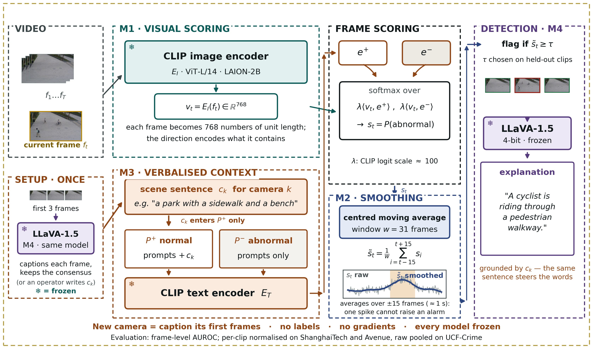
Figure 1. The DA-ZVAD framework. Every model is frozen; the verbalised scene context (M3) is the only adaptation mechanism.

Stop 1 — Two inputs: the video, and the setup step
In plain words. Two arrows come in, not one. The top one is the camera's video. The bottom one is the setup step: when a camera is installed, LLaVA looks at its first three frames and writes one sentence about the place. That sentence is the only thing that differs from one camera to the next.
Start at the far left. There are two input panels, and the separation is deliberate.
VIDEO is the camera: frames, with the current frame highlighted in amber. SETUP · ONCE is new since Phase 2. It shows the camera's first three frames going into LLaVA — marked M4 · same model, because it is the same frozen LLaVA that later writes the explanations, not an extra model.
SAY — "In Phase 2 a person typed this sentence. Now the system writes it: LLaVA captions the camera's first three frames and keeps the caption the three agree on. A new camera needs no human text, no labels and no training."
Point at the small grey line (or an operator writes c_k): the manual route still works, and on ShanghaiTech the two score the same (0.749 by hand, 0.751 by LLaVA). The k in c_k means one sentence per camera.

Stop 2 — M1, the visual branch
In plain words. How this part was built: I did not build it. It is an off-the-shelf model called CLIP, which somebody trained on hundreds of millions of pictures paired with their captions. Because of that training it puts a photograph and a sentence describing that photograph in the same place. I use it exactly as shipped — I feed it a frame, and it hands back a list of 768 numbers standing for what is in that frame. The snowflake means I never touch its settings.
Frozen CLIP image encoder, ViT-L/14, pretrained on LAION-2B. It turns each frame into 768 numbers scaled to unit length.
SAY — "CLIP was trained on hundreds of millions of image–caption pairs, so it puts a picture and a sentence describing that picture in the same space. Here it turns each frame into 768 numbers. The length is normalised away, so only the direction carries meaning — and the direction encodes what is in the frame."
The snowflake is doing real work. Say it: nothing here is trained, and nothing here is trained on my data. This is an off-the-shelf model used as-is.

Stop 3 — M3, the language branch — the heart of the method
In plain words. This is the part I actually built, so let me go slowly. I keep two short lists of phrases: things you would write about a normal scene, and things you would write about an alarming one. The camera's sentence — "a park with a sidewalk and a bench" — gets pasted onto the ends of the normal list only. Each list is then run through the same off-the-shelf model and averaged down to a single summary. So I end up with two reference points: one meaning "normal here", one meaning "abnormal". Pasting the sentence onto one side rather than both is one line of code, and it is the difference between the method working and the method inverting. I will show you that in about ten minutes.
Slow down. This is the module the thesis is about.
The scene sentence. "a park with a sidewalk and a bench." One sentence per camera, describing where it is — this one is LLaVA's own caption for camera 01. In Phase 2 it was one sentence, "a university campus walkway with pedestrians", typed once for all twelve.
Two prompt sets. P+ holds the "normal" phrases, P- the "abnormal" ones — short ensembles rather than single sentences.
The critical detail. Point at the small orange label. The scene sentence is appended to P+ only.
SAY — "This is the single most important arrow in the diagram, and getting it wrong cost me a month. The scene description tells the model what normal looks like here. An anomaly is then whatever departs from that. If I add the description to both sets, the same words land on both sides of the comparison and the two sides collapse toward each other — which is exactly what happened in my first run. I'll show you that result shortly."
That forward reference matters. It ties the architecture to the results and shows the design was earned rather than assumed.
The frozen text encoder. Each prompt is encoded and normalised, the set is averaged into one vector, and that average is normalised again — giving two prototypes: one summary vector for "normal here," one for "abnormal."

Stop 4 — Frame scoring, where the branches meet
In plain words. Now the two branches meet. I have a frame as numbers, and two reference points as numbers. I measure which of the two the frame is closer to, and turn that into a value between 0 and 1. There is no classifier here that I trained — the entire decision is which of the two written descriptions the picture resembles more. And I should be precise about what the number means: it is how much more abnormal than normal the frame reads, not the probability that something bad is happening.
The two prototypes sit at the top of the panel; the frame vector arrives from the left. The operation is a softmax over two similarities — how well the frame matches the normal prototype, and how well it matches the abnormal one, each scaled by a factor. The output is the probability the frame is abnormal.
Two details worth volunteering, because they show you know your own code:
On the scaling factor — SAY "That's not a hyperparameter I chose. It's CLIP's own logit scale, around 100, learned during CLIP's pretraining and shipped with the weights. I use it as-is."
On what the score means — SAY "It's between 0 and 1, and it's a relative quantity: how much more the frame reads abnormal than normal. It is not a calibrated probability that something bad is happening."
That second point pre-empts a calibration question and shows you know the limits of your own number.

Stop 5 — M2, temporal smoothing
In plain words. Frame-by-frame scores jump around. So I replace each frame's score with the average of it and the fifteen frames either side — about a second in each direction. One freak frame can no longer raise an alarm, but a real event lasting a couple of seconds still stands out clearly. There is nothing learned in this step at all; it is an average. The little plot inside the box shows it: thin grey is before, thick blue is after, the shaded band is the real event.
A centred moving average over a 31-frame window. No parameters at all.
SAY — "Per-frame scores are noisy. This averages each frame with the fifteen before and the fifteen after — about a second either side — so a single odd frame can't raise an alarm, but a sustained event still stands out."
Point at the small plot inside the panel: thin grey is the raw score, thick blue is smoothed, the shaded band is the actual event. That picture answers "what does smoothing do" faster than any sentence.
If asked why 31: it came from a sweep, and it has a real optimum — performance rises to 31 and falls after. Concede immediately that no validation split exists for these benchmarks, so it was selected on held-out clips rather than a clean validation set.

Stop 6 — M4, detection and explanation
In plain words. Once a stretch of frames crosses the threshold, I pick the single worst frame from that stretch and hand it — along with the same camera sentence — to the same LLaVA that wrote the camera's sentence. Only one frame per event, so the expensive part runs a handful of times per video rather than thousands. LLaVA now runs on video — it writes every camera sentence — but it has not yet been run on flagged events to write explanations.
The smoothed score is thresholded. Then a frozen LLaVA-1.5, running 4-bit, writes a sentence explaining what it sees.
Be honest in the same breath. SAY — "LLaVA now runs on video — it writes the camera sentences. What it hasn't done yet is explain flagged events. That's still open."
Volunteering that is far stronger than being caught by it. Note also the orange line under the explanation box: the explanation is grounded by the same sentence. One sentence steers both the detection and the words used to describe it.

The line along the bottom
Read it out — it is the summary of the whole figure:
New camera = caption its first frames · no labels · no gradients · every model frozen
The smaller line beneath it states the evaluation: per-clip normalised on ShanghaiTech and Avenue — the bug that cost the first run — and raw pooled on UCF-Crime, where half the videos contain no anomaly at all.

Three things to point at with your hand
If the room is only half-listening, these three gestures carry the argument.
- The snowflakes. Sweep across all four. "Nothing in this system trains."
- The orange arrow into `P+`. "The sentence enters one side of the comparison, not both."
- The setup box. "This is the entire deployment cost. The system captions three frames."

Questions they will stop you with here
"Which domain adaptation technique is this?" — None of the classical four. Fine-tuning, discrepancy alignment, adversarial adaptation and self-training all change weights using target-domain data, and I have neither target data nor gradients. They also all align the input distribution — they make source and target look alike — which only helps if the labelling function is stable. My problem is the reverse: a bicycle on a walkway and one on a road are the same pixels with opposite labels, so there is nothing to align. What I use is the foundation-model technique: adaptation through the input context with the model frozen. In the field's vocabulary — source-free, test-time, training-free, language-mediated, concept-shift-oriented.
"Why isn't that on the standard list?" — Because the vision DA surveys run 2015 to 2023 and predate foundation-model adaptation. There was no frozen model you could steer with a sentence when those taxonomies were written. That absence is the gap this thesis is about.
"Isn't CLIP already trained, so it isn't really training-free?" — CLIP is pretrained, yes, and I say so. What is training-free is the adaptation: no gradient step is taken on either benchmark and no target data is used at any point.
"Why not patch-level features?" — Whole-frame embeddings at 224×224 cannot resolve small objects, and that's a stated limitation. Patch-level scoring is item three on the Phase 3 list and the most likely route to a materially higher number.
→ Next: "The freezing isn't modesty about compute. It's the thing that makes the claim testable, and that's worth one slide on its own."

Part 3 — Method rationale and protocol (slides 6–9)

Slide 6 — Why freezing everything is the point · 60s · running 8:05
On screen: the risk, the design, the consequence, and the identifiability callout.
The beat: freezing is what makes the claim attributable rather than asserted.
In plain words. Here is the reason nothing in the system is allowed to learn. If any part of it adapted to the new site on its own and the numbers went up, I could never say whether the sentence did it or the learning did. By bolting everything down, I leave exactly one thing free to change. Then if the number moves, there is only one thing that could have moved it. That is not me being frugal with GPU time — it is the only way to make the claim checkable.
The strongest methodological point in the deck. Say it slowly.
- The risk. If the system learned even a little from the new site and performance
improved, I could not say what caused it — the sentence, or the learning.
- The design. No parameter anywhere is allowed to change. Exactly one thing can vary:
the text.
- The consequence. SAY — "So any measured difference is attributable to the
sentence. There is no other candidate."
Then the point that lands hardest: you cannot run this experiment on the competing systems. Their text is learned on source data, or entangled in an LLM prior, or paired with a trained adapter. Freezing is what makes the claim falsifiable rather than rhetorical.
→ Next: "And falsifiable means there has to be a way for me to be wrong. Here's the protocol."

Slide 7 — A protocol that can prove us wrong · 60s · running 9:05
On screen: the four conditions — none, generic, matched, mismatched — and the predicted signature.
The beat: the interpretation was fixed before any measurement.
In plain words. How I built the test: run the whole system four times over the identical video, changing nothing but the sentence. Once with no sentence. Once with a meaningless one. Once with a correct description. And once with a description of somewhere else entirely. That last run is the important one — if feeding the system a deliberately wrong description costs it nothing, then it was never reading the sentence and my whole idea is wrong. I wrote down what each outcome would mean before I ran any of them.
Run the identical pipeline four times, changing only the sentence. Generic controls for merely having context at all. Mismatched is the falsifying control.
SAY — "I fixed the interpretation before measuring anything: matched at least generic, generic at least none, and mismatched measurably worse. If a deliberately wrong description costs nothing, the method is ignoring its context and my claim is refuted."
A panel respects a test you could have failed. Then add: "and later in this deck, one I partly did."
→ Next: "So — what that ran on."

Slide 8 — What we ran · 30s · running 9:35
On screen: benchmarks, scale, hardware, backbone, run count, and the manifest note.
The beat: provenance. Keep it brief and let the content do the work.
In plain words. Every time a run finishes, the code automatically writes a small record beside the results: which version of the code ran, on which machine and graphics card, with which library versions, and how many frames and labels it actually saw. I did not do that by hand afterwards. It means any number in this talk can be traced back to the exact state of the project that produced it.
Two benchmarks, 128 test clips, 28,118 frames with frame-level ground truth. College A40. Frozen CLIP ViT-L/14. Five full runs.
SAY — "Every run writes a manifest — the code commit, whether the working tree was clean, the host, GPU, driver and library versions, the full configuration, and the frame and label counts. It's committed alongside the results, so every figure in this deck traces back to the state that produced it."
Then offer it out loud: if anyone would like to see a manifest, you can open one. If the panel has any doubt about provenance, that offer is the answer.
→ Next: "And it's worth thirty seconds on what this data actually looks like, because the pictures make the argument better than I can."

Slide 9 — What the two benchmarks actually look like · 30s · running 10:05
On screen: the grid of normal and anomalous frames, one camera per column.
The beat: the concept-shift argument, as a photograph.
In plain words. Look down any one column. It is the same camera, same angle, same lighting, in both pictures. The only thing that changes is what is happening in the frame — and the label flips from normal to anomalous. That is the whole argument of the first four slides, sitting in a photograph.
Thirty seconds, no more. Point down one column.
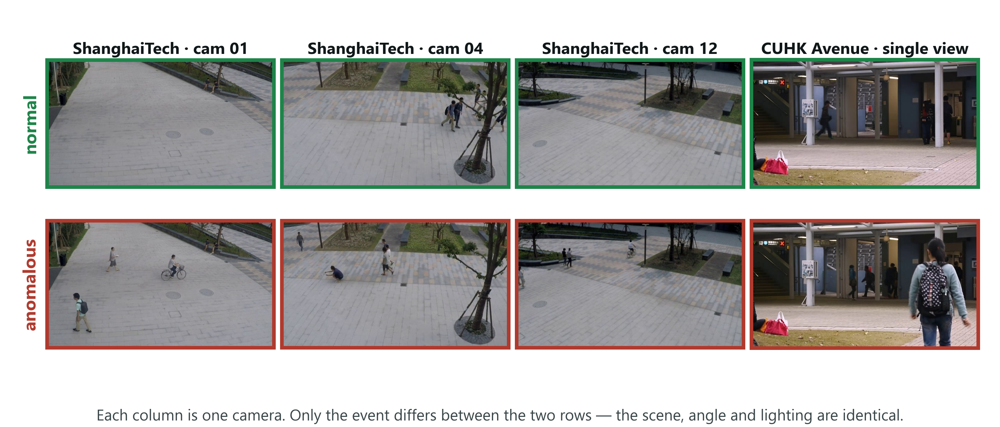
Figure 2. Normal and anomalous frames from both benchmarks. Each column is one fixed camera, so going down a column only the event changes.
SAY — "Each column is one fixed camera — the scene, the angle and the lighting are constant. Only the event changes. An empty walkway and the same walkway with a cyclist look nearly identical to a computer, and they're labelled opposite. So the label cannot be a property of how the scene looks."
If someone later challenges whether concept shift is real or contrived, come back to this slide. It is the argument in a photograph.
→ Next: "So that's the setup. Now what actually happened — and the first thing that happened is that it failed."

Part 4 — Failure and diagnosis (slides 10–13)

Slide 10 — The first result was a failure · 45s · running 10:50
On screen: 0.49, and the inverted condition table.
The beat: land the failure honestly. Do not rush and do not apologise.
In plain words. The first complete run came back at 0.49. Half. A coin flip would have done as well. And the central experiment came out backwards: the correct description performed worse than the deliberately wrong one. I want to show you this rather than skip to the version that works, because everything useful in the project came out of taking it apart.
0.49 AUROC. Fifty minutes of GPU time to produce a detector performing exactly as well as a coin flip.
And the central experiment came out backwards: the matched description — the correct one — was worst at 0.666, and the mismatched description, deliberately wrong, was among the best at 0.695.
SAY — "This is the point at which the idea looks broken."
Then pause. Let it sit for two seconds. The next three slides are why this talk is worth listening to.
→ Next: "There turned out to be two separate problems. The first one wasn't in the method at all — it was in how I was measuring."

Slide 11 — Diagnosis 1: we were measuring it wrong · 75s · running 12:05
On screen: the twelve views, the error, the analogy, and 0.49 → 0.71.
The beat: a measurement bug, fixed with no labels, using the benchmark's own protocol.
In plain words. The first problem had nothing to do with my idea. This dataset has twelve different cameras, and the model naturally scores some cameras higher than others simply because of how they look. I had thrown every frame from all twelve cameras into one big pile and ranked them together. It is like ranking students from twelve schools on raw marks when the schools mark to different standards — you destroy the ordering that was correct inside each school. Ranking within each clip first, then combining, took the same scores from 0.49 to 0.71. No labels involved, and it is the dataset's own published procedure. I simply had not been following it.
ShanghaiTech has 12 camera views, and CLIP sits at a different baseline score under each — different lighting, different angle. My error was pooling every frame from all twelve into one ranking.
Use the analogy. It works on everyone.
SAY — "It's like ranking students from different schools by raw marks when the schools grade differently. The comparison destroys the ordering."
Normalising each clip before pooling took the identical scores from 0.49 to 0.71.
Stress two things, twice if needed: the fix uses no labels, and it is the benchmark's own published protocol — I simply wasn't following it. And say that both figures appear in the paper.
→ Next: "That's a strong claim to make about your own bug, so let me show you the evidence for it."

Slide 12 — The evidence for that diagnosis · 45s · running 12:50
On screen: two panels — the embedding projection coloured by camera, and per-view similarity.
The beat: the diagnosis was not invented after the fact.
In plain words. I did not want to just assert that explanation, so here is the check. I took every frame, flattened it onto a two-dimensional map, and coloured each point by which camera it came from. The cameras land in separate clumps. Neither picture uses the answer key at all, so this is not me rationalising after the fact — it is the cause, visible directly.
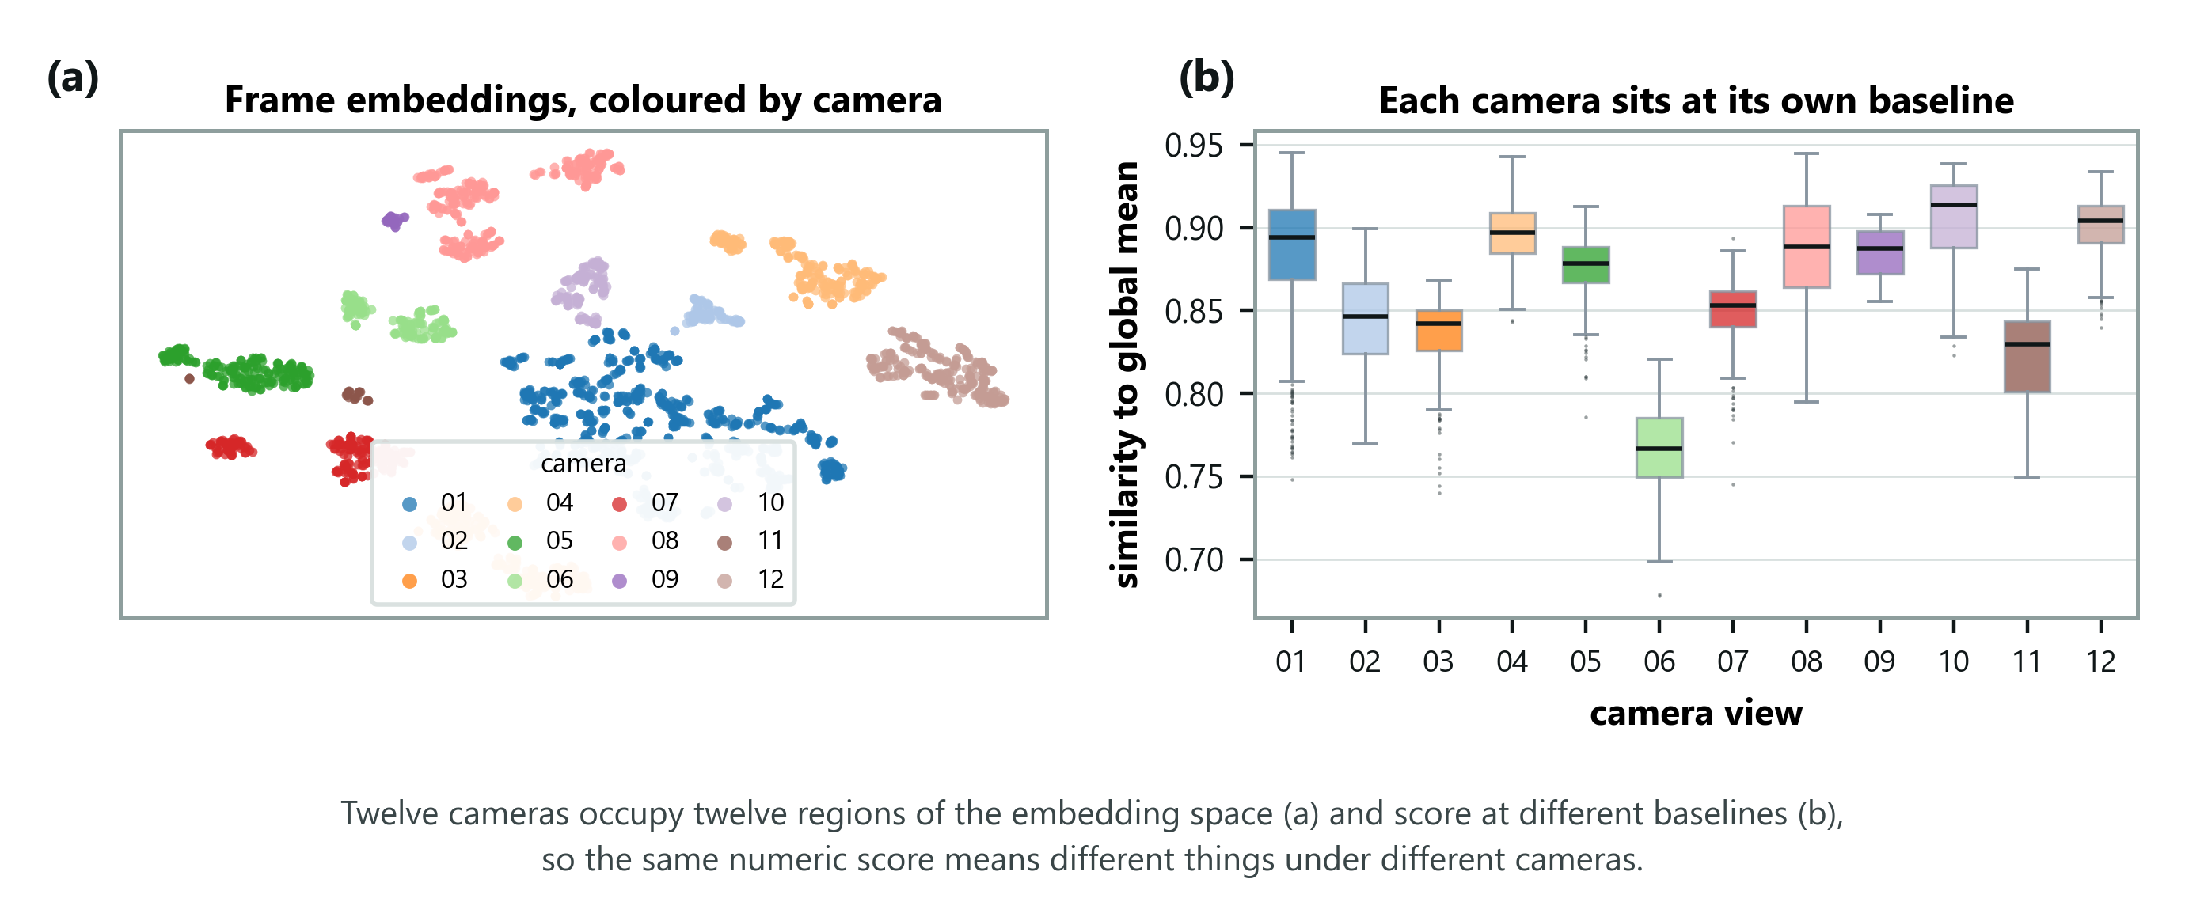
Figure 3. Left: every frame projected to two dimensions and coloured by camera. Right: similarity of each view to the average frame.
Left: every frame projected to two dimensions and coloured by camera — the views sit in separate regions. Right: how similar each view is to the average frame, differing by more than 0.13 between views.
SAY — "Neither panel uses labels, so this isn't hindsight. The cameras occupy separate regions of the space at different similarity levels, which is exactly why pooling raw scores destroyed the ordering."
→ Next: "That fixed the number. It did not fix the inversion — the correct description was still the worst one. That was a second, separate problem, and it's the more interesting of the two."

Slide 13 — Diagnosis 2: the description cancelled itself out · 90s · running 14:20
On screen: the two prompt sets with their shared words highlighted, and the fix.
The beat: the mechanism of the inversion — and why a better sentence did more damage.
In plain words. The second problem was mine, and it is the interesting one. The system compares each frame against two written descriptions: one of normal, one of abnormal. I had been pasting the scene sentence onto both of them. Each side gets averaged into a single summary, so the same words landed on both sides and the two summaries drifted toward each other — and the whole method depends on them being far apart. I was rubbing out the very contrast I was measuring. Worse: an accurate sentence matches everything on screen, so it does the most damage. That is exactly why the better sentence scored worse. The fix was one line -- attach the sentence to the "normal" side only, because the scene is what defines normal here and an anomaly is a departure from it.
The most interesting slide in the deck. Give it the time.
I had been appending the scene sentence to both prompt sets. Point at the two prompts and let the panel see the shared words.
Each set is averaged into one summary vector. Shared text enters both, so the two summaries move toward each other — and the whole method depends on them being different. I was erasing the very contrast the decision rests on.
The punchline, and it is a good one:
SAY — "An accurate description matches every frame strongly, so it absorbs the most contrast. A wrong one matches nothing, so it does no damage. That is exactly why the result inverted — the better the sentence, the worse it performed."
The fix: attach the description to the normal prompts only. The scene defines what normal looks like here; an anomaly is a departure from it.
→ Next: "So I re-ran the whole four-condition sweep with that one change. This is the result the project exists to produce."

Part 5 — The central result (slides 14–17)

Slide 14 — After the fix: the predicted signature · 75s · running 15:35
On screen: the two-row injection-point table.
The beat: the headline number, and the control that makes it mean something.
In plain words. Same models, same video, same everything — the only two things that vary are which sentence is supplied and which side it is attached to. Start with the first column, where no sentence is supplied at all: 0.707 in both rows. It has to be identical, because with no sentence there is nothing to attach anywhere. That column is my proof that nothing else changed between the two rows. Then look at 0.628: that is what a wrong sentence costs. Ten points, with nothing else in the system permitted to move.
ShanghaiTech, all 107 clips, per-clip normalised. Every model frozen; only the sentence and its injection point vary.
Injection point | none | generic | matched | mismatched | gap
Both prompt sets | 0.707 | 0.670 | 0.666 | 0.695 | −0.029
Normal set only | 0.707 | 0.691 | 0.734 | 0.628 | +0.105

Point at the `none` column first. It is 0.707 in both rows.
SAY — "That column is the control. It's identical in both rows, which confirms nothing changed between them except where the sentence was injected."
Then point at 0.628.
SAY — "A wrong sentence costs ten points. Nothing else in the system was permitted to change, so the text caused it."
→ Next: "Same numbers, drawn — because the thing that matters is a distance, and a distance is easier to see than to read."

Slide 15 — The same experiment, drawn · 30s · running 16:05
On screen: grouped bars, grey for both-sets, orange for normal-only.
The beat: the quantity of interest is the gap, and it changes sign.
In plain words. The same numbers as a picture. Do not read the height of any single bar — the thing that matters is the distance between the matched bar and the mismatched bar. In grey, that distance runs the wrong way. In orange, it runs the right way. The only difference between grey and orange is which side of the comparison the sentence was pasted onto.
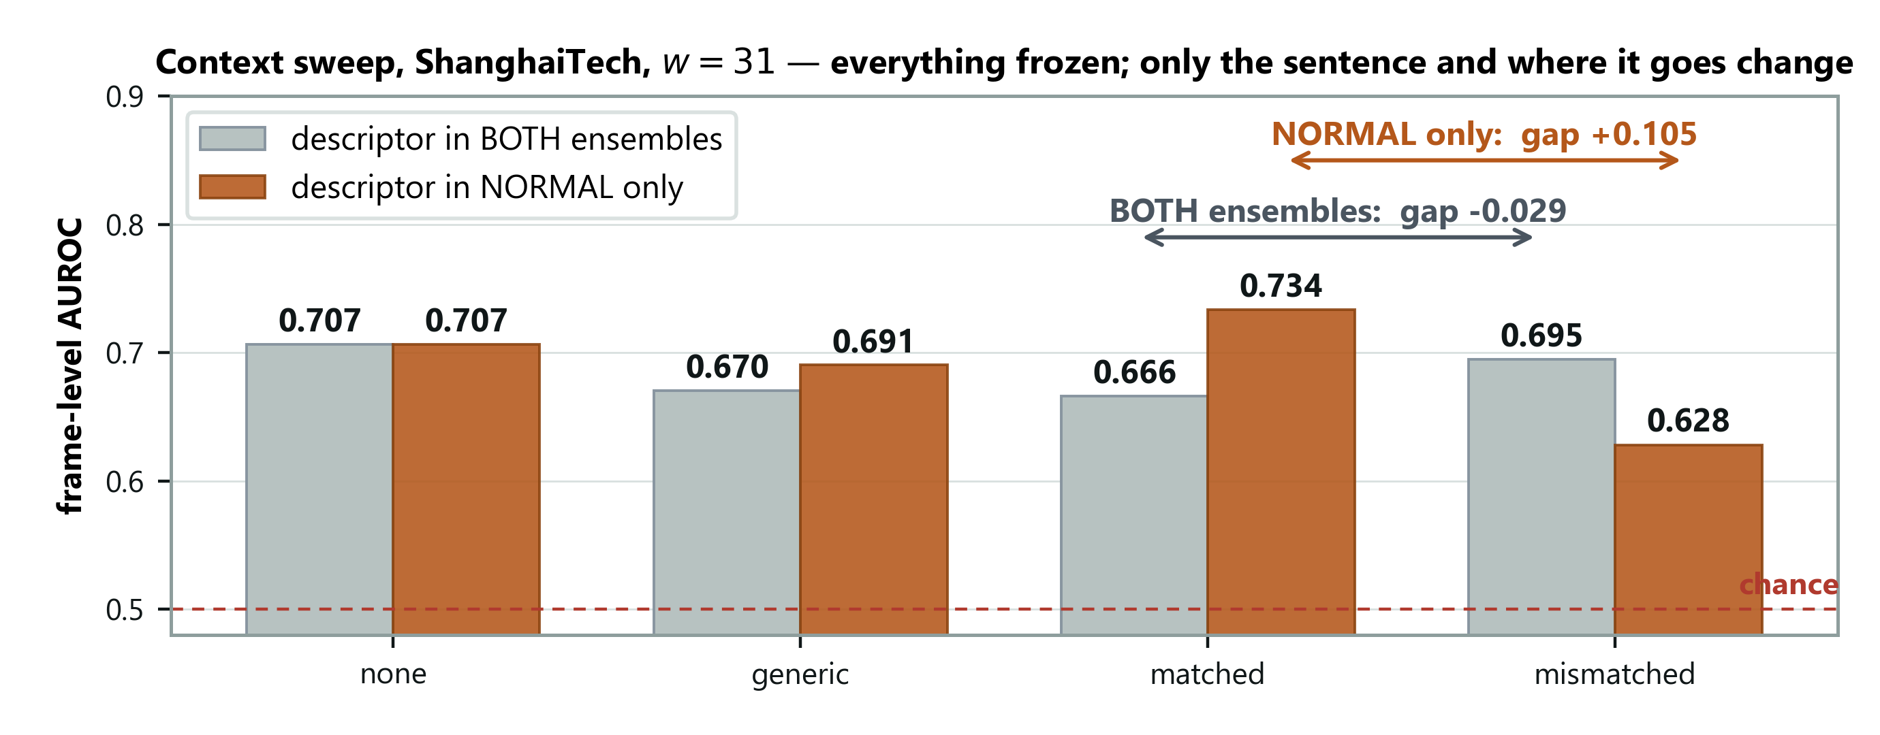
Figure 4. Grey bars put the sentence in both prompt sets; orange bars put it in the normal set only.
Trace the two arrows with your finger. The number the experiment exists to produce is the distance between the matched and mismatched bars. With grey, that distance is negative. With orange, it is +0.105.
SAY — "The only thing separating those two arrows is where the sentence was attached."
→ Next: "That's aggregated over a hundred clips. Here's what it looks like on a single one, where there's nothing aggregated to argue with."

Slide 16 — One clip, two sentences · 40s · running 16:45
On screen: two score curves over one clip, with the event marked.
The beat: the cleanest evidence in the deck — no aggregation involved.
In plain words. Everything so far has been an average over a hundred clips. This is one clip. Two lines: the same frozen models scoring the same frames, and the only difference is whether the sentence describes a campus walkway or a factory. Outside the event they sit on top of each other — which is what should happen. Inside the event they separate. There is no averaging here for anyone to argue with.
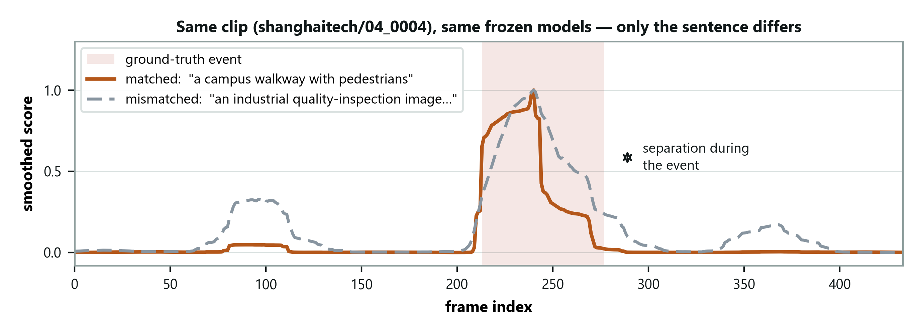
Figure 5. Same frozen models, same frames, same smoothing. Only the scene description differs.
Same frozen models, same frames, same smoothing. The only difference is whether the sentence describes a campus walkway or an industrial site.
SAY — "The curves coincide outside the event — that's on purpose, that's the control — and they separate inside it. Two runs over identical frames with identical frozen weights. There's no aggregation here to argue with."
→ Next: "Now let me be precise about what I am and am not claiming from this, because the two halves of the result are not equally strong."

Slide 17 — Stating the claim precisely · 60s · running 17:45
On screen: the weaker half, the claim made, and the mechanism.
The beat: understate deliberately. This is where credibility is won.
In plain words. I want to split my own result in half, because the two halves are not equally strong. Correct sentence versus no sentence: it helps, but only by about 0.027, and when I reshuffle which clips I test on, the numbers wobble by more than that. So I will say it points the right way and I will not claim the size of it. Wrong sentence versus correct: 0.105, far outside that wobble, and nothing else in the system was free to move. That one I will claim. The honest summary is that the sentence is doing real work, and what proves it is the damage from getting it wrong, not the benefit from getting it right.
The weaker half. A correct description beats no description by +0.027. Positive at every smoothing window, but inside the ±0.036 split-to-split spread.
SAY — "So I report the direction, not the magnitude. I'm not claiming that number."
The claim I do make. A wrong description costs −0.105. Unambiguous, and nothing else could have caused it.
The mechanism — SAY "The description constrains a decision boundary rather than adding information. It doesn't reliably lift performance when it's correct; it degrades performance sharply when it's misdirected."
The secondary finding, not present in the literature: where the description is injected dominates what it says — to the point of reversing the sign of the effect.
→ Next: "That's the language pathway on its own. The obvious next question is whether the other components I built are earning their place."

Part 6 — Ablations and boundaries (slides 18–22)

Slide 18 — Which components earn their place · 60s · running 18:45
On screen: the five-row scoring-signal table.
The beat: language alone wins, and a prediction of mine failed.
In plain words. Having got it working, I checked whether every piece I built was actually earning its place. I tried scoring frames by how much they move instead of what they contain, by how far they sit from the clip's own average, and by combinations of those with the language pathway. Language on its own wins. I will point out the one that embarrasses me: I predicted motion would help, because a bicycle at cycling speed is the obvious example of an anomaly you would think needs motion to spot. It added nothing. The image model is evidently already picking up enough of the movement on its own.
Scoring signal | Held-out AUROC | Full test set
Scene-centre normality only | 0.585 ± 0.025 | 0.585
Semantic + scene-centre | 0.645 ± 0.034 | 0.640
Kinematic — motion only | 0.685 ± 0.015 | 0.686
Semantic + kinematic | 0.711 ± 0.034 | 0.706
Semantic — language only | 0.718 ± 0.036 | 0.707

Language alone is best. Adding motion costs 0.001; adding scene-centre normality costs 0.067.
Volunteer the surprise — SAY "I expected motion to help and it doesn't. ShanghaiTech's anomalies look kinematic — a bicycle at cycling speed — so appearance and motion ought to be complementary. Measured here, they aren't. The pooled embedding already registers enough of the motion."
Reporting a prediction that failed is stronger than reporting only the ones that held.
→ Next: "Both the smoothing window and those components are easier to judge as curves, so — briefly."

Slide 19 — Window length, and what each component adds · 35s · running 19:20
On screen: two panels — the window sweep, and the component comparison with error bars.
The beat: the window has a real optimum; the component differences do not survive their error bars.
In plain words. Left panel: smoothing helps up to about a second of averaging and then starts hurting. That matters — it means there is a real best setting, rather than the measurement simply rewarding more and more blur. Right panel: the error bars. Look at how much they overlap. So the honest reading is not "language beats the alternatives", it is "nothing I added beat plain language". That is a negative result about my own extra machinery.
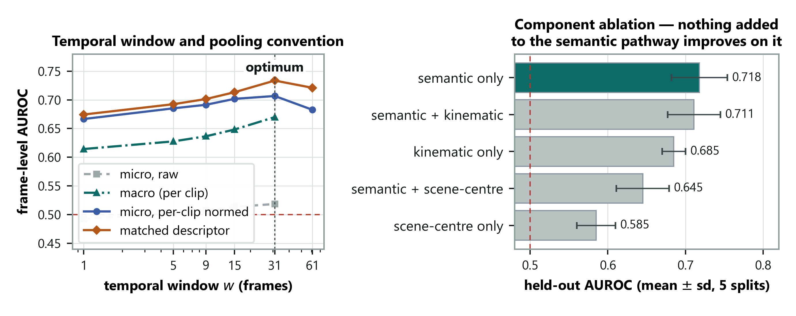
Figure 6. Left: the smoothing window sweep. Right: components with error bars.
Left: smoothing helps up to a window of 31 and then hurts — so the window has a genuine optimum rather than the metric simply rewarding more blur. The grey curve is the wrong pooling, and it never leaves chance.
Right: volunteer the weakness before anyone asks.
SAY — "The error bars overlap, so the top three are statistically tied. The honest claim is that nothing I added beat plain language. That's a negative result about my own elaborations, not a win over the alternatives."
→ Next: "Everything so far is one benchmark. The real test is whether any of it survives a second one."

Slide 20 — A second domain: the replication test · 75s · running 20:35
On screen: the two-dataset comparison table.
The beat: detection transfers, adaptation does not — and say so plainly.
In plain words. A result on one dataset is not a result. So I took the system exactly as it stood, changed nothing, retuned nothing, and pointed it at a second benchmark — swapping only the sentence. Two different things happened. The detection transferred perfectly: 0.706 against 0.707. But the adaptation almost disappeared, and a meaningless placeholder sentence actually beat an accurate description. I am telling you that myself: whatever the sentence is doing on this second dataset, it is not domain adaptation.
Identical frozen configuration applied to CUHK Avenue. Nothing retuned. Only the sentence changed.
Dataset | none | generic | matched | mismatched | gap
ShanghaiTech (12 views) | 0.707 | 0.691 | 0.734 | 0.628 | +0.105
CUHK Avenue (1 view) | 0.706 | 0.729 | 0.677 | 0.657 | +0.020

Detection transfers. 0.706 against 0.707 with no descriptor — the detector works equally well on a dataset it was never tuned for.
Adaptation does not. The gap is five times smaller, and the correct description scores below having none at all.
Give the honest reading yourself — SAY "On Avenue a placeholder beats an accurate description. Whatever benefit the description is giving here, it cannot be domain adaptation."
If asked why Avenue trails the other methods (it comes up again on slide 27), the answer has two halves, and the second is the bigger one:
SAY — "It isn't the detector failing to transfer — with no descriptor the two benchmarks give 0.706 and 0.707, identical. The first half is that a scene description has nothing to resolve on a single-camera benchmark. The second half is that Avenue's anomalies are a different kind. ShanghaiTech's are object categories — car, bicycle, motorcycle — which is exactly what CLIP is built for. Avenue's include 'too close', where nothing is semantically out of place and the anomaly is how near the object is. No sentence expresses that. It's the same resolution limit I found on MVTec: whole-frame embeddings capture what is in a scene, not how big, how fast or how near it is."
Then the conjecture, stated as a conjecture, with the experiment that tests it: ShanghaiTech has twelve camera views and Avenue has one. A scene description has work to do only when there are several environments to tell apart.
→ Next: "That's a comfortable story to tell about your own negative result, so I designed a test that could have destroyed it."

Slide 21 — We tested that explanation, and it held · 75s · running 21:50
On screen: the three-row pooled / within-view / Avenue table.
The beat: a complete research cycle — observation, explanation, falsifiable test, result.
In plain words. I had a comfortable explanation for that — the second dataset has one camera, the first has twelve, and a scene description only earns its keep when there are several places to tell apart. Comfortable explanations for your own bad results deserve suspicion, so I built a test that could have destroyed it. The first dataset is really twelve single-camera datasets stacked together. So I ran the same experiment inside each camera separately. If my explanation were wrong, the effect would have stayed strong. It dropped to a third, landing right next to the single-camera dataset. The explanation survived a test it could have failed.
ShanghaiTech is effectively twelve single-view datasets stacked together. If the descriptor works by telling the model which scene it is in, then confining the sweep to a single camera view should reproduce Avenue's flat result.
Evaluation | Views | Clips | Gap
Pooled across views | 12 | 107 | +0.105
Within a single view (mean) | 9 | 5–34 each | +0.033
CUHK Avenue (single view) | 1 | 21 | +0.020

SAY — "A within-view gap near +0.105 would have refuted this outright. It came back at a third of that, sitting right next to Avenue's figure."
Then give the caveat before they find it: three of the nine views show a negative gap, so inside a single scene the effect is not reliable.
SAY — "What the sentence mainly supplies is which scene you're in, not what counts as normal within it. That's a narrower claim than I started with, and it's the one the data supports."
Name what this slide is: a full cycle. Something odd was observed, an explanation was formed, a test that could have killed it was designed and run, and it held.
→ Next: "And since I've just quoted an average of nine views, here they all are individually."

Slide 22 — Every camera view, one at a time · 35s · running 22:25
On screen: per-view bars against the pooled line.
The beat: show the spread yourself rather than letting them find it.
In plain words. That was an average of nine cameras, so here are all nine individually rather than hidden inside a mean. Most fall well below the pooled line, three actually go the wrong way, and two nearly reach it. Each bar rests on as few as five clips. So this is a shift in the average, not a clean collapse everywhere — and I would rather say that than have someone find it.
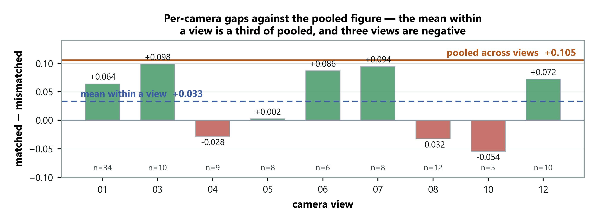
Figure 7. The orange line is the pooled result; each bar is one view on its own.
The orange line is the pooled result; each bar is one view alone. Most fall well short, three are negative — but views 03 and 07 nearly reach it. The bars rest on between five and thirty-four clips each.
SAY — "So this is a shift in the average, not a clean collapse everywhere."
Saying that before the panel spots it is the difference between a caveat and a hole.
→ Next: "If the sentence works by telling the model which camera it is looking at, then twelve cameras sharing one sentence is the wrong design. That's where Phase 3 starts."

Part 7 — Phase 3: new results (slides 23–25)

Slide 23 — A sentence per camera, written by the system · 50s · running 23:15
On screen: the per-camera chart — none, one shared sentence, own sentence by hand, own sentence by LLaVA, and two swapped controls with whiskers.
The beat: the sentence works by matching its camera, and the system can write it.
In plain words. All twelve ShanghaiTech cameras used to share one sentence, which can't tell them apart. So each camera got its own. Written by hand: 0.749. Written by LLaVA from the camera's first three frames, with no person and no labels: 0.751. Then the control — give every camera another camera's sentence. Each of those is a perfectly realistic campus description, and every one of the eleven swaps scores lower. So the benefit comes from the sentence matching its own camera.
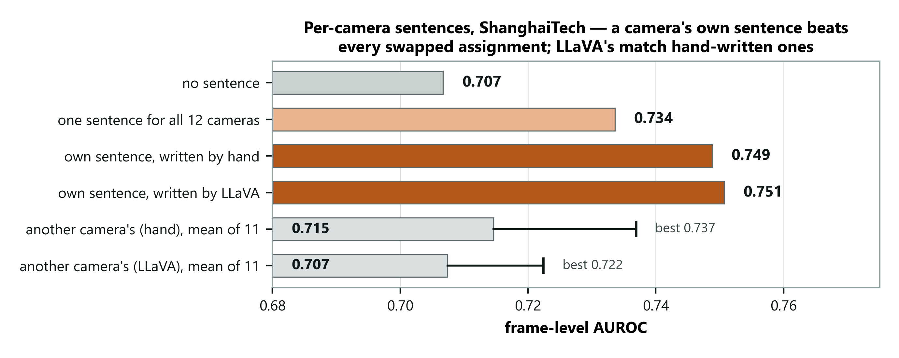
Figure 8. Per-camera sentences on ShanghaiTech.
Point at the two orange bars, then at the whiskers. Even the best swap (0.737) is below both per-camera bars.
SAY — "Every swapped sentence is a believable campus scene, so the model can't win by spotting nonsense. The only way the correct assignment wins is if the sentence matches the camera — and it does, eleven times out of eleven."
Two traps — do not say either:
- "LLaVA writes better sentences than me." 0.751 against 0.749 is noise. Say it matches.
- "Per-camera beats shared by 0.017." That's inside the ±0.036 split-to-split wobble.
Volunteer the mistake. SAY — "My first version picked the frames to caption using the labels. A real camera has no labels, so I reran it picking the first three frames blind. It moved by 0.004. The 0.751 is the label-free number."
→ Next: "That's twelve campus cameras. The real test is somewhere this was never developed — so I wrote down what I expected before running it."

Slide 24 — UCF-Crime: predictions written down first · 75s · running 24:30
On screen: 0.824, and the table of four registered predictions.
The beat: a test written in advance, one prediction failed, and I say so first.
In plain words. UCF-Crime is 290 real CCTV videos from about 290 different places — shops, streets, homes, highways — 140 of them with a crime. Before running anything I committed four predictions to git, so the timestamp proves they came first. Each video got its own LLaVA sentence from its first second of footage. Result: 0.824 with no training. Three predictions held; the most ambitious one failed.
Start with how it was done, not the number. SAY — "I wrote these four predictions down and committed them before computing a single score. So nothing here is explained after the fact."
Then the number: 0.824. LAVAD, the leading training-free method, reports 0.803 here. SAY — "That's comparable or better, not a clean win — these are other papers' numbers, and small protocol details can move them. For context, AnyAnomaly gets 0.807 here — so on the most diverse benchmark, we're ahead of both."
Then P1, before anyone asks. SAY — "P1 failed. I predicted the effect would grow with the number of scenes — 290 scenes instead of 12. It didn't; it came out the same. So I've narrowed the claim from 'the benefit scales with scene diversity' to 'the benefit needs scene diversity'."
And P2, the strongest line on the slide. A video's own sentence beats sentences borrowed from other videos by 0.110.
If asked why the main number is "raw", not per-clip normalised: half the UCF videos contain no crime. Normalising each video forces its top frame to 1.0, so every normal video would get a "maximally anomalous" frame. I fixed that choice in advance; both numbers are in the paper.
→ Next: "Here's the same result as a picture, because one bar in it is the most convincing thing in Phase 3."

Slide 25 — UCF-Crime, drawn · 30s · running 25:00
On screen: the UCF-Crime bars with LAVAD's line dashed across them.
The beat: a wrong scene description is worse than none.
In plain words. Look at the bottom bar first. When each video is given another video's sentence, it scores 0.713 — lower than giving it no sentence at all, 0.756. A description of the wrong place doesn't just fail to help; it misleads. That's the clearest evidence in the whole project that the sentence works by telling the model where it is.
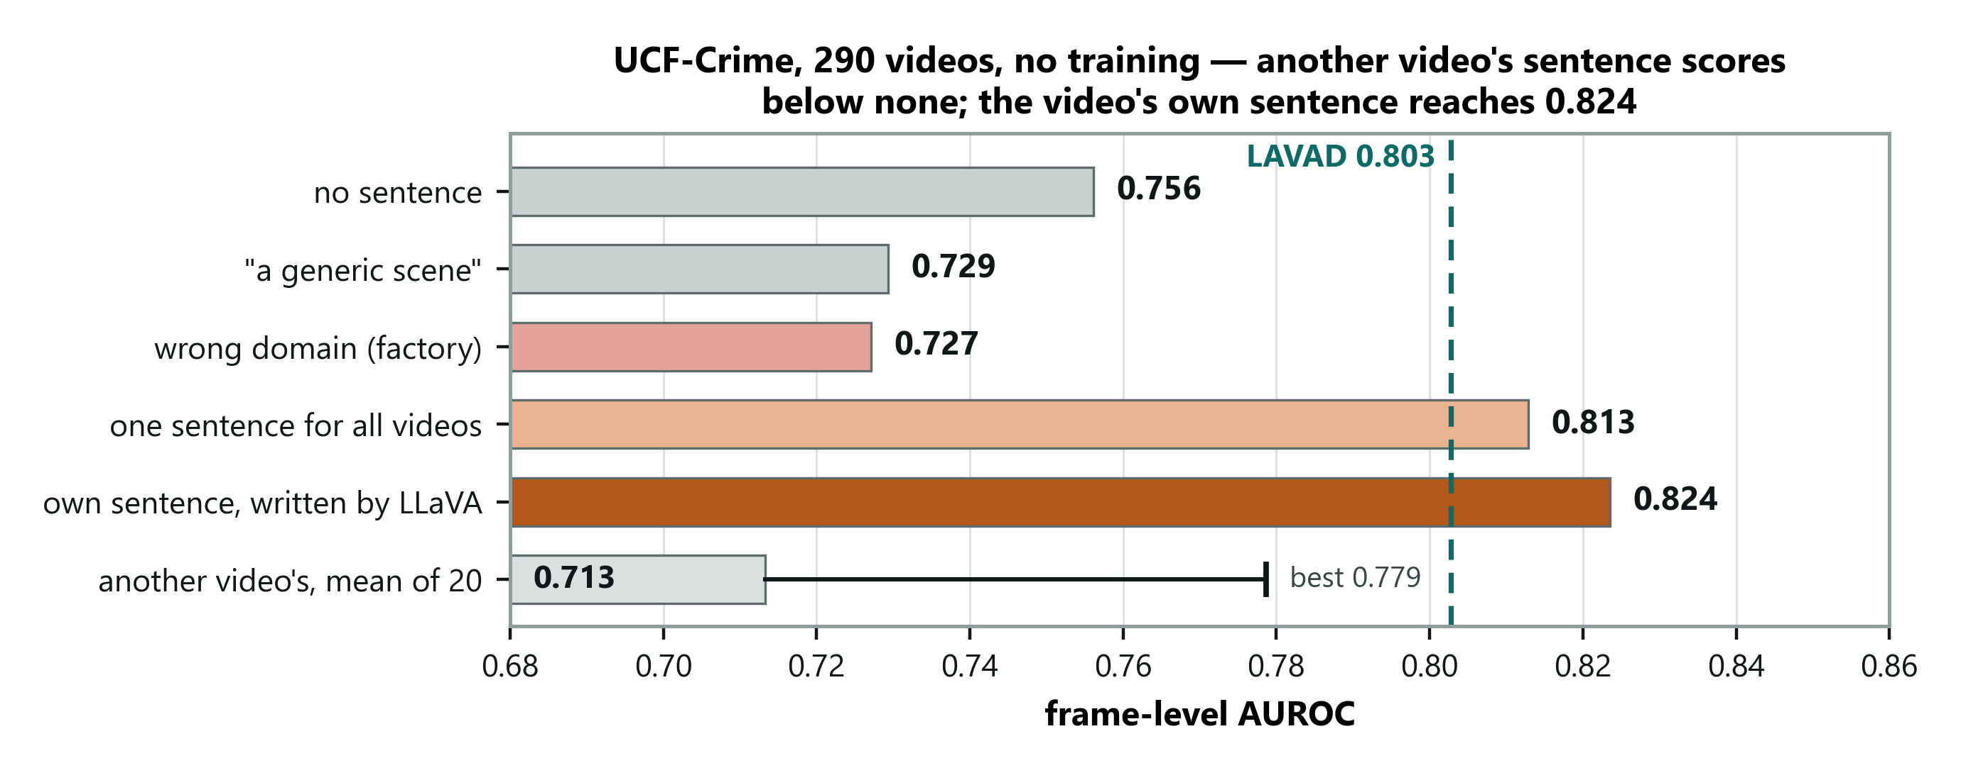
Figure 9. UCF-Crime, primary metric, with LAVAD's reported figure as a reference line.
Point at the bottom bar, then the "no sentence" bar. SAY — "Another video's sentence is worse than none. The model really is using the sentence to decide where it is."
Then the dashed line — LAVAD 0.803 — and say "comparable", not "better".
→ Next: "Those are the new results. The claim throughout is that the simplest configuration is the right one, so here is everything I tried that didn't work."

Part 8 — Assessment and close (slides 26–30)

Slide 26 — Six things that did not work · 45s · running 25:45
On screen: the six-row negative-results table.
The beat: negative results as evidence of real work.
In plain words. My claim is that the simplest version of the system is the right one. That claim is only worth anything next to the list of more complicated things I tried first. Six of them, none of which helped. A table of nothing but successes is the easiest thing in the world to produce; six diagnosed failures are not.
Modification | Outcome
Quadrant scoring, to catch small objects | No improvement in any configuration
Prompts naming bicycles and vehicles | Much worse alone — 0.486
Clip's own average as the normality reference | 0.585, and it degrades the language signal
Adding a motion signal | Costs 0.001 — not complementary
Local temporal deviation before projection | Better scorer, but narrows the context gap
Per-prompt max pooling | 0.678 against 0.707

Do not read all six. Pick two — quadrant scoring, and the bicycle prompts — then say why the table is in the deck at all:
SAY — "The claim is that the minimal configuration is the right one. That's only credible next to the alternatives that were tried. A clean table of successes is the artefact that's easy to fabricate. Six diagnosed failures are not."
Deliver that one looking at the panel, not at the screen.
Know the second row cold, because it looks like an obvious hole until it is explained. The abnormal prompts talk about fights and accidents while ShanghaiTech's anomalies are cyclists and skateboarders. I noticed that and rewrote them to name bicycles and vehicles — and it got much worse, 0.685 down to 0.486, because the rewritten prompts repeated "walkway" and "pedestrians" on both sides and reintroduced the very dilution problem M3 had just solved.
→ Next: "So where does all of that leave the work against everyone else's?"

Slide 27 — Where this sits against the literature · 75s · running 27:00
On screen: six training-free methods on Avenue and ShanghaiTech, ours highlighted.
The beat: we sit second among training-free methods on ShanghaiTech — and be honest about how much of that margin is the sentence, because most of it is not.
In plain words. Two things to be careful about on this table. First, my own number: I beat the plain CLIP baseline by twelve points, but with no sentence at all I already have ten of those twelve. Most of my margin is careful measurement and a bigger backbone, not language, and I would rather say that than have a panelist open my own table and find it. Second, the method above me is answering a different question. It asks "is the specific thing I named happening?" — so to deploy it you must first list everything that could go wrong. I ask "is anything happening that does not belong here?" — so you describe the ordinary instead. Anyone can describe the ordinary. Nobody can list the extraordinary.
This slide was rebuilt in September 2026. The old version compared us against LAVAD, which reports on UCF-Crime and XD-Violence and not on either of our benchmarks. Do not deliver the old line about "we don't match LAVAD."
Training-free method | Ave | ShT
Zero-shot CLIP | 62.3 | 60.9
Zero-shot ImageBind | 64.5 | 61.3
LLaVA-1.5 | 67.4 | 59.6
Video-ChatGPT | 76.9 | 69.1
DA-ZVAD (ours) | 67.7 | 73.4
AnyAnomaly | 87.3 | 79.7

If asked why the Avenue cell is 67.7 when slide 20 showed 0.706: because this row reports the matched condition on both benchmarks — the configuration the method proposes — rather than the best condition on each. Picking none for Avenue and matched for ShanghaiTech would be quoting a different setup per dataset to flatter the table. Say that plainly; it is a point in your favour, not against you.
Point at the zero-shot CLIP row first. That is the row that matters.
SAY — "Zero-shot CLIP gets 60.9 on ShanghaiTech; I get 73.4. But I want to be careful with that gap. With no sentence at all my pipeline already gets 70.7 — so the sentence is worth about two and a half points of it, and the rest is temporal smoothing, per-clip normalisation, prompt ensembling and a larger backbone. Most of my margin over those baselines is protocol, not language."
Volunteering that is the whole point of the slide. If you claim the twelve points and a panelist opens your own Table 9, you lose the room.
SAY — "The evidence that the language is doing work isn't this table. It's the mismatched condition: a wrong description costs ten points with everything else frozen."
Then reframe, because the table invites the wrong reading.
The panel will read this as "you are a weaker AnyAnomaly." You are not — you answer a different question, and it is the harder one.
SAY — "AnyAnomaly asks is the thing I named happening? I ask is anything happening that doesn't belong here? To deploy theirs you have to list what could go wrong — bicycle, fighting, someone falling. Anything you didn't think of produces no score, because nothing is looking for it. To deploy mine you describe what ordinarily happens, and anything departing from it gets flagged."
SAY — "An operator can always describe the ordinary. Nobody can enumerate the extraordinary. And that isn't my claim — it's theirs: their paper opens by saying abnormal events are rare and diverse and hard to collect. Putting that list in a prompt instead of a training set doesn't make the problem go away."
Then the consequence for their number.
SAY — "Which is why 79.7 needs reading carefully. To get it they state that each anomaly class in the dataset was treated as the query and the maximum taken over them. The benchmark hands them the answer key. That's fair for the task they defined — it measures closed-set performance with the class list supplied, not open-set performance at a site where nobody knows the list yet."
Do not claim you would beat them with the taxonomy withheld. You haven't run it. Say that, and name it as the next experiment — that reads as stronger than an unbacked claim.
Then the two findings, which are the actual contribution.
SAY — "And the control produced two things that apply to anyone building these systems. First, where you inject the text matters more than what it says — enough to flip the sign. Both prompt sets: minus 0.029. Normal set only: plus 0.105. Same sentence. That's prototype dilution, and it's a property of averaged prompt ensembles generally — so any paper reporting that scene descriptions don't help, without varying the fusion rule, has reported an implementation artefact. I nearly published that artefact myself."
SAY — "Second, the benefit needs several scenes to tell apart. Twelve views, plus 0.105. One view, plus 0.033. So deploy this across several scenes, not on a fixed single camera. I also predicted it would keep growing with more scenes, and UCF-Crime showed it doesn't — so I claim 'needs', not 'scales with'."
The bottom box now carries the UCF-Crime line. Point at it: 0.824 where LAVAD reports 0.803 — and say "comparable", with the frame-sampling caveat.
If you only get one sentence on this slide: "They detect the anomalies you can name. I detect the ones you can't — and along the way I found that where you put the text matters more than what it says, which would have inverted my own conclusion if I hadn't checked."
→ Next: "In the same spirit, here are the limitations — stated by me rather than found by you."

Slide 28 — Limitations we are stating ourselves · 50s · running 27:50
On screen: six limitations.
The beat: deliver these as findings, not confessions.
In plain words. These are limitations I found and am choosing to put on a slide, not ones the panel had to dig out. The third one is worth dwelling on, because it is not really about my system: the scoring procedure that this whole field uses turns out to be sensitive to a rescaling of the score that ought not to matter at all. I found it while chasing my own bug, and it applies to everybody's numbers, not just mine.
- The mechanism is bounded. It works on ShanghaiTech and UCF-Crime and nearly vanishes
on single-camera Avenue. My registered prediction that it grows with scene diversity was refuted.
- Resolution ceiling. Whole-frame embeddings at 224×224 can't resolve small objects;
quadrant scoring didn't close it and patch-level scoring is untested.
- The metric is scale-sensitive. Per-clip normalisation is affine, so a monotone
rescaling of the score changes the pooled figure even though the ranking is identical. Dwell on this one — SAY "That's a real methodological point about a protocol the whole field uses, and I found it by chasing my own bug."
- Configuration selection. No validation split exists for these benchmarks, so I split
clips and report the half never used to select.
- Metric sensitivity on UCF-Crime. Under the campus scoring method (per-video
normalisation) the context effect shrinks sharply — shared vs wrong-domain falls from +0.086 to +0.021. I report the raw metric because I registered it in advance, and I say the effect is not robust to the protocol. Also: each video's sentence comes from its first second, and in 3 of 140 crime videos the crime has already started then.
- No explanations yet. LLaVA writes the camera sentences but hasn't explained flagged
events.
→ Next: "Each of those maps to something on the next list."

Slide 29 — What comes next · 40s · running 28:30
On screen: four prioritised items, and a box listing what was done since Phase 2.
The beat: what is done since Phase 2, and what is next and why.
In plain words. Point at the box at the bottom first: the within-view control, the missing half of the mechanism, the per-camera sentences, and a whole new benchmark are done since Phase 2. Next is XD-Violence, the other benchmark LAVAD reports on; then patch-level scoring, my best shot at a higher number; then LLaVA's explanations; and UCF-Crime with scores spread to every frame, so the LAVAD comparison holds however they computed theirs.
SAY — "XD-Violence first, because it completes the LAVAD comparison. Patch-level scoring second, because it's the most likely way to move the headline number."
If asked why the industrial (MVTec) sweep was dropped: the thesis is video anomaly detection, and UCF-Crime gives a stronger domain contrast inside video. MVTec stays as the detection baseline.
→ Next: "To summarise."

Slide 30 — Summary · 45s · running 29:15
On screen: the five numbered beats.
The beat: close on the boundary, not the number.
In plain words. One line each. What I want to leave you with is not the headline number — it is the boundary. I can tell you where this works, where it does not, and which single experiment settles the part I am unsure about. And every figure here comes out of committed code with a run record attached.
One line each, no elaboration:
- The field targets covariate shift by explicit scoping; anomaly detection is dominated by
concept shift.
- Every model frozen; one sentence per camera, which the system writes itself.
- 0.751 on ShanghaiTech and 0.824 on UCF-Crime with no training; a wrong description
costs 0.105.
- Where the description is injected dominates what it says. Not in the literature.
- It needs several scenes — flat on single-camera Avenue — and a registered prediction
that it keeps growing with more scenes failed.
SAY — "One of my registered predictions failed, and I narrowed the claim because of it. All results are reproducible from committed code, run manifests and a pre-registration file."
Then stop. Do not trail off, and do not add a thank-you paragraph.
→ Next: hand over for questions. Advance to the references only if asked.

Slides 31–33 — References
Do not read these out. They are an evidence base, not a slide.
The numbering is the paper's own, so a citation on screen is the same number in the report. Be ready for one question: which survey contains the quotation? — Liu et al., 2022, reference [14].

Appendix

If you need about 21 minutes
Cut in this order and stop when it fits. Advance through cut slides without stopping rather than deleting them.
Cut | Slide | Saves
1 | 15 — the drawn version of 14 | 30s
2 | 19 — the ablation charts; fold the error-bar line into 18 | 35s
3 | 22 — per-view bars; fold "three of nine negative" into 21 | 35s
4 | 12 — the diagnostic evidence; keep only if 11 is challenged | 45s
5 | 9 — the dataset grid | 30s
6 | Trim 26 to one example instead of two | 20s
7 | 25 — the drawn UCF-Crime chart; say "another video's sentence is worse than none" on 24 | 30s
8 | Compress the slide 5 walkthrough to Stops 1, 3 and 5 | 90s

Never cut: 6, 7, 10, 11, 13, 14, 20, 21, 23, 24. Those ten are the talk.

The five sentences to know cold
- Anomaly detectors are stuck in the place they learned; we move them by writing a sentence.
- The domain-adaptation field handles "things look different"; anomaly detection is "the same
thing means something different."
- 0.751 on ShanghaiTech and 0.824 on UCF-Crime with no training at all — and a wrong
sentence costs ten points.
- Where you put the sentence matters more than what it says; putting it wrongly reverses the
result.
- It needs several scenes to tell apart — and when I predicted it would keep growing with
more scenes, the test said no, so I narrowed the claim.

If a question goes somewhere you did not prepare
The domain-adaptation literature excludes concept shift by explicit choice, and anomaly detection is built on concept shift. The papers that use language show it works but never test whether it is causally responsible. We characterise the first and supply a protocol for the second — including a control that our own framework initially failed.
And if you genuinely do not know: "I haven't tested that yet — here's the experiment that would answer it." That answer is always available, and it never sounds weak.

