Hibernate:

Hibernate also uses JNDI,JTA for communicating with application container like JBOSS for managing transactions.

How to map java objects to relational table.

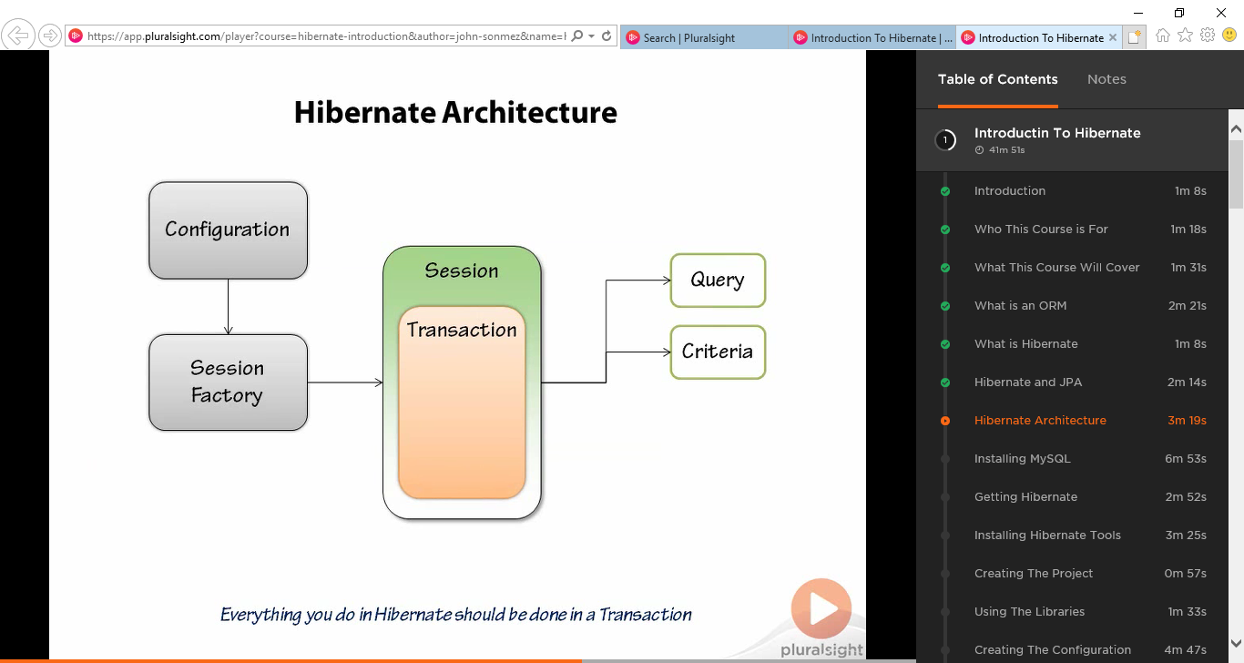

Configuration class:

Which is able to read hibernate configuration file and setup hibernate.

We need to create instance of this class in our application to use hibernate.

Session Factory:

Basically manage session for us. We need to get instance of session factory to create new session.

We normally create single instance of session factory and hold on for entire application.

When we have any work to do we ask session factory for session to execute hibernate queries and commands.

We ca directly execute hibernate commands and queries directly but its better to go with transaction.

* First ask session to start new transaction
* Do work
* And commit transaction.

We also use query and criteria classes to query database.

Service Registry(why we required service registry in hibernate 4 onwards) :

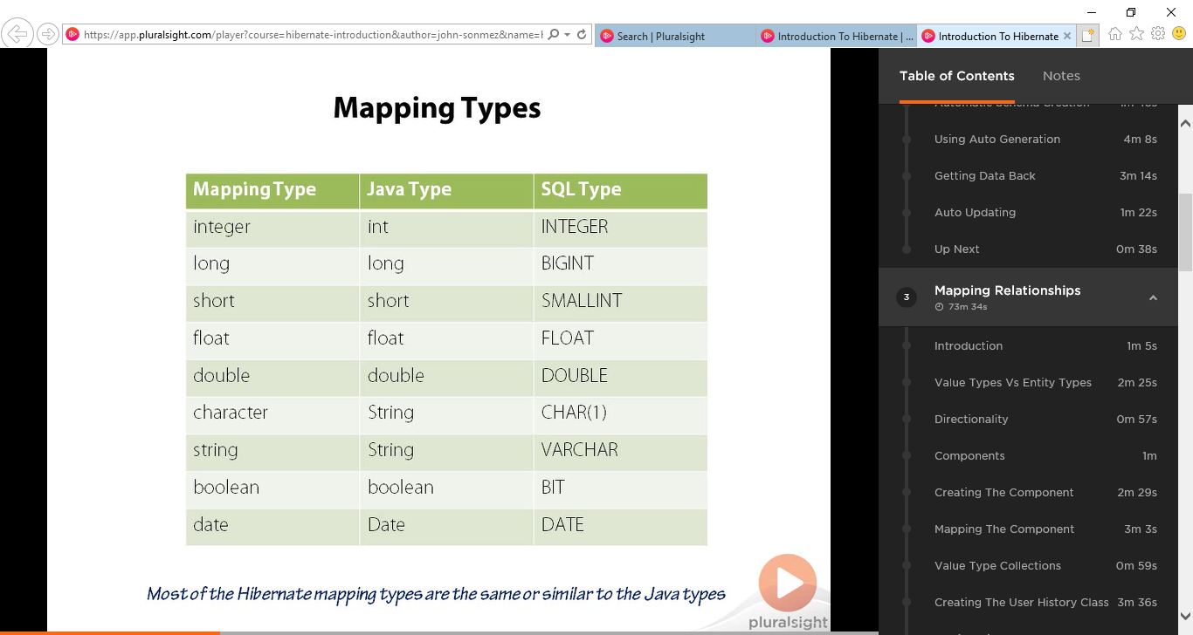

Generator (Assigned (NTS)):

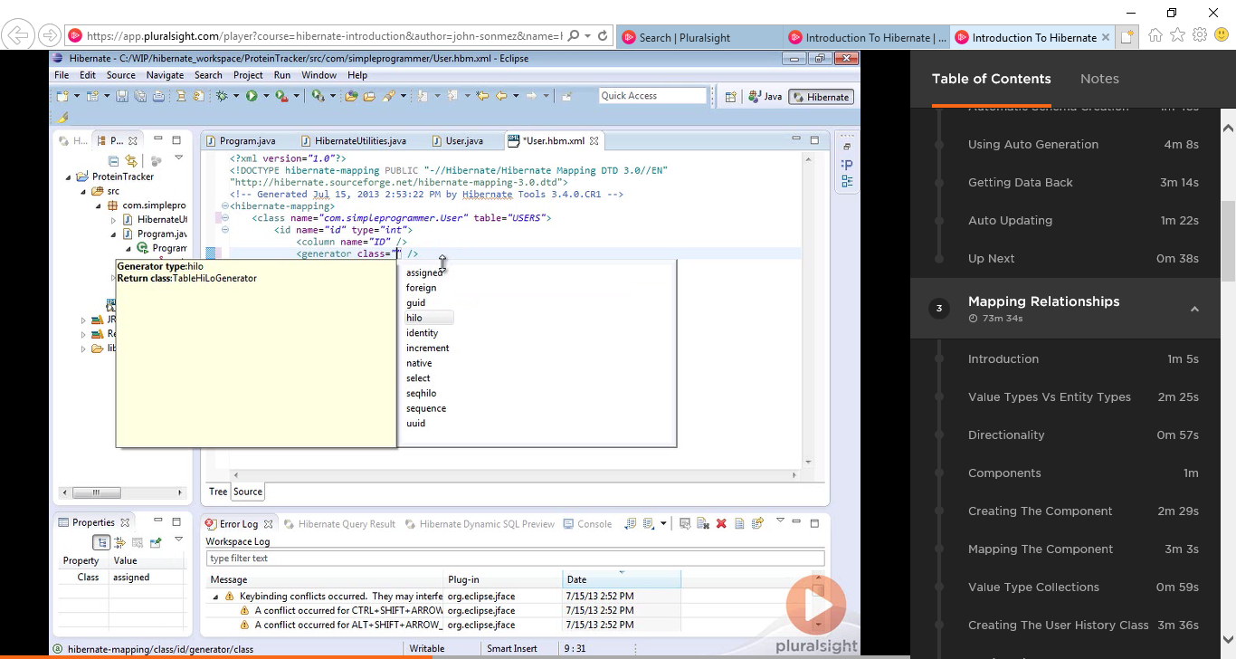

Hbm2dll.auto:

Auto generation of DDL.

For creating table automatically.

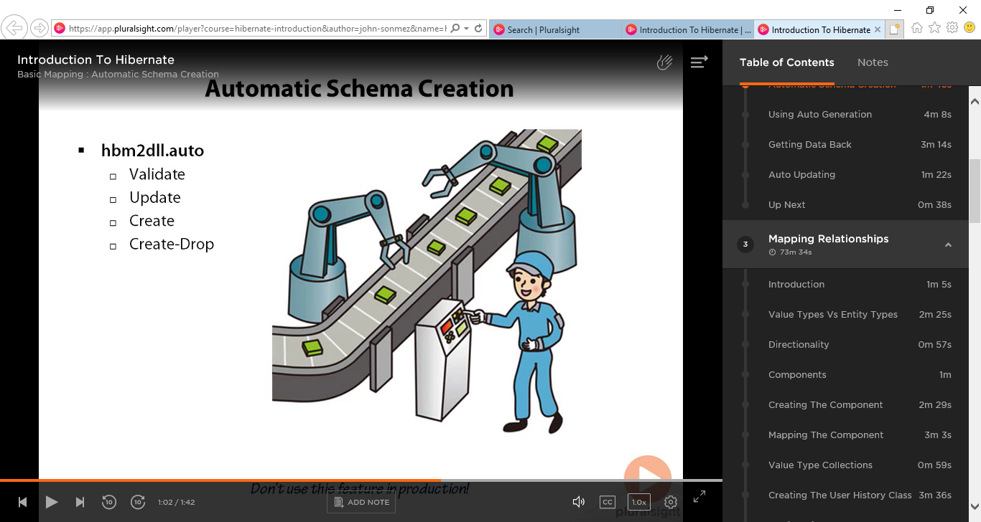

Validate: validate the schema matches to mapping file.

Update: update the new tables when they are missing.

Create: it create will create the table by dropping it each time.

Create drop : it like create, but it will create and drop the table once session factory closed.

Session.load() vs session.get():

Session.load() will throw the exception if Id does not exist.