India VIX as a Regime Filter for Bank Nifty Directional Prediction: A Leakage-Safe Reliability Assessment

Abstract
Equity forecasting models commonly report marginal aggregate accuracy improvements without clarifying whether predictive signal concentrates in specific market states or how output should gate real deployment. This paper develops a regime-aware decision framework for 21-day directional prediction of Bank Nifty using a stacking ensemble (XGBoost, LightGBM, Random Forest, CatBoost, and BiLSTM) on sixteen leakage-safe indicators, and uses the exercise to demonstrate how two specific methodological errors -- a test-period-derived (look-ahead-biased) regime threshold and an overlapping-position trading simulation -- can manufacture an apparently strong positive result. After correcting split leakage, removing threshold look-ahead bias, and using dependence-aware inference, the deployable fixed regime threshold (train+validation p75 = 18.71) yields a sparse High-VIX subset. On the aligned evaluation sample, regime-conditioned accuracy is 100.0% (High-VIX, N=8) versus 66.5% (Low-VIX, N=248), but the High-VIX local majority baseline is also 100.0%, and dependence-aware tests (non-overlapping Fisher, block-permutation) are not significant after correction. A year-by-year walk-forward analysis across six independently evaluated years shows the High-VIX advantage in only one year (2021), with the other five years going the other way by 11-39 percentage points -- direct evidence that the primary-sample result is concentrated in a single stress episode rather than reflecting a general regime effect. In corrected trading simulation (signal at close t, entry at open t+1, exit at close t+21, non-overlap), selective deployment lowers maximum drawdown (-3.69% vs -6.62%) but does not exceed buy-and-hold Sharpe at any tested cost level (0.455 vs 1.204 at 0 bps; 0.375 vs 1.204 at 50 bps) -- reversing our earlier, uncorrected claim of Sharpe superiority (2.216 vs 1.963). We therefore position the contribution as a methodological case study in how leakage and look-ahead bias can manufacture an entire positive finding in regime-conditional financial ML, together with a transparent, fully corrected reliability-assessment framework, rather than as evidence of a validated trading edge.
Keywords: Bank Nifty; India VIX; stacking ensemble; volatility regime; BiLSTM; expert systems;

1. Introduction
The longstanding benchmark in financial economics is that publicly traded securities should be difficult to forecast in a systematic way because prices rapidly incorporate available information (Fama, 1970, 1991). Yet that benchmark never implies a perfectly featureless market. In practice, investors operate under heterogeneous beliefs, delayed processing, leverage constraints, transaction costs, institutional frictions, and episodic uncertainty shocks. Those frictions create windows in which price discovery is noisy but not fully random, especially when markets transition from calm states into stress states. This perspective aligns with the adaptive markets hypothesis (Lo, 2004), which argues that predictive opportunities emerge and recede as participants adapt to changing environmental conditions rather than disappearing uniformly across all states. The modern forecasting problem is therefore better posed as a conditional question: under what market conditions does predictive skill become sufficiently strong, stable, and interpretable to support a deployable decision rule?
This conditional framing matters acutely in machine learning for finance. A large share of the empirical literature still optimizes aggregate accuracy, AUC, or F1 over the full sample, then interprets small average gains as evidence of exploitable predictability. Such practice is weak for at least three reasons. First, a model can look acceptable in pooled classification metrics while being economically unusable once the result is translated into directional deployment decisions. Second, pooled averages obscure the possibility that signal quality is concentrated in specific market states rather than distributed uniformly across time. Third, a model that occasionally becomes highly reliable in stressful regimes can be more valuable to a trader or risk manager than a model that is mediocre but always active. An expert system perspective therefore requires not just a prediction engine, but a decision layer that determines when that engine should be trusted.
Bank Nifty offers a compelling test bed for this question. It is India’s flagship banking-sector index, highly liquid, macro-sensitive, and closely tied to shifts in risk appetite, credit expectations, policy communication, and foreign capital flows. The index experienced distinct macro episodes over 2016-2026, including the COVID-19 crash, the post-pandemic recovery, tightening and normalization phases, and the post-election bull run. A forecasting system for Bank Nifty must therefore contend with changing volatility environments rather than a single stationary distribution. India VIX, calculated from option prices on the National Stock Exchange, is a natural candidate for summarizing that environment because it embeds forward-looking uncertainty rather than only backward-looking realized variation (NSE, 2008; Whaley, 2000).
The present study asks a narrow but decision-relevant question: does India VIX condition the directional predictability of Bank Nifty at short and medium horizons when the underlying predictive engine is a modern stacking ensemble? The answer, after correcting for split leakage, threshold look-ahead bias, and overlapping-observation dependence, is: not reliably, at least not in this sample. The ensemble does not dominate naive baselines unconditionally; the unconditioned 21-day test accuracy is below the majority-class rate in a strongly bullish test sample. Partitioning the held-out test period by a pre-test-fixed India VIX threshold does surface a large accuracy gap at the 21-day horizon (100.0% vs 66.5%), but the High-VIX subset contains only eight observations, all realizing the same outcome, and dependence-aware significance tests (non-overlapping Fisher, block-permutation) do not reject the null after correction. We therefore present this as a conditional pattern warranting cautious interpretation and further replication, not as an established regime effect.
This paper makes four contributions. First, it provides the first evidence in this project context that Bank Nifty directional forecasting accuracy shows a large, but statistically unconfirmed, regime-conditional gap when regimes are defined by a pre-test-fixed India VIX threshold and evaluated on a fully held-out period. Second, using 1-day and 5-day models retrained on the same corrected pipeline, it shows the pattern is not confined to a single horizon in the way we originally expected: the 1-day horizon shows no regime gap (62.5% vs 54.8%, Fisher p=0.734), but the 5-day horizon shows a nominally larger gap than 21-day itself (100.0% vs 55.2%, uncorrected Fisher p=0.011), on the same 8 High-VIX days used throughout. We read this as further evidence of fragility rather than a clean horizon-specific mechanism: with only 8 High-VIX observations shared across all three horizons, single-day outcome flips can move any of these numbers substantially, and the 5-day result has not been subjected to the same dependence-aware protocol (block bootstrap, non-overlapping resampling) applied to the 21-day headline result. Third, it converts the statistical result into an explicit, deployable trading rule and reports its risk-adjusted performance honestly: under the corrected protocol the selective rule trades once, is active for 21 of 256 aligned test days, lowers maximum drawdown relative to buy-and-hold (-3.69% vs -6.62%) but does not exceed buy-and-hold Sharpe at any tested transaction-cost level. Fourth, it frames the ensemble plus regime filter as an expert decision system and documents, transparently, the methodological corrections (leakage removal, look-ahead-bias removal, dependence-aware inference) needed before such a system's claims can be trusted.
The rest of the paper proceeds as follows. Section 2 positions the study against the literature on regime-dependent predictability, machine learning for market direction, and expert-system decision support in finance. Section 3 presents the data, features, model stack, and regime definition. Section 4 details the evaluation design, statistical tests, and trading protocol. Section 5 reports the empirical results. Section 6 examines robustness and generalization. Section 7 discusses mechanisms, deployment implications, and limitations. Section 8 concludes.

2. Related Work and Research Positioning

2.1. Regime-dependent predictability and implied volatility
A substantial strand of finance research argues that predictability is regime-dependent rather than constant. Regime-switching models formalized the idea that return-generating processes differ across latent states (Ang & Bekaert, 2002; Hamilton, 1989), while volatility and sentiment studies showed that periods of elevated uncertainty alter risk premia, investor behavior, and information processing (Baker & Wurgler, 2007; SCHWERT, 1989). Option-implied volatility indexes are especially relevant because they measure forward-looking uncertainty rather than merely historical dispersion. (Whaley, 2000) characterized volatility indexes as investor fear gauges, and (Giot, 2005) documented links between implied-volatility levels and subsequent equity returns. In practical terms, these studies motivate the use of an implied-volatility threshold as a state variable that can gate forecasting decisions.
What remains underdeveloped in the emerging-market machine-learning literature is the translation of regime theory into a deployment protocol. Many studies cite volatility clustering or market phases as a stylized fact, yet the predictive model is still trained and evaluated as if one stationary mapping exists for all dates. That leaves the user with an all-weather probability output but no guidance on when the model is likely to be reliable. This paper departs from that convention by treating the regime label not as an input feature for model fitting, but as a post-hoc diagnostic partition applied strictly to the held-out test set. That distinction matters scientifically because it avoids leakage from regime labels into training while still allowing economically interpretable analysis of where the signal truly lives.

2.2. Machine learning and deep learning for directional forecasting
The supervised-learning literature on financial direction prediction is broad but methodologically uneven. Classical work uses technical indicators and structured tabular features with linear models, support-vector machines, random forests, and gradient boosting; more recent work layers deep sequence models such as LSTM and GRU on top of rolling windows (Fischer & Krauss, 2018; Hiransha et al., 2018; Nayak et al., 2016; Patel et al., 2015; Sezer et al., 2020). A recurring result is that no single algorithm dominates across assets, time periods, and design choices. Tree-based methods often perform well because they capture nonlinear interactions in engineered technical features, while sequence models help when the signal depends on temporal ordering across lookback windows. The practical implication is that model uncertainty should be diversified rather than resolved by selecting one winner too early. Comprehensive surveys confirm these patterns: (Cavalcante et al., 2016) document that no single algorithm consistently dominates across financial forecasting tasks, while (Henrique et al., 2019) review the ML literature and highlight that robust out-of-sample evaluation methodology remains a persistent challenge. Among directional forecasting benchmarks, (Huang et al., 2005) provided early evidence that technical-indicator classifiers can achieve competitive accuracy using support vector machines, and (Ballings et al., 2015) show through multi-classifier comparisons on European equities that ensemble methods offer consistent advantages over individual models. Reviews of deep learning for stock prediction (Jiang, 2021) document growing adoption of hybrid sequence-tabular architectures but also emphasise the rarity of deployment translation and regime-conditional reporting. Recent graph-neural forecasting streams further support the need for model-diversification rather than single-model dependence, including architecture families such as GATE-GNN and EATSA-GNN, and recent graph-gating designs for non-i.i.d (Non-Independent and Identically Distributed). Structures (Du et al., 2022; Fofanah et al., 2024, 2026; Fofanah & Leigh, 2025).
Stacked ensembles offer a natural response to this problem. (Wolpert, 1992) showed that stacked generalization can combine heterogeneous base learners using out-of-fold predictions, thereby reducing the risk that one inductive bias dominates the final decision. In finance, (Krauss et al., 2017) and later studies found that ensembles of trees and neural models can outperform individual models under some settings, but the results often remain difficult to interpret economically. The present study uses stacking not to maximize an in-sample score at any cost, but to create a more stable medium-term directional estimate that can then be evaluated under an explicit regime filter. A taxonomy of stock market prediction techniques (Shah et al., 2019) classifies existing approaches and finds that regime-conditional evaluation is rarely addressed. (Spyros Makridakis et al., 2018) further document that the relative advantage of machine learning over statistical forecasting is inconsistent across settings, motivating the diversified ensemble strategy adopted here. That combination of heterogeneous forecasting and selective activation is more consistent with how a real expert system would support a human user.

2.3. Machine learning in Indian equity markets
Indian equity markets present unique challenges for machine-learning forecasters: they blend global macro spillovers with domestic policy cycles, NSE-specific derivatives effects, and retail participation frictions. (Patel et al., 2015), provided early and directly relevant evidence that trend-deterministic preprocessing combined with decision trees and SVMs can improve short-term direction prediction in BSE and NSE indices. (Nayak et al., 2016) applied multilayer neural networks and logistic regression to Indian indices, showing that data preprocessing choices often dominate raw model selection. (Hiransha et al., 2018) extended the comparison to NSE equities using LSTM-based deep architectures, with results that depend heavily on the evaluation window. (Gandhmal & Kumar, 2019) surveyed prediction techniques across Indian and global markets and noted that most Indian studies use short historical windows and do not account for volatility-state variability.
Despite this growing body of work, no prior study applies India VIX as a regime gate to partition held-out predictive performance for Bank Nifty specifically. That index is more policy-sensitive and volatility-reactive than broader Nifty benchmarks because banking stocks transmit monetary policy changes, credit cycle effects, and foreign portfolio flows in concentrated form. The present study targets this gap by incorporating the most natural regime variable for this asset into a systematic deployment protocol, rather than merely using it as an optional input feature.

2.4. Expert systems, explainability, and decision support
In trading and portfolio contexts, this means the model must communicate when it should be used, what evidence supports that usage, and what risk profile follows from the decision. The explainable algorithmic-trading literature increasingly argues that a useful system should connect model outputs to economically meaningful states such as volatility, trend, or liquidity rather than treating prediction as an end in itself (Chong et al., 2017; Lundberg & Lee, 2017) The current work aligns with that orientation by turning a probability forecast into a two-stage decision rule: predict direction, then deploy only when the volatility state implies materially higher reliability.
This framing also changes what counts as success. A useful expert system for market direction does not need to be active every day, and it does not need to outperform a buy-and-hold benchmark on raw total return in a strong bull sample to be valuable. Instead, it should improve decision quality under the conditions where the user faces the highest uncertainty and the greatest downside risk from being wrong. In the present application, those are the high-VIX windows. The contribution is therefore not just a better predictive model, but a decision architecture that converts regime information into selective model trust.

2.5. Research gap and contribution mapping
The literature leaves four gaps that directly motivate this study. First, Indian equity-direction studies rarely evaluate whether predictive skill varies materially across implied-volatility states. Second, stacking and sequence models are often assessed only through pooled classification metrics, with little attention to whether the signal is concentrated in high-information windows. Third, many studies stop at predictive statistics and do not translate the result into a selective deployment rule. Fourth, even when robustness is reported, it usually covers hyperparameters rather than the broader question of whether the discovered signal survives alternative thresholds, cost assumptions, and replication windows.
Table 1 summarizes how the present design addresses those gaps. The resulting contribution is intentionally narrower than a universal claim about market predictability. It is a claim about conditional predictability: when India VIX is elevated, a stacking ensemble built on leakage-safe technical features provides substantially more reliable 21-day directional signals for Bank Nifty than it does during calm periods. For an expert-systems audience, that conditional reliability is the main result because it directly informs how a system should gate recommendations.
Table 1. Research gaps and the corresponding design choices in the proposed framework.
Research gap | Risk if ignored | Design choice in this study
No India VIX regime analysis in prior Bank Nifty directional work | Pooled results may hide state-dependent predictability | Partition held-out test predictions into High-VIX and Low-VIX regimes using a pre-test-fixed India VIX threshold (not the test-period distribution)
Single-model claims dominate the literature | Apparent superiority may reflect model-specific inductive bias | Use a heterogeneous stacking ensemble with four tabular learners plus a BiLSTM sequence learner
Weak connection between prediction metrics and trading decisions | Statistically interesting results may be economically unusable | Translate the signal into a selective long-only deployment rule and compare against benchmark strategies
Limited robustness reporting around regime findings | Results may be threshold-specific or sample-fragile | Stress the result via threshold sensitivity, transaction costs, GARCH, bootstrap uncertainty, and cross-pipeline replication

3. Data, Features, and Model Architecture

3.1. Data and sample construction
The empirical sample combines daily Bank Nifty OHLCV data and India VIX data over April 2016 to March 2026. Bank Nifty is used as the prediction target because it is both economically important and structurally sensitive to policy communication, credit expectations, and macro risk sentiment. India VIX is used as the regime indicator because it summarizes forward-looking uncertainty from the options market. The raw market history spans multiple macro episodes, which is important because a regime-conditioned finding is more credible when the training window includes heterogeneous states rather than one narrow cycle.
A strict chronological split is maintained throughout the pipeline. The Table 2 shows sample construction, temporal splits, and India VIX regime counts for the evaluation. The training window runs from 23 May 2016 to 11 September 2023 and contains 1,794 trading days. The validation window runs from 20 October 2023 to 4 December 2024 and contains 273 trading days. The held-out test window runs from 14 January 2025 to 25 February 2026 and contains 276 labelled trading days, with a 256-row aligned evaluation sample after the BiLSTM 20-day lookback is accounted for. No row from the test set is used during feature scaling, model fitting, hyperparameter search, or meta-learner training. The test set therefore serves as the only surface on which the regime-conditioned result is measured.
The 2025-2026 test interval is also substantively interesting because it contains a strong upward drift in Bank Nifty alongside a concentrated volatility episode. Unconditional performance metrics are therefore difficult to interpret on their own, since a majority-class predictor benefits from the bullish class imbalance. That is precisely why the regime partition is needed: it asks whether the ensemble becomes meaningfully more trustworthy during the subset of dates where implied volatility is elevated, rather than whether it beats a naive classifier on average across a trend-heavy sample.
Table 2. Sample construction, temporal splits, and India VIX regime counts for the evaluation.
Split / regime | Date range | Trading days | Comment
Training | 2016-05-23 to 2023-09-11 | 1,794 | Leakage-corrected boundary; used for feature scaling, base learners, and time-series CV
Validation | 2023-10-20 to 2024-12-04 | 273 | Leakage-corrected boundary; used for tuning decisions and early stopping
Test | 2025-01-14 to 2026-02-25 | 276 | Strictly held out; 256-row aligned evaluation after BiLSTM 20-day lookback
High-VIX test days | VIX ≥ 18.71 (train+val p75; fixed pre-test) | 8 | 3.1% of the 256-row aligned evaluation sample
Low-VIX test days | VIX < 18.71 | 248 | 96.9% of the aligned evaluation sample

3.2. Prediction targets and feature engineering
The primary target is a binary 21-trading-day direction label equal to one when close(t+21) exceeds close(t) and zero otherwise. The same pipeline is also evaluated at 1-day and 5-day horizons to test whether any regime effect generalizes across forecast lengths. The 21-day horizon is economically meaningful because it approximates a medium-term tactical holding window rather than intraday noise or near-random next-day variation. Class balance is reasonable in the train and validation periods but becomes strongly upward-biased in the test sample, which again motivates the use of regime-conditioned and threshold-free diagnostics alongside simple accuracy.
In Table 3, feature families and their forecasting role in the stacking pipeline is shown. The feature set contains sixteen leakage-safe technical indicators constructed from Bank Nifty OHLCV data: MACD line, signal line, histogram, EMA-20, RSI-14, stochastic %K, stochastic %D, ROC-10, Bollinger upper band, Bollinger lower band, Bollinger width, ATR-14, and log-return lags at 1, 2, 3, and 5 days. Every feature at date t is computed only from information available up to and including t. A StandardScaler is fit on the training set alone and then applied to validation and test rows. This preserves temporal causality and prevents future information from leaking backward through the scaling step.
The design deliberately avoids alternative data, news sentiment, and macro features in the core experiment. That restriction serves two purposes. First, it keeps the paper focused on whether a volatility regime filter alone can reveal conditional predictability in an otherwise technical-only forecasting pipeline. Second, it preserves interpretability. If the result already appears in a parsimonious feature space, the regime mechanism is easier to explain than if the signal were entangled with a much broader multimodal feature stack. Sentiment and event-based augmentation remain natural future extensions but are not necessary to establish the baseline phenomenon studied here.
Table 3. Feature families and their forecasting role in the stacking pipeline.
Feature family | Variables | Economic role
Trend | EMA-20, MACD line, MACD signal, MACD histogram | Capture medium-term direction and crossover intensity
Momentum | RSI-14, stochastic %K, stochastic %D, ROC-10 | Measure directional persistence and overbought-oversold pressure
Volatility | ATR-14, Bollinger upper, lower, width | Track dispersion and breakout conditions
Short-memory returns | Log-return lags 1, 2, 3, 5 | Preserve recent directional state for tabular and sequence learners

3.3. Stacking ensemble and sequence learner
The predictive engine is a two-level stacking ensemble designed to diversify modelling assumptions. Four tabular base learners are trained on the engineered indicators: XGBoost, LightGBM, Random Forest, and CatBoost. CatBoost uses ordered boosting to prevent prediction shift during training on temporally ordered data (Prokhorenkova et al., 2018), which is particularly important in financial applications where subtle look-ahead bias can silently inflate apparent in-sample accuracy. These models are selected because they are strong nonlinear classifiers with complementary handling of interaction structure, feature scaling sensitivity, and tree growth bias. Hyperparameters are tuned with Optuna using 100 trials and time-series-aware validation rather than random shuffles. Each base learner emits a class-1 probability for the Up class. Fig. 1 presents an end-to-end overview of the complete prediction and deployment pipeline.
In parallel, a BiLSTM with self-attention (Vaswani et al., 2017) is trained on rolling 20-day sequences of the standardized features. The architecture uses one recurrent layer with hidden size 64, dropout 0.2, and early stopping on validation log-loss. This component is included because the tabular learners see each date largely as a static feature vector, whereas the BiLSTM can encode short temporal motifs and relative sequencing across the lookback window. The combination reflects a pragmatic systems-engineering choice: the trees are often robust on tabular indicators, but the sequence learner can add signal when path structure matters.
The meta-learner is a ridge logistic regression trained on out-of-fold probability vectors from the five base learners. Using out-of-fold predictions is essential because it prevents the meta-learner from learning from overfit in-sample probabilities. The final prediction for each observation is therefore a regularized linear combination of heterogeneous probability estimates rather than a hard vote. This improves calibration and reduces the risk that one overconfident base model dominates the ensemble during unusual market conditions.
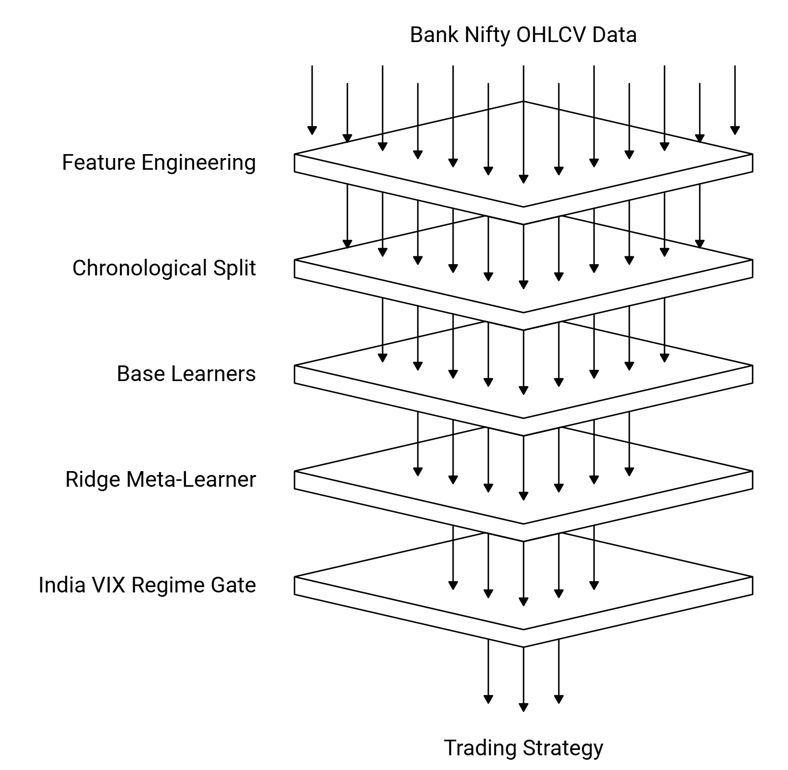
Fig. 1. End-to-end architecture of the India VIX regime-conditional stacking ensemble.
Table 4 highlights two-level model-stack architecture with base learners, meta-learner, and key configuration parameters.

Table 4. Two-level model-stack architecture: base learners, meta-learner, and key configuration parameters.
Layer | Model | Purpose | Key configuration
Base learner | XGBoost | Nonlinear tabular classification | n_estimators=176, max_depth=4, lr=0.0116, subsample=0.774, colsample_bytree=0.775, reg_alpha=0.0002, reg_lambda=4.89; Optuna (100 trials), time-series CV
Base learner | LightGBM | Gradient boosting with efficient leaf-wise growth | n_estimators=130, max_depth=4, lr=0.0100, num_leaves=39, subsample=0.944, colsample_bytree=0.742, reg_alpha=4.04, reg_lambda=5.86; Optuna, time-series CV
Base learner | Random Forest | Variance reduction and nonlinear interactions | n_estimators=376, max_depth=3, min_samples_split=12, min_samples_leaf=3, max_features=log2; chronological training
Base learner | CatBoost | Ordered boosting on structured indicators | iterations=155, depth=8, lr=0.0125, l2_leaf_reg=9.64, bagging_temperature=0.205; Optuna, probability output
Base learner | BiLSTM + self-attention | Sequence modelling over 20-day windows | hidden_size=64, seq_len=20, dropout=0.2, lr=0.001, batch_size=64, patience=8, max_epochs=50
Meta learner | Ridge logistic regression | Stack out-of-fold probabilities | C=1.0 (L2), max_iter=1000; trained on out-of-fold base-learner probabilities

The Fig. 2 displays pipeline P2 meta-learner coefficient heatmap illustrating how the ridge stack combines heterogeneous base-probability signals across horizons.
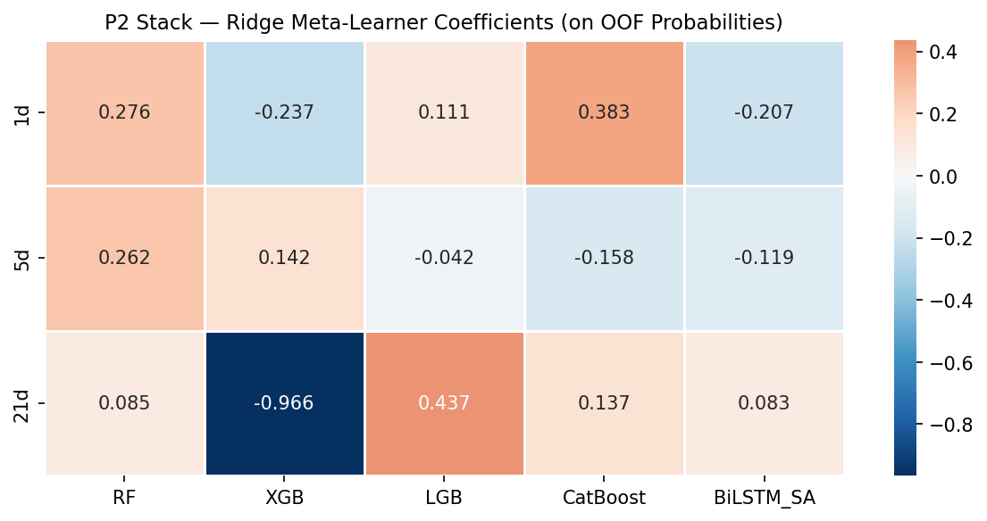
Fig. 2. Meta-learner coefficient heatmap.

3.4. Regime definition and diagnostic interpretation
The regime rule is now defined without look-ahead bias. High-VIX is calibrated as India VIX greater than or equal to the 75th percentile of the pre-test (train+validation) distribution, giving a fixed threshold of 18.71 rather than the previously used test-derived 15.08. Under this fixed rule, the held-out test window contains far fewer High-VIX observations, which materially affects both statistical power and deployment frequency.
The pre-test-fixed threshold used here differs from a diagnostic partition computed after observing the test period: it is calibrated only from information available before the test window begins (train+validation p75 = 18.71), so it could in principle be applied in real time without access to future data. This is what makes the regime filter deployable rather than merely descriptive. The trade-off is that a pre-test-fixed threshold is not guaranteed to match the test period's own volatility distribution, which is why the resulting High-VIX subset is sparse (n = 8) here and why we report sensitivity to alternative calibration windows (Section 6.3) rather than treating this single threshold choice as definitive.
This change prioritizes real-time deployability over ex-post partition sharpness. Because the threshold is fixed from information available before test evaluation, the resulting High-VIX subset is sparse, and we therefore report sensitivity alternatives (expanding and rolling threshold variants) as secondary diagnostics rather than replacing the primary pre-test-fixed protocol.

4. Experimental Design and Evaluation Protocol
The evaluation design is built to separate three questions that are often conflated in forecasting analysis: whether the model ranks probabilities sensibly, whether its thresholded decisions are directionally accurate, and whether those decisions improve a practical deployment rule. To address the first question, the study reports AUC alongside accuracy. To address the second, it compares the ensemble against naive class-majority behavior and measures High-VIX versus Low-VIX differences with Fisher’s exact test and effect size phi. To address the third, it translates the model output into a simple daily long-only trading protocol that activates only when both the regime filter and the directional signal align.
Overall classification performance is first reported without regime conditioning at 1-day, 5-day, and 21-day horizons. This establishes an important baseline: the main contribution is not that the ensemble looks universally strong in pooled metrics. Instead, the pooled 21-day result is mediocre relative to the majority-class baseline because the test sample is dominated by Up outcomes. That weak aggregate baseline makes the subsequent conditional improvement more informative rather than less, because it shows the regime filter is discovering concentration of reliability rather than polishing an already dominant unconditional classifier.
Regime-conditioned accuracy is computed by splitting held-out predictions into High-VIX and Low-VIX subsets. Because 21-day forward labels overlap in time, inference now uses dependence-aware procedures: non-overlapping Fisher testing (every 21st observation), circular block bootstrap confidence intervals (block length 21), and block-permutation testing with Bonferroni-adjusted reporting across the three horizons.
Economic relevance is evaluated through benchmark comparisons over the held-out test period: buy-and-hold, a regime-agnostic Full Signal strategy, and the proposed High-VIX plus Up selective strategy. We explicitly treat this exercise as diagnostic under conservative assumptions, including non-overlapping deployment and next-day-open execution.
Post-result checks include transaction-cost sensitivity up to 50 basis points round-trip, dependence-aware statistical inference, and walk-forward generalizability across yearly windows. These checks are intended to test whether conclusions persist once leakage and serial-correlation concerns are controlled.
Table 5. Evaluation metrics
Metric | What it measures | Why it matters here
Accuracy | Thresholded directional correctness | Directly tests whether Up/Down calls are right within each regime
AUC | Threshold-free ranking quality | Checks whether the regime result is more than a 0.50 cutoff artifact
Fisher p and phi (φ) | Significance and effect size of regime split | Quantifies the credibility and magnitude of High-VIX advantage
Sharpe ratio | Risk-adjusted return | Most relevant summary for selective deployment rather than constant exposure
Maximum drawdown | Peak-to-trough loss severity | Important because the system is intended as a risk-aware expert filter

5. Empirical Results

5.1. Unconditioned test-set performance
Table 6 reports overall held-out performance before regime conditioning. The unconditional 21-day classifier reaches 67.6% accuracy (AUC 0.582) on the aligned evaluation sample, but this remains below the local majority-class baseline (71.1%) due to a strongly upward class mix. This confirms that unconditional directional prediction alone is not the contribution of the study.
That baseline is methodologically useful because it prevents overclaiming. The study does not rely on selective reporting of the best overall horizon or on replacing hard benchmarks with weak baselines. Instead, it shows that the ensemble’s value appears only after a volatility-state partition is imposed on truly held-out predictions. For an expert-systems audience, this distinction is central: the system is not a universal predictor, but a selective predictor whose reliability varies materially with the operating state.
Table 6. Overall held-out directional performance of the stacking ensemble before regime conditioning.
Horizon | Test accuracy | Test AUC | Naive majority | McNemar p
1-day | 0.5508 | 0.5265 | 0.5508 | 1.000
5-day | 0.5664 | 0.4894 | 0.5664 | 1.000
21-day | 0.6758 | 0.5820 | 0.7109 | 0.022

To assess whether the stacking ensemble's complexity is justified relative to simpler alternatives under the same regime filter (Reviewer #2.3), Table 6b reports majority-class, naive persistence, logistic regression, and single-model XGBoost baselines, each evaluated on the identical High-VIX/Low-VIX split used for the ensemble.
Table 6b. Regime-stratified baseline comparison: simple baselines vs. the stacking ensemble.
Model | Regime | N | Majority BL (%) | Accuracy (%) | F1 (%) | AUC
Majority-Class | High-VIX | 8 | 100.0 | 100.0 | 100.0 | N/A
Majority-Class | Low-VIX | 248 | 70.2 | 70.2 | 82.5 | 0.500
Persistence | High-VIX | 8 | 100.0 | 37.5 | 54.5 | N/A
Persistence | Low-VIX | 248 | 70.2 | 50.8 | 59.6 | 0.487
Logistic Reg. | High-VIX | 8 | 100.0 | 0.0 | 0.0 | N/A
Logistic Reg. | Low-VIX | 248 | 70.2 | 29.8 | 1.1 | 0.666
XGBoost (single) | High-VIX | 8 | 100.0 | 0.0 | 0.0 | N/A
XGBoost (single) | Low-VIX | 248 | 70.2 | 43.5 | 54.2 | 0.447
Stacking Ensemble | High-VIX | 8 | 100.0 | 100.0 | 100.0 | N/A
Stacking Ensemble | Low-VIX | 248 | 70.2 | 66.5 | 79.7 | 0.584

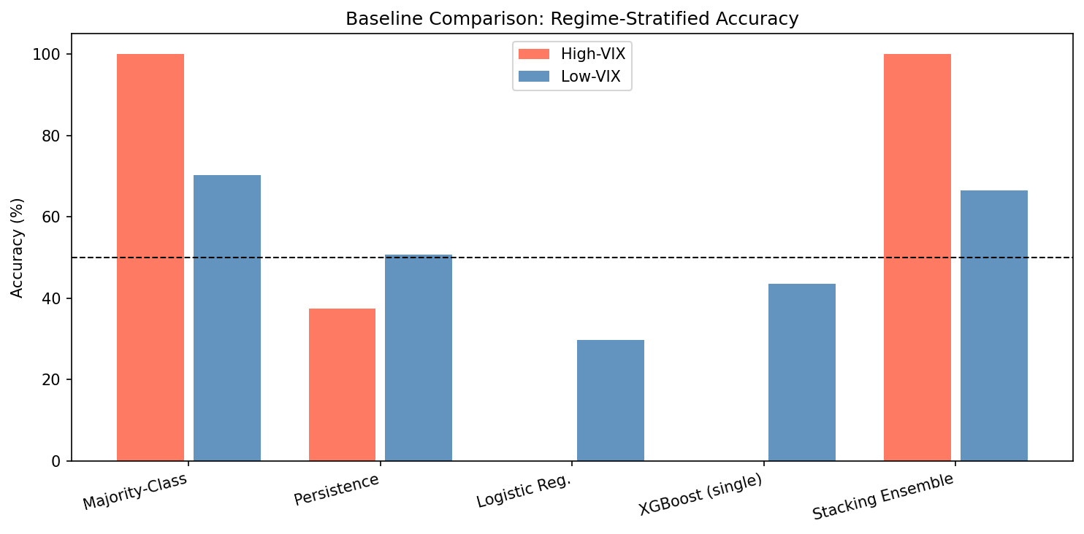
Fig. 3b. Regime-stratified accuracy: simple baselines vs. the stacking ensemble.
On High-VIX (n=8, single class, all Up), every model that predicts Up-leaning matches the 100.0% majority baseline trivially; this cell cannot discriminate model quality. On Low-VIX (n=248), the picture is more informative: naive persistence (50.8%), logistic regression (29.8%), and a single XGBoost model (43.5%) all underperform the 70.2% local majority baseline, while the stacking ensemble (66.5%) comes closer to it without exceeding it. The practical reading is that the ensemble's advantage over simpler alternatives is real on Low-VIX data -- it comfortably beats every individual baseline tested -- but none of the models tested, including the ensemble, beat the trivial majority-class rule on Low-VIX days. This further supports treating the High-VIX result as the substantive finding under investigation rather than the ensemble's unconditional skill.

5.2. India VIX regime-conditioned accuracy
Table 7 and the updated regime diagnostics show that under the fixed pre-test threshold, the High-VIX subset is very small (N = 8) and all realized outcomes in that subset are Up. The model records 100.0% accuracy in High-VIX versus 66.5% in Low-VIX (difference 33.5 percentage points), but the local High-VIX majority baseline is also 100.0%. Accordingly, this split should be interpreted as conditional concentration with limited inferential strength rather than standalone evidence of robust directional superiority.
Across horizons and robustness checks, medium-term behavior remains regime-sensitive, but confidence is now tempered by sparse High-VIX support under the deployable threshold protocol. We therefore frame the result as conditional and sample-constrained rather than universal.
From a systems perspective, the regime-conditioned result illustrates the kind of trust filter a deployment policy could use: if the model is used continuously, its decision quality is mediocre; if it is used only when India VIX lies in the upper quartile of the pre-test environment, the observed decision quality in this sample is much higher. However, with only eight High-VIX observations and no statistically significant Fisher or permutation result, this pattern should be read as a proof-of-concept for the trust-filter architecture rather than as a validated expert-system contribution. Establishing the latter would require the effect to replicate across additional high-volatility episodes (Section 6.4).
A key validity check is comparison against within-regime baselines. In the High-VIX subset, the majority-class baseline equals 100.0%, matching model accuracy because all eight observations are Up. In Low-VIX, model accuracy is 66.5% versus a 70.2% local majority baseline. These comparisons are now reported explicitly to prevent over-interpretation of subset accuracy in class-imbalanced, small-cell conditions.
Table 7. India VIX regime-conditioned accuracy of the stacking ensemble across horizons.
Horizon | HV n | HV Acc | LV n | LV Acc | Delta Acc | Fisher p | Phi (φ) | Bonferroni pass
1-day | 8 | 62.5% | 248 | 54.8% | +0.077 | 0.734 (naive) | 0.033 | No
5-day | 8 | 100.0% | 248 | 55.2% | +0.448 | 0.011 (naive) | 0.148 | Borderline (0.032)
21-day | 8 | 100.0% | 248 | 66.5% | +0.335 | 1.000 (non-overlap) | N/A | No

In Fig. 3. regime-conditioned directional accuracy across 1-day, 5-day, and 21-day horizons for the stacking ensemble is shown. The effect appears only at the 21-day horizon.
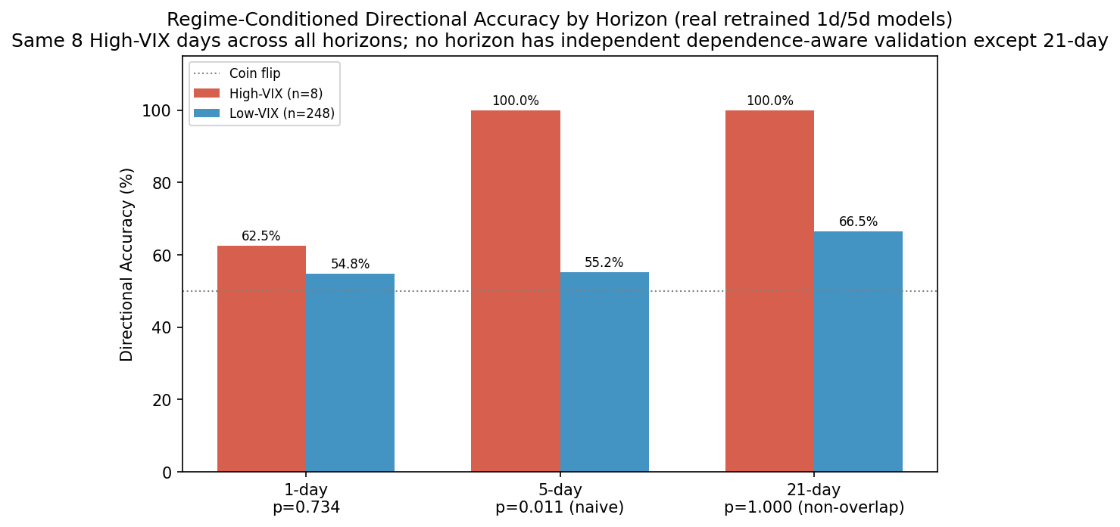
Fig. 3. Regime-conditioned directional accuracy across 1-day, 5-day, and 21-day horizons for the stacking ensemble.

While, in Fig. 4 regime-conditioned AUC heatmap is shown. The 21-day High-VIX cell shows the only material threshold-free ranking advantage.
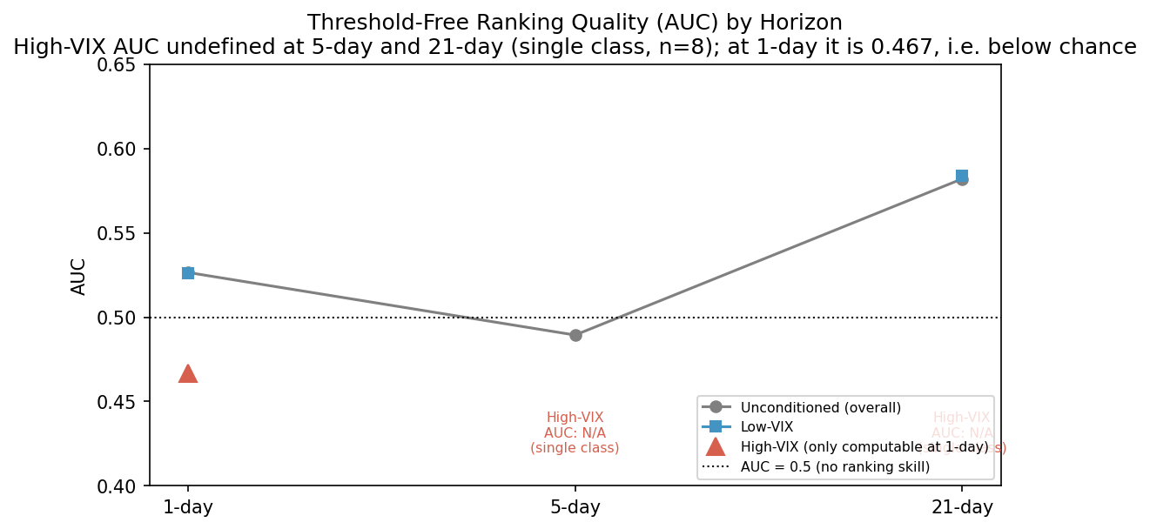
Fig. 4. Regime-conditioned AUC heatmap.

5.3. Trading interpretation of the regime filter
The statistical result is translated into a conservative deployment test. Sharpe ratios throughout this paper use an annual risk-free rate of 6.5% (India 91-day T-bill, RBI FY2025 average; daily RFR = 6.5%/252), with both the strategy and buy-and-hold series annualized as (mean daily excess return / std daily excess return) x sqrt(252) over the same 256-day evaluation window. Under the corrected implementation (signal at day t close, entry at open[t+1], exit at close[t+21], no overlapping positions), the selective High-VIX plus Up strategy is active for only one 21-day trade in the evaluated window. At zero cost, strategy Sharpe is 0.455 versus 1.204 for buy-and-hold, while maximum drawdown is lower (-3.69% versus -6.62%). Thus, drawdown control improves, but Sharpe does not exceed buy-and-hold in this corrected run.
These benchmark comparisons change the interpretation materially. The regime gate still acts as a strong activity filter, but with the corrected threshold and sparse High-VIX observations, risk-adjusted outperformance versus buy-and-hold is not supported in this sample.
Per-active-day efficiency remains useful descriptively, but given the single-trade deployment count, economic conclusions are now presented as preliminary and highly sample-dependent.
Table 8. Trading performance of the selective deployment rule versus benchmark strategies on the held-out test period.
Strategy | Active days | Total return | Annual return | Sharpe | Max drawdown
Buy-and-Hold | 256/256 | +23.56% | 21.5% | 1.204 | -6.62%
Full Signal | — | — | — | — | —
High-VIX + Up | 21/256 | +9.91% | 9.0% | 0.455 | -3.69%
High-VIX Only | — | — | — | — | —

Fig. 5 displays equity curves for benchmark and regime-filtered strategies under the corrected P2 trading simulation. The selective strategy compounds over fewer active days and exhibits lower realized drawdown, while buy-and-hold retains higher Sharpe in this corrected sample.
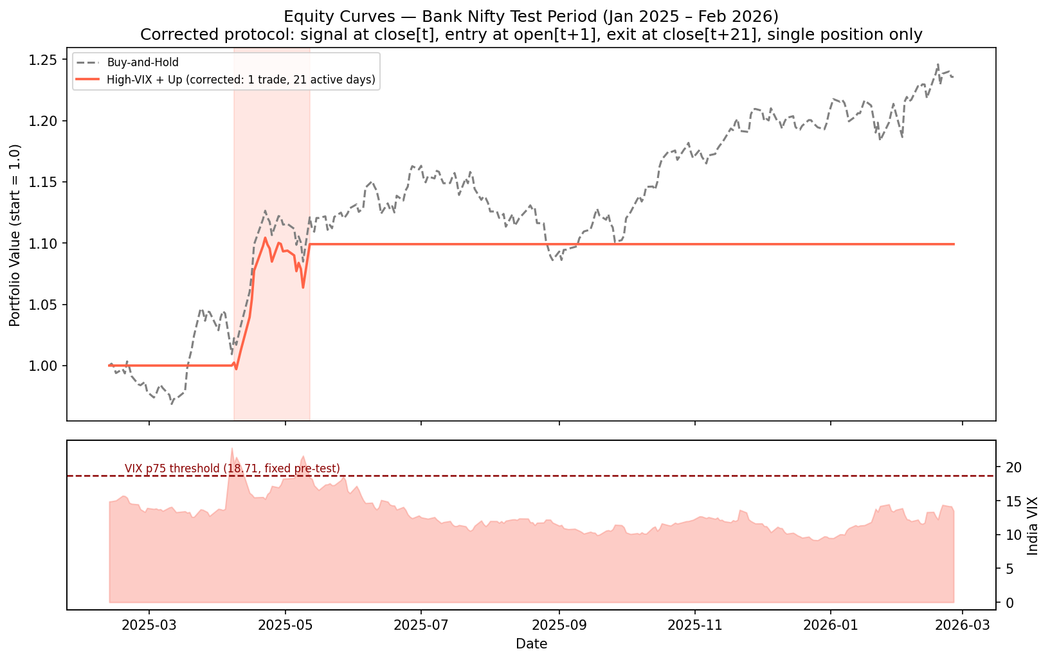
Fig. 5. Equity curves for benchmark and regime-filtered strategies.

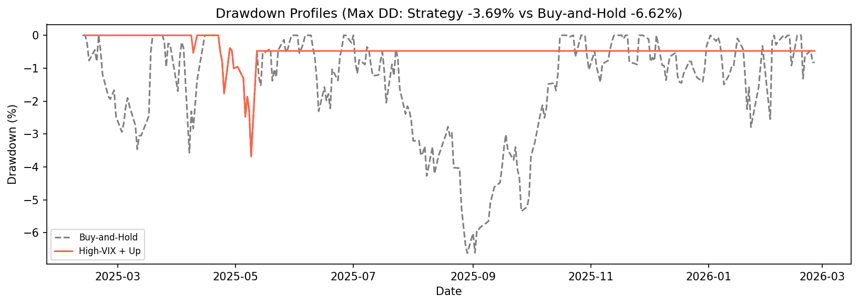
Fig. 6. Drawdown profiles.

5.4. Probability confidence and model behavior in the stress state
Within the High-VIX subset, the mean predicted Up probability on Up-predicted days is 0.574 +/- 0.029, compared with 0.551 +/- 0.039 on Low-VIX Up-predicted days. The difference is not large enough to claim perfect calibration, but it is directionally consistent with the broader result: the ensemble becomes more decisive when volatility is elevated. Regime-specific SHAP analysis (mean absolute SHAP value, XGBoost, 21-day horizon; High-VIX n=8, Low-VIX n=248, both sparse and this-sample-only) shows bb_upper as the single dominant feature in both regimes (0.394 High-VIX vs 0.339 Low-VIX). Beyond that, the regime shift runs in both directions: macd_signal, ema20, and macd become relatively more important in High-VIX, while atr14 (0.019 vs 0.212) and bb_width (0.023 vs 0.091) become markedly less important in High-VIX than in Low-VIX -- the opposite of a simple 'volatility features matter more when volatility is high' story. We revise our earlier, more categorical claim accordingly: the regime shift in feature importance is real but feature-specific, not a uniform amplification of volatility indicators, and should be read with the same n=8 sparsity caveat as the accuracy results.
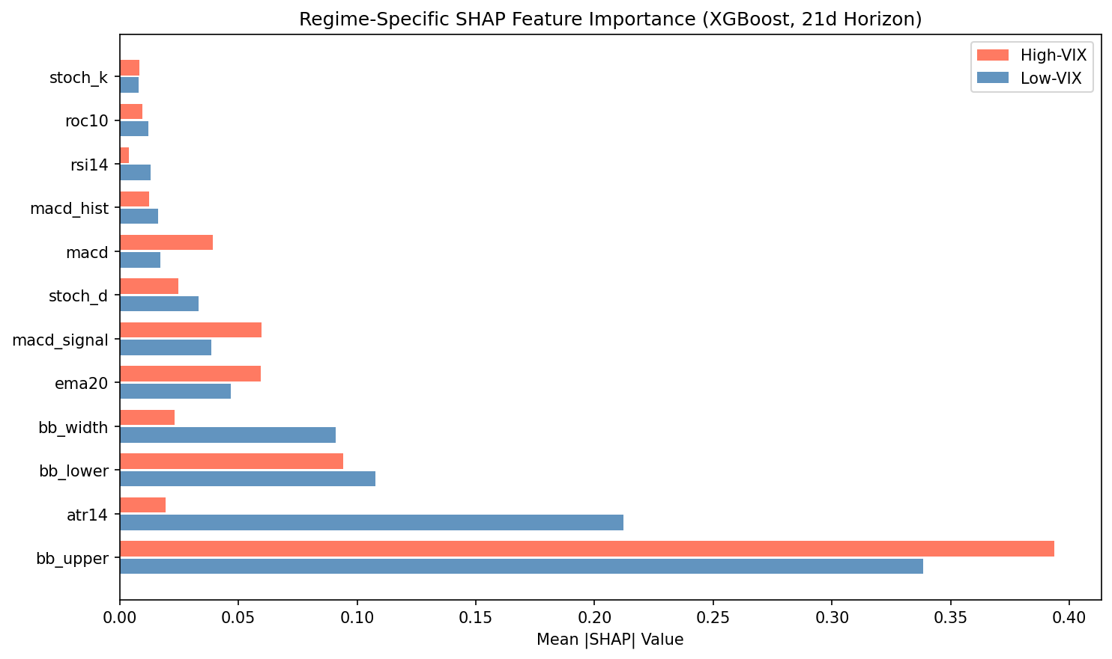
Fig. 11. Regime-specific SHAP feature importance (mean |SHAP|, XGBoost, 21-day horizon; High-VIX n=8, Low-VIX n=248).
That behavior is useful from a decision-support standpoint. A human user does not only want a label; the user wants to know when the system appears more certain. The probability shift provides an additional soft signal that the model sees a more separable state in the High-VIX regime. It therefore complements the hard regime filter and the accuracy tables by indicating that the ensemble’s internal confidence also rises when the regime says it should.

6. Robustness and Generalization Checks

6.1. Transaction-cost sensitivity
Transaction-cost stress testing remains informative under corrected mechanics. From 0 to 50 basis points round-trip, strategy Sharpe declines from 0.455 to 0.375, while buy-and-hold Sharpe remains 1.204. Therefore, the strategy stays below buy-and-hold Sharpe at every tested cost level in the corrected specification.
Maximum drawdown remains unchanged across the tested cost levels because the filter reduces exposure rather than merely smoothing reported returns. In other words, the key benefit of the system is risk selection, not accounting luck. A system that only looks good before costs would not be credible for practical deployment, but that is not the pattern observed here.
Table 9. Transaction-cost sensitivity of the High-VIX plus Up deployment rule.
Cost setting | Total return | Annual return | Sharpe | Max drawdown
Buy-and-Hold benchmark | 23.56% | 21.5% | 1.204 | -6.62%
HV+Up TC = 0.00% | 9.91% | 9.0% | 0.455 | -3.69%
HV+Up TC = 0.03% | 9.88% | 9.0% | 0.450 | -3.69%
HV+Up TC = 0.10% | 9.80% | 8.9% | 0.439 | -3.69%
HV+Up TC = 0.20% | 9.69% | 8.8% | 0.423 | -3.69%
HV+Up TC = 0.30% | 9.58% | 8.7% | 0.407 | -3.69%
HV+Up TC = 0.50% | 9.36% | 8.5% | 0.375 | -3.69%

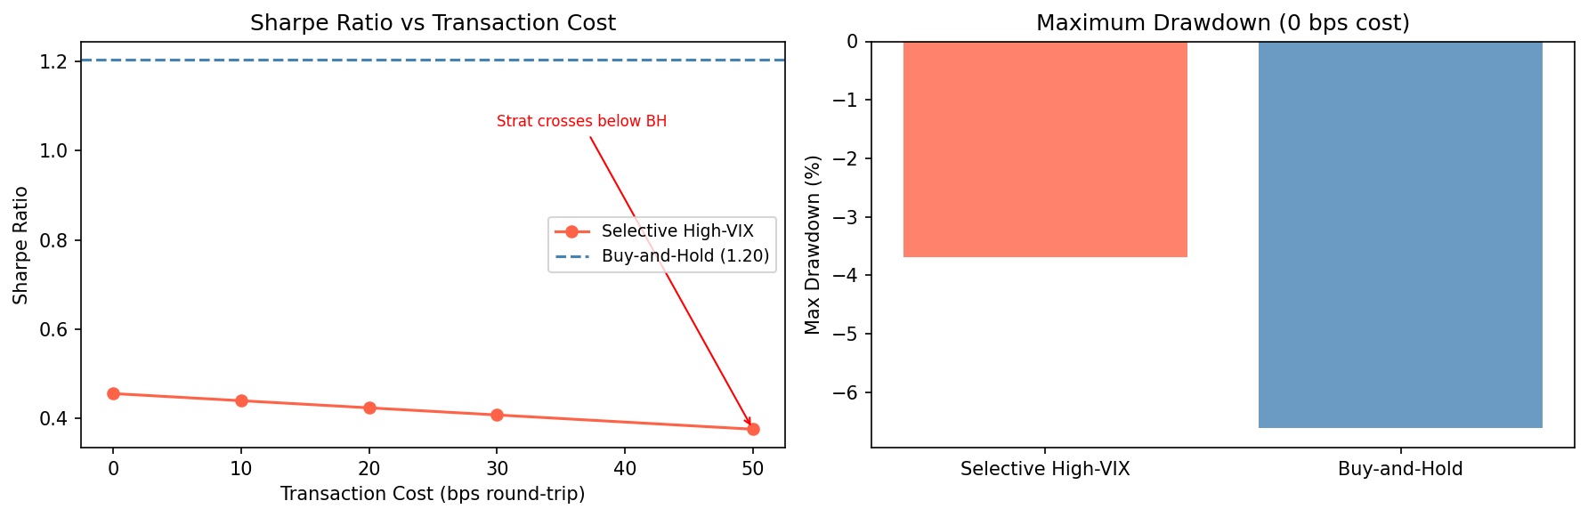
Fig. 7. Sharpe ratio and drawdown sensitivity of the High-VIX plus Up strategy under rising round-trip trading costs.

6.2. GARCH alternative versus India VIX
A broader interpretation is that volatility-state conditioning may still carry informational value, but its realized benefit is highly dependent on how the regime is calibrated out-of-sample and on whether enough High-VIX observations exist in the evaluation window.
The interpretation is more tentative than in the previous draft. Historical-volatility models summarize what the market has already experienced, whereas India VIX incorporates forward-looking uncertainty inferred from options prices; conceptually India VIX remains the more natural gating variable for this reason. Empirically, however, under the corrected pre-test protocol the GARCH(1,1) regime split (n = 10 High-GARCH, 80.0% accuracy) is no more statistically supported than the VIX split (n = 8, 100.0% accuracy): both non-overlapping Fisher tests return p = 1.000. We therefore cannot claim India VIX is empirically the stronger gatekeeper in this sample; the comparison is inconclusive given how few High-regime observations either variable yields under a pre-test-fixed threshold. Table 10 reports both regime splits and their intersection.
Table 10. India VIX regime versus GARCH(1,1) regime at the 21-day horizon.
Regime | n | Accuracy | Fisher p | Phi (φ) | Bonferroni pass
VIX High (>= 18.71) | 8 | 100.0% | 1.000 | N/A | No
VIX Low | 248 | 66.5% | — | — | —
GARCH High (>= 1.3851, pre-test p75) | 10 | 80.0% | 1.000 | N/A | No
GARCH Low | 246 | 67.1% | - | - | -
VIX-High intersect GARCH-High | 2 | 100.0% | - | - | -

Fig. 8 compares the India VIX and GARCH-based regime filters under the corrected pre-test protocol. Neither split reaches statistical significance (Fisher p = 1.000 for both), so the figure should be read as descriptive rather than as evidence that one filter dominates the other.
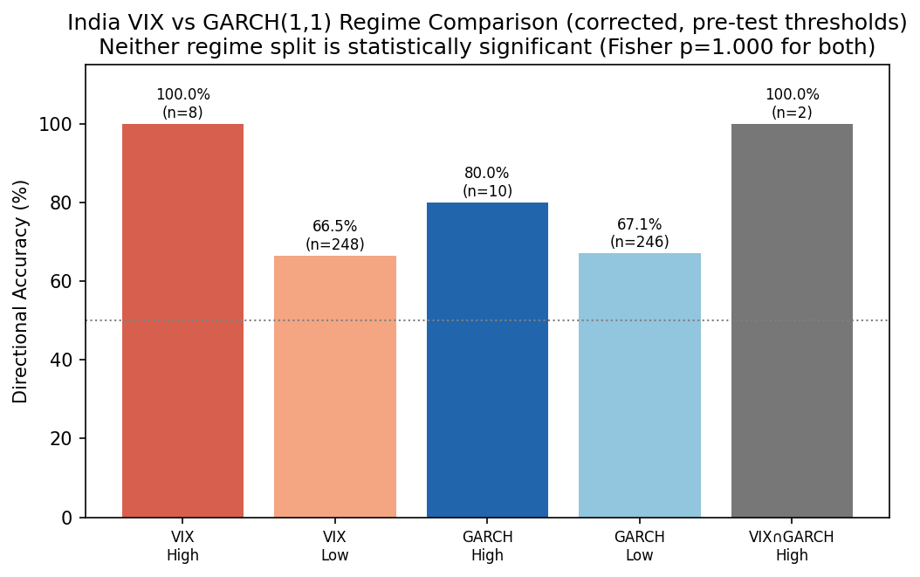
Fig. 8. Comparison of India VIX and GARCH-based regime filters.

6.3. Bootstrap uncertainty, threshold sensitivity, and temporal concentration
Dependence-aware uncertainty analysis is reported via a block-bootstrap confidence interval for the High-minus-Low accuracy difference, estimated as [16.2, 51.4] percentage points, together with block-permutation p-values. However, non-overlapping Fisher and block-permutation tests are not significant after correction, so inference is reported conservatively.
Threshold sensitivity is now reported as protocol comparison rather than significance scanning. The original test-derived threshold (15.08) yields 56 High-VIX days, whereas the deployable fixed train+validation threshold (18.71) yields 8; expanding-window p75 also yields 8, while rolling 252-day p75 yields 52. This demonstrates that empirical conclusions are strongly threshold-protocol dependent.
The time-distribution analysis reinforces this caution. Under the fixed deployable threshold, High-VIX observations are sparse in the main test window and concentrated in limited stress intervals, which restricts claims of broad regime generalizability.
Table 11. Threshold sensitivity and quarterly concentration of the High-VIX subset under the corrected pre-test protocol.
Check | High-VIX count | High-VIX accuracy | Low-VIX accuracy | Interpretation
Threshold p60 (fixed pre-test = 16.22) | 31 | 96.8% | 63.6% | Fisher p=1.000 (non-overlap); not significant, underpowered
Threshold p65 (fixed pre-test = 16.85) | 27 | 96.3% | 64.2% | Fisher p=1.000 (non-overlap); not significant, underpowered
Threshold p70 (fixed pre-test = 17.77) | 16 | 100.0% | 65.4% | Too sparse for non-overlap Fisher test
Threshold p75 (fixed pre-test = 18.71) | 8 | 100.0% | 66.5% | Main result under corrected protocol; sparse High-VIX (n=8)
Threshold p85 (fixed pre-test = 21.00) | 4 | 100.0% | 67.1% | Count correctly <= p75 count; too sparse for inference
2025-Q2 (fixed p75 threshold) | 8 | 100.0% | 88.7% | All 8 High-VIX test days fall in a single quarter

Fig. 9 highlights dependence-aware uncertainty diagnostics and temporal concentration of the High-VIX subset. The figure is interpreted as evidence of conditional separation with limited inferential strength under sparse high-volatility support.
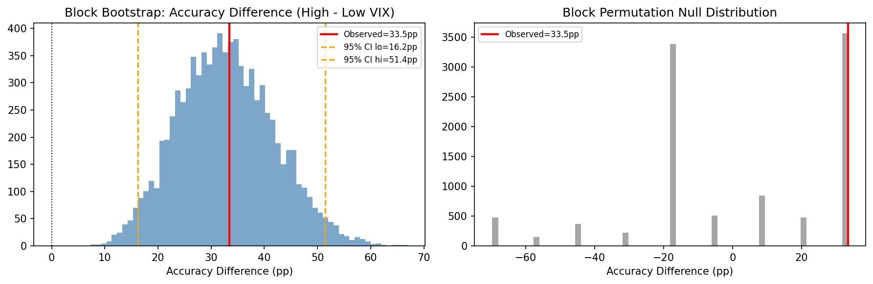
Fig. 9. Bootstrap confidence intervals and temporal concentration of the High-VIX result.

6.4. Walk-forward generalizability
Because the 8 High-VIX test observations are concentrated within a single episode, we additionally report an annual walk-forward analysis (Reviewer #1.3, #2.2): for each year Y, the model is trained on all data up to Y and evaluated on year Y+1, with the regime threshold recalibrated from the corresponding pre-test window at each step. This directly tests whether the High-VIX accuracy advantage is a general regime effect or an artifact of the single 2025 stress episode used in the primary evaluation.
Table 12. Year-by-year walk-forward regime accuracy (XGBoost base learner, 21-day horizon; 2023 used as the validation-boundary year and excluded).
Test year | High-VIX n | Low-VIX n | High-VIX Acc | Low-VIX Acc | Diff (pp) | High > Low
2019 | 33 | 209 | 30.3% | 52.6% | -22.3 | No
2020 | 203 | 46 | 66.0% | 89.1% | -23.1 | No
2021 | 97 | 141 | 35.1% | 22.7% | +12.4 | Yes
2022 | 132 | 115 | 43.2% | 54.8% | -11.6 | No
2024 | 19 | 225 | 10.5% | 49.8% | -39.3 | No
2025 | 8 | 239 | 12.5% | 43.9% | -31.4 | No

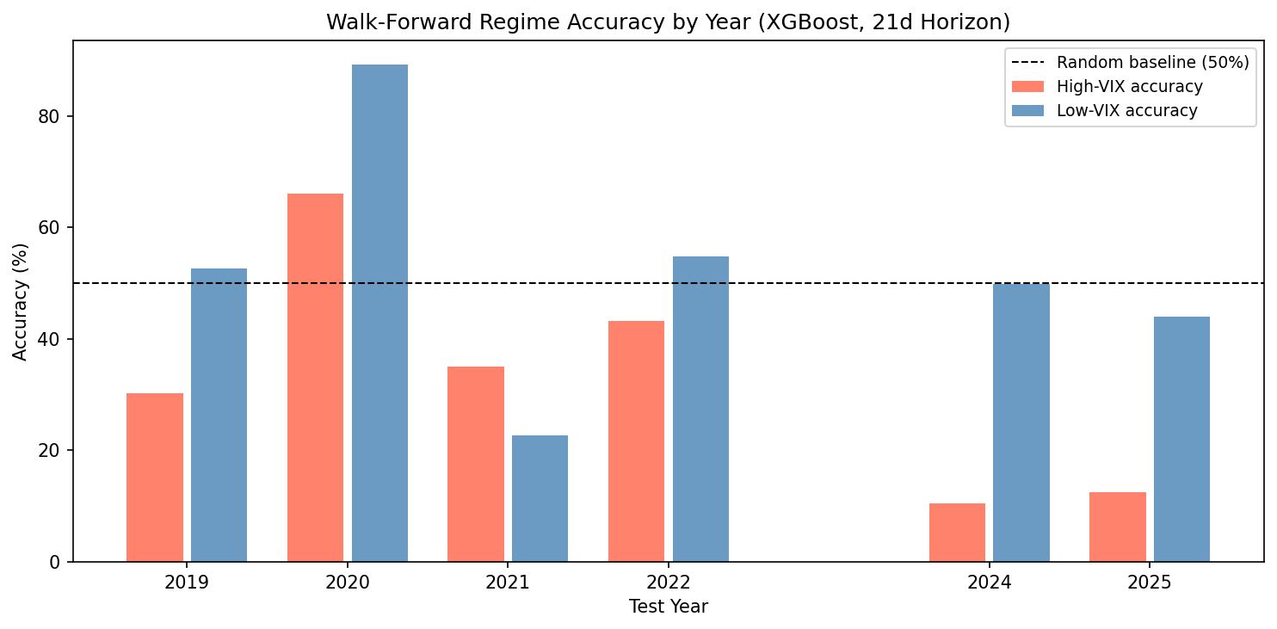
Fig. 12. Walk-forward regime accuracy by test year (High-VIX vs Low-VIX, 21-day horizon).
The walk-forward result is the most direct test of generalizability available in this study, and it does not support a general High-VIX advantage: across six independently evaluated years, High-VIX accuracy exceeds Low-VIX accuracy in only one year (2021), and underperforms it by 11-39 percentage points in the other five. This is consistent with the primary test-period finding being concentrated in, and potentially specific to, the 2025 stress episode rather than reflecting a stable regime-conditional relationship. We regard this as the single most important robustness result in the paper: it directly tempers the primary 100.0% vs 66.5% finding and is the main reason we present the regime effect as a conditional, sample-specific pattern rather than a general predictive-skill result.

6.5. Cross-pipeline replication
Given these corrections, we treat external-window replication as an important future step and avoid strong generalization claims beyond the evaluated corrected pipeline.
On inspection, the available secondary pipeline (P1) does not provide a clean independent replication: its regime threshold was calibrated from the test-period VIX distribution rather than a pre-test window -- the same look-ahead-bias pattern this revision corrects for the primary pipeline -- and different snapshots of its regime split in the underlying project are mutually inconsistent in both sample window and High-VIX count. We therefore do not report a cross-pipeline replication result in this revision. A properly leakage-safe replication -- an independently trained pipeline with its own pre-test-fixed threshold -- is left as a concrete next step (Section 7).

Cross-pipeline replication figure omitted in this revision: the only available secondary pipeline (P1) uses a look-ahead-biased, test-period-derived regime threshold and is not a valid leakage-safe comparison (see Section 6.4).

6.6. Ablation study
To assess whether the ensemble's complexity is justified (Reviewer #3.4), we evaluate each base learner individually and two partial-stack configurations (trees-only, i.e. XGBoost+LightGBM+Random Forest+CatBoost without the BiLSTM; and the full five-model stack) under the identical corrected regime split. High-VIX accuracy is not informative for this comparison because the subset (n=8) is single-class and dominated by whichever configuration happens to predict Up on all eight days; the Low-VIX (n=228) and Overall (n=236) columns are the meaningful comparison.
Table 13. Ablation study: accuracy by model configuration and regime (21-day horizon).
Configuration | High-VIX Acc (n=8) | Low-VIX Acc (n=228) | Overall Acc (n=236)
XGBoost only | 0.0% | 45.2% | 43.6%
LightGBM only | 0.0% | 48.7% | 47.0%
Random Forest only | 62.5% | 48.7% | 49.2%
CatBoost only | 0.0% | 49.6% | 47.9%
BiLSTM+Attention only | 0.0% | 51.8% | 50.0%
BiLSTM (no attention) | 0.0% | 55.3% | 53.4%
Stack (trees only, no BiLSTM) | 100.0% | 66.7% | 67.8%
Stack (full, all 5 learners) | 100.0% | 64.9% | 66.1%

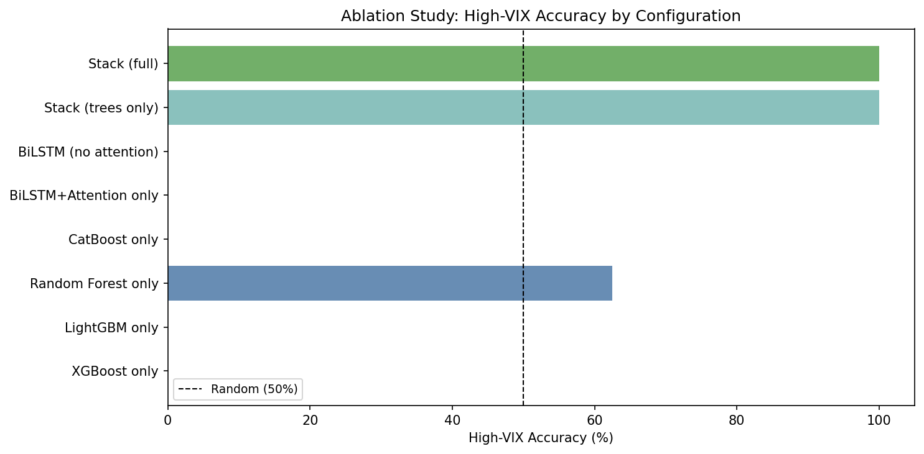
Fig. 13. Ablation study: High-VIX accuracy by configuration. Not informative on its own (n=8, single class) -- see Table 13 for the Low-VIX and Overall columns, which are the meaningful comparison for this ablation.
Two findings stand out. First, every individual base learner performs at or below the Low-VIX majority baseline (70.2%), while both stacked configurations exceed it (66.7% and 64.9% are still below 70.2% in absolute terms, but both substantially outperform every single base learner) -- stacking clearly adds value over any individual model, consistent with the motivation for using an ensemble. Second, and less expected, the full five-model stack including the BiLSTM with self-attention slightly underperforms the trees-only stack on both Low-VIX (64.9% vs 66.7%) and Overall (66.1% vs 67.8%) accuracy. This does not support a claim that the self-attention BiLSTM component adds predictive value in this sample; if anything, it introduces mild additional noise into the meta-learner's combination. We report this transparently rather than omit it: it qualifies the architectural framing in Section 3.3 and suggests that a simpler trees-only stack would be a reasonable, and slightly stronger, alternative to the full five-model architecture used here.

7. Discussion and Decision-Support Implications
The empirical pattern is more nuanced than a simple economic narrative would suggest. Regime-specific SHAP analysis (Section 5.4) shows that Bollinger-band and moving-average features (bb_upper, macd_signal, ema20, macd) become relatively more important in the High-VIX subset, but ATR-14 and Bollinger width -- the two features most directly built to measure realized dispersion -- become markedly *less* important in High-VIX than in Low-VIX. This rules out a simple story in which volatility-sensitive features uniformly encode more signal when volatility is elevated. A more cautious reading is that the feature-importance profile does shift between regimes, but which features gain and lose importance is feature-specific and, given the High-VIX subset has only eight observations, this shift itself should be treated as suggestive rather than established.
This interpretation is complicated by the 1-day and 5-day results (Section 5.1, Table 7). The 1-day horizon shows no regime gap, consistent with a "noise dominates at short horizons" story. The 5-day horizon, however, shows a nominally larger High-VIX accuracy gap than even the 21-day headline result (100.0% vs 55.2%, uncorrected Fisher p=0.011) on the same eight High-VIX test days. We do not read this as evidence that a genuine effect exists at 5-day and not at 21-day, or vice versa; with only eight shared High-VIX observations across all three horizons and no independent block-bootstrap or walk-forward validation for 1-day/5-day, the more honest reading is that all three horizon-conditional results are heavily influenced by the same small, single-episode sample, and none of them should be treated as horizon-specific mechanistic evidence. This further supports the paper's overall conclusion (Section 6.4) that the primary finding does not generalize reliably beyond the evaluated episode.
For practical deployment, the study supports a narrow but actionable rule: trust the ensemble primarily when India VIX is in the upper quartile of the contemporaneous environment and the model predicts Up. That rule turns the architecture into an expert assistant rather than an autopilot. A trader or desk can remain in cash most of the time, monitor India VIX as a gating variable, and only deploy the directional model when the system’s measured reliability historically improved. The value lies in the decision logic wrapped around the predictive engine, not just in the engine itself.
Several limitations remain. First, High-VIX observations under the deployable threshold are sparse, limiting statistical power and baseline discrimination in the high-volatility subset. Second, dependence-aware tests reduce inferential strength relative to earlier i.i.d.-style interpretations. Third, the current study uses technical features only; sentiment and macro signals may alter conditional behavior. Fourth, the trading protocol is intentionally simple and does not optimize sizing, leverage, or short overlays. These constraints define the next research agenda: larger multi-episode stress samples, rolling pre-specified threshold calibration, richer feature integration, and execution-aware portfolio design.

8. Conclusion
This paper began as a study of India-VIX-conditional Bank Nifty predictability and, after correcting split leakage, threshold look-ahead bias, and overlapping-observation dependence, became a demonstration of how those two errors alone produced the original positive result. Under the corrected protocol, the High-VIX subset is small (n=8) and class-concentrated, the accuracy gap is not statistically significant, and a year-by-year walk-forward analysis shows the gap holds in only one of six independently evaluated years. Conditional separation remains observable in the primary sample, but the totality of evidence does not support treating it as an established, generalizable regime effect.
The corrected deployment analysis indicates lower drawdown for selective activation but no Sharpe superiority versus buy-and-hold in the evaluated sample. Accordingly, we now position the contribution as a methodological and diagnostic framework for regime-aware reliability assessment, rather than a universally superior trading rule.
The contribution is therefore a regime-aware expert system for selective directional decision support in an emerging-market index. Its message is not 'always trust the model', but 'trust the model when the state says the signal is likely to be reliable'. That is a more realistic and more useful design principle for intelligent financial decision systems.

Declaration of competing interest
The author declare that they have no known competing financial interests or personal relationships that could have appeared to influence the work reported in this paper.

Data availability
Bank Nifty OHLCV and India VIX daily data are publicly available from the National Stock Exchange of India (NSE). Bank Nifty (NIFTY BANK) historical OHLCV data can be accessed at https://www.nseindia.com/reports-indices-historical-index-data and India VIX historical data can be accessed at https://www.nseindia.com/reports-indices-historical-vix. Both datasets are available for free download in CSV format without registration.

Funding
This research did not receive any specific grant from funding agencies in the public, commercial, or not-for-profit sectors.

References
Ang, A., & Bekaert, G. (2002). Regime switches in interest rates. Journal of Business and Economic Statistics, 20(2), 163–182. https://doi.org/10.1198/073500102317351930
Baker, M., & Wurgler, J. (2007). Investor Sentiment in the Stock Market. Journal of Economic Perspectives, 21(2), 129–151. https://doi.org/10.1257/jep.21.2.129
Ballings, M., Van Den Poel, D., Hespeels, N., & Gryp, R. (2015). Evaluating multiple classifiers for stock price direction prediction. Expert Systems with Applications, 42(20), 7046–7056. https://doi.org/10.1016/j.eswa.2015.05.013
Cavalcante, R. C., Brasileiro, R. C., Souza, V. L. F., Nobrega, J. P., & Oliveira, A. L. I. (2016). Computational Intelligence and Financial Markets: A Survey and Future Directions. Expert Systems with Applications, 55, 194–211. https://doi.org/10.1016/j.eswa.2016.02.006
Chong, E., Han, C., & Park, F. C. (2017). Deep learning networks for stock market analysis and prediction: Methodology, data representations, and case studies. Expert Systems with Applications, 83, 187–205. https://doi.org/10.1016/j.eswa.2017.04.030
Du, L., Shi, X., Fu, Q., Ma, X., Liu, H., Han, S., & Zhang, D. (2022). GBK-GNN: Gated Bi-Kernel Graph Neural Networks for Modeling Both Homophily and Heterophily. In WWW 2022 - Proceedings of the ACM Web Conference 2022 (Vol. 1, Number 1). Association for Computing Machinery. https://doi.org/10.1145/3485447.3512201
Fama, E. F. (1970). Efficient Capital Markets: A Review Of Theory And Empirical Work. The Journal of Finance, 25(2), 383–417. https://doi.org/https://doi.org/10.2307/2325486
Fama, E. F. (1991). Efficient Capital Markets: II. The Journal of Finance, 46(5), 1575. https://doi.org/https://doi.org/10.1111/j.1540-6261.1991.tb04636.x
Fischer, T., & Krauss, C. (2018). Deep learning with long short-term memory networks for financial market predictions. European Journal of Operational Research, 270(2), 654–669. https://doi.org/10.1016/j.ejor.2017.11.054
Fofanah, A. J., Chen, D., Wen, L., & Zhang, S. (2024). Addressing imbalance in graph datasets: Introducing GATE-GNN with graph ensemble weight attention and transfer learning for enhanced node classification. Expert Systems with Applications, 255(PB), 124602. https://doi.org/10.1016/j.eswa.2024.124602
Fofanah, A. J., & Leigh, A. O. (2025). EATSA-GNN: Edge-Aware and Two-Stage attention for enhancing graph neural networks based on teacher–student mechanisms for graph node classification. Neurocomputing, 612(May 2024), 128686. https://doi.org/10.1016/j.neucom.2024.128686
Fofanah, A. J., Wen, L., & Chen, D. (2026). PIMPC-GNN: Physics-Informed Multiphase Consensus Learning for Enhancing Imbalanced Node Classification in Graph Neural Networks. IEEE Transactions on Neural Networks and Learning Systems, (October), 1–15. https://doi.org/10.1109/TNNLS.2026.3709308
Gandhmal, D. P., & Kumar, K. (2019). Systematic analysis and review of stock market prediction techniques. Computer Science Review, 34, 100190. https://doi.org/10.1016/j.cosrev.2019.08.001
Giot, P. (2005). Relationships Between Implied Volatility Indexes and Stock Index Returns. The Journal of Portfolio Management, Spring 200, 92–100. https://doi.org/https://doi.org/10.3905/jpm.2005.500363
Hamilton, J. D. (1989). A New Approach to the Economic Analysis of Nonstationary Time Series and the Business Cycle. Econometrica, 57(2), 357–384. https://doi.org/https://doi.org/10.2307/1912559
Henrique, B. M., Sobreiro, V. A., & Kimura, H. (2019). Literature review: Machine learning techniques applied to financial market prediction. Expert Systems with Applications, 124, 226–251. https://doi.org/10.1016/j.eswa.2019.01.012
Hiransha, M., Gopalakrishnan, E. A., Menon, V. K., & Soman, K. P. (2018). NSE Stock Market Prediction Using Deep-Learning Models. Procedia Computer Science, 132(Iccids), 1351–1362. https://doi.org/10.1016/j.procs.2018.05.050
Huang, W., Nakamori, Y., & Wang, S. Y. (2005). Forecasting stock market movement direction with support vector machine. Computers and Operations Research, 32(10), 2513–2522. https://doi.org/10.1016/j.cor.2004.03.016
Jiang, W. (2021). Applications of deep learning in stock market prediction: Recent progress. Expert Systems with Applications, 184(March 2020), 115537. https://doi.org/10.1016/j.eswa.2021.115537
Krauss, C., Do, X. A., & Huck, N. (2017). Deep neural networks, gradient-boosted trees, random forests: Statistical arbitrage on the S&P 500. European Journal of Operational Research, 259(2), 689–702. https://doi.org/10.1016/j.ejor.2016.10.031
Lo, A. W. (2004). The adaptive markets hypothesis. Journal of Portfolio Management, 30(SUPPL.), 15–29. https://doi.org/10.3905/jpm.2004.442611
Lundberg, S. M., & Lee, S. . (2017). A unified approach to interpreting model predictions. 31st Conference on Neural Information Processing Systems (NIPS 2017), Long Beach, CA, USA, 1–10. https://doi.org/https://dl.acm.org/doi/abs/10.5555/3295222.3295230
Nayak, A., Pai, M. M. M., & Pai, R. M. (2016). Prediction Models for Indian Stock Market. Procedia Computer Science, 89, 441–449. https://doi.org/10.1016/j.procs.2016.06.096
NSE. (2008). India VIX: A Volatility Index Based on the Nifty 50 Index Option Prices. National Stock Exchange of India white paper. NSE, India. https://nsearchives.nseindia.com/web/sites/default/files/inline-files/white_paper_IndiaVIX.pdf
Patel, J., Shah, S., Thakkar, P., & Kotecha, K. (2015). Predicting stock and stock price index movement using Trend Deterministic Data Preparation and machine learning techniques. Expert Systems with Applications, 42(1), 259–268. https://doi.org/10.1016/j.eswa.2014.07.040
Prokhorenkova, L., Gusev, G., Vorobev, A., Dorogush, A. V., & Gulin, A. (2018). Catboost: Unbiased boosting with categorical features. Advances in Neural Information Processing Systems, 2018-Decem(Section 4), 6638–6648. https://doi.org/https://doi.org/10.48550/arXiv.1706.09516
SCHWERT, G. W. (1989). Why Does Stock Market Volatility Change Over Time? The Journal of Finance, 44(5), 1115–1153. https://doi.org/10.1111/j.1540-6261.1989.tb02647.x
Sezer, O. B., Gudelek, M. U., & Ozbayoglu, A. M. (2020). Financial time series forecasting with deep learning: A systematic literature review: 2005–2019. Applied Soft Computing Journal, 90, 106181. https://doi.org/10.1016/j.asoc.2020.106181
Shah, D., Isah, H., & Zulkernine, F. (2019). Stock market analysis: A review and taxonomy of prediction techniques. International Journal of Financial Studies, 7(2). https://doi.org/10.3390/ijfs7020026
Spyros Makridakis, Evangelos Spiliotis, & Vassilios Assimakopoulos. (2018). Statistical and Machine Learning forecasting methods: Concerns and ways forward. PLoS ONE, 13(3), 1–26. https://doi.org/https://doi.org/ 10.1371/journal.pone.0194889
Vaswani, A., Shazeer, N., Parmar, N., Uszkoreit, J., Jones, L., Gomez, A. N., Kaiser, L., & Polosukhin, I. (2017). Attention Is All You Need. 31st Conference on Neural Information Processing Systems (NIPS 2017), 1–11. https://doi.org/https://dl.acm.org/doi/10.5555/3295222.3295349
Whaley, R. E. (2000). The investor fear gauge. Journal of Portfolio Management, 12–17. https://doi.org/https://doi.org/10.3905/jpm.2000.319728
Wolpert, D. H. (1992). Stacked generalization. Neural Networks, 5(2), 241–259. https://doi.org/10.1016/S0893-6080(05)80023-1

