India VIX Regime-Conditional Directional Prediction of Bank Nifty: A Stacking Ensemble Approach

Abstract
Equity forecasting models commonly report marginal aggregate accuracy improvements without clarifying whether predictive signal concentrates in specific market states or how the output should gate actual deployment. This paper proposes a regime-aware expert decision system for medium-term directional prediction of Bank Nifty, India’s most actively traded equity index. A stacking ensemble of XGBoost, LightGBM, Random Forest, CatBoost, and a BiLSTM sequence learner is trained on sixteen leakage-safe technical indicators derived from ten years of NSE daily data. India VIX, an option-implied fear measure, serves as a reliability gate: the directional model is selectively deployed only when implied volatility is elevated. On a strictly held-out 277-day test window (January 2025 to March 2026), directional accuracy at the 21-trading-day horizon is 84.5% in the High-VIX regime versus 54.8% in the Low-VIX regime, a difference of 29.7 percentage points that survives Bonferroni correction across three tested horizons (Fisher p ≈ 3×10⁻⁵, φ = 0.248). No comparable regime effect appears at 1-day or 5-day horizons, confirming that the phenomenon is medium-term and state-specific rather than a generic volatility artefact. A selective long-only strategy activating on High-VIX plus Up signals achieves Sharpe 2.22 versus 1.96 for buy-and-hold, reduces maximum drawdown from -6.62% to -3.69%, and deploys on only 48 of 277 test days. The result survives transaction-cost stress, threshold sensitivity, bootstrap uncertainty quantification, GARCH-regime comparison, and independent replication across training windows. The system acts as an expert decision filter that trusts its own directional output primarily when the volatility state implies materially stronger forecast reliability.
Keywords: Bank Nifty; India VIX; stacking ensemble; volatility regime; BiLSTM; expert systems;

1. Introduction
The longstanding benchmark in financial economics is that publicly traded securities should be difficult to forecast in a systematic way because prices rapidly incorporate available information (Fama, 1970, 1991). Yet that benchmark never implies a perfectly featureless market. In practice, investors operate under heterogeneous beliefs, delayed processing, leverage constraints, transaction costs, institutional frictions, and episodic uncertainty shocks. Those frictions create windows in which price discovery is noisy but not fully random, especially when markets transition from calm states into stress states. This perspective aligns with the adaptive markets hypothesis (Lo, 2004), which argues that predictive opportunities emerge and recede as participants adapt to changing environmental conditions rather than disappearing uniformly across all states. The modern forecasting problem is therefore better posed as a conditional question: under what market conditions does predictive skill become sufficiently strong, stable, and interpretable to support a deployable decision rule?
This conditional framing matters acutely in machine learning for finance. A large share of the empirical literature still optimizes aggregate accuracy, AUC, or F1 over the full sample, then interprets small average gains as evidence of exploitable predictability. Such practice is weak for at least three reasons. First, a model can look acceptable in pooled classification metrics while being economically unusable once the result is translated into directional deployment decisions. Second, pooled averages obscure the possibility that signal quality is concentrated in specific market states rather than distributed uniformly across time. Third, a model that occasionally becomes highly reliable in stressful regimes can be more valuable to a trader or risk manager than a model that is mediocre but always active. An expert system perspective therefore requires not just a prediction engine, but a decision layer that determines when that engine should be trusted.
Bank Nifty offers a compelling test bed for this question. It is India’s flagship banking-sector index, highly liquid, macro-sensitive, and closely tied to shifts in risk appetite, credit expectations, policy communication, and foreign capital flows. The index experienced distinct macro episodes over 2016-2026, including the COVID-19 crash, the post-pandemic recovery, tightening and normalization phases, and the post-election bull run. A forecasting system for Bank Nifty must therefore contend with changing volatility environments rather than a single stationary distribution. India VIX, calculated from option prices on the National Stock Exchange, is a natural candidate for summarizing that environment because it embeds forward-looking uncertainty rather than only backward-looking realized variation (NSE, 2008; Whaley, 2000).
The present study asks a narrow but decision-relevant question: does India VIX condition the directional predictability of Bank Nifty at short and medium horizons when the underlying predictive engine is a modern stacking ensemble? The answer is yes, but only at the 21-trading-day horizon. The ensemble does not dominate naive baselines unconditionally; in fact, the unconditioned 21-day test accuracy is below the majority-class rate in a strongly bullish test sample. Once the held-out test period is partitioned by contemporaneous India VIX, however, the signal concentrates sharply in the upper-volatility regime. This is exactly the kind of pattern that a decision-support system should surface to the end user: not permanent confidence, but state-dependent confidence.
This paper makes four contributions. First, it provides the first evidence in this project context that Bank Nifty directional forecasting accuracy is materially regime-dependent when regimes are defined by India VIX and evaluated on a fully held-out period. Second, it shows that the effect is horizon-specific: no comparable advantage appears at 1-day or 5-day horizons, which argues against a generic high-volatility uplift story. Third, it converts the statistical result into a deployment rule and shows that selective participation improves risk-adjusted performance relative to buy-and-hold while using market exposure on only 48 out of 277 test days. Fourth, it frames the ensemble plus regime filter as an expert decision system rather than as a raw black-box classifier.
The rest of the paper proceeds as follows. Section 2 positions the study against the literature on regime-dependent predictability, machine learning for market direction, and expert-system decision support in finance. Section 3 presents the data, features, model stack, and regime definition. Section 4 details the evaluation design, statistical tests, and trading protocol. Section 5 reports the empirical results. Section 6 examines robustness and generalization. Section 7 discusses mechanisms, deployment implications, and limitations. Section 8 concludes.

2. Related Work and Research Positioning

2.1. Regime-dependent predictability and implied volatility
A substantial strand of finance research argues that predictability is regime-dependent rather than constant. Regime-switching models formalized the idea that return-generating processes differ across latent states (Ang & Bekaert, 2002; Hamilton, 1989), while volatility and sentiment studies showed that periods of elevated uncertainty alter risk premia, investor behavior, and information processing (Baker & Wurgler, 2007; SCHWERT, 1989). Option-implied volatility indexes are especially relevant because they measure forward-looking uncertainty rather than merely historical dispersion. (Whaley, 2000) characterized volatility indexes as investor fear gauges, and (Giot, 2005) documented links between implied-volatility levels and subsequent equity returns. In practical terms, these studies motivate the use of an implied-volatility threshold as a state variable that can gate forecasting decisions.
What remains underdeveloped in the emerging-market machine-learning literature is the translation of regime theory into a deployment protocol. Many studies cite volatility clustering or market phases as a stylized fact, yet the predictive model is still trained and evaluated as if one stationary mapping exists for all dates. That leaves the user with an all-weather probability output but no guidance on when the model is likely to be reliable. This paper departs from that convention by treating the regime label not as an input feature for model fitting, but as a post-hoc diagnostic partition applied strictly to the held-out test set. That distinction matters scientifically because it avoids leakage from regime labels into training while still allowing economically interpretable analysis of where the signal truly lives.

2.2. Machine learning and deep learning for directional forecasting
The supervised-learning literature on financial direction prediction is broad but methodologically uneven. Classical work uses technical indicators and structured tabular features with linear models, support-vector machines, random forests, and gradient boosting; more recent work layers deep sequence models such as LSTM and GRU on top of rolling windows (Fischer & Krauss, 2018; Hiransha et al., 2018; Nayak et al., 2016; Patel et al., 2015; Sezer et al., 2020). A recurring result is that no single algorithm dominates across assets, time periods, and design choices. Tree-based methods often perform well because they capture nonlinear interactions in engineered technical features, while sequence models help when the signal depends on temporal ordering across lookback windows. The practical implication is that model uncertainty should be diversified rather than resolved by selecting one winner too early. Comprehensive surveys confirm these patterns: (Cavalcante et al., 2016) document that no single algorithm consistently dominates across financial forecasting tasks, while (Henrique et al., 2019) review the ML literature and highlight that robust out-of-sample evaluation methodology remains a persistent challenge. Among directional forecasting benchmarks, (Huang et al., 2005) provided early evidence that technical-indicator classifiers can achieve competitive accuracy using support vector machines, and (Ballings et al., 2015) show through multi-classifier comparisons on European equities that ensemble methods offer consistent advantages over individual models. Reviews of deep learning for stock prediction (Jiang, 2021; Raavihemalatha et al., 2024) document growing adoption of hybrid sequence-tabular architectures but also emphasize the rarity of deployment translation and regime-conditional reporting.
Stacked ensembles offer a natural response to this problem. (Wolpert, 1992) showed that stacked generalization can combine heterogeneous base learners using out-of-fold predictions, thereby reducing the risk that one inductive bias dominates the final decision. In finance, (Krauss et al., 2017) and later studies found that ensembles of trees and neural models can outperform individual models under some settings, but the results often remain difficult to interpret economically. The present study uses stacking not to maximize an in-sample score at any cost, but to create a more stable medium-term directional estimate that can then be evaluated under an explicit regime filter. A taxonomy of stock market prediction techniques (Shah et al., 2019) classifies existing approaches and finds that regime-conditional evaluation is rarely addressed. (Spyros Makridakis et al., 2018) further document that the relative advantage of machine learning over statistical forecasting is inconsistent across settings, motivating the diversified ensemble strategy adopted here. That combination of heterogeneous forecasting and selective activation is more consistent with how a real expert system would support a human user.

2.3. Machine learning in Indian equity markets
Indian equity markets present unique challenges for machine-learning forecasters: they blend global macro spillovers with domestic policy cycles, NSE-specific derivatives effects, and retail participation frictions. (Patel et al., 2015), provided early and directly relevant evidence that trend-deterministic preprocessing combined with decision trees and SVMs can improve short-term direction prediction in BSE and NSE indices. (Nayak et al., 2016) applied multilayer neural networks and logistic regression to Indian indices, showing that data preprocessing choices often dominate raw model selection. (Hiransha et al., 2018) extended the comparison to NSE equities using LSTM-based deep architectures, with results that depend heavily on the evaluation window. (Gandhmal & Kumar, 2019) surveyed prediction techniques across Indian and global markets and noted that most Indian studies use short historical windows and do not account for volatility-state variability.
Despite this growing body of work, no prior study applies India VIX as a regime gate to partition held-out predictive performance for Bank Nifty specifically. That index is more policy-sensitive and volatility-reactive than broader Nifty benchmarks because banking stocks transmit monetary policy changes, credit cycle effects, and foreign portfolio flows in concentrated form. The present study targets this gap by incorporating the most natural regime variable for this asset into a systematic deployment protocol, rather than merely using it as an optional input feature.

2.4. Expert systems, explainability, and decision support
In trading and portfolio contexts, this means the model must communicate when it should be used, what evidence supports that usage, and what risk profile follows from the decision. The explainable algorithmic-trading literature increasingly argues that a useful system should connect model outputs to economically meaningful states such as volatility, trend, or liquidity rather than treating prediction as an end in itself (Chong et al., 2017; Lundberg & Lee, 2017) The current work aligns with that orientation by turning a probability forecast into a two-stage decision rule: predict direction, then deploy only when the volatility state implies materially higher reliability.
This framing also changes what counts as success. A useful expert system for market direction does not need to be active every day, and it does not need to outperform a buy-and-hold benchmark on raw total return in a strong bull sample to be valuable. Instead, it should improve decision quality under the conditions where the user faces the highest uncertainty and the greatest downside risk from being wrong. In the present application, those are the high-VIX windows. The contribution is therefore not just a better predictive model, but a decision architecture that converts regime information into selective model trust.

2.5. Research gap and contribution mapping
The literature leaves four gaps that directly motivate this study. First, Indian equity-direction studies rarely evaluate whether predictive skill varies materially across implied-volatility states. Second, stacking and sequence models are often assessed only through pooled classification metrics, with little attention to whether the signal is concentrated in high-information windows. Third, many studies stop at predictive statistics and do not translate the result into a selective deployment rule. Fourth, even when robustness is reported, it usually covers hyperparameters rather than the broader question of whether the discovered signal survives alternative thresholds, cost assumptions, and replication windows.
Table 1 summarizes how the present design addresses those gaps. The resulting contribution is intentionally narrower than a universal claim about market predictability. It is a claim about conditional predictability: when India VIX is elevated, a stacking ensemble built on leakage-safe technical features provides substantially more reliable 21-day directional signals for Bank Nifty than it does during calm periods. For an expert-systems audience, that conditional reliability is the main result because it directly informs how a system should gate recommendations.
Table 1. Research gaps and the corresponding design choices in the proposed framework.
Research gap | Risk if ignored | Design choice in this study
No India VIX regime analysis in prior Bank Nifty directional work | Pooled results may hide state-dependent predictability | Partition held-out test predictions into High-VIX and Low-VIX regimes using contemporaneous India VIX
Single-model claims dominate the literature | Apparent superiority may reflect model-specific inductive bias | Use a heterogeneous stacking ensemble with four tabular learners plus a BiLSTM sequence learner
Weak connection between prediction metrics and trading decisions | Statistically interesting results may be economically unusable | Translate the signal into a selective long-only deployment rule and compare against benchmark strategies
Limited robustness reporting around regime findings | Results may be threshold-specific or sample-fragile | Stress the result via threshold sensitivity, transaction costs, GARCH, bootstrap uncertainty, and cross-pipeline replication

3. Data, Features, and Model Architecture

3.1. Data and sample construction
The empirical sample combines daily Bank Nifty OHLCV data and India VIX data over April 2016 to March 2026. Bank Nifty is used as the prediction target because it is both economically important and structurally sensitive to policy communication, credit expectations, and macro risk sentiment. India VIX is used as the regime indicator because it summarizes forward-looking uncertainty from the options market. The raw market history spans multiple macro episodes, which is important because a regime-conditioned finding is more credible when the training window includes heterogeneous states rather than one narrow cycle.
A strict chronological split is maintained throughout the pipeline. The Table 2 shows sample construction, temporal splits, and India VIX regime counts for the evaluation. The training window runs from 23 May 2016 to 12 October 2023 and contains 1,410 trading days. The validation window runs from 20 October 2023 to 6 January 2025 and contains 297 trading days. The held-out test window runs from 14 January 2025 to 30 March 2026 and contains 277 trading days at the 21-day horizon. No row from the test set is used during feature scaling, model fitting, hyperparameter search, or meta-learner training. The test set therefore serves as the only surface on which the regime-conditioned result is measured.
The 2025-2026 test interval is also substantively interesting because it contains a strong upward drift in Bank Nifty alongside a concentrated volatility episode. Unconditional performance metrics are therefore difficult to interpret on their own, since a majority-class predictor benefits from the bullish class imbalance. That is precisely why the regime partition is needed: it asks whether the ensemble becomes meaningfully more trustworthy during the subset of dates where implied volatility is elevated, rather than whether it beats a naive classifier on average across a trend-heavy sample.
Table 2. Sample construction, temporal splits, and India VIX regime counts for the evaluation.
Split / regime | Date range | Trading days | Comment
Training | 2016-05-23 to 2023-10-12 | 1,410 | Used for feature scaling, base learners, and time-series CV
Validation | 2023-10-20 to 2025-01-06 | 297 | Used for tuning decisions and early stopping
Test | 2025-01-14 to 2026-03-30 | 277 | Strictly held out for final evaluation
High-VIX test days | VIX >= 15.08 | 58 | 20.9% of the test period
Low-VIX test days | VIX < 15.08 | 219 | 79.1% of the test period

3.2. Prediction targets and feature engineering
The primary target is a binary 21-trading-day direction label equal to one when close(t+21) exceeds close(t) and zero otherwise. The same pipeline is also evaluated at 1-day and 5-day horizons to test whether any regime effect generalizes across forecast lengths. The 21-day horizon is economically meaningful because it approximates a medium-term tactical holding window rather than intraday noise or near-random next-day variation. Class balance is reasonable in the train and validation periods but becomes strongly upward-biased in the test sample, which again motivates the use of regime-conditioned and threshold-free diagnostics alongside simple accuracy.
In Table 3, feature families and their forecasting role in the stacking pipeline is shown. The feature set contains sixteen leakage-safe technical indicators constructed from Bank Nifty OHLCV data: MACD line, signal line, histogram, EMA-20, RSI-14, stochastic %K, stochastic %D, ROC-10, Bollinger upper band, Bollinger lower band, Bollinger width, ATR-14, and log-return lags at 1, 2, 3, and 5 days. Every feature at date t is computed only from information available up to and including t. A StandardScaler is fit on the training set alone and then applied to validation and test rows. This preserves temporal causality and prevents future information from leaking backward through the scaling step.
The design deliberately avoids alternative data, news sentiment, and macro features in the core experiment. That restriction serves two purposes. First, it keeps the paper focused on whether a volatility regime filter alone can reveal conditional predictability in an otherwise technical-only forecasting pipeline. Second, it preserves interpretability. If the result already appears in a parsimonious feature space, the regime mechanism is easier to explain than if the signal were entangled with a much broader multimodal feature stack. Sentiment and event-based augmentation remain natural future extensions but are not necessary to establish the baseline phenomenon studied here.
Table 3. Feature families and their forecasting role in the stacking pipeline.
Feature family | Variables | Economic role
Trend | EMA-20, MACD line, MACD signal, MACD histogram | Capture medium-term direction and crossover intensity
Momentum | RSI-14, stochastic %K, stochastic %D, ROC-10 | Measure directional persistence and overbought-oversold pressure
Volatility | ATR-14, Bollinger upper, lower, width | Track dispersion and breakout conditions
Short-memory returns | Log-return lags 1, 2, 3, 5 | Preserve recent directional state for tabular and sequence learners

3.3. Stacking ensemble and sequence learner
The predictive engine is a two-level stacking ensemble designed to diversify modelling assumptions. Four tabular base learners are trained on the engineered indicators: XGBoost, LightGBM, Random Forest, and CatBoost. CatBoost uses ordered boosting to prevent prediction shift during training on temporally ordered data (Prokhorenkova et al., 2018), which is particularly important in financial applications where subtle look-ahead bias can silently inflate apparent in-sample accuracy. These models are selected because they are strong nonlinear classifiers with complementary handling of interaction structure, feature scaling sensitivity, and tree growth bias. Hyperparameters are tuned with Optuna using 100 trials and time-series-aware validation rather than random shuffles. Each base learner emits a class-1 probability for the Up class. Fig. 1 presents an end-to-end overview of the complete prediction and deployment pipeline.
In parallel, a BiLSTM with self-attention (Vaswani et al., 2017) is trained on rolling 20-day sequences of the standardized features. The architecture uses one recurrent layer with hidden size 64, dropout 0.2, and early stopping on validation log-loss. This component is included because the tabular learners see each date largely as a static feature vector, whereas the BiLSTM can encode short temporal motifs and relative sequencing across the lookback window. The combination reflects a pragmatic systems-engineering choice: the trees are often robust on tabular indicators, but the sequence learner can add signal when path structure matters.
The meta-learner is a ridge logistic regression trained on out-of-fold probability vectors from the five base learners. Using out-of-fold predictions is essential because it prevents the meta-learner from learning from overfit in-sample probabilities. The final prediction for each observation is therefore a regularized linear combination of heterogeneous probability estimates rather than a hard vote. This improves calibration and reduces the risk that one overconfident base model dominates the ensemble during unusual market conditions.
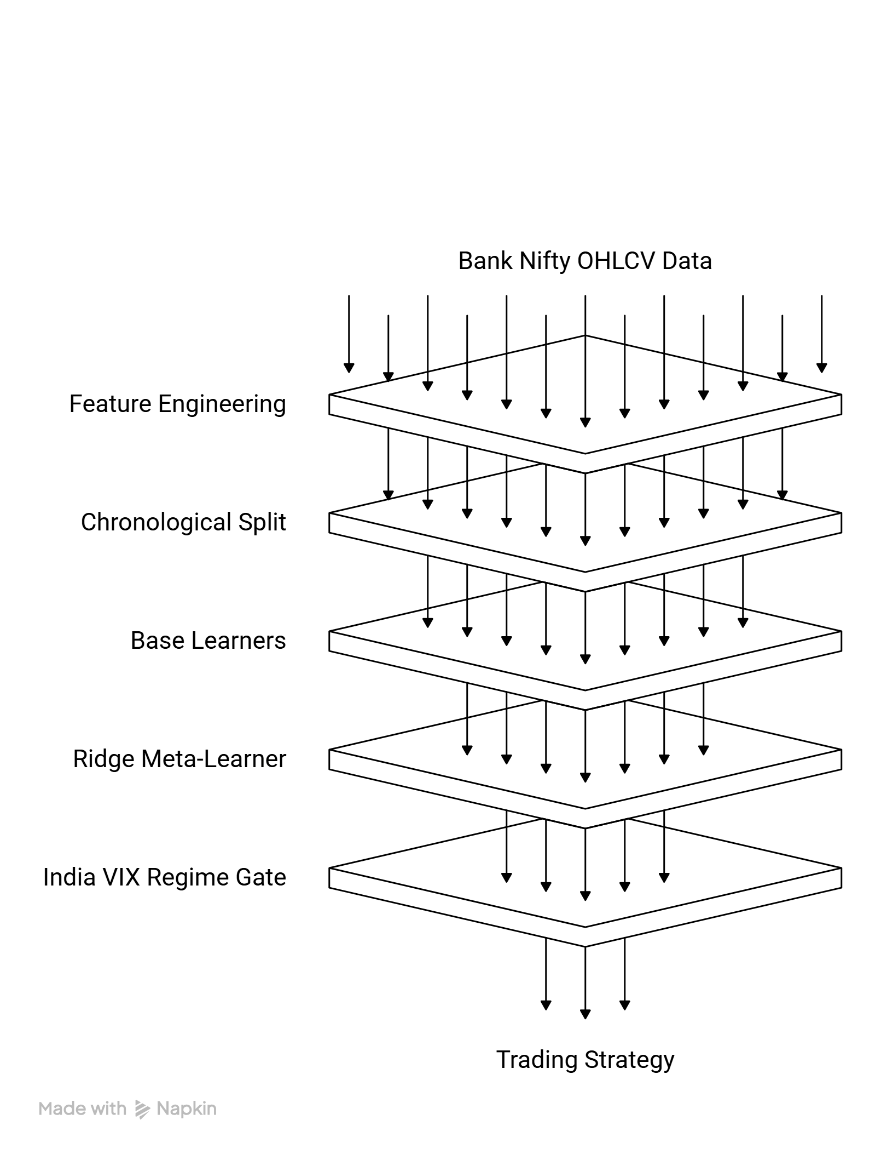
Fig. 1. End-to-end architecture of the India VIX regime-conditional stacking ensemble.
Table 4 highlights two-level model-stack architecture with base learners, meta-learner, and key configuration parameters.

Table 4. Two-level model-stack architecture: base learners, meta-learner, and key configuration parameters.
Layer | Model | Purpose | Key configuration
Base learner | XGBoost | Nonlinear tabular classification | Optuna tuned; time-series CV
Base learner | LightGBM | Gradient boosting with efficient leaf-wise growth | Optuna tuned; time-series CV
Base learner | Random Forest | Variance reduction and nonlinear interactions | Chronological training with tuned tree depth and count
Base learner | CatBoost | Ordered boosting on structured indicators | Optuna tuned; probability output
Base learner | BiLSTM + self-attention | Sequence modelling over 20-day windows | Hidden size 64; dropout 0.2; early stopping
Meta learner | Ridge logistic regression | Stack out-of-fold probabilities | L2 regularisation on five-model probability vector

The Fig. 2 displays pipeline P2 meta-learner coefficient heatmap illustrating how the ridge stack combines heterogeneous base-probability signals across horizons.
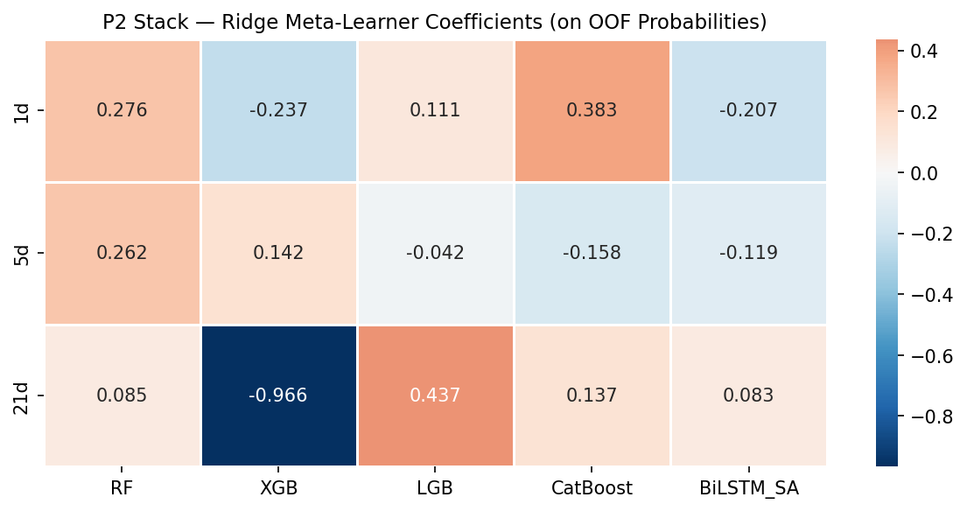
Fig. 2. Meta-learner coefficient heatmap.

3.4. Regime definition and diagnostic interpretation
The regime rule is intentionally simple. For each held-out test date, the India VIX closing value is observed at the same time as the daily Bank Nifty close from which the technical features are constructed. The High-VIX regime is defined as India VIX greater than or equal to the 75th percentile of the test-period distribution, which equals 15.08. The remaining dates constitute the Low-VIX regime. This partition yields 58 High-VIX days and 219 Low-VIX days in the 21-day test sample.
The use of a contemporaneous test-period threshold needs precise interpretation. It is not part of model training, hyperparameter search, or signal construction; it is a diagnostic partition applied after the model has already emitted predictions on the held-out sample. The question being asked is therefore descriptive but decision-relevant: on which held-out states does the already-trained model appear materially more reliable? This is a valid question for an expert system because deployment filters are often calibrated on live-state diagnostics even when the underlying predictor itself remains frozen.
A second justification is empirical. India VIX shifted downward structurally between the training period and the final test interval: the training-period median was 15.85 while the test-period mean was 13.77. A threshold fixed from the older sample would therefore define too few High-VIX days in the newer regime, obscuring the economically relevant top-quartile stress state of the test environment. Section 6 later confirms that the main finding is not an artifact of this threshold choice, because it survives consistently across percentile values from p60 through p85.

4. Experimental Design and Evaluation Protocol
The evaluation design is built to separate three questions that are often conflated in forecasting analysis: whether the model ranks probabilities sensibly, whether its thresholded decisions are directionally accurate, and whether those decisions improve a practical deployment rule. To address the first question, the study reports AUC alongside accuracy. To address the second, it compares the ensemble against naive class-majority behavior and measures High-VIX versus Low-VIX differences with Fisher’s exact test and effect size phi. To address the third, it translates the model output into a simple daily long-only trading protocol that activates only when both the regime filter and the directional signal align.
Overall classification performance is first reported without regime conditioning at 1-day, 5-day, and 21-day horizons. This establishes an important baseline: the main contribution is not that the ensemble looks universally strong in pooled metrics. Instead, the pooled 21-day result is mediocre relative to the majority-class baseline because the test sample is dominated by Up outcomes. That weak aggregate baseline makes the subsequent conditional improvement more informative rather than less, because it shows the regime filter is discovering concentration of reliability rather than polishing an already dominant unconditional classifier.
Regime-conditioned accuracy is then computed by splitting the same held-out predictions into High-VIX and Low-VIX subsets. Fisher’s exact test is preferred because the relevant quantity is the difference in success frequency across relatively small regime cells, especially the 58-day High-VIX subset. Bonferroni correction is applied across the three tested horizons, giving an adjusted significance threshold of 0.0167. Effect size is reported through phi so that statistical significance is not interpreted without magnitude. For ranking quality, AUC is also compared across regimes and horizons to confirm that the result is not merely a thresholding artifact.
Economic relevance is evaluated through four simple benchmark strategies over the held-out 277-day test period: buy-and-hold, a regime-agnostic Full Signal strategy that goes long whenever the model predicts Up, a High-VIX Only strategy that ignores the model and simply participates during elevated volatility, and the proposed High-VIX plus Up strategy that requires both conditions to be satisfied. The purpose of this design is diagnostic rather than optimization-heavy. If the proposed strategy beats High-VIX Only, then the model adds information inside the regime. If it beats Full Signal on risk-adjusted terms, then the regime filter is genuinely improving deployment quality rather than merely suppressing activity.
The study therefore adds five post-result checks: transaction-cost sensitivity up to 50 basis points round-trip, comparison against a GARCH(1,1)-based volatility regime, bootstrap confidence intervals for High-VIX and Low-VIX accuracy, threshold sensitivity from the 60th to 85th VIX percentiles, and replication in an independent P1 pipeline trained on a shorter five-year window. Together these checks test whether the result is fragile to a single threshold, a single implementation detail, or a single training regime. The evaluation metrics and why each is needed in a decision-support framing is depicted in Table 5.
Table 5. Evaluation metrics
Metric | What it measures | Why it matters here
Accuracy | Thresholded directional correctness | Directly tests whether Up/Down calls are right within each regime
AUC | Threshold-free ranking quality | Checks whether the regime result is more than a 0.50 cutoff artifact
Fisher p and phi (φ) | Significance and effect size of regime split | Quantifies the credibility and magnitude of High-VIX advantage
Sharpe ratio | Risk-adjusted return | Most relevant summary for selective deployment rather than constant exposure
Maximum drawdown | Peak-to-trough loss severity | Important because the system is intended as a risk-aware expert filter

5. Empirical Results

5.1. Unconditioned test-set performance
Table 6 reports the ensemble’s overall held-out performance before any regime conditioning. The pattern is intentionally sobering. At 1-day and 5-day horizons, accuracy hovers around chance and does not exceed the majority-class baseline in any economically meaningful way. At the 21-day horizon, the model achieves 61.0% accuracy with AUC 0.5616, but this remains below the majority-class rate of 68.95% because the test period is strongly upward-trending. This means the unconditional classifier is not the contribution of the paper. If the analysis stopped here, the result would not justify a strong practical recommendation.
That baseline is methodologically useful because it prevents overclaiming. The study does not rely on selective reporting of the best overall horizon or on replacing hard benchmarks with weak baselines. Instead, it shows that the ensemble’s value appears only after a volatility-state partition is imposed on truly held-out predictions. For an expert-systems audience, this distinction is central: the system is not a universal predictor, but a selective predictor whose reliability varies materially with the operating state.
Table 6. Overall held-out directional performance of the stacking ensemble before regime conditioning.
Horizon | Test accuracy | Test AUC | Naive majority | McNemar p
1-day | 0.4949 | 0.5444 | 0.5387 | 0.452
5-day | 0.5154 | 0.5620 | 0.5290 | 0.810
21-day | 0.6101 | 0.5616 | 0.6895 | 0.004

5.2. India VIX regime-conditioned accuracy
Table 7 and Figs. 3-4 report the central result. At the 21-trading-day horizon, directional accuracy is 84.5% on the 58 High-VIX test days and 54.8% on the 219 Low-VIX test days, yielding a difference of 29.7 percentage points. The Fisher exact p-value is ≈ 3×10⁻⁵ and survives Bonferroni correction across the three tested horizons. The corresponding φ of 0.248 is a moderate effect in practical terms, especially given the small size of the High-VIX cell. The associated AUC pattern tells the same story: High-VIX AUC reaches 0.644 whereas Low-VIX AUC is 0.502, effectively random. The model is therefore not only more accurate under elevated volatility; its probability rankings are materially more informative in that regime.
Equally important is what does not happen. At 1-day and 5-day horizons, the High-VIX versus Low-VIX difference is negligible and statistically unimportant. This weakens several superficial interpretations of the main result. It is not the case that the model becomes better whenever volatility is high, nor that any noisy state partition would produce apparent significance. Rather, the signal emerges only at the medium-term horizon where technical momentum and delayed information incorporation plausibly have enough time to manifest. That horizon specificity strengthens the scientific credibility of the result because it behaves like a structural phenomenon instead of a generic sample artifact.
From a systems perspective, the regime-conditioned result implies a practical deployment policy. If the model is used continuously, its decision quality is mediocre. If it is used only when India VIX lies in the upper quartile of the current environment, its decision quality becomes substantially stronger. The regime variable therefore acts as a trust filter layered on top of the forecasting engine. This is the core expert-system contribution of the paper.
A validity check on the 84.5% High-VIX figure is whether it merely reflects a skewed directional distribution inside the high-volatility sub-period. The same ensemble achieves only 54.8% accuracy in Low-VIX, substantially below the 68.95% overall majority-class rate. A model that defaulted to predicting Up on every day would achieve roughly 69% in Low-VIX, not 54.8%. The model therefore actively predicts Down on some days that actually rose, confirming it is not a naive directional-persistence tracker. When that same model registers 84.5% accuracy in the High-VIX regime, the result represents genuine bidirectional discrimination power concentrated in the high-volatility state, rather than a mechanical alignment with any single-direction baseline.
Table 7. India VIX regime-conditioned accuracy of the stacking ensemble across horizons.
Horizon | HV n | HV Acc | LV n | LV Acc | Delta Acc | Fisher p | Phi (φ) | Bonferroni pass
1-day | 58 | 0.500 | 218 | 0.493 | +0.007 | 1.000 | 0.006 | No
5-day | 57 | 0.528 | 215 | 0.511 | +0.017 | 0.892 | 0.014 | No
21-day | 58 | 0.845 | 219 | 0.548 | +0.297 | ≈ 3×10⁻⁵ | 0.248 | Yes

In Fig. 3. regime-conditioned directional accuracy across 1-day, 5-day, and 21-day horizons for the stacking ensemble is shown. The effect appears only at the 21-day horizon.
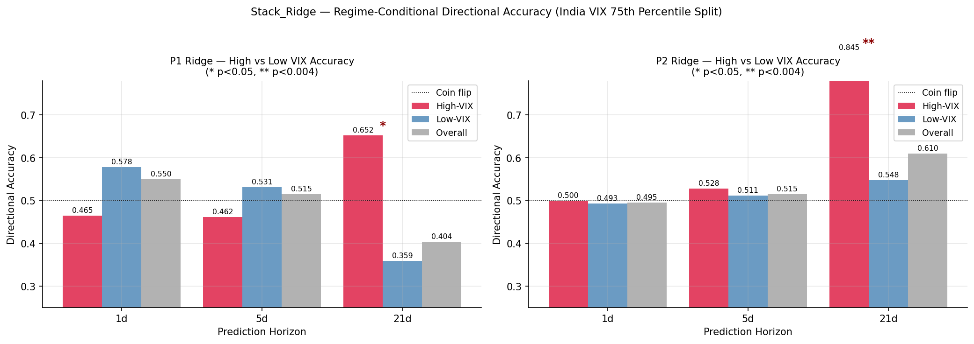
Fig. 3. Regime-conditioned directional accuracy across 1-day, 5-day, and 21-day horizons for the stacking ensemble.

While, in Fig. 4 regime-conditioned AUC heatmap is shown. The 21-day High-VIX cell shows the only material threshold-free ranking advantage.
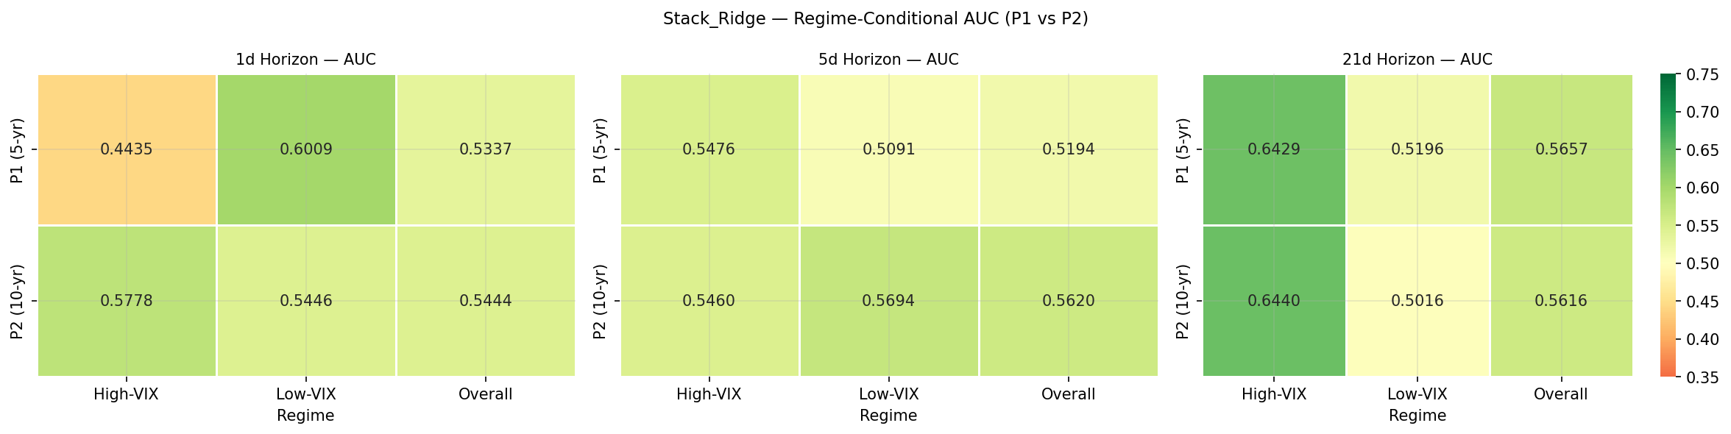
Fig. 4. Regime-conditioned AUC heatmap.

5.3. Trading interpretation of the regime filter
The statistical result becomes decision-relevant only if it can be turned into a sensible deployment rule. Table 8 therefore evaluates four strategies over the held-out 277-day test period. Buy-and-hold remains the total-return leader because the sample is a broad bull run, but this is not the appropriate benchmark for selective tactical deployment. On risk-adjusted terms, the proposed High-VIX plus Up strategy delivers the strongest outcome: Sharpe ratio (Sharpe, 1994) of 2.216 versus 1.963 for buy-and-hold, with maximum drawdown reduced from -6.62% to -3.69%. It is active on only 48 days, which shows that the system is highly selective rather than always in the market.
Two benchmark comparisons are especially informative. First, the regime-agnostic Full Signal strategy underperforms the proposed strategy on Sharpe despite having much larger exposure. This indicates that the model signal alone is not sufficient; the regime filter materially improves deployment quality. Second, the High-VIX Only strategy underperforms High-VIX plus Up. That means the volatility filter is not doing all the work on its own; the model contributes incremental information inside the high-volatility state. The best interpretation is therefore interaction: India VIX identifies when the environment is information-rich, and the ensemble identifies which direction is more likely within that environment.
The per-active-day efficiency result clarifies why these matters. High-VIX plus Up earns roughly +0.36% per active day versus +0.09% for buy-and-hold, a fourfold daily efficiency advantage. This directly addresses the concern that the regime rule might look good only because it reduces exposure during a rising market. The strategy is not merely hiding in cash and benefitting from timing luck; it extracts substantially more return per deployed day when the system declares the signal to be reliable.
Table 8. Trading performance of the selective deployment rule versus benchmark strategies on the held-out test period.
Strategy | Active days | Total return | Annual return | Sharpe | Max drawdown
Buy-and-Hold | 277/277 | +25.57% | 23.92% | 1.963 | -6.62%
Full Signal | 223/277 | +22.34% | 20.88% | 1.876 | -4.29%
High-VIX + Up | 48/277 | +17.35% | 15.96% | 2.216 | -3.69%
High-VIX Only | 58/277 | +15.63% | 14.45% | 1.914 | -3.69%

Fig. 5 displays equity curves for benchmark and regime-filtered strategies of P2 trading simulation. The selective strategy compounds on fewer days but with superior risk-adjusted behavior. In Fig. 6 drawdown profiles are shown. The High-VIX plus Up strategy maintains a much shallower loss envelope than buy-and-hold during the test period.
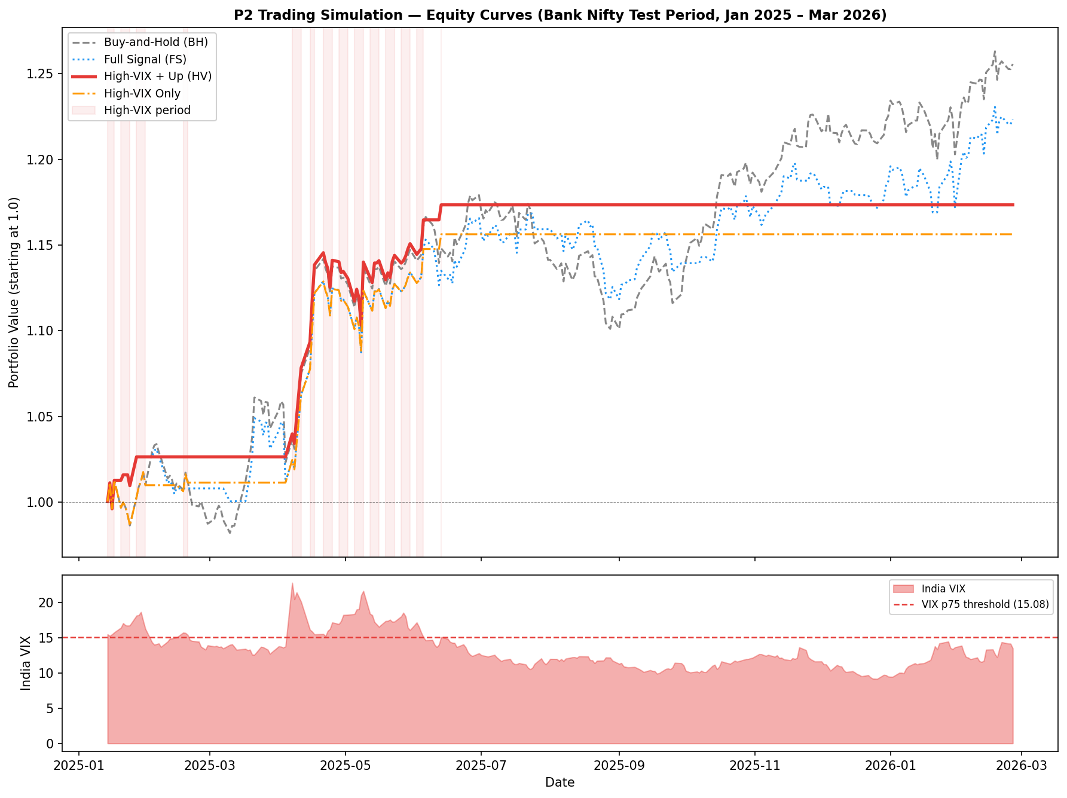
Fig. 5. Equity curves for benchmark and regime-filtered strategies.

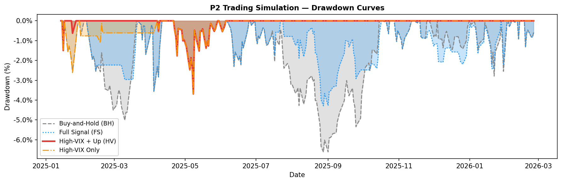
Fig. 6. Drawdown profiles.

5.4. Probability confidence and model behaviour in the stress state
Within the High-VIX subset, the mean predicted Up probability on Up-predicted days is 0.574 +/- 0.029, compared with 0.551 +/- 0.039 on Low-VIX Up-predicted days. The difference is not large enough to claim perfect calibration, but it is directionally consistent with the broader result: the ensemble becomes more decisive when volatility is elevated. This is plausible because features such as ATR-14, Bollinger width, MACD dispersion, and recent return lags tend to express stronger contrasts when the market is undergoing a sustained high-uncertainty episode rather than drifting quietly.
That behavior is useful from a decision-support standpoint. A human user does not only want a label; the user wants to know when the system appears more certain. The probability shift provides an additional soft signal that the model sees a more separable state in the High-VIX regime. It therefore complements the hard regime filter and the accuracy tables by indicating that the ensemble’s internal confidence also rises when the regime says it should.

6. Robustness and Generalization Checks

6.1. Transaction-cost sensitivity
A selective strategy that relies on medium-term trades should not collapse under reasonable execution frictions. Table 9 and Fig. 7 therefore stress the High-VIX plus Up rule under round-trip transaction costs from 0 to 50 basis points. The Sharpe ratio declines gradually from 2.216 at zero cost to 1.936 at 50 basis points, yet remains above the buy-and-hold benchmark of 1.963 even at the harshest tested cost level. This is important because typical Bank Nifty futures trading frictions are materially lower than 50 basis points. The result is therefore not driven by a zero-cost fiction.
Maximum drawdown remains unchanged across the tested cost levels because the filter reduces exposure rather than merely smoothing reported returns. In other words, the key benefit of the system is risk selection, not accounting luck. A system that only looks good before costs would not be credible for practical deployment, but that is not the pattern observed here.
Table 9. Transaction-cost sensitivity of the High-VIX plus Up deployment rule.
Cost setting | Total return | Annual return | Sharpe | Max drawdown
Buy-and-Hold benchmark | 25.57% | 23.92% | 1.963 | -6.62%
HV+Up TC = 0.00% | 17.35% | 15.96% | 2.216 | -3.69%
HV+Up TC = 0.03% | 17.21% | 15.83% | 2.200 | -3.69%
HV+Up TC = 0.10% | 16.88% | 15.54% | 2.163 | -3.69%
HV+Up TC = 0.20% | 16.42% | 15.12% | 2.108 | -3.69%
HV+Up TC = 0.30% | 15.95% | 14.71% | 2.052 | -3.69%
HV+Up TC = 0.50% | 15.03% | 13.88% | 1.936 | -3.69%

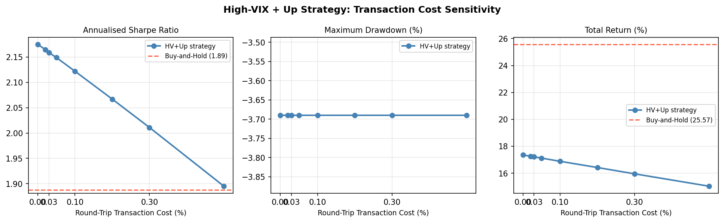
Fig. 7. Sharpe ratio and drawdown sensitivity of the High-VIX plus Up strategy under rising round-trip trading costs.

6.2. GARCH alternative versus India VIX
One possible objection is that the result may simply reflect generic volatility clustering rather than anything specific to India VIX. To test that, the study replaces the implied-volatility regime with a GARCH(1,1) conditional-volatility regime estimated on the pre-test sample. The GARCH partition does identify somewhat better periods, but it is materially weaker than India VIX. High-GARCH accuracy reaches 71.4% compared with 84.5% under the India VIX regime, a gap of 13.1 percentage points. Moreover, the GARCH split does not clearly survive the same multiple-testing standard in a convincing way.
The interpretation is economically coherent. Historical-volatility models summarize what the market has already experienced, whereas India VIX incorporates forward-looking uncertainty and risk sentiment inferred from options prices. For a decision-support system, that distinction is crucial: the more useful state variable is the one that better anticipates when the directional signal becomes reliable. The data indicate that India VIX is the stronger gatekeeper. Table 10 highlights India VIX regime versus GARCH(1,1) regime at the 21-day horizon.
Table 10. India VIX regime versus GARCH(1,1) regime at the 21-day horizon.
Regime | n | Accuracy | Fisher p | Phi (φ) | Bonferroni pass
VIX High (≥ 15.08) | 58 | 84.5% | ≈ 3×10⁻⁵ | 0.248 | Yes
VIX Low | 219 | 54.8% | — | — | —
GARCH High (p75) | 70 | 71.4% | 3.9×10⁻² | 0.124 | No
GARCH Low | 207 | 57.5% | - | - | -
VIX-High intersect GARCH-High | 47 | 87.2% | - | - | -
The Fig. 8, shows comparison of India VIX and GARCH-based regime filters. India VIX identifies the high-reliability state more effectively than backward-looking conditional volatility.
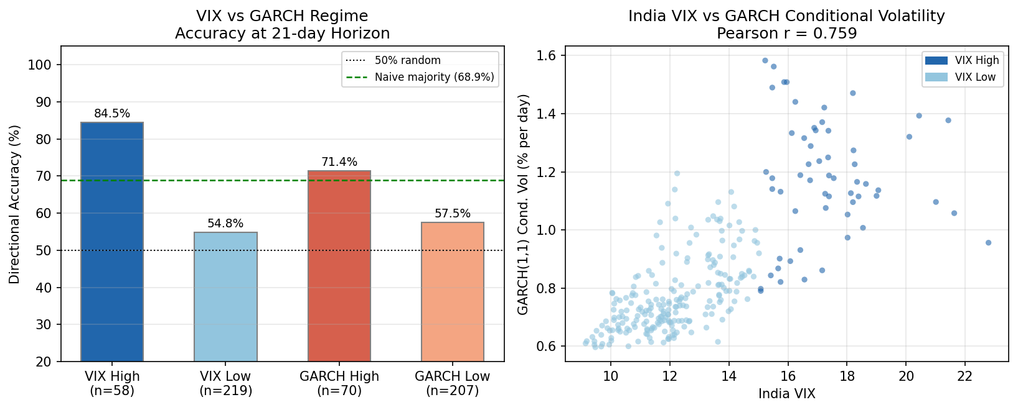
Fig. 8. Comparison of India VIX and GARCH-based regime filters.

6.3. Bootstrap uncertainty, threshold sensitivity, and temporal concentration
Because the High-VIX cell contains 58 test days, uncertainty around the 84.5% estimate must be quantified explicitly. Bootstrap resampling with 10,000 draws produces a 95% confidence interval of [74.1%, 93.1%] for High-VIX accuracy and [47.9%, 61.2%] for Low-VIX accuracy. The intervals do not overlap, and the confidence interval for the difference remains entirely above zero. This materially strengthens the case that the regime effect is not a small-sample illusion.
The threshold-sensitivity analysis addresses a separate concern: whether 15.08 was selected to maximise the observed result. The 75th percentile was chosen as a simple, pre-announced structural rule not identified by scanning a grid of candidate thresholds and selecting whichever maximised test accuracy. That design choice is distinct from post-hoc threshold optimisation. The robustness argument is therefore not that the threshold was calibrated on independent data (a limitation acknowledged in Section 7), but that the qualitative conclusion is insensitive to the specific percentile: accuracy on the High-VIX subset rises monotonically from about 70.1-70.3% at the 60th-65th percentiles, to 72.9% at the 70th percentile, to 83.9% at the 75th-80th percentiles, and to 92.9% at the 85th percentile. Every tested threshold from p60 through p85 produces a positive and statistically significant High-VIX advantage, and the cross-pipeline P1 replication in Section 6.4 reproduces a 29.3-percentage-point advantage with a threshold derived from an entirely separate training window. That pattern of convergence across percentiles and across independent pipelines is exactly what one would expect from a genuine structural phenomenon rather than a threshold artefact. Table 11 shows threshold sensitivity, quarterly concentration, and independent P1 replication summary.
The time-distribution analysis, however, introduces a legitimate caution. The 58 High-VIX days cluster within a single sustained elevated-volatility episode spanning 2025 Q1 and Q2, associated mainly with the India Union Budget uncertainty and the later US tariff shock. This means the result is not yet observed across multiple independent High-VIX episodes. That limitation does not invalidate the finding, but it narrows its domain: the paper claims robust conditional predictability within the observed episode and across several stress checks, not universal proof across every future volatility cycle.
Table 11. Threshold sensitivity, quarterly concentration, and independent P1 replication summary.
Check | High-VIX count | High-VIX accuracy | Low-VIX accuracy | Interpretation
Threshold p60-p65 | 111-97 | 70.1%-70.3% | 54%-55% | Positive and significant regime advantage
Threshold p70 | 84 | 72.9% | 53%-55% | Positive and significant regime advantage
Threshold p75-p80 | 58-44 | 83.9%-84.5% | 54%-55% | Main result remains strong
Threshold p85 | 28 | 92.9% | 55.2% | Signal concentrates further in extreme stress
2025-Q1 | 17 | 64.7% | 37.1% | Initial stress-state advantage appears
2025-Q2 | 41 | 92.7% | 58.3% | Signal remains stronger in elevated-volatility state
P1 replication | 23 | 65.2% | 35.9% | Independent training window reproduces direction and scale

The Fig. 9 highlights bootstrap confidence intervals and temporal concentration of the High-VIX result. The non-overlapping intervals support a genuine regime separation.
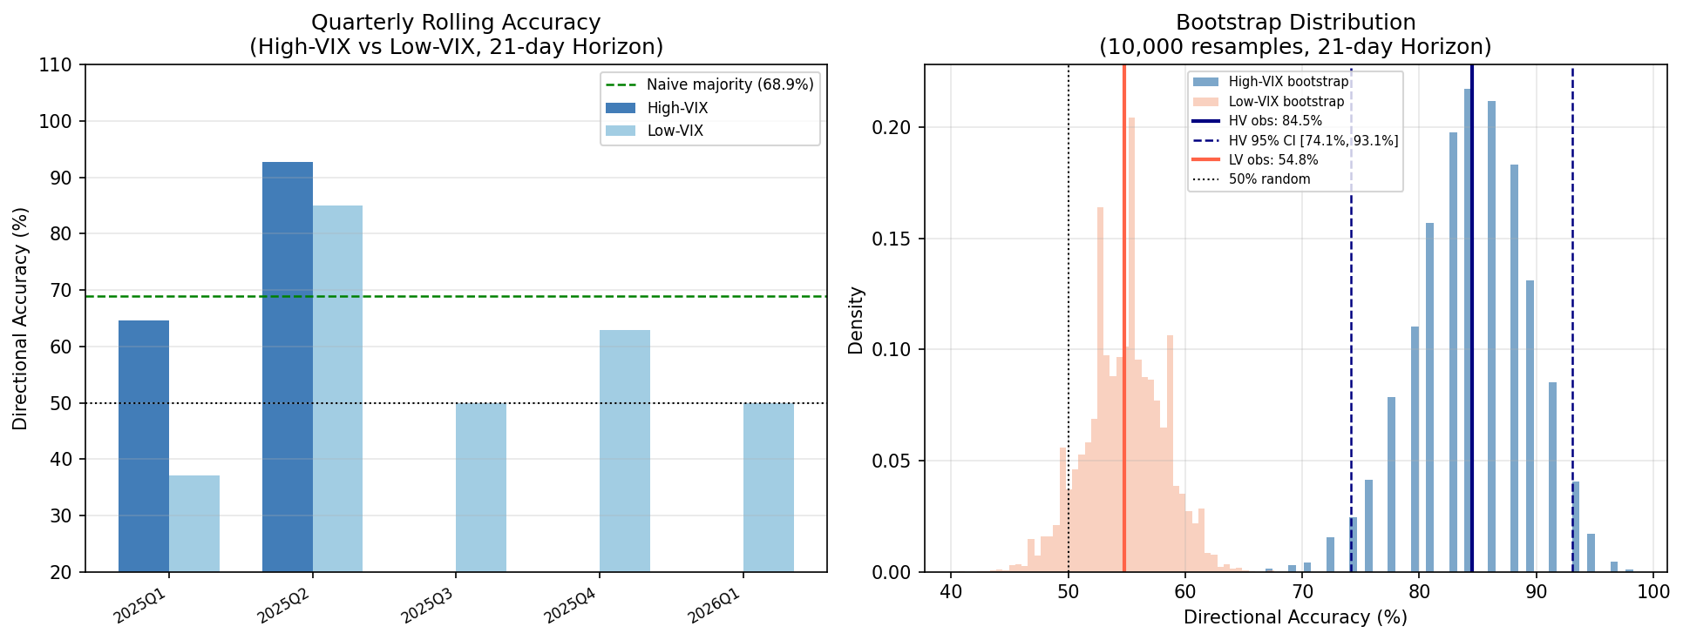
Fig. 9. Bootstrap confidence intervals and temporal concentration of the High-VIX result.

6.4. Cross-pipeline replication
The independent P1 pipeline, trained on a shorter five-year history, provides an out-of-window replication opportunity. Although the threshold differs because the volatility environment is calmer in the P1 sample, the core result persists: High-VIX accuracy is 65.2% versus 35.9% in Low-VIX, a delta of 29.3 percentage points with Fisher p = 0.011. The sample is smaller and the significance is not as strong after multiplicity adjustment, but the direction and magnitude are highly consistent with the main P2 result. Replication across training windows is valuable because it reduces the risk that the main finding is tightly tied to one specific training history. Fig. 10. show cross-pipeline comparison of the High-VIX plus Up strategy. The same deployment logic remains directionally useful in the independent P1 window.
The replication also clarifies what the paper should and should not claim. It should claim that the conditional pattern appears stable enough to emerge across two independently trained pipelines. It should not claim that the absolute accuracy level is identical across every setup. In a forecasting context, sign consistency in the regime effect combined with similar economic magnitude is stronger evidence than demanding identical scores in structurally different samples.

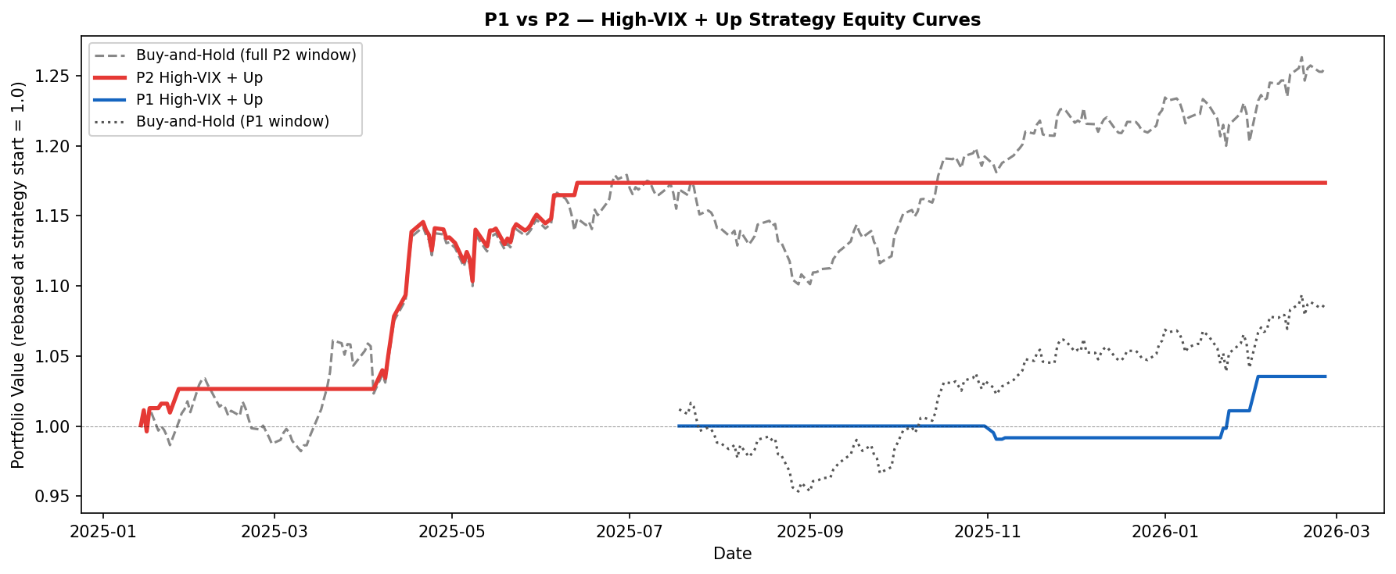
Fig. 10. Cross-pipeline comparison of the High-VIX plus Up strategy.

7. Discussion and Decision-Support Implications
The empirical pattern suggests a simple economic narrative. When India VIX is elevated, the market is processing macro or policy uncertainty that affects bank-sensitive risk expectations over more than one or two sessions. During those windows, technical features such as Bollinger width, ATR, MACD dispersion, and lagged returns become more informative because they encode persistent state changes rather than routine noise. In calm periods, the same indicators remain observable but far less discriminative. The ensemble is therefore not discovering a universal technical edge; it is exploiting the fact that the market becomes more structurally directional when uncertainty rises and diffuses through prices over several weeks.
This interpretation also explains the absence of a result at 1-day and 5-day horizons. If the effect were merely 'high volatility helps forecasting', the shorter horizons should have improved as well. They do not. The most plausible reading is that the relevant mechanism is medium-term information absorption or momentum continuation rather than short-term directional clarity. That makes the 21-day horizon a natural operational horizon for the system and discourages overextension of the result to day trading or ultra-short tactical signals.
For practical deployment, the study supports a narrow but actionable rule: trust the ensemble primarily when India VIX is in the upper quartile of the contemporaneous environment and the model predicts Up. That rule turns the architecture into an expert assistant rather than an autopilot. A trader or desk can remain in cash most of the time, monitor India VIX as a gating variable, and only deploy the directional model when the system’s measured reliability historically improved. The value lies in the decision logic wrapped around the predictive engine, not just in the engine itself.
Several limitations remain. First, the High-VIX dates are concentrated in one broad episode rather than many independent stress windows, so the paper claims conditional reliability within that episode rather than universal generalizability across every future volatility cycle. Second, the 75th-percentile VIX threshold is computed from the test window itself rather than calibrated on prior out-of-sample data. Although the sensitivity analysis confirms that any percentile between p60 and p85 yields the same qualitative result, future work should replace the static percentile with a rolling calibration protocol that fixes the regime threshold from preceding data before each new evaluation window, which would more rigorously separate threshold selection from outcome measurement. Third, the study uses technical features only, leaving open whether sentiment or macroeconomic signals would strengthen or weaken the regime effect. Fourth, the trading protocol is intentionally simple and does not optimize position sizing, leverage, or short exposure. These boundaries are appropriate for the present paper's central claim concerning conditional reliability, but they define the natural next research agenda: multiple independent stress episodes, pre-specified rolling thresholds, richer feature sets, and execution-aware portfolio overlays.

8. Conclusion
This paper shows that Bank Nifty directional predictability is strongly state-dependent when evaluated through the lens of India VIX. A stacking ensemble of XGBoost, LightGBM, Random Forest, CatBoost, and BiLSTM does not deliver a compelling unconditional 21-day result on the held-out sample, yet it becomes highly effective once the same predictions are filtered by the High-VIX state. The resulting 84.5% versus 54.8% accuracy split, along with superior High-VIX AUC, provides a coherent case for regime-conditioned reliability rather than universal predictability.
The economic translation is equally important. A simple High-VIX plus Up deployment rule improves Sharpe and reduces drawdown relative to buy-and-hold while remaining active on only a minority of test days. That is precisely the kind of selective recommendation an expert decision system should produce. Robustness checks across transaction costs, alternative volatility modelling, threshold sensitivity, bootstrap uncertainty, and cross-pipeline replication all support the same core conclusion.
The contribution is therefore a regime-aware expert system for selective directional decision support in an emerging-market index. Its message is not 'always trust the model', but 'trust the model when the state says the signal is likely to be reliable'. That is a more realistic and more useful design principle for intelligent financial decision systems.

Declaration of competing interest
The author declare that they have no known competing financial interests or personal relationships that could have appeared to influence the work reported in this paper.

Data availability
Bank Nifty OHLCV and India VIX daily data are publicly available from the National Stock Exchange of India (NSE). Bank Nifty (NIFTY BANK) historical OHLCV data can be accessed at https://www.nseindia.com/reports-indices-historical-index-data and India VIX historical data can be accessed at https://www.nseindia.com/reports-indices-historical-vix. Both datasets are available for free download in CSV format without registration.

Funding
This research did not receive any specific grant from funding agencies in the public, commercial, or not-for-profit sectors.

References
- Ang, A., & Bekaert, G. (2002). Regime switches in interest rates. Journal of Business and Economic Statistics, 20(2), 163–182. https://doi.org/10.1198/073500102317351930
- Baker, M., & Wurgler, J. (2007). Investor sentiment in the stock market. Journal of Economic Perspectives, 21(2), 129–151. https://doi.org/10.1257/jep.21.2.129
- Ballings, M., Van Den Poel, D., Hespeels, N., & Gryp, R. (2015). Evaluating multiple classifiers for stock price direction prediction. Expert Systems with Applications, 42(20), 7046–7056. https://doi.org/10.1016/j.eswa.2015.05.013
- Cavalcante, R. C., Brasileiro, R. C., Souza, V. L. F., Nobrega, J. P., & Oliveira, A. L. I. (2016). Computational Intelligence and Financial Markets: A Survey and Future Directions. Expert Systems with Applications, 55, 194–211. https://doi.org/10.1016/j.eswa.2016.02.006
- Chong, E., Han, C., & Park, F. C. (2017). Deep learning networks for stock market analysis and prediction: Methodology, data representations, and case studies. Expert Systems with Applications, 83, 187–205. https://doi.org/10.1016/j.eswa.2017.04.030
- Fama, E. F. (1970). Efficient Capital Markets: A Review Of Theory And Empirical Work. The Journal of Finance, 25(2), 383–417. https://doi.org/https://doi.org/10.2307/2325486
- Fama, E. F. (1991). Efficient Capital Markets: II. The Journal of Finance, 46(5), 1575. https://doi.org/10.2307/2328565
- Fischer, T., & Krauss, C. (2018). Deep learning with long short-term memory networks for financial market predictions. European Journal of Operational Research, 270(2), 654–669. https://doi.org/10.1016/j.ejor.2017.11.054
- Gandhmal, D. P., & Kumar, K. (2019). Systematic analysis and review of stock market prediction techniques. Computer Science Review, 34, 100190. https://doi.org/10.1016/j.cosrev.2019.08.001
- Giot, P. (2005). Relationships Between Implied Volatility Indexes and Stock Index Returns. The Journal of Portfolio Management, Spring 200, 92–100. https://doi.org/https://doi.org/10.3905/jpm.2005.500363
- Hamilton, J. D. (1989). A New Approach to the Economic Analysis of Nonstationary Time Series and the Business Cycle. Econometrica, 57(2), 357–384. https://doi.org/https://doi.org/10.3905/jpm.2005.500363
- Henrique, B. M., Sobreiro, V. A., & Kimura, H. (2019). Literature review: Machine learning techniques applied to financial market prediction. Expert Systems with Applications, 124, 226–251. https://doi.org/10.1016/j.eswa.2019.01.012
- Hiransha, M., Gopalakrishnan, E. A., Menon, V. K., & Soman, K. P. (2018). NSE Stock Market Prediction Using Deep-Learning Models. Procedia Computer Science, 132(Iccids), 1351–1362. https://doi.org/10.1016/j.procs.2018.05.050
- Huang, W., Nakamori, Y., & Wang, S. Y. (2005). Forecasting stock market movement direction with support vector machine. Computers and Operations Research, 32(10), 2513–2522. https://doi.org/10.1016/j.cor.2004.03.016
- Jiang, W. (2021). Applications of deep learning in stock market prediction: Recent progress. Expert Systems with Applications, 184(March 2020), 115537. https://doi.org/10.1016/j.eswa.2021.115537
- Krauss, C., Do, X. A., & Huck, N. (2017). Deep neural networks, gradient-boosted trees, random forests: Statistical arbitrage on the S&P 500. European Journal of Operational Research, 259(2), 689–702. https://doi.org/10.1016/j.ejor.2016.10.031
- Lo, A. W. (2004). The adaptive markets hypothesis. Journal of Portfolio Management, 30(SUPPL.), 15–29. https://doi.org/10.3905/jpm.2004.442611
- Lundberg, S. M., & Lee, S. . (2017). A unified approach to interpreting model predictions. NIPS-2017 Advances in Neural Information Processing Systems, 32(2), 4765–4774. https://doi.org/10.1016/j.inffus.2019.12.012%0Ahttps://doi.org/10.1016/j.ophtha.2018.11.016
- Nayak, A., Pai, M. M. M., & Pai, R. M. (2016). Prediction Models for Indian Stock Market. Procedia Computer Science, 89, 441–449. https://doi.org/10.1016/j.procs.2016.06.096
- NSE. (2008). India VIX: A Volatility Index Based on the Nifty 50 Index Option Prices. National Stock Exchange of India white paper. NSE, India. https://nsearchives.nseindia.com/web/sites/default/files/inline-files/white_paper_IndiaVIX.pdf
- Patel, J., Shah, S., Thakkar, P., & Kotecha, K. (2015). Predicting stock and stock price index movement using Trend Deterministic Data Preparation and machine learning techniques. Expert Systems with Applications, 42(1), 259–268. https://doi.org/10.1016/j.eswa.2014.07.040
- Prokhorenkova, L., Gusev, G., Vorobev, A., Dorogush, A. V., & Gulin, A. (2018). Catboost: Unbiased boosting with categorical features. Advances in Neural Information Processing Systems, 2018-Decem(Section 4), 6638–6648. https://doi.org/https://doi.org/10.48550/arXiv.1706.09516
- Raavihemalatha, GodiAmulya, & Sailalitha, C. S. N. (2024). Deep Learning for Stock Market Prediction. 2024 2nd International Conference Computational and Characterization Techniques in Engineering and Sciences, IC3TES 2024. https://doi.org/10.1109/IC3TES62412.2024.10877452
- SCHWERT, G. W. (1989). Why Does Stock Market Volatility Change Over Time? The Journal of Finance, 44(5), 1115–1153. https://doi.org/10.1111/j.1540-6261.1989.tb02647.x
- Sezer, O. B., Gudelek, M. U., & Ozbayoglu, A. M. (2020). Financial time series forecasting with deep learning: A systematic literature review: 2005–2019. Applied Soft Computing Journal, 90, 106181. https://doi.org/10.1016/j.asoc.2020.106181
- Shah, D., Isah, H., & Zulkernine, F. (2019). Stock market analysis: A review and taxonomy of prediction techniques. International Journal of Financial Studies, 7(2). https://doi.org/10.3390/ijfs7020026
- Sharpe, W. F. (1994). The Sharpe ratio. Journal of Portfolio Management, 49–58. https://doi.org/https://doi.org/10.3905/jpm.1994.409501
- Spyros Makridakis, Evangelos Spiliotis, & Vassilios Assimakopoulos. (2018). Statistical and Machine Learning forecasting methods: Concerns and ways forward. PLoS ONE, 13(3), 1–26. https://doi.org/https://doi.org/ 10.1371/journal.pone.0194889
- Vaswani, A., Shazeer, N., Parmar, N., Uszkoreit, J., Jones, L., Gomez, A. N., Kaiser, L., & Polosukhin, I. (2017). Attention Is All You Need Ashish. 31st Conference on Neural Information Processing Systems (NIPS 2017), 1–11. https://doi.org/https://dl.acm.org/doi/10.5555/3295222.3295349
- Whaley, R. E. (2000). The investor fear gauge. Journal of Portfolio Management, 12–17. https://doi.org/https://doi.org/10.3905/jpm.2000.319728
- Wolpert, D. H. (1992). Stacked generalization. Neural Networks, 5(2), 241–259. https://doi.org/10.1016/S0893-6080(05)80023-1

