Topic:- Train a light weight model to identify make and model of the cars.

Dataset - [Car Images Dataset | Kaggle](https://www.kaggle.com/datasets/kshitij192/cars-image-dataset)

**Number of cars -in data set**

Number of images in class Audi: 814

Number of images in class Hyundai Creta: 271

Number of images in class Mahindra Scorpio: 316

Number of images in class Rolls Royce: 311

Number of images in class Swift: 424

Number of images in class Tata Safari: 441

Number of images in class Toyota Innova: 775

Questions –

1. Find out the make and model that is most represented and the one that is least represented class? Is there a class imbalance problem, how would you handle class imbalance if it were to exist (2 marks)

balance dataset-

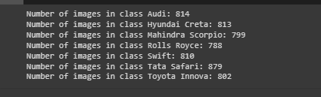

Most represented class: Audi with 814 images

Least represented class: Hyundai Creta with 271 images

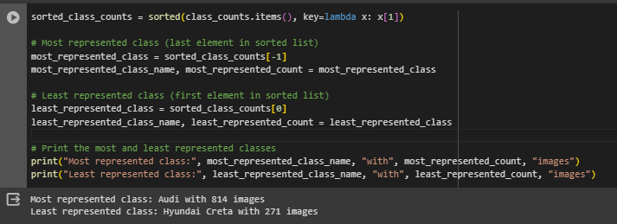

1. Apply the image processing techniques and explain the benefits of those technique (2 marks)

**Image Resizing-** It reduces computational overhead by reducing the dimensionality of the input images, making training faster and more efficient. Additionally, it allows the model to learn features from images of varying sizes.

**Rescaling (rescale=1.0 / 255) -**This rescales the pixel values of the images to the range [0, 1]. Normalizing pixel values to a common scale helps in stabilizing the training process and accelerating convergence.

**Rotation Range (rotation_range=20) -** Randomly rotating images by up to 20 degrees introduces variations in the orientation of objects in the images. This helps in improving the model's ability to generalize to different orientations of objects in real-world scenarios.

**Height Shift Range Width Shift Range**

-parameters in data augmentation control the random shifting of images vertically and horizontally, respectively, introducing variations in the positioning of objects and enhancing the model's robustness to spatial transformations.

**Shear Range** (shear_range=0.2) - Applying shear transformations to images deforms them along the x-axis or y-axis, introducing variations in the shape of objects. This augmentation helps in enhancing the model's ability to recognize objects from different perspectives.

**Zoom Range** (zoom_range=0.2) - Randomly zooming into or out of images by up to 20% simulates variations in the scale of objects. This augmentation technique helps in improving the model's robustness to variations in the size of objects.

1. Train a lightweight model, show train and validation loss curves, show steps taken to tune hyper params (1 marks)

using   
 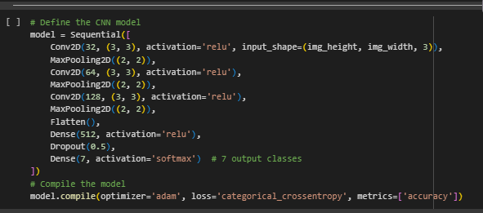

**Convolution->Relu->Pooling->Convolution->Relu->Pooling->Flattening->Fully Connected layer**

**CNN Layer-This layer is the first layer that is used to extract the various features from the input images.**

**Pooling layer-It is to decrease the size of the convolved feature map to reduce the computational costs**

**Fully Connected layer-It consists of the weights and biases along with the neurons and is used to connect the neurons between two different layers.**

**Dropout-To overcome overfitting problem, a dropout layer is utilised wherein a few neurons are dropped from the neural network during training process resulting in reduced size of the model.**

**Relu Activation Function-It decides which information of the model should be send in the forward direction and which ones should not at the end of the network.**

and also use Yolo v8 for yolo

create a data set from roboflow algorithm.

use pretranied model for creating classification, object detection and segmentation.

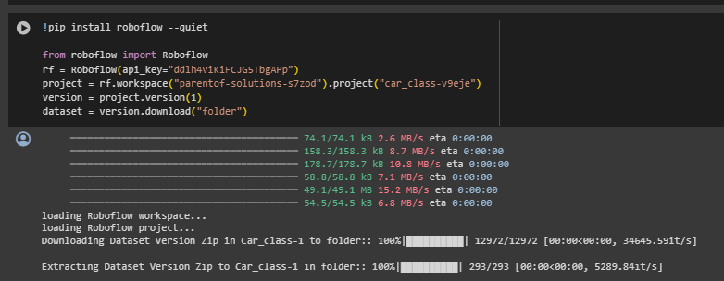

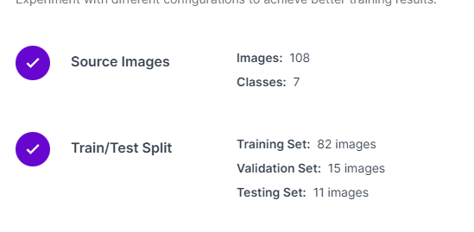

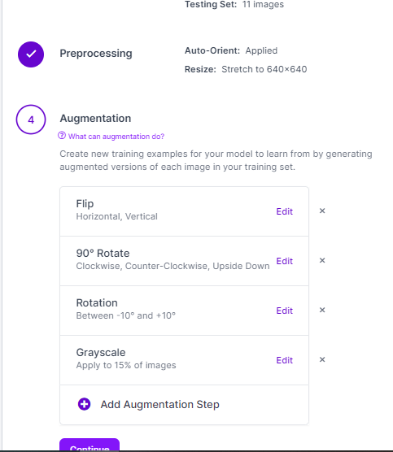

1. Determine metric to evaluate performance of the model. Report how the model is performing on the metric (2 Marks)

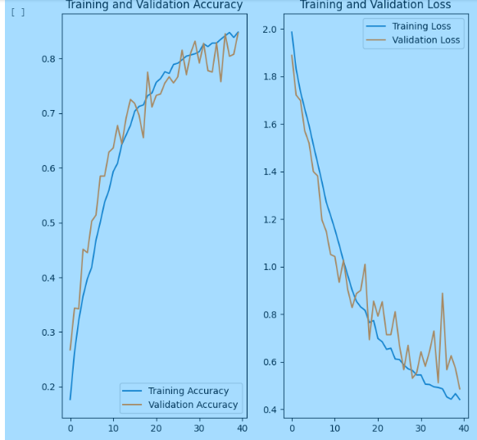

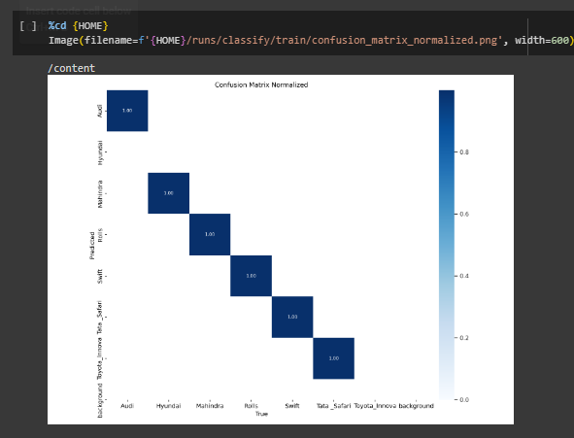

1. Deploy (3 marks)
   1. As a rest api endpoint
   2. Mobil app model

<http://127.0.0.1:8000/docs>

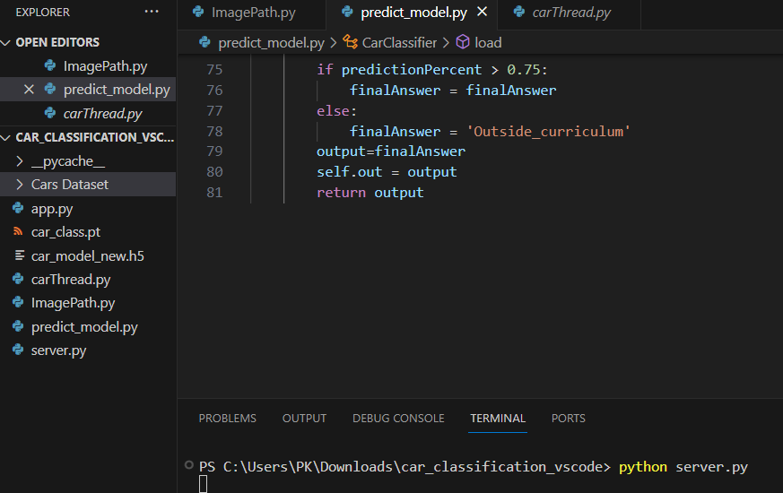

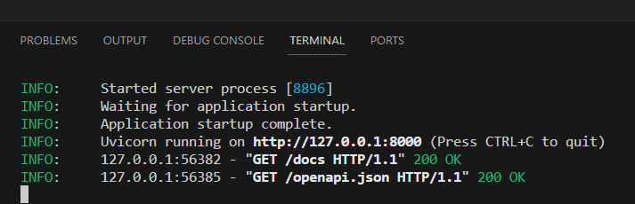

test the images in fast api app

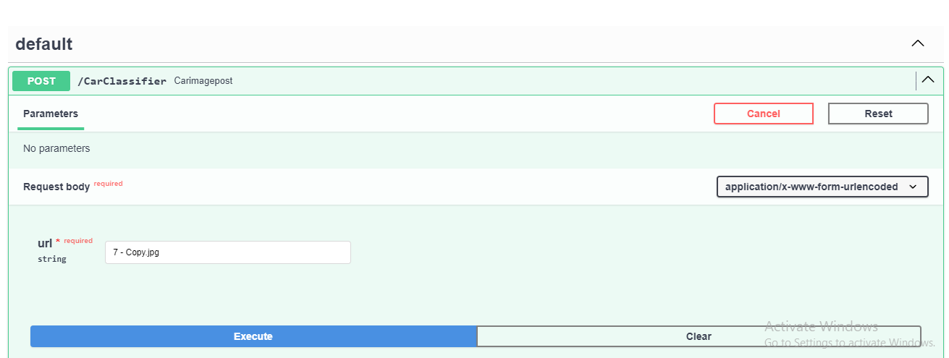

then after predict the model i am getting output of image name

