**Reactjs**

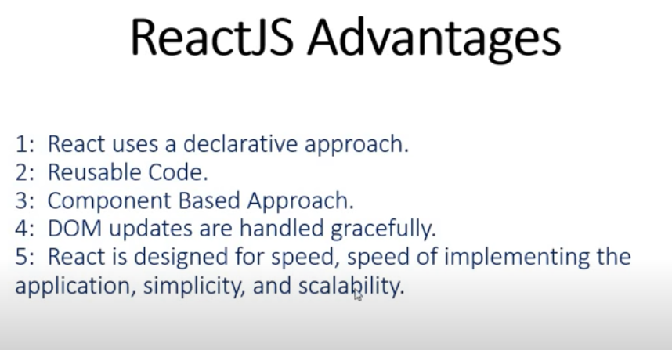

**Installing react:**

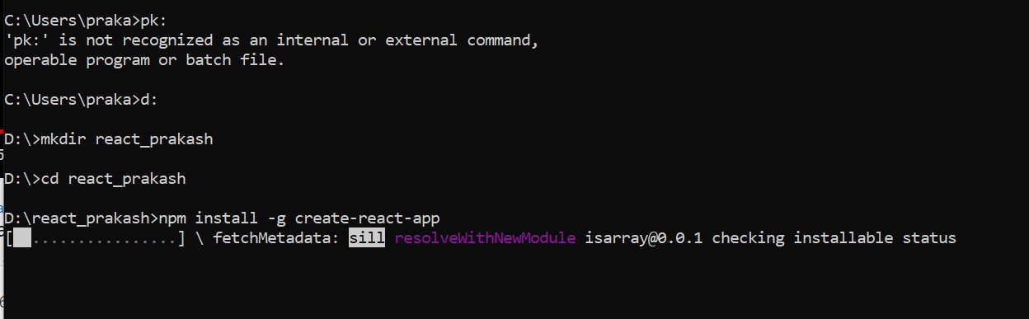

**npm install -g create-react-app**

**create-react-app reactproject**

**……………………**

**cd reactproject**

**npm start**

**npm- (node package manager)**

