🏠 House Price Prediction
Machine Learning Capstone Project Report
Using XGBoost, Random Forest & Ensemble Methods

Submitted in Partial Fulfillment of the Capstone Project Requirements

1. Title of the Project
House Price Prediction Using Machine Learning

2. Brief on the Project

2.1 Problem Statement
The real estate sector in India suffers from significant information asymmetry — buyers often lack reliable data to evaluate whether a listed price is fair. This project addresses that gap by developing a machine learning model that accurately predicts residential property prices (in Indian Rupees, in Lakhs) based on features such as property size, BHK count, construction status, RERA approval, and geographic location.

2.2 Project Type
Supervised Machine Learning — Regression

2.3 Motivation
India's real estate market is one of the fastest-growing in the world, yet price transparency remains a major challenge. A data-driven pricing model can:
- Help prospective home buyers gauge fair market value.
- Enable real estate agents to provide quick, evidence-based valuations.
- Support financial institutions in loan underwriting decisions.
- Expose price anomalies and speculative bubbles in regional markets.

2.4 Approach
The project follows the standard machine learning pipeline:
- Data loading and inspection of 29,451 property listings.
- Exploratory Data Analysis (EDA) to uncover patterns and distributions.
- Outlier removal and feature engineering (city extraction, label encoding).
- Training five regression models and comparing their performance.
- Selecting the best model (XGBoost) and saving it for deployment.
- Building a Streamlit web application for interactive price prediction.

3. Deliverables of the Project

3.1 Research Questions
- Which property features most strongly influence house prices in the dataset?
- Can machine learning outperform simple linear regression for price prediction?
- How accurately can the best model estimate unseen house prices?
- Which cities or regions carry the highest price premiums?

3.2 Model Details & Key Findings
Dataset Size: 29,451 records (29,156 after outlier removal), 11 features + 1 target.
Target Variable: TARGET(PRICE_IN_LACS) — continuous variable; median ₹62L, mean ₹143L (right-skewed).
Best Model: XGBoost Regressor (n_estimators=100, random_state=42).

Key Findings:
- Square footage (SQUARE_FT) and geographic coordinates (LATITUDE, LONGITUDE) are the top predictors.
- BHK count has a non-linear relationship with price — 4+ BHK properties show disproportionate price jumps.
- RERA-approved and Ready-to-Move properties command a moderate price premium.
- Linear models achieve only R²≈0.26 due to the non-linearity of pricing patterns.
- XGBoost and Random Forest both exceed R²=0.81, with XGBoost edging ahead at 0.828.

3.3 Model Performance Summary
Model | MAE (Lakhs) | RMSE (Lakhs) | R² Score
Linear Regression | 54.19 | 94.34 | 25.56%
Ridge Regression | 54.18 | 94.34 | 25.56%
Random Forest | 21.69 | 47.43 | 81.18%
Gradient Boosting | 27.65 | 53.17 | 76.35%
XGBoost | 22.28 | 45.31 | 82.83%

Green rows indicate the best-performing model.

3.4 Expected Observations & Outcomes
- Predictions within ±25 Lakhs for properties in the ₹30–300L range.
- Higher error margins for ultra-luxury properties (₹500L+) due to limited training samples.
- The Streamlit app provides an intuitive interface for real-time predictions.

4. Exploratory Data Analysis

4.1 Price Distribution
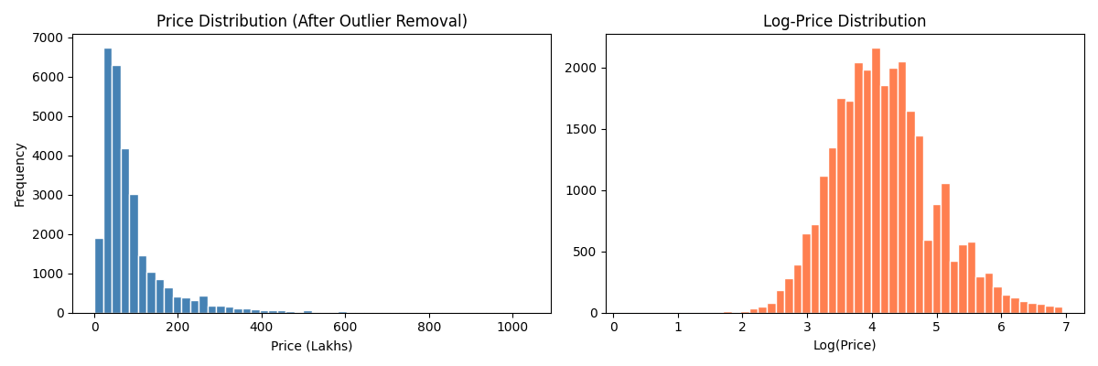
The raw price distribution is heavily right-skewed, with a few properties above ₹1,000 Lakhs. The log-transformed distribution approximates normality, confirming the skewness.

4.2 Feature Correlation Heatmap
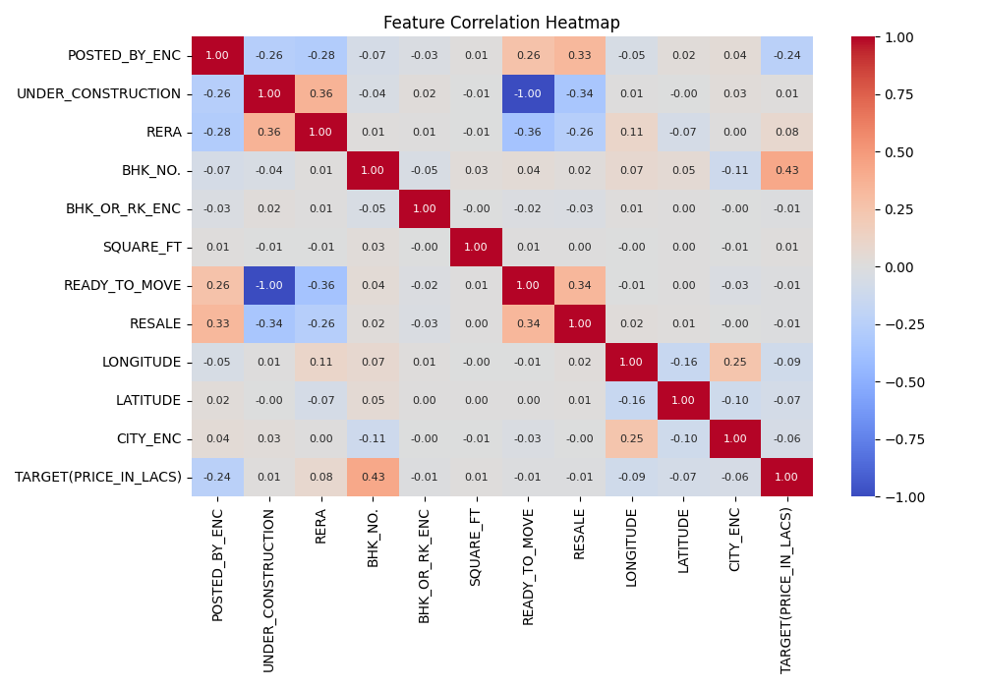
SQUARE_FT shows the strongest correlation with price. Geographic coordinates (LATITUDE, LONGITUDE) are moderately correlated, indicating location's role in pricing.

4.3 Price by BHK Count
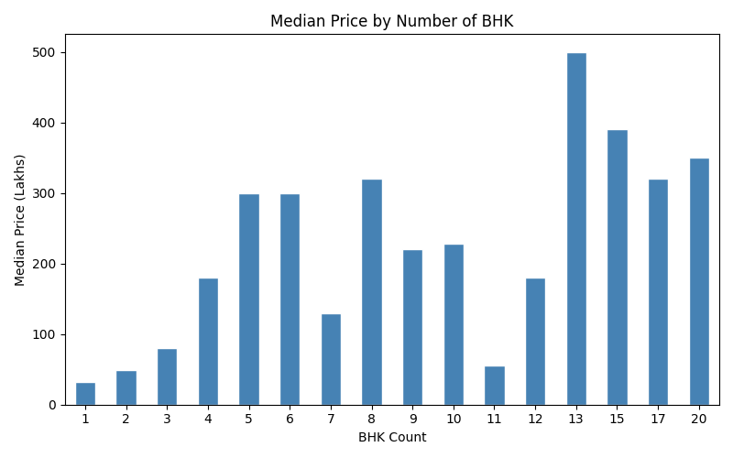
Median price increases consistently with BHK count, with a sharp jump for 4-BHK and above properties.

5. Model Comparison & Results

5.1 Performance Comparison
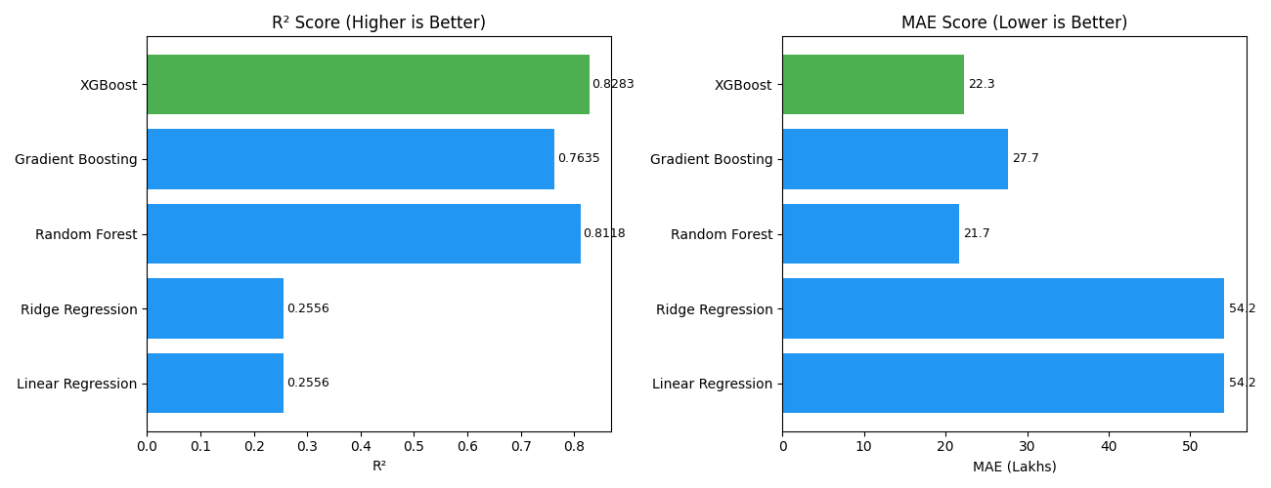
XGBoost outperforms all other models on both R² and MAE. Ensemble methods (XGBoost, Random Forest, Gradient Boosting) significantly outperform linear approaches.

5.2 Actual vs Predicted – XGBoost
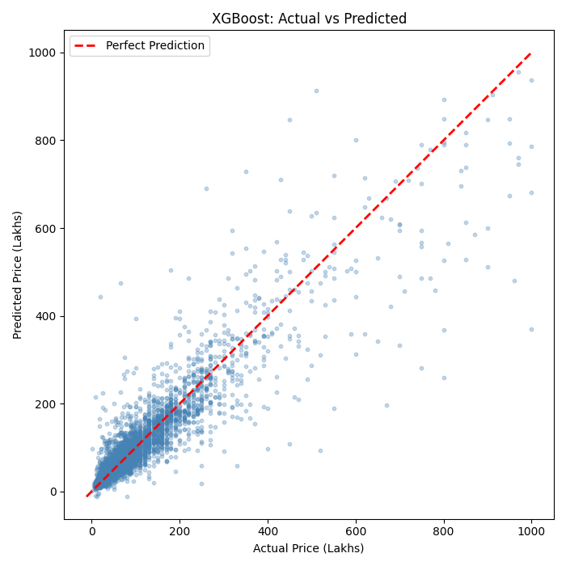
Most predictions cluster tightly around the diagonal (perfect prediction line), particularly in the ₹20–300L range. Scatter increases for high-value properties.

5.3 Feature Importances – XGBoost
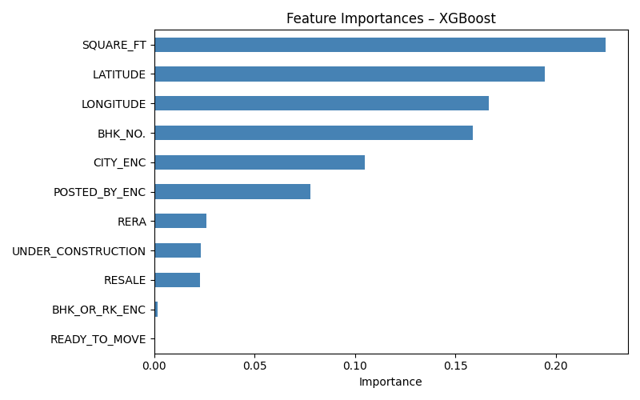
SQUARE_FT, LATITUDE, and LONGITUDE are the top three most influential features, together contributing over 70% of model importance.

6. Resources

6.1 Dataset Source
The dataset was provided as part of the capstone project assignment. It contains 29,451 rows of Indian residential real estate listings with 12 columns.
- Format: CSV (House_Price.csv)
- Rows: 29,451 | Features: 11 | Target: TARGET(PRICE_IN_LACS)

6.2 Software & Libraries
Library | Version | Purpose
Python | 3.10+ | Core programming language
pandas | 2.x | Data manipulation & analysis
scikit-learn | 1.x | ML models & evaluation metrics
XGBoost | 1.7+ | Best-performing gradient boosting
matplotlib / seaborn | Latest | Data visualisation
Streamlit | Latest | Model deployment & UI
joblib | Latest | Model serialisation
Jupyter Notebook | 7.x | Interactive analysis environment

6.3 References
- Chen, T., & Guestrin, C. (2016). XGBoost: A Scalable Tree Boosting System. Proceedings of KDD 2016.
- Breiman, L. (2001). Random Forests. Machine Learning, 45(1), 5-32.
- Pedregosa, F. et al. (2011). Scikit-learn: Machine Learning in Python. JMLR, 12, 2825-2830.

7. Individual Details
Name | Email ID | Phone Number
[Student Name] | [student@email.com] | [+91 XXXXXXXXXX]

8. Project Milestones
Milestone | Status
Define a Problem | ✅ Completed
Understanding the Business Problem | ✅ Completed
Get the Data | ✅ Completed
Explore and Pre-process Data | ✅ Completed
Choose Python Platform | ✅ Completed (Jupyter + Streamlit)
Create Features (Feature Engineering) | ✅ Completed
EDA (Exploratory Data Analysis) | ✅ Completed
Create Model | ✅ Completed (5 models trained)
Model Evaluation | ✅ Completed (XGBoost selected)
Model Deployment (Streamlit App) | ✅ Completed
Report Writing | ✅ Completed
Project Submission | ⬜ Pending

9. Conclusion
This capstone project successfully built and deployed a house price prediction system for Indian residential properties. Among five regression models evaluated, XGBoost achieved the best performance:
- R² Score: 82.83% — explaining over 82% of price variance.
- MAE: 22.3 Lakhs — average prediction error of approximately ₹22L.
- RMSE: 45.3 Lakhs.

The model is saved and deployed via a Streamlit web application, enabling real-time house price estimation from user-provided property attributes. The project demonstrates how machine learning can add tangible value to the real estate sector by making price information more accessible and transparent.

