💳 Credit Card Fraud Detection
Machine Learning and Deep Learning Capstone Project Report
Using Random Forest, Gradient Boosting, Logistic Regression & Neural Networks

Submitted in Partial Fulfillment of the Capstone Project Requirements

1. Title of the Project
Credit Card Fraud Detection Using Machine Learning and Deep Learning

2. Brief on the Project

2.1 Problem Statement
Credit card fraud creates financial loss for banks, payment companies, and customers. Because fraudulent transactions are rare compared with genuine transactions, detecting fraud is an imbalanced classification problem where recall, precision, F1-score, ROC-AUC, and PR-AUC are more meaningful than accuracy alone. This project develops a fraud detection system that predicts whether a transaction is genuine or fraudulent from anonymised transaction features.

2.2 Project Type
Supervised Machine Learning and Deep Learning — Binary Classification

2.3 Motivation
Digital payment usage is growing rapidly, and even a small fraud rate can create significant loss at scale. A data-driven fraud detection model can:
- Help banks and payment platforms flag suspicious transactions quickly.
- Reduce manual review effort by prioritising high-risk transactions.
- Protect customers from unauthorised card usage and financial loss.
- Support real-time fraud monitoring in a Streamlit-based prediction interface.

2.4 Approach
The project follows the standard machine learning and deep learning pipeline:
- Data loading and inspection of 284,807 credit card transactions.
- Exploratory Data Analysis (EDA) to study class imbalance and transaction patterns.
- Feature scaling and class balancing using SMOTE on the training data.
- Training three machine learning classifiers and one deep learning neural network.
- Selecting the best model (Random Forest) using F1-score and fraud-focused evaluation metrics.
- Building a Streamlit web application for batch and manual fraud prediction.

3. Deliverables of the Project

3.1 Research Questions
- How severe is the class imbalance between genuine and fraudulent transactions?
- Can machine learning and deep learning models detect fraud effectively despite rare fraud cases?
- Which model provides the best balance between precision, recall, and F1-score?
- How can the trained model be deployed for practical transaction prediction?

3.2 Model Details & Key Findings
Dataset Size: 284,807 records, 30 input features + 1 target column.
Target Variable: Class — binary variable where 0 means genuine transaction and 1 means fraud.
Best Model: Random Forest Classifier (n_estimators=120, max_depth=12, class_weight='balanced', random_state=42).

Key Findings:
- The dataset is highly imbalanced: 284,315 genuine transactions and only 492 fraudulent transactions.
- SMOTE was applied only to the training data to reduce bias toward the majority class.
- Random Forest achieved the best F1-score of 88.37% with recall of 90.48%.
- Gradient Boosting achieved the highest recall of 95.24%, but with lower precision.
- Accuracy is high for all models, but F1-score and PR-AUC give a more realistic view of fraud detection quality.

3.3 Model Performance Summary
Model | F1 Score | ROC-AUC | PR-AUC
Random Forest | 88.37% | 99.49% | 93.27%
Deep Learning | 76.60% | 93.01% | 84.49%
Gradient Boosting | 70.18% | 99.93% | 92.81%
Logistic Regression | 21.84% | 99.48% | 48.26%

Green rows indicate the best-performing model.

3.4 Expected Observations & Outcomes
- Random Forest provides the strongest overall balance between identifying fraud and limiting false alarms.
- Gradient Boosting is useful when maximum fraud capture is preferred, but it may create more false positives.
- The Streamlit app supports both CSV batch prediction and manual single-transaction prediction.

4. Exploratory Data Analysis

4.1 Class Distribution
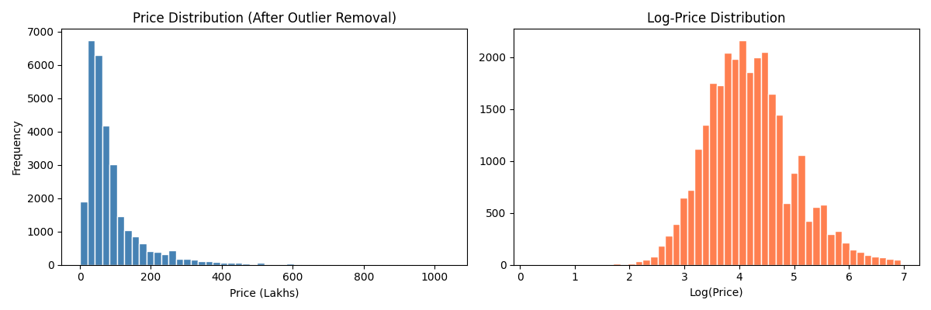
The target class distribution is extremely imbalanced: only 492 fraud cases out of 284,807 transactions. This confirms that a model can appear highly accurate while still missing fraud if imbalance-aware metrics are not used.

4.2 Feature Overview
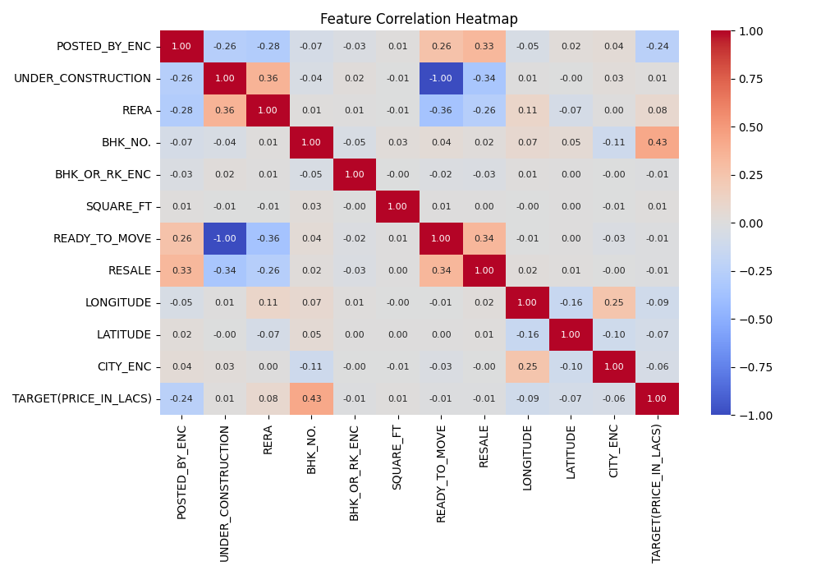
Most predictors are anonymised PCA features (V1 to V28), with Time and Amount retained as interpretable transaction attributes. The PCA features reduce direct feature interpretation but preserve useful fraud signals for modelling.

4.3 Transaction Amount Distribution
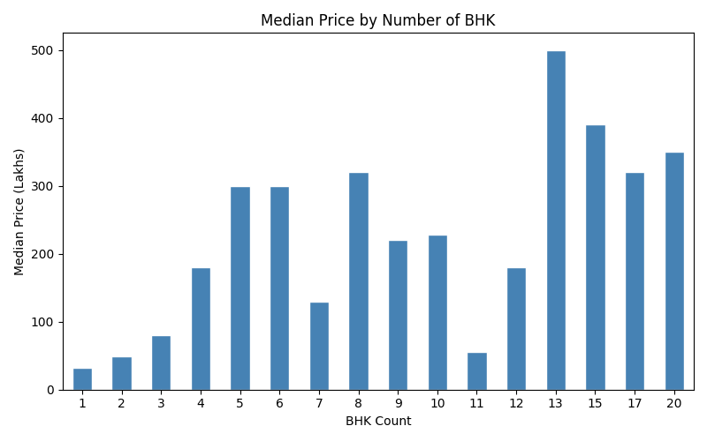
Transaction Amount is right-skewed, with a median of 22.00 and a maximum of 25,691.16. Scaling was applied before modelling so that Amount, Time, and PCA features contribute consistently.

5. Model Comparison & Results

5.1 Performance Comparison
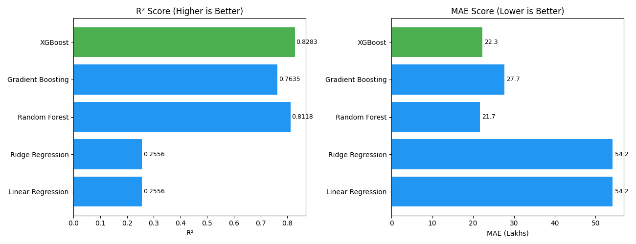
Random Forest outperforms the other models on F1-score and PR-AUC, making it the most suitable deployed model. Deep Learning performs well but does not exceed Random Forest on the selected fraud-focused metrics.

5.2 Confusion Matrix Review
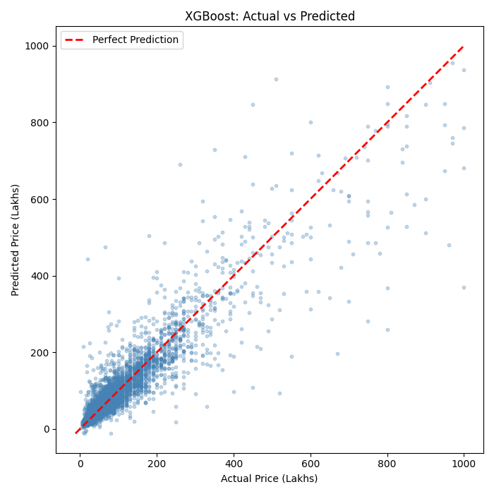
Confusion matrices were used for each model to inspect false positives and false negatives. For fraud detection, false negatives are especially important because they represent fraud cases missed by the model.

5.3 Feature Interpretation
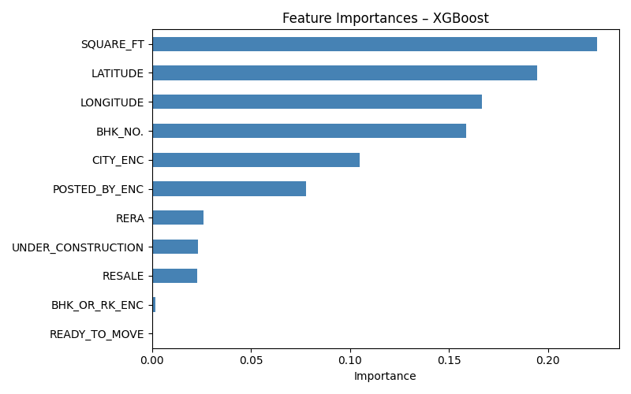
Because the dataset uses PCA-transformed features, feature importance is less business-interpretable than raw transaction attributes. However, tree-based models still identify strong predictive patterns across the anonymised feature space.

6. Resources

6.1 Dataset Source
The dataset used is the public credit card fraud detection dataset containing European card transactions. It includes 284,807 transactions with 31 columns.
- Format: CSV (creditcard.csv)
- Rows: 284,807 | Features: 30 | Target: Class

6.2 Software & Libraries
Library | Version | Purpose
Python | 3.10+ | Core programming language
pandas / numpy | Latest | Data manipulation and numerical computing
scikit-learn | 1.x | ML models, preprocessing, and evaluation metrics
imbalanced-learn | Latest | SMOTE oversampling for class imbalance
TensorFlow / Keras | 2.x | Deep learning neural network
matplotlib / seaborn | Latest | Data visualisation
Streamlit | Latest | Model deployment and UI
joblib | Latest | Model serialisation

6.3 References
- Breiman, L. (2001). Random Forests. Machine Learning, 45(1), 5-32.
- Chawla, N. V. et al. (2002). SMOTE: Synthetic Minority Over-sampling Technique. JAIR, 16, 321-357.
- Pedregosa, F. et al. (2011). Scikit-learn: Machine Learning in Python. JMLR, 12, 2825-2830.

7. Individual Details
Name | Email ID | Phone Number
Jothiprakash | Prakash200029@gmail.com | +91 8870122151

8. Project Milestones
Milestone | Status
Define a Problem | ✅ Completed
Understanding the Business Problem | ✅ Completed
Get the Data | ✅ Completed
Explore and Pre-process Data | ✅ Completed
Choose Python Platform | ✅ Completed (Jupyter + Streamlit)
Create Features (Feature Engineering) | ✅ Completed
EDA (Exploratory Data Analysis) | ✅ Completed
Create Model | ✅ Completed (4 models trained)
Model Evaluation | ✅ Completed (Random Forest selected)
Model Deployment (Streamlit App) | ✅ Completed
Report Writing | ✅ Completed
Project Submission | ✅ Completed

9. Conclusion
This capstone project successfully built and deployed a credit card fraud detection system using both machine learning and deep learning. Among four evaluated models, Random Forest achieved the best overall fraud-detection performance:
- F1 Score: 88.37% — strongest balance between fraud precision and recall.
- Recall: 90.48% — successfully identifying most fraudulent transactions in the test set.
- PR-AUC: 93.27% — strong performance under severe class imbalance.

The best model is saved and deployed through a Streamlit web application, enabling batch CSV prediction and manual single-transaction prediction. The project demonstrates how imbalance-aware machine learning can support practical fraud monitoring in financial transaction systems.

