REVIEW-II
Online Exam Management System
1.INTRODUCTION:
The Exam Management System is developed to streamline the traditional examination process by integrating automation and digital technologies. Conventional exam handling involves excessive paperwork, manual scheduling, and delays in result processing, which often leads to inefficiency and errors. This system provides a centralized platform for administrators, teachers, and students to manage all exam-related activities in a secure and user-friendly manner. It reduces time consumption, enhances transparency, and ensures smooth conduct of exams. By providing online registration, scheduling, evaluation, and result publication, the system improves productivity and reliability in academic institutions.

2.ABSTRACT :
The Exam Management System provides a reliable, efficient, and transparent solution to manage examinations in academic institutions. By digitizing exam activities such as scheduling, registration, and result generation, it reduces manual workload and minimizes errors. The system ensures security, accuracy, and timely publication of results, thereby enhancing trust among students and administrators. With scalability and flexibility, it can be adopted by schools, colleges, and universities to simplify their examination processes.

3.SOFTWARE SPECIFICATION:
Operating System: Windows / Linux / macOS
Front-end: HTML, CSS, JavaScript (or React/Angular for advanced UI)
Back-end: PHP / Java / Python (Django, Flask, or Spring Boot)
Database: MySQL / PostgreSQL / Oracle
Web Server: Apache / Tomcat / Nginx
IDE/Tools: VS Code, Eclipse, or NetBeans
4.HARDWARE REQUIREMENTS:
Processor: Intel Core i3 or higher
RAM: Minimum 4 GB (8 GB recommended)
5.SYSTEM IMPLEMENTATION:
- Home Page

- User Registration
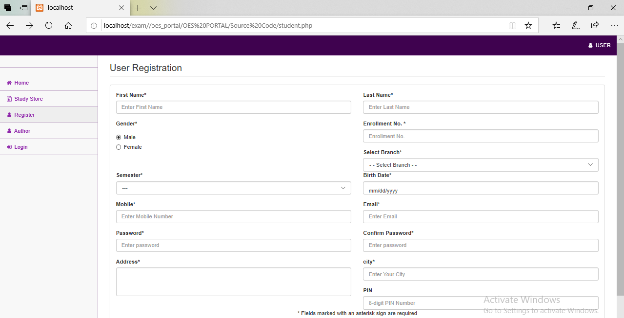

- User Login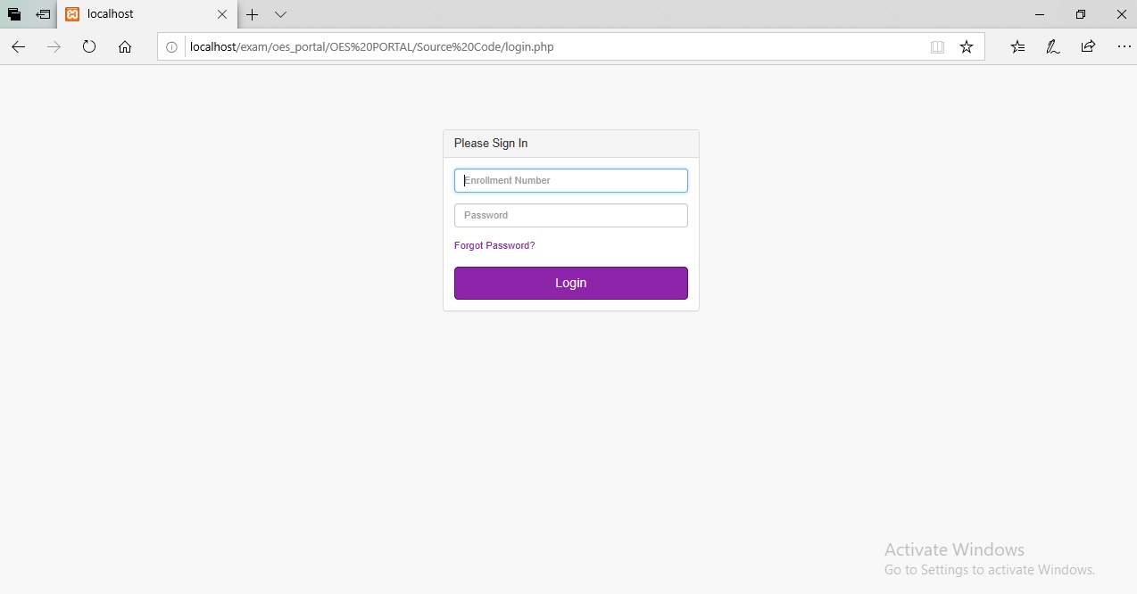
- Exam Registration
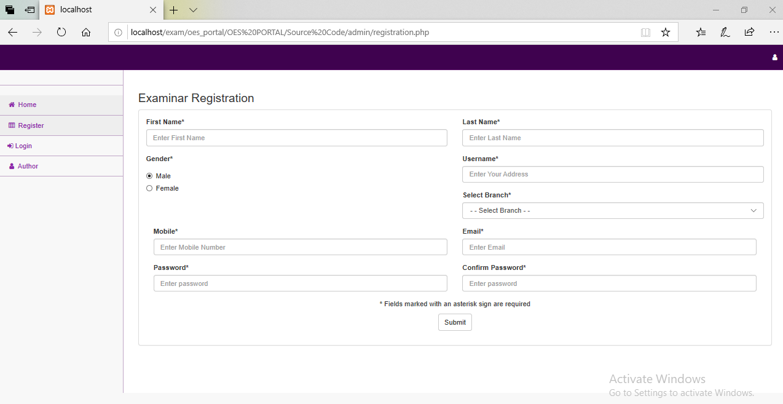

- Result Page
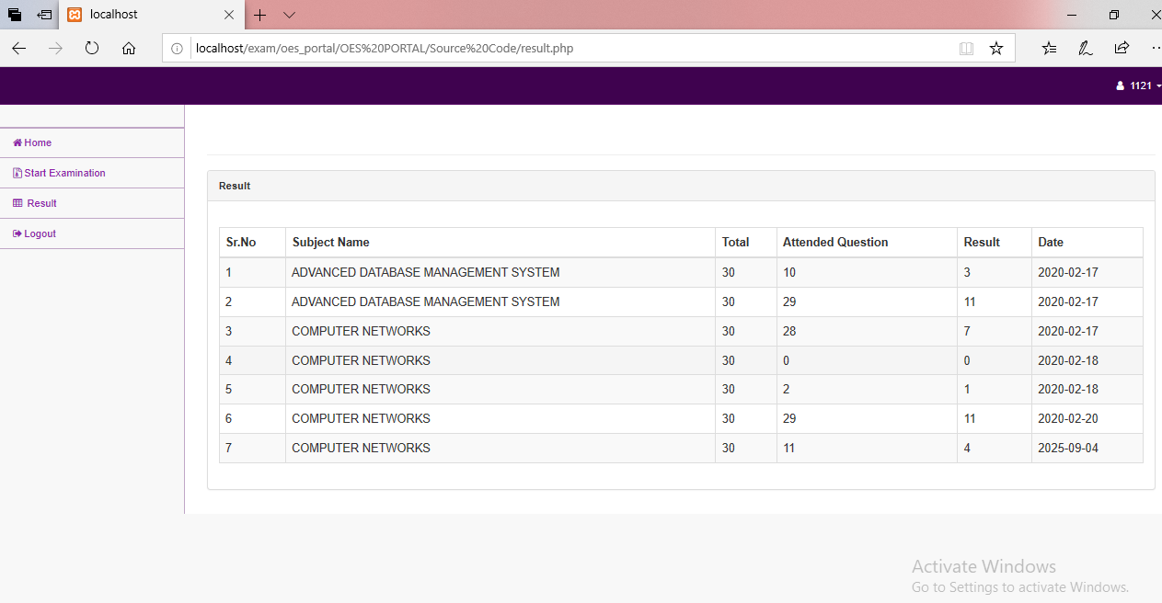
- Admin Login
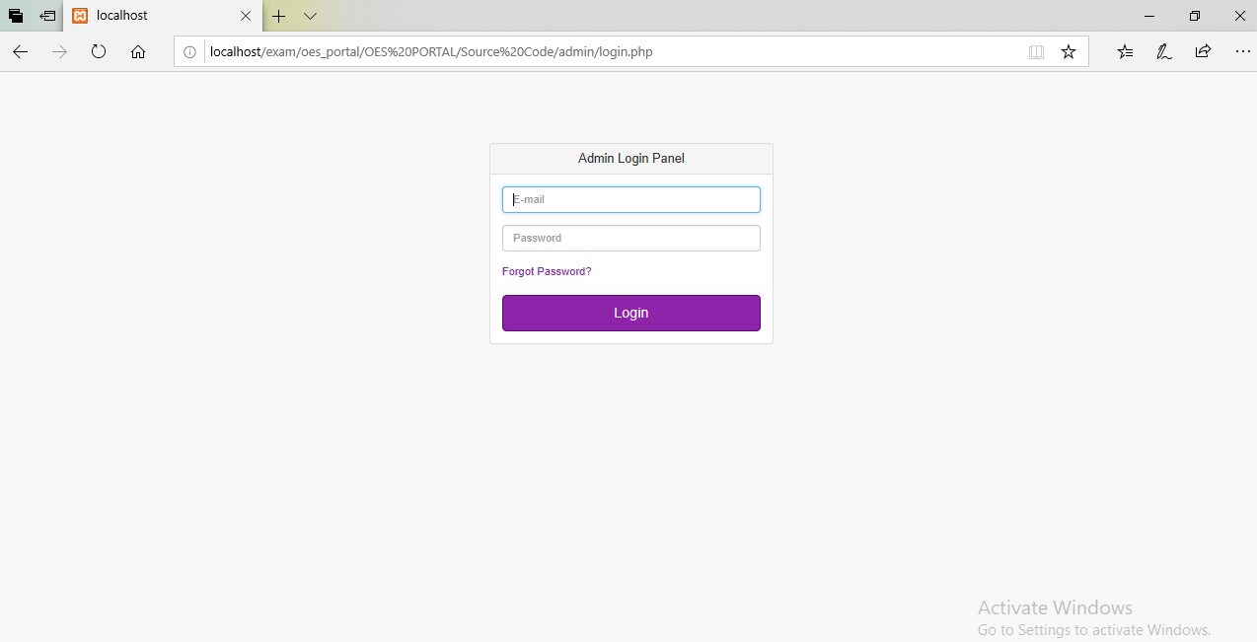

6.ER DIAGRAM :
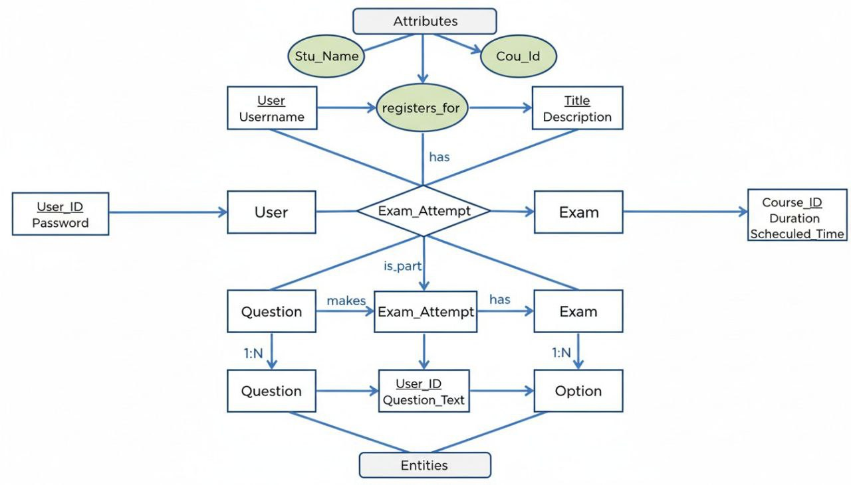

7.CONCLUSION :
The Exam Management System provides a reliable, efficient, and transparent solution to manage examinations in academic institutions. By digitizing exam activities such as scheduling, registration, and result generation, it reduces manual workload and minimizes errors. The system ensures security, accuracy, and timely publication of results, thereby enhancing trust among students and administrators. With scalability and flexibility, it can be adopted by schools, colleges, and universities to simplify their examination processes.

