END-TO-END MIGRATION PLAN — v6.0
Azure SQL MI → AWS RDS for SQL Server
ETL: ADF + SSIS + Windows Services + Azure Functions → AWS Glue + Lambda + Step Functions + EventBridge
50TB Estate | 2TB OLTP | AI: GitHub Copilot (primary) + Devin (optional)
Attribute | Value
Version | v6.0 — Target database changed from Aurora PostgreSQL to AWS RDS for SQL Server (lift-and-shift, same engine as source). Schema conversion no longer required. PostgreSQL expert engagement removed. Risk register reduced from 26 to 24 (collation and SQLSTATE remediation risks eliminated; RDS feature-parity risk added). See RDS SQL Server Infrastructure Migration Guide for full platform detail.
AI Toolchain | GitHub Copilot (GHCP) — mandatory primary tool. Devin AI — optional; plan does not depend on it
DB Source | Azure SQL Managed Instance (SQL Server)
DB Target | AWS RDS for SQL Server + Amazon S3 + Amazon Athena
ETL / Compute Source | Azure Data Factory pipelines | SSIS packages on Azure VM | Windows Services on Azure VM | Azure Functions (in ADF)
ETL Orchestration | AWS Glue Workflows + Conditional Triggers | AWS Step Functions | Amazon EventBridge
ETL Transformation | AWS Glue PySpark Jobs (70–75%) | Glue Visual ETL (25–30%) | Glue Python Shell (lightweight)
Compute (replaces Azure VM) | AWS Lambda (event-driven) | Glue Python Shell | Step Functions Standard Workflow (stateful)
Programme Duration | 22–28 weeks (re-baseline to 30–36 at Week-4 gate if censuses surface merge replication or heavy MSDTC)

0. Version Change Log
Ref | Change
V6-1 | TARGET DATABASE CHANGED — Aurora PostgreSQL 16 replaced with AWS RDS for SQL Server (lift-and-shift, same engine as source). Driven by hard Azure contract timeline — removes schema conversion, collation strategy, and PostgreSQL expertise requirement from the critical path.
V6-2 | SCHEMA CONVERSION GUIDE ARCHIVED — replaced by the new RDS SQL Server Infrastructure Migration Guide (platform design, edition/licensing, feature-parity audit, homogeneous DMS migration, Day 2 operations).
V6-3 | RISK REGISTER REDUCED 26→24 — collation/case-sensitivity risk and SQLSTATE remediation risk removed (not applicable to a same-engine migration); RDS feature-parity gap risk added; PostgreSQL expertise risk replaced with RDS specialist requirement (existing DBA team, no external consultant needed).
V6-4 | AI TOOLCHAIN — GHCP role reframed from "SP language conversion" to "SP caller migration": stored procedures remain T-SQL unchanged; GHCP scaffolds the new pyodbc-based Lambda/Glue callers that replace ADF/SSIS invocation.
V6-5 | ETL MIGRATION GUIDE, CUSTOM TOOL, AND BUSINESS CASE — all updated in this same pass to reflect the RDS SQL Server target (pyodbc instead of psycopg2, T-SQL MERGE instead of PostgreSQL ON CONFLICT, no PL/pgSQL conversion workstream).
V4-1 | SCOPE ADDED — SSIS Packages (Azure VM via ADF IR): full PySpark rewrite workstream, starts Week 1 (longest lead time). Census and design in Phase 1; GHCP pair-coding throughout.
V4-2 | SCOPE ADDED — Windows Services (Azure VM): classified by trigger type: schedule-based → EventBridge + Glue Python Shell; event/poll-based → SQS + Lambda; stateful long-running → Step Functions Standard Workflow.
V4-3 | SCOPE ADDED — Azure Functions (embedded in ADF pipelines): classified by complexity: event-driven → Lambda; in-pipeline step → Glue Python Shell; lightweight utility → Glue Python Shell.
V4-4 | AI TOOLCHAIN — Devin demoted to optional (approval may not be granted). GitHub Copilot (GHCP) is the primary and mandatory AI tool across every workstream.
V4-5 | GHCP ROLE EXPANDED — Now covers all workstreams: SP caller migration coaching, PySpark coaching, SSIS→PySpark port, Lambda handler scaffolding, Step Functions ASL generation, CI/CD pipeline generation, PR review annotation, test scaffolding, CloudWatch alarm generation.
V4-6 | DIAGRAMS ADDED — 8 enterprise-standard architecture and flow diagrams on dedicated landscape pages: Before Architecture, After Architecture, Before vs After Map, HLD Target System, LLD Glue ETL Flow, LLD SSIS/Windows Svc/Azure Fn Patterns, DMS CDC Flow, Programme Gantt Timeline.
V4-7 | All v3.0 retained: ETL strategy changed from Airflow/MWAA to AWS Glue Workflows + Step Functions + EventBridge.
V4-8 | All v2.0 gap remediations retained where still applicable: replication retirement, linked server redesign, application remediation, DDL freeze, connection architecture, data classification, T2 residency decision. Collation strategy and temp table playbook are no longer required — target is AWS RDS for SQL Server (same engine as source), see RDS SQL Server Infrastructure Migration Guide.

1. AI Toolchain — GitHub Copilot (Primary) + Devin AI (Optional)
GitHub Copilot is the mandatory, primary AI tool. Every workstream — ETL, SSIS, Windows Services, Azure Functions, CI/CD, infrastructure-as-code — is designed to run with GHCP alone. Devin AI is additive if approved. Note: with the database target now AWS RDS for SQL Server (same engine as source), there is no stored procedure language conversion workstream — T-SQL stored procedures move as-is. GHCP's database-related role shifts from conversion coaching to caller-migration coaching (changing what invokes each SP from ADF/SSIS to Glue/Lambda).

1.1 GitHub Copilot (GHCP) — Mandatory Primary Tool
GHCP is always on — it is the quality backbone of this migration
GHCP works inline in VS Code, JetBrains, and Visual Studio, and annotates every GitHub PR. It requires only a per-seat licence — no approval gate.
It covers every conversion type in this programme: SP caller migration (T-SQL stays as-is; the calling code changes from ADF/SSIS to pyodbc-based Lambda or Glue Python Shell); PySpark DataFrame API completions; OLEDB→JDBC/ODBC translation; Lambda handler scaffolding; Step Functions ASL (Amazon States Language) generation; EventBridge cron expression generation; GitHub Actions CI/CD pipeline generation; CloudWatch alarm YAML; unit test scaffolding alongside every converted artefact.
In the absence of Devin, developers write conversion code themselves with GHCP providing live suggestions — the architecture and quality bar are identical; only throughput changes.

Workstream | GHCP Role (always active)
SP caller migration | SP body remains T-SQL unchanged; GHCP scaffolds the new caller (pyodbc-based Lambda or Glue Python Shell) that replaces the ADF Stored Procedure Activity or SSIS Execute SQL Task; parameterised call generation; injection-safety check; annotates every PR
SSIS → Glue PySpark | OLEDB→JDBC coaching; package-sequence → Glue Workflow IaC scaffolding; PySpark DataFrame API completions; unit-test generation per job
Windows Services → Lambda/Glue | .NET timer loop → EventBridge cron IaC; BackgroundService → Lambda handler scaffolding; Step Functions ASL state-machine generation
Azure Functions → Lambda | Azure Fn handler → Lambda handler port; requests/boto3 API mapping; Glue Python Shell scaffolding for in-pipeline steps
ADF → Glue ETL | PySpark transformation completions; ADF expression → Column API conversion; Glue Workflow IaC definition scaffolding; DPU sizing recommendations
CI/CD pipelines | Generates GitHub Actions: lint → pytest (GlueContext mock) → S3 deploy script → IaC apply → approval gate → prod promote
Monitoring & alerting | CloudWatch alarm JSON/YAML; Glue job metric dashboards; DMS CDC monitoring scripts; RDS SQL Server replication/failover watchdog Lambda

1.2 Devin AI — Optional Supplemental Tool
Devin adds batch throughput — the plan is fully executable without it
If Devin is APPROVED: it handles high-volume repetitive batch work (SP caller migration batches, simple ADF pipeline JSON → Glue IaC). It is ticket-driven, opens PRs autonomously, and GHCP reviews every PR.
If Devin is NOT APPROVED: developers run GHCP-assisted sessions (5–10 SP callers or 2–3 pipelines per session). Same architecture, same quality gates, same test standards. Timeline impact: +2–4 weeks on the SP-caller and simple-ADF conversion tracks only. SSIS, Windows Services, and Azure Functions tracks are unaffected (always GHCP + developer).

Workstream | With Devin (approved) | Without Devin (GHCP only)
SP caller migration | Batch 25/ticket → GHCP PR review | GHCP session 5–10 SP callers; dev writes with inline suggestions
Simple ADF pipelines | Autonomous per-pipeline ticket | GHCP scaffold; 2–3 pipelines per session
SSIS rewrites | Always GHCP + Developer (too complex) | Same path — no change
Windows Services | Always GHCP + Developer | Same path — no change
Azure Functions | Always GHCP + Developer | Same path — no change
Timeline impact | On plan (22–28 weeks) | +2–4 weeks on SP-caller and simple-ADF tracks only

1.3 Work-Item Quality Standard
Element | Requirement | Example
Title | Specific object + action | Migrate SP caller: dbo.usp_GetCustomerOrders → Lambda (pyodbc)
Input | Source file path or pipeline JSON | Source: ADF Stored Procedure Activity referencing dbo.usp_GetCustomerOrders
Output | Exact deliverables | Lambda function (pyodbc caller) + unit test file + migration notes — SP itself is unchanged
Accept criteria | Binary pass/fail, measurable | CI green; output row-counts match; SP invocation parameters correctly mapped
Batch size | 25 SP callers (Devin); 5–10 (GHCP session); 1 pipeline per ETL ticket | —
Exclusions | Never in autonomous Devin batches | Linked-server SPs, MSDTC-dependent procedures, SSIS, Win Svc, Azure Fn

2. Data Estate Classification
Tier | Size | Class | Target
T1 | ~2 TB | Application DB — Critical | AWS RDS for SQL Server | OLTP | Near-zero downtime
T2 | ~10–15 TB | Warm History (1–3 yrs) | Residency decision at Week-3 gate — see §2.2
T3 | ~33–38 TB | Cold Archive (3+ yrs) | Amazon S3 + Parquet + Glue Data Catalog + Athena. §2.1 compliance pass required.

2.1 Data Classification & Compliance Pass
- Per table: PII yes/no, applicable regime (GDPR/HIPAA/PCI/SOX), retention period, erasure obligation — before tier assignments are final.
- S3 archive controls: SSE-KMS, deny-by-default bucket policy, Lake Formation column-level permissions for Athena, CloudTrail data events on archive buckets. Object Lock only where retention demands it (conflicts with right-to-erasure).
- Erasure on Parquet: periodic Glue compaction job rewriting partitions minus erased records, or Apache Iceberg table format for row-level deletes.
- Tier assignments require Security + Data Architecture sign-off — not just a cost sign-off.

2.2 T2 Warm-Tier Residency Decision (Week-3 gate)
Option | Design | Trade-off
A — All-RDS | Full 10–15TB in RDS SQL Server date-partitioned tables | Higher storage footprint on the RDS instance; zero query-routing complexity. Right if T2 is queried directly by the OLTP application.
B — Rolling window (recommended) | RDS holds a 12-month rolling window; older partitions exported to S3 Parquet by a scheduled Glue job, then removed via SQL Server partition SWITCH or scheduled delete; >12-month data queried via Athena | Best cost/complexity balance — but the ">12 months = Athena" policy must be signed off by every consuming team. Partition SWITCH requires the table to already use SQL Server table partitioning — confirm at Week-3 gate.
C — Federation | Athena federated query to RDS SQL Server, or app-level routing layer | Most flexible, most complex. Only if consumers genuinely need seamless cross-tier queries.

T2 Residency Decision Drives Architecture and Cost
Tiering the 50TB estate across RDS (hot/warm) and S3 (cold) is materially more cost-efficient than holding the full estate on RDS — see the Business Case document for the financial comparison.
This decision also determines query-routing complexity for every team consuming T2 data and must be signed off by all consuming teams before the Week-3 gate closes.

3. ETL & Compute Migration Strategy
This plan covers all ETL and compute workloads running on Azure: ADF pipelines, SSIS packages on the Azure VM, Windows Services on the Azure VM, and Azure Functions invoked by ADF pipelines. Each has a distinct migration pattern determined by its trigger type and runtime characteristics. The database target for all ETL output is AWS RDS for SQL Server — see the RDS SQL Server Infrastructure Migration Guide for full platform detail.

3.1 Strategic Rationale — Full Azure Stack vs AWS Target
Dimension | Azure (Retiring) | AWS Target (v4)
Pipeline orchestration | ADF Pipelines (Azure-proprietary JSON) | Glue Workflows + Conditional Triggers — IaC-deployed, serverless, free to run
Complex control flow | ADF ForEach / nested pipelines | AWS Step Functions — Map/Choice/Wait/Retry states; visual state machines; ASL in IaC
Heavy ETL transform | ADF Mapping Data Flows (proprietary GUI) | Glue PySpark Jobs — open Apache Spark; portable to EMR or Databricks if needed
Simple ETL / copy | ADF Copy Activity + simple Data Flows | Glue Visual ETL (25–30%) or Glue Python Shell (lightweight utilities)
SSIS on Azure VM | SSIS packages via ADF Integration Runtime | Glue PySpark Jobs — full rewrite; GHCP pair-coding; starts Week 1; zero VM dependency after
Windows Services on VM | Scheduled/polling .NET background services | EventBridge + Glue Python Shell (scheduled); SQS + Lambda (polling); Step Functions (stateful)
Azure Functions in ADF | HTTP-triggered compute, ADF Web Activity | Lambda (event-driven) or Glue Python Shell (in-pipeline steps) — same Python logic, no runtime change
Event triggers | ADF Blob/Schedule event triggers | EventBridge rules — S3 events / cron schedules / custom event bus → Glue Workflow or Step Functions
VM infrastructure | Azure VM — patching, scaling, manual ops | Fully serverless — zero VMs after cutover; zero idle cost; zero patching
Portability | Azure-specific across all layers | PySpark logic portable (EMR, Databricks); orchestration is AWS-native

3.2 Target ETL Architecture — Full Stack
Layer | AWS Component | Replaces | Notes
Orchestration — standard | Glue Workflows + Conditional Triggers | ADF Pipeline JSON | Success/failure chains; IaC-only definition; zero orchestration cost
Orchestration — complex | Step Functions state machine | ADF ForEach; Windows Svc stateful | Map (ForEach), Choice (If/Else), Retry with backoff; Standard or Express WF
Event triggers | Amazon EventBridge rules | ADF triggers; Windows Task Scheduler | S3 events, cron, custom event bus → Glue Workflow or Step Functions
Heavy transform | Glue PySpark Job (G.1X / G.2X) | ADF Mapping Data Flow; SSIS | Full Spark API; auto-scale DPUs; job bookmarks; GHCP coaches PySpark
Simple ETL | Glue Visual ETL job | Simple ADF Data Flows | 25–30% of estate; no-code; either/or rule — never mixed with PySpark
Lightweight scripts | Glue Python Shell job | ADF Stored Proc / Copy; Azure Fn pipeline steps; simple Win Svc | Python + pyodbc/boto3; <1 DPU; negligible cost
Event-driven compute | AWS Lambda | Azure Functions | EventBridge → Lambda; HTTP triggers; SQS event-source mapping
Data movement | S3 staging + native RDS SQL Server BULK INSERT, or AWS DMS for ongoing sync | ADLS Gen2; SSIS OLEDB sinks | Bulk load from S3 into RDS SQL Server — fastest path for one-time loads
Schema registry | Glue Data Catalog | ADF Linked Services + Datasets | Used by Glue, Athena, and EMR; crawlers auto-discover S3 schemas
CI/CD | GitHub Actions (GHCP-generated) | Manual ADF ARM deployments | lint → pytest → S3 deploy → IaC apply → approval → prod

3.3 SSIS Package Migration Pattern (starts Week 1 — highest lead time)
Highest-complexity ETL workload — full rewrite, no shortcuts
SSIS packages have no direct port to AWS Glue. Every package must be rewritten as a Glue PySpark job. This is the most labour-intensive ETL workstream and has the longest lead time. It therefore starts in Week 1, in parallel with Phase 1 assessment — do not wait for the ADF inventory to finish before scoping SSIS.
GitHub Copilot is the primary tool: inline PySpark coaching, OLEDB→JDBC translation, SSIS expression → PySpark Column API conversion, package-sequence → Glue Workflow Trigger IaC scaffolding from SSIS package metadata.

SSIS Concept | AWS Glue / PySpark Equivalent
SSIS Package (container) | Glue PySpark job (Python script deployed to s3://glue-scripts/)
Data Flow Task | PySpark DataFrame pipeline: spark.read → .transform → .write
OLEDB / OLE DB Source | spark.read.jdbc(url, table, properties) with RDS SQL Server JDBC URL and SSL
OLEDB / OLE DB Destination | df.write.jdbc(url, table, mode="append", properties)
Flat File Source / Destination | spark.read.csv() / df.write.parquet() via S3 path
Lookup Transformation | df.join(lookup_df, on=key, how="left") — broadcast hint for small lookups
Conditional Split | Multiple df.filter() branches to separate sinks
Derived Column | df.withColumn("col", expr) — GHCP converts SSIS expression language inline
Aggregate Transformation | df.groupBy(*keys).agg(*measures)
Sort Transformation | df.orderBy(*cols) — warn: full shuffle; avoid unless semantically required
Union All | df.unionByName(other_df) — use unionByName to enforce schema alignment
Execute SQL Task | Glue Python Shell job: pyodbc cursor.execute(sql)
Send Mail Task | Lambda invoke (SNS.publish) or boto3 SES — triggered from Glue Python Shell
Package sequence (parent/child) | Glue Workflow: parent Trigger → child job Trigger (SUCCEEDED condition chains)
Package parameters | Glue job parameters (--key value) via Workflow run properties; surfaced as sys.argv
SSIS Variables | Python variables within PySpark script; Glue job parameters for cross-job values

3.4 Windows Services Migration Pattern
Windows Service Type | AWS Replacement | GHCP Role
Scheduled batch (e.g., nightly at 02:00) | EventBridge cron rule → Glue Workflow start | Generates EventBridge rule IaC from Windows Task Scheduler config
Polling listener (e.g., folder/queue watch) | S3 event notification → SQS queue → Lambda | Scaffolds Lambda handler replacing .NET BackgroundService polling loop
Stateful multi-step worker | Step Functions Standard Workflow | Generates ASL state machine from .NET state-machine logic
Long-running batch (>15 min) | Step Functions Standard Workflow invoking Glue jobs | Generates ASL + Glue job IaC; Standard WF supports hours-long execution
Heartbeat / health-check | EventBridge rate rule → Lambda → CloudWatch custom metric | Scaffolds Lambda handler + metric put; cheapest AWS compute option
ETL step (called by SSIS or ADF) | Glue Python Shell job within Glue Workflow | Converts .NET ETL logic to Python + pyodbc/boto3 within Glue job

3.5 Azure Functions Migration Pattern
Azure Function Trigger / Usage | AWS Replacement | Implementation Notes
HTTP trigger — ADF Web Activity call | Glue Python Shell job (in Glue Workflow) | Web Activity step → Python Shell node; requests/boto3 same logic; no HTTP server needed
HTTP trigger — external event-driven | Lambda with Function URL or API Gateway | Handler port is typically 1:1 Python; GHCP scaffolds handler; EventBridge can be upstream trigger
Timer trigger (scheduled function) | EventBridge cron → Lambda | Lighter than Glue Python Shell for pure compute; cold start acceptable for scheduled jobs
Blob / Storage event trigger | S3 event → EventBridge rule → Lambda | S3 PutObject/Delete events via EventBridge replaces Blob event trigger
Queue trigger (Service Bus / Storage Q) | SQS queue → Lambda (event-source mapping) | SQS trigger on Lambda replaces Service Bus / Azure Queue trigger; same message body format
Durable Functions orchestration | Step Functions Standard Workflow | Fan-out/fan-in → Map + Parallel state; checkpointing → Standard WF execution history

3.6 ADF Pipeline Classification — Glue Migration Target
ADF Pattern | Glue / AWS Target | GHCP Tool | Complexity
ADF Pipeline (sequencing shell) | Glue Workflow + Conditional Triggers | IaC scaffold | Low
Copy Activity → RDS SQL Server DB | Glue Python Shell + pyodbc bulk insert / S3 staging | GHCP | Low
Copy Activity → S3 | Glue Python Shell + boto3 S3 copy | GHCP | Low
Stored Procedure Activity | Glue Python Shell + pyodbc execute | GHCP | Low
Mapping Data Flow — simple | Glue Visual ETL (GUI candidate) or Glue PySpark | GHCP | Medium
Mapping Data Flow — complex | Glue PySpark Job + custom UDFs | GHCP + Developer | High
ForEach Activity | Step Functions Map state (parallel or sequential) | GHCP + Developer | Medium
If Condition / Switch | Step Functions Choice state | GHCP + Developer | Medium
Execute Pipeline (nested) | Step Functions sub-state-machine or Workflow chain | GHCP + Developer | Medium
Web Activity (calls Azure Function) | Glue Python Shell job (lightweight) or Lambda (event) | GHCP | Low–Med
Schedule Trigger | EventBridge scheduled rule → Glue Workflow | GHCP IaC | Low
Blob / S3 event trigger | EventBridge S3 rule → Glue Workflow | GHCP IaC | Low
SSIS via Integration Runtime | Full Glue PySpark rewrite — see §3.3 | GHCP + Developer | High (Wk 1)
Upsert sink pipelines | §3.7 pattern decision required before conversion | Developer + GHCP | Medium–High

3.7 Upsert / Update-Strategy Decision Table
Source Pattern | RDS SQL Server Pattern | When to Use
Upsert on key, single-row | INSERT ... ON CONFLICT (key) DO UPDATE SET ... | OLTP-style upserts; unique constraint required on key
Bulk upsert / SCD loads | Stage to temp table → MERGE (PG 15+ / RDS SQL Server) | Set-based loads; clearer intent than ON CONFLICT
Full-partition refresh | Delete-insert within partition or partition swap | When Glue job naturally replaces a full date partition
Soft-delete propagation | UPDATE ... SET deleted_at = now() + filtered consumers | Source flags deletes rather than removing rows

3.8 GUI-vs-PySpark Rule (non-negotiable)
Either/Or Rule — enforced by GHCP PR check
Each Glue job is 100% Glue Visual ETL OR 100% PySpark — never hybrid. Visual ETL jobs containing Custom Code transform nodes lose IaC deployability, CI/CD diffability, and GHCP tooling (the "hybrid trap").
Classification buckets: (1) Visual ETL candidate — simple filter/project/join/aggregate on well-shaped data, ~25–30% of estate; (2) PySpark/GHCP-convertible — standard Spark patterns, ~40–50%; (3) PySpark/human-required — custom UDFs, SSIS rewrites, complex logic, ~25–30%.
GHCP PR check rejects any Visual ETL job definition that contains a CustomCode node.

4. Architecture Diagrams
Eight enterprise-standard diagrams follow on dedicated landscape pages (Figures 1–8). They cover: current-state Azure architecture, target AWS architecture, component migration mapping, high-level system design, low-level ETL execution flow, SSIS/Windows Svc/Azure Fn migration patterns, DMS CDC pipeline, and programme Gantt timeline.

5. End-to-End Migration Phases
Phase | Weeks | Scope
P1 | 1–4 | Assessment & Inventory — five DB censuses + SSIS/Windows Svc/Azure Fn scoping (all start Week 1)
P2 | 3–8 | Environment Setup & Schema Conversion — Glue/Lambda/SFN stack; Replication Retirement (2a); Linked Server Redesign (2b); Collation Strategy (2c); Temp Table Playbook (2d)
P3 | 6–12 | Application DB Migration — 2TB via DMS Full Load + CDC; DDL freeze; sequence reseed
P4 | 1–20 | Full ETL & Compute Migration — SSIS (starts Wk 1); Windows Svc; Azure Fn; ADF → Glue (5 parallel streams)
P4b | 3–20 | Application Remediation — drivers (Npgsql/pgJDBC), ORM dialect, retry SQLSTATE codes, connection load test
P5 | 8–16 | Warm History Migration — 10–15TB per §2.2 residency decision
P6 | 8–18 | Cold Archive — 33–38TB to S3 + Parquet + Glue Data Catalog + Athena (§2.1 compliance controls applied)
P7 | 14–22 | Testing & Validation — case-sensitivity regression, Glue vs ADF/SSIS parity, DMS validation, load test
P8 | 20–26 | UAT, Cutover & Go-Live — 13 gate criteria, 14-step runbook
P9 | 26–30 | Hypercare & Azure Decommission — SQL MI + ADF + SSIS VM + Windows Svc + Azure Fn + Azure VM decommissioned

Phase 1 — Assessment, Inventory & Planning (Weeks 1–4)

Five Mandatory DB Censuses
Census | Method | Deliverable
Replication topology | distribution.dbo.MSPublications / MSSubscriptions | Publisher→subscriber register; merge replication → immediate architect escalation
Linked servers | sys.servers + sys.sql_modules scan (OPENQUERY/EXEC AT) | Per-SP usage list; MSDTC flagged; sizes architect-review queue
Temp-table patterns | sys.sql_modules scan #temp/##temp/@tablevar; cross-procedure flag | Pattern counts; mandatory-manual-review queue size
LOB audit | max(datalength()) per VARCHAR(MAX)/NVARCHAR(MAX)/VARBINARY(MAX) | Per-table DMS LOB mode decision (Limited 32KB vs Full)
Adjacent objects | DML triggers, SQL Agent jobs, DB Mail, Service Broker | Full conversion backlog: triggers→PG functions; Agent→Glue+EventBridge; SB→SQS

SSIS, Windows Service & Azure Function Scoping (Week 1 — runs in parallel)
Scope Item | Method | Output
SSIS packages | Enumerate .dtsx files on Azure VM; review ADF IR package references | Package list: source/target systems, transform complexity, schedule, LOE estimate
Windows Services | Enumerate Windows Services on Azure VM; review .NET service code | Service list: trigger type (schedule/poll/stateful), dependencies, LOE
Azure Functions | Sweep all ADF pipeline JSON for Activity type="AzureFunction"; enumerate Function Apps | Function list: trigger type, code complexity, ADF pipeline membership, LOE
Classification | Apply §3.3–3.5 patterns to each inventoried object | Per-object bucket: AWS target component + GHCP effort estimate → backlog created

Phase 2 — Environment Setup & Infrastructure Migration (Weeks 3–8)
With the database target now AWS RDS for SQL Server (same engine as source), Phase 2 is an infrastructure provisioning and configuration exercise, not a schema conversion exercise. See the RDS SQL Server Infrastructure Migration Guide for full platform design detail — edition/licensing decision, instance sizing, feature parity audit, and security configuration.

AWS Infrastructure Provisioning (Glue-Centric Stack)
Resource | Configuration
RDS for SQL Server | Multi-AZ; dev→staging→prod. Edition (Standard/Enterprise) per feature-parity audit; parameter group with CLR enabled if required
Glue Data Catalog | Single catalog; databases per domain; crawlers for S3 sources; shared by Glue jobs and Athena
Glue Connections | JDBC connection to RDS SQL Server per environment; VPC network connection; no credentials in scripts
Glue IAM roles | GlueServiceRole per environment; least-privilege S3 + RDS + CloudWatch + Glue permissions
S3 buckets | glue-scripts/ (job code); glue-temp/ (7-day lifecycle); etl-staging/; warm-history/; cold-archive/; dms-staging/
Step Functions | State machine per complex pipeline family; Standard WF for long-running; Express for high-frequency
EventBridge | Rules: S3 event → Glue Workflow; cron schedule → Glue Workflow; custom event bus for Azure Fn replacement triggers
Lambda | Functions replacing Azure Functions and SP callers — deployed via SAM/CDK; EventBridge event-source mapping or Function URLs
AWS DMS | r6i.4xlarge Multi-AZ; source: Azure SQL MI; target: RDS SQL Server; homogeneous full-load-and-cdc task — no schema/type translation required
GitHub repos | sqlserver-ddl/ | glue-jobs/ | glue-workflows/ (IaC) | step-functions/ (ASL) | lambda-functions/

Phases 2a–2c run as parallel workstreams
Sub-phase | Workstream | Key decisions
2a | Replication Topology Retirement | Inventory → replacement design (RDS read replica / DMS feed) → parallel validation → switchover at cutover T+35–50min → decommission Week 30
2b | Linked Server & Agent Job Reconfiguration | Census → endpoint/connection string update per linked server → confirm MSDTC-dependent procedures separately (still requires redesign — see RDS SQL Server Infrastructure Migration Guide §4.1 and §4.4) → recreate SQL Server Agent jobs on RDS, redesigning any CmdExec/PowerShell steps as Lambda
2c | Feature Parity Validation | Run the full feature-parity audit (RDS SQL Server Infrastructure Migration Guide §3) against the source estate — CLR permission levels, Service Broker, FileStream, Database Mail — before the DMS task starts; flag any redesign items to the Week-4 Go/No-Go gate

Phase 3 — Application DB Migration (2TB, Weeks 6–12)
DDL Freeze Policy — effective at DMS task start, communicated Week 5
DMS does not replicate DDL. Any schema change during the CDC window silently desynchronises source and target.
Hard DDL freeze on Azure SQL MI from DMS task start. Emergency exception process: apply to source SQL Server → manually apply identical DDL to RDS SQL Server target → DMS table-level reload → re-validate. Weekly schema-drift diff via GHCP-generated reconciliation script. Same-engine migration means the emergency DDL replay is a direct T-SQL script application — no cross-engine translation step.

Step | Action
1 | Enable CDC on Azure SQL MI (database + per-table); set transaction log retention ≥72 hours
2 | Create DMS replication instance — r6i.4xlarge, Multi-AZ
3 | Create source endpoint (Azure SQL MI) and target endpoint (RDS SQL Server) — homogeneous endpoint configuration, no schema/type mapping step required
4 | Create migration task: full-load-and-cdc; LOB mode per Phase-1 audit; batch apply on high-write tables; target prep = do nothing
5 | Start full load — 8–16 parallel threads; expected 12–20 hours for 2TB
6 | Post-full-load: UPDATE STATISTICS on all RDS SQL Server tables; reseed any IDENTITY columns if needed via DBCC CHECKIDENT
7 | CDC auto-starts; replays buffered changes accumulated during full load then streams ongoing changes
8 | Monitor: CDCLatencySource alarm >60s; CDCLatencyTarget alarm >120s; steady-state target <5s; pre-cutover gate <2s for 72h
9 | Application and SP regression testing against CDC-current RDS SQL Server target (always production-current during CDC window) — no SQL dialect testing required since the engine is unchanged
10 | All 13 gate criteria met → cutover sprint

Phase 4 — Full ETL & Compute Migration (5 parallel streams, Weeks 1–20)
Stream | Start | Scope | Primary Tool
SSIS → Glue PySpark | Wk 1 (first) | Full PySpark rewrites — one package per GHCP session; CI/CD from day one | GHCP + Developer
Windows Services → Lambda/Glue/SFN | Wk 3 | Classify by trigger type → EventBridge/Lambda/Step Functions per §3.4 | GHCP + Developer
Azure Functions → Lambda/Glue | Wk 4 | Port Python/C# function code to Lambda; ADF Web Activity steps → Glue Python Shell | GHCP + Developer
ADF simple pipelines → Glue | Wk 6 | Copy/Proc/REST/schedule pipelines; GHCP scaffold or Devin ticket (if approved) | GHCP (+ Devin opt.)
ADF Data Flows → Glue PySpark/Visual | Wk 6 | Per §3.8 either/or rule; upsert patterns per §3.7; GHCP PySpark coaching | GHCP + Developer

Phase 7 — Testing & Validation (Weeks 14–22)
Validation | Method | Pass Criteria
Row count | SQL: Azure SQL MI vs RDS SQL Server | 100% match all tables
Checksum / hash | Canonical-text hash per PK-range chunk | 0 discrepancies
Case-sensitivity regression | Top-200 workload with deliberately mixed-case test data | Result sets match exactly
Temp-table scope regression | Nested-call tests for every cross-procedure temp-table SP | Output matches source SP
Glue vs ADF output | Row-level parallel-run diff on shared test dataset | 0 discrepancies
SSIS vs Glue PySpark output | Record-level diff on shared test dataset | <0.001% variance
Windows Svc vs Lambda/Glue | Functional parity on representative test events | Functional match
Azure Fn vs Lambda | Functional parity; response codes match | Functional match; p99 latency within 20%
Connection load test | 2× production peak through RDS Proxy | Zero errors; stable p95
Glue DPU benchmarks | DPU type/count vs data volume | Spend within ±20% of estimate; no job timeout

Phase 8 — Cutover (Weeks 20–26)

13 Pre-Cutover Gate Criteria
Gate | Threshold | Owner
DMS CDC lag | <2 seconds sustained 72 consecutive hours | DBA + CloudWatch
SP regression | 100% of critical SPs passing | QA + GHCP test suite
Glue job parallel run | 100% successful in Glue prod; parallel-run exit criteria met per pipeline | ETL team
ADF vs Glue reconciliation | 0 data discrepancies on all pipelines | GHCP validation scripts
SSIS vs Glue PySpark parity | <0.001% variance on shared test dataset | ETL team
Win Svc vs Lambda/Glue | Functional parity validated on test events; on-call confirmed | ETL team + Ops
Azure Fn vs Lambda | Functional parity; all ADF Web Activity steps working in Glue | ETL team
RDS SQL Server query performance | p95 within 15% of Azure SQL MI baseline | DBA
App regression suite | 0 critical failures including isolation-behaviour tests | App Dev Lead + QA
Case-sensitivity regression | Top-200 workload matches with mixed-case data | DBA Lead
Connection load test | 2× peak; zero connection errors; stable p95 through RDS Proxy | App Dev Lead
Subscriber validation | Every replication subscriber replacement parallel-validated | DBA Lead
Rollback rehearsal | Full rollback completed in staging; execution time <5 minutes | Migration Lead

14-Step Cutover Runbook
Step | Action | T+
1 | Enable maintenance mode — stop all user writes | T-0
2 | Stop all ADF triggers + SSIS package schedules + Windows Service schedulers + SQL Server replication agents | T+5 min
3 | Verify source quiesced: zero active user sessions; CDC capture queue fully drained | T+10 min
4 | Verify DMS CDC lag = 0 on CDCLatencySource and CDCLatencyTarget — stable for ≥5 minutes | T+15 min
5 | Run final GHCP-generated row-count validation scripts on all critical tables | T+20 min
6 | Final IDENTITY reseed on RDS SQL Server if needed (captures any CDC-window inserts) | T+22 min
7 | Stop DMS task; retain DMS infra read-only for 2 weeks | T+25 min
8 | Switch DNS / application connection strings to RDS SQL Server writer + read replica endpoints | T+30 min
9 | Enable all Glue Workflows in production — activate all EventBridge rules and cron triggers | T+35 min
10 | Activate Lambda functions — enable EventBridge rules and SQS event-source mappings | T+37 min
11 | Subscriber switchover: re-point BI to RDS SQL Server read replica; start DW feed Glue jobs | T+40–55 min
12 | Disable maintenance mode — resume user writes | T+55 min
13 | Smoke test critical app flows + Glue job triggered run + Lambda test invocation | T+70 min
14 | Monitor RDS SQL Server + Glue + Lambda + Step Functions for 4 hours — Go/No-Go decision | T+4 hrs

Rollback Automation
GHCP pre-builds a GitHub Actions rollback workflow before cutover weekend: revert connection strings to Azure SQL MI → re-enable ADF triggers → disable Glue EventBridge rules → disable Lambda SQS event-source mappings.
Execution <5 minutes. Azure SQL MI and ADF remain read-only for 4 weeks post-cutover. First 4 hours are the highest-risk window — any writes to RDS SQL Server after cutover are not present on rollback.

6. Master Timeline — 10 Parallel Workstreams
Track | Wk 1–4 | Wk 5–8 | Wk 9–12 | Wk 13–16 | Wk 17–20 | Wk 21–26 | Wk 27–30
Schema & DB Code (GHCP) | Assessment + censuses | Schema convert + GHCP SP sessions | SP batches + validation | Sign-off | Final fixes | Done | —
App DB (DMS CDC) | Setup DMS | Full Load + ANALYZE + reseed | CDC active (DDL freeze) | CDC + app testing | UAT gate criteria | Cutover | DMS retain 2wk
Replication Retirement | Topology census | Replacement design + sign-off | Build replacements | Subscriber validation | Switchover rehearsal | T+35–55 cutover | Decommission Wk30
SSIS → PySpark (FIRST) | Scope + design Wk 1 | GHCP pair-coding rewrites | Unit + integration tests | Parallel run vs SSIS | UAT | Glue prod switch | SSIS IR removed
Win Svc → Lambda/Glue/SFN | Inventory + classify | Design EventBridge/Lambda/SFN | Build + test | Functional parity check | UAT | Prod switch | VM decommission
Azure Fn → Lambda/Glue | Inventory + classify | Port code (GHCP) | Test + parity check | Integration test | UAT | Prod switch | Fn decommission
ADF → Glue ETL | ADF inventory + classify | Convert pipelines (GHCP) | Parallel run vs ADF | DPU tuning + validation | UAT | ADF switch off | ADF decommission
App Remediation | Data-access inventory | Connection string + pool re-tuning | App regression vs RDS SQL Server | Feature parity checks | Load test 2× peak | UAT + cutover | Hypercare
Warm History (T2) | Residency decision Wk3 | DMS/BCP export by partition | Load RDS SQL Server; validate partitions | Rolling-window Glue job live | Done | — | —
Cold Archive (T3) | Transfer plan + compliance | Export + S3 upload | S3+Parquet+controls; Glue catalog | Athena test queries | Done | — | —

7. Programme Governance & People Plan
A migration programme of this scope affects every technical team in the organisation. The governance model defines how the programme is run, how decisions are made, and how the team is structured to sustain 28 weeks of parallel workstreams without change fatigue or BAU conflict.

7.1 Programme Structure
Role | Responsibilities | Dedicated vs BAU split
Programme Sponsor | Board-level accountability; Go/No-Go gate authority; budget approval; business stakeholder management | Part-time — present at Week-4 gate, monthly steering, and cutover decision
Migration Lead | Day-to-day programme management; cross-stream dependency management; weekly heartbeat; risk escalation; rollback decision authority | Fully dedicated — no BAU work during programme
DBA Lead | Infrastructure migration oversight; census execution; linked server and Agent job reconfiguration decisions; feature-parity audit sign-off; DMS CDC monitoring; cutover DBA operations | Fully dedicated — no BAU DBA work during programme. 1–2 DBA engineers supporting.
ETL Lead | SSIS/ADF/Windows Services/Azure Functions migration; custom tool pilot and calibration; parallel run sign-off; SFTP partner coordination | Fully dedicated — no BAU ETL work during programme. 3–4 ETL engineers supporting.
Application Lead | Application data access audit; connection string/endpoint updates; connection pool re-tuning for RDS; feature-parity verification; application regression suite | Fully dedicated — 2 application developers supporting. Substantially reduced scope vs a cross-engine migration — no SQLSTATE remediation or driver family change required.
Cloud Architect | AWS environment design; RDS SQL Server/Glue/Lambda/Step Functions provisioning; cross-account integration design; performance tuning; security architecture | Fully dedicated during Phases 1–2; part-time phases 3–8
QA Lead | Test strategy execution; data reconciliation methodology; negative tests; parallel run diff scripts; UAT coordination with business SMEs | Fully dedicated phases 5–9. Part-time phases 1–4.
RDS SQL Server Specialist (existing DBA team — no external expert required) | Census review and G1 gate decisions on edition/licensing, instance sizing, and feature-parity gaps; performance regression investigation; RDS-specific operational guidance (Multi-AZ failover, Performance Insights) | Existing SQL Server DBA skills transfer directly to RDS — no new database engine to learn. No mandatory external consultant engagement, unlike the original Aurora PostgreSQL plan.
Business SME (per functional area) | Requirements document review for ETL jobs in their domain; business outcome test definition; UAT acceptance | Part-time — 4–8 hours per week during requirements review and UAT phases

7.2 BAU Conflict Management
BAU conflict is the primary delivery risk in enterprise migrations — not technical complexity
A 28-week programme occupying 10+ people simultaneously will compete with ongoing business-as-usual work. Application feature development, database maintenance, ETL incident response — these do not stop because a migration is in progress.
For each dedicated team member: their BAU responsibilities must be explicitly assigned to someone else for the duration of the programme, or the scope of their BAU work must be formally reduced. This is a management decision that must be made before Week 1, not discovered in Week 8 when the DBA Lead is handling both migration work and a production incident.
DDL freeze implications: the schema DDL freeze (active for ~20 weeks during DMS CDC) means the application development team cannot deploy schema changes during this period. This is a major constraint on feature delivery that must be communicated to the business and product teams before the freeze begins (Week 5 communication, Week 6 freeze start).

7.3 Skills and Training Plan
Skill Gap | Team Affected | Training Approach | Timing
PySpark — set-based DataFrame operations | ETL team (SSIS/ADF background) | 2-week hands-on bootcamp: real data, real Glue environment, GHCP coaching. Not slides — live coding on representative ETL patterns from the estate. | Weeks 1–2 before SSIS rewrite begins
RDS SQL Server platform specifics — Multi-AZ failover, Performance Insights, parameter groups, native backup/restore via S3 | DBA team (existing SQL Server background — no new database engine to learn) | AWS-delivered training (AWS Skills Builder); RDS SQL Server deep-dive workshop with AWS Solutions Architect | Week 2–4
pyodbc connection patterns for Lambda/Glue SP callers | ETL development team | GHCP-assisted code review sessions; reference patterns from Custom Tool Implementation Guide §5.3; focused half-day workshop | Week 2–3
Step Functions ASL (state machine language) | ETL team | AWS-delivered training; GHCP generates ASL scaffolds from pipeline descriptions; review 3 real pipeline ASL definitions before writing any new ones | Week 2–3
AWS Transfer Family (SFTP administration) | Operations team | AWS Transfer Family workshop; hands-on partner sandbox testing in Week 3 | Week 2–3

7.4 Migration Heartbeat — Weekly Coordination Model
A 28-week programme with 10 parallel workstreams requires a weekly forcing function
Weekly migration heartbeat meeting: 60 minutes, all stream leads, fixed agenda. Not a status report — a blocker review and decision forum.
Single shared dashboard (not a slide deck) visible to all attendees. Tracks: objects migrated vs remaining per stream; DMS CDC lag; GHCP PR acceptance rate; open [MANUAL] items in custom tool; SFTP partners confirmed vs total; open P1/P2 risks.
One metric everyone sees: percentage of total migration scope complete. If any stream is >2 weeks behind at Week 10, an immediate recovery plan is required — not at the next monthly review.
Business sponsor attends: Week-4 Go/No-Go gate, Week-12 mid-programme health check, Week-20 cutover readiness review, cutover day T+4hr Go/No-Go decision.

8. Risk Register (24 Risks)
Risk | Prob | Impact | Mitigation | Owner
Undocumented business logic in SSIS/ADF — faithfully migrated bugs produce wrong outputs silently | High | Critical | Business SME review of requirements documents (Stage 1 output) before Stage 2 code generation. SME must confirm logic produces correct business results — not just that it describes the source package accurately. | Business Analyst Lead + ETL Lead
BAU conflict reduces team capacity below what parallel workstreams require | High | High | Explicit BAU coverage plan per dedicated team member before Week 1. DBA/ETL/App Lead BAU reassigned or formally reduced for programme duration. | Programme Sponsor + Eng Manager
RDS SQL Server feature-parity gap discovered late (e.g. Service Broker, FileStream, MSDTC dependency) | Med | High | Full feature-parity audit (RDS SQL Server Infrastructure Migration Guide §3) completed in Week 1–2, before G1 gate. Any gap found triggers redesign work item, not a late surprise during cutover testing. | DBA Lead
Rollback executed post-cutover — data written to RDS SQL Server not recoverable to source | Med | Critical | Business formally agrees acceptable data loss window before cutover. Data recovery procedure (RDS export + source apply) documented and rehearsed for ≤4hr rollback scenario. | Migration Lead + Business Sponsor
Custom tool not ready by SSIS rewrite start date | Med | High | Sprint 0 (L1+L2+L4 scaffold) must complete before Week 3. If Sprint 0 slips: fallback activates immediately — GHCP + AWS SCT as baseline. GHCP prompt templates prepared Week 1 regardless of tool status. | ETL Lead
SFTP partner coordination extends beyond programme timeline | High | High | SFTP partner outreach begins Week 1 (not Week 3). Partner inventory complete by Week 2. Any partner with >8-week lead time identified by Week 2 and escalated. Cutover does not proceed unless all active SFTP partners have confirmed switch. | Operations + ETL Lead
SSIS rewrite scope underestimated — most complex ETL workload with no direct port | High | High | Week-1 census + individual LOE per package; GHCP pair-coding not solo dev; starts first; custom tool accelerates eligible packages | ETL Lead
Windows Service polling semantics don't map cleanly to Lambda (timeout, state) | Med | Med | Classify carefully: stateful → Step Functions; pure poll → SQS+Lambda; test timeout pre-cutover | ETL Architect
Azure Function dependencies hidden inside ADF pipelines not inventoried | Med | High | Full ADF Web Activity type sweep in Phase 1; review every ADF pipeline JSON | ETL Lead
PySpark skill gap on team | High | Med | 2-week hands-on bootcamp Wks 1–2; GHCP real-time coaching; start with simple Data Flows; dedicated PySpark reviewer per PR | Eng Manager
Glue cold-start latency unacceptable for near-real-time pipelines | Med | Med | Identify latency-sensitive pipelines in Phase 1; pre-warm via lightweight scheduled job; consider Glue Streaming | ETL Architect
Glue Workflow 25-job limit breached by large pipelines | Med | Med | Identify pipelines with >25 activities in Phase 1; decompose into sub-workflows or convert to Step Functions | ETL Lead
ADF pipeline has Azure-specific dependencies (ADLS, Synapse) | High | High | Phase 1 inventory; redesign data paths to S3; extra LOE budgeted per ADLS-dependent pipeline | ETL Lead
DMS CDC lag never stabilises | Low | High | r6i.4xlarge Multi-AZ; batch apply on hot tables; investigate source write volume; t-log retention ≥72h | DBA Lead
RDS SQL Server query performance regression vs Azure SQL MI baseline | Med | High | Right-size RDS instance class against actual Azure SQL MI DTU/vCore/IOPS metrics (not assumed); query plan comparison on top-50 queries by execution count; DBA Lead signs off p95 benchmark before UAT gate | DBA Lead
Merge replication — historically limited Publisher support on RDS SQL Server | Med | High | Week-1 inventory; validate current AWS documentation for the specific RDS SQL Server version; pre-approved escalation to AWS DMS ongoing replication if native support is confirmed unavailable; 2–3 sprint reserve; re-baseline Wk-4 if found | Architect
Linked-server SPs stall SP conversion velocity | High | High | Week-1 census; architecture decisions before batch work; excluded from all automated batches | DBA Lead + Architect
Cross-procedure temp-table SPs silently wrong after conversion | Med | Critical | Pattern census; excluded from automated batches; developer + DBA dual review; nested-call tests | DBA Lead
DDL change during CDC window desynchronises target | Med | High | Hard DDL freeze from DMS start; weekly schema-drift diff; exception process with table-level reload; freeze communicated to all teams Week 5 | Migration Lead
Application connection pool exhaustion on RDS SQL Server at go-live | Med | High | Confirm RDS SQL Server connection limit for the chosen instance class; application pool sizing validated against that limit; 2× peak load test as gate criterion | App Dev Lead
Business outcome tests not defined until UAT — late discovery of result differences | Med | High | Business outcome test definitions agreed with SMEs in Week 3–4 (not Week 20). Tests run against CDC-current RDS SQL Server from Week 14 onwards, not only at UAT. | QA Lead + Business SME
Downstream replication subscribers stale at cutover | Med | High | Subscriber inventory + replacement workstream; switchover T+40–55 in runbook; per-subscriber validation gate | DBA Lead
PII lands in S3/Athena without controls | Med | Critical | Data classification on tiering; Lake Formation + KMS + CloudTrail; Parquet erasure strategy | Security + Data Arch
Change fatigue — programme momentum drops in Weeks 14–20 as team carries dual BAU + migration load | Med | Med | Weekly heartbeat with visible progress metric; Sponsor attends Week-12 and Week-20 reviews; explicit recognition of milestone completions; BAU coverage plan reviewed at Week 12 | Migration Lead + Programme Sponsor

9. First 30 Days — Action Plan
Wk | Action | Owner | Output
1 | Run AWS SCT on application DB — SP complexity report | DBA | SP complexity ratings + exclusion list
1 | Replication topology census (MSPublications / MSSubscriptions query) | DBA | Publisher→subscriber register
1 | Linked-server census — sys.servers + sys.sql_modules scan | DBA | Per-SP list; MSDTC flagged
1 | Temp-table pattern census — cross-procedure #temp flag | DBA | Pattern counts; mandatory-review queue sized
1 | SSIS package inventory — enumerate .dtsx files; classify; create SSIS rewrite backlog | ETL Lead | Package list with LOE per package
1 | Windows Service inventory — classify by trigger type per §3.4 | ETL Lead | Service list: EventBridge / Lambda / SFN target per service
1 | Azure Function inventory — sweep all ADF pipeline JSON for Web Activity nodes | ETL Lead | Function list: trigger type + complexity + ADF membership
1 | Application data access audit — full sweep: ORM queries, inline SQL, error number catch blocks, SSRS/Power BI data sources, connection string locations | App Dev Lead | Severity-classified data access inventory; error number catch block list for SQLSTATE remediation
1 | SFTP partner inventory and outreach begins — do not wait for Phase 4 | Operations + ETL Lead | Partner register with lead times; partners with >8-week change windows escalated immediately
1 | Enable GHCP on all developer and DBA IDEs; configure workspace context | Eng Manager | All devs active with GHCP
1 | Export all ADF pipelines as JSON | ETL Team | ADF pipeline catalog; SSIS IR packages identified
1 | Measure Azure→AWS bandwidth (iperf3) to determine Snowball need | NetOps | Snowball go/no-go input
1 | Provision RDS SQL Server dev instance (edition confirmed per feature-parity audit) + Glue dev environment | Cloud Arch | Dev targets ready for Week-2 pilot
1–2 | Hands-on PySpark bootcamp (not slides — live coding on actual migration data) | Eng Manager | Skill-gap mitigation started; GHCP PySpark coaching validated
2 | Classify 50TB estate T1/T2/T3 + data-classification pass (PII/regime/retention/erasure per table) | DBA+Arch+Security | Compliance-validated tier assignments
2 | Classify ADF pipelines per §3.6 buckets; flag upsert sinks per §3.7; count per bucket | ETL Lead | Backlog sized with absolute counts; Devin ticket volume known
2 | LOB audit — max(datalength()) per MAX-type column | DBA | Per-table DMS LOB mode decisions (limited vs full)
2 | App data-access inventory — GHCP repo sweep + ORM / driver inventory | App Dev Lead | Inline SQL count; remediation backlog sized
2 | Adjacent object inventory — DML triggers, SQL Agent jobs, DB Mail, Service Broker | DBA | Full DB conversion backlog
2 | First SSIS package GHCP pair-coding session (simplest package as pilot) | ETL Lead + Dev | First PySpark rewrite PR; GHCP coaching quality assessed
2 | First GHCP SP session (5–10 simple CRUD SPs); or first Devin batch (25 SPs if approved) | DBA | First SP conversions; ACU-per-SP baseline (Devin) or GHCP throughput baseline
3 | Feature-parity audit complete — CLR permission levels, Service Broker, FileStream, MSDTC, linked server inventory | DBA + App Lead | Signed feature-parity report feeding all infrastructure work items
3 | T2 residency decision (§2.2) — recompute §7.2 storage cost rows | Architect | Documented decision with app-team sign-off; cost table recomputed
3 | Restore first backup to RDS SQL Server dev — validate native objects (SPs, triggers, CLR) execute correctly as-is | DBA | Restore validated and green
3 | Deploy first Glue jobs to dev environment — run parallel vs ADF / SSIS reference | ETL | First Glue jobs live; parallel validation started
3 | DMS pilot on smallest non-critical DB | DBA | DMS pilot complete; LOB mode validated
4 | Publish DDL freeze policy to all dev teams (effective at DMS task start in Week 6) | Migration Lead | Freeze policy + exception process communicated
4 | Review all pilot output quality — GHCP SP fidelity, SSIS rewrite quality, pipeline parity | Migration Lead | Adjusted GHCP prompts and IaC templates
4 | Go / No-Go gate — with real census data. Re-baseline to 30–36 weeks NOW if: merge replication found | heavy MSDTC | SSIS count >50 packages | Azure Fn dependencies exceed estimate | Leadership | Phase 2 greenlit OR programme re-baselined with new milestone dates
4 | If Devin approved: review ACU burn rate; re-forecast total Devin cost at this gate | Migration Lead | Devin budget reforecast or cancellation decision

The Strategic Principle of v4.0
GitHub Copilot is the AI backbone across every workstream — not just code generation, but coaching developers on PySpark, pyodbc/RDS connectivity patterns, Lambda, and Step Functions patterns that are new to the team.
AWS Glue + Lambda + Step Functions + EventBridge is the serverless operating model that replaces not just ADF, but the entire Azure VM: SSIS packages, Windows Services, and Azure Functions all collapse into managed AWS services with zero infrastructure to operate.
The Week-1 inventories — replication topology, linked servers, temp-table patterns, SSIS packages, Windows Services, Azure Functions — give the Week-4 Go/No-Go gate real data. A bad surprise re-baselines in Week 4, not in Phase 3 under schedule pressure. That is the design.

Confidential | June 2026 | v6.0 — RDS SQL Server target | SSIS + Windows Services + Azure Functions in scope | GHCP primary AI tool | 8 architecture diagrams

Figure 1 · Current State — Azure Architecture (Before Migration) | SQL MI · ADF · SSIS on VM · Windows Services · Azure Functions · ADLS Gen2 · Downstream Consumers
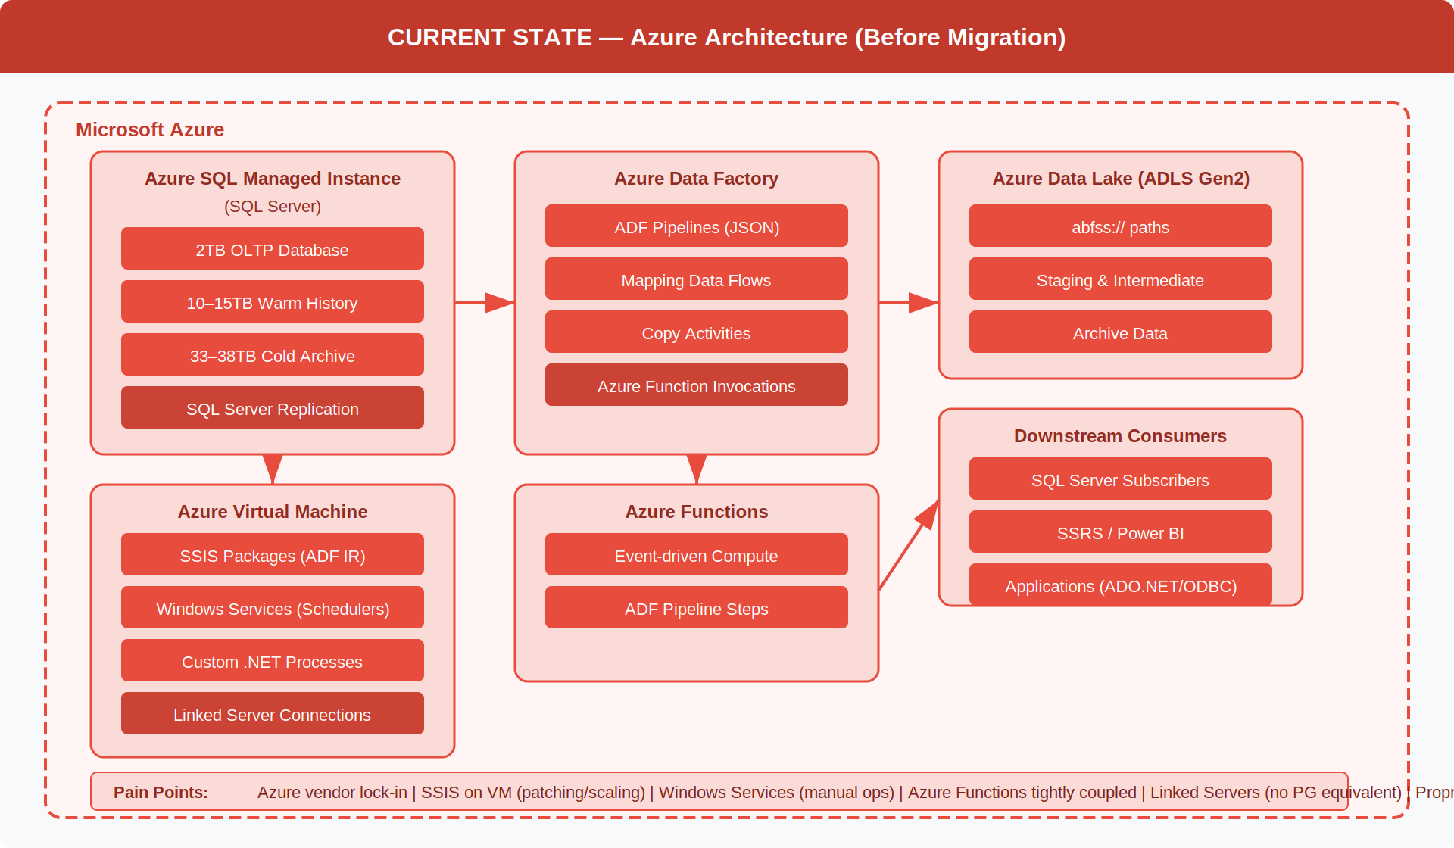

Figure 2 · Target State — AWS Architecture (After Migration) | RDS SQL Server · Glue Platform · Lambda · Step Functions · EventBridge · S3 · Athena · Re-pointed Consumers
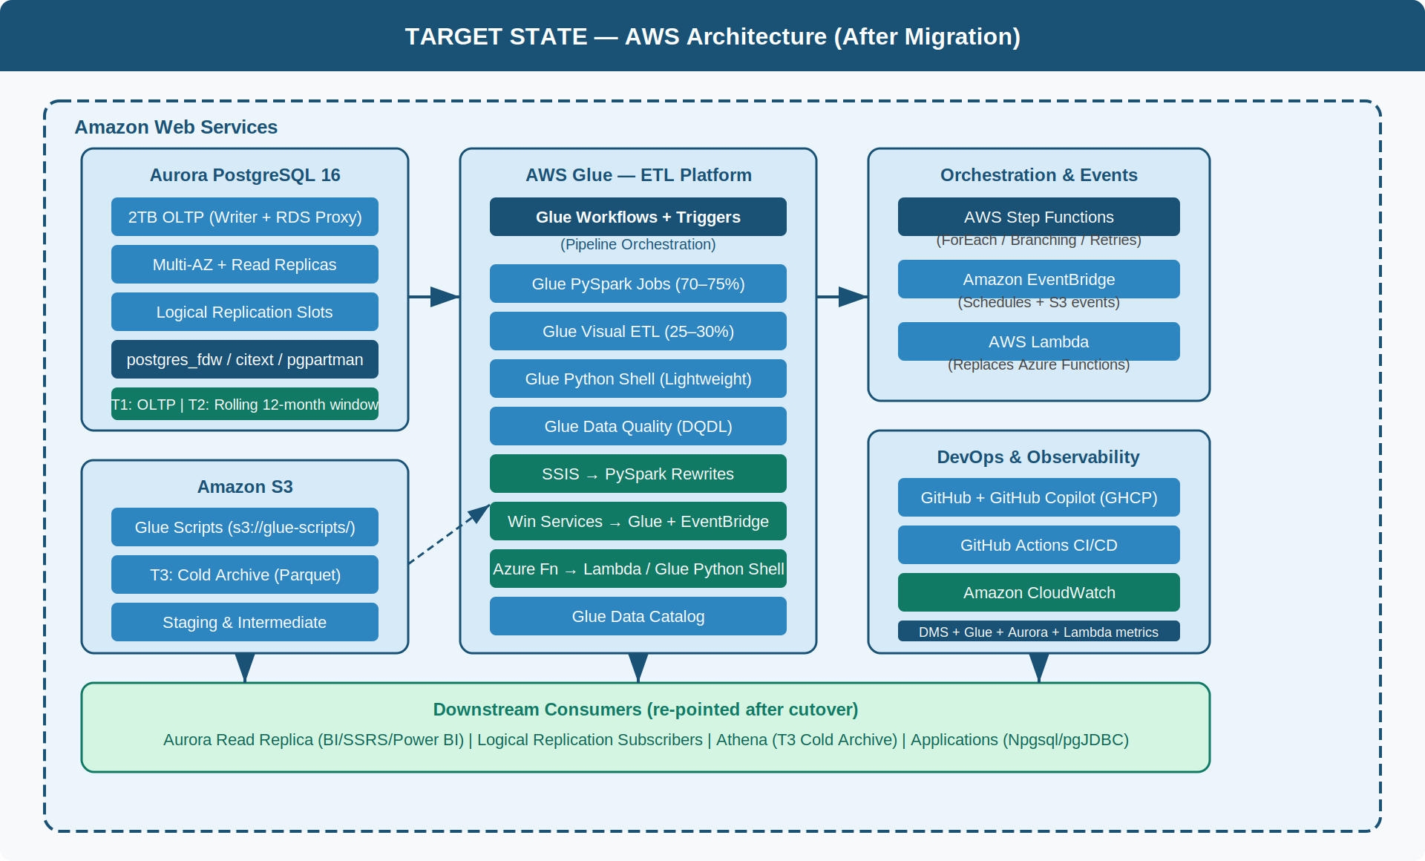

Figure 3 · Before vs After — Component Migration Map | Each Azure source component mapped to its AWS target with migration approach
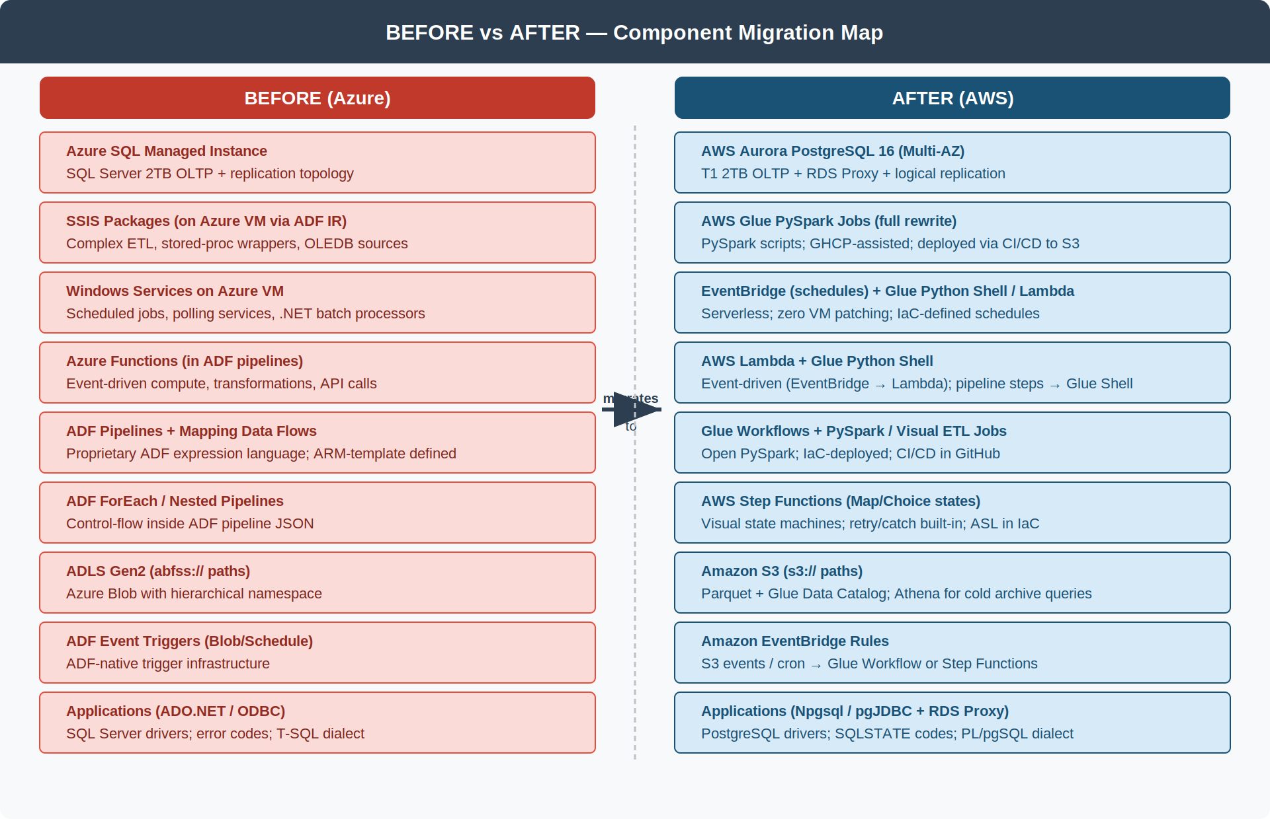

Figure 4 · High-Level Architecture — Target AWS System | Ingestion · Processing (Glue Platform) · Storage · Consuming Application layers
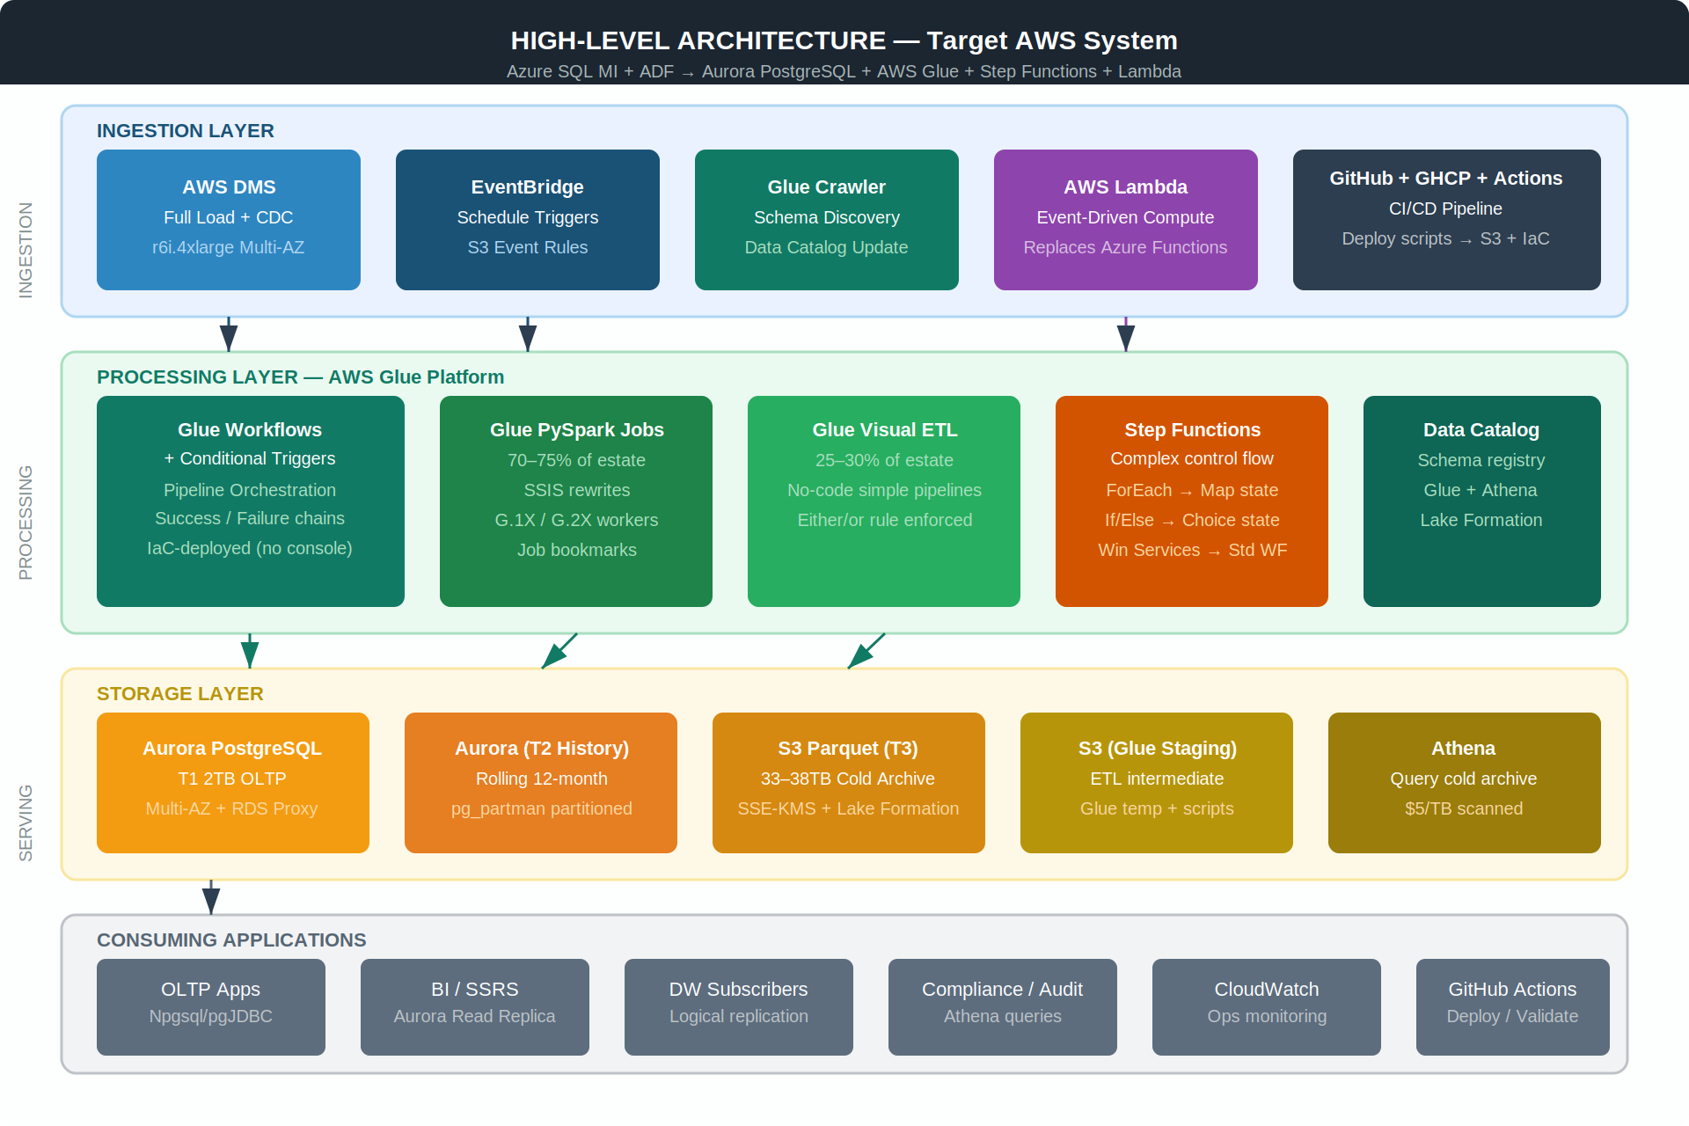

Figure 5 · Low-Level Design — Glue ETL Pipeline Execution Flow | Trigger · Job Chain · Step Functions path · Error Handling · GHCP CI/CD
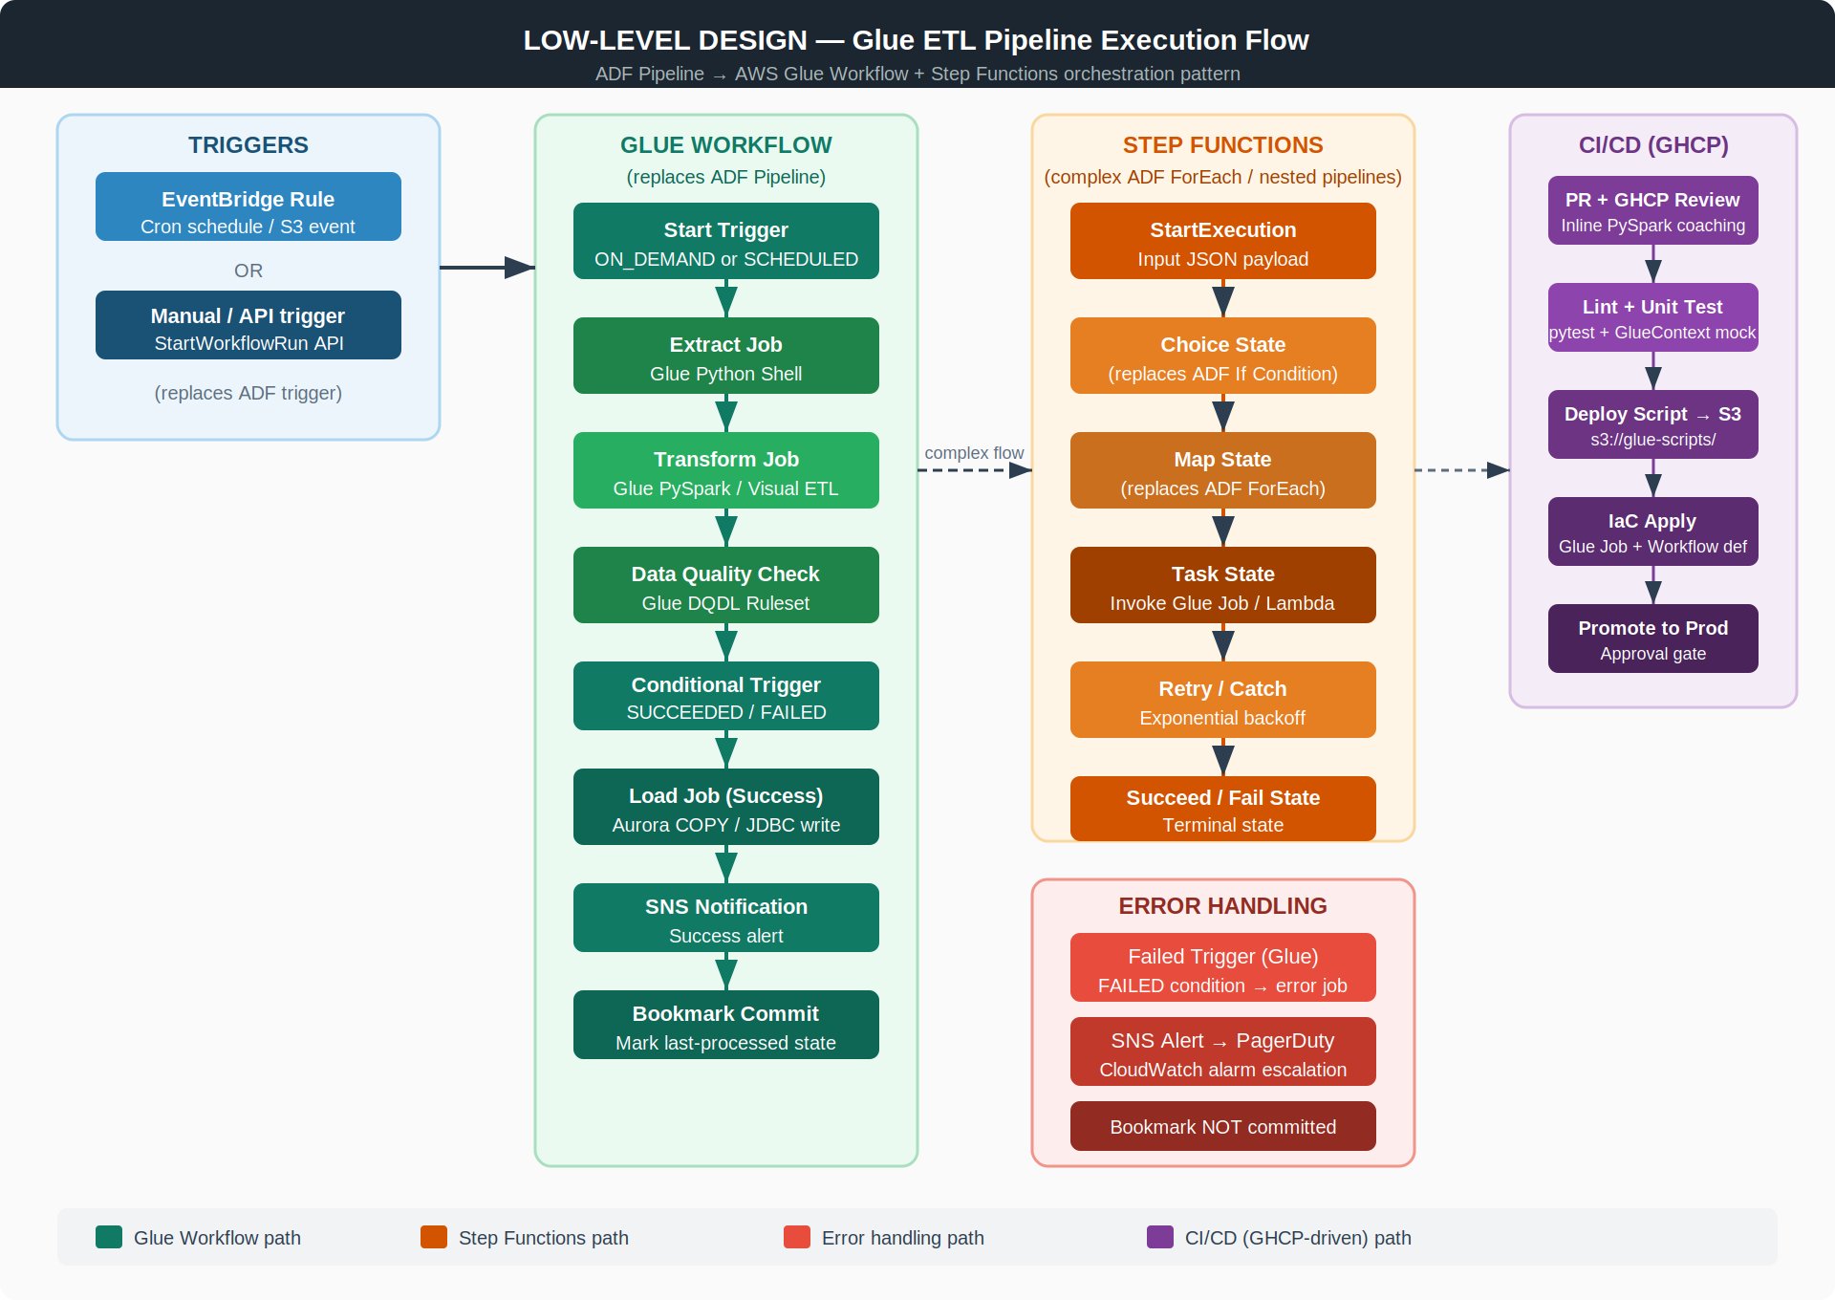

Figure 6 · Low-Level Design — SSIS · Windows Service · Azure Function Migration Patterns and Target Component Mapping
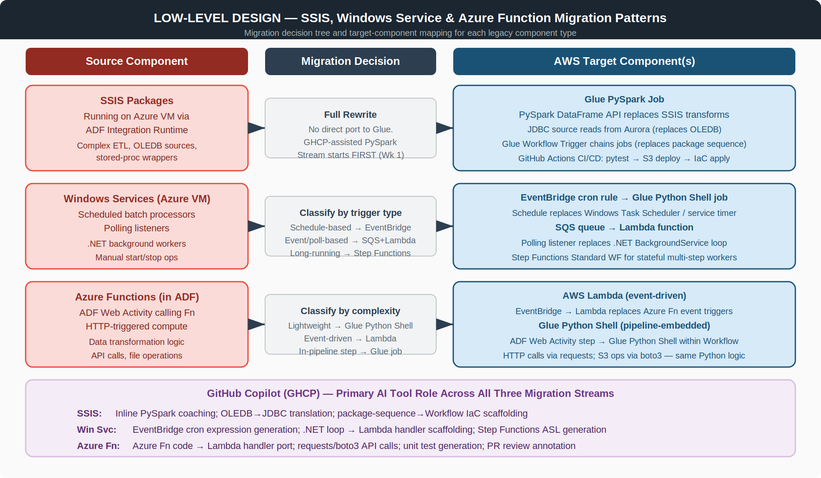

Figure 7 · Database Migration Flow — AWS DMS Full Load + CDC | Azure SQL MI source · DMS phases · RDS SQL Server target · Monitoring · Cutover sequence
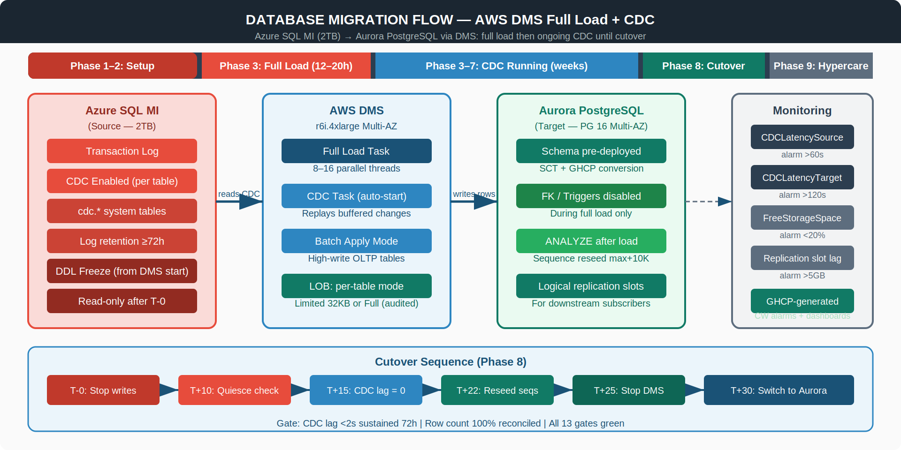

Figure 8 · Programme Timeline — 10 Parallel Workstreams · 30 Weeks · Week-4 Go/No-Go · Week-26 Cutover milestones
