PUBLIC TRANSPORTATION EFFICIENCY ANALYSIS

PHASE IV

7145_UNITEDINSTITUTEOFTECHNOLOGY_Proj_212990_Team_1

Team Mentor: [kavitha@uit.ac.in](mailto:kavitha@uit.ac.in)

Member Name: Archana N

archuneelan@gmail.com

**SEGMENT 1**

**Abstract:**

**Building the analysis by creating visualizations using IBM Cognos and integrating code for data analysis.**

Remember that IBM Cognos provides a user-friendly interface for creating reports and visualizations, and you can combine it with custom code to achieve more complex data analysis tasks. The specific code and scripting languages you use will depend on your analysis requirements.

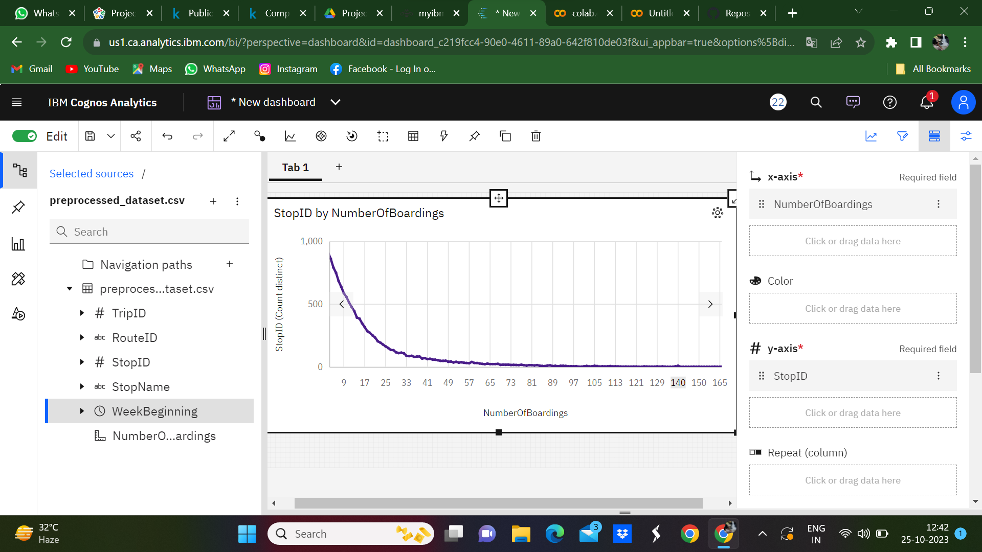

By creating this graph and providing a clear explanation, you'll be able to analyze and communicate the efficiency of public transport routes based on the stop ID by Number of Boardings.

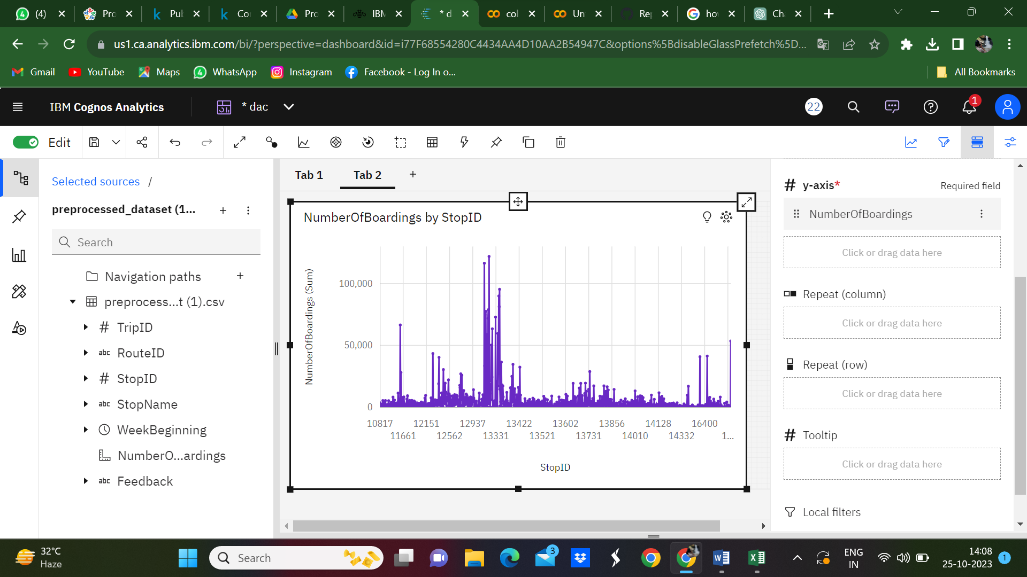

For each route, create a line that corresponds to the number of boardings. The height of the bar should represent the number of boardings for that specific route and the other side represent the stop ID.

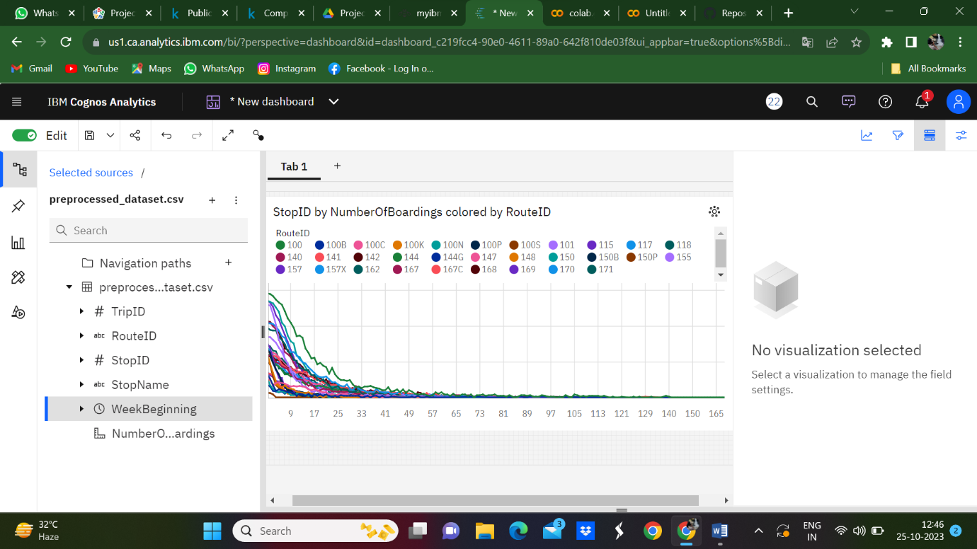

Consider using different colors for the lines to make it visually appealing and easy to differentiate between routes of the stop ID by Number of Boardings colored by Route ID.

SEGMENT 2:

**Design dashboards and reports in IBM Cognos to visualize passenger feedback.**

Customization of these visualizations and metrics will depend on your specific requirements and data. IBM Cognos provides a range of tools and capabilities for creating, customizing, and sharing these reports and dashboards.

**The below link is the IBM Coignos dashboard:**

https://us1.ca.analytics.ibm.com/bi/?perspective=dashboard&id=i77F68554280C4434AA4D10AA2B54947C&options%5BdisableGlassPrefetch%5D=true&options%5Bcollections%5D%5BcanvasExtension%5D%5Bid%5D=com.ibm.bi.dashboard.canvasExtension&options%5Bcollections%5D%5BfeatureExtension%5D%5Bid%5D=com.ibm.bi.dashboard.core-features&options%5Bcollections%5D%5Bbuttons%5D%5Bid%5D=com.ibm.bi.dashboard.buttons&options%5Bcollections%5D%5Bwidget%5D%5Bid%5D=com.ibm.bi.dashboard.widgets&options%5Bcollections%5D%5BcontentFeatureExtension%5D%5Bid%5D=com.ibm.bi.dashboard.content-features&options%5Bcollections%5D%5BsaveServices%5D%5Bid%5D=com.ibm.bi.dashboard.saveServices&options%5Bcollections%5D%5Btemplates%5D%5Bid%5D=com.ibm.bi.dashboard.templates&options%5Bcollections%5D%5BvisualizationExtension%5D%5Bid%5D=com.ibm.bi.dashboard.visualizationExtensionCA&options%5Bcollections%5D%5BboardModel%5D%5Bid%5D=com.ibm.bi.dashboard.boardModelExtension&options%5Bcollections%5D%5BcontentTypes%5D%5Bid%5D=com.ibm.bi.dashboard.contentTypes&options%5Bcollections%5D%5BserviceExtension%5D%5Bid%5D=com.ibm.bi.dashboard.serviceExtension&options%5Bcollections%5D%5BlayoutExtension%5D%5Bid%5D=com.ibm.bi.dashboard.layoutExtension&options%5Bcollections%5D%5BcolorSetExtensions%5D%5Bid%5D=com.ibm.bi.dashboard.colorSetExtensions&options%5Bconfig%5D%5Bproduct%5D=CA&options%5Bconfig%5D%5BeditPropertiesLabel%5D=true&options%5Bconfig%5D%5BenableCustomVisualizations%5D=true&options%5Bconfig%5D%5BassetTags%5D%5B%5D=dashboard&options%5Bconfig%5D%5BfilterDock%5D=true&options%5Bconfig%5D%5BshowMembers%5D=true&options%5Bconfig%5D%5Bupgrades%5D=dashboard-core%2Fjs%2Fdashboard%2Fupgrades&options%5Bconfig%5D%5BassetType%5D=exploration&options%5Bconfig%5D%5BgeoService%5D=CA&options%5Bconfig%5D%5BsmartTitle%5D=true&options%5Bconfig%5D%5BnavigationGroupAction%5D=true&options%5Bconfig%5D%5BenableDataQuality%5D=false&options%5Bconfig%5D%5BmemberCalculation%5D=false&isAuthoringMode=true&boardId=i77F68554280C4434AA4D10AA2B54947C&objRef=i77F68554280C4434AA4D10AA2B54947C

**Program to generate passenger feedback**

import csv

def categorize_feedback(number_of_boardings):

    if number_of_boardings <= 4:

        return "good"

    elif number_of_boardings > 4 and number_of_boardings <= 8:

        return "average"

    elif number_of_boardings > 8:

        return "bad"

input_csv_file = '/content/Dataset.csv'

output_csv_file = '/content/preprocessed_dataset.csv'

with open(output_csv_file, 'w', newline='') as output_file:

    fieldnames = ["TripID", "StopName", "Feedback"]

    writer = csv.DictWriter(output_file, fieldnames=fieldnames)

    writer.writeheader()

    with open(input_csv_file, 'r', newline='') as input_file:

        reader = csv.DictReader(input_file)

        for row in reader:

            trip_id = row["TripID"]

            stop_name = row["StopName"]

            number_of_boardings = int(row["NumberOfBoardings"])

            feedback = categorize_feedback(number_of_boardings)

            writer.writerow({"TripID": trip_id, "StopName": stop_name, "Feedback": feedback})

print(f"Feedback data has been written to {output_csv_file}")

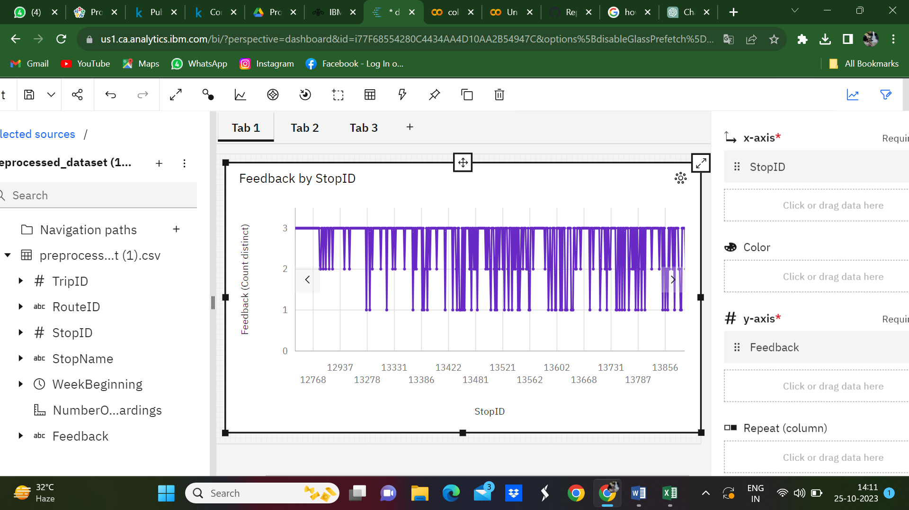

A "Feedback by Stop ID Comparison Graph" is a visual representation that allows you to compare feedback received at different stops in a public transportation system. It helps you understand how passengers rate the service quality at various stops or stations.

SEGMENT 3

**To perform advanced data analysis, such as calculating service punctuality rates :**

To perform advanced data analysis, such as calculating service punctuality rates, IBM Cognos provides a range of tools for advanced data analysis, including calculated measures, data exploration, and reporting capabilities. The specific analysis you perform will depend on your data and the metrics you want to calculate, such as service punctuality rates. Custom calculations in calculated measures, in particular, are powerful tools for deriving insights from your data.

**Punctuality Rate:**

In public transport efficiency analysis, punctuality rate refers to the measure of how often public transport services adhere to their scheduled or expected arrival times. It is a key performance indicator used to assess the reliability and quality of public transportation services.

**Program to generate the Punctuality Rate**

import csv

input_csv_file = '/content/preprocessed_dataset (1).csv'

punctual_trips = 0

total_trips = 0

with open(input_csv_file, 'r', newline='') as input_file:

    reader = csv.DictReader(input_file)

    for row in reader:

        feedback = row["Feedback"]

        if feedback in ["good", "average"]:

            punctual_trips += 1

        total_trips += 1

punctuality_rate = (punctual_trips / total_trips) * 100

print(f"Punctuality Rate: {punctuality_rate:.2f}% (Based on 'good' and 'average' feedback for {total_trips} trips)")

output

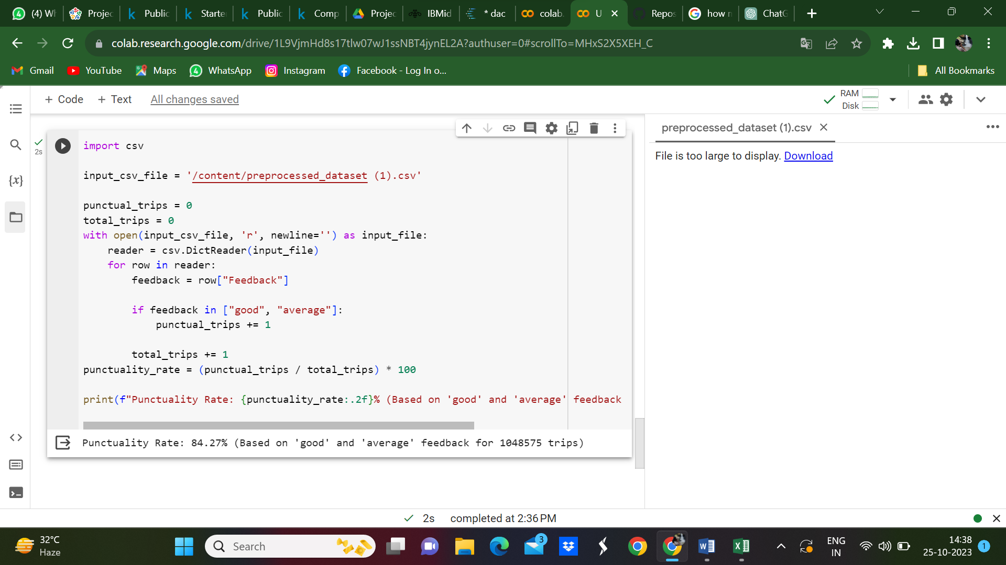

Conclusion:

In today's data-driven world, predictive data analysis and visualization are invaluable for businesses and organizations seeking to gain a competitive edge, optimize their operations, and make informed decisions that drive success. The ability to harness the power of data and turn it into actionable insights is a key driver of innovation and efficiency across various industries, In conclusion, using IBM Cognos for data analysis provides a robust platform for organizations to extract meaningful insights, drive data-driven decisions, and effectively communicate their findings. n summary, IBM Cognos is a comprehensive and powerful tool for data analysis, helping organizations leverage their data assets for better decision-making, improved business processes, and enhanced data communication. It empowers users to transform data into actionable insights and promotes a data-driven culture within an organization