1)After Downloading jenkins extract and install it and then type localhost:8080.Initially it will ask password which you will get in C:\Program Files (x86)\Jenkins\secrets

Initialadminpassword(784378dea00a486290bb73ff16b686f3).

2)Jenkins has its standard server that is wildstone.

**************How to start and stop jenkins*************

1)Go to jenkins installtion directory and type below command

C:\Program Files (x86)\Jenkins>jenkins.exe stop

C:\Program Files (x86)\Jenkins>jenkins.exe start

how to change port of jenkins(Java -jar jenkins.war --httpPort=9090

*****************How to setup jenkins in tomcat************

1)Download tomcat and install it after installing put jenkins.war in webapps folder.(Jenkins.war you will get in C:\Program Files (x86)\Jenkins)

************************How to add user and set rule*******************************

For adding user

Manage Jenkins<Manage users<Create User

How to manage roles

Install role based strategy plugin

1)go to manage Jenkins < manage Jenkins and search plugin and select check box for installing.

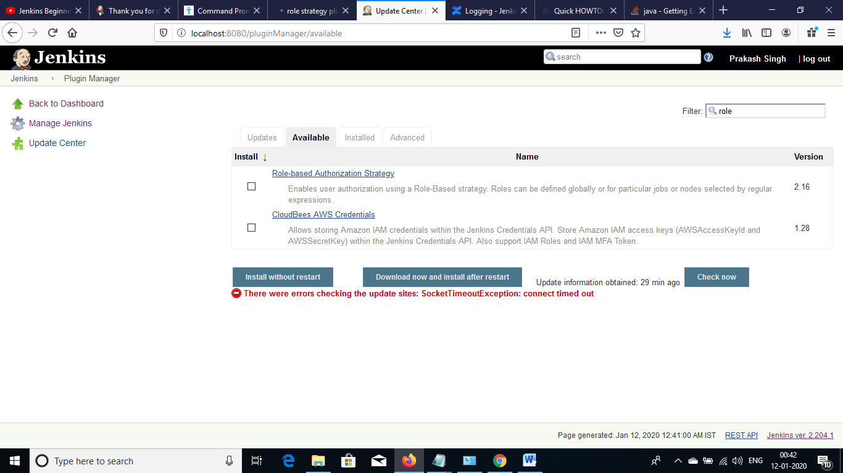

After installing go to manage Jenkins <configure global security and check are you getting role based strategy.This option will only come after installing plugin.Then you have to select Role based strategy option and then apply and save.

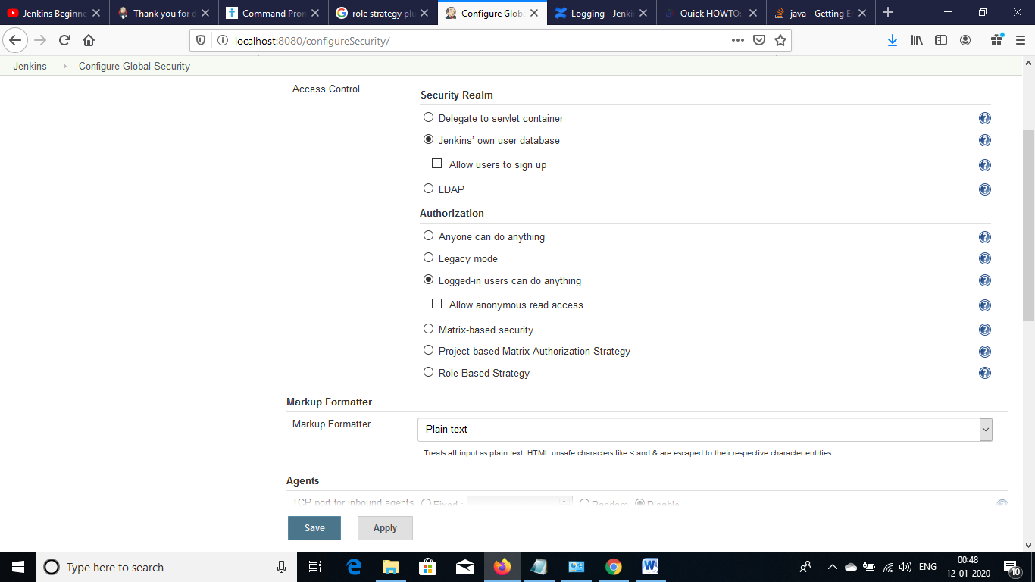

So when you login with assigned user then you will get below error because you have not assigned role yet you have just configured the role.

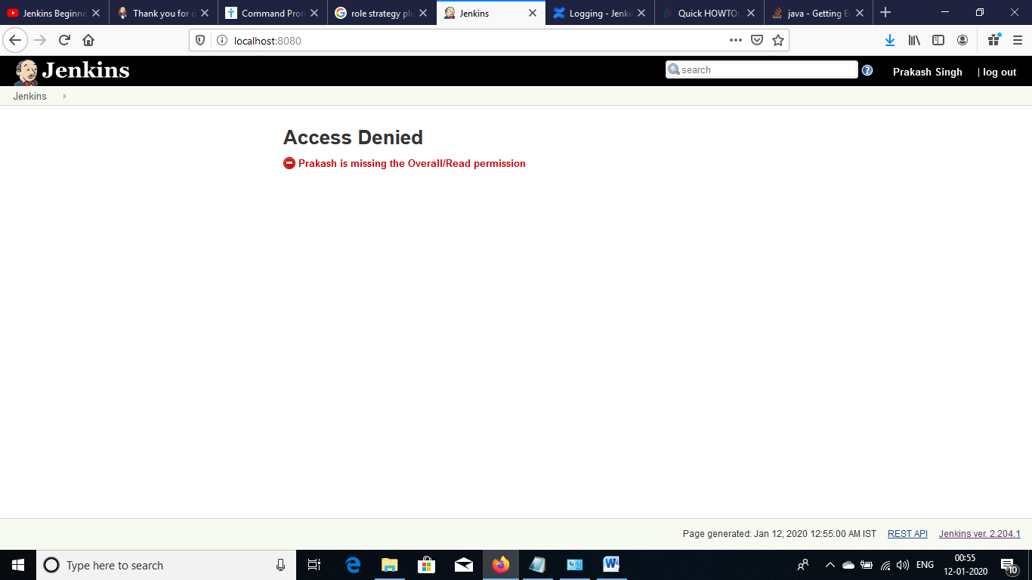

Now manage and assign role.For assigning role login with admin and select manage and assign role and select manage roles.

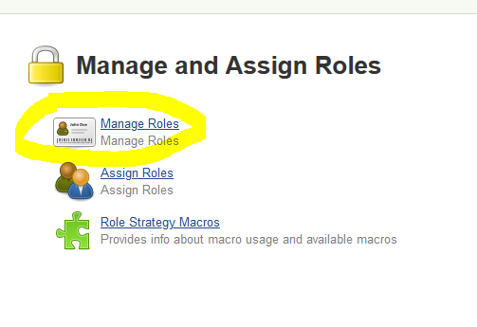

Inside manage role add role by clicking on Role to add section and assign permission and then apply and save.

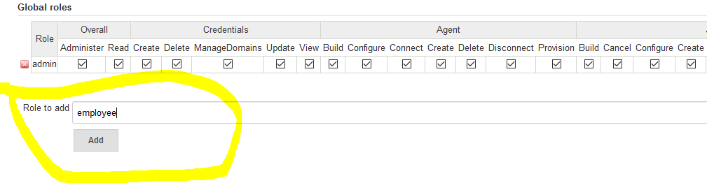

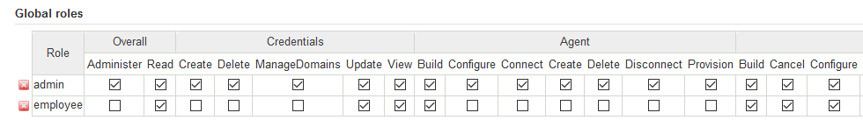

Now add project roles.After adding project roles give all rights because developer is going to access only those project which is starting with dev.

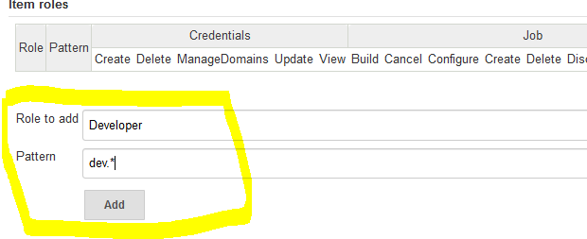



Now Assign roles we have managed roles above.Click on assign roles.

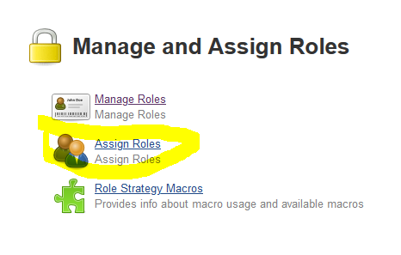

* Add user in search box of Global as well as project roles and add its roles as developer or tester.

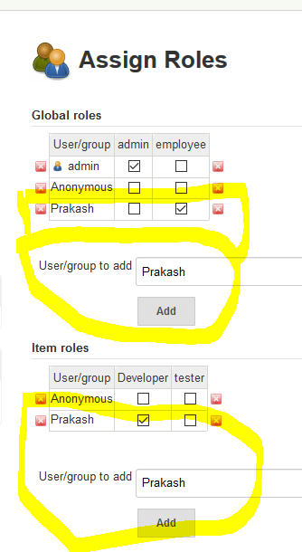

Basic Configuration

Go to manage Jenkins <Configure system

* If you want to display some message enter in below text box.

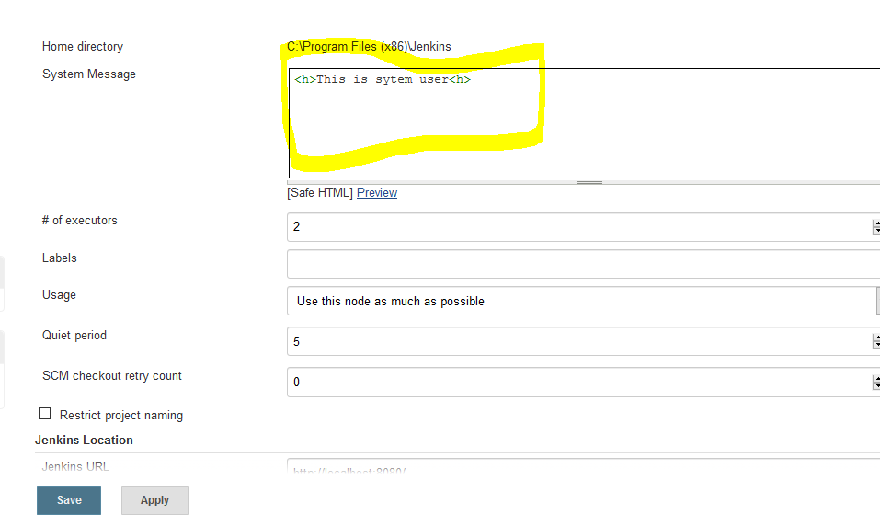

* If you want to fix number of build jenkins will perform(means number project it will run) then give number in number of executor box
* Labels: Suppose you want to make your jenkins as master node and you want execution of project on different machine/server(Prod,Dev)then we have to manage nodes and then define levels.

For creating Nodes go to manage Nodes under manage configuration and click on create nodes and define Labels and Usage.

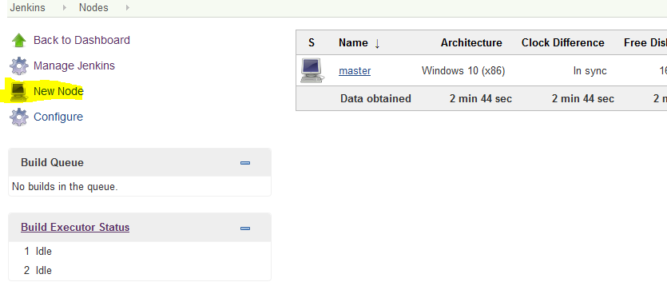

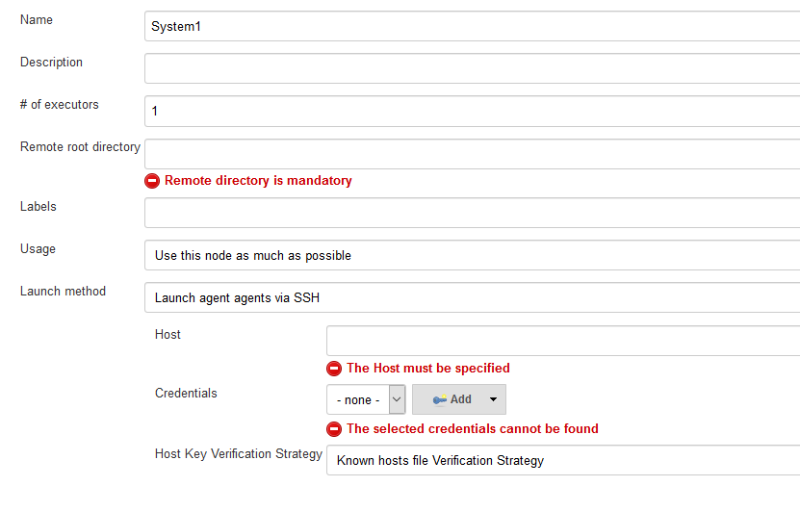

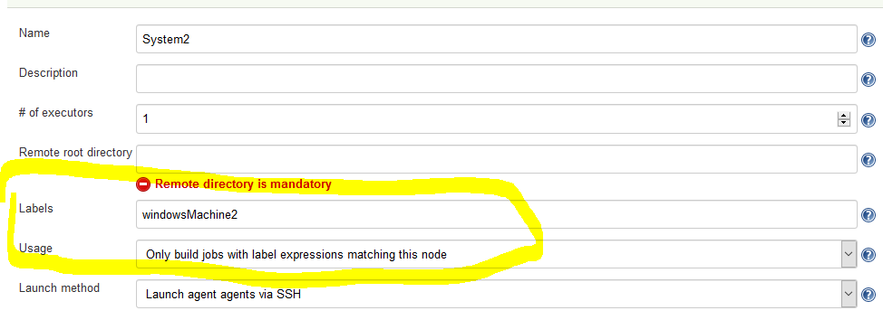

Once Node creation will be done we will configure it in our project .

Go to your project and click on configuration and check below checkbox and give you level which you have created while managing Nodes.

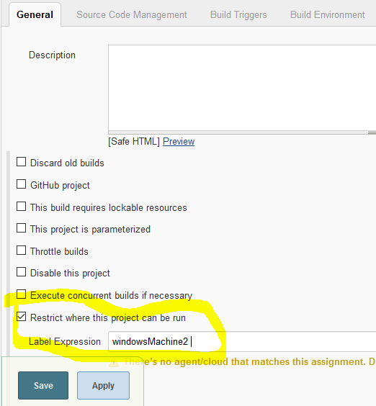0

* Quit period:Jenkins will wait for a time to build application.

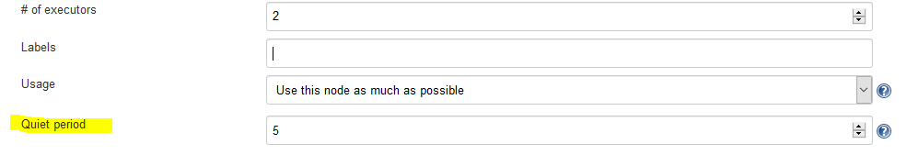

* Restrict project naming: You can give pattern for giving project Name if pattern will not match then it will not allow for creating project with that name.
* Global properties:Here we can set common properties with key value pair which will be access by all the jobs created in jenkins.and it will be accessed by ${Key}.

***************************************************************

Configuration for build of Job.

1)Check on build periodically.In build periodically we will schedule job for building.

2)In Poll SCM if any code is commited to GIT or any repository build will start automatically.

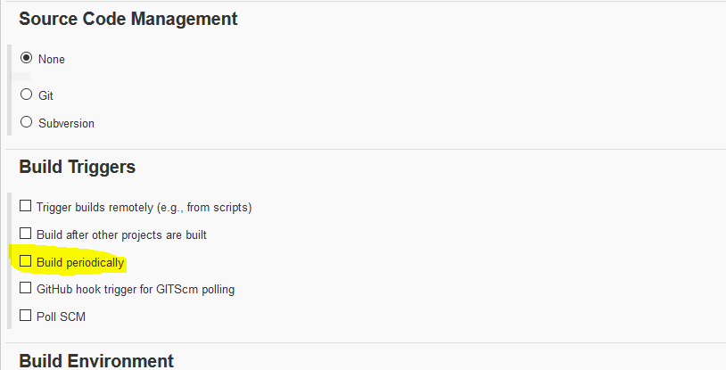

If you give ***** and click outside then jenkins will give you message.

3)Add Build setup:If you are windows user select Execute windows batch command.

4)Trigger Build remotely is used for building through url from any browser. Hit with JENKINS_URL/job/Mt940/build?token=1234

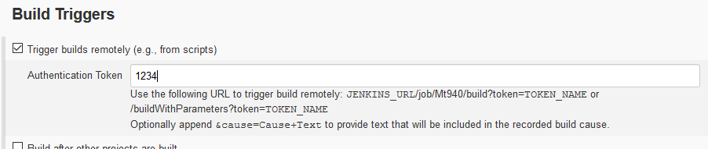

5)If you want to build your project after another project then select Build after other project

************************Jenkins Integration with Git*****************

So for this we have to learn git first so lets start git first

1Install git and open git bash from project folder and type git init you will get .git folder.

2)git status to check how many files needs to be commited.

3)git add file/folder name

4)git commit –m “added project mt940”

While adding if you get below error.

*** Please tell me who you are.

Run

git config --global user.email "[you@example.com](mailto:you@example.com)"  
git config --global user.name "Your Name"

to set your account's default identity.  
Omit --global to set the identity only in this repository.

fatal: unable to auto-detect email address (got 'me@me-PC.(none)')

Solution: git config --global user.email "[prakash.113101@gmail.com](mailto:prakash.113101@gmail.com)"  
git config --global user.name "prakash90-cpu"

NOTE:By above command code has been moved to git repository now we will move to our local repository(PrakashRepository) on git.

5)Copy repository url and type below command to move to local repository.

git remote add origin <https://github.com/prakash90-cpu/prakashRepository.git>

But still it will not show your git on your local repository because you have not pushed your code.

git push –u origin master if it not works then try git push origin master so our code will be moved to local repository. After doing this if still nots work push forcefully git push -f origin master

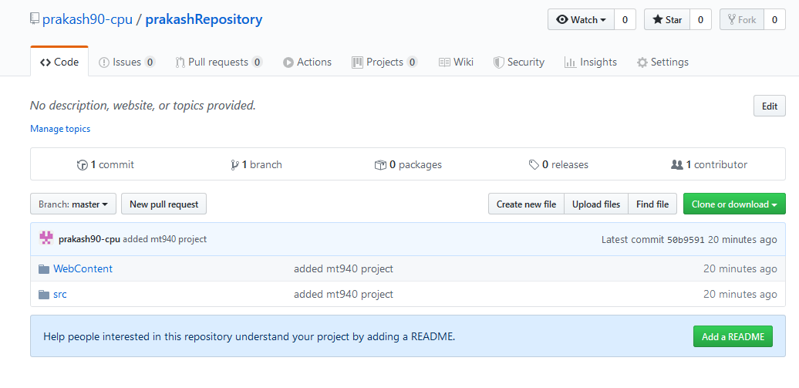

**** Now we will configure to genkins and build using Jenkins.

1) 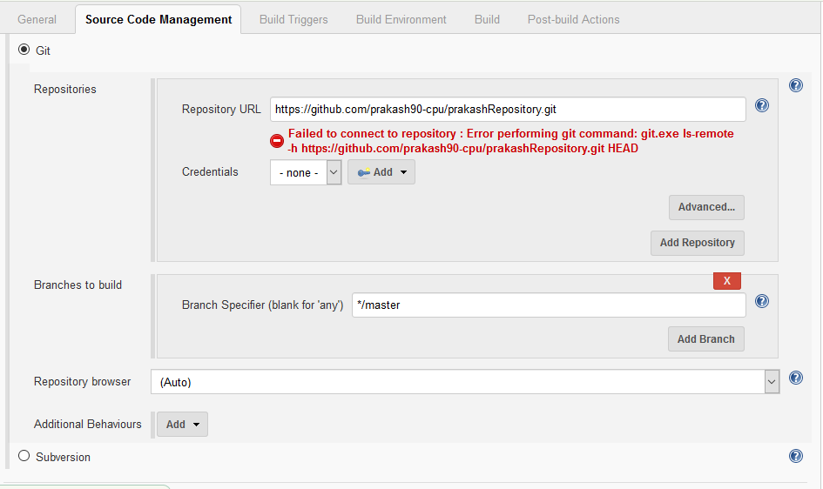

If above error comes then insert credential of GIT.

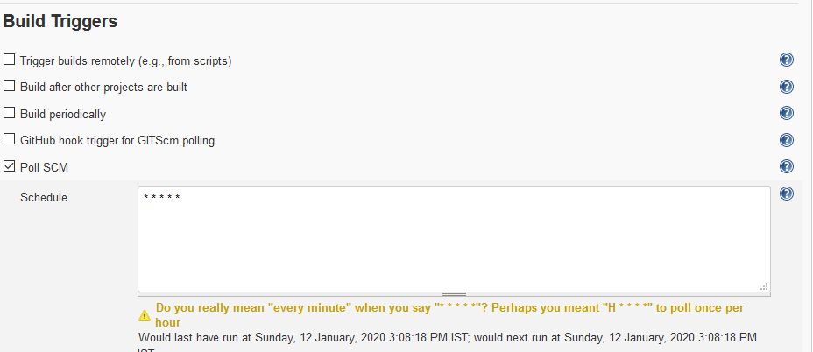

If we select Poll SCM and give * * * * * then it will check every second to git and if any changes will be done it start build.

Automated Deployment

Automated deployment is a process of automating the deployment process in a continous delivery system.(Build<deploy<to test environment<release to production environment)

1)Start jenkins and install deploy plugin.

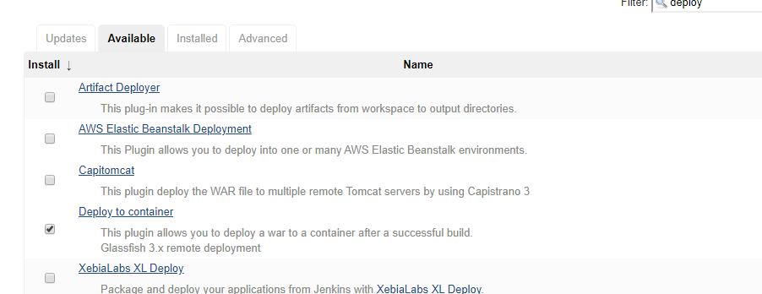

2)after installing plugin configure your build and add post build action (deploy war or ear to container)

3) 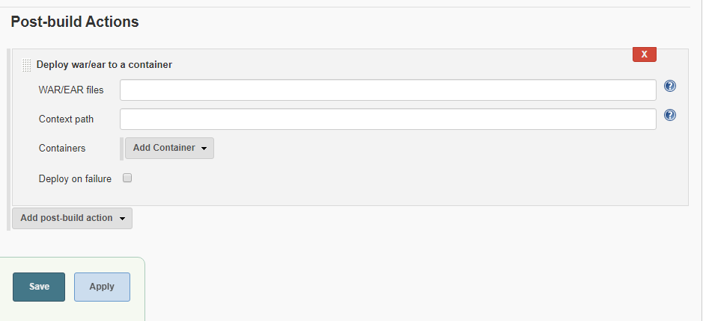

* War/ear files->*./** .war
* context path mt940.war(Name of application)
* select any container like tomcat and then open tomcat user.xml and add user or use existing user or leave as it is (F:\Tomcat\apache-tomcat-8.5.50\conf)
* start tomcat and give below configuration 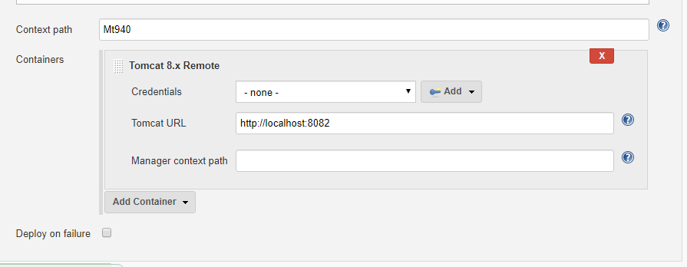
* Now click on build button of jenkins then automatically project will be deployed.

Email Sending through jenkins

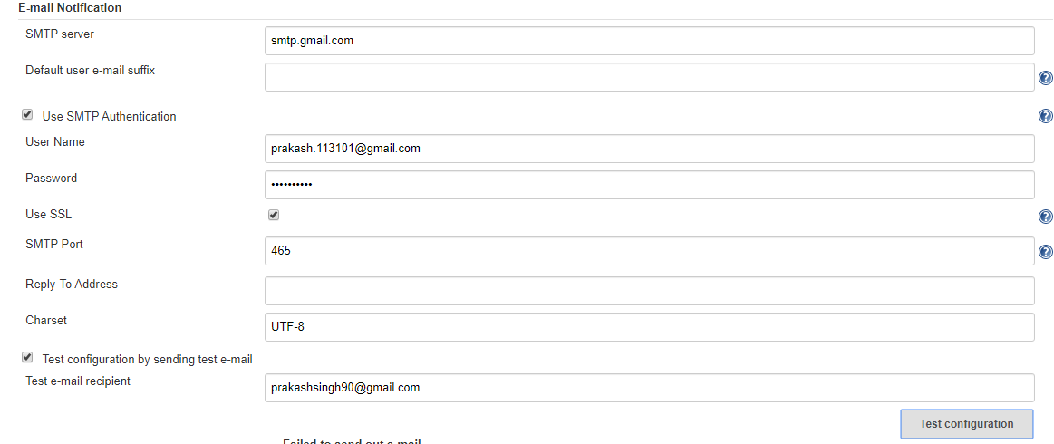

Jenkins pipeline

Pipeline:Multiple section of pipe which has inlet and outlet.

