Git Branching Strategies
A practical guide with diagrams and simple explanations
A branching strategy is a set of team rules for how code flows from "someone is working on it" to "it is live in production." The right choice depends on three things: how many people are on the team, how often you ship, and whether you need to support old versions of the product.
This guide walks through the five strategies in common use today, from simplest to most complex. Each section includes a diagram showing how branches move, plain-English explanations, and guidance on when to pick it.

1. Trunk-Based Development
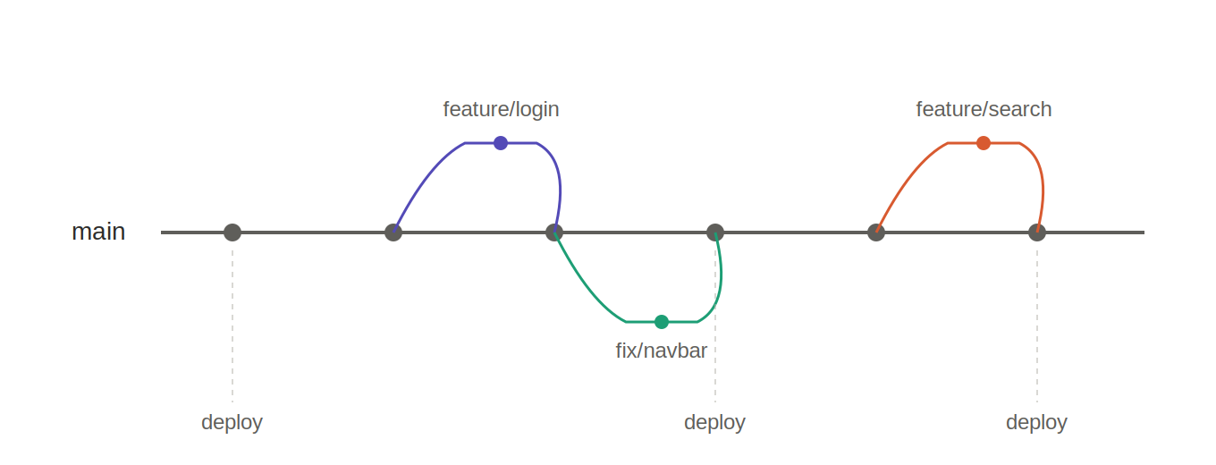

The idea
Everyone on the team commits to a single branch called "main" (sometimes called the "trunk"). There are no long-lived feature branches. If a developer does branch off, the branch lasts a few hours at most, not days or weeks. Work that is not yet ready for users is hidden behind a feature flag, which is a switch in the code that turns the feature on or off without deploying new code.

How it works, step by step
- A developer pulls the latest version of main to their computer.
- They make a small change, usually no more than a few hours of work.
- They either commit directly to main, or make a tiny branch and merge it back the same day.
- Automated tests run on every commit. If tests fail, the team fixes main immediately before doing anything else.
- Unfinished features sit in the code but are wrapped in feature flags so users never see them until they are ready.

Best for
Mature teams with strong automated testing, a reliable CI/CD pipeline, and feature flag tooling. This is what most elite engineering organizations use. Google, Facebook, and many high-performing teams operate this way.

Pros
- Almost no merge conflicts because branches never live long enough to drift apart.
- Problems are discovered within hours, not weeks.
- Encourages small, reviewable changes.
- Pairs naturally with continuous deployment.

Cons
- Requires a serious investment in automated testing. A broken main blocks the whole team.
- Needs feature flag infrastructure for anything larger than a tiny change.
- Demands discipline; inexperienced teams struggle without the right guardrails.

2. GitHub Flow
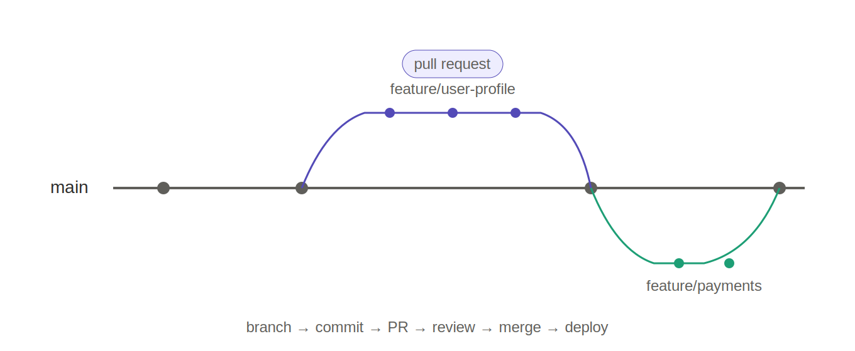

The idea
GitHub Flow is the lightweight, pull-request-centric workflow popularized by GitHub itself. There is one permanent branch (main) and short-lived feature branches that get merged back through a pull request. It is arguably the easiest modern strategy to learn and is a great starting point for most teams.

How it works, step by step
- Create a new branch off main with a descriptive name, for example feature/user-profile.
- Make your commits on that branch and push it to the shared repository.
- Open a pull request so the team can review the code and run automated tests.
- Address feedback, push more commits, and iterate until the PR is approved.
- Merge the PR into main. Main is always deployable, so deploying happens automatically or with a single click.
- Delete the feature branch once it is merged.

Best for
Small to medium teams building web applications or SaaS products that deploy to a single production environment. If you are starting a new project today and are not sure which strategy to use, this is the safest first choice.

Pros
- Simple to explain and hard to get wrong.
- Pull requests create a natural place for code review and discussion.
- Works well with most CI/CD tools out of the box.

Cons
- Assumes a single production environment. If you need staging, QA, or pre-prod gates, it does not provide a clear mechanism.
- Does not handle versioned releases well; it assumes the latest main is always what ships.

3. GitLab Flow
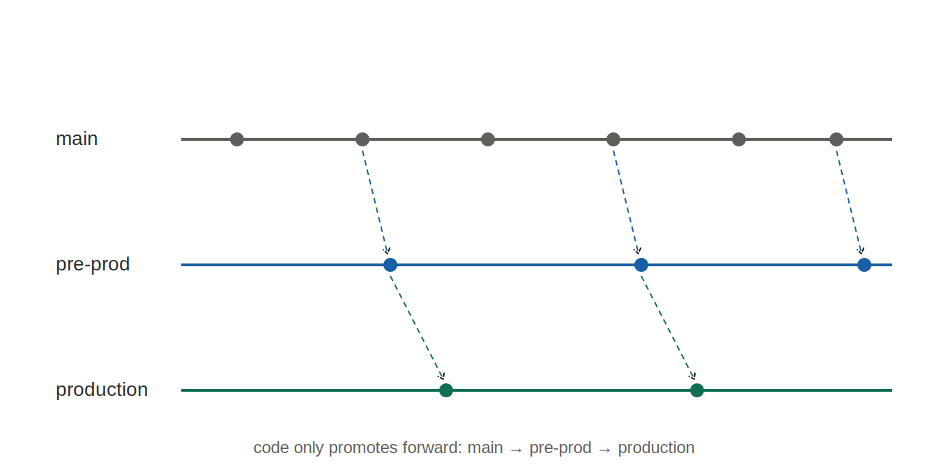

The idea
GitLab Flow takes GitHub Flow and adds environment branches on top. Instead of deploying straight from main, code promotes forward through a chain of branches that each represent an environment: main leads to pre-production, pre-production leads to production. The key rule is that code only ever flows downstream. You never cherry-pick fixes backward; every fix starts on main and cascades forward.

How it works, step by step
- A developer opens a feature branch off main, just like in GitHub Flow.
- They complete the work, open a pull request, get it reviewed, and merge it into main.
- When a deployment to staging is ready, the team merges main into the pre-production branch, which triggers a deploy to the staging environment.
- QA or stakeholders verify the change in staging.
- Once approved, pre-production merges into production, which deploys to live users.
- If a bug is found in production, the fix is made on main first, then promoted forward through pre-production to production.

Best for
Teams that cannot deploy directly from main. Common scenarios include regulated industries, products with mandatory QA gates, or customers who expect staging environments for validation before release.

Pros
- Clear, linear promotion path that is easy to audit.
- Supports staging and QA gates without the heavy overhead of Git Flow.
- Keeps the advantages of pull-request-centric workflows.

Cons
- More branches to understand and maintain than GitHub Flow.
- The "always flow forward" rule takes some discipline, especially for hotfixes.

4. Git Flow
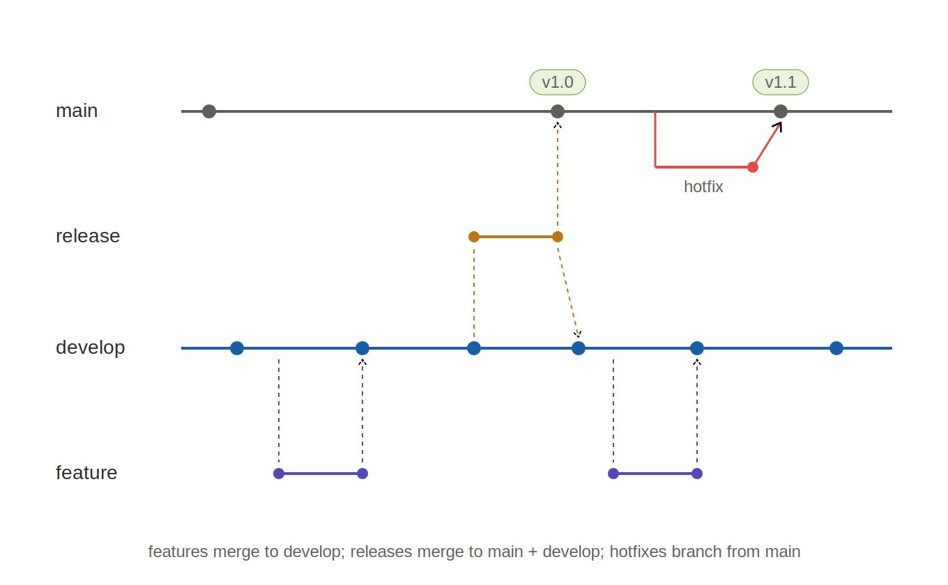

The idea
Git Flow is the classic heavy-duty model introduced by Vincent Driessen in 2010. It uses two long-lived branches (main and develop) plus three kinds of short-lived supporting branches: feature branches, release branches, and hotfix branches. Each branch type has a specific role and a specific set of merge rules.

The five branch types
- main: holds only released, production-ready code. Every commit here represents a numbered release and is tagged (v1.0, v1.1, etc.).
- develop: the integration branch where finished features collect before being cut into a release. New work is not done directly on develop; it merges in from feature branches.
- feature/*: one branch per new feature, cut from develop and merged back into develop when done.
- release/*: cut from develop when the team is preparing a new numbered release. Only bug fixes, documentation updates, and version bumps happen here. Once stable, the release branch merges into both main (to ship it) and develop (to keep any fixes in the main line).
- hotfix/*: an emergency fix for production. Branches directly from main, not develop. When done, it merges into both main and develop so the fix is not lost.

How it works, step by step
- Developers start new work by branching feature/ off develop.
- When a feature is finished, it merges back into develop via a pull request.
- When enough features have accumulated, the team cuts a release/ branch from develop.
- QA and bug-fixing happens on the release branch. No new features are added here.
- When the release is stable, it merges into main (and gets tagged, e.g., v1.0) and also back into develop.
- If a critical bug is found in production, a hotfix/ branch comes off main. The fix merges into both main (tagged as v1.0.1) and develop.

Best for
Versioned software with scheduled releases and multiple supported versions. Good examples include desktop applications, open source libraries, firmware, and mobile apps with app-store review cycles. The original author himself has publicly noted that Git Flow is not a good fit for web apps with continuous delivery.

Pros
- Explicit, well-documented release process.
- Natural fit for software with parallel supported versions.
- Clear, unambiguous hotfix path.

Cons
- Heavy overhead; lots of ceremony for simple changes.
- Poor fit for continuous deployment. Many teams that adopted Git Flow years ago now regret it.
- Confusing for newcomers; five branch types and specific merge rules are a lot to learn.

5. Forking Workflow
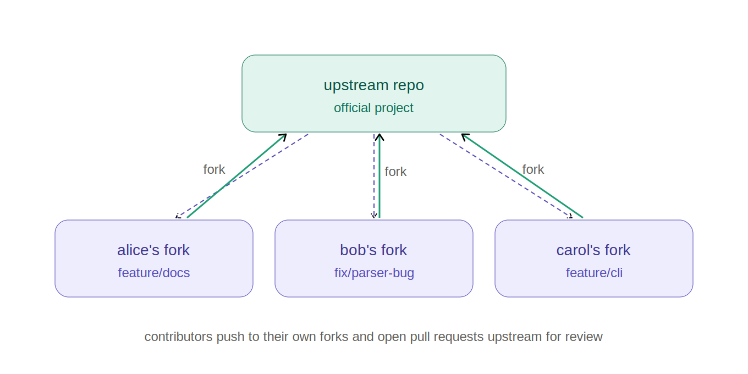

The idea
In the forking workflow, contributors do not push to the main repository at all. Instead, each contributor creates a personal copy of the entire repository (a "fork") on the hosting platform, does their work there, and opens a pull request back to the original "upstream" repository. Maintainers of the upstream project review and merge those pull requests.

How it works, step by step
- A contributor clicks "Fork" on GitHub, GitLab, or similar. This creates an independent copy of the repository under their own account.
- They clone their fork to their computer and add the original project as a second remote, conventionally named "upstream".
- They create a feature branch in their fork and make their changes there.
- They push the branch to their own fork.
- They open a pull request from their fork to the upstream project.
- Maintainers review, request changes if needed, and eventually merge the PR.
- Contributors periodically pull changes from upstream into their fork to stay in sync.

Best for
Open source projects and any situation where people need to contribute code but should not have direct write access to the canonical repository. Linux, React, Kubernetes, and essentially every major open source project uses this model.

Pros
- Clean separation between the official project and contributor work.
- No trust relationship needed to contribute; anyone can propose changes.
- Maintainers keep full control over what enters the official repository.

Cons
- Overkill for internal teams where everyone already has write access.
- Contributors need to keep two remotes (origin for their fork, upstream for the real repo) in sync, which adds complexity.

Quick Decision Guide
Use this as a cheat sheet when picking a strategy for a new project, or when deciding whether to change what your team is currently doing.

Start with GitHub Flow if...
- You are starting a new project and are not sure what to pick.
- You build a web app or SaaS product and deploy to one production environment.
- Your team is small to medium-sized.

Move to Trunk-Based Development when...
- You have solid automated tests and CI/CD.
- You have (or can adopt) feature flag tooling.
- You want to deploy multiple times a day and reduce merge friction.

Use GitLab Flow if...
- You have staging or QA environments that require gated promotion.
- You are in a regulated industry that needs an audit trail of what shipped where.
- GitHub Flow is not structured enough, but Git Flow is too heavy.

Use Git Flow only if...
- You ship versioned, numbered releases.
- You support multiple old versions in parallel (for example, a library maintaining v1.x and v2.x at the same time).
- Your release cadence is measured in weeks or months, not hours.

Use the Forking Workflow if...
- You run an open source project.
- External contributors do not have or should not have write access to the main repository.

Final advice
Pick the simplest strategy that meets your actual needs today, not the needs you imagine you might have in two years. It is much easier to add structure to a lightweight workflow when you need it than to rip out an over-engineered one after a team has gotten used to it. When in doubt, start with GitHub Flow.

