Project Scope Document
Beauty, Grooming, and Wellness Marketplace SaaS
  - Prepared for product planning, solution design, and phased development
Version 1.0 | Draft scope for MVP and scale phases
Document purpose | Primary business model | Target tenant types
Define complete scope, features, architecture direction, and delivery boundaries for a multi-tenant SaaS platform. | Two-sided marketplace + merchant SaaS subscription + booking commission + promotional placements. | Beauty parlours, barbershops, salons, spas, nail studios, makeup artists, wellness studios, and freelancers.

1. Executive summary
This document defines the end-to-end scope for a multi-tenant software-as-a-service platform that helps end users discover, compare, and book nearby personal-care providers while enabling merchants to manage availability, staff, bookings, customer relationships, payments, subscriptions, and business analytics.
The platform is intentionally broader than a beauty parlour application. It is designed as a category-agnostic marketplace for appointment-based grooming and wellness businesses, including beauty parlours, hair salons, barbershops, spas, nail studios, skincare clinics, makeup artists, and home-service professionals.

2. Product vision and goals
- Provide customers with a fast way to find the nearest relevant service providers and book verified available slots.
- Enable merchants to digitize operations across services, schedules, staff, payments, customer management, and reporting.
- Operate as a scalable multi-tenant SaaS platform where each merchant can subscribe to a plan and manage one or many branches.
- Create a flexible domain model that supports in-store appointments, walk-ins, and home-service bookings.

3. In scope
- Consumer-facing mobile/web marketplace for search, booking, payment, and reviews.
- Merchant-facing web portal for branch setup, service catalog management, staff rosters, appointment operations, CRM, offers, and reporting.
- Platform administration console for onboarding, subscription management, moderation, settlements, analytics, and category governance.
- Geolocation, maps, search indexing, slot management, notifications, and payment integrations.

4. Out of scope for initial release
- Native POS hardware integrations, biometric attendance, and payroll disbursement.
- Advanced AI image analysis, tele-consultation, and clinical records for regulated medical treatments.
- Deep ERP integrations and franchise white-label replication for enterprise customers.

5. Business context
The platform serves four primary participant groups: customers, merchants, operational staff, and the SaaS operator.
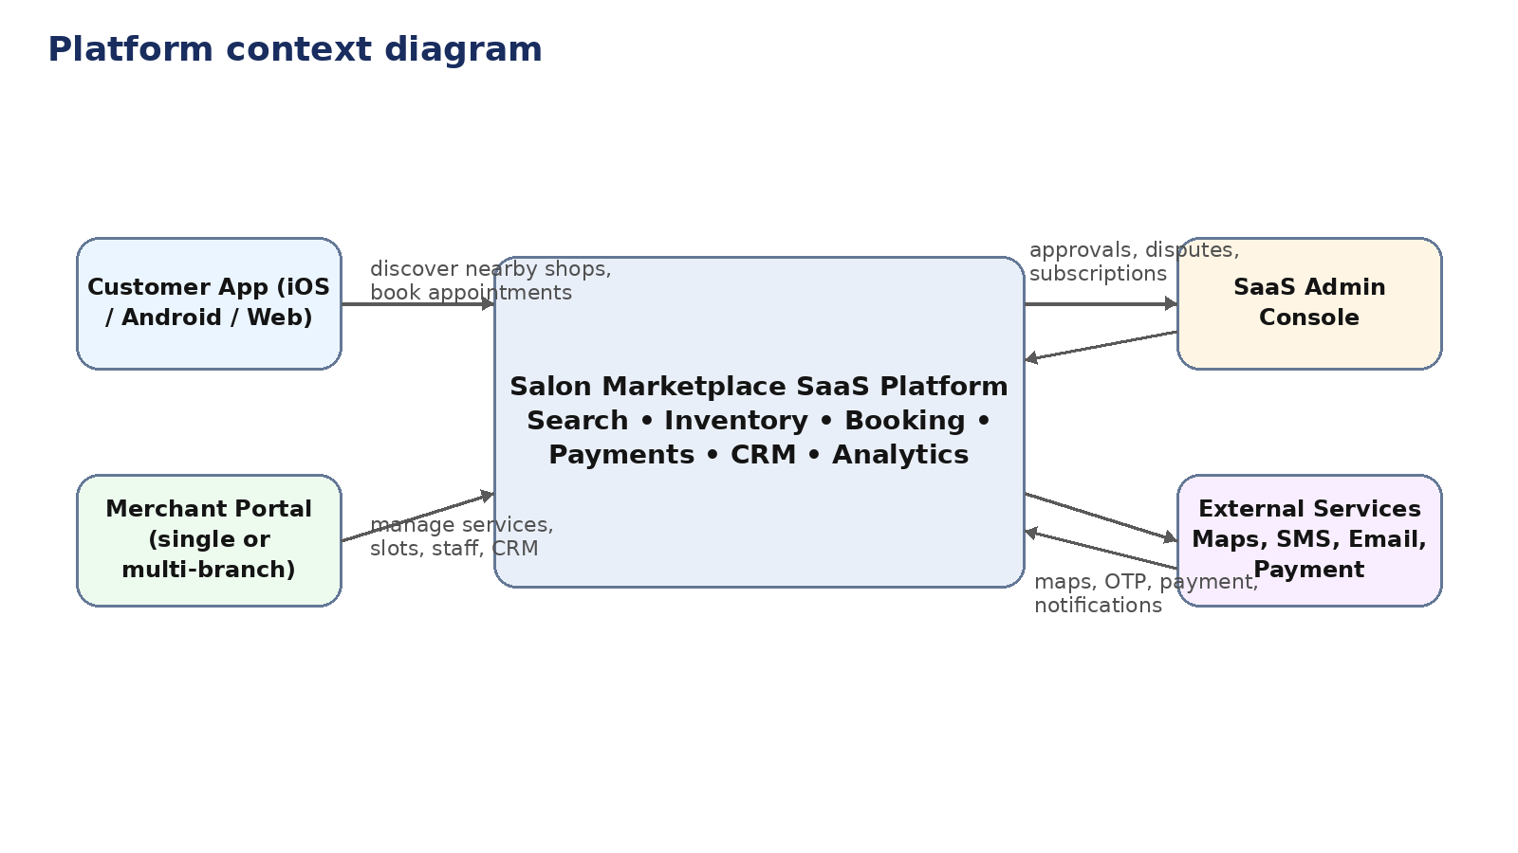
Figure 1. Platform context diagram

6. Stakeholders and personas
Persona | Needs | Primary features | Success metric
Customer | Find nearby providers quickly, compare price and quality, and book with confidence. | Location search, filters, slot visibility, payment, reminders, reviews. | Search-to-book conversion
Merchant owner | Increase bookings while controlling staff, availability, and promotions. | Catalog management, calendars, CRM, subscription, reporting. | Utilization and repeat visits
Branch staff | See assigned jobs, update status, and manage walk-ins. | Daily schedule, check-in, service completion, notes. | On-time fulfillment
Platform admin | Grow tenants, enforce quality, and resolve issues. | Approvals, moderation, disputes, billing, analytics. | Merchant activation and churn

7. Functional scope by module

7.1 Customer marketplace
- Account registration and login by phone, email, OTP, and social identity providers.
- Location-aware discovery with list and map views, nearest available shops, category filters, distance filters, budget filters, and sort options.
- Detailed shop profiles with services, packages, staff, gallery, ratings, amenities, policies, and branch information.
- Appointment booking with real-time slot retrieval, preferred staff selection, bundled services, cancel/reschedule, waitlist, and booking history.
- Payments, vouchers, loyalty, wallet, invoices, tips, and post-service review collection.

7.2 Merchant SaaS portal
- Tenant onboarding, business verification, branch creation, configurable business hours, holiday calendars, and service areas.
- Service catalog creation with category, duration, buffers, pricing, promotional pricing, tax, and gender or age applicability.
- Staff roster management with skills, branch assignment, shifts, breaks, leave, and commissions.
- Calendar operations for appointments, walk-ins, manual bookings, check-in, service status updates, no-show handling, and customer notes.
- CRM, offers, memberships, package redemption, customer segmentation, and reporting dashboards.

7.3 Admin console
- Merchant approval, document verification, category governance, content moderation, review moderation, and fraud or abuse handling.
- Plan management, subscription billing, commission rules, settlements, coupon administration, and featured listing controls.
- Operational dashboards for active tenants, bookings, GMV, support tickets, performance by geography, and churn.

8. Detailed feature requirements

Discovery and search
Feature | Requirement details
Geo search | Search by current location, map viewport, postal area, or saved address.
Filters | Category, service type, distance, rating, price range, gender-specific service, home service, open now, available now.
Ranking | Distance-aware ranking blended with availability, rating, popularity, and sponsored boosts.
Listing cards | Thumbnail, name, branch, next available slot, distance, rating, price indicator, offer tag.

Booking engine
Feature | Requirement details
Slot generation | Create bookable slots from branch hours, staff shifts, service duration, buffers, and capacity rules.
Conflict control | Prevent double booking by lock-and-confirm flow and concurrency checks.
Multi-service flow | Allow customers to add several services within one appointment when scheduling rules permit.
Lifecycle | Requested, tentative, confirmed, checked-in, in-service, completed, cancelled, no-show, refunded.

Merchant operations
Feature | Requirement details
Branch setup | Multiple branches per tenant, independent hours, geo coordinates, tax region, and service coverage.
Staff and skills | Map services to eligible staff; optional auto-assignment or customer-selected specialist.
Walk-in handling | Queue walk-ins, estimate wait time, assign staff, and convert to completed visits.
CRM | Customer profiles, visit history, preferences, allergies/notes, loyalty balance, and messaging segments.

Commercial controls
Feature | Requirement details
Subscription plans | Plan-specific limits for branches, staff seats, advanced reports, promotions, and API access.
Promotions | Coupons, happy-hour offers, first-visit discounts, referral rewards, and featured placement.
Payments | Online capture, pay-at-store, partial deposits, refunds, tipping, taxes, and settlement reporting.
Reviews | Verified review prompts after completion, moderation queue, and merchant response.

9. UML use cases
The following use case view identifies the most important interactions between actors and the marketplace SaaS platform.
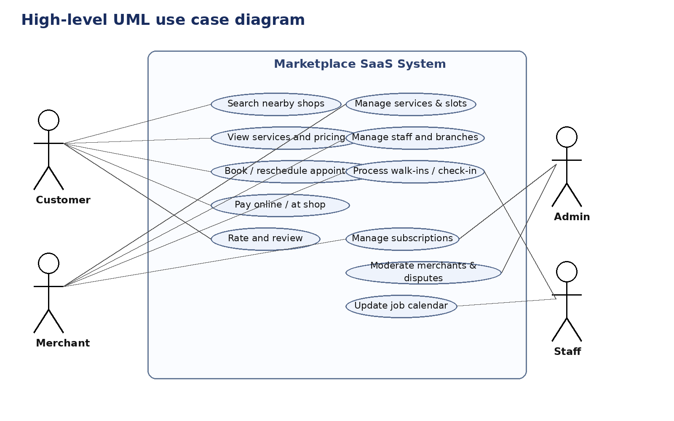
Figure 2. High-level UML use case diagram

10. Solution architecture
The architecture should be implemented as a multi-tenant service-oriented platform with clear separation between experience channels, application services, core domain services, and data/integration layers. Tenant isolation must be enforced in data access, APIs, and reporting.
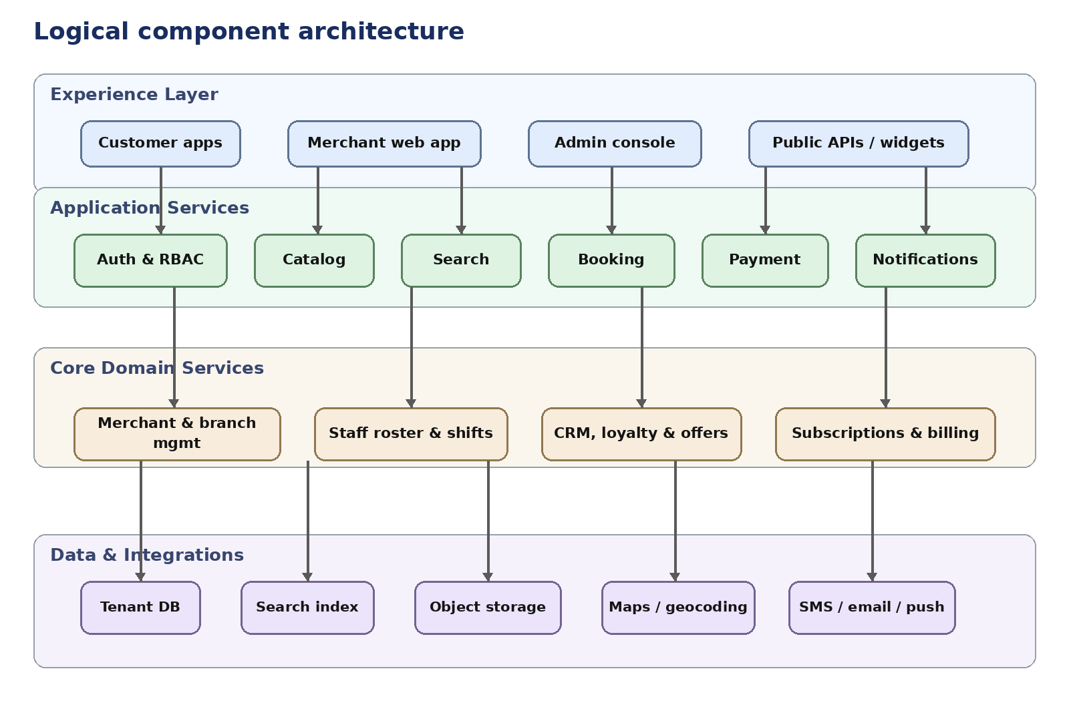
Figure 3. Logical component architecture

11. Booking workflow
The booking flow is central to the product. It must support deterministic slot locking, merchant policy validation, payment authorization, and final appointment creation with user notifications.
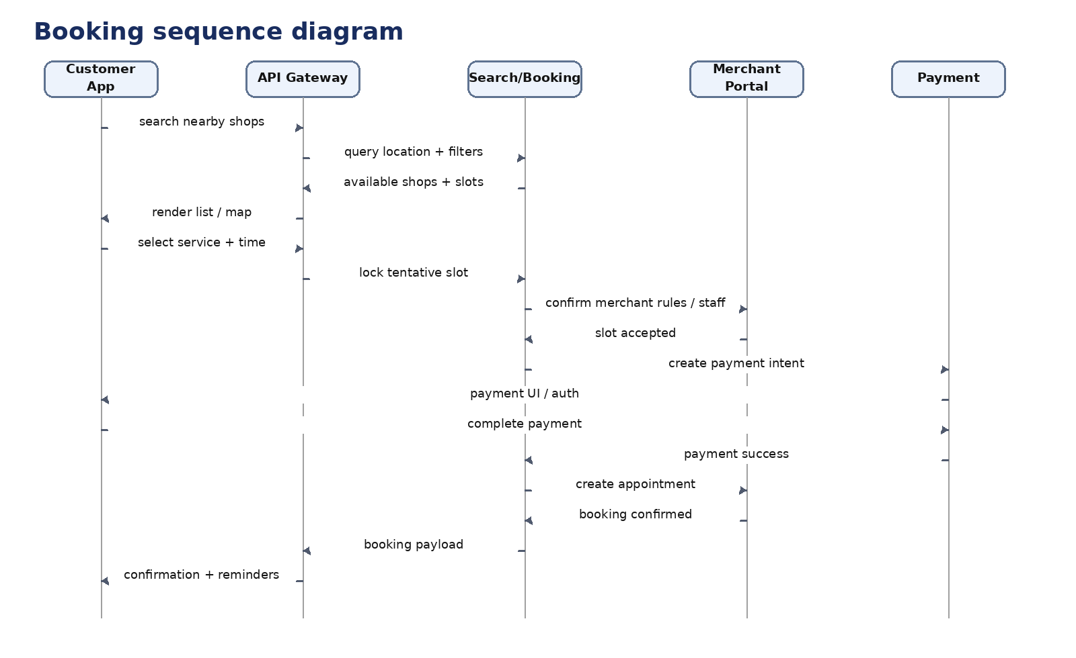
Figure 4. Booking sequence diagram

12. Domain model
The domain model below captures the core entities that should be represented in the platform's backend and data contracts. The exact implementation may differ, but the relationships must support tenant isolation, branch-level operations, service availability, and appointment lifecycle integrity.
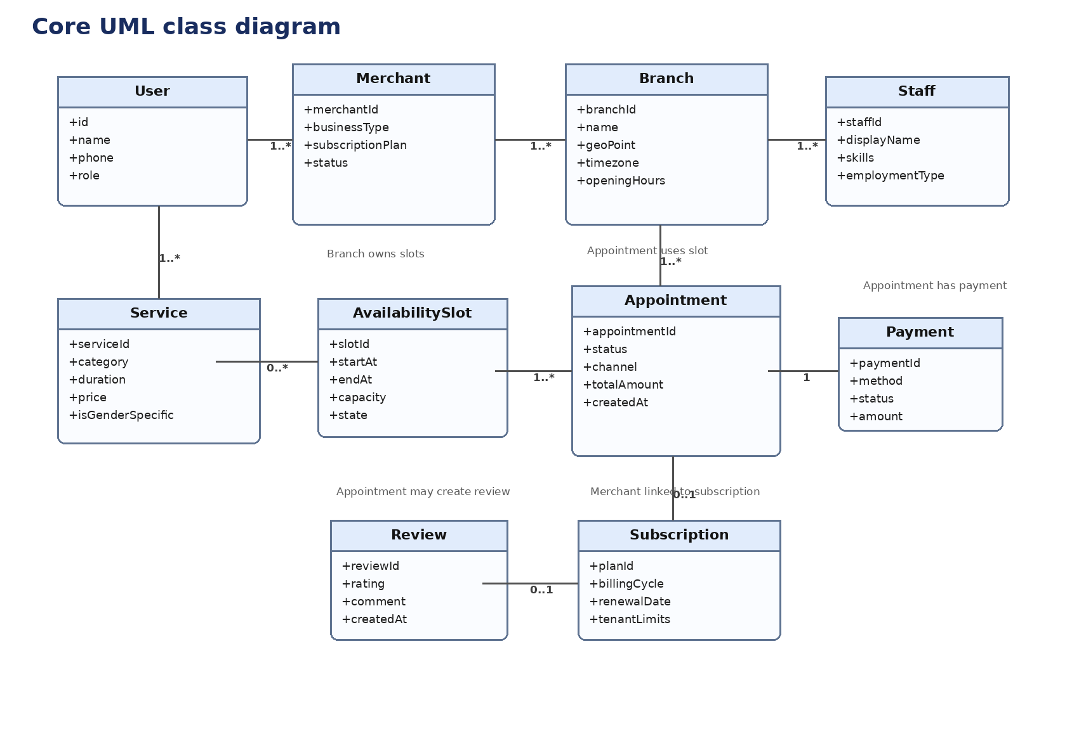
Figure 5. Core UML class diagram

13. Data model considerations
- Every tenant record must carry a tenant identifier and branch-level entities must support multi-branch permissions.
- Appointment history must be immutable enough for financial auditing while allowing operational status changes through event logs.
- Location entities should store both raw address fields and normalized geospatial coordinates for efficient search.
- Availability calculations should support branch-wide service capacity as well as staff-specific capability constraints.

14. Non-functional requirements
Category | Target | Notes
Performance | < 2 seconds for primary search results under normal load | Search response may return paged results with lazy-loaded secondary content.
Availability | 99.9% monthly uptime target for production | Planned maintenance windows excluded.
Security | Role-based access, encrypted secrets, audit logs, OWASP-aligned controls | Sensitive data masked in support tooling.
Scalability | Support tenant growth from single branch to multi-city chains | Horizontal scaling for APIs and background workers.
Privacy | Consent, retention controls, and jurisdiction-aware compliance | GDPR-like controls and local regulations where applicable.
Observability | Centralized logs, metrics, traces, alerting, and business events | Booking funnel instrumentation mandatory.

15. Integrations
- Maps and geocoding provider for nearest-search, branch pins, route guidance, and reverse geocoding.
- SMS, email, and push notification providers for OTP, reminders, cancellations, and promotions.
- Payment gateway for cards, wallets, refunds, settlement reconciliation, and optional deposit capture.
- Storage/CDN for branch images, service galleries, and generated invoices.

16. Roles and permissions
Role | Channel | Typical actions | Access boundary
Customer | App/Web | Search, book, pay, review, manage profile | Own account and bookings
Merchant owner | Portal | Configure catalog, branch, staff, offers, reports | Own tenant and authorized branches
Branch manager | Portal | Manage bookings, check-in, staff schedule, customer notes | Assigned branch or branches
Staff | Portal/Mobile | View schedule, update appointment status | Assigned jobs only
Platform admin | Admin console | Approvals, billing, moderation, analytics | Operator-wide with privileged logging

17. Phase plan

Phase 1 - MVP
- Customer onboarding, location search, listing profiles, service catalog, real-time slots, booking, notifications, ratings, basic merchant portal, basic admin console, subscription plans.
- Merchant features limited to one or more branches, staff roster, appointment calendar, service setup, and basic sales dashboards.

Phase 2 - Growth
- Wallet, loyalty, memberships, promotions, referrals, waitlist, advanced analytics, walk-ins, queueing, and customer segmentation.
- Branch manager role, staff app/calendar, package redemption, and stronger operational reporting.

Phase 3 - Scale
- Public APIs, white-label capability, partner widgets, AI recommendations, marketplace ads, and enterprise chain management.
- Deeper integrations including accounting connectors, inventory, payroll-adjacent reporting, and franchise controls.

18. Acceptance criteria snapshot
- A customer can discover providers within a selected radius and see only valid available slots for the chosen date and service.
- A merchant can configure services, staff skills, and operating hours without engineering intervention.
- No appointment can be confirmed twice for the same conflicting slot or staff allocation.
- The platform admin can approve or suspend merchants and track subscription state per tenant.

19. Key assumptions and risks
- Marketplaces with in-store and home-service models require clear service-area and travel-time rules.
- Ratings and ranking algorithms may materially affect merchant trust; transparency and moderation workflows are required.
- If multiple payment providers or local tax regimes are expected, billing design should be abstracted early.
- Geolocation accuracy and poor merchant data quality can harm discovery relevance; onboarding validation is critical.

20. Recommended next documents
- Product requirements document with user stories and acceptance criteria by module.
- UX flows and wireframes for customer booking, merchant onboarding, and staff calendars.
- System design document covering tenancy model, search indexing, availability engine, and event processing.
- Delivery roadmap with sprint plan, team roles, and estimation.

