Entity Relationship Diagram (ERD)
Beauty Parlour / Barbershop / Salon / Spa SaaS Platform
  - Logical data model for a PostgreSQL-based multi-tenant marketplace and merchant-management
platform.
Prepared for solution design, schema planning, and implementation handoff.
Database | PostgreSQL (recommended with UUID primary keys, JSONB, and PostGIS for nearest-branch discovery)
Model scope | Customer app, merchant dashboard, SaaS admin, booking, payments, CRM, POS, home service, analytics
Diagram note | The diagrams in this document are logical ERDs focused on entity boundaries and foreign-key flow. Physical indexes and partitioning are listed separately.

Document contents
- 1. Modeling assumptions
- 2. Core marketplace ERD
- 3. SaaS / platform governance ERD
- 4. Domain-by-domain entity catalog
- 5. Core relationship rules
- 6. PostgreSQL implementation notes

1. Modeling assumptions
- One tenant can operate one or many businesses, and each business can own one or many branches.
- The platform supports marketplace customers, merchant staff, merchant admins, and platform admins in the same users table with role scoping.
- A booking can contain multiple services. Each appointment service can be assigned to one or more staff members when required.
- Service availability is branch-aware and staff-aware. Precomputed slot tables can be used for fast discovery, while appointments remain the source of truth.
- Payments, invoices, tips, discounts, memberships, and wallets are modeled separately so the design can support both marketplace checkout and in-store POS flows.
- Location search should use PostGIS geography or geometry types to support nearest-branch queries and service-area matching.
Recommended primary-key strategy: UUIDs across all business entities, with created_at, updated_at, and optional deleted_at columns on nearly every mutable table.
PK | Primary key
FK | Foreign key
1 to many | One parent row references many child rows
JSONB / PostGIS | Recommended PostgreSQL-native types for flexible metadata and geospatial search

2. Core marketplace ERD
This diagram covers the primary transactional flow for discovery, booking, service delivery, payments, reviews, and notifications.
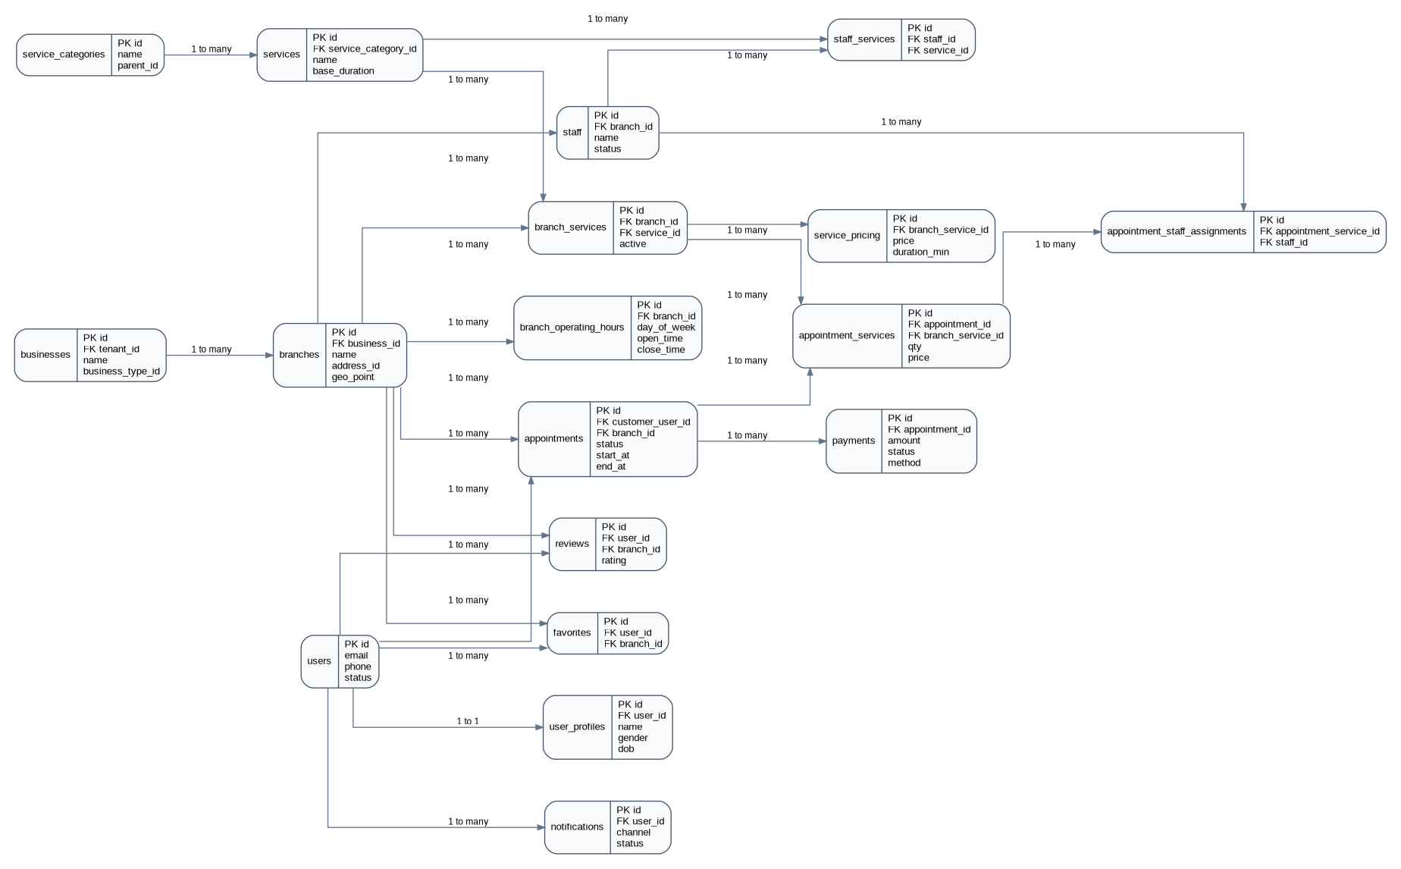
Figure 1. Core marketplace logical ERD.

3. SaaS and platform-governance ERD
This diagram covers tenancy, subscriptions, onboarding, access control, settlements, support, and auditability.
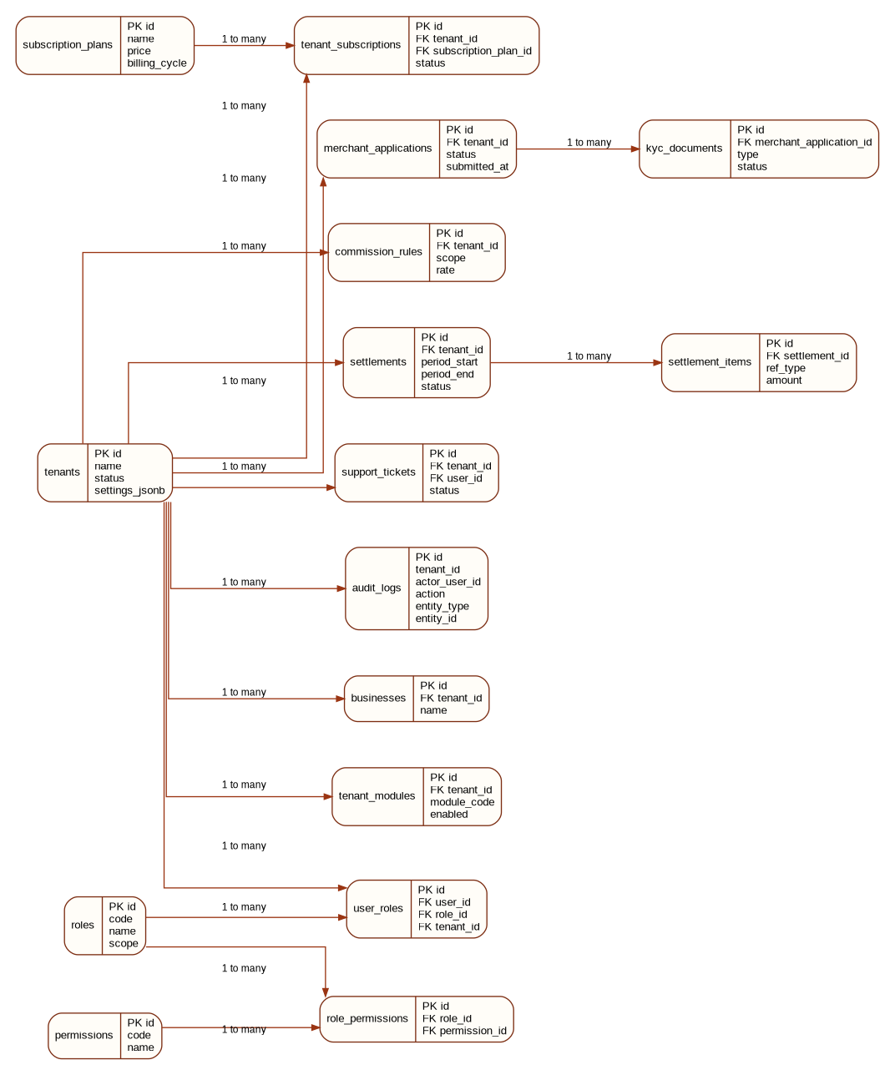
Figure 2. SaaS / platform-governance logical ERD.

4. Domain-by-domain entity catalog
The following registry is intended to be implementation-ready. It lists the recommended entities for a scalable initial architecture. Not every table is required on day one; use the MVP scope from your product plan to phase rollout.

1. SaaS tenancy and subscriptions
Entity | Suggested key fields | Purpose
tenants | id, created_at, updated_at | Top-level tenant/workspace for each merchant organization or chain.
subscription_plans | id, created_at, updated_at | Master catalog of SaaS plans offered by the platform.
tenant_subscriptions | id, created_at, updated_at, status | Tenant enrollment, billing state, and subscription dates.
tenant_modules | id, created_at, updated_at | Feature flags/modules enabled per tenant.
tenant_settings | id, created_at, updated_at | Tenant-level configuration in structured columns plus JSONB.

2. Identity, access control, and customer accounts
Entity | Suggested key fields | Purpose
users | id, created_at, updated_at | All platform users: customers, staff users, merchant admins, platform admins.
user_profiles | id, created_at, updated_at | Extended personal profile and demographic details.
roles | id, created_at, updated_at | Role definitions such as customer, branch_manager, staff_member, tenant_admin.
permissions | id, created_at, updated_at | Atomic permissions used for role-based access control.
role_permissions | id, created_at, updated_at, FK columns | Maps permissions to roles.
user_roles | id, created_at, updated_at, FK columns | Maps roles to users, optionally scoped by tenant or branch.
user_addresses | id, created_at, updated_at | Saved customer addresses and visit locations.
user_devices | id, created_at, updated_at | Push token/device registration and device audit.
user_notification_preferences | id, created_at, updated_at | Opt-in/opt-out preferences by channel and category.

3. Merchant business structure
Entity | Suggested key fields | Purpose
business_types | id, created_at, updated_at | Lookup values such as beauty_parlour, barbershop, spa, nail_studio.
businesses | id, created_at, updated_at | Merchant business entity owned by a tenant.
branches | id, created_at, updated_at, FK columns | Physical outlet or operating branch.
branch_addresses | id, created_at, updated_at | Normalized address data for a branch.
branch_operating_hours | id, created_at, updated_at | Weekly opening hours per branch.
branch_holidays | id, created_at, updated_at | Recurring or one-off holiday closures.
branch_closures | id, created_at, updated_at | Emergency/special closures and blocked dates.
branch_service_areas | id, created_at, updated_at | Coverage polygons/radius for home-service fulfillment.

4. Service catalog and pricing
Entity | Suggested key fields | Purpose
service_categories | id, created_at, updated_at | Hierarchical categories such as Hair, Skin, Nails, Grooming.
services | id, created_at, updated_at | Master service definitions reusable across branches.
service_variants | id, created_at, updated_at | Size/gender/complexity variants of a service.
service_addons | id, created_at, updated_at | Optional add-on items sold with a core service.
service_bundles | id, created_at, updated_at | Packages that combine multiple services.
branch_services | id, created_at, updated_at, FK columns | Branch-specific activation of a service.
service_pricing | id, created_at, updated_at, FK columns | Price, duration, and tax setup by branch-service or variant.
service_duration_rules | id, created_at, updated_at | Dynamic duration adjustments by staff or variant.
service_availability_rules | id, created_at, updated_at | Restrictions by time, day, or booking channel.

5. Staff and workforce planning
Entity | Suggested key fields | Purpose
staff | id, created_at, updated_at | Staff member master record.
staff_profiles | id, created_at, updated_at | Additional HR/public profile fields for staff.
staff_branch_assignments | id, created_at, updated_at | Assignment of staff to one or more branches.
staff_services | id, created_at, updated_at, FK columns | Services a staff member is qualified to perform.
staff_working_hours | id, created_at, updated_at | Staff-specific weekly schedule.
staff_breaks | id, created_at, updated_at | Break windows that affect availability.
staff_leaves | id, created_at, updated_at | Leave, off-days, and blocked periods.
staff_commissions | id, created_at, updated_at | Commission model and payout rules.

6. Discovery, geospatial, and search
Entity | Suggested key fields | Purpose
cities | id, created_at, updated_at | City master for filters and reporting.
zones | id, created_at, updated_at | Operational zone or locality inside a city.
geo_locations | id, created_at, updated_at | Reusable geocoded points or polygons.
saved_locations | id, created_at, updated_at | Customer quick-access locations.
search_history | id, created_at, updated_at | Search terms, filters, and user discovery history.
distance_cache | id, created_at, updated_at | Optional cache for repeated route or proximity calculations.
branch_live_status | id, created_at, updated_at | Open now / busy / accepting walk-ins / temporarily offline.

7. Booking and appointment workflow
Entity | Suggested key fields | Purpose
appointments | id, created_at, updated_at, status | Appointment header with customer, branch, schedule, and status.
appointment_services | id, created_at, updated_at, FK columns | Line items for each service booked.
appointment_staff_assignments | id, created_at, updated_at, FK columns | Specific staff assigned to an appointment line.
appointment_status_history | id, created_at, updated_at | Audit trail of booking state changes.
appointment_notes | id, created_at, updated_at | Operational notes from customer, shop, or admin.
appointment_reschedule_history | id, created_at, updated_at | History of date/time changes.
appointment_cancellations | id, created_at, updated_at | Cancellation details, actor, reason, and charges.
appointment_checkins | id, created_at, updated_at | Arrival/check-in/check-out timestamps.
waitlists | id, created_at, updated_at | Customer waitlist entries for unavailable slots.
queue_tokens | id, created_at, updated_at | Walk-in or in-branch queue management.
branch_slots | id, created_at, updated_at | Materialized branch slot availability.
staff_slots | id, created_at, updated_at | Materialized staff slot availability.
availability_cache | id, created_at, updated_at | Computed availability snapshots for fast discovery.

8. Payments, invoicing, and settlements
Entity | Suggested key fields | Purpose
payment_methods | id, created_at, updated_at | Saved methods or payment instrument metadata.
payments | id, created_at, updated_at, status | Payment intent/receipt linked to appointment or order.
payment_transactions | id, created_at, updated_at | Gateway transaction events and reconciliation IDs.
refunds | id, created_at, updated_at | Refund requests and processed refunds.
invoices | id, created_at, updated_at | Tax invoice header.
invoice_items | id, created_at, updated_at | Invoice line items for services, products, taxes, discounts.
tax_rules | id, created_at, updated_at | GST/VAT/sales tax setup by region or service.
tips | id, created_at, updated_at | Tips allocated to staff.
platform_fees | id, created_at, updated_at | Marketplace commission, convenience fees, and charges.
commission_rules | id, created_at, updated_at | Rules for platform or tenant commission calculation.
settlements | id, created_at, updated_at, status | Payout batch to tenant/merchant.
settlement_items | id, created_at, updated_at | Detailed lines rolled into a settlement.

9. CRM, loyalty, and promotions
Entity | Suggested key fields | Purpose
favorites | id, created_at, updated_at, actor/ref FK | Customer-saved branches or shops.
reviews | id, created_at, updated_at, actor/ref FK | Ratings and feedback for a branch/service/staff.
review_replies | id, created_at, updated_at | Merchant responses to customer reviews.
ratings_summary | id, created_at, updated_at | Precomputed rating aggregates.
customer_notes | id, created_at, updated_at | Internal merchant notes about customer preferences.
customer_tags | id, created_at, updated_at | Labels such as VIP, allergy, frequent-customer.
promotions | id, created_at, updated_at | Offers configured by platform or merchant.
promo_codes | id, created_at, updated_at | Redeemable coupon codes.
promo_redemptions | id, created_at, updated_at, actor/ref FK | Usage records of promo codes.
campaigns | id, created_at, updated_at | Marketing campaigns.
referrals | id, created_at, updated_at | Referral links, invite records, and rewards.
memberships | id, created_at, updated_at | Membership product master.
membership_plans | id, created_at, updated_at | Recurring membership plan definitions.
customer_memberships | id, created_at, updated_at | Customer subscription to a membership.
loyalty_accounts | id, created_at, updated_at | Points balance per customer.
loyalty_transactions | id, created_at, updated_at, actor/ref FK | Accrual and redemption ledger.
wallets | id, created_at, updated_at | Stored-value wallet.
wallet_transactions | id, created_at, updated_at, actor/ref FK | Wallet credit/debit ledger.
gift_cards | id, created_at, updated_at | Gift card issuance and redemption.

10. Messaging, support, media, and compliance
Entity | Suggested key fields | Purpose
notifications | id, created_at, updated_at | Notification header to user or merchant.
notification_templates | id, created_at, updated_at | Reusable email/SMS/push templates.
notification_logs | id, created_at, updated_at | Delivery attempt logs and provider responses.
messages | id, created_at, updated_at | Message records in chat/support channels.
chat_threads | id, created_at, updated_at | Conversation thread header.
support_tickets | id, created_at, updated_at | Issue tracker for customer or merchant support.
complaints | id, created_at, updated_at | Formal complaint/dispute entry.
disputes | id, created_at, updated_at | Payment or service disputes requiring investigation.
kyc_documents | id, created_at, updated_at | Verification documents for merchants.
merchant_applications | id, created_at, updated_at | Merchant onboarding/approval requests.
verification_status_history | id, created_at, updated_at | Timeline of verification actions.
media_files | id, created_at, updated_at | Stored media metadata.
business_galleries | id, created_at, updated_at | Business-gallery mapping.
branch_galleries | id, created_at, updated_at | Branch-gallery mapping.
staff_galleries | id, created_at, updated_at | Staff-gallery mapping.
service_images | id, created_at, updated_at | Service image mapping.
documents | id, created_at, updated_at | Other uploaded files/contracts/certificates.
audit_logs | id, created_at, updated_at, actor/ref FK | Immutable audit trail of sensitive actions.

11. POS, inventory, and home services
Entity | Suggested key fields | Purpose
orders | id, created_at, updated_at, status | POS or ecommerce order header.
order_items | id, created_at, updated_at | Service/product line items in an order.
product_categories | id, created_at, updated_at | Product category master.
products | id, created_at, updated_at | Retail product master.
product_variants | id, created_at, updated_at | SKU-level product variants.
inventory_items | id, created_at, updated_at | On-hand inventory by branch.
inventory_movements | id, created_at, updated_at, actor/ref FK | Inventory in/out adjustments.
suppliers | id, created_at, updated_at | Product suppliers.
purchase_orders | id, created_at, updated_at | Purchase orders for stock replenishment.
stock_adjustments | id, created_at, updated_at | Manual stock correction log.
home_service_bookings | id, created_at, updated_at | At-home service fulfillment header.
service_zones | id, created_at, updated_at | Deliverable operational zones.
travel_fees | id, created_at, updated_at | Distance-based or zone-based travel charges.
staff_travel_schedule | id, created_at, updated_at | Travel blocks around home-service visits.
visit_addresses | id, created_at, updated_at | Actual visit location for home-service appointments.

12. Analytics and integrations
Entity | Suggested key fields | Purpose
events | id, created_at, updated_at | Product analytics event stream.
user_sessions | id, created_at, updated_at | Authentication/session tracking.
page_views | id, created_at, updated_at | App screen/page visit log.
search_events | id, created_at, updated_at | Search-specific analytics.
booking_events | id, created_at, updated_at | Funnel and conversion events around appointments.
coupon_usage_analytics | id, created_at, updated_at | Precomputed coupon KPI table.
api_keys | id, created_at, updated_at | Third-party or tenant API credentials.
webhooks | id, created_at, updated_at | Outbound webhook subscriptions.
integration_logs | id, created_at, updated_at | Requests/responses to external systems.
fraud_flags | id, created_at, updated_at | Risk indicators for suspicious activity.

5. Core relationship rules
- A tenant owns many businesses; a business owns many branches.
- A customer user creates many appointments; each appointment belongs to exactly one branch.
- An appointment contains one or more appointment_services rows; each line references a branch_service.
- A branch can activate many services, and each activated service can have one or many pricing rows over time or by variant.
- A staff member can perform many services, and a service can be performed by many staff members.
- A branch receives many reviews and favorites from users.
- One appointment can produce multiple payment transactions, but payment reconciliation should roll up to a single payment record per capture/refund cycle.
- A subscription_plan can be assigned to many tenant_subscriptions; only one active primary subscription should exist per tenant at a given time.
- Merchant onboarding can generate many KYC documents and many verification history entries.
- Promotions, loyalty, wallet, membership, and invoice entities should remain loosely coupled so each commercial program can evolve independently.

6. PostgreSQL implementation notes
- Use UUID primary keys with default generation at the database layer.
- Use timestamptz for all user-visible timestamps such as booking slots, payments, and notifications.
- Use JSONB for flexible settings, gateway payloads, feature flags, and provider metadata, but keep searchable business attributes in first-class columns.
- Use PostGIS geography(Point, 4326) for branch and customer coordinates. Add GIST indexes for nearest-branch search.
- Create unique constraints for natural composite pairs such as (user_id, role_id, tenant_id), (staff_id, service_id), and (branch_id, service_id).
- Partition or archive high-volume event tables such as notifications, events, audit_logs, payment_transactions, and search_history as scale grows.
- Add partial indexes for active bookings, active branch services, active subscriptions, and unresolved tickets.
- Store immutable history in appointment_status_history, verification_status_history, payment_transactions, and audit_logs instead of overwriting important state transitions.
Recommended next artifact: convert this ERD into a physical schema specification with column types, constraints, indexes, and migration ordering.

