TOGAF Visual Study Guide
What TOGAF is, why it exists, who uses it, and how to remember it visually
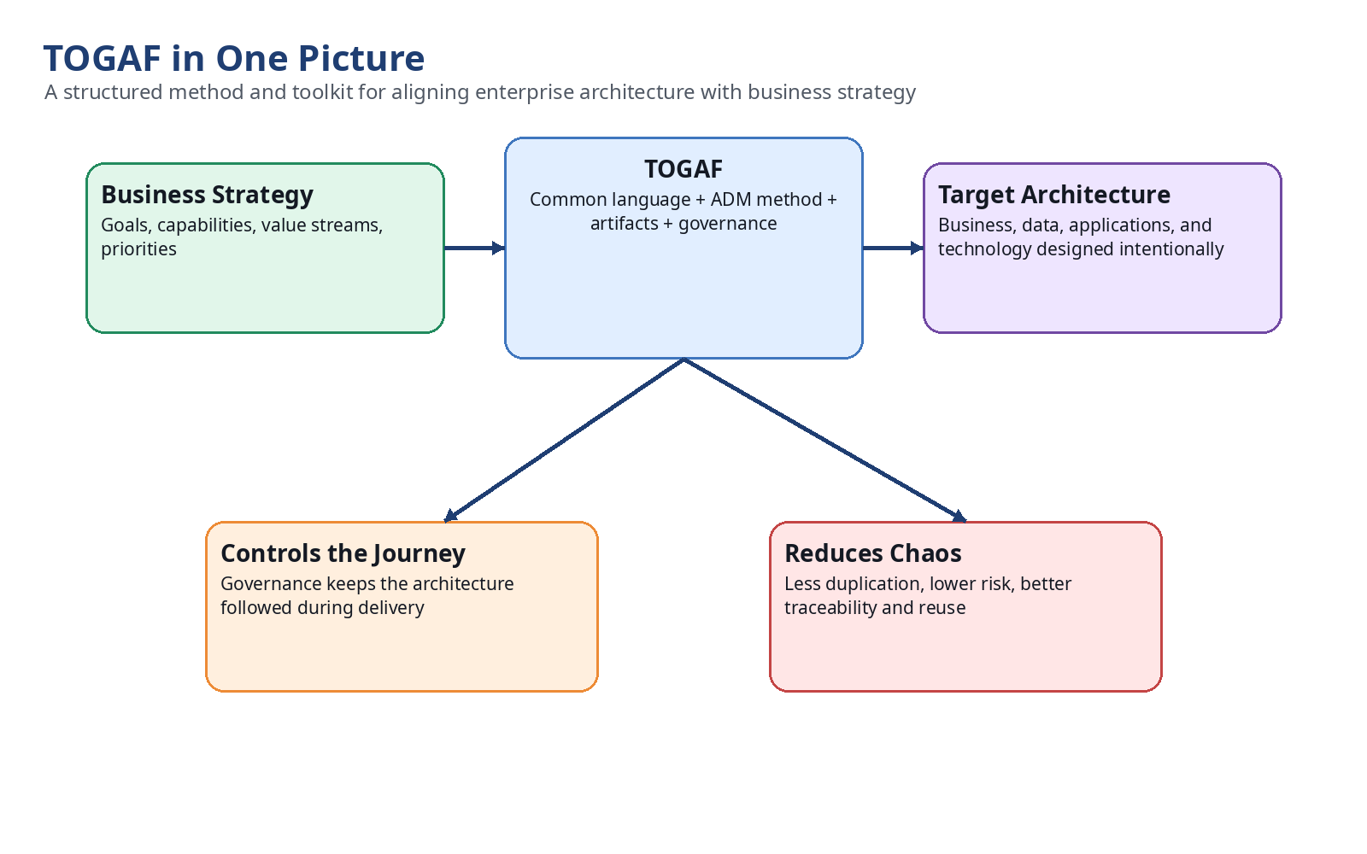

1. One-Sentence Definition
TOGAF, The Open Group Architecture Framework, is a structured, vendor-neutral enterprise architecture framework that helps an organization align its business strategy, data, applications, and technology through a repeatable method, reusable artifacts, and governance.
In simple words: TOGAF is a recipe book and toolkit that helps an organization move from its current technology landscape to a desired future technology landscape without losing sight of business purpose, architecture scope, and governance control.

2. Why TOGAF Exists
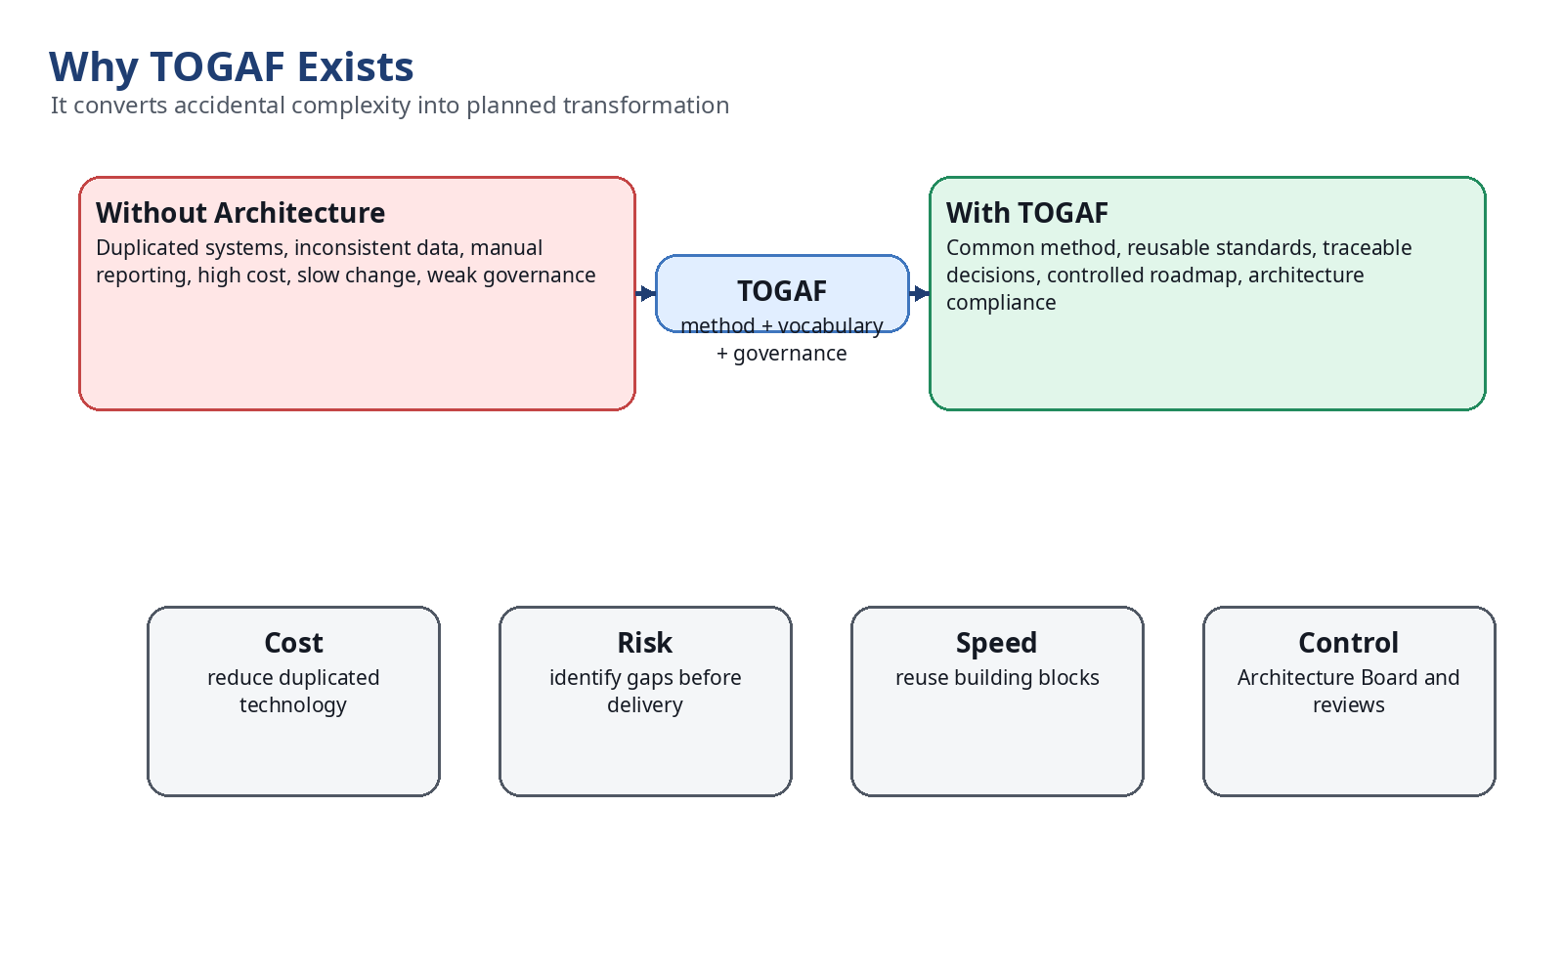
Large organizations naturally accumulate duplicated systems, inconsistent data, isolated teams, and technology chosen by local preference. TOGAF exists to replace accidental architecture with deliberate architecture.
- It creates a repeatable method for architecture work.
- It gives business, IT, security, data and delivery teams a common language.
- It reduces risk by forcing clear current-state, target-state and gap analysis.
- It supports governance so the architecture is followed during implementation.

3. ADM: The Core TOGAF Method
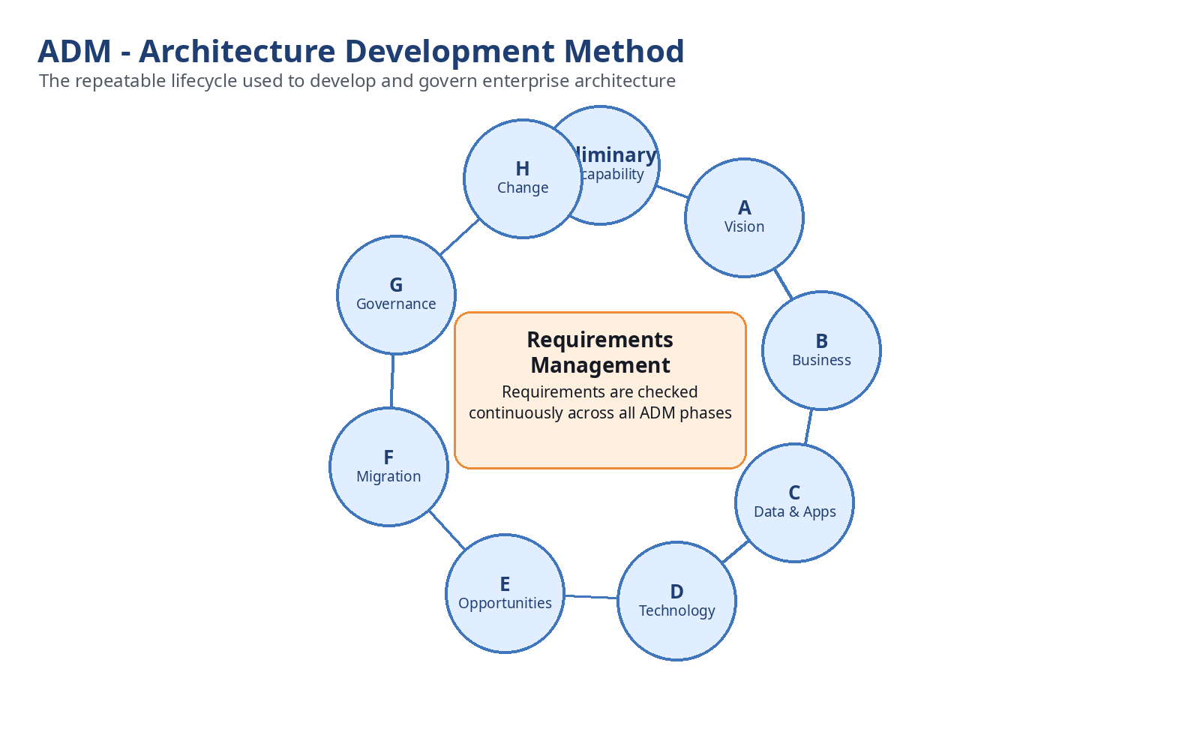
The ADM, or Architecture Development Method, is the heart of TOGAF. It is a cycle because architecture is not a one-time document; it evolves as business requirements, technology and risks change.
ADM Phase | Purpose | Simple Meaning
Preliminary | Establish architecture capability | Set up the architecture practice
Phase A | Architecture Vision | Agree why the change is needed
Phase B | Business Architecture | Define business capabilities and processes
Phase C | Information Systems Architecture | Define data and application architecture
Phase D | Technology Architecture | Define infrastructure and platform architecture
Phase E | Opportunities and Solutions | Identify solution options
Phase F | Migration Planning | Plan transition roadmap
Phase G | Implementation Governance | Check delivery follows architecture
Phase H | Architecture Change Management | Manage change after implementation

4. The Four Architecture Domains
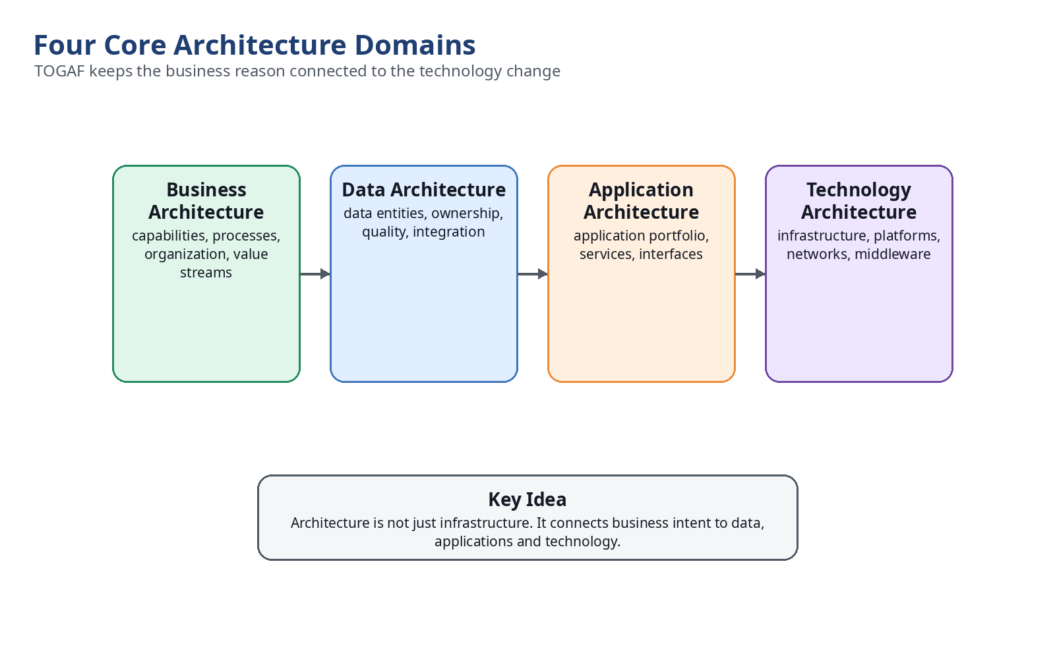
TOGAF does not treat architecture as only technology. It connects business intent to data, applications and technology.

5. Traceability: How Business Strategy Becomes IT Investment
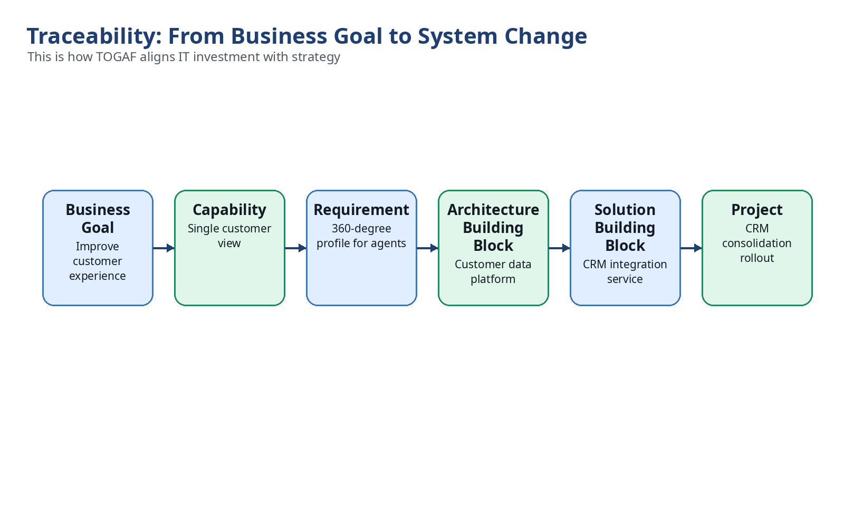
Traceability is one of the biggest practical benefits of TOGAF. A project should not exist just because a team wants a new system. It should trace back to a goal, capability, requirement and architecture decision.

6. Target Users and Their Focus Areas
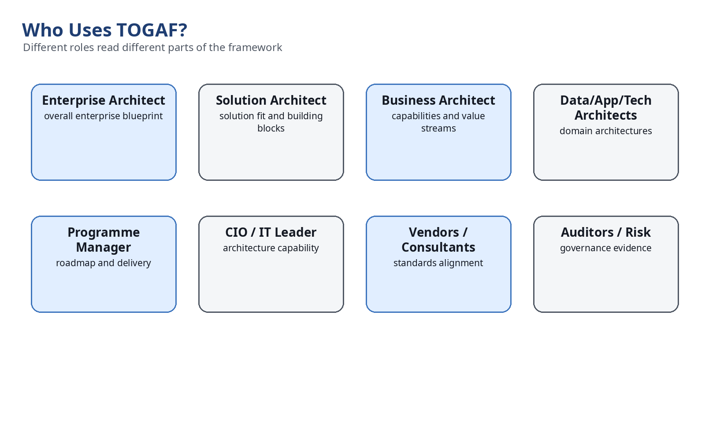
User Group | Why They Use TOGAF | Typical Focus
Enterprise Architects | Design and govern the enterprise-wide blueprint | ADM, content framework, repository
Solution Architects | Design solutions that fit the enterprise architecture | Phases B-D, building blocks
Business Architects | Map capabilities and value streams to IT | Business architecture, capability modelling
Data/Application/Technology Architects | Define domain-specific architecture | Phases C-D, reference models
Programme and Project Managers | Connect architecture deliverables to delivery | Phases E-G
CIOs and IT Leadership | Establish architecture capability and control | Preliminary phase, governance
Vendors and Consultants | Align products and services with recognized standards | Reference models, standards
Auditors and Risk Officers | Check decision control and compliance | Architecture governance, compliance reviews

7. Governance: Making Sure Architecture Is Followed
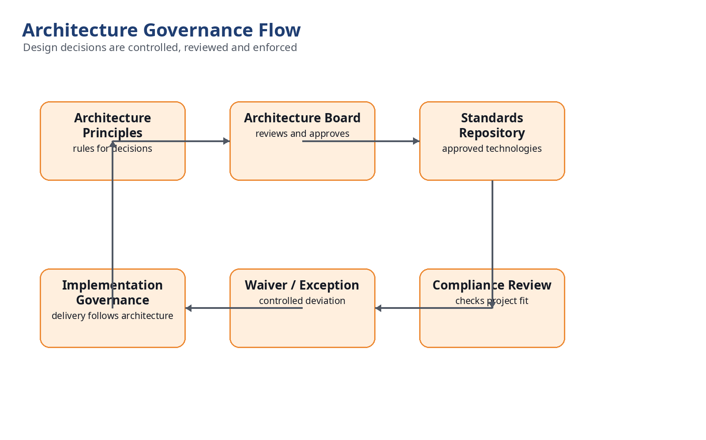
Governance is the control mechanism. Without governance, architecture remains a document. With governance, architecture becomes a decision system used during procurement, project design and delivery.

8. Architecture Repository
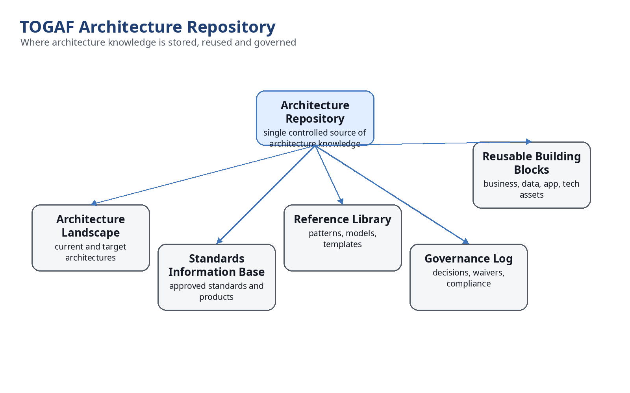
The repository stores reusable architecture knowledge: current and target architectures, approved standards, reference models, decisions, waivers, patterns and reusable building blocks.

9. Real-World Example: Global Bank CRM Consolidation
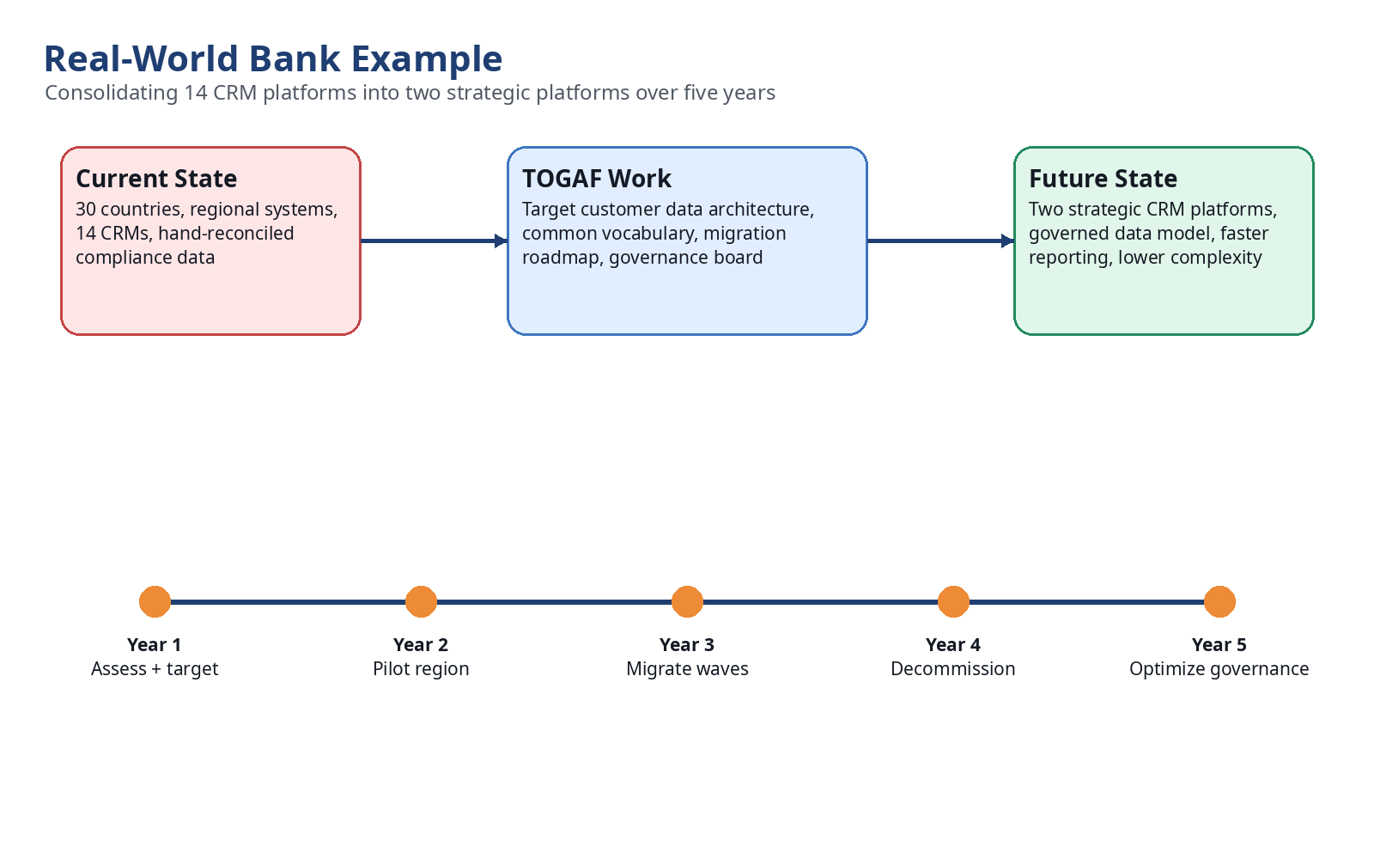
A multinational bank with 30 countries and 14 CRM systems uses TOGAF to define a target customer-data architecture, create a five-year migration roadmap, and establish an Architecture Board. The result is not simply fewer CRM systems; the result is controlled transformation aligned to compliance, reporting, customer experience and cost reduction.

10. Easy Mental Model
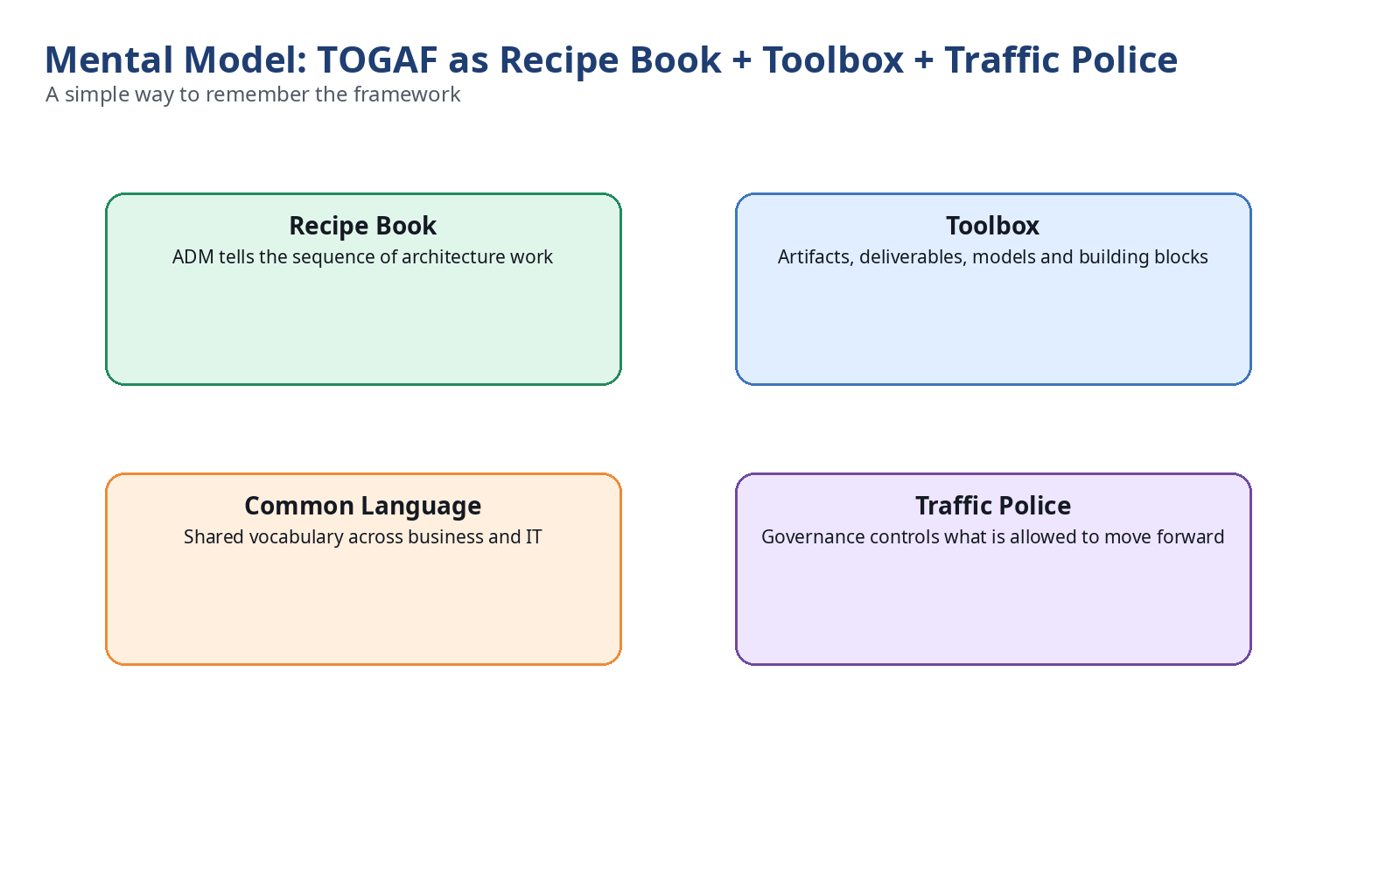
Remember TOGAF as four things: recipe book, toolbox, common language and traffic police. The ADM is the recipe. Artifacts and building blocks are the toolbox. Shared terms are the common language. Governance is the traffic police.

11. Quick Revision Cheat Sheet
Concept | Remember Like This
TOGAF | Enterprise architecture framework for aligning business and IT
ADM | Step-by-step architecture lifecycle
Business Architecture | What the business needs to do
Data Architecture | What information the enterprise needs and controls
Application Architecture | What systems and services support the business
Technology Architecture | What platforms and infrastructure run the systems
Architecture Governance | Decision control and compliance
Architecture Repository | Library of architecture knowledge and approved standards
Building Blocks | Reusable pieces of architecture or solution design
Traceability | Clear link from strategy to project implementation

12. Interview-Style Questions
Q: What problem does TOGAF solve?
A: It solves uncontrolled enterprise complexity by giving a common method, vocabulary, artifacts and governance process for architecture change.
Q: Is TOGAF only for IT infrastructure?
A: No. TOGAF covers business, data, application and technology architecture.
Q: What is the ADM?
A: ADM is the Architecture Development Method, the repeatable lifecycle used to create, migrate, govern and change enterprise architecture.
Q: Why is governance important in TOGAF?
A: Governance ensures that projects, procurement and implementation follow the approved architecture, or receive controlled exceptions.
Q: What is the difference between current and target architecture?
A: Current architecture describes how the enterprise works today. Target architecture describes the desired future state. The roadmap defines the transition.

