Consistent Hashing — System Design Interview (Diagram + Answers)

Master Diagram
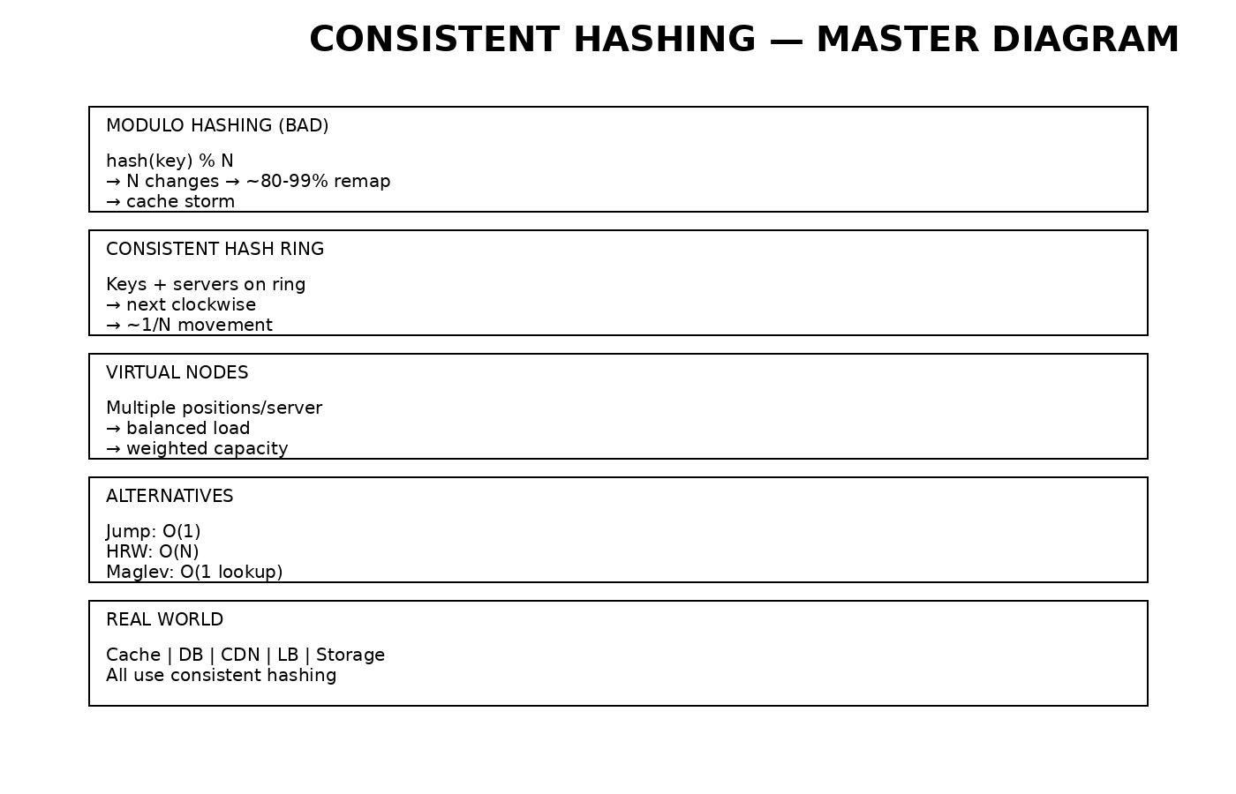

1. Design a Distributed Cache (Memcached)
Use consistent hashing at the client. Each key is hashed to a node on a ring with virtual nodes.
• Add/remove node → ~1/N keys move
• Prevents cache stampede
• No coordination between servers
Diagram above: ring + virtual nodes explain routing.

2. Design Redis Cluster
Use 16,384 hash slots instead of a ring.
slot = CRC16(key) % 16384
• Nodes own slot ranges
• MOVED redirects guide clients
• Scaling = slot migration (~1/N movement)
Diagram: slot-based consistent partitioning.

3. Design Cassandra-like DB
Use consistent hashing ring (token ring).
• Hash partition key → token
• Store on primary + next clockwise replicas
• Virtual nodes balance load
Diagram: ring + replication clockwise.

4. Design Sticky Session Load Balancer
Use consistent hashing on session_id.
server = hash(session_id)
• Stateless (no session table)
• Works across multiple LBs
Diagram: hash → server mapping.

5. Design CDN Edge Cache
Hash URL → edge server.
• Same content → same server
• Maximizes cache hit rate
• Adding node → small % reroute
Diagram: URL → consistent node.

6. Design Distributed Storage (S3/HDFS)
Hash object/block → node.
• Even distribution
• Add/remove node → ~1/N data moves
• Rebalancing incremental
Diagram: data spread across nodes.

