|  |  |  |  |  |
| --- | --- | --- | --- | --- |
| N | P | Non-Optimized(microseconds) | Optimized (microseconds) |  |
| 64 |  | 2159 | 3052 |  |
| 128 |  | 10031 | 24114 |  |
| 256 |  | 94917 | 197182 |  |
| 512 |  | 1045091 | 1590790 |  |
| 1024 |  | 9958964 | 12774045 |  |
| 2048 |  | 197916962 | 121966620 |  |

When the Matrix Size is increased then we can see that the Optimized Code Execution time is getting decreased as highlighted in green above.

Optimized Matrix Multiplication:

Algorithm: Strassen’s Multiplication of Matrices Algorithm

A simple method for matrix multiplication would take O(N3) times.

Strassen’s algorithm faster than the general matrix multiplication algorithm. The Strassen’s algorithm’s time complexity is O(n^2.80).

1. Reduce the given matrix A and B into two small 2x2 matrix
2. 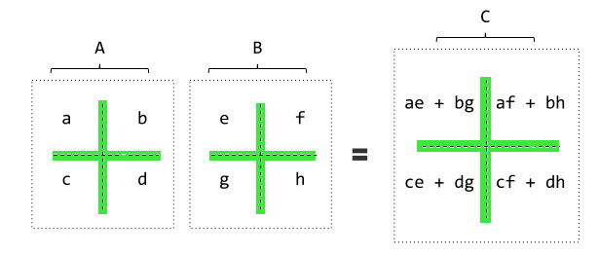
3. P1 = A(F-H)  
   P2 = (A+B)H  
   P3 = (C+D)E  
   P4 = D(G-E)  
   P5 = (A+D)(E+H)  
   P6 = (B-D)(G+H)  
   P7 = (A-C)(E+F)

[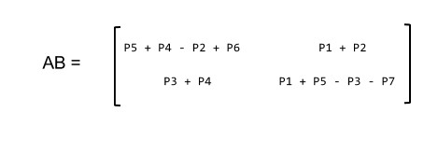](http://wikistack.com/wp-content/uploads/2015/02/Strassens-Algorithm.jpeg)

Generally, Strassen’s Method is not preferred for practical applications for following reasons.

1) The constants used in Strassen’s method are high and for a typical application Naive method works better.

2) For Sparse matrices, there are better methods especially designed for them.

3) The submatrices in recursion take extra space.  
4) Because of the limited precision of computer arithmetic on non-integer values, larger errors accumulate in Strassen’s algorithm than in Naive Method

Prakash Bangaru

University At Albany, New York, USA

#2 Assistant Professor, KalolInstitute of Technology & research Center, Gujarat, India