Retrieval-Augmented Generation (RAG)

Baseline pipeline
text | chunk_id | section
Project Name is TPM Promotion Analytics. | bc0efca6-a3aa-4095-ad81-2e14ac143003 | Project Information
Subject Area is Trade Promotion Management. | dcc2203f-d67b-4dbf-8d71-d060ba089560 | Project Information
Source System is SAP TPM. | 6b98bf1d-87c7-4a24-ab5c-21c2d6d60e64 | Source Information
Target System is Databricks Gold. | e92d7b25-510f-44bb-a0e7-2b43285d7060 | Target Information
Load Type is Incremental. | b3a2faa5-efef-4c92-a62a-5fe541c145d4 | Load Strategy
PromotionID is directly mapped to Promotion_ID. | 5c20399c-187f-462b-b45e-30e5921b9cca | Column Mapping
CustomerID is mapped to Customer_ID using Customer Master lookup. | add262d6-2eda-40b9-a622-bc9654bbb986 | Column Mapping
ProductID is mapped to Product_ID using Product Master lookup. | afa89139-e599-4c1c-adf9-dcd68a1f897d | Column Mapping
StartDate is directly mapped to Promo_Start_Date. | 9240aa43-a5fb-4969-8d1e-0153da52dc82 | Column Mapping
EndDate is directly mapped to Promo_End_Date. | a3975e3c-49dd-489e-80fc-bd4b2724f484 | Column Mapping
PlannedVolume is rounded to two decimal places before loading into Planned_Volume. | d375af51-fe7a-4308-ad4c-c76e09725322 | Column Mapping
ExpectedRevenue is rounded to two decimal places before loading into Expected_Revenue. | 0050b903-c7e2-46da-9cea-24ba6c4619bb | Column Mapping
LastModifiedTS is used as the watermark column and loaded into Last_Update_TS. | 1072236e-3fce-4f4f-9d03-ae2f7780ecc5 | Column Mapping
Promotion End Date must be greater than Start Date. | e668854e-a00c-4949-80f9-ab234b8710c4 | Business Rule
Customer and Product must exist in reference tables. | afb9814f-6b07-4fc9-9da7-6632bf82d757 | Business Rule
Expected Revenue must be greater than zero. | e587bfa1-2dd3-480a-8c9d-3e225226bedd | Business Rule
Reject duplicate Promotion ID records. | ba0df764-b948-466d-886c-6e5a999346f1 | Business Rule
Promotion.CustomerID joins with customer_master.CustomerID. | 7e9aabf5-c7c3-436c-8d6a-eb954d29440f | Join Logic
Promotion.ProductID joins with product_master.ProductID. | 2be63114-a79f-4176-a64c-37dd220d6b5e | Join Logic

answer | question
Answer: TPM Promotion Analytics is a project related to Promotion Performance Analysis and Promotion Revenue Tracking.  Sources:  - STTM_TPM_Promotion.xlsx | Project Information | bc0efca6-a3aa-4095-ad81-2e14ac143003  - Release Notes - Promotion STTM.docx | Reporting | 83c3137c-bfe0-4a24-9b28-e98cb0045590  - Release Notes - Promotion STTM.docx | Reporting | 116eb679-c100-4d33-800b-7500adafeec8 | What is TPM Promotion Analytics?
Answer: CustomerID is mapped to Customer_ID, using Customer Master lookup.  Sources:  - STTM_Customer.xlsx | Column Mapping | 8ca438c5-e9fa-49e7-a834-a388eaae80ed  - STTM_TPM_Promotion.xlsx | Column Mapping | add262d6-2eda-40b9-a622-bc9654bbb986 | How is CustomerID mapped?
Answer: PromotionID must be unique. [Source 37, Business Rule, dfb1b66e-9849-4f04-b397-68c7570b1aec]  Sources:  - Release Notes - Promotion STTM.docx | Business Rule | dfb1b66e-9849-4f04-b397-68c7570b1aec | What business rules exist for promotions?
Answer: Information not found in provided documents.  Sources:  - None | What source system provides promotion data?
Answer: The validation rules are that records must contain valid identifiers and dates must be valid, and specifically for customer sales, records must contain valid product identifiers.  Sources:  - Promotion_DRD.docx | Business Rule | ac69d6c4-0ea0-40f1-a5f0-ad411ba3377e  - Promotion_DRD.docx | Business Rule | 9d86cd92-dbf0-4ac2-9eef-31fbbac03850  - Customer_Sales_DRD.docx | Business Rules | e84ec2a4-9800-48b0-80b9-e66ab8e4ff14 | What are the validation rules?

Chunking tradeoffs
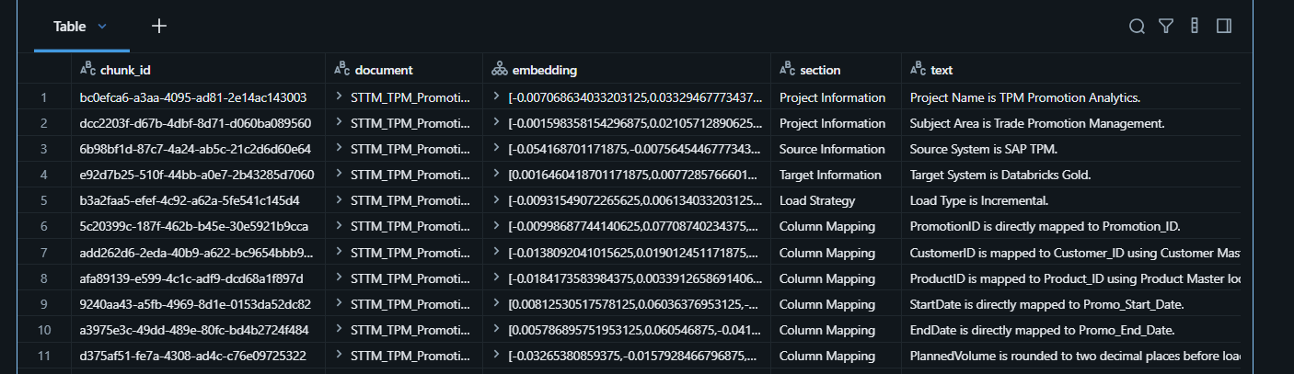
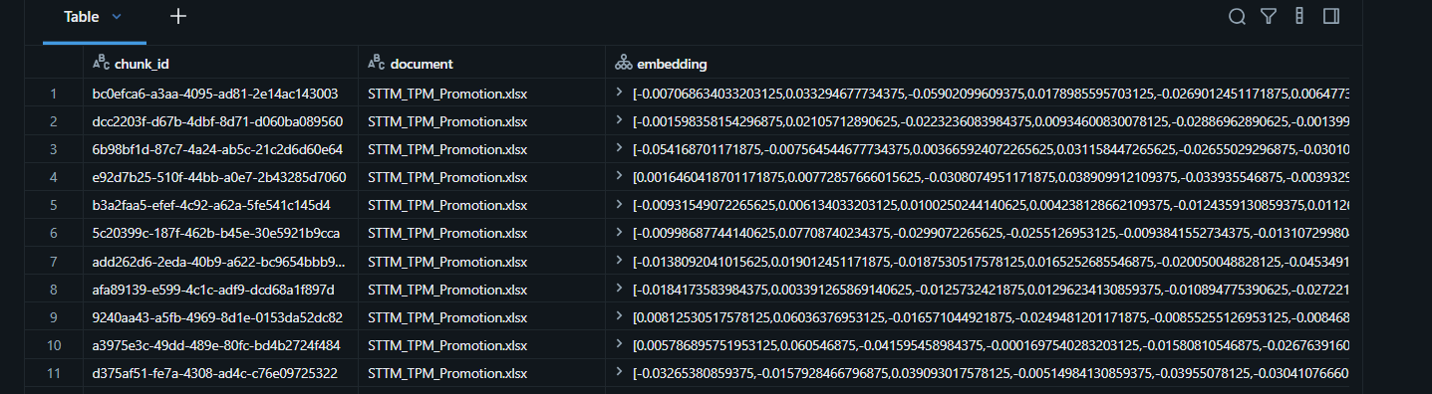

Metadata-filtered retrieval
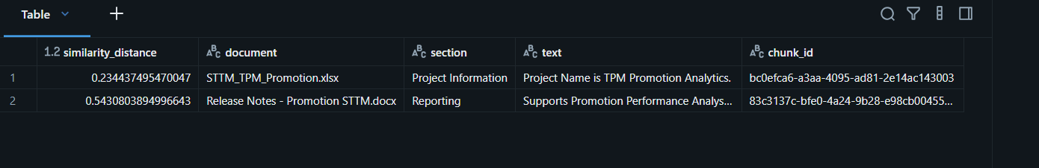

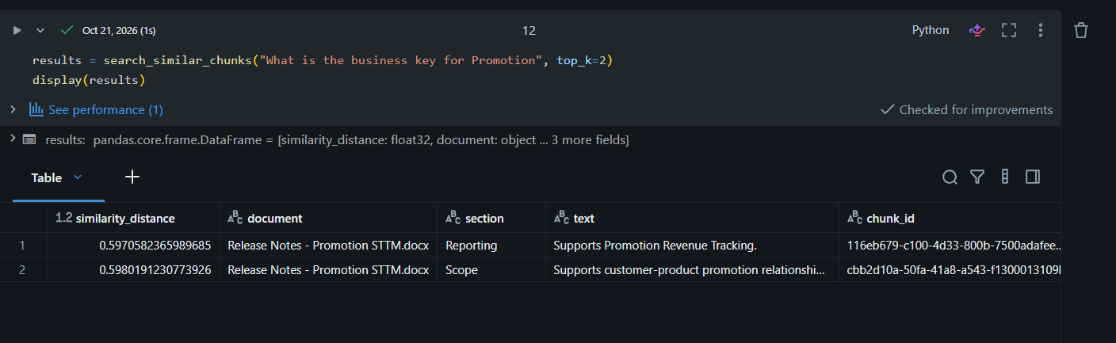

Groundedness failure hunt


