Databricks Agent Creation (Mosaic AI Agent Framework)

1.First tool-calling agent
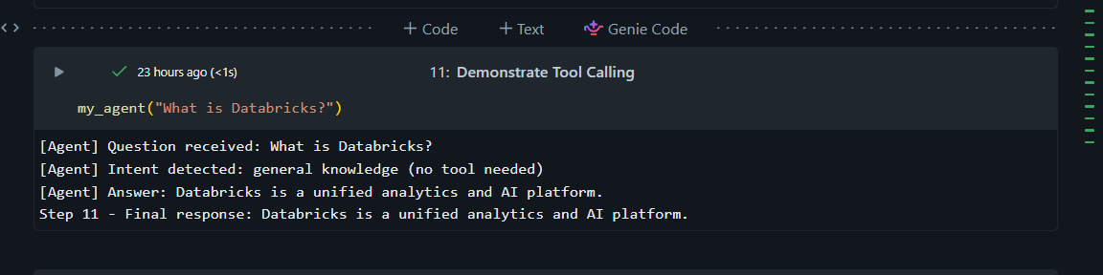

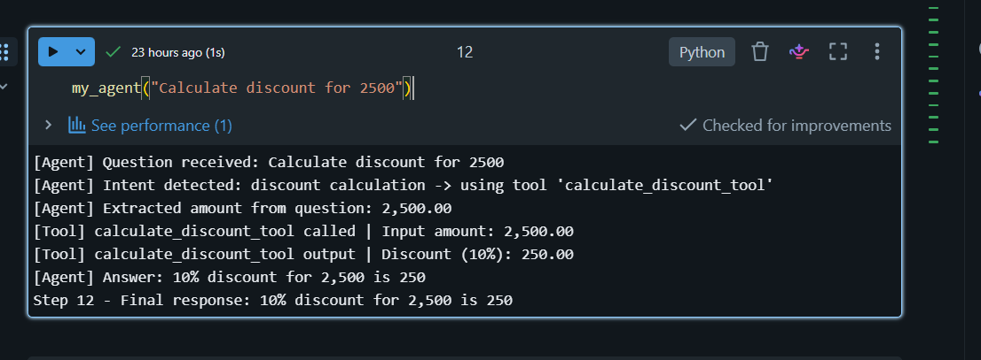

2. Multi-tool composition
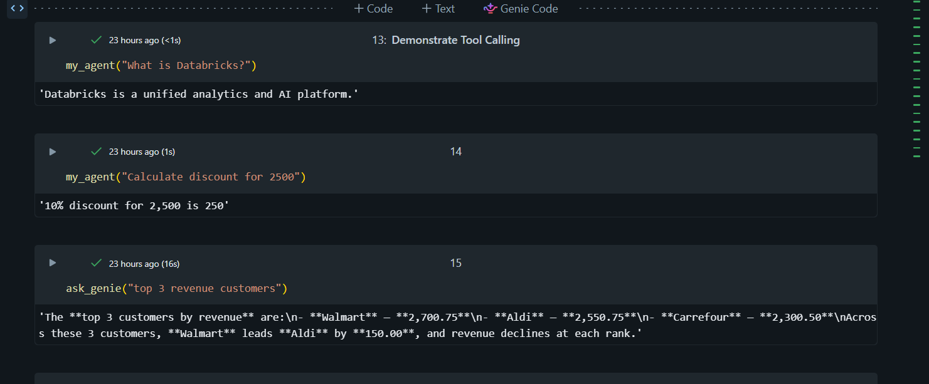
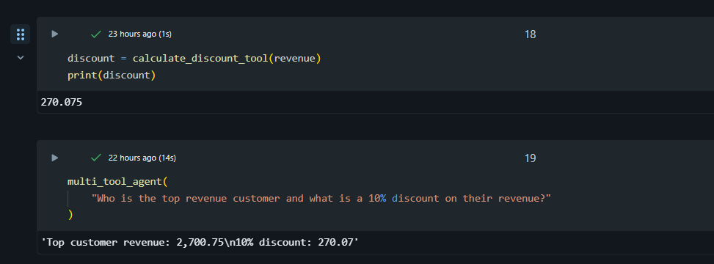

3.Evaluation before trust
Evaluation Input:
eval_set = [
{
"question": "Calculate discount for 1000",
"expected": "100"
},
{
"question": "Calculate discount for 5000",
"expected": "500"
},
{
"question": "Calculate discount for 0",
"expected": "0"
},
{
"question": "Top 3 revenue customers",
"expected": "Walmart"
},
{
"question": "Which customer has highest revenue?",
"expected": "Walmart"
},
{
"question": "Total sales by country",
"expected": "USA"
},
{
"question": "What is Databricks?",
"expected": "analytics platform"
},
{
"question": "Who is the top revenue customer and what is a 10% discount on their revenue?",
"expected": "270"
},
{
"question": "Calculate discount for -100",
"expected": "error"
},
{
"question": "Calculate discount for 999999",
"expected": "99999.9"
}
]

Output:
question | expected | actual
Calculate discount for 1000 | 100 | 10% discount on 1,000 is 100
Calculate discount for 5000 | 500 | 10% discount on 5,000 is 500
Calculate discount for 0 | 0 | 10% discount on 0 is 0
Top 3 revenue customers | Walmart | The **top 3 revenue customers** are **Walmart** with **2,700.75**, **Aldi** with **2,550.75**, and **Carrefour** with **2,300.50**. Across all **3 returned customers**, revenue declines steadily from rank 1 to rank 3.
Which customer has highest revenue? | Walmart | **Walmart** has the highest revenue, with total revenue of **2700.75**. Based on the result shown, **Walmart** is the top revenue-generating customer in the data returned by the query.
Total sales by country | USA | Total sales by country are shown for **5 countries**. Some of the top values are:  - **USA**: **3,450.75**  - **Germany**: **2,550.75**  - **France**: **2,300.50**  - **UK**: **2,070.75**  - **Spain**: **980.00**  Among these results, the **USA** has the highest total sales and **Spain** has the lowest.
What is Databricks? | analytics platform | I can answer sales questions or discount calculations.
Who is the top revenue customer and what is a 10% discount on their revenue? | 270 | Top customer revenue: 2,700.75  10% discount: 270.07
Calculate discount for -100 | error | 10% discount on 100 is 10
Calculate discount for 999999 | 99999.9 | 10% discount on 999,999 is 100,000

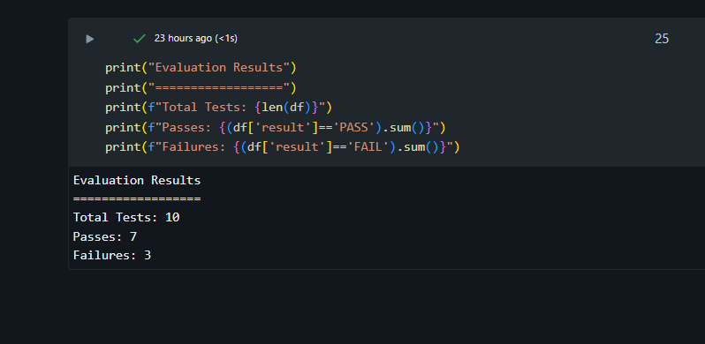

4. Tracing and root-cause
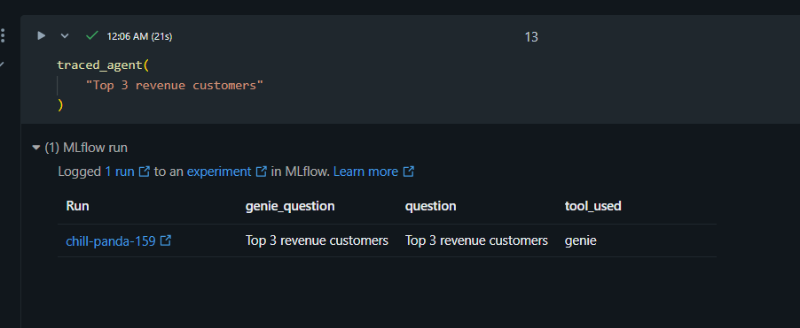

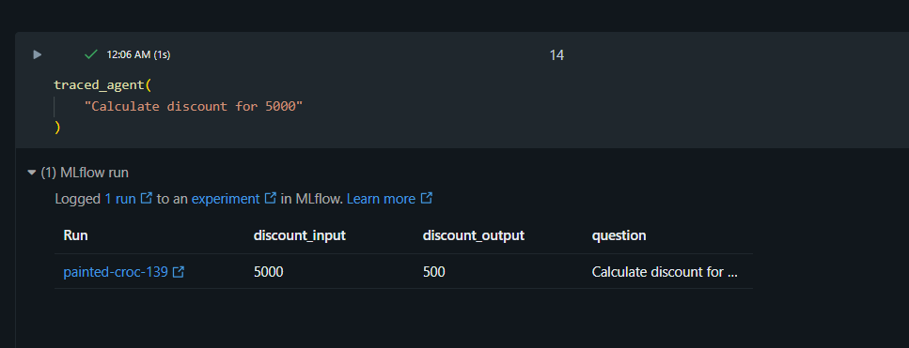
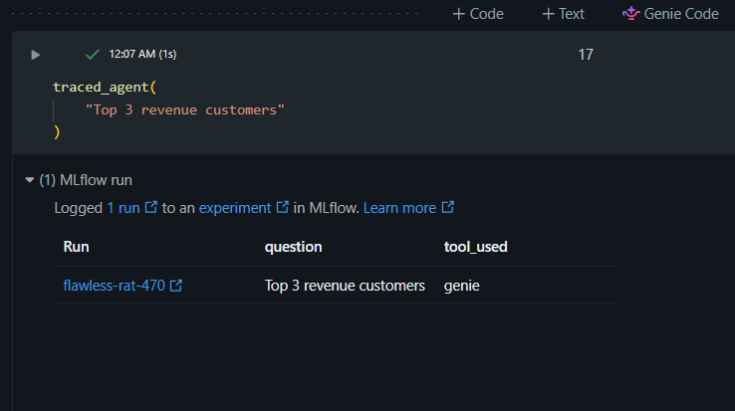

5.Deployment and monitoring


