# **Chapter 5: Testing**

Testing is the process to find errors in software application so that application functions according to the end user’s requirements. It ensures the quality of the software products and identify the defects in software. We have different types of testing approaches but in our project I have done white box and black box testing only.

## **5.1: White Box Testing.**

White Box Testing is the type of testing that is based on analysis of the internal structure, design, implementation of the component or system. This method is also known as Clear Box testing, Glass Box Testing etc. This method is named so because the software program, in the eyes of the tester like a white box inside which one clearly sees. The white box testing is done at the unit level. In white box testing unit testing is done.

### **5.1.1: Unit Testing.**

Unit testing is performed on each unit and block of code as it is developed. Unit testing is performed by programmer. Bugs identified in this stage are cheaper and easy to fix. It helps to identify the majority of bugs at the early stages of software development lifecycle.

#### **Advantages of White Box Testing:-**

* It helps in code optimization by finding hidden errors.
* White box tests cases can be easily automated.
* Testing can start early in SDLC even if GUI is not available.
* Testing is more thorough as all code paths are usually covered.

#### **Disadvantages of White Box Testing:-**

* It can be quite complex and costly.
* It is time consuming process
* It requires the professional resources, with detailed programing.

## **5.2: Black Box Testing.**

Black Box Testing is also known as behavioural testing. It is software testing method in which the internal structure, design, implementation of the software. These tests can be functional or non-functional through usually functional.

#### **Advantages of Black Box Testing:-**

* Test cases can be designed as soon as the specifications are complete.
* Tester need not to know programming language.
* Tester are done from a user’s point of view.

#### **Disadvantages of Black Box Testing:-**

* Tests can be redundant if the software designer has already run a test case.
* Only small number of possible inputs can be tested.
* It is challenging to design test cases without having clear functional specifications.

In Our Project I have done some of the test cases for unit testing as shown in below:-

|  |  |  |  |  |  |  |
| --- | --- | --- | --- | --- | --- | --- |
| Test Plan | Test Description | Test Data | Expected Result | Actual Result | Status | Remarks |
| Valid Email Test | | | | | | |
| Email Testing | Verify Email | [test@test.com](mailto:test@test.com) | Test Passed | Passed | Pass |  |
| Password Test | | | | | | |
| Password Test | Password is equal to confirm password | 123,123 | Test Passed | Passed | Pass |  |
| Phone Number Test | | | | | | |
| Test Phone Number | Phone number should contains 10 digits | 9810633682 | Test Passed | Passed | Pass |  |
| No of Seat Test | | | | | | |
| Test No of Seats | No of seats verify | 120 | Test Passed | Passed | Pass |  |

* Email Testing:-

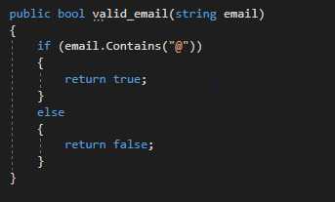

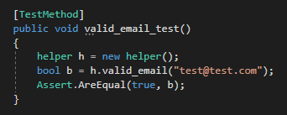

* Password Verify:-

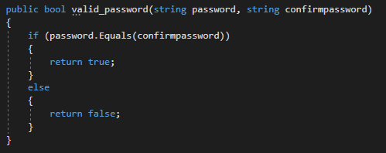

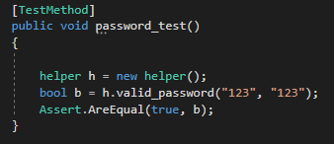

* Phone Number Validation:-

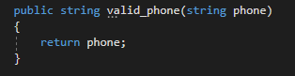

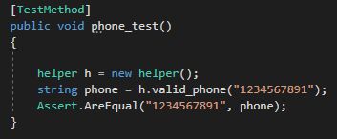

* No of Seat Verify:-

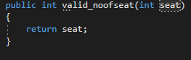

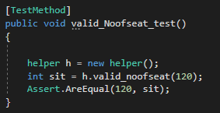

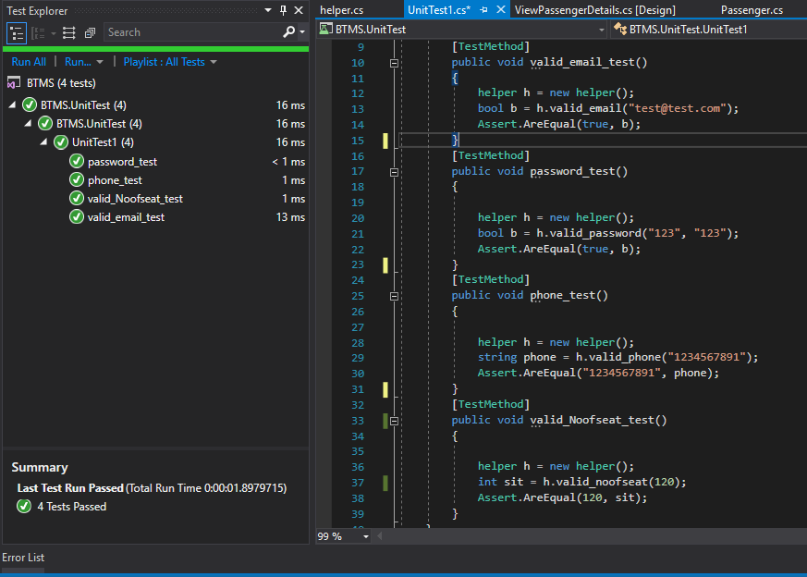

**Black Box Testing:-**

**Test Case:-**

|  |  |  |  |  |  |  |
| --- | --- | --- | --- | --- | --- | --- |
| Test Plan | Test Description | Test Data | Expected Result | Actual Result | Status | Remarks |
| Login | | | | | | |
| Login | Verify Username and Password | Prakash,123 | Login Successfully | Incorrect Username and Password | Failed | Incorrect username and password |
| Login | Verify Username and Password | Pk,123 | Login Successfully | Login Successfully | Pass |  |
| Register | | | | | | |
| Admin Register | Registration of Admin | Null Values | Registered successfully | Please fill up all fields | Failed | Null Values not Accepted |
| Admin Register | Registration of Admin | Prakash,haudekanxa0@gmail.com,123 | Registered successfully | Registered successfully | Pass |  |

