1. Grade Checker
Take a score as input and print the grade based on the following:
90+ : "A"
80-89 : "B"
70-79 : "C"
60-69 : "D"
Below 60 : "F"
here we used a basic if else statement to carry out marks and all.
Answer
Grade Checker Program
Takes a score as input and prints the corresponding grade
Get score from user input
--------------------------------------------------------------------------
grade_checker.py
score = float(input("Enter your score: "))
if score >= 90:
grade = "A"
elif score >= 80:
grade = "B"
elif score >= 70:
grade = "C"
elif score >= 60:
grade = "D"
else:
grade = "F"
print(f"Your grade is: {grade}")
-------------------------------------------------------------------------------------------------------------
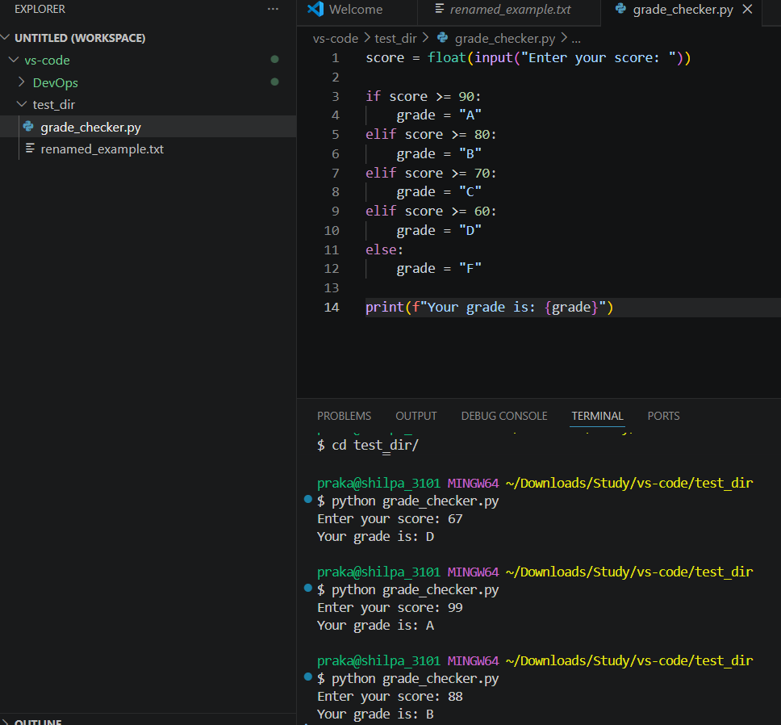
Determine grade using if-else statements
Print the grade

2 Student Grades
Create a dictionary where the keys are student names and the values are their grades. Allow the user to:
Add a new student and grade.
Update an existing student’s grade.
Print all student grades.
Used dictionary and basic operations. Using if else:
---------------------------------------------------------------------------------------------------------
student_grades.py
students = {}
valid_grades = ["A", "B", "C", "D", "F"]
while True:
print("\n--- Student Grade System ---")
print("1. Add student")
print("2. Update grade")
print("3. Show all students")
print("4. Exit")
choice = input("Enter your choice: ")

# Add student
if choice == "1":
name = input("Enter student name: ")
if name in students:
print("Student already exists!")
else:
grade = input("Enter grade (A/B/C/D/F): ").upper()
if grade in valid_grades:
students[name] = grade
print("Student added successfully!")
else:
print("Invalid grade! Please enter A, B, C, D, or F.")

# Update grade
elif choice == "2":
name = input("Enter student name to update: ")
if name in students:
grade = input("Enter new grade (A/B/C/D/F): ").upper()
if grade in valid_grades:
students[name] = grade
print("Grade updated successfully!")
else:
print("Invalid grade!")
else:
print("Student not found!")
# Display all students
elif choice == "3":
if students:
print("\nStudent Grades:")
for name, grade in students.items():
print(name, ":", grade)
else:
print("No students found!")
# Exit
elif choice == "4":
print("Exiting program...")
break

else:
print("Invalid choice! Please try again.")

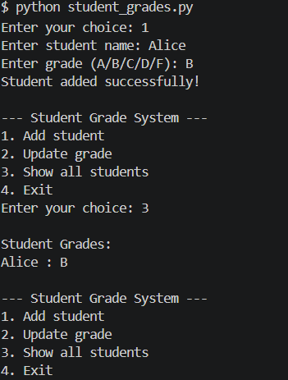
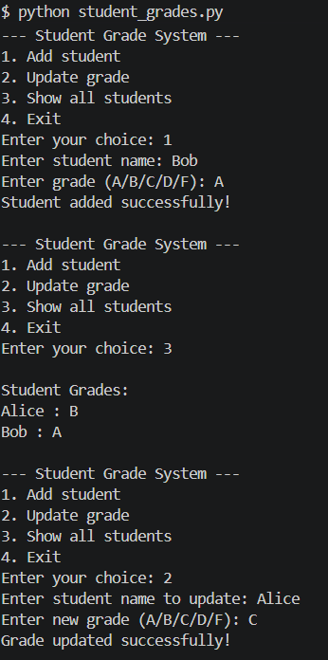
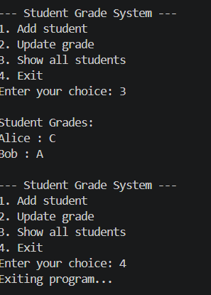

3.Write to a File
Write a program to create a text file and write some content to it.
Using file functions like write and open.

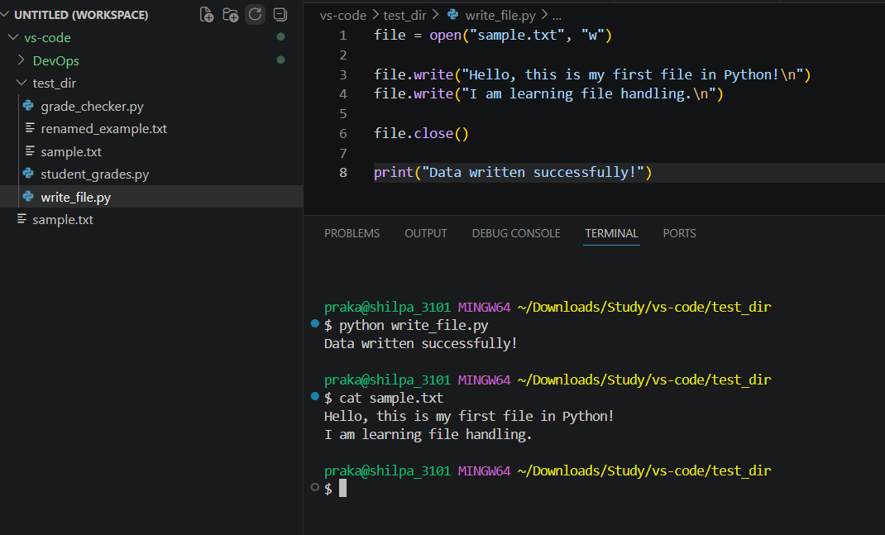

4. Read from a File
We used open in read mode and file.read to read and print to display.
