1. Create a Flask application with an /api route. When this route is accessed, it should return a JSON list. The data should be stored in a backend file, read from it, and sent as a response.

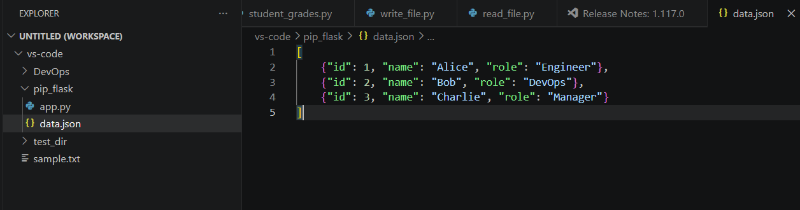
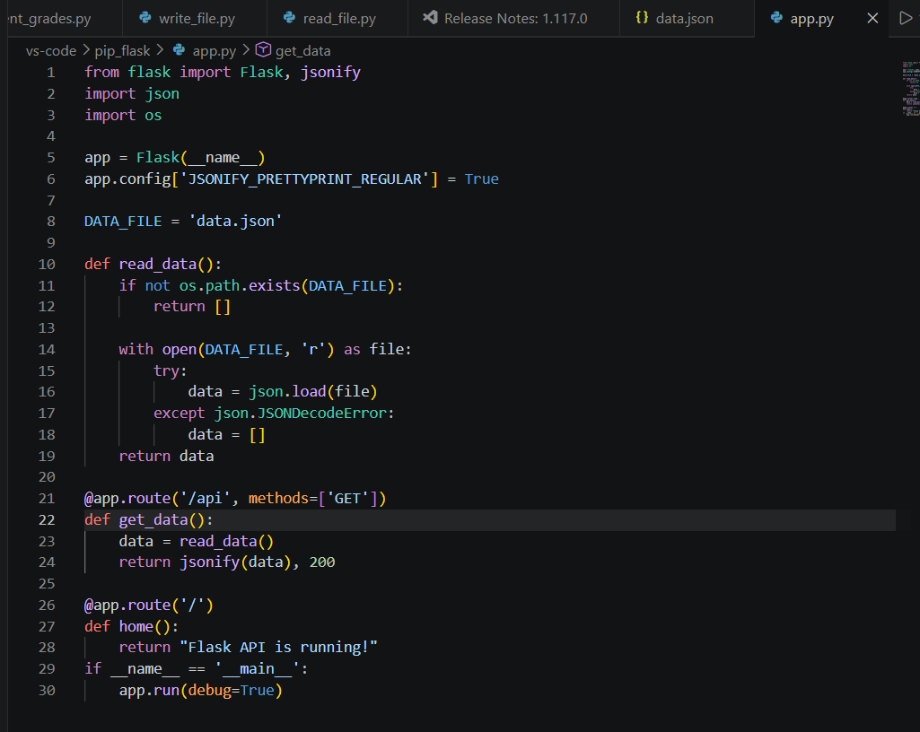

from flask import Flask, jsonify
import json
import os

app = Flask(__name__)
app.config['JSONIFY_PRETTYPRINT_REGULAR'] = True

DATA_FILE = 'data.json'

def read_data():
if not os.path.exists(DATA_FILE):
return []

with open(DATA_FILE, 'r') as file:
try:
data = json.load(file)
except json.JSONDecodeError:
data = []
return data

@app.route('/api', methods=['GET'])
def get_data():
data = read_data()
return jsonify(data), 200

@app.route('/')
def home():
return "Flask API is running!"
if __name__ == '__main__':
app.run(debug=True)
