**Lab 1 Record – PS-1: Linux Network Troubleshooting**

**Aim:** To identify and exercise the given network troubleshooting commands in Linux to diagnose and resolve network issues.

**i) Basic Connectivity Check Command:**

* ping -c 4 8.8.8.8
* ping -c 4 archlinux.org

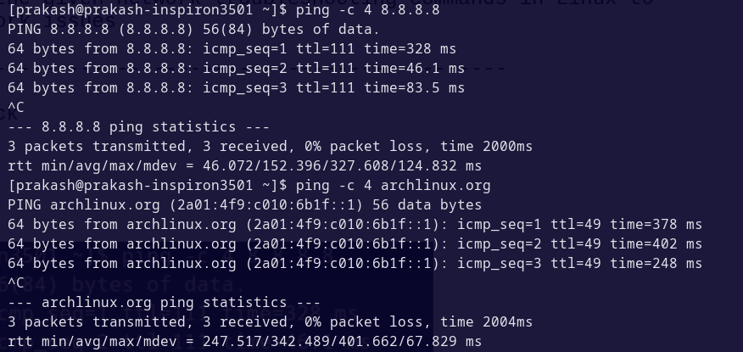 **Output:**

**ii) Checking Interface and Routing Command:**

* ip addr show
* ip route show

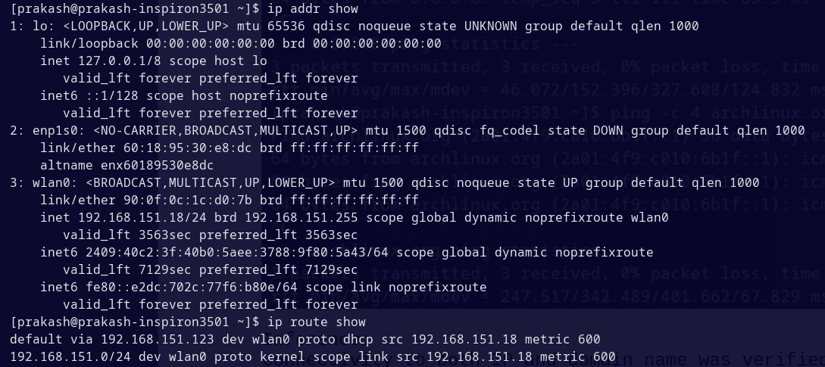**Output:**

**iii) DNS Resolution Testing Command:**

* nslookup archlinux.org
* dig archlinux.org
* host archlinux.org

**Output:**

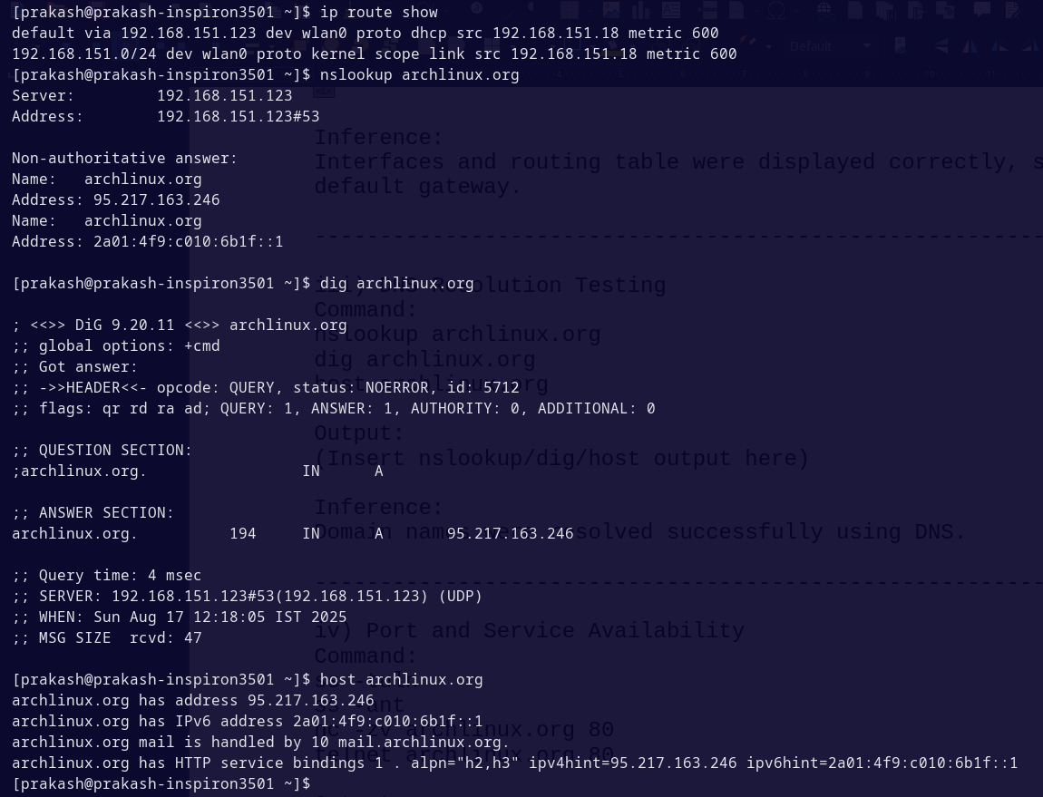

**iv) Port and Service Availability Command:**

* ss -tuln
* ss -ant
* nc -zv archlinux.org 80
* telnet archlinux.org 80

**Output:**

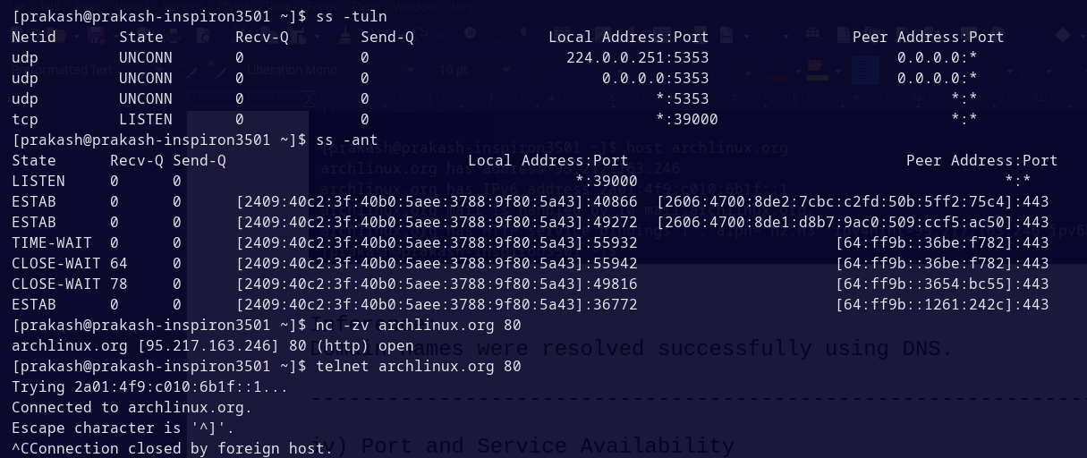

**v) Trace Path of Packet Command:**

* traceroute archlinux.org
* tracepath archlinux.org

**Output:**

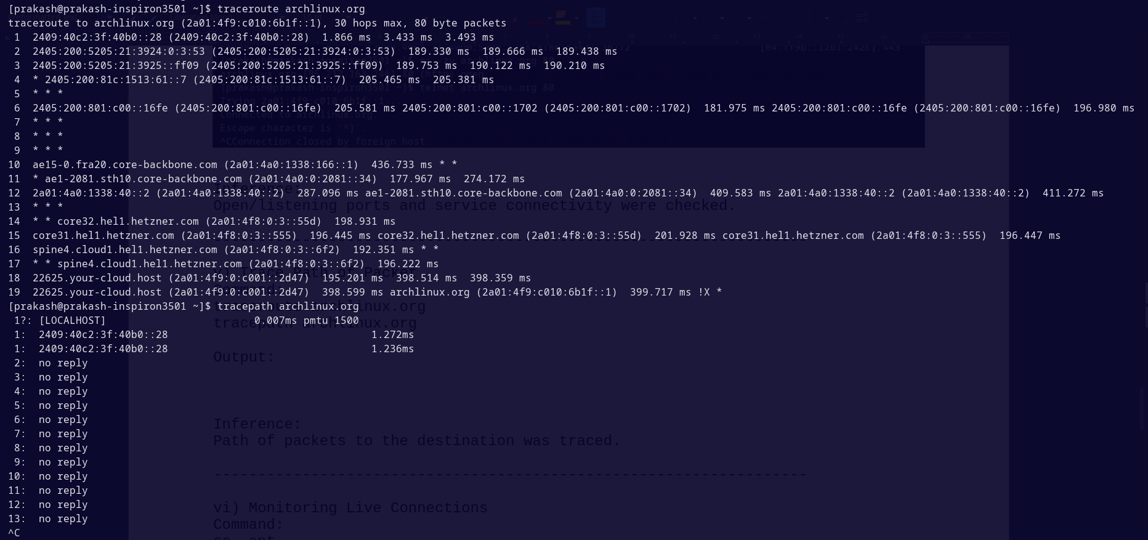

**vi) Monitoring Live Connections Command:**

* ss -ant
* sudo tcpdump -i any

**Output:**

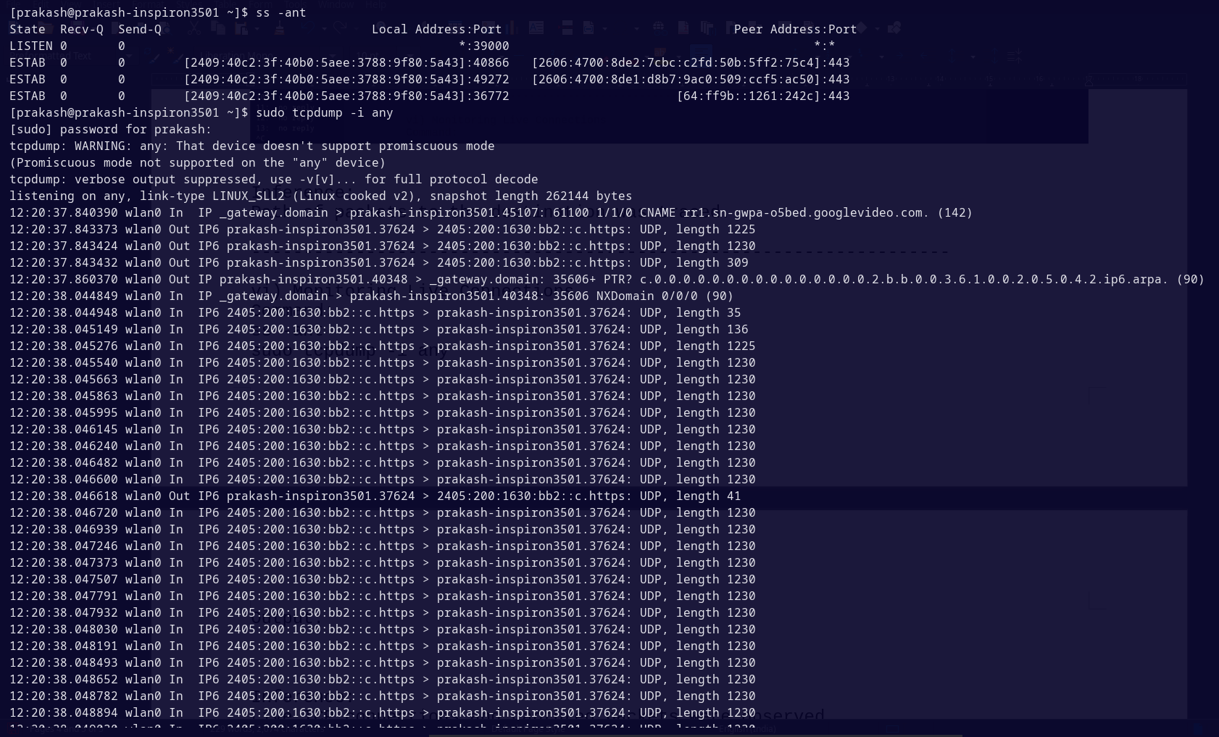

**vii) Capture HTTP Traffic (Advanced) Command:**

* sudo tcpdump -i any tcp port 80 -c 20 > tcpdump_output.txt

**Output:**

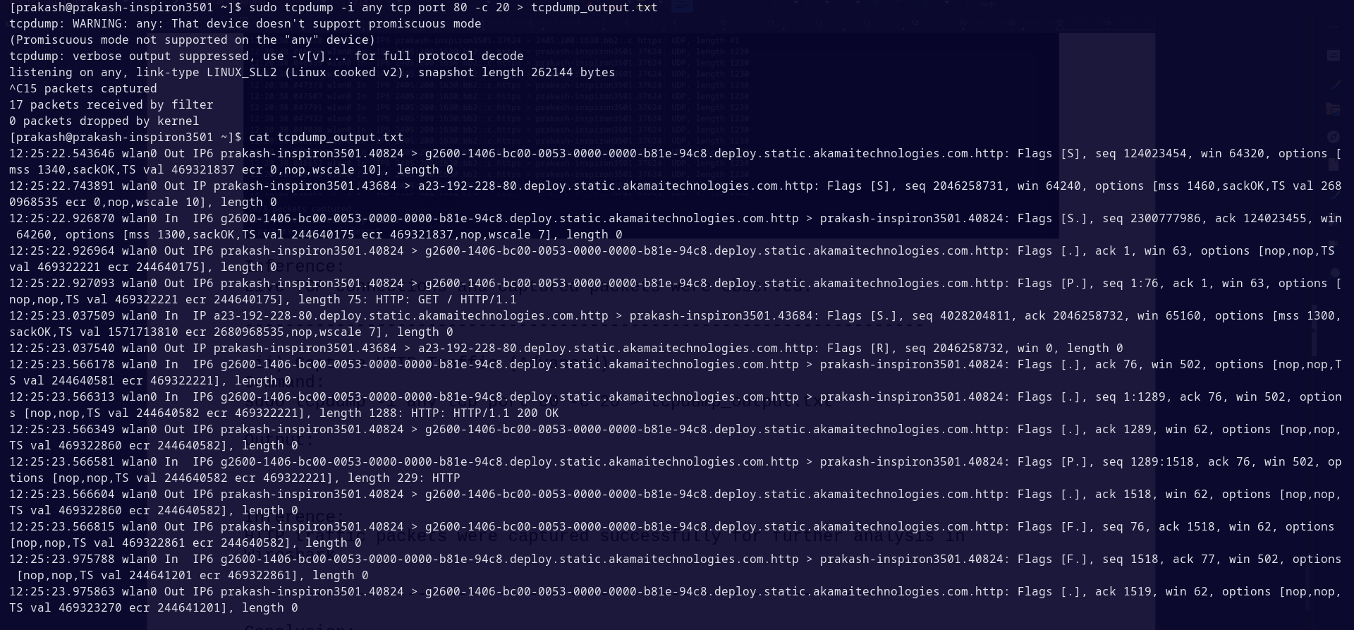

**Conclusion:**

The practical exercise demonstrated the use of Linux network troubleshooting commands for connectivity, routing, DNS, ports, trace path, monitoring, and packet capture.