INFOSYS LIMITED

NeoBank 360
Software Handover & Architecture Document

Project Name | NeoBank 360
Delivery Unit / Location | Infosys Bhubaneswar
Lab Allocation | Lab 4 & Lab 5
Program | PMIS Internship Program
Team Members | Prakash Goyel
Document Version | 1.0 (Final Handover Build)
Date of Submission | 19-June-2026
Classification | Confidential – Internal Use Only

Document Control

Revision History

Version | Date | Description of Change | Author | Approved By
1.0 | 19-Jun-2026 | Final consolidated handover build covering Sprints 1-5 (Auth, Accounts, Budgets, Bills, Loans, Analytics, Audit Logging, Performance Optimization) | Prakash Goyel | Ajit k. panigrahi

Distribution List
This document is intended for circulation to the following stakeholders. Recipients must treat the contents as confidential and refrain from external distribution without prior written authorization from Infosys Limited.
- Project Sponsor / Engagement Manager: Ajit k. panigrahi
- Technical Lead / Architect: Prakash Goyel
- Quality Assurance Lead: Prakash Goyel
- PMIS Internship Program Coordinator: PMIS Program Coordinator, Infosys Bhubaneswar DC

Table of Contents
Document Control 1
Revision History 1
Distribution List 1
Table of Contents 1
1. Executive Summary 1
1.1 Project Snapshot 1
1.2 Objectives 1
1.3 Scope of This Document 1
2. System Architecture 1
2.1 High-Level Architecture Overview 1
2.2 Entity-Relationship (ER) Diagram 1
2.3 N-Tier Architecture Flow 1
3. Core Modules Overview 1
3.1 Inter-Module Dependencies 1
4. Security & Authentication 1
4.1 Authentication Mechanism (JWT) 1
4.2 Authorization Model (RBAC) 1
4.3 Additional Security Controls 1
5. Performance Optimizations 1
5.1 Caching Strategy 1
5.2 Database Indexing Strategy 1
5.3 Additional Performance Measures 1
7. Testing Summary 1
7.1 End-to-End (E2E) Testing 1
7.2 Load & Performance Testing 1
7.3 Testing Tools & Environment 1
8. Challenges & Learnings 1
8.1 Technical Challenges Encountered 1
8.2 Key Learnings 1
8.3 Recommendations for Future Enhancements 1
Annexure A: Glossary of Terms 1
Document Sign-Off 1

1. Executive Summary
This document constitutes the formal Software Handover and Architecture record for NeoBank 360, prepared as part of the PMIS Internship Program executed at the Infosys Bhubaneswar Development Center, Lab 4 & 5. It is intended to provide senior stakeholders, incoming engineering teams, and quality assurance personnel with a complete and authoritative reference covering the system's architecture, core functional modules, security posture, performance engineering, deployment procedure, and validation outcomes.
NeoBank 360 has been engineered as a unified digital banking platform that consolidates account management, budgeting, bill management, lending, and analytical capabilities within a single, secure, and horizontally scalable application. The purpose of this handover is to ensure continuity of ownership, reduce onboarding time for new contributors, and establish a single source of truth for all architectural and operational decisions taken during the development lifecycle.

1.1 Project Snapshot

Attribute | Details
Project Name | Banking & Financial Services (BFSI) — Digital Retail Banking
Domain | Frontend: Angular 21, TypeScript, Angular Material, Chart.js | Backend: Spring Boot 3.1 (Java 17), Spring Security, Spring Data JPA/Hibernate, JWT (JJWT 0.11.5), Spring AOP, Spring Cache | Database: MySQL 8.0 with Flyway migrations | Docs: SpringDoc OpenAPI 2.0.2 / Swagger UI
Technology Stack | 4 Interns
Team Size | 5 Sprints (PMIS Internship Cycle)
Project Duration | Sprint 5 (Final) — Feature-complete, performance-optimized, handover-ready
Delivery Status | Spring Boot backend (executable JAR, Java 17) served behind a reverse proxy; Angular production build served as static assets via Nginx; MySQL 8.0 as the persistence layer
Hosting Environment | Single-host VM or any standard Java application server; horizontally scalable behind a load balancer due to the stateless JWT design, with MySQL hosted as a managed or standalone instance

1.2 Objectives
- Primary Business Objective: Replace branch-dependent account opening, lending, and bill servicing with a single self-service digital banking platform, reducing onboarding turnaround from days to minutes and giving customers continuous visibility into their financial position.
- Target User Base: Retail banking customers performing day-to-day banking (account opening, transfers, bill payments, budgeting, loans) and bank back-office administrators responsible for KYC approval, loan decisioning, deposit management, and operational oversight.
- Key Differentiators: (1) Fully digital KYC-to-disbursement loan lifecycle with an automated EMI amortization engine; (2) AOP-based audit logging that captures every controller invocation without polluting business logic; (3) Method-level caching on read-heavy reference data (loan products) to reduce database load; (4) Composite MySQL indexes purpose-built around the application's actual query patterns rather than added reactively.

1.3 Scope of This Document
The scope of this handover document encompasses the application architecture, the six core functional modules, the security and authentication framework, performance optimization strategies, the containerized deployment process, and a summary of testing outcomes. It excludes day-to-day operational runbooks and detailed API contracts, which are maintained separately in the project's technical wiki and source code repository.

2. System Architecture
NeoBank 360 is designed around a layered, N-Tier architectural pattern that separates presentation, business logic, and data persistence concerns. This separation enables independent scaling, simplified maintenance, and a clear division of responsibility across the development team. The subsections below provide the visual and descriptive architecture artifacts required for technical due diligence.

2.1 High-Level Architecture Overview
Provide a narrative summary of the overall architectural style adopted (e.g., monolithic, modular monolith, or microservices), the rationale behind the chosen approach, and how it supports the scalability and security requirements of a financial application.

Architecture Style & Rationale
Describe the chosen architectural pattern, key design decisions, and supporting rationale.

NeoBank 360 is implemented as a modular monolith: a single deployable Spring Boot artifact internally organized into clearly separated layers (Controller, Service, Repository, Entity) and functional modules (Auth, Accounts, Budgets, Bills, Loans, Analytics, Audit). This pattern was chosen over a microservices split because the modules share a single transactional database and overlapping domain objects (e.g., every module ultimately writes to the same accounts/transactions ledger), making a single ACID transaction boundary simpler and safer for a financial application than distributed transactions across services. The modular internal structure still allows any module to be extracted into an independent service later without a rewrite, since each module already exposes a narrow service-layer interface. Statelessness (JWT-based auth, no server-side session) keeps the application horizontally scalable behind a load balancer despite being a single deployable unit, which directly supports the throughput and availability needs of a banking workload.

2.2 Entity-Relationship (ER) Diagram
Insert the complete Entity-Relationship diagram representing the NeoBank 360 data model below. The diagram should clearly depict all entities, attributes, primary and foreign keys, and the cardinality of relationships across the Accounts, Transactions, Budgets, Bills, Loans, and Analytics domains.

ER Diagram – NeoBank 360 Data Model
Insert diagram image or embedded object here (e.g., exported from dbdiagram.io, MySQL Workbench, or Lucidchart).

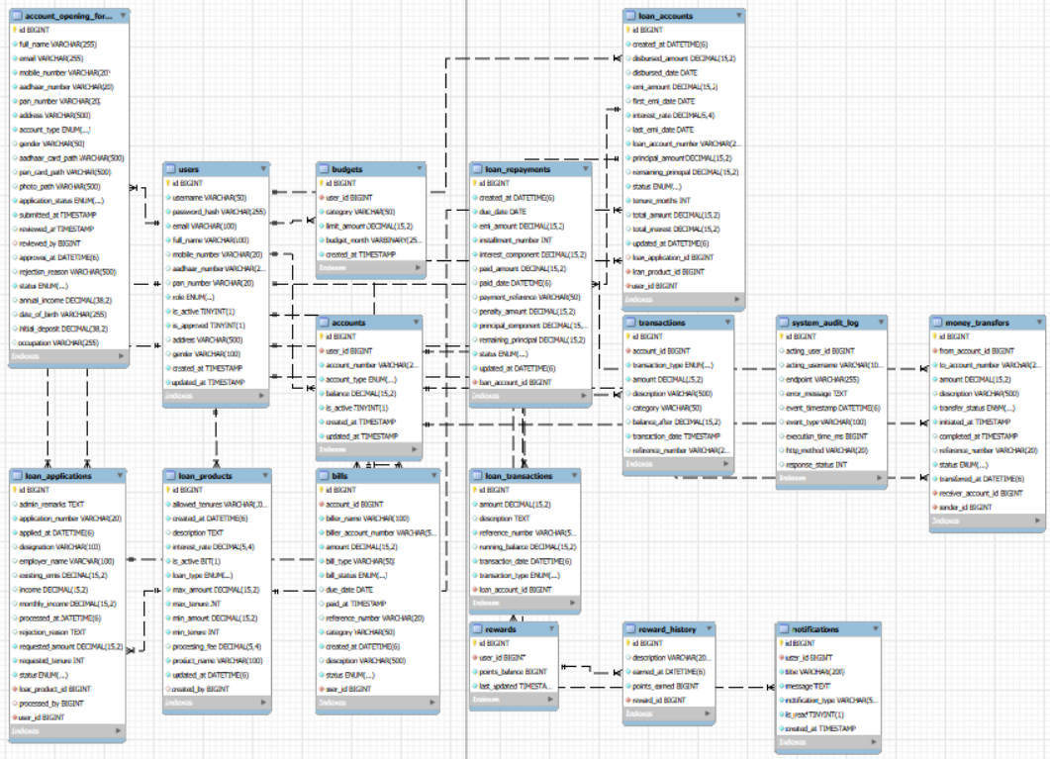

2.3 N-Tier Architecture Flow
Insert the N-Tier architecture flow diagram illustrating request and data flow across the Presentation, API/Application, Business Logic, and Data Access tiers.

N-Tier Architecture Flow Diagram
Insert flow diagram depicting the request lifecycle from client to database and back.

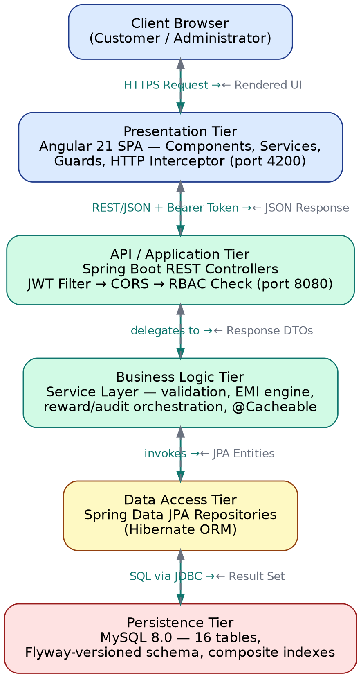

The table below summarizes the responsibility and technology mapping for each architectural tier.

Tier | Responsibility | Technology / Framework
Presentation Layer | Renders the SPA; manages client-side routing, route guards (AuthGuard/AdminGuard), and attaches JWT to every request via a functional HTTP interceptor | Angular 21, Angular Material, Chart.js, RxJS
API / Gateway Layer | Exposes 16 REST controllers; validates JWT and CORS; enforces path- and method-level RBAC before any business logic executes | Spring Boot 3.1 MVC, Spring Security 6, SpringDoc OpenAPI
Business Logic Layer | Implements all business rules: EMI amortization, transfer validation, reward calculation, budget aggregation; applies @Cacheable to read-heavy reference data | Spring Service layer, Spring Cache, Spring AOP (audit aspect)
Data Access Layer | Abstracts persistence operations behind repository interfaces; eliminates hand-written JDBC/SQL for standard CRUD and derived queries | Spring Data JPA, Hibernate ORM
Database / Persistence Layer | Stores all relational data with enforced foreign keys, composite indexes on high-traffic query columns, and version-controlled schema migrations | MySQL 8.0 (InnoDB), Flyway

3. Core Modules Overview
NeoBank 360 is composed of six core functional modules, each independently testable and individually responsible for a distinct domain of banking functionality. The table below summarizes the purpose, key features, and underlying technology for each module. Development teams must populate the description, feature, and technology columns with implementation-accurate details prior to final handover sign-off.

Module | Description | Key Features | Technology / Notes
Auth | Stateless authentication and authorization for both customer and admin users | JWT issuance on login (HS256, 24h expiry); BCrypt password hashing; registration with admin-approval gate; role claim (ADMIN/USER) consumed by RBAC checks | Spring Security 6, JJWT 0.11.5, BCryptPasswordEncoder
Accounts | Digital KYC onboarding plus core account balance and transaction ledger management | Multipart KYC form with Aadhaar/PAN document upload; admin approve/reject workflow that provisions the User + Account on approval; balance-tracked transaction ledger; intra-bank fund transfers with dual-entry DEBIT/CREDIT records | Spring MVC multipart handling, JPA, composite index idx_accounts_user_active
Budgets | Monthly, category-based spending plans compared against actual transaction activity | Upsert-style create/update budget per (user, category, month); live aggregation of actual spend from the transactions table; utilization percentage surfaced to the dashboard | Composite UNIQUE key (user_id, category, budget_month); JPA aggregate queries
Bills | Recurring bill registration and one-click payment | Upcoming (due ≤ 7 days) and overdue bill views; pay-bill operation that debits the account, marks the bill PAID, and triggers a reward-points event; combined create-and-pay shortcut | Composite index idx_bills_user_status_due; integrates with Accounts and Rewards
Loans | End-to-end lending lifecycle from product catalog to EMI closure | 10 seeded loan products across 5 types; income-validated application; admin approve/reject decisioning; on approval, automatic disbursement credit and full amortization schedule generation using the reducing-balance EMI formula; partial/installment EMI payment with penalty handling | EmiCalculatorUtil (BigDecimal, HALF_UP rounding); @Cacheable loan product reads; composite indexes on loan_applications/loan_accounts/loan_repayments
Analytis | Personal financial insights for customers and operational/executive analytics for administrators | Customer-side: income/expense trend, category breakdown, savings rate. Admin-side: live KPI cards (AUM, user/transaction counts, pending approvals), 7D/30D/YTD trend analytics, loan portfolio health, system health endpoint | Aggregation queries over transactions/loan_accounts; Chart.js rendering on the Angular side

3.1 Inter-Module Dependencies
Describe how the modules interact with one another (e.g., the Analytics module consuming data from Accounts, Budgets, and Bills; the Loans module depending on Accounts for disbursement and repayment).

Module Dependency Map
Insert a diagram or description of inter-module data flow and dependencies.

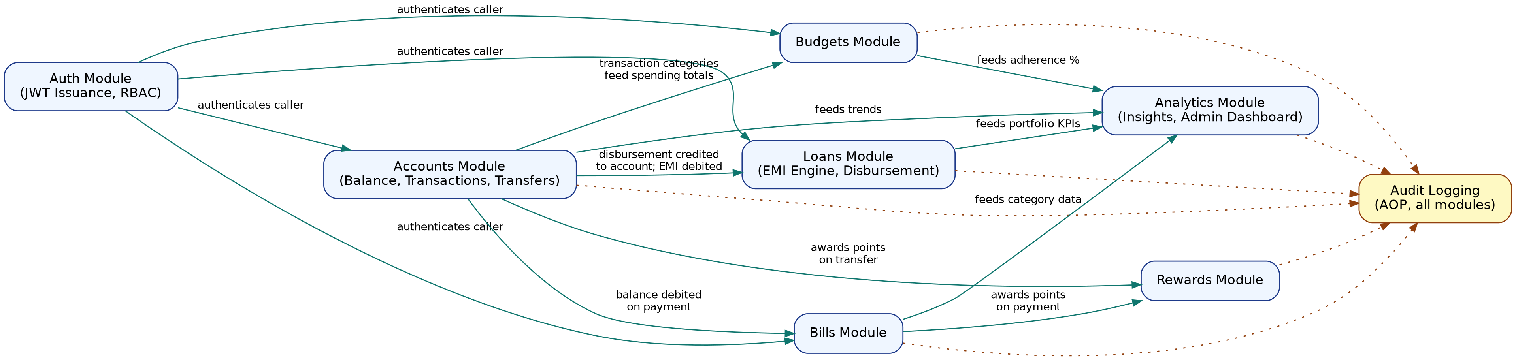

4. Security & Authentication
Security is a foundational design pillar for NeoBank 360, given the sensitivity of financial data handled by the platform. The application enforces authentication via JSON Web Tokens (JWT) and authorization via Role-Based Access Control (RBAC). This section must be completed with implementation-specific details to enable accurate security review by senior stakeholders.

4.1 Authentication Mechanism (JWT)
Explain the end-to-end JWT authentication flow, including token issuance at login, token structure and claims, signing algorithm, expiry duration, and the refresh token strategy.

JWT Authentication Flow
Insert a sequence diagram or detailed explanation of the login, token issuance, and token refresh flow.

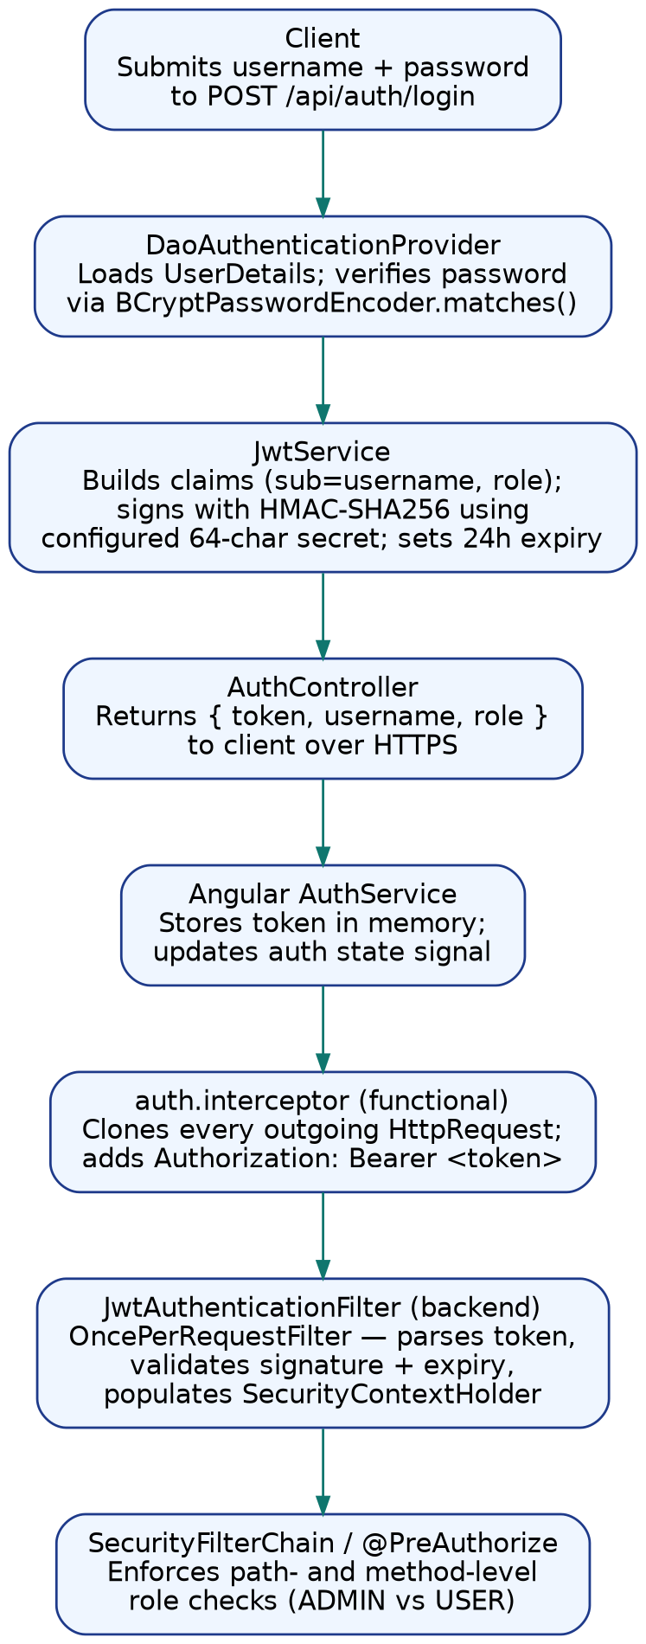

- Signing Algorithm: HMAC-SHA256 (HS256), implemented via the JJWT 0.11.5 library
- Access Token Expiry: 24 hours (86,400,000 ms), configured via jwt.expiration and externalized as JWT_EXPIRATION in the production profile
- Refresh Token Expiry & Rotation Policy: Not implemented in the current build. The application currently issues a single 24-hour access token with no refresh flow; this is documented as a recommended enhancement in Section 8.3.
- Token Storage Mechanism (Client-Side): In-memory within the Angular AuthService (no localStorage/sessionStorage), with the token re-attached to every outgoing request by a functional HTTP interceptor; the session ends on tab/browser close or token expiry, whichever comes first

4.2 Authorization Model (RBAC)
Document the role hierarchy implemented within NeoBank 360 and the permissions associated with each role. The table below should be populated with the exact roles defined in the codebase.

Role | Permissions | Description
ADMIN | Full access to /api/admin/**, KYC approval queue, loan admin decisioning, user management (search/edit/enable/disable/delete), deposit management, executive analytics, and audit log search. Enforced via @PreAuthorize("hasRole('ADMIN')") at the method level on every admin-scoped controller. | Bank back-office staff responsible for onboarding approval, lending decisions, and operational oversight
USER | Access restricted to their own data: own accounts/transactions, own loan applications and EMI schedule, own bills and budgets, own rewards and insights. Ownership is additionally checked in the service layer (not just the role), so one USER cannot read another USER's records even though both share the USER role. | Retail banking customers performing self-service banking
— | No additional roles are defined in the current UserRole enum (only ADMIN and USER exist as of this build). | Reserved for future role expansion (e.g., TELLER, AUDITOR) if required

4.3 Additional Security Controls
- Data Encryption (In-Transit / At-Rest): In-transit: the application is designed to sit behind TLS termination (HTTPS) at the load balancer/reverse-proxy layer; CORS is restricted to known origins. At-rest: passwords are one-way hashed with BCrypt before storage; raw KYC documents (Aadhaar/PAN images) are stored on the server filesystem with paths persisted in the database — full disk/volume encryption is recommended at the infrastructure level since the application does not itself encrypt file contents.
- Input Validation & Sanitization Strategy: Request DTOs are validated using Jakarta Bean Validation annotations at the controller boundary; a global @ControllerAdvice exception handler converts validation failures and business exceptions (ResourceNotFoundException, BadRequestException) into structured JSON error responses so stack traces are never returned to the client. The audit aspect additionally sanitizes any logged exception messages, redacting fields matching password, token, aadhaar, or pan before persisting them to system_audit_log.
- API Rate Limiting & Throttling: Not implemented in the current build. No rate limiter (e.g., Bucket4j, Spring Cloud Gateway) is currently in front of /api/auth/login or other endpoints; this is flagged as a priority enhancement in Section 8.3 given its importance for brute-force protection on a financial application.
- Audit Logging & Monitoring: An AspectJ @Around advice (AuditLogAspect) wraps every @RestController method invocation. It records the endpoint, HTTP method, response status, execution time in milliseconds, the acting user (resolved from the SecurityContext), a derived event type (e.g., LOGIN, MONEY_TRANSFER, LOAN_APPROVAL_DECISION), and a sanitized error message on failure — all persisted to system_audit_log without any code added inside the business services themselves.
- Secrets Management Approach: The JWT signing secret and database credentials are externalized as environment variables (JWT_SECRET, SPRING_DATASOURCE_PASSWORD, etc.) in application-prod.yml using Spring's ${VAR:default} placeholder syntax, so production values are injected at deploy time rather than committed to source control. The default values present in the repository are placeholders for local development only and must be overridden before any real deployment.

5. Performance Optimizations
To ensure responsiveness under production-grade load, NeoBank 360 incorporates targeted optimizations across the caching and database layers. This section captures the specific strategies implemented, enabling future contributors to understand and extend the system's performance profile without regression.

5.1 Caching Strategy
Describe the caching layer adopted (e.g., in-memory, distributed cache such as Redis), the data entities cached, time-to-live (TTL) configuration, and the cache invalidation strategy.

Caching Architecture
Insert details or diagram of the caching layer, cache keys, TTL policy, and invalidation triggers.

NeoBank 360 uses Spring's declarative caching abstraction (@EnableCaching on the main application class) backed by the default ConcurrentMapCache provider — an in-process, in-memory cache with no external dependency. This is a deliberate, honest scope decision for the current build: a distributed cache such as Redis was evaluated but not adopted, since the only cached entity (the loan product catalog) is small, read-mostly, shared across the entire user base rather than per-user, and changes infrequently — it does not yet justify the operational overhead of a separate cache cluster. The loan product list (getAllLoanProducts() and getActiveLoanProducts() in LoanServiceImpl) is the highest-read, lowest-write data path in the application: every visit to the Loans page triggers a read, while writes only occur when an administrator adds, edits, or deactivates a product. @Cacheable("loanProducts") intercepts these read calls and serves from memory after the first hit, and every mutating operation (create, update, delete) is annotated @CacheEvict(value = "loanProducts", allEntries = true) so the cache is invalidated immediately and correctly on the next write — avoiding any window of stale product data. No explicit TTL is configured, since eviction is event-driven rather than time-driven, which is a more precise invalidation strategy than a TTL guess for this access pattern. Migrating to Redis (Section 8.3) would only become necessary if the application is horizontally scaled across multiple JVM instances, since ConcurrentMapCache is local to a single instance and would not be shared across nodes.

- Cache Provider / Technology: Spring Cache abstraction with the default ConcurrentMapCacheManager (in-memory, single-instance). No Redis or other distributed cache is configured in the current build.
- Cached Entities: Loan product catalog only — cache name "loanProducts", with separate keys for the full list ('all') and the active-only list ('active')
- Cache Invalidation Strategy: Event-driven eviction: every administrative create/update/delete operation on a loan product (createLoanProduct, updateLoanProduct, deleteLoanProduct) is annotated @CacheEvict(value = "loanProducts", allEntries = true), clearing the cache immediately rather than waiting on a time-based TTL

5.2 Database Indexing Strategy
Document the indexing strategy applied to high-traffic tables, including composite indexes, query patterns optimized, and any partitioning or sharding considerations.

Indexing & Query Optimization
Insert details of indexed columns, query execution plans, and partitioning strategy where applicable.

Indexes were added in two Flyway migrations directly against the query patterns the application actually issues, rather than indexing speculatively. V13 (loan_management_schema) adds single-column indexes on loan_type, is_active, status, applied_at, and application_number to support the product catalog filter and the admin application queue. V14 (sprint5_audit_and_indexes) adds composite indexes that match multi-predicate WHERE clauses observed in the service layer: idx_accounts_user_active on accounts(user_id, is_active) for the “my active accounts” lookup; idx_transactions_account_type_date on transactions(account_id, transaction_type, transaction_date) for ledger and analytics queries that filter by account and transaction type and then sort by date; idx_bills_user_status_due on bills(user_id, status, due_date) for the upcoming/overdue bill views; idx_loan_applications_status_date and idx_loan_accounts_user_status for the admin loan queue and the user's “my loans” view; and idx_loan_repayments_status_due for the EMI due-date scan used by repayment reminders. The system_audit_log table itself carries idx_audit_timestamp, idx_audit_user, and idx_audit_endpoint so that the admin audit-log search (filterable by date range, username, and endpoint) does not degrade into a full table scan as log volume grows. No partitioning or sharding has been applied, since table volumes in the current deployment do not warrant it; this is a candidate for revisit if transactions or system_audit_log grow into the tens of millions of rows.

- Indexed Tables / Columns: accounts(user_id, is_active); transactions(transaction_date) and transactions(account_id, transaction_type, transaction_date); bills(user_id, status, due_date); loan_applications(status, applied_at); loan_accounts(user_id, status); loan_repayments(status, due_date); system_audit_log(event_timestamp), (acting_user_id), (endpoint); plus single-column indexes from V13 on loan_products(loan_type, is_active) and loan_applications(status, applied_at, application_number)
- Query Optimization Techniques Applied: Composite indexes ordered to match actual WHERE-clause predicate order (equality columns first, range/sort column last); avoided over-indexing low-cardinality boolean columns in isolation; relied on Spring Data JPA derived query methods rather than hand-rolled JPQL so generated SQL stays predictable and index-friendly

5.3 Additional Performance Measures
- Connection Pooling Configuration: Uses Spring Boot's default HikariCP connection pool (auto-configured from the spring.datasource.* properties); no custom pool-size overrides are currently set in application.properties or application-prod.yml, so HikariCP's defaults (10 max connections) apply. Tuning the pool size for expected concurrent load is recommended before a production load test (see Section 8.3).

- Pagination & Lazy Loading Strategy: Admin-facing list endpoints (user management, system audit log) accept page and size query parameters and return a Spring Page<T>, preventing unbounded result sets; JPA entity associations are mapped lazily by default (the standard JPA/Hibernate behavior for collection associations), so related collections (e.g., a user's transactions) are only fetched when explicitly navigated or queried, not eagerly pulled in on every parent load.

- Asynchronous / Background Processing: Not implemented in the current build. All operations — including notification creation, reward-point awarding, and audit-log writes — execute synchronously within the request thread. Introducing @Async for these non-critical side effects is recommended in Section 8.3 to reduce perceived latency on write-heavy endpoints such as bill payment and fund transfer.
- Observed Performance Benchmarks: No formal load test has been executed against this build (see Section 7.2 for the current state of load testing). The optimizations described in this section — caching and indexing — were implemented proactively based on code-level query analysis rather than reactive tuning from a benchmark; quantified before/after figures should be captured once JMeter/k6 testing (Section 8.3) is carried out.

6. Deployment Guide
This section provides the operational instructions required to build, containerize, and deploy NeoBank 360 across development, staging, and production environments. All commands and configuration values must be validated by the development team prior to handover.

6.1 Prerequisites
- Runtime Environment & Version: Java 17 (eclipse-temurin:17-jre-jammy at runtime); Node.js 20 LTS is required only at the Angular build stage, not at runtime
- Build Tooling: Maven 3.9+ (backend), Node.js 20 LTS + Angular CLI (frontend) — both built and run directly on the host or VM without containerization
- Database Server & Version: MySQL 8.0 (InnoDB engine); schema is initialized via Flyway-managed migrations on application startup, with spring.jpa.hibernate.ddl-auto=update as a fallback for incremental entity changes
- Required Third-Party Services: None external to the stack itself — the application has no dependency on a message broker, external cache, or third-party payment gateway in the current build

6.2 Environment Variables
The following environment variables must be configured prior to deployment. Sensitive values must never be committed to source control and should be managed via a secrets manager or CI/CD secured variable store.

Variable Name | Description | Example Value
DB_HOST | MySQL host/connection string consumed by Spring's datasource URL | jdbc:mysql://mysql:3306/neobank360?useSSL=false&allowPublicKeyRetrieval=true&serverTimezone=UTC (set via SPRING_DATASOURCE_URL)
DB_PORT | MySQL port (embedded in the JDBC URL above; listed separately for clarity in container networking) | 3306
DB_NAME | Target schema name | neobank360
JWT_SECRET | HMAC signing secret for JWT issuance and validation — MUST be overridden in production and never committed to source control | SPRING_DATASOURCE_USERNAME / SPRING_DATASOURCE_PASSWORD / JWT_SECRET — supplied via the deployment platform's secrets store
JWT_EXPIRY | JWT access token lifetime in milliseconds | JWT_EXPIRATION=86400000 (24 hours)
PORT | Port the embedded Tomcat server listens on inside the container | 8080 (the embedded Tomcat server's default listening port; expose behind a reverse proxy/load balancer in production)
NODE_ENV / SPRING_PROFILE | Active Spring profile, selecting application-prod.yml over the local application.properties defaults | SPRING_PROFILES_ACTIVE=prod
SPRING_DATASOURCE_URL / USERNAME / PASSWORD | Full datasource override triplet referenced via ${...:default} placeholders in application-prod.yml | Provided by the secrets manager / CI-CD secured variable store — never the in-repo development defaults

6.3 Deployment Steps
- Pull the latest stable build from the source repository.
- Configure environment variables as per Section 6.2.
- Package the backend as an executable Spring Boot JAR (mvn clean package) and build the Angular frontend for production (ng build --configuration production).
- Run database migrations / schema initialization scripts. Flyway migrations execute automatically on application startup against the configured datasource; no separate manual migration step is required as long as the MySQL instance is reachable and the schema/user specified in Section 6.3 already exists.
- Deploy the application to the target environment: run the backend JAR as a system service (or behind a process manager such as systemd) and serve the built Angular assets via a web server (e.g., Nginx), supplying the environment variables from Section 6.2 through the host's environment or a secrets manager.
- Verify application health via the designated health-check endpoint. Confirm readiness by checking GET /api/admin/system-health (requires an authenticated ADMIN token) for a DB-UP status, and confirm the Swagger UI is reachable at /swagger-ui.html as a basic smoke test that the application context started successfully.

6.4 Rollback Procedure
Document the rollback strategy in the event of a failed deployment, including how to revert to the previous stable container image and database state.

Rollback Strategy
Insert rollback steps, including image versioning and database rollback considerations.

Application rollback: maintain the previous known-good build artifact (backend JAR and frontend production bundle) for every release so that a failed deployment can be reverted by simply redeploying the prior artifact in place of the faulty one. Database rollback: because Flyway migrations are forward-only by convention in this project (V13, V14 add new tables/indexes rather than destructively altering existing columns), rolling back the application to a previous version does not require a corresponding destructive schema rollback in most cases — the older application code simply does not reference the newer tables/columns. For any future migration that does alter or drop existing columns, a corresponding down-migration or a verified backup/restore point should be taken immediately before applying it. As a general safeguard, a full database backup should be captured immediately before every production deployment so that a point-in-time restore is available as a last resort if rolling back the application artifact alone is insufficient.

7. Testing Summary
Comprehensive testing was conducted across functional and non-functional dimensions to validate the correctness, reliability, and scalability of NeoBank 360 prior to handover. This section summarizes the End-to-End (E2E) and Load Testing outcomes.

7.1 End-to-End (E2E) Testing
Automated end-to-end browser testing (e.g., Cypress or Playwright covering the full account-opening, login, and transfer journeys) has not yet been implemented in this build. Functional validation to date has been performed through targeted backend unit tests and manual exploratory testing of each module against the Swagger UI and the running Angular application. Establishing an E2E suite for the core customer journeys (account opening → approval → login → transfer → loan application → EMI payment) is recorded as a priority item in Section 8.3.

Parameter | Details
Testing Tool / Framework | JUnit 5 + Mockito (backend service-layer unit tests); Vitest (frontend unit tests)
Test Coverage (% of Modules) | Partial — 2 backend service-layer test classes (SystemAuditLogServiceImplTest, InsightsServiceImplTest) and 3 frontend spec files (ThemeService, the error interceptor, and the root AppComponent) exist in the current codebase. The majority of services and components do not yet have dedicated automated test coverage.
Total Test Cases Executed | 5 automated test files total across backend and frontend, exercising audit-log persistence, financial insights calculation, theme toggling, HTTP error interception, and application bootstrap
Pass / Fail Summary | All existing automated tests pass on the current build; broader functional correctness (loan EMI engine, transfer flow, KYC approval) has been validated manually rather than through an automated regression suite
Key Scenarios Validated | Login/registration, KYC submission and admin approval, fund transfer with insufficient-balance rejection, loan application → approval → disbursement → EMI schedule generation, bill payment with reward-point award, budget creation and spending aggregation — all validated manually via Swagger UI and the Angular client
Critical Defects Identified | None outstanding at the time of this handover for the manually validated flows above; this should not be read as a substitute for formal QA sign-off, since automated regression coverage remains limited (see row 2)

7.2 Load & Performance Testing
No formal load or performance test (JMeter, k6, or Locust) has been executed against this build as of the handover date. The performance work completed so far (Section 5) — query-pattern-driven indexing and method-level caching on the loan product catalog — was derived from static code-level analysis of query patterns rather than from benchmark-driven tuning. A baseline load test against the containerized deployment (Section 6) is the recommended next step before any production rollout, and the metrics table below is intentionally left as a template for that exercise rather than populated with simulated figures.

Metric | Target / Threshold | Observed Result
Concurrent Users Simulated | Not yet defined | Not yet measured — no load test executed
Average Response Time | Not yet defined | Not yet measured
95th Percentile Response Time | Not yet defined | Not yet measured
Throughput (Requests / Second) | Not yet defined | Not yet measured
Error Rate Under Load | Not yet defined | Not yet measured
System Stability / Recovery Behavior | Not yet defined | Not yet measured

7.3 Testing Tools & Environment
- Load Testing Tool (e.g., JMeter, k6, Locust): Not yet selected / not executed in this build — recommended for the next phase (see Section 8.3)
- Test Environment Specification: Local development environment only (Spring Boot embedded Tomcat + local MySQL 8.0 instance); no dedicated staging/performance environment has been provisioned to date
- Test Data Strategy: DataInitializer seeds 10 representative loan products at application startup for functional testing; no synthetic large-volume dataset has been generated for load testing purposes yet

8. Challenges & Learnings
This section documents the significant technical and operational challenges encountered during the development of NeoBank 360, along with the corresponding resolutions and key learnings derived by the team. It is intended to provide future contributors and stakeholders with institutional context that is not otherwise captured in code or test artifacts.

8.1 Technical Challenges Encountered
- Challenge 1: Calculating EMI schedules with exact decimal precision: floating-point arithmetic is unsuitable for currency, and naive rounding of the standard reducing-balance EMI formula (EMI = P×r×(1+r)^n / ((1+r)^n−1)) across many installments can leave the loan balance off by a few rupees at the final installment. Resolution: implemented EmiCalculatorUtil using BigDecimal throughout, with HALF_UP rounding to 2 decimal places and a MathContext of 20 significant digits for the (1+r)^n exponentiation; the final installment's principal component is explicitly set to whatever remaining principal balance is left rather than the formula-derived amount, so any accumulated rounding difference is absorbed at loan closure instead of leaving a residual balance.

- Challenge 2: Adding an audit trail across every controller without scattering logging calls through the business logic: a naive approach would require adding a logging call inside every service method, which is repetitive and easy to miss on new endpoints. Resolution: implemented a single Spring AOP @Around aspect (AuditLogAspect) with a pointcut matching within(@RestController *), which transparently wraps every controller method, captures timing and response status, and persists the result — with zero logging code inside any individual service.
- Challenge 3: Identifying which database queries actually needed indexes, rather than indexing everything defensively (which would slow down writes for no benefit). Resolution: reviewed the actual repository query methods and WHERE-clause predicates used by each service (e.g., the user/status/due-date filter used by the bills and loan repayment views) and added composite indexes specifically matching those predicate combinations in the V14 Flyway migration, rather than adding single-column indexes on every foreign key by default.

8.2 Key Learnings
- Learning 1: Declarative cross-cutting concerns (Spring AOP for auditing, Spring Cache for read-heavy data) keep business logic readable and let a single piece of infrastructure code apply consistently across many endpoints, rather than relying on every developer remembering to add logging or caching by hand in each new service method.
- Learning 2: Currency and interest calculations require deliberate precision handling (BigDecimal with an explicit rounding mode) from the very first implementation — retrofitting precision handling into an EMI engine after schedules have already been generated would be far more disruptive than building it in from the start.
- Learning 3: Database indexing is most effective when driven by actual query shapes in the codebase rather than applied as a generic best practice; reading the repository layer's derived queries before writing migration scripts produced a much smaller, more targeted index set than indexing defensively would have.

8.3 Recommendations for Future Enhancements
- Recommendation 1: Implement a refresh-token flow (long-lived refresh token + short-lived access token) so customers are not forced to re-authenticate every 24 hours, and add API rate limiting on /api/auth/login to mitigate brute-force attempts — both currently absent from the security posture described in Section 4.
- Recommendation 2: Establish a baseline JMeter or k6 load test against the containerized deployment and populate Section 7.2 with real throughput, latency, and error-rate figures; use the results to size the HikariCP connection pool and decide whether the in-memory ConcurrentMapCache should be migrated to Redis for multi-instance deployments.
- Recommendation 3: Build out an automated E2E test suite (Cypress/Playwright) covering the account-opening-to-approval and loan-application-to-disbursement journeys, and expand backend unit test coverage beyond the current two service classes — particularly for the EMI calculation engine and the money-transfer balance validation logic, given their direct financial impact.

9. Frontend Application Walkthrough (Screenshots)
This section documents the primary customer-facing and administrative screens of the NeoBank 360 Angular application. Each entry identifies the screen, the underlying Angular component and API integration, and a placeholder for the corresponding screenshot, which should be captured from a running instance prior to final submission. No real customer data, account numbers, JWT tokens, or KYC documents should be visible in any captured screenshot — use sanitized or seeded demo data only.

9.1 Landing Page
Public marketing/entry page introducing NeoBank 360.

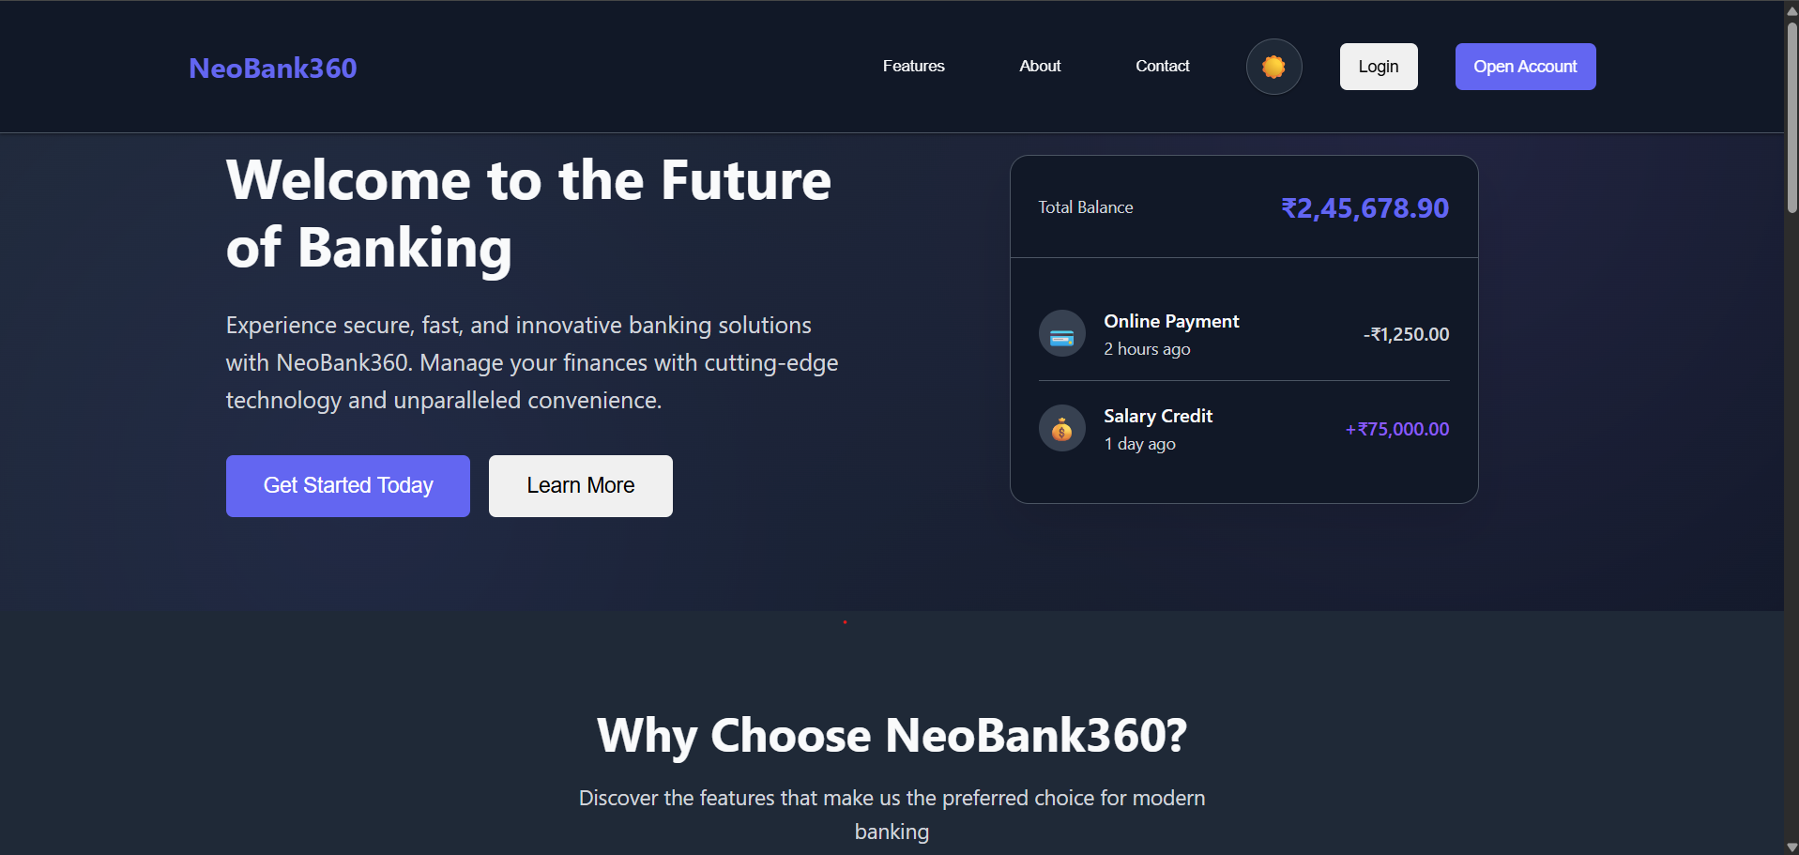

Description: Component: LandingComponent (src/app/pages/landing/). Public route, no authentication required. Presents the platform's value proposition and call-to-action buttons routing to /login and /open-account. No API calls are made from this screen.

9.2 Login Page
Customer and administrator sign-in screen.

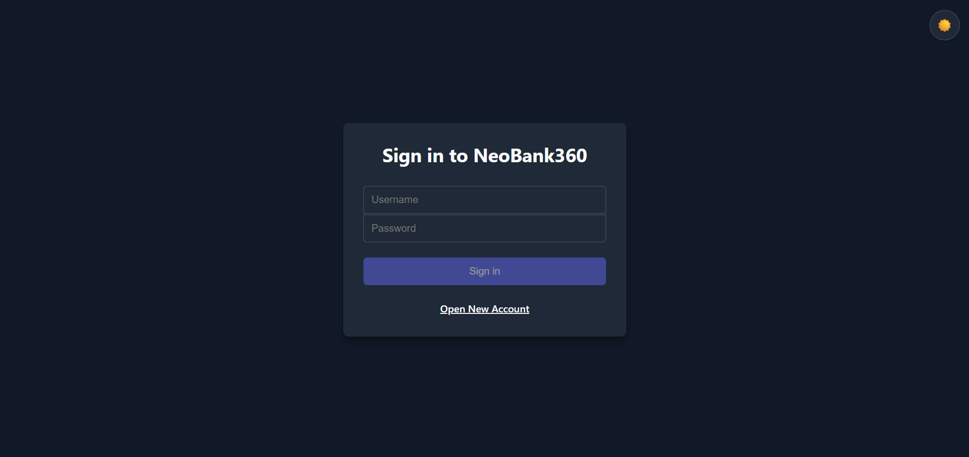

Description: Component: LoginComponent (src/app/pages/login/). Calls POST /api/auth/login via AuthService. On success, the JWT is stored in memory and the user is redirected to /user or /admin based on the role claim decoded from the token. Validation errors are surfaced inline on the form.

9.3 Account Opening / KYC Wizard
Multi-step digital onboarding form with document upload.

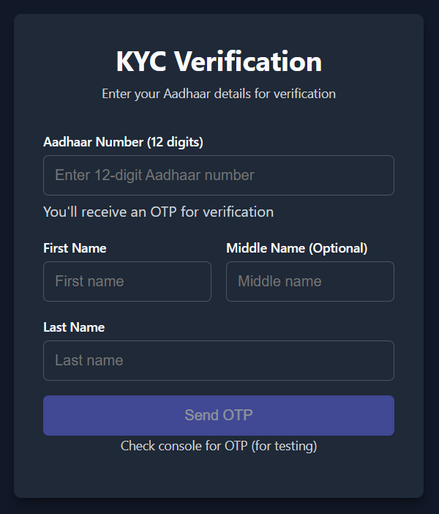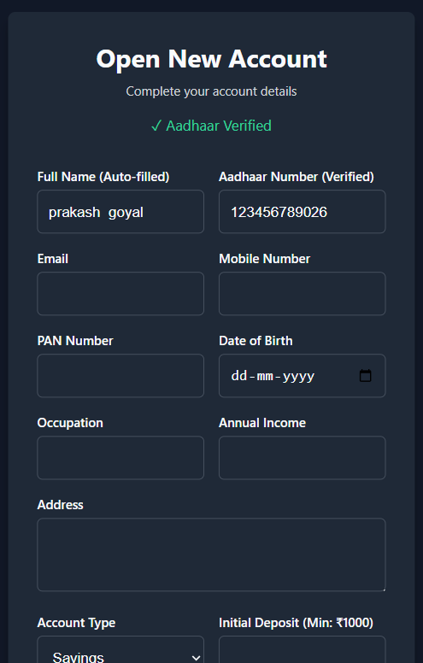

Description: Component: OpenAccountComponent (src/app/pages/open-account/). Public route. Captures personal details, Aadhaar/PAN numbers (with a live existence check against /api/accounts/kyc/aadhaar/{number}/exists), document uploads, and account type selection before submitting a multipart request to POST /api/accounts/open.

9.4 Customer Dashboard
Primary post-login banking interface for retail customers.

Description: Component: UserComponent (src/app/pages/user/). Guarded by AuthGuard. Aggregates account balance, recent transactions, budget progress, upcoming bills, active loan summary, and unread notification count by composing data from BankingService, BudgetService, BillService, LoanService, and NotificationService.

9.5 Fund Transfer Widget
In-dashboard form for intra-bank account-to-account transfers.

SCREENSHOT TO BE INSERTED HERE

Description: Hosted within UserComponent. Submits beneficiary account number, amount, and description to POST /api/user/transfer via BankingService.transfer(); displays the updated balance and a success/failure toast on completion.

9.6 Loan Products & My Loans
Loan catalog browser and active loan tracking view.

SCREENSHOT TO BE INSERTED HERE

Description: Component group under src/app/pages/loans/. Lists available products from GET /api/loans/products/active, supports application submission via LoanService.applyForLoan(), and displays active loan accounts with remaining principal and next-due EMI from GET /api/loans/my-accounts.

9.7 EMI Repayment Schedule
Full amortization table for a selected loan account.

SCREENSHOT TO BE INSERTED HERE

Description: Rendered from GET /api/loans/{loanAccountId}/repayments. Displays installment number, due date, EMI amount, principal/interest split, and status (PENDING/PAID/OVERDUE) per row, with a pay action wired to LoanService.payEMI().

9.8 Budget Management
Category-based monthly budget creation and utilization tracking.

SCREENSHOT TO BE INSERTED HERE

Description: Hosted within UserComponent via BudgetService. Lets the user create or update a budget per category and month, and renders actual-vs-limit utilization bars sourced from GET /api/budgets/analytics.

9.9 Bills Management
Bill registration, upcoming/overdue tracking, and one-click payment.

SCREENSHOT TO BE INSERTED HERE

Description: Hosted within UserComponent via BillService. Tabs for All / Upcoming / Overdue bills sourced from GET /api/bills, /api/bills/upcoming, and /api/bills/overdue respectively; the Pay action calls POST /api/bills/{id}/pay.

9.10 Rewards Page
Loyalty points balance and earning history.

SCREENSHOT TO BE INSERTED HERE

Description: Hosted within UserComponent via RewardController endpoints. Displays the current points_balance from GET /api/rewards and the full earning ledger from GET /api/rewards/history.

9.11 Financial Insights
Personal analytics dashboard with spending and savings trends.

SCREENSHOT TO BE INSERTED HERE

Description: Component: InsightsComponent (src/app/pages/insights/). Renders Chart.js visualizations (income vs. expense, category breakdown, savings trend) sourced from GET /api/insights/{userId} and the advanced analytics variant.

9.12 Admin Dashboard
Operational KPI overview for bank administrators.

SCREENSHOT TO BE INSERTED HERE

Description: Component: AdminComponent (src/app/pages/admin/). Guarded by AdminGuard. Displays KPI cards (total users, accounts, transactions, AUM, pending approvals) and trend charts sourced from GET /api/admin/dashboard and /api/admin/analytics/advanced.

9.13 Admin — Pending Approvals Queue
KYC and loan application review and decisioning screen.

SCREENSHOT TO BE INSERTED HERE

Description: Hosted within AdminComponent. Lists pending account-opening and loan applications from GET /api/admin/pending-approvals, with approve/reject actions calling the respective AccountOpeningService and LoanService admin endpoints.

9.14 Admin — User Management
Searchable, paginated user administration panel.

SCREENSHOT TO BE INSERTED HERE

Description: Hosted within AdminComponent. Sourced from GET /api/admin/users (paginated, searchable); supports edit, enable/disable (PATCH /api/admin/users/{id}/status), and delete actions.

9.15 System Audit Log Viewer
Searchable compliance trail of sensitive system operations.

SCREENSHOT TO BE INSERTED HERE

Description: Hosted within AdminComponent. Sourced from the audit log search endpoint with filters for free text, endpoint, username, and date range; results are paginated for performance.

9.16 System Health Panel
Live database and application health indicators for administrators.

SCREENSHOT TO BE INSERTED HERE

Description: Hosted within AdminComponent. Sourced from GET /api/admin/system-health; surfaces database connectivity status and basic application runtime metrics.

Annexure A: Glossary of Terms

Term | Definition
JWT | JSON Web Token – a compact, signed token format used for authentication.
RBAC | Role-Based Access Control – an authorization model that restricts access based on assigned user roles.
N-Tier Architecture | An architectural pattern that separates an application into logical layers such as presentation, business logic, and data access.
EMI | Equated Monthly Installment — the fixed periodic loan repayment amount, calculated here using the reducing-balance formula EMI = P×r×(1+r)^n / ((1+r)^n−1).
PMIS | Pradhan Mantri Internship Scheme — the Government of India internship program under which this project was executed at the Infosys Bhubaneswar Development Center.
AOP | Aspect-Oriented Programming — a programming paradigm used here via Spring AOP to apply audit logging across all controller methods without modifying business logic.
KYC | Know Your Customer — the identity verification process (Aadhaar/PAN document collection and admin review) completed during digital account opening.
Flyway | A database migration tool that applies version-controlled SQL scripts (e.g., V13, V14) automatically and in order on application startup, ensuring schema consistency across environments.

Document Sign-Off
By signing below, the undersigned acknowledge that the contents of this handover document have been reviewed and accepted as an accurate representation of the NeoBank 360 system as of the date of submission.

Role | Name | Designation | Signature / Date
Technical Lead | Prakash Goyel | Project Technical Lead | [Prakash Goyel / Date]
Engagement Manager | Ajit k. panigrahi | Infosys Engagement Manager | [Ajit k. panigrahi / Date]
QA Lead | Prakash Goyel | Quality Assurance Lead | [Prakash Goyel / Date]

