Below is an interview-ready brief analysis of your NeoBank360 project.
Project Core
NeoBank360 is a full-stack internet banking system built with:
Backend:
Spring Boot 3, Spring Security 6, JWT, Spring Data JPA, Hibernate, MySQL, DTO pattern, Swagger, JUnit/Mockito.
Frontend:
Angular standalone architecture, Angular guards, HTTP interceptors, Chart.js/ng2 style charts, Angular Material, Tailwind/custom CSS, dark/light theme, responsive dashboards.
Architecture:
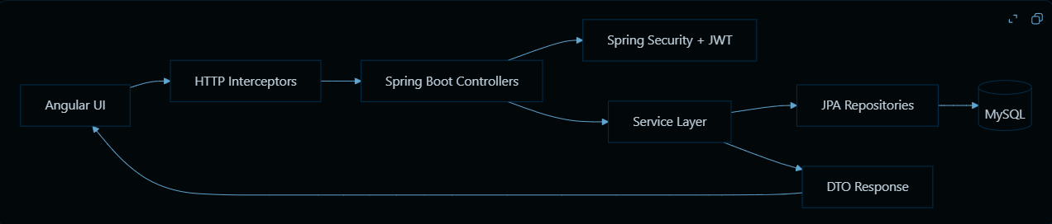
Important Backend Topics Used
- REST API design with Spring MVC controllers
- DTO architecture for secure request/response models
- JWT authentication and stateless security
- Role-based access control with @PreAuthorize
- Spring Security filter chain
- JPA entity relationships
- Repository aggregation queries using SUM, COUNT, GROUP BY
- Transaction management with @Transactional
- Global exception handling using @RestControllerAdvice
- Audit logging using Spring AOP
- EMI calculation using reducing balance formula
- Loan approval workflow automation
- Budget and bill category mapping
- Reward points and notifications
- Caching with @Cacheable / @CacheEvict
- JUnit and Mockito testing
Important Frontend Topics Used
- Angular standalone components
- Lazy routes and route guards
- JWT injection using HTTP interceptor
- Global error handling interceptor
- Chart.js financial dashboards
- Reactive theme switching using Angular signals/effects
- Responsive dashboards with CSS Grid/Flexbox
- Admin dashboard, user dashboard, loan UI, insights UI
- API service abstraction
- Dark/light mode support
- Pagination/filtering/table style admin screens
Important Backend Methods And Logic
Authentication:
- AuthServiceImpl.authenticate()
  - Accepts username/password.
  - Uses AuthenticationManager.
  - Loads user from UserRepository.
  - Generates JWT with username, role, and userId.
  - Returns LoginResponse.
- JwtService.generateToken()
  - Stores claims: role, userId.
  - Signs token using HS512.
  - Enables stateless authentication.
Loan Management:
- LoanServiceImpl.applyForLoan()
  - Validates product availability.
  - Checks duplicate pending applications.
  - Validates loan amount between min/max.
  - Validates tenure against allowed tenures.
  - Creates LoanApplication with PENDING status.
- LoanServiceImpl.processLoanApplication()
  - Admin approves/rejects.
  - Prevents reprocessing approved/rejected loans.
  - On approval calls loan account generation.
- createLoanAccount()
  - Calculates EMI.
  - Creates loan account.
  - Sets disbursed date, first EMI date, remaining principal.
- generateRepaymentSchedule()
  - Creates full amortization schedule.
  - Saves every EMI installment into loan_repayments.
EMI Formula:
EMI = P × r × (1+r)^n / ((1+r)^n − 1)
Where:
- P = principal
- r = monthly interest rate
- n = tenure months
Implemented in:
- EmiCalculatorUtil.calculateEmi()
- generateAmortizationSchedule()
Rounding:
- Uses BigDecimal
- Scale: 2
- Rounding: HALF_UP
- Final installment adjusts rounding difference so remaining balance closes exactly.
Budget/Bills:
- PaymentCategoryUtil.normalizeBillCategory()
  - Electricity, Water, Gas/LPG → Bill Payment
  - Mobile, DTH, Broadband → Recharge Payment
  - Credit Card → Card Payment
  - Loan EMI → EMI Payment
  - Insurance → Insurance Payment
  - Metro/Bus/Train → Travel Payment
Insights:
- InsightsServiceImpl.getFinancialInsights()
  - Calculates total income from CREDIT transactions.
  - Calculates total expense from DEBIT transactions.
  - Savings = income - expense.
  - Returns six-month trend.
  - Does owner check: requesterId must match userId.
Admin Analytics:
- AdminDashboardServiceImpl.getDashboard()
  - Total users
  - Active users
  - Total loans
  - Pending approvals
  - Total transactions
  - Platform savings rate
- AdminDashboardRepository
  - Uses optimized aggregation queries.
  - Avoids loading full entity lists for dashboard counts/sums.
System Audit:
- AuditLogAspect
  - Captures controller API calls centrally.
  - Records endpoint, method, status, execution time, user, event type.
  - Why AOP?
    - Avoids writing audit code inside every controller.
    - Keeps business logic clean.
    - Ensures consistent auditing across APIs.
    - Uses REQUIRES_NEW in audit service so audit persistence is isolated from the main business transaction.
  - Important note: current implementation is synchronous, not fully async. For true non-blocking audit logging, you could add @Async or a queue later.
Performance Decisions
- Admin analytics use aggregation queries instead of fetching all rows.
- Insights use GROUP BY monthly/category aggregation.
- Loan products are cached using:
  - @Cacheable("loanProducts")
  - @CacheEvict on create/update/delete
- Read-only analytics methods use:
  - @Transactional(readOnly = true)
- Dashboard APIs return DTO projections, reducing payload size and entity hydration.
Frontend Important Functions
Auth:
- AuthInterceptor.intercept()
  - Reads token from localStorage.
  - Adds Authorization: Bearer token.
  - Prevents repeating token logic in every service.
- ErrorInterceptor.intercept()
  - Converts API errors into snackbar messages.
  - Improves user experience compared to raw browser alerts.
Theme:
- ThemeService
  - Uses Angular signal
  - Stores selected theme in localStorage.
  - Applies theme to document root.
Charts:
- InsightsDashboardComponent.renderCharts()
  - Builds income/expense, spending, budget, net worth, rewards, and loan payoff charts.
  - Uses theme-aware chart options.
- AdminDashboardComponent.renderCharts()
  - Builds transaction trend, category breakdown, and loan analytics charts.
Loan UI:
- LoansApplyComponent
  - Product selection
  - Amount/tenure form
  - EMI preview
  - Submit loan application
User Dashboard:
- Spending chart
- Budget chart
- Recent transactions
- Bills
- Rewards
- My loans
- EMI payment
Admin Dashboard:
- User approvals
- Loan products
- Loan decisions
- Analytics
- System health
- Audit logs
Business Impact
- Automated EMI schedule generation saves loan officers from manually creating installment records.
- Duplicate pending loan prevention reduces operational errors.
- Admin approval workflow mirrors real banking authorization.
- Budget and bill linking helps customers understand category-wise spending.
- Insights dashboard improves financial awareness.
- Audit logs support compliance and accountability.
- JWT + RBAC protects customer and admin operations.
- Aggregated dashboards help management monitor platform health quickly.
Architecture Diagram
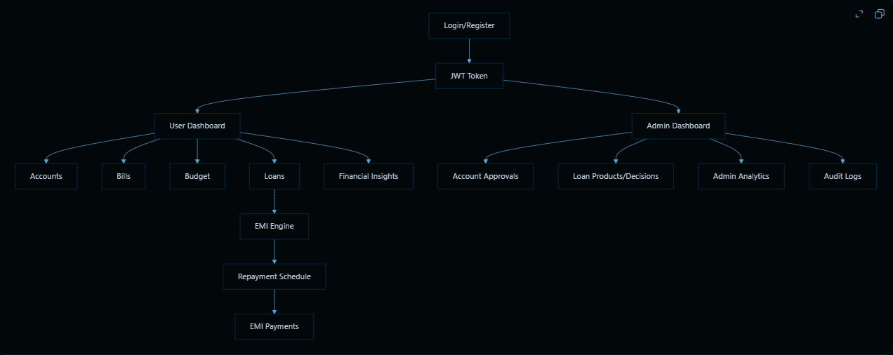
Interview Practice Questions
Backend:
- Explain the complete login flow from Angular login form to JWT generation.
- Why did you use JWT instead of session-based authentication?
- How does JwtAuthenticationFilter authenticate each request?
- What is the role of @PreAuthorize?
- Explain how ADMIN-only APIs are protected.
- Why did you use DTOs instead of exposing entities directly?
- Explain the EMI formula used in your project.
- How do you handle decimal precision in financial calculations?
- What happens automatically after a loan is approved?
- How do you prevent duplicate pending loan applications?
- How are repayment schedules generated?
- How does EMI payment update account balance and loan balance?
- Explain budget vs actual calculation.
- How are bill payments mapped into budget categories?
- Why did you use aggregation queries for analytics?
- What is @Transactional(readOnly = true) and why is it useful?
- Why did you use AOP for audit logging?
- What is the purpose of REQUIRES_NEW in audit logging?
- How does global exception handling improve API consistency?
- What backend tests did you write and what do they verify?

Frontend:
- Why did you use Angular standalone components?
- How does the auth interceptor work?
- How does the error interceptor improve UX?
- How are routes protected for user/admin?
- How does the dashboard update charts?
- How does dark/light mode work?
- How do Chart.js colors change with theme?
- How do you handle responsive layouts?
- How does the loan application UI flow work?
- How does the frontend communicate with Spring Boot APIs?
Scenario Questions:
- If EMI amount is showing zero, where would you debug first?
- If CORS blocks login, what backend config would you check?
- If ADMIN can access USER page, what security layer failed?
- If charts are blank, what frontend lifecycle issue might exist?
- If repayment payment fails, what database fields would you inspect?
- If dashboard is slow, how would you optimize it?
- If audit logging slows APIs, how would you make it async?
- If users report invisible text in dark mode, how would you debug CSS?
- If duplicate Aadhaar KYC is allowed, what backend validation is missing?
- How would you deploy this project in production?

Best interview line:
“NeoBank360 is not just CRUD. It includes real banking workflows: JWT security, RBAC, loan approval automation, EMI amortization, repayment tracking, budget-linked bill payments, financial analytics, admin monitoring, audit logging, and responsive fintech dashboards.”

